4-1-2021
Student name: | Jose Carmona Rodriguez
Student ID: | 1917096
Module No: | BMSW4005
Lecturer: | Lloyd Beharry
Professional career development
Banking and international finance
Table of contents
Introduction 2
1.The employment relationship. 2
1.1 Responsibilities for employee and employer. 2
1.2 Main piece of health and safety legislation 3
2. Recruitment process. 3
2.1 Application form 4
2.2 Reflecting writing task1 (Kolb model) 4
3.Professional career development. (K. model) work in a bank 5
3.1 SWOT analysis and strategy. 5
3.2 Johari window 6
3.3 Personal development plan 7
Conclusion 8
Bibliography 9
Appendix 1 10
Appendix 2 11
Appendix 3 12
Appendix 4 13

Introduction
this report will be focused on how to develop my personal career. Firstly, the employment relationship will be explained. Secondly, the recruitment process. I also will do a Kolb style reflecting writing on the role play (task 1) and then another one on myself. To make the report more effective, I will also use some topics that we learned during this term such as SWOT analysis, Johari window or personal development plan.

1.The employment relationship.
Acts of parliament: it is the first legislation that refers to all laws proposed by parliament. In theory, parliament can legislate laws, but this has been affected by European rights. Delegate legislation are the laws created by government missions or legal authorities. Common laws it is one of the most important sources in UK. It is carried out by judges when similar events occur to seek equal solutions. Equity has helped to bridge common law differences because it has achieved many remedies throughout history.
European union law: it has been in force since the United Kingdom entered the UE. If there is any conflict between them, the law will be automatically eliminated. The forms of European rights need the agreement of all EU members. If it is accepted by all, the objectives will be regulated. Until now, the laws of the European Union have been stronger than the laws of parliaments, limiting the United Kingdom. (LawTeacher, 2019)
There are many rights over EU and UK, but since 01/01/2021, the formal separation by Brexit arrived and these laws are no longer applied.

1.1 Responsibilities for employee and employer.
The employment law It is the law for employer-employee relationships looking for a way to protect both. In case of not complying with it and violating the rights, it could be sanctioned. Legislation existing because it aims to ensure fair business processes. Without these types of laws, workers would be legally unprotected. The employment law cover points such as age discrimination, bulling and harassment, disability, discrimination based on race, religion, sexuality or gender, dismissal and employee grievances, employment contracts, equal pay, holiday pay, minimum wage, parental leave, redundancy or working hours.
The rights of employees: written terms describing labour rights and responsibilities (contract), sick pay, holidays or parental leave and the right to claim unfair dismissal. The rights of workers: written terms describing labour rights and responsibilities (contract), national minimum wage, paid holidays, payroll, and protection against illegal discrimination. The rights of the self-employers: protection of health and safety in client facilities and protection against discrimination. (Croner, 2020)

1.2 Main piece of health and safety legislation
Although it is not a law, it affects all workers. Have a duty to cover health and safety at work when addressing employee issues. The law of health safety at work etc. 1974, covers all measures on this in Britain. The three basic rights are the right to know: the employees have the right to be informed. Participate rights: employees can participate in improving the workplace and controlling health hazard. The right to refuse unsafe work: the law protects any type of complaints in case the worker refuse. Other important legislations are bribery law 2010, data protection Act and regulations on working time. (Croner, 2020)

2. Recruitment process.
There are many essential factors to do a good recruitment to find the perfect candidate for the job. These are the most important steps to follow for the hiring to be effective:
Before posting the ad, it is necessary to dig deeper to understand the skills needed for the new job, the level of role required, and the responsibilities the new hire will have. Once that we know what it takes for the position, we must create a plan with an efficient process to get the best candidates in a short period of time so that good candidate will not hiring by other companies. It is very important to specify the type of work and the type of people required for the vacancy, including key responsibilities, challenges, or opportunities without forgetting the skills, education, and qualifications.
The manager is responsible for searching for the correct candidate through online platforms or traditional routes such as newspapers or job agencies. For the selection process, it is necessary to examine all the candidates and rank them to continue advancing. Once classified, must contact the candidates for a telephone interview or give them a type of task to perform to find out which are the appropriate candidates.
Before starting the interview, it is necessary to make sure the type of questions that will be asked and allow time for the answers given by the candidates to align them with the role. Many candidates will come prepared, so it is important to ask them deep questions and ask for examples of experience as the candidate knowledges appears on the CV. Once, the candidate has been classified, it is essential to monitor their employment references. Then the candidate will be informed of the decision by offering the job and will be given all the necessary information. If the candidate accepts, the contract will be signed. Lastly, the incorporation stage is one of the most important steps. Once the employee beings to work, it is essential to ensure that the employee feels part of the team from the first day, that all the work tools are adequate, and thus can carry out the functions. (Aslanian, 2019)

2.1 Application form
This type of document allows employers to provide all the necessary documentation about the people who are looking for a job and apply to work in the company because it offers the opportunity to describe all the skills and professionalism of the people. The most important points that should appear in an application form to be perfect are the personal information, introductory questions, education, and qualifications, work experience and previous jobs, skills, abilities, and knowledge, personal interests, and hobbies, personal and professional references. profiling and competency tests and CV and covering letter. (Butler, 2020)

2.2 Reflecting writing task1 (Kolb model)
This was completely new for me. I did not imagine that to do an interview I had to follow a guide as a worker or as a manager. Honestly, I have had few jobs interviews in my life because whenever I found a job, my friends helped me, or the business was owned by a relative of mine. Even so, when I have had an interview, I have always improvised without following any guide. As an employer, I have never interview anyone before.
During term three, Mrs Lloyd introduced the role play. He explained to us how to prepare as an employer and employee to put it into practice in week nine, where we were able to practice both parts.
Basically, role play is normally used for hiring, especially for customer service or people management roles. The interviewer takes on the task of client or employee, and the candidate will take care to completing the task.
The purpose of the role play is that the situation is very similar to the working conditions to check in what way it is developing and the way in which it is performed. (FISH4JOBS, 2017)
My role play partner was Mihaela Bohe. Firstly, we used a template to fill in all our data about the job that we were going to apply as employee. The structure was simple, we asked five questions each and when we finished, we gave ourselves the opportunity to ask one last question, and then, we gave the feedback. First, I was the employee and then employer. The questions that she asked me were in line with my job, but in my own opinion, I think was better when I was the employer because I prepared quite well. My questions were brief but very professional and appropriate for the situation. The type of questions was:
- Please, can you tell me few things about you?
- Why do you want to work with us?
- Why do you want this kind of job?
- What are your weaknesses?
- What are your strengths?
As can be reflected in the previous point, the questions were simple but very important in a job interview. I honestly think we got both parts right.
Even so, for next time I would like to be more prepared and rehearse a lot so that everything goes perfectly. I will also try to find better questions by touching on topics such as salary and employee expectations. I will also try to remove questions such as the number one from the list because in these types of questions the employee could speak for a long time, which is not good.

3.Professional career development. (K. model) work in a bank
I have two futures plans in my mind. First to all, I had planned to continue at level 5 and 6, but during this year, I thought that I could start banking and international finances career next year because I believe that finances is more in demand in the working market. The problem is that I do not know if I will be able to pass the math test that is required of me at the university I want to apply. Another reason I want to change universities is because I work at the same university that I want to apply, so this can make my life a bit easier because I would not have to travel, so I would study and work in the same place, helping me save money and time.
On the one hand, I like the course I am doing and its modules. I am interested about the way we learn communication, academic skills and I am sure that I would also like leadership and health care, so I do not rule out this situation of entirely in my plans. On the other hand, I am very good at mathematics, but I do not put it into practice in writing, which is why I am afraid of failing the exam. I do not have much idea about banking and international finances, but I know what I like and would like to try because if I manage to do this career, maybe one day I can work in a bank in my country with a good position there, and thus improve my lifestyle and futures plans a bit more.
One of the most important point that I would like to focus on during these next three years would be mathematics and finances to achieve the goal that I have proposed.
To clear the doubts and see my possibilities, I will do some exercises such a SWOT analysis or PDP and thus see my abilities to achieve it. I will also present the first plan I had at the beginning of this course in ACE term 1 because in case finances go bad, I will return in October to this university to finish the two missing levels.

3.1 SWOT analysis and strategy.
This type of analysis is used to evaluate and develop any type of strategic planning, evaluating the internal parts (strengths and weaknesses) and the external parts (opportunities and threats), helping to facilitate in a realistic way any topic to be discussed. (Scott, 2020)
In my case, it will be focused on my job and studies.
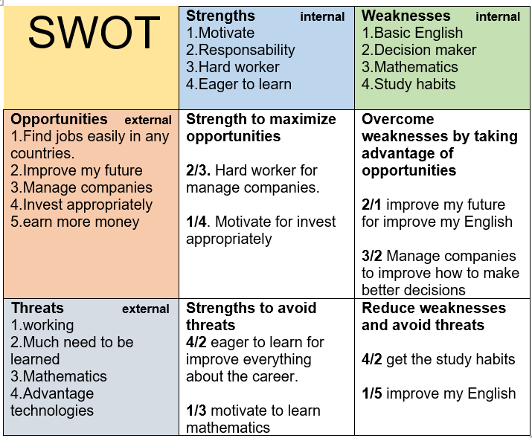

3.2 Johari window
This model helps us discover things about ourselves and about others, helping to improve the way we interact and improving the confidence of the group members. The system is simple but effective, separated by four factors. (Luke, 2019)
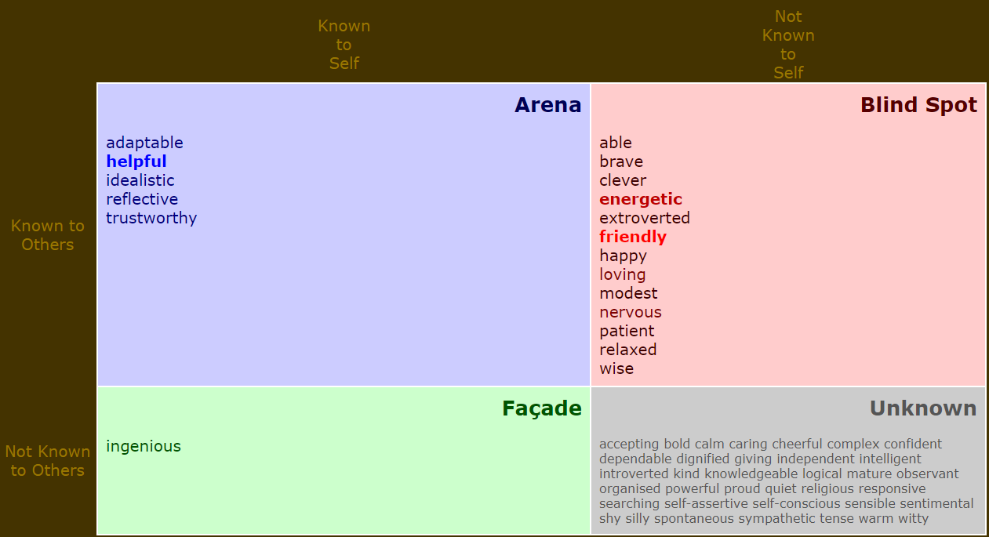
Except for ingenious, my friends have almost the same thoughts that I have about me. This motivates me and helps to reinforce my personality and to see that I am on the right way.

3.3 Personal development plan
 | Next three to six month | Next six to two years | Next two to three years
Goal | Improve English and mathematics | BSc (Hons) banking and international finances | Finish the career, placement, and then work in a bank
Skills and knowledge to be learned | Mathematics  Writing English and speaking  Summer Finances course at city university  IETLS exam.  Grade GCSE maths.  Time management. | Banking and financial institutions, business skills, finance and investment, introductory financial accounting, macroeconomics, and statistics for finance.  Continue with maths and finances. | Year 2:  Bank risk management, corporate finance and valuation, derivatives, financial econometrics, international banking, intermediate financial accounting, introduction to real estate investment and introduction to business law  Year 3:  International finances, monetary economics, bank strategy and management, real estate finance and funding, strategy for business, banking regulation, corporate strategy, and emerging markets.
Next step | Apply for the university and loan. | Improve the language.  Extras English courses | After second and third year I will do a placement year.
Recourses | Flexibility at work.  Full summer holidays.  Access to all online courses. | Flexibility at work.  motivation | Time to study.  Extra time to stay learning finance in the office where I work.
Time schedule | From 3pm to 8 pm  Start from 04/01/2021 until September 2021 | October 2021 until October 2022 | October 2022 until October 2025

I believe that having development all these tools has helped me advance in my personal career in many ways such as planning my future during the next three years because I can see everything clear about my future or seeing the strengths and weaknesses to improve them.
As I mentioned before, if I do not pass the English and maths exam for the finances career, I will return to UWTSD again to finish this career. PDP and SWOT analysis of this second option will be added in appendix.

Conclusion
Due to this assignment, it is possible to see the importance of all the tools to learn about ourselves to help us advance in our goals, the importance of doing our own recruitment process to hire employees and the laws that cover all people in the work environment in UK.

Bibliography
Aslanian, J., 2019. Hellotalent. [Online]
Available at: https://www.hellotalent.com/blog/step-recruitment-process/
[Accessed: 23 December 2020].
Butler, J., 2020. SAVETHESTUDENT!. [Online]
Available at: https://www.savethestudent.org/student-jobs/successful-job-application-form.html
[Accessed: 26 December 2020].
Croner, 2020. Croner. [Online]
Available at: https://croner.co.uk/resources/employment-law/legislation-list/
[Accessed: 21 December 2020].
FISH4JOBS, 2017. FISH4JOBS. [Online]
Available at: https://www.fish4.co.uk/career-advice/nail-role-play-interview/
[Accessed: 22 December 2020].
LawTeacher, 2019. LawTeacher. [Online]
Available at: https://www.lawteacher.net/free-law-essays/english-legal-system/acts-of-parliament-in-the-uk.php
[Accessed: 27 December 2020].
Luke, H., 2019. cms. [Online]
Available at: https://cmsvoc.co.uk/blog/what-is-the-johari-window-model/
[Accessed: 28 December 2020].
Scott, G., 2020. Investopedia. [Online]
Available at: https://www.investopedia.com/terms/s/swot.asp
[Accessed: 30 December 2020].

Appendix 1

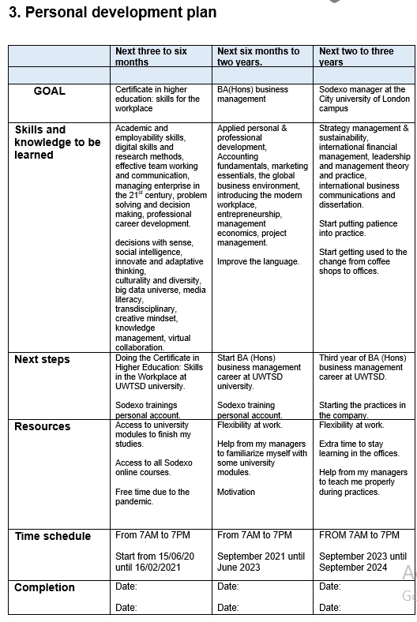
PDP if I fail in banking and international finance.

Appendix 2

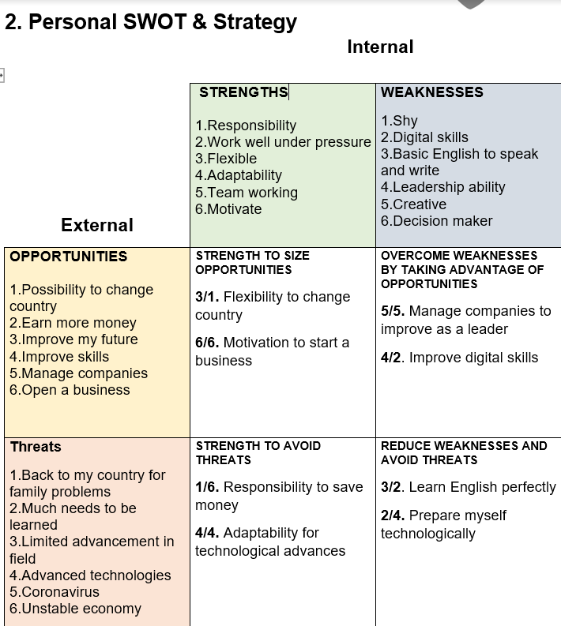

Appendix 3
Role Play interview
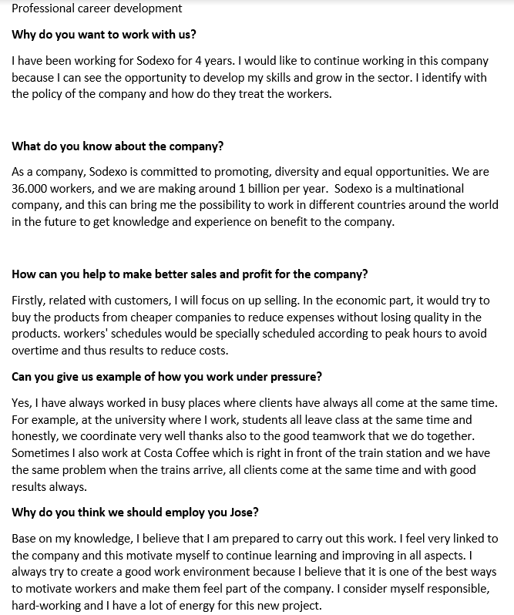

Appendix 4
Application Form


