

UWTSD
OME

BEng

Academic Year 2024 - 2025

Kieran Howells

Chemistry Lab Report 3

Supervisor: Ewa Kazimierska
April 2025

Table of Contents
List of Figures iii
List of Tables iv
List of Equations v
List of Abbreviations vi
1 Introduction 1
1.1 Purpose of Experiment 1
1.2 Hypotheses 1
1.3 Variables 2
2 Results 3
2.1 Experimental Data 3
2.2 Key Findings 7
3 Discussion 8
3.1 Experimental results 8
3.2 Relation to OME 9
3.3 Limitations 9
4 Conclusions 10
5 References 15
Appendices 16

List of Figures
Figure 1 Calorimeter Apparatus Set up [1] 7
Figure 2 Results from Heat capacity experiment 17
Figure 3 Calculations of HC 18
Figure 4 Results from specific heat capacity experiment 19
Figure 5 Calculations of specific heat capacity 20
Figure 6 Results from specific molar heat experiment 21
Figure 7 Calculation of specific molar heat 22

List of Tables
Table 1 Results from first procedure 3
Table 2 Results from measuring the specific heat capacity of a metal 5
Table 3 Results from measuring molar heat of reaction between HCl with NaOH 6

List of Equations
Equation 1 Q = m * C_{p} * ΔT 1
Equation 2 - Q _{metal} = Q _{water} + Q _{calorimeter} 1
Equation 3 m _{metal} x C_{p metal} x ΔT _{metal} = - (m _{water} x C_{p} _{water} x ΔT _{water} + HC _{calorimeter} x ΔT _{calorimeter} 1
Equation 4 Q _{reaction} = - (m _{water} x C_{p water} x ΔT _{water} + HC _{calorimeter} x ΔT _{calorimeter} 1
Equation 5 – Q _{hot-water} = Q _{cold-water} +Q _{calorimeter} 1
Equation 6 Q _{calorimeter} = HC _{calorimeter} x ΔT _{calorimeter} 1
Equation 7 q _{reaction} = Q _{reaction}/n _{reactant} 1
Equation 8 n _{reactant} = V _{reactant} x C _{reactant} 1

List of Abbreviations
DI | Deionised
HCL | Hydrochloric Acid
NaOH  H₂0  DI  OME  RDX  HMX  C_{p}  NaCl  HC  ΔT | Sodium Hydroxide  Water  Deionised  Ordinance, Munitions, Explosives  Research Development Explosive  1,3,5,7-Tetranitro-1,3,5,7-tetraazacyclooctane  Specific Heat Capacity  Sodium Chloride  Heat Capacity  Change in Temperature

Introduction

Purpose of Experiment
This experiment was used to find the find the specific heat capacity of a mass of aluminium and the molar heat capacity of the reaction between NaOH and HCl. This experiment consisted of 3 parts to find the necessary information to calculate Heat capacity of the calorimeter, specific heat capacity of aluminium and the heat capacity per mole of the neutralisation of HCl.
Equations needed for this experiment:
Equation 1 Q = m * C_{p} * ΔT
Equation 2 - Q _{metal} = Q _{water} + Q _{calorimeter}
Equation 3 m _{metal} x C_{p metal} x ΔT _{metal} = - (m _{water} x C_{p} _{water} x ΔT _{water} + HC _{calorimeter} x ΔT _{calorimeter}
Equation 4 Q _{reaction} = - (m _{water} x C_{p water} x ΔT _{water} + HC _{calorimeter} x ΔT _{calorimeter}
Equation 5 – Q _{hot-water} = Q _{cold-water} +Q _{calorimeter}
Equation 6 Q _{calorimeter} = HC _{calorimeter} x ΔT _{calorimeter}
Equation 7 q _{reaction} = Q _{reaction}/n _{reactant}
Equation 8 n _{reactant} = V _{reactant} x C _{reactant}

Hypotheses
As there are 3 sections to this experiment there will be 3 hypotheses.
The first of these is the calculation of heat capacity of the calorimeter. To do this we will get two known volumes of water at two different know temperatures and pour them into the calorimeter. Measuring the resultant temperature will allow us to calculate the heat capacity.
The next procedure was the calculation of the specific heat capacity of a known mass of aluminium. The results from this calculation are expected to be like aluminium’s known specific heat capacity.

The final calculation was conducted to find the molar heat of the neutralisation of an acid of known volume and concentration. This again has a known value and the student’s calculations should give a similar value accounting for external factors.

Variables
The independent variable is the “Object” (object referring to both a physical object or chemical reaction) within the calorimeter.
The Dependant variable are the temperatures measured within the 3 sections.
The control variables are the increments in which temperature is measured and the apparatus used in each experiment.

Results

Experimental Data
The student results were recorded during the experiment. The results in table 1 were collected after the student put cold and hot water into the calorimeter and measured the resultant temperature. They then calculated Q values using equation 1, equation 5 and equation 6. This allowed the student to calculate the heat capacity (referred as HC from this point) of the coffee cup calorimeter.
T _{hot} = 60.6 °C | m _{hot-water} = 50g | ΔT _{hot-water} = -21.5 °C
T _{cold} = 19.5 °C | m _{cold-water} = 50g | ΔT _{cold-water} = 19.6 °C
T _{max} = 39.1 °C |  | ΔT _{calorimeter} = 19.6 °C
Q _{cold-water} = 4102.28J | Q _{hot-water} = -4499.95J | Q _{calorimeter} = -397.67J
Table 1 Results from first procedure
Table 1 shows the results gathered during the experiment and the Q values that were calculated from given figures and results gathered. These calculations were as followed:
Using equation 1 the student calculated the specific heat capacity of the hot water.
m = 50g
C_{p} = 4.186J/(g°C)
ΔT = -21.5°C
Q = m x C_{p} x ΔT
Q _{hot-water} = -4499.95J

Using equation 1 the student then calculated the specific heat capacity of the cold water.
m = 50g
Cp = 4.186(J/g°C)
ΔT = 19.6°C
Q = m x C_{p} x ΔT
Q _{cold-water} = 4102.28J
The student then combines equation 5 & 6 to find the HC value.
If (- Q _{hot-water}) = Q c_{old-water} + Q _{calorimeter}
Then Q _{hot-water} = - (Q c_{old-water} + Q _{calorimeter})
And if
Q _{calorimeter} = HC _{calorimeter} x ΔT _{calorimeter}
Then the two combined gives:
Q _{hot-water} = - (Q c_{old-water} + HC _{calorimeter} x ΔT _{calorimeter})
or
Q _{hot-water} + Q c_{old-water} = - HC _{calorimeter} x ΔT _{calorimeter}
-4499.95 + 4102.28 = – 397.67J
- 397.67J = -19.6 HC _{calorimeter}
HC = 20.4(J/°C)

The next sections of the experiment included heating up a known mass of aluminium and placing it into the calorimeter filled with water of known volume. The student then measured the temperature until it reached a maximum. Results were recorded during the experiment and are shown in table 2
T_{hot} = 100.3 °C | M _{metal} = 18.6g | ΔT _{water} = -71.9°C
T _{cold} = 19.8 °C | M _{water} = 30g | ΔT _{water} = 8.6 °C
T _{max} = 28.4 °C |  | ΔT _{calorimeter} = 8.6 °C
C_{p metal} = 0.94 J/(g°C) | Q _{hot-water} = -4499.95J | Q _{calorimeter} = -397.67J
Table 2 Results from measuring the specific heat capacity of a metal
Table 2 show the results gathered in the section measuring specific heat capacity of a known mass of aluminium. These results were calculated using equation 3 and the previously calculated HC value. Calculations are shown below.
Equation 3 m _{metal} x C_{p metal} x ΔT _{metal} = - (m _{water} x C_{p} _{water} x ΔT _{water} + HC _{calorimeter} x ΔT _{calorimeter}
The student has all these values apart from C_{p metal} therefore they can substitute all the values in and rearrange to calculate the specific heat capacity of aluminium
18.6g x -71.9°C x C_{p metal} = - (30g x 4.186 J/(g°C) x 8.6°C + 20.4(J/°C) x 8.6°C)
-1337.34 x C_{p metal} = - (1255.43)
Therefore (negatives cancel)
C_{p metal} = 1255.43/1337.34
C_{p metal} = 0.94 J/(g°C)

The specification of the experiment stated that after the maximum temperature was reached the student must keep recording temperature until the temperature fell by 2°C. The student found that this took 20 minutes and readings were taken every 10 seconds. This gave the student 118 temperature readings. The student believed this was an anomaly and an error had been made. Table 4 show the beginning of this temperature decrease but due to the extended time taken for the temperature to decrease some values were lost as another place to record them had to be found
The final segment of the experiment was measuring the molar heat of a reaction between HCl and NaOH.
This reaction can be shown as HCl + NaOH NaCl + H₂0
The results were gathered during the experiment and were recorded in table 3
T _{start} = 18.3°C (+2°C) | T _{end} = 25.8°C | ΔT = 5.5°C
V _{HCl} = 50ml | C _{HCl} = 1M | n _{HCl} = 50mol
V _{NaOH} = 52ml | C _{NaOH} = 1M | n _{NaOH} = 50mol
Q _{reaction} = 1261.15J
Q _{reaction} = 25223J
Table 3 Results from measuring molar heat of reaction between HCl with NaOH
The student calculated 2 of these figures using equation 4, equation 7 and equation 8. The student began by assess what the limiting reactant would be. As shown in table 3 the volumes of NaOH and HCl are different and the balance equation above shows that they react on a 1:1 ratio. As there is only 50ml of HCl this must be the limiting reactant. Using equation 8 the student can calculate the number of moles of reactant. As the volume is in mL and 1.0M means 1 mole per litre the student converted 50mL into 0.05L and entering these into equation 8 results in n _{reactant} = 0.05. To find Q _{reaction} equation 4 was used. Using the HC value previously calculated and the results from table 3 the following answer was found to be 25223J per mole or 25.2KJ.

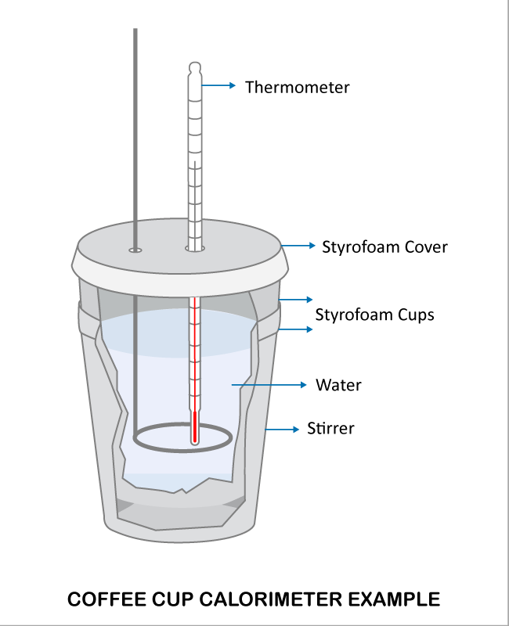
Figure 1 Calorimeter Apparatus Set up [1]
Water could be replace with an object (object meaning a physical item or reaction)

2.2 Key Findings
The student’s key findings from the experiment were that the ambient temperature has a serious effect on the experiment. Due to Bunsen burners being required to heat up the water and aluminium and the class having multiple burners on the room temperature was raised significantly. This becomes an issue as the room temperature at the beginning and end of the experiment was lower than in the middle. This external factor effects the results and the accuracy. Also the apparatus that was used varied in consistency especially in the cups as some had damage.

Discussion

Experimental results
The student found that the results from the experiment were close to values that are agreed to be correct but there is some variance. In the first section the student found the HC value to be 20.4°C. When compared to peers the student found there is a large variance within the values that people calculated. This is due to human factors and the quality of apparatus present as some may have better quality tools than others.
After finding the heat capacity of the calorimeter the student then conducted a test to find the specific heat capacity of 18.6g of Aluminium. The method used for this had flaws as the aluminium was heated in a beaker filled with water. This became a problem as there was an amount of direct heating to the mass of aluminium meaning that the mass and water would not be in total thermal equilibrium. There was also human error in the time taken for the mass to be transferred to the calorimeter itself. These could be remedied by suspending the mass within the beaker during heating and then having different tool to pick up the aluminium instead of tongs. Despite the errors made the student found the specific heat capacity of aluminium to be 0.94 J/(g°C) which compared to the true value of approximately 0.9 J/(g°C) [2] the result is reasonably accurate.

The final part of the experiment was the calculation of molar heat of the reaction between HCl and NaOH. The student had issues with this as the ambient temperature of the room affected the start temperature meaning that the accuracy of the results and subsequent calculations will have been affected. Due to this an assumption had to be made for the experiment to continue as planned. This is show in table 3 as one of the results has +2°C in brackets. This reduced the variance between the calculated answers and the true value but due to an assumption being made the overall accuracy was reduced. Again, despite the errors and external factors the answer that was found lay within a reasonable range. [3]

Relation to OME
In OME calorimetry is a valuable experiment as it allows for the analysis of properties of different energetic material. The best energetic materials have a high energy yield but are also insensitive. This allows for them to have multiple uses and be safer due to the insensitivity. Calorimetry is a way of analysing the thermal properties of energetics which allows for the calculation of values such as specific molar heat capacity. [4] This method can also be used to aid the calculation of the thermal decomposition of explosives.

Limitations
Calorimetry as an experiment is a reliable and tested method for identifying specific heat capacity. Limitation can be found in this experiment as the use of Styrofoam cups as a calorimeter and not a specifically design device has negative effect on results. Human error is also apparent as temperature measurements, timing increments and the transfer of items into the calorimeter has possibility for errors. The student met some of these limitations and remedies for these could include improving the apparatus, automatic temperature monitoring, repeated readings are a few ways in which this could be improved.

Conclusions
The findings of this experiment show the values of heat capacity of the calorimeter, specific heat capacity of aluminium and the molar heat capacity to be the within a reasonable range to the true values. The hypotheses stated have been supported with the results gathered although some of these could be argued to have errors present in results from external factors and human error.

References

[1] | “The Difference between a coffee cup calorimeter and an oxygen bomb calorimeter,” DDS Calorimeters, [Online]. Available: https://ddscalorimeters.com/the-difference-between-a-coffee-cup-calorimeter-and-a-bomb-calorimeter/. [Accessed 1 05 2025].
[2] | C. R. Quick, P. Dumitraschkewitz, J. E. K. Schawe and S. Pogatscher, “Fast differential scanning calorimetry to mimic additive manufacturing processing: specific heat capacity analysis of aluminium alloys,” Journal of Thermal Analysis and Calorimetry, vol. 148, no. 02, pp. 651-662, 2023.
[3] | M. V. Lopez-Ramon, F. Stoeckli, C. Moreno-Castilla and F. Carrasco-Marin, “On the characterization of acidic and basic surface sites on carbons by various techniques,” Carbon, vol. 37, no. 8, pp. 1215-1221, 1999.
[4] | B. Yan, H. Li, Y. Guan, H. Ma, J. Song, F. Zhao and Y. Zhang, “Thermal Behavior, Specific Heat Capacity and Detonation Characterization of 3,3-Dinitroazetidinium 3,5-Dinitrobenzoate,” Propellants, Explosives, Pyrotechnics, vol. 4, no. 43, pp. 398-403, 2018.

Appendices
Equipment
- X2 Styrofoam cups
- Lid
- Thermometer
- Stirring rod
- Beaker
- Waste beaker
- 50mL or HCl
- 52mL or NaOH
- 18.6g of aluminium
- Bunsen Burner
- Gauze
- Tripod
- Heat resistant mat
Method
Method for HC experiment
- Add 50mL of water to Styrofoam cups and close with lid, add thermometer and stirring rod.
- Add 50mL of water into a separate beaker and place over Bunsen burner until temperature reaches 80°C. Turn off gas and wait until temperature reaches 60°C. Record the temperature as T _{hot-water}
- Measure temperature of water in the Calorimeter and record as T _{cold-water}
- Add hot water into the calorimeter and mix continuously and record the maximum temperature as T _{max}
- Use Equations 1, 5 and 6 to calculate HC of calorimeter

Method for Measuring specific heat capacity
- Weigh mass of metal sample and record it as m _{metal}
- Set up a water bath, heat water until boiling and place metal mass into water bath. Leave to boil for 5 minutes. Avoid directly heating metal. After 5 minutes close gas and wait 2 minutes.
- While waiting, measure 30mL of water and place into calorimeter. Measure the temperature and record as T _{cold}
- After the 2 minutes of waiting are over record the temperature of hot water as T _{hot} and add metal into calorimeter using tongs
- Stir water well and record temperature every 10 seconds. Fill in datasheet along side this and once temperature has reached its maximum keep recording until temperature reduces by 2°C. Record maximum temperature as T _{max}.
- Using equation 3 calculate the specific heat capacity of aluminium.

Method for measuring specific molar heat
- Measure out 52mL of NaOH of 1.0M into the calorimeter and 50mL of 1.0M of HCl into separate beaker.
- Place side by side and allow for temperatures to equalise. Record as T _{start}
- Add The HCl quickly into the calorimeter and record the temperature when it reaches a maximum and record as T _{end}
- Calculate Q _{reaction} using equation 4
- Calculate q _{reaction} using equation 8

Results from experiment
Time (s) | T_{water} (°C) | Time (s) | T_{water} (°C) | Time (s) | T_{water} (°C)
0 | 19.8 | 120 | 28.4 | 240 | 28.4
10 | 28.1 | 130 | 28.4 | 250 | 28.4
20 | 28.2 | 140 | 28.4 | 260 | 28.4
30 | 28.3 | 150 | 28.4 | 270 | 28.3
40 | 28.4 | 160 | 28.4 | 280 | 28.3
50 | 28.4 | 170 | 28.4 | 290 | 28.3
60 | 28.4 | 180 | 28.4 | 300 | 28.3
70 | 28.4 | 190 | 28.4 | 310 | 28.2
80 | 28.4 | 200 | 28.4 | 320 | 28.2
90 | 28.4 | 210 | 28.4 | 330 | 28.1
100 | 28.4 | 220 | 28.4 | 340 | 28.1
110 | 28.4 | 230 | 28.4 | 350 | 28.1
Table 4 Timing results from specific heat capacity experiment
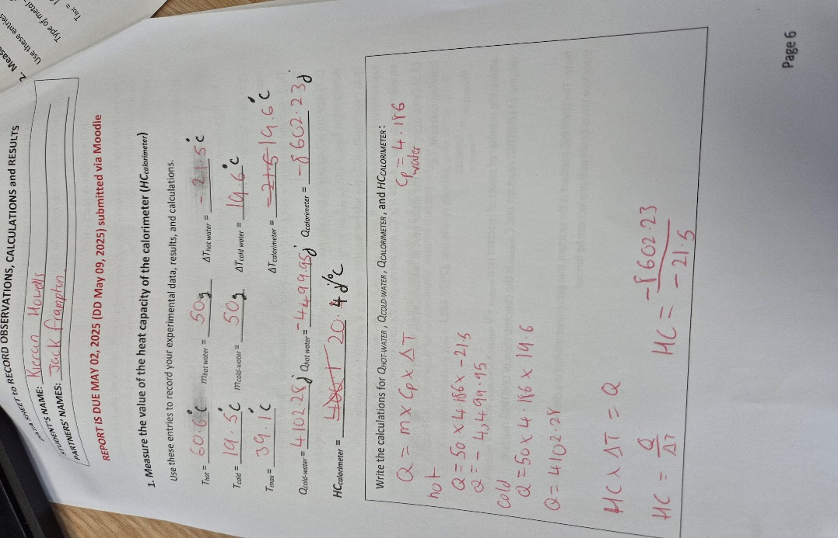
Figure 2 Results from Heat capacity experiment
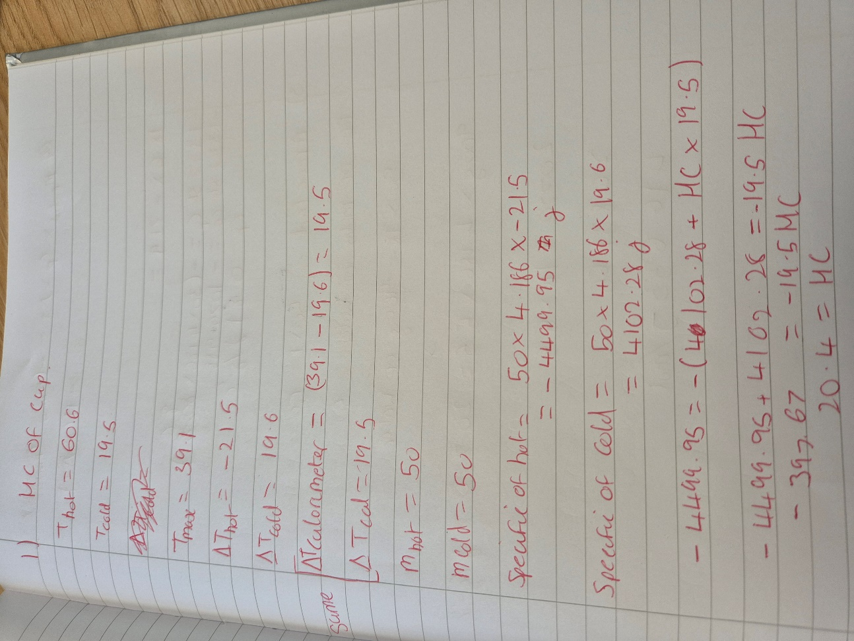
Figure 3 Calculations of HC
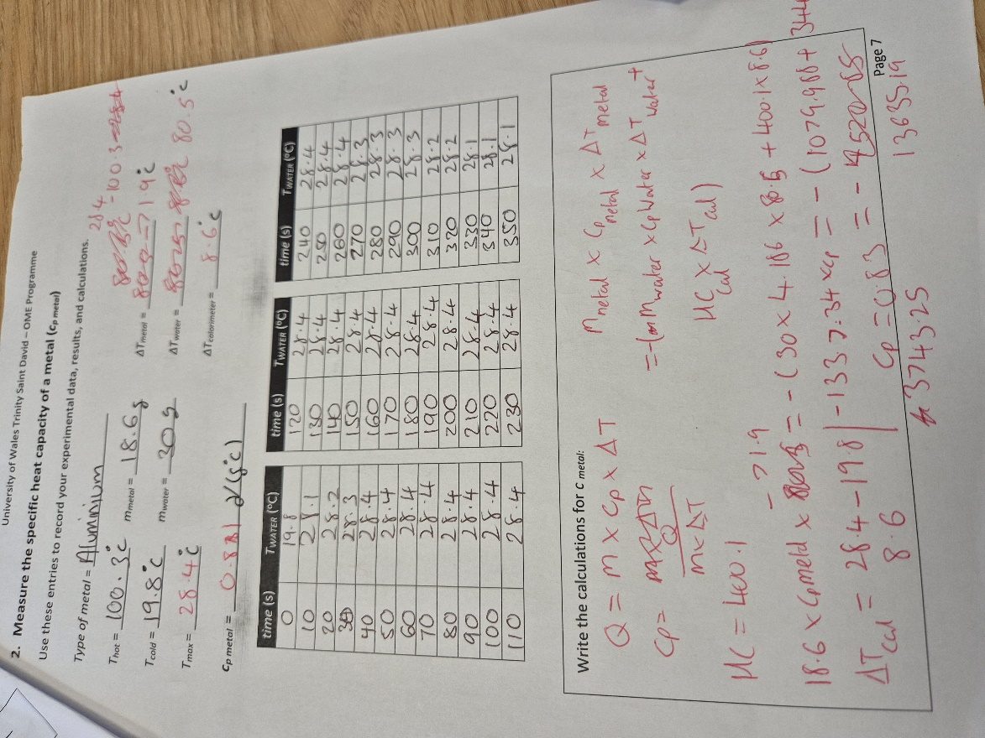
Figure 4 Results from specific heat capacity experiment
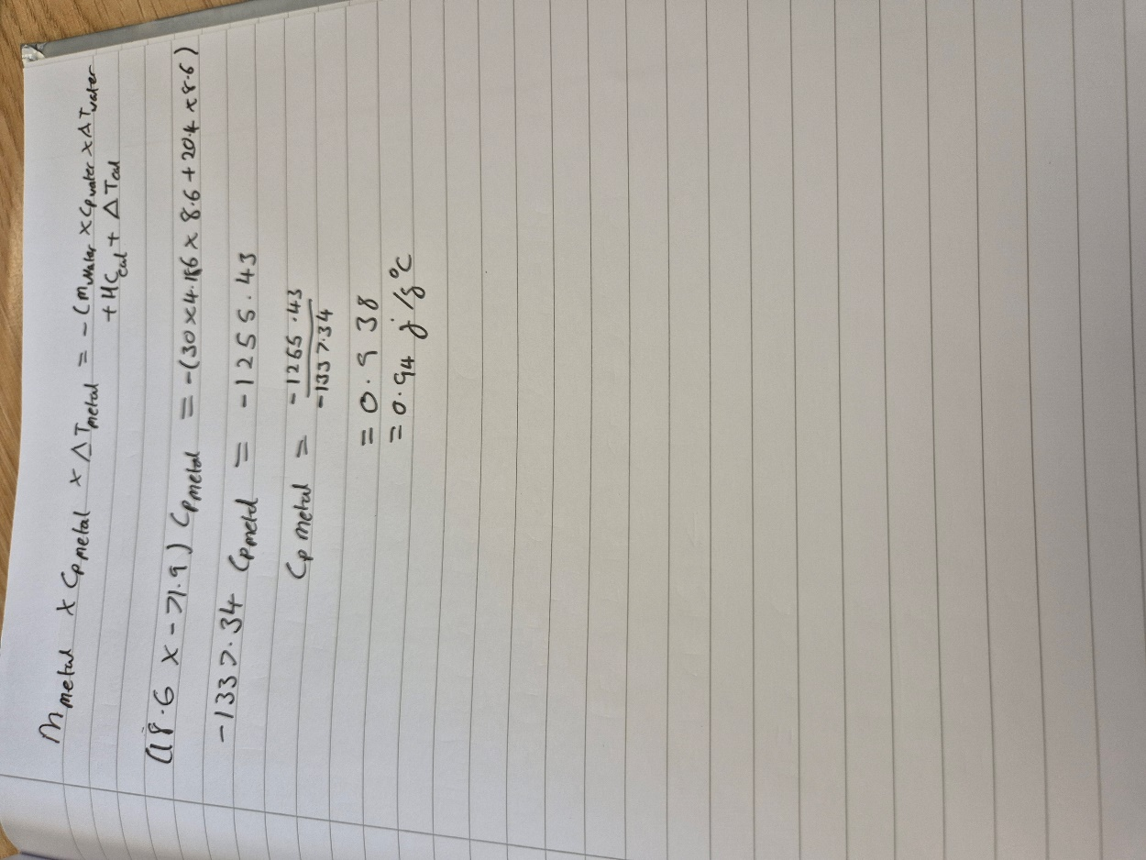
Figure 5 Calculations of specific heat capacity

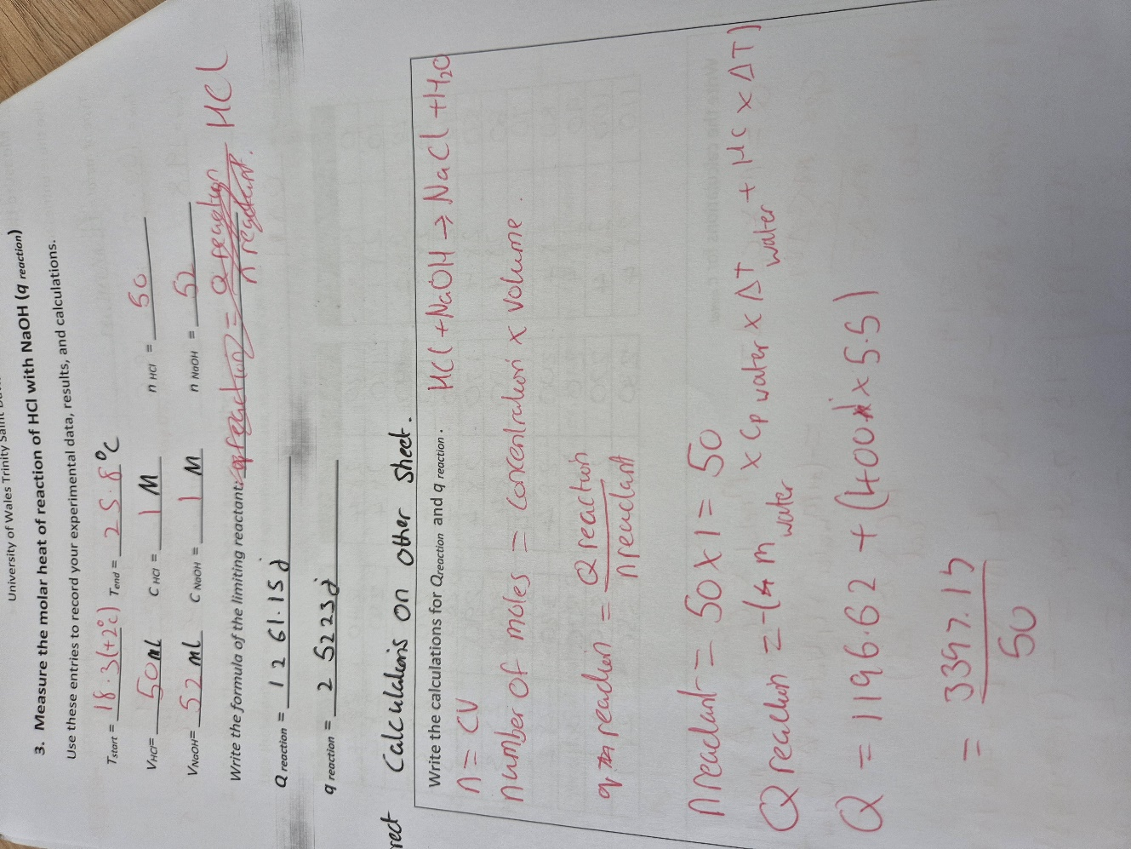
Figure 6 Results from specific molar heat experiment
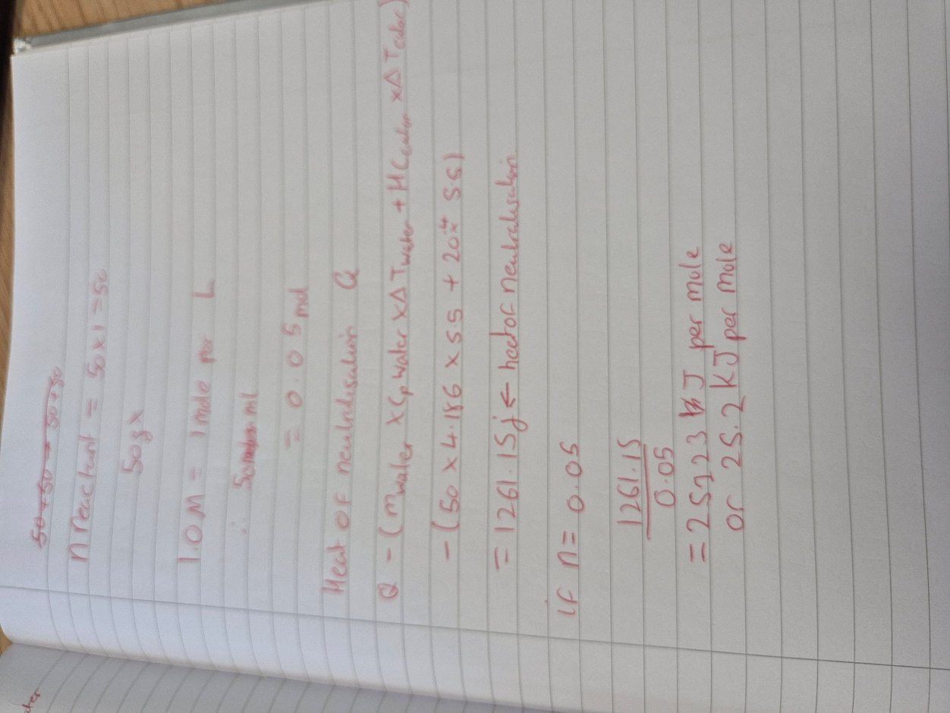

Figure 7 Calculation of specific molar heat

