BMSW4001
Academic and Employability Skills (ACE)
Student name: Ancuba Cassama
Student ID 2119362
(Assignment 1) Task 2 - Reflective Report
Lecturer: Lizeta Demetriou
Submission Date: 27/04/2022

Contents
Introduction . . . . . . . . . . . . . . . . . . . . . . . . . . . . . . . . . . . . . . . . . . . . . . . . . . . . . . . . . . . . . . . . . 2
Reflection . . . . . . . . . . . . . . . . . . . . . . . . . . . . . . . . . . . . . . . . . . . . . . . . . . . . . . . . . . . . . . . . . . . 2
Conclusion . . . . . . . . . . . . . . . . . . . . . . . . . . . . . . . . . . . . . . . . . . . . . . . . . . . . . . . . . . . . . . . . . . 4
References . . . . . . . . . . . . . . . . . . . . . . . . . . . . . . . . . . . . . . . . . . . . . . . . . . . . . . . . . . . . . . . . . . 5
Appendix . . . . . . . . . . . . . . . . . . . . . . . . . . . . . . . . . . . . . . . . . . . . . . . . . . . . . . . . . . . . . . . . . . . 6

Introduction
This reflective report will certainly help me getting to know and be aware of my limits and progress during this term to know what I have learned because reports assist you in better understanding your learning style, the courses you're studying, and defining your long-term objectives. It can aid in the development of critical thinking and problem-solving abilities, both of which are essential for academic success. However, it has other applications that are related to life skills: it is an important component of personal development. It encourages to develop my skills and prepares me for the world of employment. Analysis of my acts or occurrences and consideration of the implications is a habit that I should develop (DOYE Chris, 2013).

Reflection
On the first weeks we spoke about the modules aims and how they would help us learn and take responsibilities for our learning so we could always feel free to ask questions. Also, we accessed how could get strategies and software skills to cope with effective study in higher education which I enjoyed because it taught me new and better habits of study and planning.
Although we have covered many skills throughout the weeks, this report is focused on the ones I need to improve the most which are Time Management, Academic Writing, Summarising and Presentation skills.

I will reflect by using Gibb’s reflective model which I feel more related to and familiarized with. Because in this model of reflective cycle the steps we take is more of what I felt during this period. Firstly, I will explain this model how it consists in six different steps which are description, feelings, evaluation, analysis, conclusion and action plan. By following these steps I will explain my experience so far. With the description I will tell how I felt when I first started this course and what I have seen when I went through in class. Then I will put my feelings to describe how I felt in relation to the first experience and gives me opportunity of having an opinion in relation to the specific subject. I will also evaluate my own experience being a good or bad experience which will allow me to access information of my understanding on the matter. In addition, by gathering all this information, I will analyse and create my own future decisions to take a better view on what I want to do onwards. The conclusion this is where I finally can see the two sides of the coins what we could have done differently for different result on my learning experience. Lastly, I will action plan: when I finally learn from the experience and make strategies to meet different and better accurate results in time to come (The University of Edinburgh, 2020).

On the first week of learning we spoke about time management tools and techniques and done some exercises about this. We discussed how we can use more efficiently our time and that made me think that I don’t use appropriately my time. Two of the activities were about reviewing my use of time and how I manage it, which made me aware of how much time I was wasting on tasks that are not so important or productive.
I relate to this subject a lot and feel a bit uncertain regarding it because it is an essential skill that successful people have in the power as part of success, and I want to improve and acquire that skill. However, our teacher reassured me and my colleagues giving us different types of techniques to improve positively and productively on succeeding and organizing it better. Personally, in the sport therapist area that I want to follow, it will require me to be flexible and be able to manage my time well succeed.
By reflecting on what I need to improve when it comes to better managing my time, I have come to know my weaknesses and how I can develop this. I can start by doing weekly planners or daily planners. I think I prefer daily planners as it will be more detailed and more specific, allowing me to see exactly what I need to do throughout the day and help me be more productive and reaching the end of the week on track with all my tasks. According to Burns and Sinfield (2016), other ways of managing time with success is by taking control of my studies with determination, getting an overview of what I need to do (this is where the daily or weekly planners are very helpful), by being positive, pacing myself and prioritise the time to do one activity at a time to don’t get confused or anxious with lots of things at the same time. Also, setting goals that are specific and timed will help me keeping focused and motivated.

In week two we spoke about academic writing and how to write academic essays in a proper and corrective mode and we have done some practical exercises involving the use of paraphrase and summarize to see our understanding and to improve our writing in the academic field, which I really enjoyed because it’s a skill that I need to improve. Improving my vocabulary and learning to be clearer and more direct in how I express my ideas will also help me with me writing. I had no clue and haven’t studied this before but in the other side I felt very confident to learn because it’s very important to my future career to self-know how to address or approach my clients in more polite and professional mode and surely it will help me in future academic essays and assignments. An important action with academic writing is good referencing, which is essential not only avoid plagiarism but to support my arguments as well with facts. Harvard referencing is not something I have done before and was totally unaware of how to do, but the exercises in class and the extensive lectures about this have helped me a lot. Even though I am still developing this, I believe I am learning to do it quicker and better week by week. I plan to develop the academic writing skill by practicing in reading articles, journals and taking essentials notes by writing them down in a notebook however I will add punctuation into it because it helps to avoid me repeating sentences and be clear (Berkeley.edu, 2022). Also, I will use the articles or journals I read to work on my referencing by writing it down at the end of each reading.

On the third week and as I have mentioned above, we have also discussed summarizing which is a very important subject that I felt related to as I struggle to explain things in my own words specially with English not being my first language. If I want to explain something, I go around trying to find examples to explain what I am speaking, and this is where the tutor comes and explains us about summarizing which is very valuable for me. For me summarizing is vital, as it helps me to go straight into the focus of conversation or subject without providing so much unnecessary details. Furthermore, in class the tutor provided us some activities with exercises where she would give us some text examples so we could summarize it in the best academic way possible. I feel very much comfortable doing summarizing as our tutor taught me in the easiest and simplest manner for my understanding. I plan to develop this skill by taking more notes, reading more newspaper to have more vocabulary and learn more synonyms to add into my vocabulary as it will help me academically and professionally as I want to take steps towards to have my degree to exert my sport therapist goal (Mindtools.com, 2017).
Lastly but not least we had to present in front of all the class about our future career and do a research based on the specific area we want to follow. Now that the tutor told us what we were to do I felt a bit insecure not because of the designated task but to public speak in front of all my colleagues for the reason that I am bit of a shy person and don’t like to be the centre of the attention. However, I think I learned a lot with the tutor in the past weeks as she prepared me for every task descripted, I felt reassured and learnt a lot more about the sport therapy at the same time as I was doing my research for my presentation. I realise this was preparing me to organize my steps towards my future and what I actually need to do in order to succeed, and I have many steps onward and need to gain more experience to improve my skills. Moreover, in the day of the presentation I was confident with the job and research I had done because I put all my effort into it so anything on the feedback would be positive and constructive for my improvement, but for my fear of public speaking in front of all my colleagues and teacher without trembling and get what I wanted to say correctly it was quite unavoidable to stop thinking about. However, thankfully when I started presenting, I did not feel any discomfort and spoke clearly and tried to put into action everything I learned in class and in my descripted task. I think I can overcome this specific dilemma by practicing more by reading frequently, listening more to native persons, actively and correctly participating in class and more presentations will help me develop the confidence to public speak to small or large crowds (Cudoo Blog, 2021). I think the classes were very productive and I feel with more knowledge not just in academic levels but in professional way.

Conclusion
When I first started this course with Lizeta Demetriou for academic and employability skills I was unsure because of the gap in years without studying so I was feeling a bit behind in comparison with my colleagues especially with English not being my first language. However, the tutor always made sure to explain in the clearer and most patient way possible way so nobody could stay or feel behind on the tasks required and learning by asking questions and talk about any doubts or insecurities, luckily with my humble colleagues we have been helping each other to learn and complete tasks and now I feel a lot more confident speaking and showing my difficulties and doubts.
This reflection has helped me gain insight on my learning throughout the semester, my strengths and weaknesses, and what I need to develop.
Looking back, although I have started the academic year with lots of insecurities and fears regarding each skill, I feel much more confident and able to put all the learning and skills into practice.
By setting goals and putting into practice the ideas for improvement for each of the skills, I feel assured that I will develop them further and continue my academic journey with success as well as looking forward to my professional life.

References
Berkeley.edu. (2022). Nine Basic Ways to Improve Your Style in Academic Writing | Student Learning Centre. [online] Available at: https://slc.berkeley.edu/writing-worksheets-and-other-writing-resources/nine-basic-ways-improve-your-style-academic-writing [Accessed 21 April 2022].
Burns, T. and Sinfield, S. (2016) Essential study skills: the complete guide to success at university. 4th edition. London: SAGE.
Cudoo Blog. (2021). 8 Ways to Improve Your Speaking Skills in 2021 - Cudoo Blog. [online] Available at: https://cudoo.com/blog/8-ways-to-improve-your-speaking-skills-in-2019/ [Accessed 21 April 2022].
‌DOYE Chris (2013). Reflection explanation HO. [online] Available at: http://www.docs.hss.ed.ac.uk/iad/Learning_teaching/Academic_pastoral/Reflect/Reflection_explanation_HO.pdf [Accessed 21 April 2022].
Gibbs, G. (1988) Learning by Doing: A Guide to Teaching and Learning Methods. London, UK: Further Education Unit.
Mindtools.com. (2017). Paraphrasing and Summarizing: – Summing Up Key Ideas In Your Own Words. [online] Available at: https://www.mindtools.com/pages/article/paraphrasing-summarizing.htm [Accessed 24 Apr. 2022].
‌The University of Edinburgh. (2020). Gibbs’ Reflective Cycle. [online] Available at: https://www.ed.ac.uk/reflection/reflectors-toolkit/reflecting-on-experience/gibbs-reflective-cycle [Accessed 24 Apr. 2022].
‌

‌

‌
Appendix

Appendix 1: Practical Portfolio Presentation Slide 1
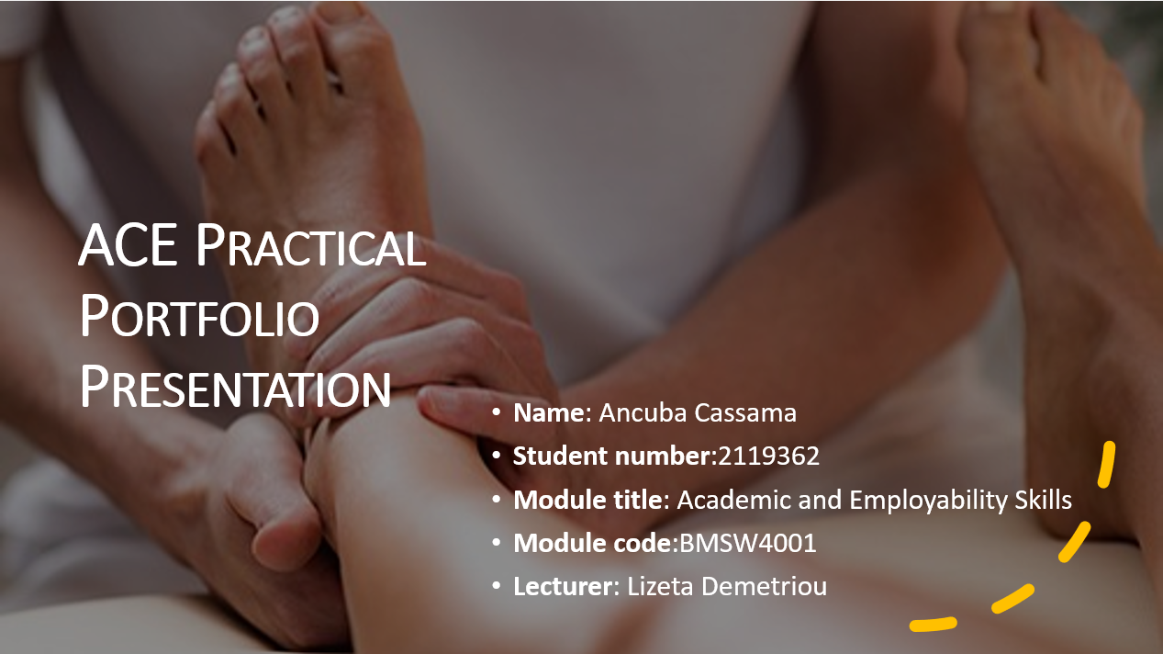

Appendix 2: Practical Portfolio Presentation Slide 2
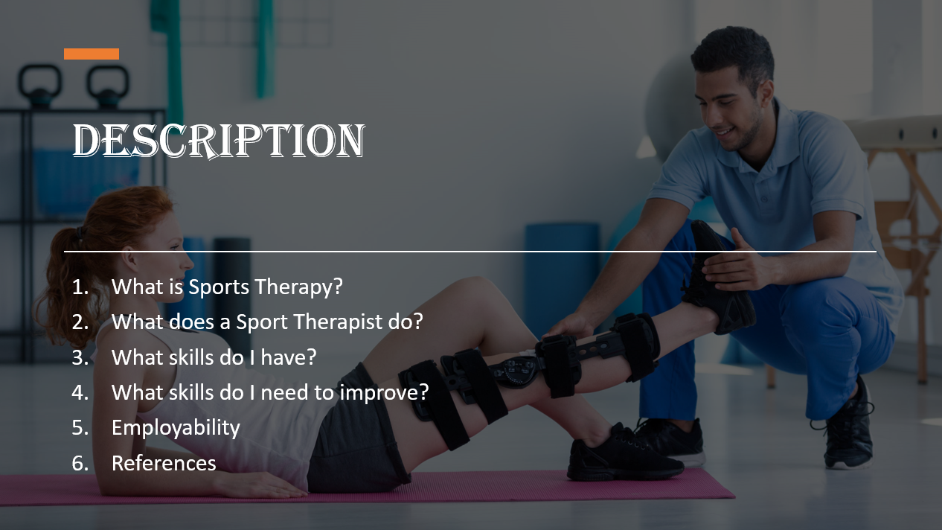

Appendix 3: Practical Portfolio Presentation Slide 3
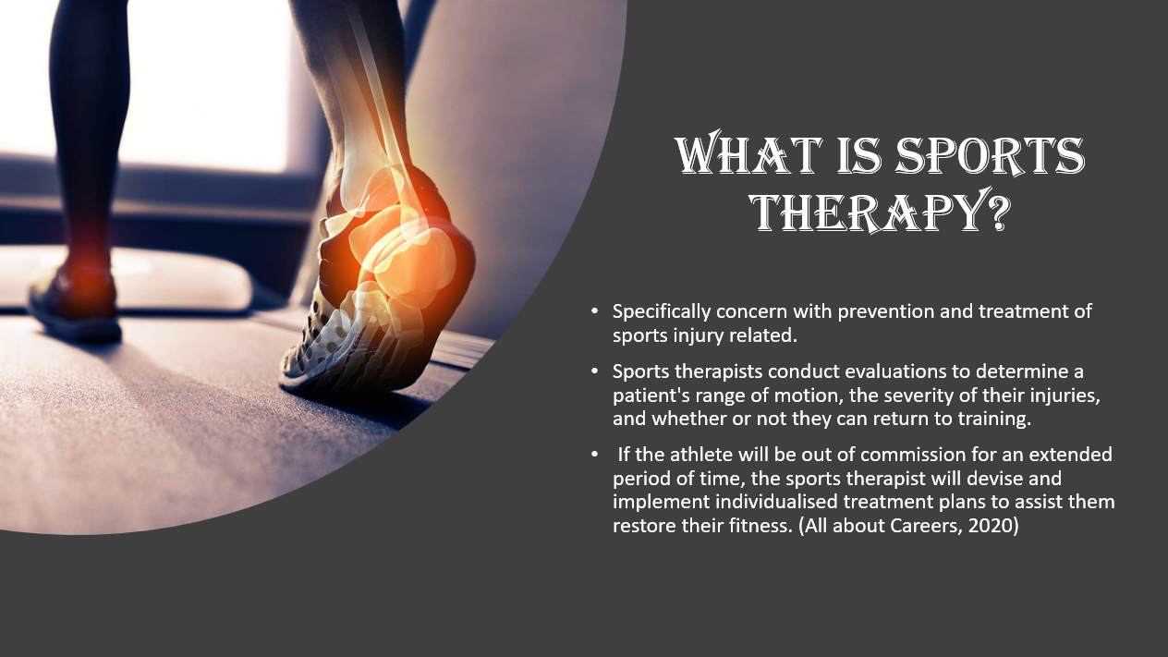

Appendix 4: Practical Portfolio Presentation Slide 4
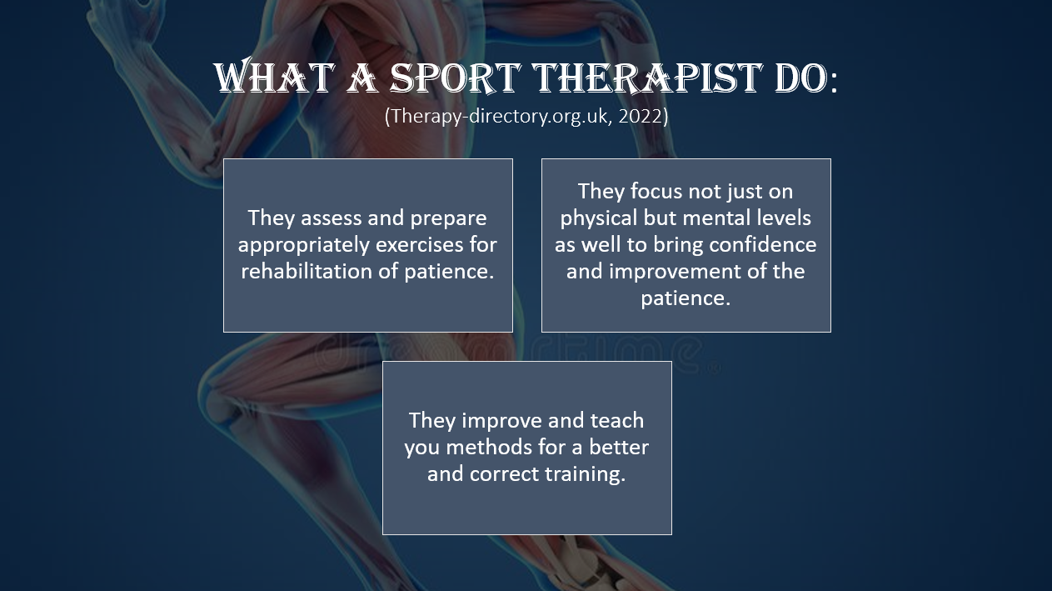

Appendix 5: Practical Portfolio Presentation Slide 5
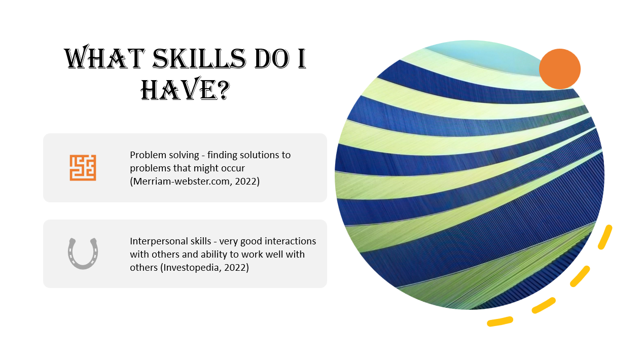

Appendix 6: Practical Portfolio Presentation Slide 6
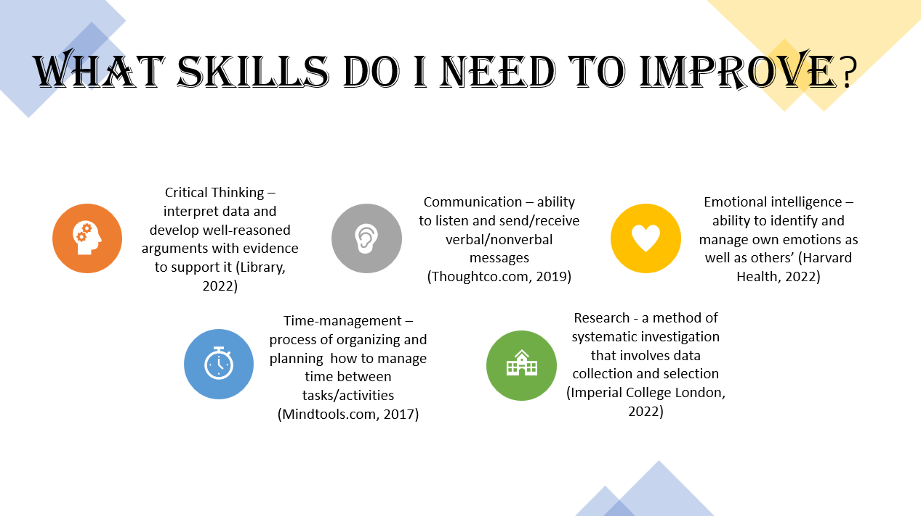

Appendix 7: Practical Portfolio Presentation Slide 7
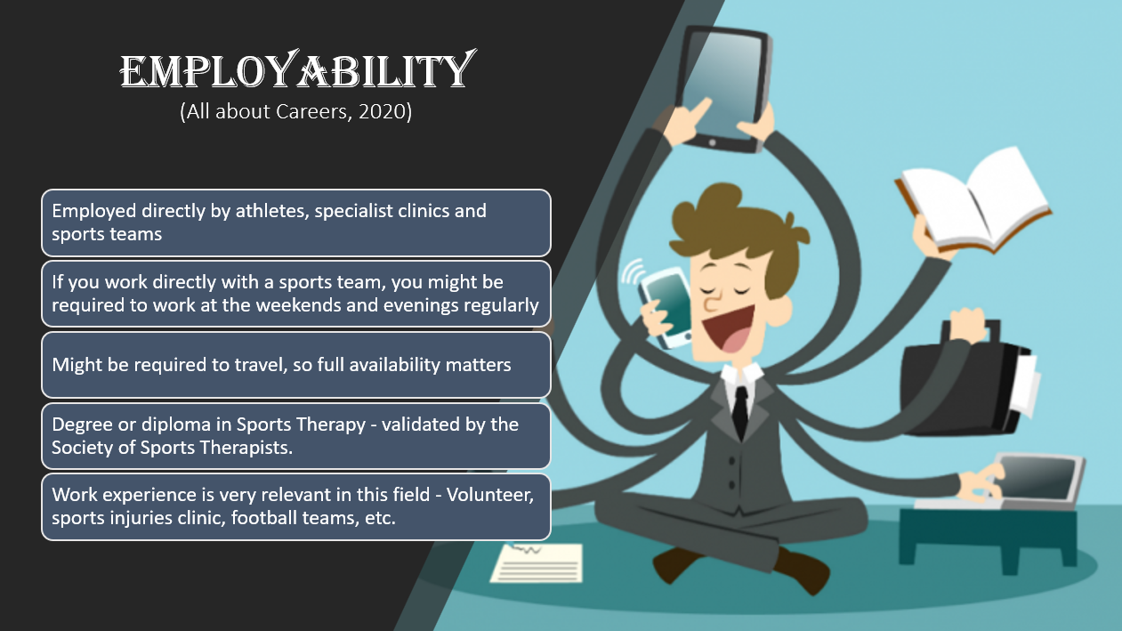

Appendix 8: Practical Portfolio Presentation Slide 8


