The Effect of Sensation Seeking and Tempo of Music on Time Perception
University of Wales Trinity Saint David
1702765

Abstract:

An experiment was conducted to investigate the effect of sensation seeking and tempo of music on time perception, using a task created on super lab. The main aim of this study was to see whether participants who scored high levels of sensation, and were exposed to a fast tempo of music, would significantly over or under-estimate time. It was believed that those exposed to fast tempo of music would over-estimate time, however, the results showed that majority of individuals underestimated time, which results in the hypothesis being rejected.

Introduction
Sensation seeking (SS) is a personality trait that links to an individual’s difference in incentive of unusual and intense sensual experiences (Norbury & Husain, 2015). Various experiments have been formed to see the effects of SS on time perception in many ways. Droit-Volet, Brunot and Niedenthal (2004), created a study that looked at the insight of the period of emotional events. The study involved participants to be trained on a temporal bisection task, where the stimuli, a pink oval, was put onto the screen for either 400ms or 1600ms, this served as short or long standards. When presented comparison durations, which were between 400ms and 1600ms, these were represented by three emotions expressed by faces (happiness, sadness and anger) and a neutral expression. The study found that the emotional faces tended to increase the speed of the internal clock.

Another experiment that investigated effects of SS on time perception is Angrilli et al, (1997). The study analysed the impact of affective factors on time perception. The participants were split into two groups of subjects for two, four and six seconds. The first group estimated the projection duration on an analogy scale, whilst the other group reproduced the intermissions by pressing a button. The results found that time estimation did not show a main effect of valence or arousal, yet it was found that time was underestimated. Taking in the factors of both literatures, the hypothesis for this study is that individuals who scored high levels of SS and were exposed to a fast tempo of music would significantly over-estimate time perception.

Methods:
Participants
Within the study was a total of 60 participants, 29 males and 31 females, that were used in the Super Lab experiment, which was within an individual lab setting. The age range of these participants was between 18 and 51 (M= 25.07, SD = 8.53) (see appendix A).
Design
The study was designed with a quantitative 2x3 multifactorial ANOVA. The reason for this is because it was used to measure time perception and Sensation Seeking. The between-subject study was also used which was because of various factors that were measured (e.g. time perception; tempo of music; male/female; levels of SS). The independent variables measured within the study were tempo of music and Sensation Seeking (SS; High and Low). There were three levels of music used in this study, fast tempo involved an upbeat pop song, slow tempo was classical music and then there was no music. To examine high levels of SS, a questionnaire was created, which contained 20 questions (see appendix F).

Materials
The study involved two sections, the first section involved a Sensation Seeking (SS) questionnaire (see appendix F). The main purpose of this questionnaire was to analyse the participant’s level of SS. This questionnaire was created using the 4 Likert Scale which was called the Arnett Inventory of Sensation Seeking, also referred to as AISS. Once the questionnaire was filled out, the responses were combined. This was calculated by using a point scoring system, for example A=4, B=3, C=2 and D=1. The points were added up to achieve the total number, the higher the number meant there was higher levels of SS. However, there were six question scores that was to be reversed, this meant subtracting these scores from the total number (see appendix F).
The second section of the study required the participant to undergo a super lab experiment. Before participants began the study, a screen appeared which contained information about the study and the instructions for the super lab experiment which began with a practice run and then the actual experiment, where the results were recorded. Both the practice run, and experiment contained the exact same layout. A stimulus fixation cross appeared in the centre of the screen. For the practice run, the cross appeared for 400ms and 1600ms, after this was completed, the cross appeared for 400ms, 600ms, 800ms, 1000ms, 1200ms and 1600ms. A pink oval appeared after the cross twenty-two times where the 1000ms oval appeared only ten times out of twenty-two. The participant was required to state whether the cross appeared for a short or long time, whilst listening to either fast music, slow music or no music. This measured whether the participant would over or under estimate the time perception based on their SS questionnaire, which was completed in section one.

Procedure
Before beginning the experiment, an ethics form was submitted to the School Research Ethics Committee prior to data collection, once this was approved, studies could begin. Participants were first given a consent (see appendix B) form which noted what the study was about and whether they gave their permission for their information to be used but remain confidential. Participants began by filling out a questionnaire which had questions such as whether they thought marrying someone from a foreign country would be interesting. This was used to see whether their SS was high or low. Participants marked their responses by circling either A- describes me very well; B- describes me somewhat; C- does not describe me very well or D – does not describe me at all (see appendix F).

The second part of the study involved taking part in a super lab experiment, before taking part in the real test, the participant underwent a practice which was not marked. Once completed, the real test began which was marked. This involved either fast, slow or no music playing, whilst the participant decided whether the pink oval (See appendix D) was there for a short or long period of time, which was completed twenty-two times. Once this had come to an end, the participant filled out a demographic form (see appendix E) which asked for their age and gender, then a debrief sheet was handed to them explaining the aim of the study, what was explored within the study and if they wish to withdraw, it could be done at any given time, and also there was an email address given if any further questions were raised (see appendix C).

Results
A 2 x 3 between-subject ANOVA was conducted to measure the effects between sensation seeking (high low) and the music (fast, slow, none) and was measuring the outcome of time perception. The mean of time perception was (6.58) and the standard deviation is 2.62. For sensation seeking the mean is 53.43 and the standard deviation is 6.30. The interaction effect between music group and sensation seeking and was shown to be non-significant F (2, 54) = .23, P. 80. Additionally, the main effect of SS is seen to be non-sig seen as F (1, 54) = .037. P= .851. Music group non-sig F (2, 54) = .34, P=.72 (SEE APPENDIX A).
The main effect of study being non-significant indicates there was not an effect between the levels of SS on time perception. This goes against our hypothesis, so the original hypothesis must be rejected, this is due to the reliability level being greater than 0.05, therefore it is significantly reliable (SEE APPENDIX A).

Discussion
A study was conducted to discover whether, if exposed to fast tempo music, participants would over-estimate time perception. The results to this study found that there was no correlation with people who scored high levels of SS, who were exposed to a fast tempo of music, would significantly over-estimate time. This means that the hypothesis must be rejected. The literature used within this study, and from the outcomes of these studies, that participants would overestimate time (Droit-Volet, Brunot & Niedenthal, 2004).

Due to the hypothesis being rejected, there are many possible factors which the reason, one being the demographic data. This only asked for the age and gender of the participant, therefore there was no way of knowing how many different ethnicities where used in the experiment, therefore making it biased. Which is shown in the study conducted by Angrilli et al, (1997). This study also did not consider ethnicity as a factor. If this study were to be done again, the demographic data would need to include a question asking for the ethnicity of the participant.

Another factor that could be altered to make the study more reliable is the age of the participant. The age range for this study was 18-51, which could possibly restrict the results. If there was a higher maximum age, there would be an unbiased result due to people having different outcomes within the study. A final factor, if this study were to be produced again, would be the reliability of the questionnaire. If the participant did not actually care about the study, or was in a rush, they may not pay much attention to the questionnaire and rush through, therefore some answers may not be true to how the person feels.

Reference list

Angrilli, A., Cherubini, P., Pavese, A., & Manfredini, S. (1997). The influence of affective factors on time perception. Perception & psychophysics, 59(6), 972-982.
Droit‐Volet, S., Brunot, S., & Niedenthal, P. (2004). BRIEF REPORT Perception of the duration of emotional events. Cognition and Emotion, 18(6), 849-858.
Norbury, A., & Husain, M. (2015). Sensation-seeking: dopaminergic modulation and risk for psychopathology. Behavioural brain research, 288, 79-93.

Appendices
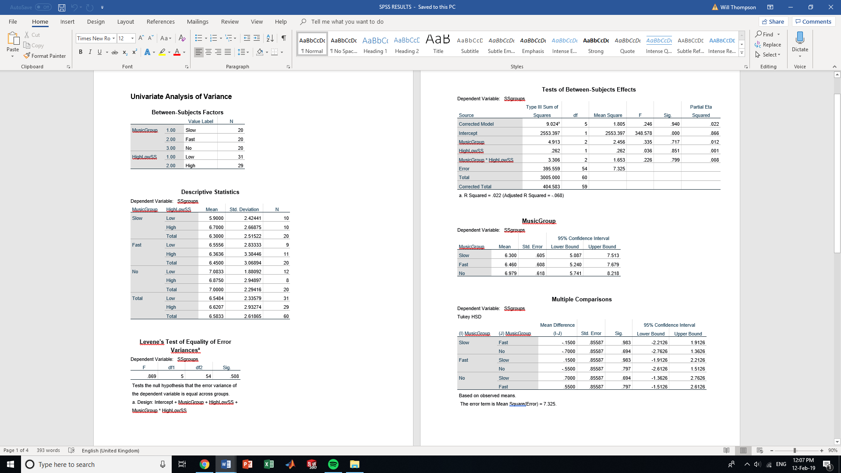
Appendix: A

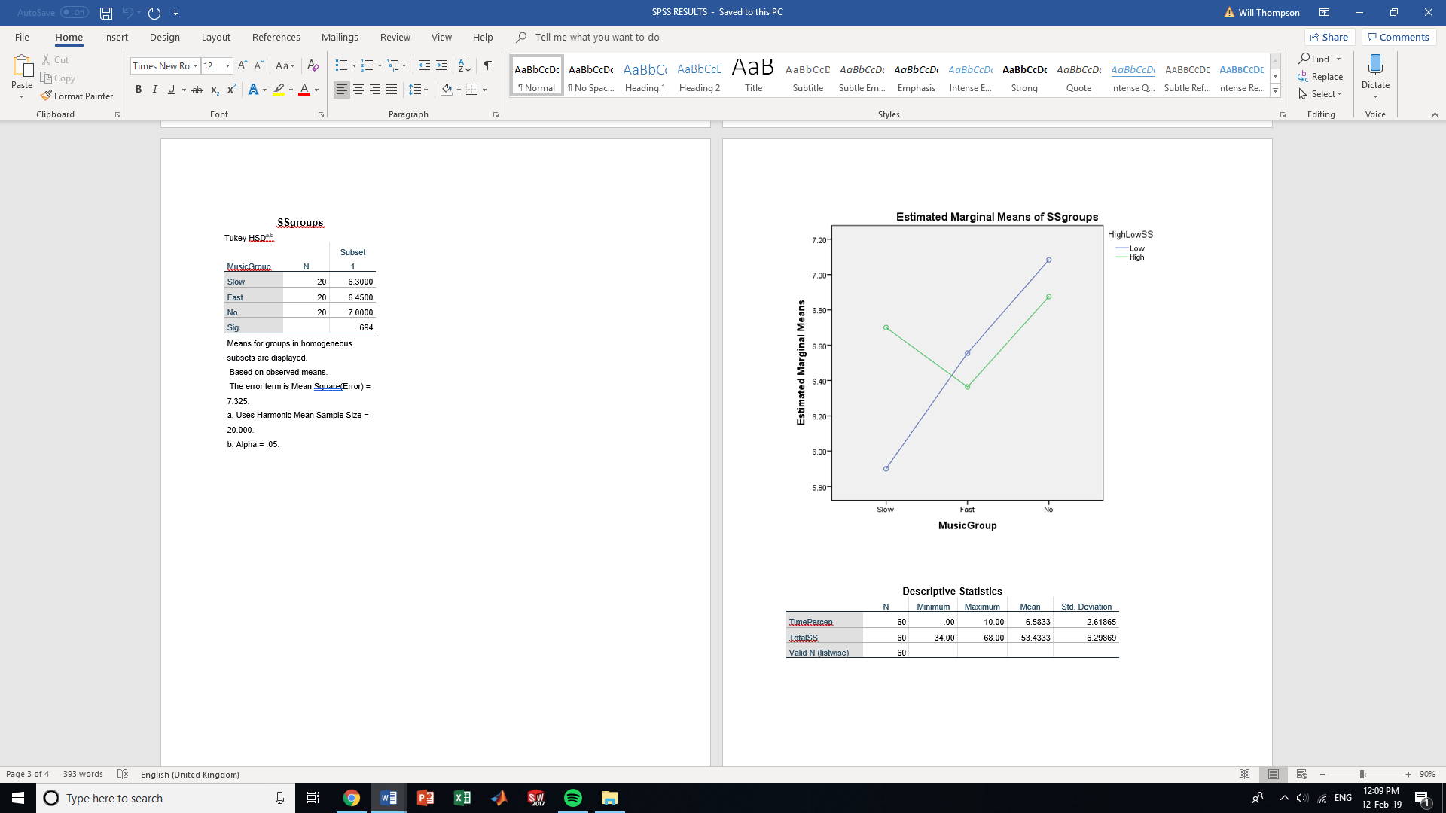

Appendix: B

School of Psychology
Townhill Campus
Swansea

Study Consent Form

I understand that this research study is being carried out by a 2nd year Psychology Student for the purpose of a module assessment, and that taking part in this study will involve [brief description]
This task will take approximately XX minutes to complete.
I understand that participation in this study is entirely voluntary and I am free to withdraw participation at any time without giving a reason. I am aware that if I have concerns about the study I can discuss these concerns with the researcher or academic supervisor at any time during or after the study.
I understand that the information provided by me will be held confidentially, with a code assigned in place of my name. These data will be stored indefinitely in accordance with the Data Protection Act.
I also understand that at the end of the study I will be provided with a debrief form and the opportunity to discuss any issues with the researchers.

I, ___________________________________( NAME) consent to participate in the study conducted by Kristen Hyett, Lucie Isaac, Laurence Jones, Sophie Matthews and Alisha Wady, School of Psychology, University of Wales Trinity Saint David, Swansea under the supervision of Stacey Coleman.

Participant Signature:________________________________________________
Date:___________________
Name and signature of researcher taking consent
___________________________________________________________________

Appendix: C
School of Psychology
SA1 Campus
Swansea

Study Debrief Sheet
The Effect of Sensation Seeking and Tempo of Music on Time Perception

Thank you for taking part in this study.

The aim of this study was to explore the effect of sensation seeking and tempo of music on time perception using a task created using Superlab.

We specifically wanted to explore whether individuals who scored high on levels of sensation and were exposed to a fast tempo of music would significantly over or under-estimate time.

If you wish to withdraw your data from the study you must tell the researcher now. After this point, all of your data will remain confidential and we will not trace it back to you.

If taking part in this study has raised any questions please speak to the principal researcher Kristen Hyett on 1700850@student.uwstd.ac.uk or contact the academic supervisor Stacey Coleman on Stacey.coleman@uwtsd.ac.uk.

Thank you once again for taking time to participate in this study.

Kristen Hyett
Sophie Matthews
Lucie Isaac
Alisha Wady
Laurence Jones

BA Counselling Studies and Psychology

University of Wales Trinity Saint David, Swansea

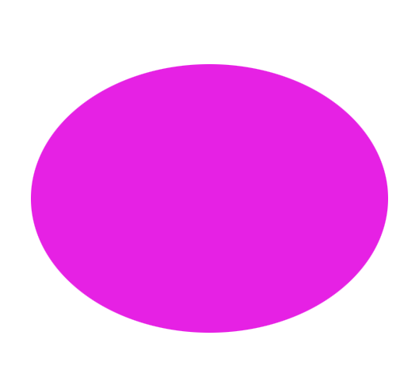
Appendix: D

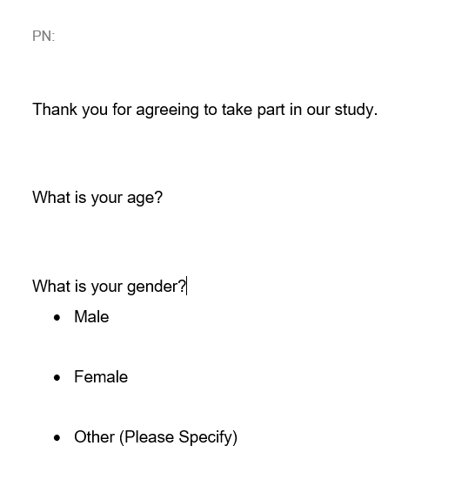
Appendix: E

Appendix: F
For each item, indicate which response best applies to you:
A) describes me very well
B) describes me somewhat
C) does not describe me very well
D) does not describe me at all

1. I can see how it would be interesting to marry someone from a foreign country.

A B C D

2. When the water is very cold, I prefer not to swim even if it is a hot day.

A B C D

3. If I have to wait in a long line, I'm usually patient about it.

A B C D

4. When I listen to music, I like it to be loud.

A B C D

5. When taking a trip, I think it is best to make as few plans as possible and just take it as it comes.

A B C D

6. I stay away from movies that are said to be frightening or highly suspenseful.

A B C D

7. I think it's fun and exciting to perform or speak before a group.

A B C D

8. If I were to go to an amusement park, I would prefer to ride the rollercoaster
or other fast rides.

A B C D

9. I would like to travel to places that are strange and far away.

A B C D

10. I would never like to gamble with money, even if I could afford it.

A B C D

11. I would have enjoyed being one of the first explorers of an unknown land.

A B C D

12. I like a movie where there are a lot of explosions and car chases.

A B C D

13. I don't like extremely hot and spicy foods.

A B C D

14. In general, I work better when I'm under pressure.

A B C D

15. I often like to have the radio or TV on while I'm doing something else, such as reading or cleaning up.

A B C D

16. It would be interesting to see a car accident happen.

A B C D

17. I think it's best to order something familiar when eating in a restaurant.

A B C D

18. I like the feeling of standing next to the edge on a high place and looking down.

A B C D

19. If it were possible to visit another planet or the moon for free, I would be among the first in line to sign up.

A B C D

20. I can see how it must be exciting to be in a battle during a war.

A B C D

Scoring: Combine responses to items, with A = 4, B = 3, C = 2, D = 1, so that higher score = higher sensation seeking. For items followed by (-), scoring should be reversed.

