Module Code: LCHS7006
Module Title: Quality Assurance and Service Improvements
Assignment: Component 2
Title: Improving Incident Reporting and Governance in Neonatal Care

Student Name: Hefzur Rahman
Student ID: 2431586

Table of Contents
1. Introduction 3
2. Critical Analysis and Frameworks. 5
2.1 Theoretical Underpinnings of quality and Governance. 5
2.1.1 Principles of clinical governance. 5
2.1.2 Frameworks of Patient Safety (NHS, WHO) 5
2.1.3 Applicability of Quality Improvement Theories. 6
2.2 Root Cause Analysis Tools 6
2.2.1 Fishbone (Ishikawa) Analysis of Reporting Failures 6
2.2.2 Application of the 5 Whys 7
2.2.3 Donabedian Model: Structure Process Outcome Analysis. 8
2.3 Organisational and System-Level Analysis. 9
2.3.1 SWOT (Internal and External Factors) Analysis. 9
2.4 Discussion: Connexion Theory to the Problem. 10
2.4.1 The Failure of Governance that Facilitated the Unsafe Practise. 10
2.4.2 Implication on Patient Safety, Outcomes, and Mortality. 10
2.4.3 Research, Policy and Real-World Case Evidence. 12
3. Quality Improvement Plan and Recommendations. 12
3.1.1 Summary of the proposed service improvements. 12
3.2 Quality Improvement Tool Implementation. 13
3.2.1 PDSA Cycle of Strengthening Incident Reporting. 13
3.2.2 Lean Culture to minimise Reporting Barriers. 13
3.2.3 Six Sigma (DMAIC) in order to increase the accuracy of reporting. 14
3.3 Implementation Strategy 15
4. Conclusion 16
References 17

1. Introduction
Background to the Organisation
Countess of Chester Hospital NHS Foundation Trust is an acute and specialist district general hospital that offers its services to Cheshire and North Wales. Being a part of the NHS, it is subjected to the national regulations of quality, safety, and clinical governance. Before the mentioned concerns, the organisation had a typical profile of service delivery but major weaknesses in internal governance, leadership responsiveness and incident management later exposed major vulnerability within its safety systems.
Introduction to the Neonatal Unit.
The neonatal unit of the hospital has Level 2 care, as it deals with premature and clinically weak infants who need specialised care, ventilator-assisted care, and constant care. The unit consists of multidisciplinary teams, such as neonatologists, nurses, and other allied health professionals. Its patient population is vulnerable due to which strong safety systems, proper documentation, and quick escalation processes are highly required. The high-risk setting of the unit requires the rigid compliance with the national safety standards of the neonatal setting, as well as efficient early warning systems.
Statement of the Quality Problems: Incident reporting and Whistleblowing failures.
One problem that was observed to be critical in the neonatal unit was the constant failure of incident reporting and whistleblowing systems (Zarbock et al., 2023). Concerns on recurring unexplained neonatal deteriorations were not properly escalated and documented by clinicians. Leadership ignored or downplayed staff reports on a regular basis thereby establishing a culture of fear, defensiveness and organisational protectionism. Such failures ensured that the unusual clinical patterns were not investigated in time and that the harmful conditions were left unchecked underscoring the vulnerability of the entire system in its governance structure, communication structure and accountability structure.

Health-based Significance of the Problems.
Reporting and whistleblowing failures are significant risks to the entire population, especially in neonatal facilities where the late response can prove to be life-threatening. Good surveillance mechanisms are needed to ensure that harmful damages that could be prevented are detected, the vulnerable babies are kept safe, and the community does not lose confidence in health facilities. The morbidity and mortality become more common when the problems are not brought to light. These systemic vulnerabilities are detrimental to the national patient safety agendas and the quality of healthcare in general in the broader health system.
Aim and Scope of the Report.
The report is a critical analysis of governance failure issues associated with incident reporting and whistleblowing in the neonatal unit and an analysis of their role in unsafe clinical practise. It assesses root causes and organisational vulnerabilities using predetermined models, such as Fishbone, Donabedian, SWOT, and quality improvement models. The report also suggests evidence-based suggestions to improve safety systems, improve the culture of reporting, and help to improve sustainable service in high-risk healthcare settings.

2. Critical Analysis and Frameworks.

2.1 Theoretical Underpinnings of quality and Governance.

2.1.1 Principles of clinical governance.
The clinical governance is the backing structure in ensuring and enhancing healthcare quality by being accountable, transparent, and continually improving (Whiteing, 2024). Majumdar and Hussain (2018) note that clinical governance involves combined control of risk management, audit, clinical effectiveness, patient participation, and staff management. The principles in the Countess of Chester Hospital neonatal unit were massively undermined in a way that unsafe practises were tolerated even when trends of unexpected neonatal downward spiral were evident. Good governance requires prompt identification of abnormalities but the organisation did not put up effective mortality surveillance mechanisms or prioritise concerns by clinicians, which is a systemic failure of multiple pillars of governance. This is in line with Ellis (2025), who says that organisations that do not learn out of early warning signs sabotage the principles of professional accountability. The Lucy Letby ethical case revealed evident violations in the supervision, leadership responsiveness, and organisational learning, which are the indicators of the weakening of clinical governance.

2.1.2 Frameworks of Patient Safety (NHS, WHO)
Patient safety models like the NHS Patient Safety Strategy, and the global safety standards of WHO are focused on safe systems, reporting culture and an active risk management approach. According to Ammouri et al. (2015), psychological safety, open communication, and non-punitive reporting systems are the main environmental factors of a robust safety culture. These were lacking in the neonatal unit where the endeavours made by the clinicians to report issues were ignored and the whistleblowers subjected to institutional pressure. As Harkensee (2023) explains, the case of Letby demonstrated that the inability to report a failure of whistleblowing may result in disastrous consequences when safety principles are not incorporated into organisational behaviour. NHS models emphasise incident learning but Macrae (2016) notes that most systems do not work due to the tendency of organisations to emphasise on avoidance of blame, rather than system redesign. Misalignment with the NHS and the WHO concepts of safety is manifested in the fact that the leadership of the hospital did not apply national guidelines that indicated an urgent need to escalate repeated critical incidents. These gaps in governance are what allow sentinel events to take place without any notice as the avoidable deaths and collapses that went on within the unit were.

2.1.3 Applicability of Quality Improvement Theories.
Quality improvement (QI) theories are systematic methods of analysing failures and redesigning unsafe systems. Kronick et al. (2015) believe that it is impossible to implement continuous quality improvement without real-time monitoring, feedback loops, and repeated interventions. The Lean and Six Sigma approaches focus on minimising waste, achieving reliability of the process, and controlling variations all of which are directly applicable to enhance incident reporting and governance. Arabi et al. (2016) reveal that the QI-based incident management systems can contribute greatly to the learning out of defects, but these systems were not widely used in the neonatal unit at Chester. QI models are especially critical in clinical settings that are risky like neonatal care, where quick response, uniform escalation, and solid documentation are crucial.

2.2 Root Cause Analysis Tools

2.2.1 Fishbone (Ishikawa) Analysis of Reporting Failures
The Ishikawa analysis shows multi-level failures in categories of organisations. In the category of People, leadership was shown to be resistant to do what consultants wanted, which is an example of managerial bias and insufficient supervisory skills, which are also reflected by the work of Lewis (2023), who emphasises the idea that unregulated managers in the NHS can bury safety issues. The processes were characterised by disjointed reporting channels, lack of documentation and mortality trend analysis. Policies were not properly followed or simply neglected, especially the ones linked to whistle blowing and escalation of critical incidents. Factors in the environment was work load pressures and the organisational culture of defensiveness which discouraged free communication. There were also technology gaps; according to Alotaibi and Federico (2017), digital incident reporting systems enhance the accuracy of data, and the unit did not have efficient digital tools and analytics.

2.2.2 Application of the 5 Whys
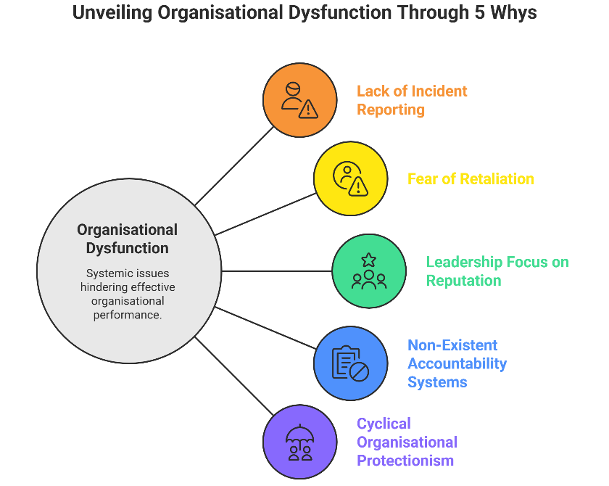

Figure 1 Application of the 5 Whys (Author)

The use of the 5 Whys approach puts forward the level of organisational dysfunction (Tomašev et al., 2019). The problem was not over-escalated since incident reports were not regularly filed. No reports were made in case the staff were afraid of the undesirable consequences and thought that the leadership would disregard the issues. There was fear since in the past when clinicians have spoken up, senior clinicians, raised issues have been issued with formal disciplinary measures. This was the case since leadership focused on the organisational reputation rather than patient safety. This was done by leadership since the accountability systems in clinical governance framework were non-existent. This is evidenced by the fact that, as Kirkup and Titcombe (2023) state, whistleblowers in the NHS are usually retaliated against instead of being supported, which corresponds to the systemic hindrances to express professional issues. The 5 Whys thus reveals the cyclical nature of organisational protectionism, which did not allow early intervention.

2.2.3 Donabedian Model: Structure Process Outcome Analysis.
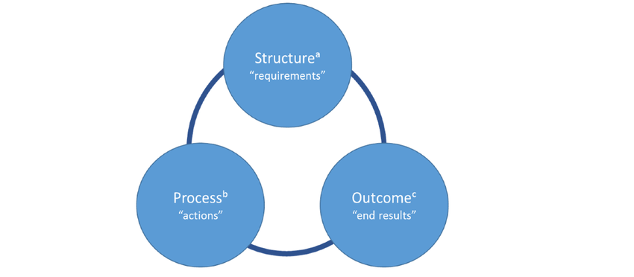

Figure 2 Donabedian Model (Arabi et al., 2016)

Applying the model of Donabedian helps to understand why structural deficits made the processes fail and eventually lead to disastrous consequences (Schwendimann et al., 2018). The neonatal unit had poor governance control, managerial capabilities, as well as incident reporting mechanisms. Such process failures as the inadequate identification of clinical patterns, exclusion of staff concerns, and the absence of obligatory escalation were realised. The results were dire: several neonatal deaths and collapses, which could not be explained, were observed within a short-term, but the systemic review was not performed until long after. This is consistent with Glasper (2024), who states that the Letby case is an example of how structural and cultural vulnerabilities can facilitate abuse against children because they hamper early warning mechanisms. The model by Donabedian thus brings out the direct translation of historical organisational flaws into preventable death.

2.3 Organisational and System-Level Analysis.

2.3.1 SWOT (Internal and External Factors) Analysis.
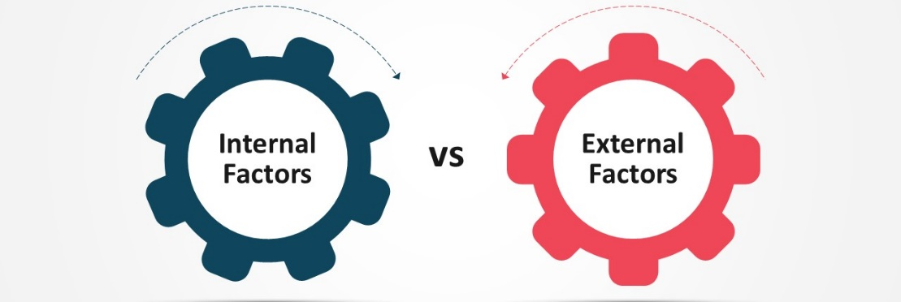

Figure 3 Internal and External Factors (Kronick et al., 2015)

Internal Factors:
As a SWOT analysis provided, the internal weaknesses surpassed the strengths in the neonatal unit (Scandal, 2023). Specialist clinical neonatal clinicians and access to NHS-wide safety protocols were also considered strength, but were not made full use of. Such weaknesses were hierarchical leadership, ineffective communication, insufficient documentation, and lack of digital incident tracking, which is concise with what Macrae (2016) criticised about reporting systems. there were possibilities to make use of technology-based reporting and external audits, but they were not achieved.
External Factors:
Extrinsic risks were in the form of national shortages of workforce in the country, rising neonatal acuity, and growing public scrutiny, which enhanced the effects of failures in governance. Greenhalgh et al. (2016) suggest that the co-creation process with clinicians enhances better governance but Chester did not connect leadership with the concerns of frontline staff. Consequently, there was a combination of weaknesses and threats that were creating an environment and allowing the care that was not safe to remain unnoticed.

2.4 Discussion: Connexion Theory to the Problem.

2.4.1 The Failure of Governance that Facilitated the Unsafe Practise.
The lack of governance in the neonatal unit permitted the unsafe practise to go unimpeded (Richardson et al., 2017). It was not led in accordance with known NHS governance structures and issues raised by consultants were ignored many times. There were no systematic review and escalation of incident data, which compromised organisational learning. This is in line with Flower (2015), who emphasises that organisations, which lack transparency in reporting their activities, often hide their areas of weaknesses in their operations. In the case of Chester, it is reported that clinicians were asked to apologise on raising concerns which in itself is a sign of an organisational defensiveness and not accountability within an organisation. The clinical voice suppression of this nature is inconsistent with the safety frameworks and is directly related to the extended damage.

2.4.2 Implication on Patient Safety, Outcomes, and Mortality.
The result of not responding to the signs of its early manifestation was catastrophic in clinical terms. According to the APRICOT study, the critical event rate is 5.2% in European paediatric anaesthesia that is severe (Habre et al., 2017), but the cluster of unexplained collapses was even higher in Chester in the neonatal unit. Between 2015 and 2016, several cases of neonatal deaths were occurring above the expected mortality rates in similar Level 2 neonatal units. That surplus mortality may be summed up thus:

Table 1. Comparative Neonatal Safety Outcomes
Indicator | Expected Level 2 Neonatal Unit | Countess of Chester Neonatal Unit
Severe critical events | 5.2% | Elevated cluster reported
Unexplained collapses | Rare | Multiple recurring events
Neonatal mortality trend | Stable or decreasing | Significant increase 2015–2016
Incident escalation rate | High in safety-focused units | Low, with suppressed reporting
Source: Hospital investigation reports and Lewis (2023)
The table shows the variance between the anticipated and the observed safety indicators. The ongoing malfunction in deaths and collapses with the little formal reporting of incidence incidents depict a flawed safety system. Curley et al. (2015) showed the significance of standardised clinical procedures in mitigating risks in paediatrics, but the processes involved in Chester were contrary to the safety practise guidelines. As a result, babies were exposed to avoidable damage, and organisational system flaws helped to promote further unsafe environments.

2.4.3 Research, Policy and Real-World Case Evidence.
Studies conducted globally indicate that inability to raise issues is a significant cause of avoidable damages. According to Capper et al. (2024), in several cases, healthcare workers do not want to engage in whistleblowing because of the fear of being retaliated, which can be observed with neonatal clinicians in Chester. According to Jesudason (2024), NHS disasters are often caused by the lack of willingness by the leadership to listen to its employees. In a similar vein, Leveson (2015) points out that safety must have leading indicators and active tracking, but the hospital did not have effective predictive systems. Comparisons with other cases like the Mid Staffordshire scandal show that there are recurrent trends of managerial defensiveness, ineffective accountability and inability to respond to clinical warnings. The NHS Duty of Candour policy framework was poorly applied, which demonstrates the lack of policy-practise fit.

3. Quality Improvement Plan and Recommendations.

3.1.1 Summary of the proposed service improvements.
Improvement of the services should be targeted directly at the failure in incident reporting, whistleblowing, and governance control. To avoid future harm, it is necessary to strengthen leadership accountability, introduce psychological safety, and apply digital reporting platforms. The Arabi et al. (2016) evidence shows that the learning of defects is much more advanced through the application of comprehensive incident management systems, which necessitates the systematic analysis processes. Strong escalation measures in line with the NHS safety standards should also be included so that the warning signs are addressed in a timely manner. Cultural change is essential; employees should feel secure and strong so to speak to raise issues without any fear of retaliation. To embed these changes, it is necessary to coordinate with the QI methodologies to make it sustainable and quantifiably effective in the long term.

3.2 Quality Improvement Tool Implementation.

3.2.1 PDSA Cycle of Strengthening Incident Reporting.
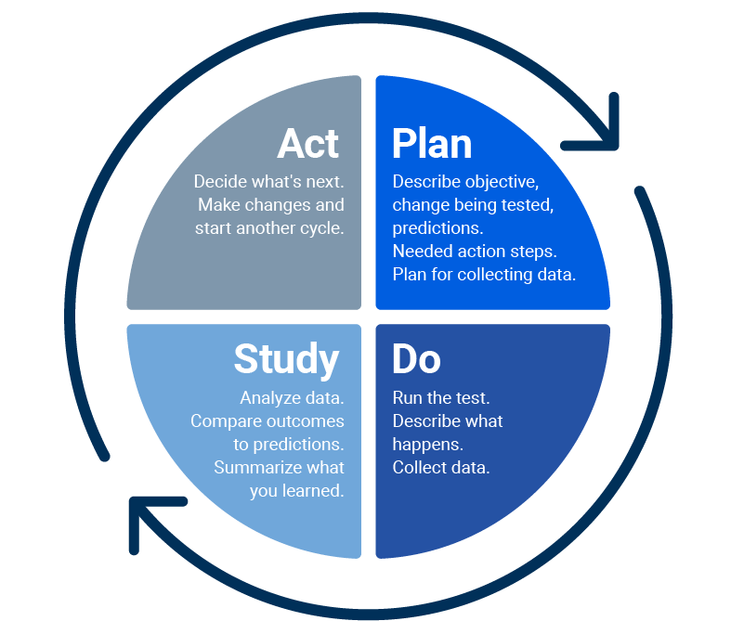

Figure 4 PDSA Cycle (Peerally et al., 2017)

The PDSA can be used to facilitate recurrent enhancement in reporting reliability. The Plan phase implies redesigning reporting policies and introducing clear-cut escalation triggers and the introduction of digital reporting tools. At the Do stage, pilot trials of these interventions in the neonatal unit may identify barriers in operation. The “Study phase will imply the analysis of the trends of the incidents, employee engagement rates, and feedback, which will allow revealing the ongoing challenges. Lastly, the successful changes are institutionalised in the form of the changes into the structure of governance, which is called the Act phase. Kronick et al. (2015) highlight that PDSA cycles are the best in the continuous quality monitoring, therefore they are applicable in the environment where the escalation and high vigilance is needed.

3.2.2 Lean Culture to minimise Reporting Barriers.
The lean strategies would shorten the reporting procedures and decrease the number of wastes in the work process. Simplifying the reporting pathway can be achieved by determining non-value-added steps, e.g. unnecessary paperwork or lack of clarity of approval. The flow improvement of Lean also means that vital information is delivered to decision-makers as quickly as possible and the chances of unnoticed anomalies are kept to a minimum. Favarò et al. (2017) demonstrate that high-reliability systems have better reporting accuracy and timeliness with streamlined reporting, which confirms the relevance of Lean. The application of Lean in the neonatal unit would involve redesign and standardisation of the reporting templates and removing bureaucratic challenges that could not allow staff to report issues without hesitations.

3.2.3 Six Sigma (DMAIC) in order to increase the accuracy of reporting.
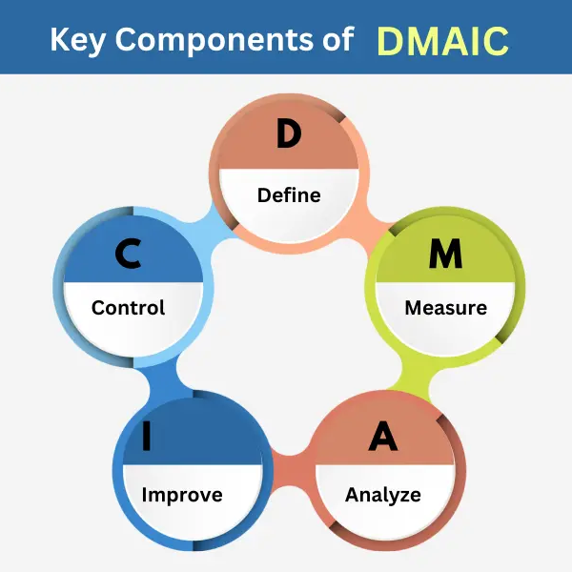

Figure 5 Six Sigma (DMAIC) (Peerally et al., 2017)

Six Sigma offers a systematic approach in eliminating variability as well as enhancing reliability in reporting of incidents. To identify defects in existing reporting mechanisms, the DMAIC model, which includes the definitions, Measure, Analyse, Improve, Control provides the opportunity to identify defects in the current reporting mechanism. Lack of proper reporting and whistleblowing flaws are officially defined as defects within the system in the “Define phase. Measure entails quantification of reporting frequency, timeliness and accuracy. Root causes such as cultural opposition and passive leadership are identified under analyse. Improve is concerned with such interventions as digital reporting systems and the training of staff. The aspect of control will be used to make sure that there is long-term compliance by the monitoring of dashboards and making periodic audits. Huq et al. (2016) prove that clinical systems can be made much safer with the help of structured risk-analysis approaches, which contributes to the applicability of DMAIC in the designated environment.

3.3 Implementation Strategy
1. Leadership and Workforce Engagement Plan
The leadership should embrace transparent responsive behaviours that show dedication to patient safety. To engage, it is necessary to build psychologically safe spaces where the staff complaints are confirmed and addressed. Multidisciplinary meetings in the regularity, the observability of leadership and accountability structures evoke trust and encourage shared responsibility towards safety.
2. Training and Capacity Building.
Specific education initiatives must improve the staff level of competence in incident reporting, early warning identification and escalation channels. The training should include simulation exercises, case learning and orientation to digital reporting system after which the safety practises should be uniformly applied to the workforce.
3. Monitoring and Plan of Evaluation.
The monitoring needs to be based on real-time reporting dashboards, a monthly analysis of trends related to incidents, independent reviews to determine compliance with safety procedures. The improvement in reporting volume, timeliness, and responsiveness should be evaluated, and the interventions should cause demonstrable safety improvements.
4. Sustainability Considerations
The long-term sustainability requires the integration of reporting practises in the organisational policies, accountability of leadership and periodic audits. The incessant involvement, regular retraining, and support of the national patient safety models will guarantee that time-based and clinical needs-related changes will continue to enhance the improvement of the situation.

4. Conclusion
Summary of Key Findings
As it has been shown in this report, the root causes of the ongoing risks at the neonatal unit were incident reporting failure, lack of whistleblowing, and governance structure. It is demonstrated that health care environments with weak reporting cultures, defensiveness on the part of the managers, and a lack of learning mechanisms hindered patient safety systems, which is consistent with broader issues reported by Mitchell et al. (2016). The process of the ineffective root cause analysis also added to the slow identification of harm, which strengthens the systemic character of governance failures (Peerally et al., 2017).
Quality and Patient Safety Implications.
The results highlight the fact that the lack of proper implementation of transparency requirements, such as the Duty of Candour that undermines the quality and reliability of patient safety models, as observed by Oliver (2024). Strong reporting tools like Critical Incident Reporting Systems will help to identify trends and harm prevention but they do not work without organisational dedication to responsiveness and learning (Petschnig and Haslinger-Baumann, 2017). Therefore, reporting failures put patients at unjustifiable risk.
Concluding thoughts on Service Enhancement.
To achieve sustainable improvement, it is necessary to incorporate the formal reporting procedures, provide the support to the staff members that express their concerns, and guarantee analytical rigour in the investigations of the incidents. Organisational learning should be a top priority, as well as active identification of risks, which is consistent with the evidence, according to which a well-developed system of surveillance is able to identify the first signs of an emerging safety concern (Raschi et al., 2019). Enhancement of governance, transparency, and accountability will also help to create safer clinical environments and avoid system failures that will be disastrous.

References
Alotaibi, Y. K., and Federico, F. (2017). The impact of health information technology on patient safety. Saudi medical journal, 38(12), 1173.
Ammouri, A. A., Tailakh, A. K., Muliira, J. K., Geethakrishnan, R., and Al Kindi, S. N. (2015). Patient safety culture among nurses. International nursing review, 62(1), 102-110.
Arabi, Y. M., Owais, S. A., Al-Attas, K., Alamry, A., Alzahrani, K., Baig, B., ... and Taher, S. (2016). Learning from defects using a comprehensive management system for incident reports in critical care. Anaesthesia and Intensive Care, 44(2), 210-220.
Capper, T., Ferguson, B., and Muurlink, O. (2024). Health professionals' experiences of whistleblowing in maternal and newborn healthcare settings: A scoping review and thematic analysis. Women and Birth, 37(3), 101593.
Curley, M. A., Wypij, D., Watson, R. S., Grant, M. J. C., Asaro, L. A., Cheifetz, I. M., ... and Pediatric Acute Lung Injury and Sepsis Investigators (PALISI) Network. (2015). Protocolized sedation vs usual care in pediatric patients mechanically ventilated for acute respiratory failure: a randomized clinical trial. Jama, 313(4), 379-389.
Ellis, P. (2025). Professional development. Learning lessons 1. Wounds UK, 21(2).
Favarò, F. M., Nader, N., Eurich, S. O., Tripp, M., and Varadaraju, N. (2017). Examining accident reports involving autonomous vehicles in California. PLoS one, 12(9), e0184952.
Flower, J. (2015). The international integrated reporting council: a story of failure. Critical perspectives on Accounting, 27, 1-17.
Glasper, E. A. (2024). Child Killers in Our Midst: Why the Lessons Learned About Safeguarding Shortfalls in the Care of Sick Children Must Not Be Confined to the Trash Can of History. Comprehensive Child and Adolescent Nursing, 47(1), 1-6.
Greenhalgh, T., Jackson, C., Shaw, S., and Janamian, T. (2016). Achieving research impact through co‐creation in community‐based health services: literature review and case study. The Milbank Quarterly, 94(2), 392-429.
Habre, W., Disma, N., Virag, K., Becke, K., Hansen, T. G., Jöhr, M., ... and Didier, A. (2017). Incidence of severe critical events in paediatric anaesthesia (APRICOT): a prospective multicentre observational study in 261 hospitals in Europe. The Lancet Respiratory Medicine, 5(5), 412-425.
Harkensee, C. (2023). Letby case: the public deserves the truth; whistleblowers deserve protection. bmj, 383.
Huq, M. S., Fraass, B. A., Dunscombe, P. B., Gibbons Jr, J. P., Ibbott, G. S., Mundt, A. J., ... and Yorke, E. D. (2016). The report of Task Group 100 of the AAPM: Application of risk analysis methods to radiation therapy quality management. Medical physics, 43(7), 4209-4262.
Jesudason, E. (2024). Reducing the risk of NHS disasters. Journal of medical ethics, 50(7), 482-488.
Kirkup, B., and Titcombe, J. (2023). Patient safety: listen to whistleblowers. bmj, 382.
Kronick, S. L., Kurz, M. C., Lin, S., Edelson, D. P., Berg, R. A., Billi, J. E., ... and Welsford, M. (2015). Part 4: systems of care and continuous quality improvement: 2015 American Heart Association guidelines update for cardiopulmonary resuscitation and emergency cardiovascular care. Circulation, 132(18_suppl_2), S397-S413.
Leveson, N. (2015). A systems approach to risk management through leading safety indicators. Reliability engineering and system safety, 136, 17-34.
Lewis, R. (2023). Lucy Letby: child murder case highlights need to regulate managers and improve whistleblowing procedures. The Conversation.
Macrae, C. (2016). The problem with incident reporting. BMJ quality and safety, 25(2), 71-75.
Majumdar, S., and Hussain, S. M. (2018). Clinical Governance and its Role in Patient Safety and Quality Improvement. In Scott-Brown's Otorhinolaryngology and Head and Neck Surgery (pp. 389-394). CRC Press.
Mitchell, I., Schuster, A., Smith, K., Pronovost, P., and Wu, A. (2016). Patient safety incident reporting: a qualitative study of thoughts and perceptions of experts 15 years after ‘To Err is Human’. BMJ quality and safety, 25(2), 92-99.
Oliver, D. (2024). David Oliver: How well is the duty of candour enforced in the NHS?. bmj, 385.
Peerally, M. F., Carr, S., Waring, J., and Dixon-Woods, M. (2017). The problem with root cause analysis. BMJ quality and safety, 26(5), 417-422.
Petschnig, W., and Haslinger-Baumann, E. (2017). Critical Incident Reporting System (CIRS): a fundamental component of risk management in health care systems to enhance patient safety. Safety in Health, 3(1), 9.
Raschi, E., Mazzarella, A., Antonazzo, I. C., Bendinelli, N., Forcesi, E., Tuccori, M., ... and De Ponti, F. (2019). Toxicities with immune checkpoint inhibitors: emerging priorities from disproportionality analysis of the FDA adverse event reporting system. Targeted oncology, 14(2), 205-221.
Richardson, A., Peart, J., Wright, S. E., and McCullagh, I. J. (2017). Reducing the incidence of pressure ulcers in critical care units: a 4-year quality improvement. International Journal for Quality in Health Care, 29(3), 433-439.
Scandal, M. S. (2023). The Lucy Letby case: lessons for health systems. Lancet, 402(747), 01839-1.
Schwendimann, R., Blatter, C., Dhaini, S., Simon, M., and Ausserhofer, D. (2018). The occurrence, types, consequences and preventability of in-hospital adverse events–a scoping review. BMC health services research, 18(1), 521.
Tomašev, N., Glorot, X., Rae, J. W., Zielinski, M., Askham, H., Saraiva, A., ... and Mohamed, S. (2019). A clinically applicable approach to continuous prediction of future acute kidney injury. Nature, 572(7767), 116-119.
Whiteing, P. (2024). Lucy Letby inquiry could be a missed opportunity if it does not look at the wider issue. Journal of Patient Safety and Risk Management, 29(1), 5-7.
Zarbock, A., Nadim, M. K., Pickkers, P., Gomez, H., Bell, S., Joannidis, M., ... and Forni, L. G. (2023). Sepsis-associated acute kidney injury: consensus report of the 28th Acute Disease Quality Initiative workgroup. Nature Reviews Nephrology, 19(6), 401-417.

