
Professional Career Development.
BMSK4005


By Carl Mitchell ID 1806399
November 2018

Contents

1.0 Introduction 2
2.0 Findings 3
2.1 Part 1 3
SWOT 3
MYERS BRIGGS 4
VARK 4
JOHARI WINDOW 6
GO MAD 8
2.2 Part 2 10
Conclusions 11
Reference list 12

Introduction
There are many resources available to use to make myself aware of how to go about finding out my personality, strengths and weakness which I can use to ready myself as a potential employee. These may be in the form of online activities as well as Questionnaires with positive results. Some of these tools are widely used in organisations, they may look and be named differently but have the same basic strategies involved to achieve similar outcomes. According to Morgan (2017), “There are several steps required for the development any skill”
I will show a few examples of written and visual tools as well as the outcomes which can then be put to good use in my professional Development Plan.

Findings

Part 1

SWOT
According to Morrison (2016), SWOT is credited to Albert Humphrey who in the 60s and 70s led a research project at Stanford University and used information from top companies. He identified several key areas and was First called the SOFT analysis but later changed in 1964 at a conference in Urick to SWOT.
Below is an example.
I will conduct a SWOT analysis on myself to identify my strengths and weaknesses.
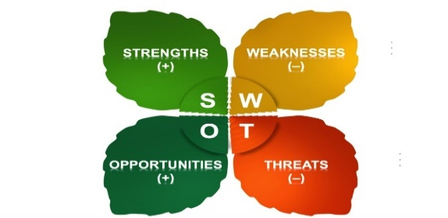
Strengths. Weaknesses.
Organised. Remembering things.
Good at teaching others. Overthink things.
Use personal experience for preventative measures. Writing skills.
Good at teamwork. Use of time between work, university
Can solve problems using logic. and homelife.
Good at using tools to achieve goals.
Opportunities. Threats.
Willing to advance my education. Confidence in own abilities.
Willing to learn as well as train and teach in other areas. I don’t drive which can limit my area
Organise my time better with work, home and University. of travel to work.
Other tools include Questionnaires to identify my learning styles.

MYERS BRIGGS
Here I have used the Myers Briggs Personality Profiling test.
In the Guardian Online, Lewis, (2018) Informs that the Myers Briggs test or MBTI is the most used Questionnaire in the world, developed in the 1943 by Katherine Cook Biggs and her daughter Isabel Biggs Myers based on the ideas of Swiss psychoanalyst Carl Jung. Based on a series of questions with only an A or B answer to determine the type of person you are.
Once completed the results in the score sheet come to this conclusion.

( X is for answer)
 | a | B |  | a | b |  | a | B |  | a | b
1 |  | X | 2 |  | X | 3 | X |  | 4 |  | X
5 |  | X | 6 |  | X | 7 | X |  | 8 | X
9 | X |  | 10 |  | X | 11 | X |  | 12 |  | X
13 | X |  | 14 |  | X | 15 | X |  | 16 | X
17 |  | X | 18 |  | X | 19 | X |  | 20 |  | X
 | Extrovert | Introvert |  | Sensing | Intuitive |  | Thinking | Feeling |  | Judging | Perceptive

As I can clearly see from the results, I’m an intuitive and thinking person but also shows some threats and opportunities, mainly when I use my senses and feelings when learning.

VARK
Another Tool that is used is called VARK.
This Stands for…V- Visual A-Aural R-Read/Write K-Kinesthetic.
4 different types of study strategies.
Morgan (2017), Writes that this was developed in the early 1990s by Fleming and Mills and puts in the factor that information can be taken differently from each individual to identify the best learning style. In 2006 Fleming and Baume argue that the questionnaire is not solely for learning styles but more of a means of communication and to relies on what can be taken on board and used to best suit how the person can learn.

After taking this questionnaire, the results are as follows. (Answers in brackets).
Question | A category | B category | C category | D category
1
2 | V | A | (R) | K
3 | (R) | V | A | K
4 | A | (R) | V | K
5 | K | V | (R)
6 | K | V | (R) | A
7 | A | R | (K) | V
8 | V | R | A | (K)
9 | (A) | V | K
10 | K | (R) | A
11 | V | A | (R) | K
12 | K | A | (R) | V
13 | A | R | (V)
14 | R | V | (K) | A
15

1
1
8
3
Total of V’s -by Visual Study Strategies
Total of A’s -by Aural Study Strategies
Total of R’s -by Read/Write Study Strategies
Total of K’s -by Kinesthetic Study Strategies

As I can clearly see, my best learning style involves the Read/Write Strategies.
Suggestions on how to use this information are,
INTAKE. To take in the information. This may involve lists, dictionaries, handbooks, readings as well as other visual information.
SWOT. Study Without Tears. To make a learnable package. This suggests to re-write and go over my work as well as the use of diagrams and graphs.
OUTPUT. To perform well in the examination. This consists of practicing with questions and answers and to write and arrange words into hierarchies and points.

JOHARI WINDOW
Another self-awareness tool is called the JOHARI WINDOW.
Chandler & Munday (2011) suggest that the Johari window was created in 1955 by Joseph Luft and Harry Ingham, it is a simple psychological tool for self-understanding.
According to Morgan (2017) he shows the issue that the window has where we hide the things we do not like about ourselves as well as where others will not let us know what they think about us as not to cause offence.
Here is an example of the window explaining each area of information weather known or hidden from an individual.

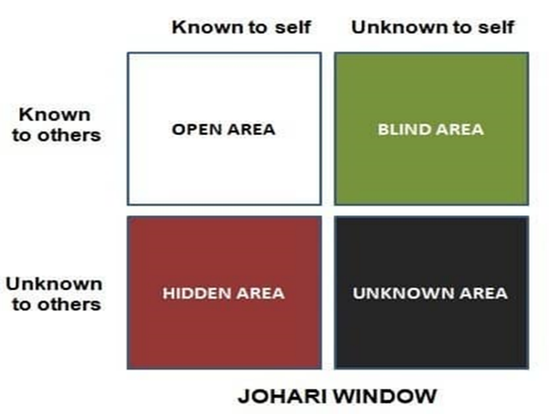

By using these learning tools and questionnaires. It is possible for me to have an understanding of some of these areas in the window, especially the Unknown to self-area, which I was not aware of but can now see the potential strengths and weaknesses that have become apparent in my findings.
I can now use all this information from the SWOT analysis, learning style questionnaires as well as the JOHARI WINDOW to put into the next steps which will help me with my areas of development.

Below is a quick example of using my weaknesses, strengths and threats and to turn them into opportunities.
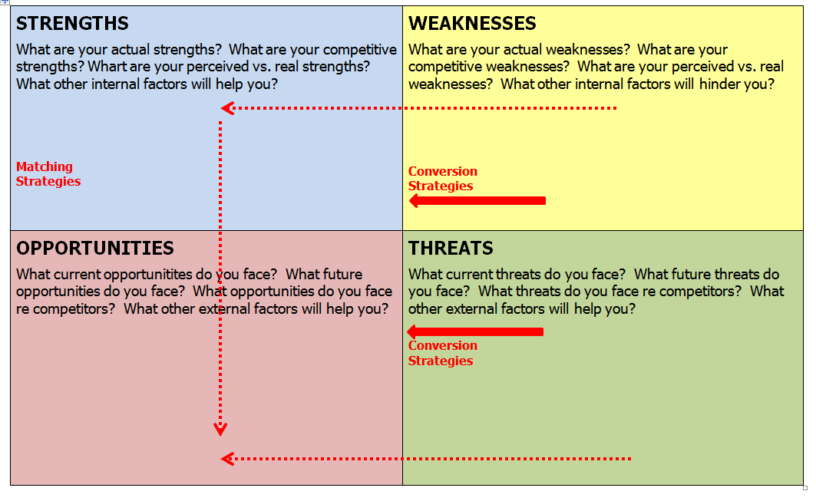
STRENGHTS. WEAKNESSES.
Intuitive. Extrovert.
Thinking. Judging and perceptive.
Reading and Writing. Kinesthetic Study Strategies.
Introvert. Writing skills.
Organised. Remembering things.
Teamwork and teaching others. Overthinking.

OPPORTUNITIES. THREATS.
Willing to learn. Make use of time.
Set goals to make time for tasks. Visual study strategies.
Go over things to ensure better outcomes. Aural study strategies.
Recognise lesser skills to work on and adapt to my needs. Sensing and feeling.

After using a few of these tools I can see a pattern forming with a few of my strengths and weaknesses. Some are clearer than others with can be used to focus on more.

GO MAD
According to Gilbert, (2014) the Go Mad model thinking system was developed by Andy Gilbert and Ian Chakrvorty with the book published in 1999. A better understanding can be found on the website Gomadthinking.com.
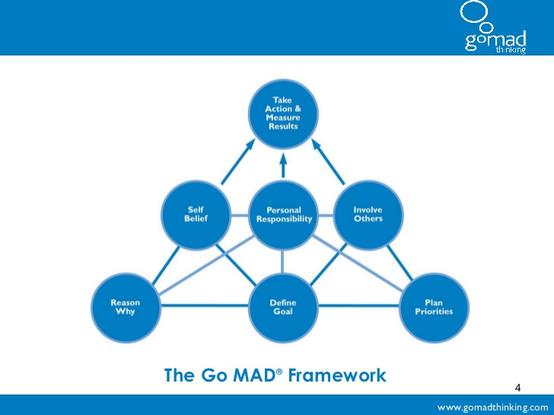
In a video, Gilbert, (2014) Using the Go Mad framework as a Diagnostic Tool, Mentions using examples of past events and looking at what key points were stronger and weaker then to think of future events were these points would be useful. Also, by asking yourself the right questions for certain areas as well as to “dip in and dip out” of each key point.

There are 7 Key principles shown above but are focused on certain areas.
1 Focuses on why you want to make a difference.
2 Questions what difference you want to make.
3-7 uses these principles on going about how to make the difference.
There are also 3 levels of the framework to create a pyramid which is foundation based for a strong structure explaining that the weaker the bottom then the other 2 levels won’t work no matter if they seem to be strong. This also consists of internal and external triangles focusing on each with a level of self-belief, realistic time and goals (Gilbert, 2014).

I have constructed my own Go Mad shown below based on the above 7 key principles.

Take a step back to review
myself. Reflect on what went well
as well as what I could different. Let the
people involved in my life know how I am doing.
Take a break.

I believe I can achieve this Make sure I am able to get This involves my family and
with as much support as I can stuff done on time as not to fall and friends. Mainly my wife,
get but I am aware that it is me back as well as get distracted and children as well as my boss to
who can push myself further to focus on the pay off. understand my needs and if
better goals. need be, alter my work time.

To advance my career. 9 Improve writing skills.9 Make use of the options
Brush up on skills. 8 think things through better.9 and allotted time for each
Believe that I can do it. 9 Learning as I go to achieve my of my activities.* Create a
Prove to others what is tasks in university as well work work-life balance. * Then
achievable.9 and my home life. 9 review every 4 weeks to
improve. *

Part 2
I will now construct a Personal Development Plan with will demonstrate my awareness, needs and how I will go about using the information including SMART to support me in my objectives. Morgan (2017) States that any management, organisation will have some version of SMART to set the best goals, but the letters will have other meanings.

Personal Development Plan.
 | Skill and opportunity | Where I am | My Objective | How to reach my objective | How to monitor progress | Desired timeframe | Support used
Key Objective 1 | Improve writing and I.T skills | Struggling with re-familiarising myself with unused past skills | To write and use I.T tools with efficiency. | Gain confidence. Learn at every opportunity. | Write down days spent on each task. Feedback from tutors, spouse and even fellow students. | By the end of 2nd module. As I progress it will save time. Review and address if stuff takes longer. | VARK. Go Mad.  Be SMART
Key Objective 2 | Think things through carefully | Tend to overthink and waste time. | Use time wisely. Take a step back to go over things. | Preparation.  Use what works well.  Know my limitations. | Use preventative measures. Learn from mistakes. | By end of this year and have good understanding of structures in my assignments. | KOLBS learning cycle. 7 habits of highly effective people. (Steven Covey)
Key Objective 3 | Make use of time | Seem to juggle between work, home and University. | To use certain days for each as not to get overwhelmed. | Try to keep 1 day spare for unforeseen circumstances. Efficiently use the time I have. | Review after each assignment to see how much time can be used as well as saved. | Ongoing. But once properly practiced, the benefits will show. | People in work, home, university as well as myself
Key Objective 4 | Kinesthetic study skills | Was unaware of weakness. | Be able to adapt and use when needed. | Gain confidence, get more involved with class. | Use some spare time to use skill and see what works well. | By the end of December. (After PowerPoint Presentation). | Tutor, class mates, What’s app group.
Key Objective 5 | Visual study skills | Can get bored easily if something looks the same all the time. | Make things look different and stand out. Try to appeal to everyone. | Go over my work, even past completed work. Use feedback when given. | Keep work in folder, for quick review. Ask for feedback form other people. | Before breaking up for holidays. | PowerPoint slides. Videos. Use library more often.

Conclusions
So, by using all the various questionnaires and learning styles, it has created a personal map of my strengths, weaknesses, opportunities which with this knowledge I have now used to create my own personal development plan. I can now go forward with this and put it into use and monitor my progress accordingly. Then as time goes by it can then be adapted when other skills and opportunities arise. The Personal development plan can be used in many ways, especially when a goal can be a potential employee in a job, this gives self-awareness and with research into any career or position can be used to sell yourself to a future employer.

Reference list
Chandler, D. & Munday, R. (2011) ‘A Dictionary of Media and Communication’ : Oxford University press [online] http://www.oxfordreference.com.ezproxy.uwtsd.ac.uk/view/10.1093/acref/9780199568758.001.0001/acref-9780199568758-e-1453 (accessed 12/11/2018).

Gilbert, A. (2014) ‘Using the Go Mad framework as a Diagnostic Tool’ [online] https://www.youtube.com/watch?v=Rco1r1xBfPQ (accessed 12/11/2018).

Lewis, T. (2018) ‘Myers-Briggs personality test: what kind of person are you?’ [online] https://www.theguardian.com/science/2018/sep/15/myers-briggs-not-sure-youre-really-our-type-merve-emre-author-origins-validity-personality-tests ( accessed 12/11/2018).

Morgan, P. (2017) p 27, ‘The business Students Guide to Study and Employability’. London: Sage.

Morgan, P. (2017) p.29 ‘The business Students Guide to Study and Employability’. London: Sage.

Morgan, P. (2017) p38, ‘The business Students Guide to Study and Employability’. London: Sage.

Morgan, P. (2017) p97, ‘The business Students Guide to Study and Employability’. London: Sage.

Morrison, M. (2016) ‘Swot analysis (TOWS matrix) Made simple’ [online] https://rapidbi.com/swotanalysis/#comments ( accessed 12/11/2018).

