Manufacturing Systems and Simulation
ACEA 6002
Applying Lean Techniques

Student Number: 2114818

Table of Contents

Introduction………………………………………………………………………… Pg 3

Tensile Testing Process…………………………………………………………. Pg 3

Value from the customer’s perspective………………………………………… Pg 4

Figure 1 - map of distance travelled in the transportation ………………… Pg 5

Figure 2 – map of ET Lab ………………………………………………………… Pg 6

Types of waste from the tensile testing process ……………………………. Pg 6

A consideration of potential problems………………………………….……... Pg 7

Closing discussion, considerations, and conclusion ….……………………. Pg 8

References ………………………………………………………………………… Pg 11

Introduction
A process which has the potential for many improvements to be made leaner in a department at Trostre Steel Works is the tensile testing. The tensile testing process has not changed for over 30 years. It is by now an old-fashioned process. However, is has clear potential to become a more efficient and overall, a better process. This report provides an overview of what tensile testing process is; how the tensile testing process adds value to the customer; an evaluation of how the tensile testing process can be made leaner; a consideration of the potential problems that can occur from the evaluation considered; and finally, how to overcome these problems.
There are numerous Lean Manufacturing Tools that’s used in today’s industries, these are [1]:
- Control Charts
- Kanban Boards
- Kaizen
- 5S
- Poka-Yoke
- SMED
- Value Stream Mapping
The lean technique best fit for the tensile process will be the Kaizen Lean Technique, as it’s meant to improve work process in various ways, which will be discussed in the report. “There are 5 Fundamental KAIZEN™ Principles that are embedded in every KAIZEN™ tool and every KAIZEN™ behaviour. The 5 principles are: Know your Customer, Let it Flow, Go to Gemba, Empower People and Be Transparent. The implementation of those 5 principles in any organization is fundamentally important for a successful Continuous Improvement culture and to mark a turning point in the progression of quality, productivity, and labour-management relations.” [2]
The advantages of Kaizen Lean Technique are [3]:
- A better workplace and a safer working environment
- Better commitment and employee retention
- Improved problem-solving skills and quality of teamwork
- Increased competitiveness and customer satisfaction
- Reduced waste and overly hard work
- Increased productivity and overall company success

Tensile Testing Process
The tensile testing process at Trostre has been a questionable process that requires improvements. Each shift, the operators at the exit of the coating lines, sample 1 metre of the outer part of the coil. This process is done for each coil that comes off the ECCS 4 and ETL 5 of each shift. There are 14 shifts each week: a 12 hour day shift and 12 hour night shift. On average, 90 coils are coated between the two coating lines each shift. The tensile testing is a retro testing process from the previous shift.
The 1 metre samples are then placed on the sample trolley on both coating lines. These are collected by the shift technician at the start of the shift, and brought back to the ET Lab compound, where the power press is located to punch out a tensile panel.
After the samples have been collected and transported back to the ET Lab, the shift technician then stamps a panel out of every 1 metre sample sheet from both coating lines. Each 1 metre sample has a barcode sticker of the TOPS ID, which is placed by the exit end operator of the coating line. The shift technician would scan the barcode using a scanner. This process confirms the shift technician has received the sample and the order details. The barcode is also vital for the shift technician as they scan the barcode to know its TOPS ID, recording the TOPS ID on the freshly stamped out panel.
The panels are then transferred by the shift technician into the press room, where the panels are stamped for a tensile dog bone sample, enabling it to be put on the tensile machine. The shift technician would press a dog bone from each panel. The dog bones are marked up with its TOPS ID by the technician with a marker pen. The tensile dog bones are then barcoded to be placed on the tensile machine and then pulled, to collect the mechanical tensile data.
The tensile testing process takes on average four hours to complete. This includes the collection, preparation, and final testing process. The problem that can emerge from this process is that the coils that come off the coating line from the previous shift, would have most likely have been packed and transported into the warehouse during the current shift. As the tensile testing process takes time, this could result in coils being returned from the warehouse for removal due to tensile failure.

Value from the customer’s perspective
The tensile testing process is valuable from the customer perspective and from a quality point. This is because tensile testing demonstrates whether the mechanical properties of the coil is within the ‘Euronorm’ or the customer specification. It is vital that the mechanical properties of the steel material are within customer specification as this will provide its quality to the end product. If the mechanical properties are out of specification, this could lead to a failure at the customer plant. This would result in downtime in its forming section for maintenance, and loss in money for all the affected material, or damage to the machinery at the customer plant.
If the results were on the top end, this would result in tool wear at the customer plant. The department could review the tensile results of each temper and adjust the results to fall more towards the middle of the specification. This could be achieved by changing the chemistry in the cast and the percentage in the rolling or the annealing temperatures in order to prolong customer tool life. This would also be completed to reduce further risks of mechanical failures at the customer plant.
Additionally, the department supplies the test results to the customers via the test certification process. This is used to the proof of the product such as customs, taxation and tariff exemption in the United States and the European Union.
This can also be used at the customer plant to schedule the coils on their lines, to further aid in machine tool life, by running all soft material first and gradually running all the harder material last to ensure further tool life at customer plant.
The tensile testing process enables the collection of tensile data and calculates averages to give compliance for the customer. Compliance within the tensile testing process builds trust in the product and with the customer. This proves that the mechanical properties of the different tempers produced at the plant are legally within specification. This is an emotional connection with customers as it gains trust which will lead to loyalty, which is essential to the business. This is also essential, because if a problem occurs with the material, the customer is more likely to agree to work collaboratively with the department.
From a personalisation point of view, the tensile testing process creates value for the customer. This is because customers can request longitudinal, diagonal, and transverse tensile testing, depending on their needs.
Below in Figure 1, a map demonstrates the distance that a technician covers when transporting the trolley. Starting from the ET Lab compound, the trolley is transported by the shift technician to ETL 5 where they pick up all the 1 metre sheets from the previous shift and place these on the trolley. They then transport the trolley with the ETL 5 samples to ECCS 4 to collect the 1 metre samples from the previous shift on to the trolley on top of the ETL 5 samples. They then transport back to the ET Lab compound to be punched. (The route is highlighted in red).
Figure 1.
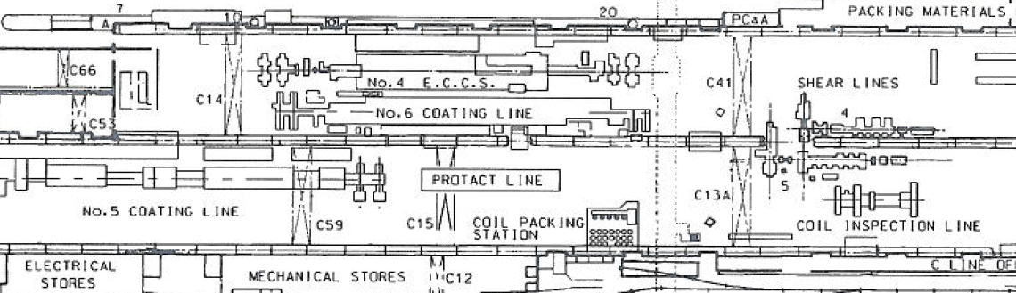
Below in Figure 2 is a map of the ET Lab, outlining where the shift technician would punch each 1m meter sheet (1) at the compound from the trolley. They would then transport the panels into the power press room to be punched for dog bones. After the dog bones are punched (2), they are then transported into the Zwick tensile room (3), where they are then pulled on the tensile machine.

Figure 2.
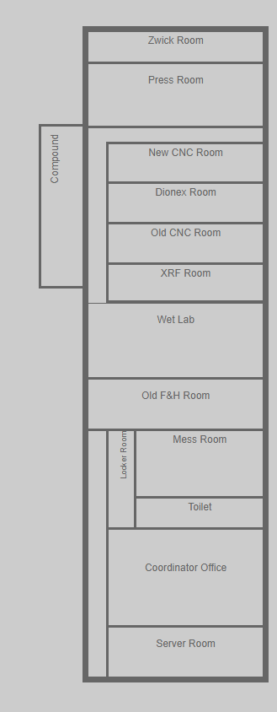
3

2

1

Types of wastes from the tensile testing process.
The tensile testing process that has been used for decades at Trostre has many wastes that affect the overall process of the tensile testing. The most common type of waste in this process is transportation. Effectively, there are three unnecessary transportations used in this process. These are:
- Carrying the freshly cut 1 meter sample from the coil onto the sample trolley.
- The shift technician transporting the sample trolley from the two-coating line to the ET Lab outside compound.
and finally,
- the transportation of the tensile panels from the outside compound into the press room, where the panels are punched for a tensile dog bone.
A suggestion to make this a leaner process could be to have a press built on the coating line. Here, it would be punched on the coating line and placed into a sample hatch on the line with a barcode of the TOPS ID of the coil. This is where the shift technician could then carry these panels rather than using a trolley containing approximately 90 x one-meter samples across the plant.
This would immediately reduce dangers and risks to the shift technician as the sample trolley is heavy to manoeuvre particularly with large tractors and cranes carrying coils being driven around the plant.
A leaner process to that would be to include a conveyor belt in the plant which transports the panels to the ET Lab compound. This would save time and improve safety to the shift technician.
If the panel is pressed at the line, the power press in the ET Lab is not required. This would reduce, on average, an hour to the shift of pressing each 1 metre sheet from the trolley in the compound. This would also reduce any human error of the shift technician marking the panel with the incorrect ID, which could result in an untrue test. Coils could be sent back out of the warehouse for resampling at the CIL, which could incur further costs.
By removing the power press at the ET Lab compound, this would create more space in the compound for possibly extra storage for samples or a bigger work bench for the shift and day technician to do their testing.
Installing a pneumatic tube at the exit of the coating lines, would enable the operator to place the dog bones in a container and transport these in a tube in the basement of the plant, which would travel from the exit of the coating lines to the press room. This would remove the need of a trolley and the transportation waste of the shift technician when colleting the samples from the coating lines.
Another consideration would be to move the ET Lab by the exit of the coating lines. This would reduce the transportation by roughly 300m.
Motion is another factor of waste in the tensile process. These are the factors:
- The shift technician is required to punch out each individual 1 metre sheet off the trolley.
- The freshly punched panels are then punched again for a tensile dog bone in the power press room, ready for it to be put on the tensile machine.
A further consideration to make the process leaner, is a power press on the coating line to punch and label with its TOPS ID. The shift technician could then collect the panels from the coating line, taking out the motion for the shift technician to use power press in the ET Lab compound, and marking up the panel.
Another suggestion to make the tensile testing process leaner, is to have a double press on the coating lines, where one power press punches the panel and the other power press for the dog-bones with each dog bone marked up with the TOPS ID. This suggestion would remove: the motion of punching out the panel in the compound; the motion of punching out the dog bones at the power press in the press room; the marking up of the TOPS ID on the dog bone. However, due to the risk of the material failing, it would require a dog bone press that can punch four dog bones simultaneously for re-testing. This could potentially be a problem as it would be an excessive amount of dog bones.
Overall, these suggestions would reduce the tensile testing process time significantly. They would also reduce human error from the marking up of the tensile panels/dog bones. This would result in the shift technician being able to pick up the samples from the coating lines and placing the tensiles straight on to the tensile machine.
This would result in quicker tensile results, allowing time for the day technician to catch the failed tensile coil from going into the warehouse. This would also save time in the transportation process, to and from the warehouse and avoid delaying the delivery time to the customer. This would also save money from the coil having to be returned from the warehouse. Packaging material is used to put on the coil. Therefore, if the coil has had to be returned, the packaging material has to be removed in order for it to be put on the CIL for removal and sampling. So, this suggestion could also reduce waste material packaging if the coil is diverted to the CIL rather than straight into the warehouse.
A consideration of potential problems
One potential problem that could arise from the suggestions already considered is the availability of space with the current plant layout for several improvements.
The first problem is space for the panel power press to be fitted on the exit of the coating lines. To add another dog bone power press next to the panel power press would require significant space. Another potential problem associated with implementing the improvements is, if the power press is down on maintenance, an error in punching the material could cause damage due to the build-up.
If the power press is down on maintenance, the power presses at the ET Lab would be removed due to the double power press at the exit of the coating lines. This could potentially lead to additional risks in that it would cause a build-up of material at the exit of the coating lines as well as there being no back-up presses at the ET Lab. This would result in longer waiting times due to no tensile results and high stock levels of coils being held in the warehouse.
Another problem to having a double power press at the exit of the coating lines would be cost of the power press. This could be an issue to the business as a panel power press would cost £30,000 and a dog bone press would cost £20,000. Therefore, the total cost would be £100,000. These problems could be overcome by having a trained and skilled mechanic that would be responsible for the maintenance of the power press. Another way to overcome this problem could be at the exit line, where the operator could carry out a visual check on the power presses after every coil. Each coil takes, on average, 20 minutes, which allows sufficient time for the operator to check if the material has been pressed successfully. This will also allow the exit operator to remove any trimmings or scrap material before the next coil is punched, and if not, to report the matter to the mechanic responsible of maintaining the power press.
A further potential problem associated with implementing a conveyor belt or a pneumatic tube would be the space required to build it. The current infrastructure would require the conveyor belt to be built underneath the plant in the basement. Additionally, the conveyor belt / pneumatic tube could break down, resulting in the shift technician having to walk over to the coating lines to pick up the dog-bones. A further barrier would be the installation costs. This would also require downtime for the installation process.
To overcome these barriers, using the basement map would enable decisions to be reached in relation to the best route for the conveyor belt / pneumatic tube to be installed, to reduce waste material.
To justify the costs, a detailed presentation outlining suggestions for potential improvements could be provided to all levels of management within Tata Steel at a board meeting. This presentation would include a critical analysis of current risks, costs, actual data, problems and current efficacy against the benefits, savings and the possibility, with careful investment, of creating a safer, leaner and more efficient working environment.
Finally, as this would require downtime for the installation process, the installation could be done at shutdown over the Christmas period to avoid downtime during production weeks.

Closing discussion, considerations, and conclusion
A Kaizen report of the tensile testing process.
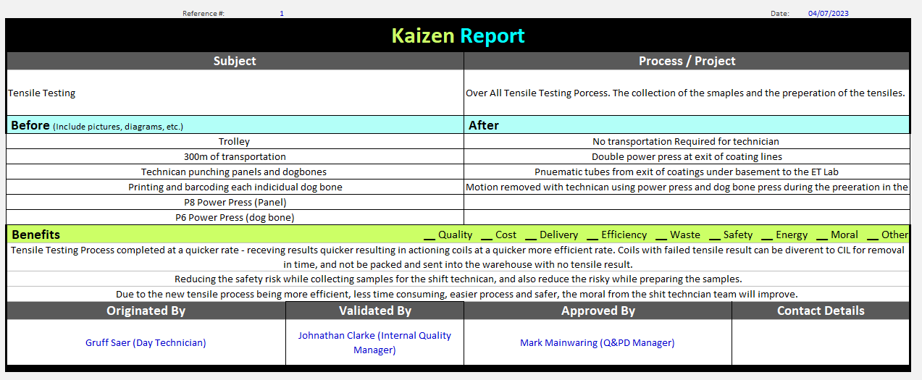

The types of waste that occur from the tensile testing process are medial problems, that could be resolved by making the tensile testing process leaner. A new ET Lab at the exit of the coatings’ lines would be an effective solution as it would overcome the transportation waste and consequently save costs of buying a power press for each line. It would also reduce the risk of the build-up of material at the exit of the coating line, should the power press breakdown. However, the cost of building a new ET Lab at the exit of the coating line would be extortionate, and the current plant layout would not be suitable without some major building re-structure or new build.
A suggestion of having one power press panel at the exit of the coating lines would be cheaper than having a double power press. Nevertheless, this would still require a dog bone power press at the exits of the coating lines.
Another suggestion to make the process leaner is to add a conveyor belt or pneumatic tube from the coating lines to the ET Lab. The conveyor belt would be a better solution as it would enable tensile panels to be delivered, which would eliminate the need of a dog bone press at the coating lines. However, due to the plant layout this would be a significant challenge as it would require substantial space under the basement which is not feasible. Therefore, having considered the challenges, barriers and possibilities, the installation of a pneumatic tube would be the most practical and effective solution, as it would not take up much space in the basement as this only involves installing tubes which would run under the basement.
The power press and dog bone power press installed at the exit of the coating lines would be the best solution as it would be the best fit for the plant layout and more obtainable compared to a new ET Lab at the exit of the coating lines. This lean suggestion will reduce the motion waste to the technician and reduce the safety to the technician when collecting the samples. This would make the entire process leaner as tensiles are already barcoded with the TOPS ID, ready for the shift technician to place these immediately on the tensile machine. Even so, the benefits of these improvements outweigh the overall cost of the installation and could therefore be justified to ensure that a new and more cost-effective lean improvement process would come from this.
Finally, the most effective and efficient recommendations to make the tensile testing process leaner at Trostre works would be to install a power press panel and a dog bone power press at the exit of the coating lines. With a pneumatic tube in place from the exit of the coating lines to the ET Lab, the exit operator would collect the tensile from the dog bone press into a container and send to the ET Lab. In this scenario, the shift technician could then collect the tensiles from the container and place these on the Zwick tensile test machine. This improves the safety of collecting and preparing the tensiles. It could also improve the morale of the shift technician as the overall process is leaner and more efficient. These recommendations would reduce transportation waste, removing the need for the shift technician to push the trolley to the coating lines and bring back a stack of 1 metre samples. It would also reduce the risk of collecting and preparing the tensiles. These recommendations would also reduce motion waste as it would eliminate the need for the technician to punch each 1 metre sample, and to punch a tensile dog bone from each panel.

References
[1] No Name. (No Date). What is Lean Manufacturing?. [Online]. TWI Global. Available at: https://www.twi-global.com/technical-knowledge/faqs/faq-what-is-lean-manufacturing#AdvantagesandDisa [Accessed 5 July 2023].
[2] Kaizen Institute. (No Date). What is Kaizen. [Online]. Kaizen. Available at: https://kaizen.com/what-is-kaizen/#:~:text=There%20are%205%20Fundamental%20KAIZEN,Empower%20People%2 [Accessed 5 July 2023].
[3] Kos, B. (2023). Kaizen - Constant improvement as the winning strategy. [Online]. SPICA. Available at: https://www.spica.com/blog/kaizen-method [Accessed 5 July 2023].

