Assessment 4: Image Commentary

Michelle Hogan

The image that I have chosen is ‘a young lady dressed in ermine and with a crown, kneeling before the Virgin and Child’ in MS Laud Misc. 188.
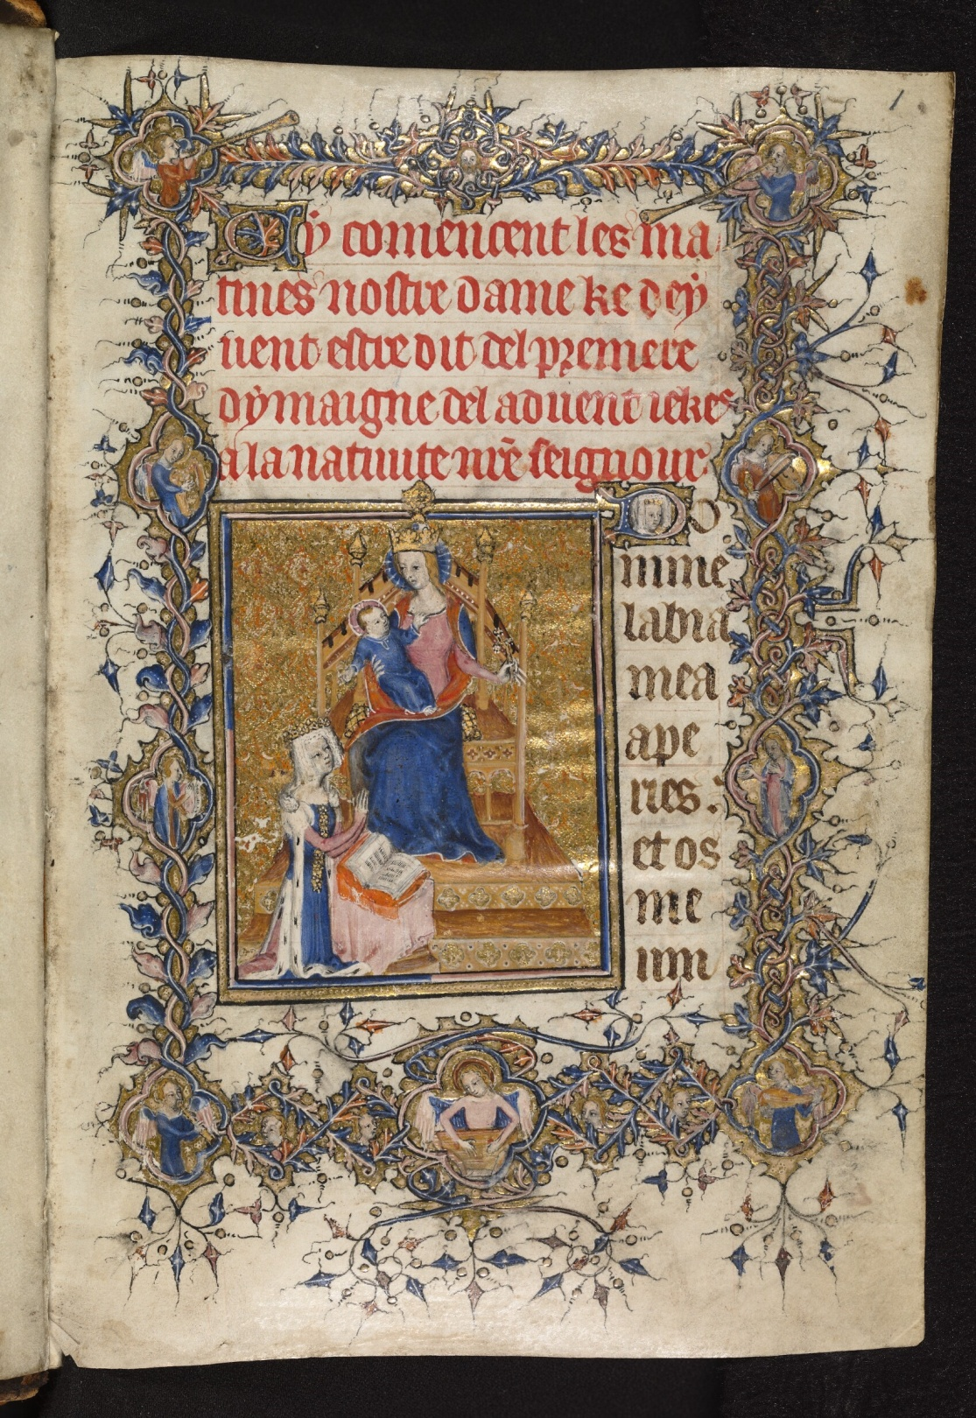
Source: Bodleian Library University of Oxford, ‘a young lady dressed in ermine and with a crown, kneeling before the Virgin and Child’ on parchment (MS. Laud Misc. 188, fol.1 recto, the front of the manuscript page). https://digital.bodleian.ox.ac.uk/objects/6101d6a5-ae46-4285-b182-79c3c08599f0/
This miniature is in a Book of Hours, Use of Rome, in the Bodleian Library (MS. Laud Misc. 188). Its place of origin is England. Until the late Thirteenth Century, the Psalter (or Book of Psalms) ‘was almost the only liturgical book used by the laity for private devotion’, and it was supplanted by the Book of Hours (also known as a primer or horae). These books were extremely popular and according to Wendy Stein, ‘from the fourteenth to the mid-sixteenth century, more books of hours were made than any other type of book’. Many of these books were beautifully decorated, and the purpose of their illustrations was for reflection. The text is known as the Hours of the Virgin (or Little Office of the Blessed Virgin), and the prayers were meant to be said regularly throughout the day, hence the name. Reciting these devotions, asserts Michelle Brown, is an expression of the laity’s ‘desire to imitate the prayer life of the religious’. Both Stein and Brown point out how popular books of hours were, and many of them have survived in museums and libraries, like the Bodleian. Nearly 800 of them made for use in England are in libraries around the world.

This illumination is lavish, with considerable use of gold. Its backdrop is a gold and orange pattern, with gold decoration extending to the double-layered pedestal or platform, where the Virgin Mary sits on what looks like an intricately-carved chair or throne. The pedestal and throne look as though they are made of wood, and the throne has four posts rising up from it, topped by pointed ornaments. The back of the throne seems to be in the shape of a gothic arch, culminating in a gold ornament. Mary is wearing a blue garment with a pink bodice and sleeves; she appears to be wearing a cape, with its red lining visible. These colours are mirrored in the clothing of the young lady, who is wearing a blue garment with pink sleeves and a cloak edged with ermine fur. The drapery on all the clothing looks natural. The black and gold colours (with white or silver detail) of the cushion on which Mary sits are reflected to a certain extent, by the decoration on the front of the young lady’s dress, and also her crown, which is considerably smaller than Mary’s. The infant Jesus, who is being held by Mary on her lap, is dressed in a blue garment with long sleeves, and has a pink halo. Mary’s head is framed by what looks like a blue halo. These two figures have red hair, which resembles gold, and this contrasts with the white hair or headdress of the young lady. She is in a praying position before the Virgin, and has a book in front of her on a small stand covered with a pink cloth.
There are a number of images of the Virgin Mary in this Book of Hours, mostly in the form of historiated initials and further on there is a crucifixion scene (fol. 73r). The colours are predominately blue, pink and red, with gold for decorated borders, as in this illumination. On this page, above the blue, pink and gold frame is the rubric, written in red, and here the French words ‘notre dame’ can be seen clearly, written in gothic script. Within the rinceau-style decorated border, small angelic figures can be seen – some of whom are playing stringed instruments and trumpet-like instruments. There appears to be an image of the young girl’s face within the historiated initial ‘D’ at the top right corner of this miniature, perhaps with the intention of making the book even more personal. The whole page is about 17.5 cm tall, although the book depicted in this image appears to be somewhat larger than this. Illuminated manuscripts were expensive to produce, because the materials used, such as the bindings, covers, colours – including gold leaf (or gold powder or saffron) – were costly. Further, the preparation of the parchment, and the writing and illumination process was time consuming for the scribes and artists. Monastic scribes might have been able to devote about six hours a day to writing manuscripts, while professional scribes could have spent longer doing their work; some manuscripts could take more than a year to produce. Illuminated manuscripts, then, were commissioned by wealthy patrons, like royalty and members of the court.

Devotion to the Virgin Mary was ‘a key focus’ of Christianity at this time, and there was a shift in more personal devotional practice. A Book of Hours might also include gospel lessons, psalms, and prayers to saints called Suffrages. As Stein points out, a patron could choose which supplemental texts to include, and this personalisation added to the popularity of these books. She adds that the rise of a prosperous bourgeoisie and increasing literacy also contributed to the demand for such books, so that ordinary citizens could own them, as well as the nobility. In addition, the production of manuscripts moved from ‘clerical control to professional scribes, artists and booksellers’, making these books easier to acquire. In Western Europe there was a growth of the cult of the Virgin Mary in the twelfth and thirteenth centuries, which was partly inspired by the writings of theologians like Bernard of Clairvaux. Mary was worshipped as the ‘Queen of Heaven and Intercessor for the salvation of humankind’.
In the thirteenth century, there were enough people who were interested ‘in the pursuit of a serious interior religious life’, to provide a market for Books of Hours. The illuminations contained within these books were significant, and Eamon Duffy points out that they were ‘part of the religion of the image’. Not only this, but Duffy also states that the pictures were often ‘as important to their users as the texts they accompanied’, and their purpose was to enhance comprehension. In this manuscript, the Office of the Virgin with the Hours of the Cross worked in, there are decorated initials and borders at the beginning of each Hour. The contents include Advent and Christmastide, and the illuminations show these occasions in similar colours to those of the young girl with the Virgin (fol. 1r), although there could be as many as four artists and associated decorators. The language used in this book was Latin and Old French (842 – c. 1400), both used in England at the time. The name ‘Lumley’ appears several times on the end flyleaf, and this book might have belonged to John, Lord Lumley, who died in 1609. One of its former owners was William Laud (1573 – 1645), who became Archbishop of Canterbury in 1633, during the reign of Charles I. His reforms caused a great deal of tension, though, and he was executed after being found guilty of high treason.

There is a paradox concerning images in the Middle Ages, as Thomas Tolley has discussed. The gentry’s attitude towards the visual arts, he points out, was sometimes negative. Although pictures were recognised as ‘useful for drawing the faithful closer to God’, ‘imagery for its own sake, as in the sumptuous decoration of books or buildings, was often regarded as a dangerous diversion’. There was a concern, shared by John Wyclif and his Lollard followers, about idolatry if people were to mistake ‘the divinity of holy figures with the form of their pictorial representations’. This attitude does not seem to have extended to royalty or the nobility, and members of these classes often commissioned illuminated manuscripts, like highly decorated Books of Hours.
The garments worn by the figures in this image tell us something about their status. The colour blue, which each of them wears, became more widely used from the eleventh century, when ‘it began to be associated with the Virgin Mary’. Its adoption by the French royal family emphasised its prestige. Perhaps the most likely reason for this is that it was an expensive pigment. Ultramarine (an inorganic pigment) also known as blue azure, was made from lapis lazuli, obtained from Afghanistan. The lapis not only had to be ground, but it also had to be prepared ‘according to Cennini’s recommendation’, a costly process, to make it dark blue. Sometimes the substitute azurite (copper carbonate) was used instead of ultramarine, which was less expensive – but still fairly costly. Two organic blues could be made from the plants woad and indigo. We can see why a rich, deep blue would have been used for Jesus and the Virgin Mary, but here the young girl is also wearing it, which might be to show her piety and connection to the holy mother and son. There is also blue in the decorated border, which enhances its impact on the viewer or reader. The presentation of a manuscript text, or mise-en-page, is important in drawing one’s attention to the image and writing.

There was a fairly rigid class system in the fourteenth century, although the increase in wealthy merchants brought about some change. The clothes that people were allowed to wear depended on their place in society, and were determined by sumptuary laws, passed at various times between 1281 and 1363. Only someone of the highest echelons of society would be wearing ermine and a crown, like the young girl. The Virgin Mary is the most prominent person in the image though, and both she and the infant Jesus Christ are higher in status here; their divinity takes precedence over any important worldly figure. The Virgin herself is paradoxical, because she is a virgin and a mother. She gave birth in a stable, a very humble place, yet the holiness is in the humility. People might have been more inclined to pray to Mary in particular, during this rather turbulent century, with the Great Famine (1315 – 17), the Black Death in the 1340s and beyond, and the Hundred Years’ War (1337 – 1453). They might have been praying for salvation during those difficult times, or intercession for members of their family.
The young girl in this Book of Hours might be its owner, or a member of the family who commissioned it. She is from a wealthy background, and appears to be important, because she is wearing ermine fur and a crown. However, this image shows her as subservient to the Virgin Mary and Christ child, who are on a chair which looks like a throne, against a sumptuous background. Books like this were very much in demand for a number of reasons, like religious attitudes, especially towards the Virgin Mary, and historical ones. There seems to be a distinct colour scheme in this manuscript, with plenty of blue and gold – which were expensive – as well as orange and pink. This illumination shows a high level of detail and artistic accomplishment, and its effect is striking. It also provides the reader or viewer with an image on which to focus for personal piety. Each Book of Hours was probably unique, as their contents and illustrations or illuminations were chosen individually. The claim that highly decorated manuscripts might lead to idolatry seems reasonable, but these books remained popular despite such accusations. The argument that readers of these books might be pious because they concentrated on what the figures represented rather than merely their outward form is also valid. It surely fulfils its purpose if beautiful script and lavish illuminations in a Book of Hours encourages prayer and devotion. It is fortunate for us that a fairly large number of Books of Hours were produced and have survived in libraries and collections around the world, so that we too can appreciate the effort and artistry that went into them.

1974 words

Bibliography

Books

Brown, M., Understanding Illuminated Manuscripts, a Guide to Technical Terms, Los Angeles: J. Paul Getty Museum (1994) (revised edition, 2018).

Clemens, R., and Graham, T., Introduction to Manuscript Studies, Ithaca, New York: Cornell University Press (2007).

Duffy, E., Marking the Hours English People and their Prayers 1240 – 1570, New Haven: Yale University Press (2011).

Tolley, T., ‘Visual Culture’, in Radulescu, R. and Truelove, A., (editors), Gentry Culture in Late-Medieval England, Manchester: Manchester University Press (2005).

Online Resources

Department of Medieval Art and the Cloisters, ‘The Cult of the Virgin Mary in the Middle Ages’, in Heilbrunn Timeline of Art History, New York: The Metropolitan Museum of Art, 2000 (October 2001), https://www.metmuseum.org/toah/hd/virg/hd_virg.htm [Accessed 12th December 2023].

Gardham, J., ‘Book of the Month, The Hunterian Psalter’, Glasgow University Library Special Collections Department, (May 2007), https://www.gla.ac.uk/myglasgow/library/files/special/exhibns/month/may2007.html. [Accessed 8th December 2023].

Oxford, Bodleian Library, Miniature, Fol. 1: ‘a young lady dressed in ermine and with a crown, kneeling before the Virgin and Child’ MS. Laud Misc. 188, (14th November 2019), https://digital.bodleian.ox.ac.uk/objects/6101d6a5-ae46-4285-b182-79c3c08599f0/ [Accessed 6th December 2023].

Sparkes, A., ‘The Life and Death of William Laud’, Historic UK, (2nd January 2018), https://www.historic-uk.com/HistoryUK/HistoryofEngland/The-Life-and-Death-Of-Wiliam-Laud/ [Accessed 13th December 2023].

Stein, W. A., ‘The Book of Hours: A Medieval Bestseller’, Heilbrunn Timeline of Art History, New York: The Metropolitan Museum of Art, 2000 (June 2017), https://www.metmuseum.org/toah/hd/hour/hd_hour.htm. [Accessed 9th December 2023].

Julie Gardham, ‘The Hunterian Psalter’, Glasgow University Library Special Collections Department, (2007), https://www.gla.ac.uk/myglasgow/library/files/special/exhibns/month/may2007.html.
Wendy A. Stein, ‘The Book of Hours: A Medieval Bestseller’, Heilbrunn Timeline of Art History, (2017), https://www.metmuseum.org/toah/hd/hour/hd_hour.htm.
Michelle Brown, Understanding Illuminated Manuscripts, a Guide to Technical Terms, (1994), p. 15.
Eamon Duffy, Marking the Hours, (2011), p. 3.
Rinceau is a pattern of vines and ivy leaves.
Raymond Clemens and Timothy Graham, Introduction to Manuscript Studies, (2007), p. 23.
Stein (2017) https://www.metmuseum.org/toah/hd/hour/hd_hour.htm.
Stein (2017) https://www.metmuseum.org/toah/hd/hour/hd_hour.htm.
‘The Cult of the Virgin Mary in the Middle Ages’, Heilbrunn Timeline of Art History, (2001), https://www.metmuseum.org/toah/hd/virg/hd_virg.htm.
Duffy, (2011), p. 6.
Duffy, (2011), p. 11.
Duffy, (2011), pp. 11-12.
Bodleian Library, https://digital.bodleian.ox.ac.uk/objects/654b7cbe-ebea-4959-b8fb-35bb6cbb564f/surfaces/42595c40-6f81-4643-a4ff-10ed9389c645/.
Provenance, Bodleian Library, https://digital.bodleian.ox.ac.uk/objects/654b7cbe-ebea-4959-b8fb-35bb6cbb564f/surfaces/5dc2a9bb-da1d-48c4-846e-52e114642ea3/.
Abigail Sparkes, ‘The Life and Death of William Laud’, Historic UK, (2018), https://www.historic-uk.com/HistoryUK/HistoryofEngland/The-Life-and-Death-Of-Wiliam-Laud/
Thomas Tolley, ‘Visual Culture’, in Radulescu, R. and Truelove, A., (editors), Gentry Culture in Late-Medieval England, (2005), p. 168.
Tolley, (2005), p. 168.
Tolley, (2005), p. 168.
Clemens and Graham, (2007), p. 31.
Clemens and Graham, (2007), p. 32.

