

Strategic Management and Sustainability
LCBB6004

Student name: Mihaela Dodoc
Student ID: 2022006
Programme: BA Business Management

Table of Contents
Introduction 3
Business Strategies of Volkswagen 3
Resources and Capabilities of Volkswagen 6
Volkswagen's Competitive Approach to Sustainability and the Environment 9
Recommendations for Future Sustainability Practices 12
Conclusion 13
References 14
Appendix 16

Introduction
Volkswagen (VW) is a famous German automobile company that faced a significant scandal identified as the "dieselgate" scandal in 2015. The scandal contained the installation of productions cheating devices in VW vehicles, which permitted them to pass regulatory tests while exceeding acceptable emission limits in real-world situations (Blackwelder et al., 2016). This revelation directed to a global crisis as well as strictly impacted VW's status, resulting in litigation and financial consequences. The purpose of this report is to evaluate Volkswagen's business strategies, resources including capabilities, and its method to sustainability and the environment over the past five years. By examining these aspects, we aim to provide perceptions into how VW has overseen its business operations as well as dealt with the outcome from the scandal. Additionally, the report will offer recommendations for additional sustainability practices which could help VW progress competitive benefits in the future.

Business Strategies of Volkswagen
In the consequences of the profoundly damaging 'dieselgate' emissions cheating scandal that ejected in 2015, Volkswagen has had to accept a series of important strategic changes to rebuild its competitiveness, reputation, as well as market position.
Cost Leadership
VW's strategy has relied heavily on an internal emphasis on cost cutting and boosting productivity. Over the course of several years, VW planned to save $4 billion because of this rigors cost-cutting campaign by eliminating jobs, simplifying models, merging research and development projects, streamlining procurement, and improving global coordination. Volkswagen was able to double down on its cost leadership position by capitalising on its established expertise in lean, high-volume auto production (Batista et al., 2020). Volkswagen plans to maximise its massive size to become even more cost competitive by ruthlessly simplifying production networks, platforms, and models; maximising purchasing leverage; and strictly controlling spending.
Slower macroeconomic growth, price-sensitive consumers, and disruptive new technologies all pose a danger to the established business model of the auto industry, as revealed by the PESTEL research. The fierce competition and influential buyers in the mass market vehicle category where scale and cost are most important are highlighted by Porter's Five Forces analysis. Volkswagen's relentless cost-cutting has been important in the company maintaining and expanding its market position.
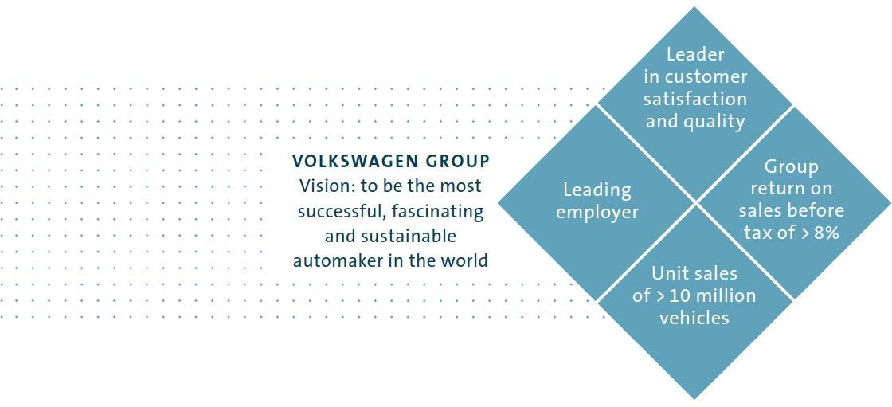
Figure: Business Strategies of Volkswagen group (Blackwelder, 2016)
Electrification Push
At the same time, VW has made a significant strategic investment in EVs, with ambitious goals like releasing 70 new EV models by 2028 and selling over 26 million EVs by 2029 (Blackwelder et al., 2016). This is a major shift in VW's strategy as it prepares for a future with zero emissions. The policy shift is in line with the PESTEL trend of governments worldwide banning the sale of new vehicles powered by internal combustion engines after 2030 (Volkswagen Newsroom, 2023). The market for VW's standard gasoline and diesel-powered vehicles is threatened by EVs, as revealed by Porter's Five Forces research.
Volkswagen plans to lead the industry in adjusting to the new technology and competitive landscape by placing itself at the forefront of EV development with large, targeted investment (Schanze, 2020). To maintain its sales volumes and market share as demand moves away from fossil fuel vehicles over the future decade, VW must adopt this first-mover strategy in EVs.

China Focus
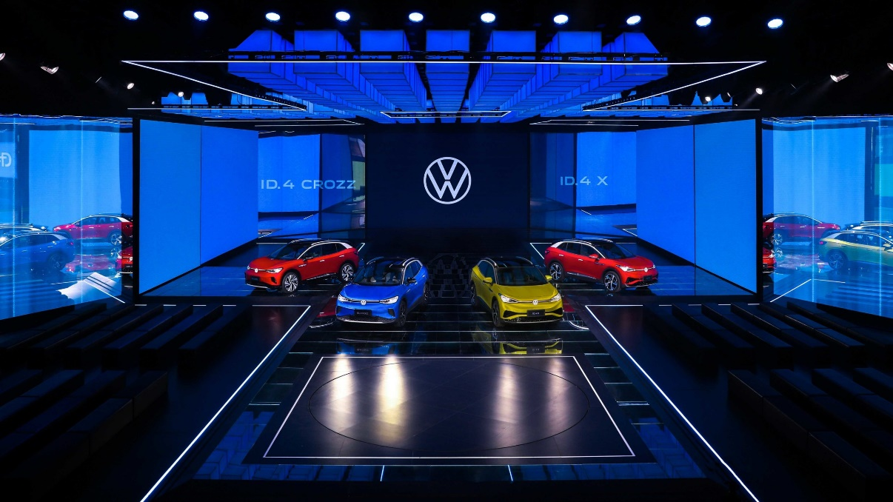
Figure: Volkswagen in China's NEV Market (Volkswagen AG, 2020)
Volkswagen has also redirected its efforts to increase its market share in China, its largest market, and the source of more than 40 percent of the company's total sales volume worldwide (Volkswagen AG, 2020). Volkswagen has strengthened its position in China by catering vehicles and features to local tastes, expanding its presence in the country through joint ventures, and buying a 50% stake in a joint venture formed with JAC (Jung and Sharon, 2019). China's rising earnings, rapid urbanisation, and government policies that encourage growth all show up as positives in a PESTEL analysis. VW's goods are differentiated in the market because of the company's commitment to localising production and product development in accordance with Porter's Five Forces. VW's dominance in China is a vital component to the company's overall success.
The combination of these expense, EV and China strategies demonstrates VW practically adapting its business model to new conditions while retaining traditional scale and manufacturing advantages. This strategic agility has been vital in bolstering VW's market position and competitiveness after the deep reputational damage from the emissions scandal.

Resources and Capabilities of Volkswagen
Over the past five years, Volkswagen (VW) has exhibited a range of resources as well as capabilities, which have supported its business approaches. Let’s analyse these resources including capabilities, considering tangible as well as intangible assets, human resources, technological capabilities, and financial properties, and analysis their alignment with VW’s present business strategies.
- Tangible Assets: VW controls a strong manufacturing setup with a huge global network of production abilities. These tangible assets incorporate advanced production plants, distribution bases, including a well-established dealer arrangement (Batista et al., 2020). This extensive infrastructure is associated with VW's global expansion approach, allowing the company to effectively produce and deliver vehicles in different markets. The physical presence and production capabilities promote VW's ability to meet customer requirements and grow its market share.
- Intangible Assets: Volkswagen's intangible asset, its brand's reputation, is important. Although the company's reputation took an initial hit during the "dieselgate" controversy, Volkswagen has since recovered (Rausch-Phan and Siegfried, 2022). The Volkswagen name is synonymous with sturdy construction and German precision. This intangible asset works in tandem with VW's product differentiation and brand positioning strategy to win over new clients and keep existing ones happy. VW has a huge competitive edge because of its well-known brand reputation.
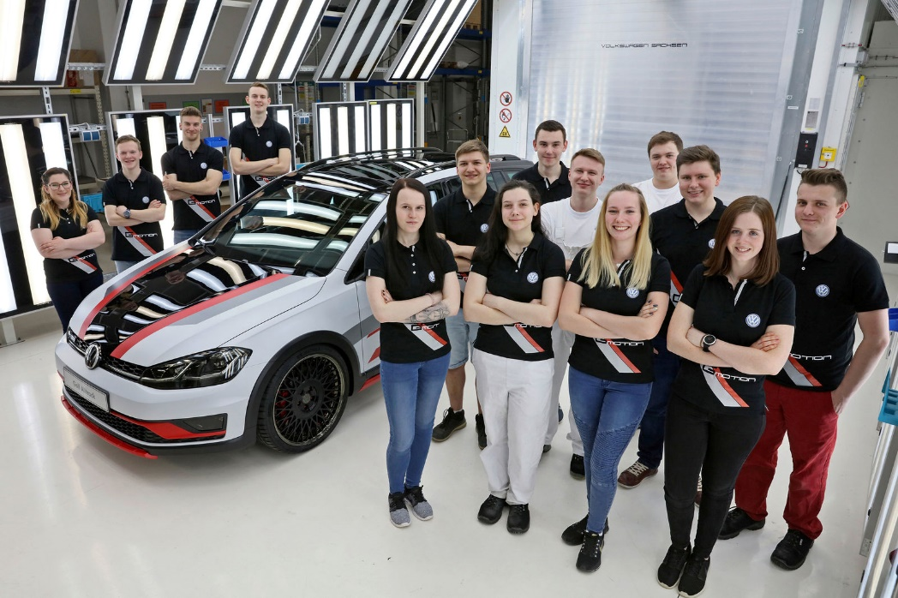
Figure: Human Resources and Organization’s, Volkswagen (Máté, 2022)
- Human Resources: Volkswagen has a talented and diversified staff of engineers, designers, and production experts. Company initiatives, such as those related to electric car development and digitalisation, are supported by the talents of the company's employees (Kompalla et al., 2017). Volkswagen can maintain its competitive edge in a sector that is changing at a breakneck pace because of the efforts of its talented workforce. Volkswagen has also implemented training and development programmes to better equip its employees with the skills they'll need to contribute to the company's strategic objectives.
- Technological Capabilities: Volkswagen has spent a lot of money on R&D to improve its technological prowess, thus it ranks well in this category. The creation of autonomous driving technologies, connected car features, and alternative fuel vehicles are all part of these endeavours. VW's technological prowess is congruent with the company's objective of providing cutting-edge products at competitive prices (Máté and Péter, 2022). The company's interest in electric vehicles, for instance, is indicative of its dedication to sustainability and is in step with the worldwide movement towards greener modes of transportation.
- Financial Resources: The financial stability of Volkswagen is a key asset that helps it implement its business plans. Volkswagen has had enough money on hand to keep running, engage in research and development, and adopt strategic initiatives despite the "dieselgate" scandal's monetary effects (Henry, 2021). This solid financial footing is in line with VW's business goals, providing the company with the resources it needs to grow, innovate, and maintain its market leadership.
Volkswagen's current business strategy is an effective fit for the company's resources and strengths. The company's global expansion strategy is backed up by its manufacturing infrastructure and distribution network (Volkswagen Newsroom, 2023). Differentiation and positioning of products benefit from the company's stellar reputation and talented team. VW can provide cutting-edge products and services in response to ever-shifting consumer preferences because of its technological prowess (Máté, 2022). Strategic ventures need reliable financial backing to keep going, even in the face of adversity. However, it is critical to recognise that VW's reputation and financial resources were temporarily impacted by the "dieselgate" affair. The corporation has invested in sustainability programmes and compensated affected customers, but the effect on resources and capabilities cannot be ignored.
By supporting its electric vehicle portfolio, investing in cutting-edge technology and digitalisation, and testing out novel business models like mobility services and connected car platforms, Volkswagen (VW) can better match its resources and skills with its strategic goals. In addition, consistent funding for staff training and development programmes would equip workers with the know-how to effectively support VW's strategic goals. Volkswagen can maintain its competitive edge in the automotive sector by making the most of its current assets while also investing heavily in future-oriented projects, such as the development of greener vehicles and better transportation infrastructure.

Volkswagen's Competitive Approach to Sustainability and the Environment
Volkswagen (VW) has made substantial progress towards improving competitiveness while giving top priority to sustainability as well as environmental responsibility. The purpose of this assessment is to analyse the results of the "dieselgate" scandal on Volkswagen's competitiveness by analysing the company's sustainability efforts, initiatives, as well as changes.
Sustainability Efforts and Initiatives:
- Electric Vehicle Focus: Volkswagen's sustainability strategy relies heavily on the widespread adoption of electric vehicles (EVs). The ID.3 and ID.4 EVs are the result of the company's heavy investment in EV research and development (Claudy et al., 2016). Volkswagen's focus on EVs is part of a larger strategy to lessen the transportation sector's carbon footprint and reliance on nonrenewable fuels.
- Renewable Energy Integration: Volkswagen has promised to use renewable energy in its facilities. To lessen its carbon footprint, the company has put money into wind and solar power projects to supply its factories with electricity (Schanze, 2020). VW's dedication to sustainable practises is demonstrated here by this initiative to reduce the company's carbon footprint.
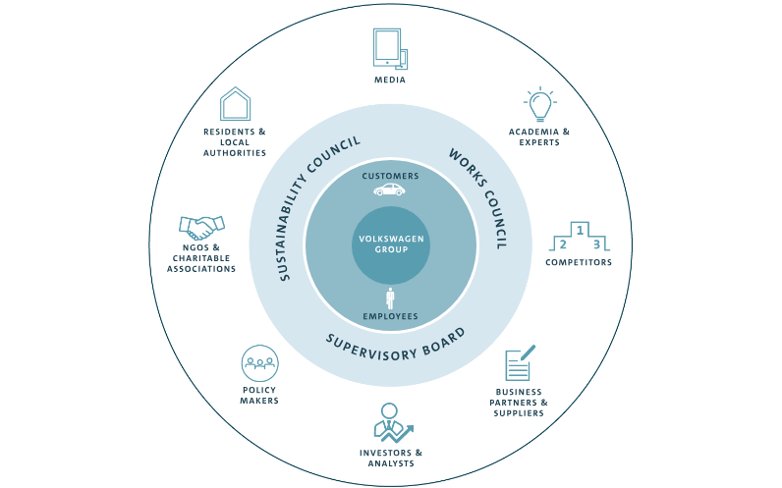
Figure: Sustainability-Volkswagen Group (Máté and Péter, 2022).

- Circular Economy Implementation: Volkswagen uses the principles of the circular economy to get the most out of its materials and produce as little waste as possible. The organisation has recycling programmes in place, actively recovering materials from retired vehicles and reusing them in production (Jung and Sharon, 2019). This method reduces the damage done to the environment by the mining of raw materials and conserves as many useful materials as possible.
Changes in Response to the "Dieselgate" Scandal:
As a result of the "dieselgate" scandal, in which Volkswagen was found to have cheated on emissions tests, the company had to reevaluate its approach to environmental responsibility. To restore consumer confidence and strengthen the company's position in the market, Volkswagen made several adjustments.
- Shift Towards Electric Vehicles: As a result of the scandal, Volkswagen has put more emphasis on producing electric vehicles. Accelerated development as well as investment in EV technology resulted from the company's recognition of EVs' potential as a more sustainable and emission-free substitute and a way to rebuild customer trust and loyalty (Majláth, 2016). This change proved VW's dedication to eco-friendly transportation and helped the company win back customers' trust.
- Strengthened Compliance and Governance: To prevent future ethical and environmental violations, VW instituted stronger compliance and governance precautions. To better prioritise environmental responsibility and sustainable practises, the company has a new CEO and oversight committees (Kompalla et al., 2017). This reorganisation was made so that VW could better achieve its sustainability goals and win back the trust of its various constituencies.
- Increased Transparency and Accountability: Volkswagen aimed to increase openness and responsibility by instituting extensive systems for reporting on environmental as well as social impacts (Beske et al., 2009).. The company actively provides its progress and goals in sustainability reports and uses sustainability reporting structures such as the Global Reporting Initiative (GRI). This newly acquired openness strengthens VW's credibility and gives stakeholders a deeper understanding of the company's sustainability initiatives.
Impact on Competitive Position:
VW's competitive position has been significantly impacted by the company's sustainability attempts and changes as a result to the "dieselgate" scandal:
- Enhanced Brand Reputation: VW has improved its image as a sustainable, environmentally responsible company by shifting its focus to electric vehicles, incorporating renewable energy, and adopting circular economy principles (Máté and Péter, 2022). Consumers looking for greener products have responded positively to these initiatives, giving VW an edge over its slower-to-change competitors.
- Increased Customer Appeal: Volkswagen's (VW's) dedication to environmental protection has increased the popularity of its electric vehicle (EV) lineup among eco-conscious shoppers (Beukes and Van Wyk, 2016). The company's commitment to renewable energy and circular economy practises is a major selling point. VW's competitiveness is bolstered by the increased customer appeal, which leads to gains in market share and customer loyalty.
- Mitigation of Financial Risks: Volkswagen's strategy of prioritising sustainability reduces financial risks during its shift to a low-carbon future (Beukes and Van Wyk, 2016). The company is setting itself up to take advantage of shifting market demands and to prevent penalties or financial losses due to noncompliance with regulations focused on reducing vehicle emissions by pursuing electric vehicles as well as renewable energy.
- Market Differentiation: Volkswagen can set itself apart from rivals in the industry because of its sustainable initiatives, which demonstrate the company's dedication to resolving environmental issues (Kompalla et al., 2017). VW's competitive position is bolstered by these distinctions, allowing the company to more effectively market to consumers who value sustainability in their transportation choices.
Volkswagen's leadership in environmental and sustainability initiatives has helped the company gain market share. Volkswagen has made significant progress towards sustainability while remaining competitive through initiatives like a greater emphasis on electric vehicles, the incorporation of renewable energy, and the adoption of circular economy principles (Yang et al., 2013). The "dieselgate" scandal prompted several changes at Volkswagen, including an emphasis on electric vehicles (EVs), increased compliance and governance, and greater transparency, all of which have strengthened VW's sustainability efforts and bolstered the company's competitive advantage. All these efforts have helped increase VW's image and customer base, reduced the company's exposure to financial risk, and established VW as an industry pioneer in eco-friendly transportation.

Recommendations for Future Sustainability Practices
To support its competitive rank going forward, Volkswagen should:
- Accelerate EV acceptance beyond targets by distributing more models quicker, offering variable pricing/financing, customization options as well as forming strategic associations (Volkswagen Newsroom, 2023). Being first-to-scale in EVs can offer advantages as the market conversions from ICE vehicles.
- Undertake closed loop trade by highly reusing components, remanufacturing, including recycling. This decreases input costs as well as ecological impact. It is made on VW's large-scale manufacturing facilities.
- Develop place sustainable vehicle modes shaped for customer segments determined on eco-friendly mobility. VW's design as well as development strengths can be leveraged to make unique green models.
- Obtain sustainability official recognition through the complete value chain to enable reliable signaling of upgrades made since the diesel disgrace. Independent justification of progress can further recover VW's reputation.
- Apply carbon offset programs throughout vehicle purchases to increase appeal among climate-concerned consumers (Volkswagen Newsroom, 2023). Offsets enable consumers to directly focus on the emissions effect of their vehicles.
- Report broadly on sustainability KPIs correlated to carbon, energy, water usage, waste generation as well as other metrics. Clarity and accountability will prove the intensity of VW's commitment as well as rebuild public trust.
By determinedly pursuing these sustainability approaches, Volkswagen can continue increasing its competitive position in position of differentiation, costs, reputation, as well as risk management. Sustainability can develop an entire pillar of long-term competitive advantage.

Conclusion
This report analyses Volkswagen's post-diesel emissions scandal business strategies, resources, capabilities, and sustainability initiatives. According to the findings, VW is making sustainability a priority in its quest to regain its competitive edge and market leadership. Key suggestions centred on quickening the pace of electric vehicles, closed-loop production, specialised green business models, sustainability accreditations, carbon offsetting, and thorough reporting. If these projects are implemented well, VW will be even better able to incorporate sustainability into its culture and business practises. Transforming such a large automaker quickly enough to keep up with regulatory and market shifts is difficult, though. Volkswagen may be able to recover from past reputational damage by focusing relentlessly on sustainability.

References
Batista, P., de Oliveira, O.V. and de Lima, F.A., 2020. Organizational and Institutional Factors that Intensify the Use of Greenwashing by the World’s Major Car Manufacturers. Journal of Marketing Management, 8(2), pp.37-46.
Beske, P., Koplin, J. and Seuring, S., 2009. The use of environmental and social standards by German first‐tier suppliers of the Volkswagen AG. Corporate social responsibility and environmental management, 15(2), pp.63-75.
Beukes, C. and Van Wyk, G., 2016. An investigation of the marketing performance measurement practices in Hatfield Volkswagen group. African Journal of Business Management, 10(6), pp.131-139.
Blackwelder, B., Coleman, K., Colunga-Santoyo, S., Harrison, J.S. and Wozniak, D., 2016. The volkswagen scandal.
Claudy, M.C., Peterson, M. and Pagell, M., 2016. The roles of sustainability orientation and market knowledge competence in new product development success. Journal of Product Innovation Management, 33, pp.72-85.
Henry, A., 2021. Understanding strategic management. Oxford University Press.
Jung, J.C. and Sharon, E., 2019. The Volkswagen emissions scandal and its aftermath. Global business and organizational excellence, 38(4), pp.6-15.
Kompalla, A., Geldmacher, W., Just, V. and Lange, S., 2017. Tailored automotive business strategies in the context of digitalization and service-oriented models. Calitatea, 18(156), p.77.
Majláth, M., 2016. How does greenwashing affect the firm, the industry and the society-The case of the VW emission scandal. Proceedings of Fikusz 2016, 111.
Máté, G.B. and Péter, F., 2022. Volkswagen Group marketing, economic and financial analysation. In Proceedings of FIKUSZ Symposium for Young Researchers (pp. 603-621). Óbuda University Keleti Károly Faculty of Economics.
Ovidijus Jurevicius (2021). Volkswagen SWOT Analysis 2023 - SM Insight. [online] Strategic Management Insight. Available at: https://strategicmanagementinsight.com/swot-analyses/volkswagen-swot-analysis/
Rausch-Phan, M.T. and Siegfried, P., 2022. Green supply chain management. In Sustainable Supply Chain Management: Learning from the German Automotive Industry (pp. 47-90). Cham: Springer International Publishing.
Schanze, C. and Volkswagen, A.G., 2020. Future of CAN from the prospective of an OEM. In 17th CAN in Automation Conference, ICC.
Volkswagen Newsroom. (2023). Strategy. [online] Available at: https://www.volkswagen-newsroom.com/en/strategy-3912
Yang, N., Colvin, C. and Wong, Y.Y., 2013. Navigating corporate social responsibility components and strategic options: The IHR perspective. Academy of Strategic Management Journal, 12(1), p.39.
‌

Appendix
SWOT Analysis
Strengths | Weaknesses
- Global manufacturing setup | - Reputational harm from the "dieselgate" scandal
- Strong brand status | - Legal effects and settlements
- Proficient workforce | - Dependency on traditional ignition engine vehicles
-Technological advancements (Ovidijus Jurevicius, 2021) | - Reasonably late entry into the electric automobile market

Opportunities | Threats
- Expanding market for electric vehicles | - Extreme competition from other car manufacturer in the EV market
- Increasing consumer demand for sustainable mobility | - Stringent emissions as well as regulatory standards
- Possibility for partnerships and collaborations in the EV market | - Rapid technological developments in the automotive industry (Ovidijus Jurevicius, 2021).
- Favorable government policies as well as incentives for EV adoption | - Shifting consumer preferences as well as demand for alternative mobility results

PESTLE Analysis
Category | Factors
Political | - Strict emissions regulations and specifications
 | - Legal effects and litigation
Economic | - Market pressure for electric vehicles
 | - Financial effect of settlements
Sociocultural | - Consumer consciousness of environmental issues
 | - Effect on consumer trust
Technological | - Improvements in electric vehicle technology
 | - Advancement in emission reduction technology
Legal | - Emissions and protection regulations
 | - Litigation and legal settlements
Environmental | - Attention on sustainability
 | - Environmental impact of emissions

