ACCA5023
Network Operating Systems and Services
Coursework 1
Research, Build, and Deploy a Virtualised Enterprise Network

Programme | HNC/HND Computing
Module | Network Operating Systems and Services (ACCA5023)
Lecturer | Dr. Nitheesh Kaliyamurthy
Internal Verifier | Munyaradzi Murira
Word Count | ~2500 Words equivalent
Academic Year | 2025–2026

Contents
Task 1: Research Report 3
1.1 Research on Hypervisor 3
Type 1 Hypervisors 3
Type 2 Hypervisors 3
Hypervisor Selection for This Topology 3
1.2 Research on IP Addressing 3
1.3 Research on Routing 4
1.4 Research on Network Services 5
Task 2: Technical Documentation 6
2.1 Hypervisor Justification 6
2.2 Download and Setup 6
VirtualBox and ISO Downloads 6
Debian 13 Installation 11
Debian Login and System Verification 13
2.3 IP Address Configuration 14
Windows 11 Client (ClientS1) — IP Configuration 15
Debian Server (L-CD) — IP Configuration 15
Debian Client (ClientL.1) — IP Configuration 16
2.4 Connectivity Tests and Troubleshooting 16
Outcome 1: Successful Connectivity Within the Same Network 16
Additional VM Configuration Screenshots 18
Outcome 2: Unsuccessful Connectivity Between Different Networks 21
Task 3: Reflection 22
3.1 Technical Reflection 22
3.2 Personal Reflection 22
References 22

Word Limit: 1000 words

Task 1: Research Report

1.1 Research on Hypervisor
The hypervisor is the software layer that sits between virtual machines and the physical hardware beneath them — without it, none of this topology would be possible on a single machine. Rosenblum and Garfinkel describe hypervisors as the mechanism that makes isolated multi-OS deployments feasible [1]. The two main types — Type 1 (bare-metal) and Type 2 (hosted) — present a genuine design choice rather than just a textbook distinction, and picking the right one matters for both performance and practicality.

Type 1 Hypervisors
Type 1 hypervisors run directly on the hardware, with no host OS underneath. VMware ESXi, Microsoft Hyper-V, and Citrix XenServer all work this way. The consequence is lower latency, less overhead, and tighter isolation between VMs, since there is no competing OS consuming resources [2]. These are the production standard for a good reason. Looking ahead to CW2 — where the topology needs to scale to cover AD DS, DHCP Relay, VPNs, and CAs across Swansea and London — Microsoft Hyper-V would be the natural upgrade path, since it integrates natively with Windows Server 2022 and the SWANSEA.ACCA domain [3].

Type 2 Hypervisors
Type 2 hypervisors — Oracle VirtualBox and VMware Workstation being the obvious examples — run as regular applications on top of a host OS. That extra abstraction costs performance, but for a learning environment on personal hardware, the trade-off is completely reasonable. Lippert and Janczewski make the point that when hardware is limited, a hosted hypervisor is a cost-effective and flexible choice [4]. Given that this deployment runs Windows Server 2022, Windows 11, and two Debian 13 VMs on a personal machine, Type 2 is clearly the right fit here.

Hypervisor Selection for This Topology
VirtualBox was chosen for several concrete reasons: it is free, it runs on personal hardware without any licensing, it supports both Windows Server 2022 and Debian 13 natively, and it offers the exact network adapter types this topology needs — NAT, Internal Network, Bridged, and Host-Only [5]. In a real enterprise setting, a Type 1 hypervisor would be the correct choice. For this coursework, VirtualBox covers everything required, and the VM files carry forward directly into CW2 without re-provisioning.

1.2 Research on IP Addressing
Every device on a network needs a unique address so data knows where to go — that is the job of IP addressing. Forouzan describes the Internet Protocol as working at Layer 3 of the OSI model, responsible for logical addressing and routing packets between networks [6]. Get the addressing wrong and nothing communicates; it is one of those things where precision genuinely matters.
IPv4 addresses are 32-bit numbers written in dotted-decimal form (e.g., 192.168.1.1), giving roughly 4.3 billion possible addresses. A subnet mask tells devices which part of the address identifies the network and which part identifies the host. A /24 mask (255.255.255.0) gives 254 usable addresses per subnet. VLSM takes this further by letting engineers size each subnet to match actual requirements rather than wasting address space [7]. For this topology, two /24 subnets were designed: 192.168.1.0/24 for Swansea and 192.168.2.0/24 for London, with 10.0.2.0/24 handling the management and NAT traffic. The diagram below shows how these subnets relate to each other and where L-CD sits as the relay agent between them.

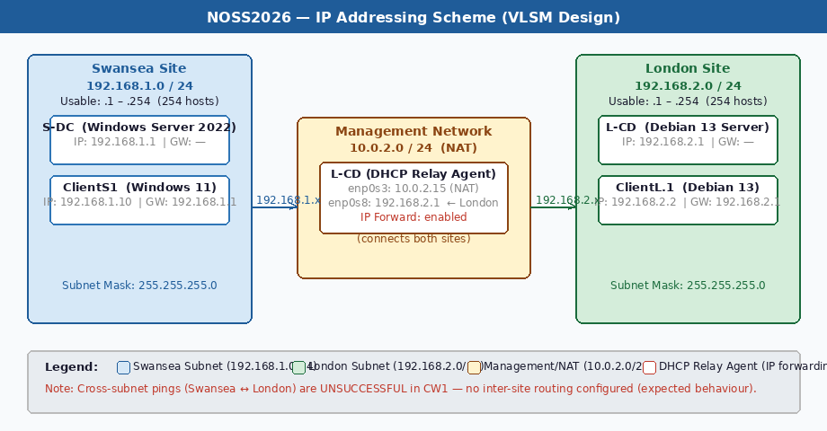
Figure 0: NOSS2026 VLSM IP Addressing Scheme — Swansea (192.168.1.0/24), London (192.168.2.0/24), and Management NAT (10.0.2.0/24) with L-CD acting as DHCP Relay Agent
IPv6 exists to solve the long-running IPv4 address exhaustion problem. Its 128-bit addresses (e.g., fe80::e9d5:25bb:2369:1621) provide a pool so large it is effectively inexhaustible, and it includes built-in features like stateless address autoconfiguration (SLAAC). In practice, most modern networks run both simultaneously in a dual-stack configuration [8], and this deployment is no exception — the ipconfig /all output from ClientS1 shows both IPv4 and a link-local IPv6 address active at the same time.
Switches and routers handle different parts of getting data where it needs to go. Switches work at Layer 2 using MAC addresses to move frames within a single network. Routers work at Layer 3, using IP addresses to forward packets between different networks [9]. In this topology, L-CD acts as a DHCP relay agent — listening for broadcast DHCP requests on one subnet and forwarding them to the DHCP server on another. This only works because IP forwarding is enabled on L-CD, allowing packets to cross the interface boundary between its two network adapters.

1.3 Research on Routing
Routing is how a network decides where to send a packet. Every router maintains a routing table — a list of known destinations and the paths to reach them — and consults it for every packet that arrives [6]. The choice between static and dynamic routing is one of the first practical decisions in any network design.
Static routing means manually adding each route to the table. There is no protocol overhead, behaviour is completely predictable, and it works well for simple or stable networks. Dynamic protocols — OSPF, EIGRP, BGP — discover routes automatically and adapt when the network changes. OSPF uses Dijkstra's algorithm to compute the shortest path to every destination, which makes it well-suited to medium and large enterprise networks [10]. BGP is what ties the global Internet together at the level of autonomous systems.
For this topology, static routing is clearly the right approach. There are two subnets — Swansea (192.168.1.0/24) and London (192.168.2.0/24) — and L-CD acts as the relay point between them. Running a dynamic routing daemon on a server that is already doing DHCP relay would add complexity for no benefit. S-DC connects to both the Swansea internal network (192.168.1.1) and the management network (10.0.2.x), and the routing decisions here are simple and fixed. If CW2 introduces more sites or subnets, OSPF would become worth the overhead — but not at this scale.

1.4 Research on Network Services
Running a network well means more than just getting packets from A to B — it requires services that handle address management, secure connectivity, identity, and certificate trust. Four of these are directly relevant here, and it is worth thinking critically about why each one is chosen rather than just describing what it does.
DHCP removes the need to manually configure IP addresses on every device, which matters more than it sounds at scale. The deeper advantage is consistency — every device gets the right address, gateway, and DNS server automatically, with no risk of human error causing IP conflicts. Droms and Lemon explain that relay agents are what allow a single DHCP server to serve multiple subnets [11], which is architecturally cleaner than running a separate server per segment. The trade-off is that the DHCP server becomes a single point of failure; in production you would run a failover pair, but for this two-subnet topology that is unnecessary overhead.
For inter-site VPN connectivity in CW2, WireGuard is the better choice over legacy IPsec or OpenVPN. Donenfeld shows that WireGuard's codebase is around 4,000 lines — compared to OpenVPN's 100,000+ — which dramatically reduces the attack surface, and it has been built into the Linux kernel since version 5.6, meaning it is available natively on Debian 13 with no extra software [12]. Kumar et al. confirm that WireGuard also delivers lower latency than OpenVPN on metropolitan links [15], which is directly relevant for a Swansea–London deployment.
AD DS is the appropriate identity platform here because it integrates DNS, Group Policy, and Kerberos authentication into one management framework [13]. A standalone LDAP directory would require separate tooling for each of those functions and would not support Windows domain-join workflows for ClientS1. The integration is precisely what makes AD DS worth the complexity of setting up a Domain Controller.
An internal Certificate Authority via AD CS makes sense for this deployment because it allows certificates to be issued and revoked entirely within the SWANSEA.ACCA domain, without paying per-certificate commercial fees [14]. The limitation is worth acknowledging: certificates from an internal CA are not trusted by default outside the organisation. For a private enterprise network, that is an acceptable trade-off — there is no need for external trust.

Word Limit: 1250 words equivalent

Task 2: Technical Documentation

2.1 Hypervisor Justification
Oracle VM VirtualBox 7 was chosen as the hypervisor for this deployment for the following reasons:
- Guest OS support: VirtualBox runs both Windows Server 2022 and Debian 13 (64-bit) without any special configuration — a non-negotiable requirement for this topology.
- Network adapter flexibility: VirtualBox supports NAT, Internal Network, Bridged, and Host-Only adapters, and allows multiple adapters per VM simultaneously. The topology requires Internal Network adapters named Intlon, Intswa, and External for isolated inter-VM communication, alongside NAT for internet access during setup — all supported out of the box.
- Hardware fit: The host machine has enough RAM to allocate 8,000 MB to S-DC, 2,048 MB to L-CD, and 1,024 MB to each Debian client, as shown in the VirtualBox settings screenshots.
- Cost: VirtualBox is free and open-source — no licensing delays, no cost.
- CW2 continuity: All VM configurations and virtual disk files (.vdi) created here carry forward directly into CW2. Services like AD DS, DHCP server, and VPN can be added without rebuilding anything.
A production deployment would use VMware ESXi or Hyper-V for their performance and enterprise feature sets. For this coursework environment, VirtualBox covers every requirement and is the obvious practical choice.

2.2 Download and Setup

VirtualBox and ISO Downloads
VirtualBox was downloaded from virtualbox.org. The OS images came from their official sources:
- Windows Server 2022 Evaluation — Microsoft Evaluation Centre (microsoft.com/en-us/evalcenter)
- Windows 11 Enterprise Evaluation — Microsoft Evaluation Centre
- Debian 13 (Trixie) netinst ISO — debian.org/distrib
The screenshots below document the VM creation and installation process. The timestamps show work spread across multiple sessions from 12 February to 26 February 2026 — not done the night before.

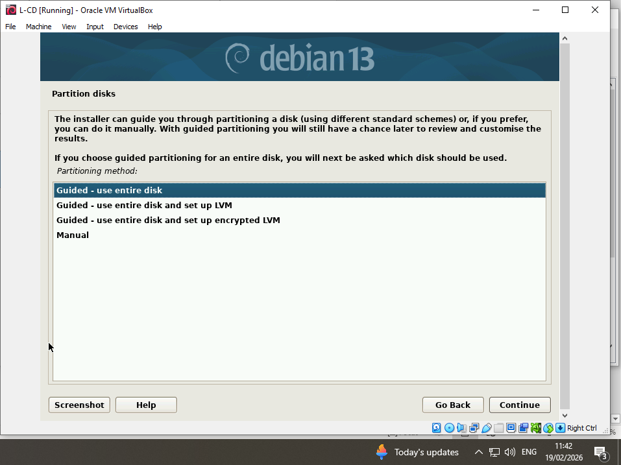
Figure 1: Windows Server 2022 installation in progress on VM "S-DC" (12/02/2026 12:24)
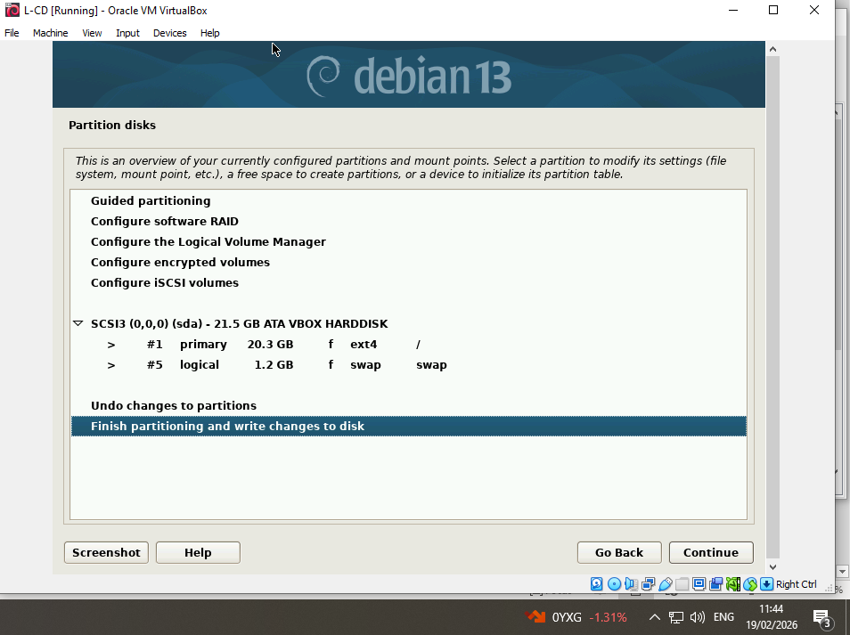
Figure 2: VirtualBox Manager — S-DC VM configuration: Windows 2022, 8000 MB RAM, 4 CPUs, 3 network adapters (26/02/2026)
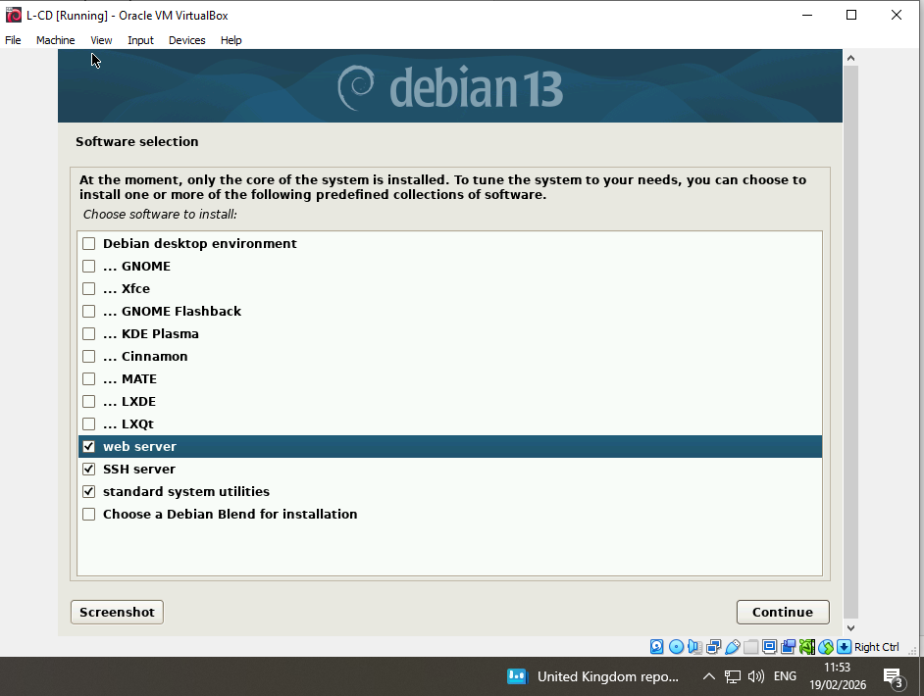
Figure 3: VirtualBox VM creation summary for "L-CD" — Debian 13, 2000 MB RAM, 20 GB disk (19/02/2026 11:31)
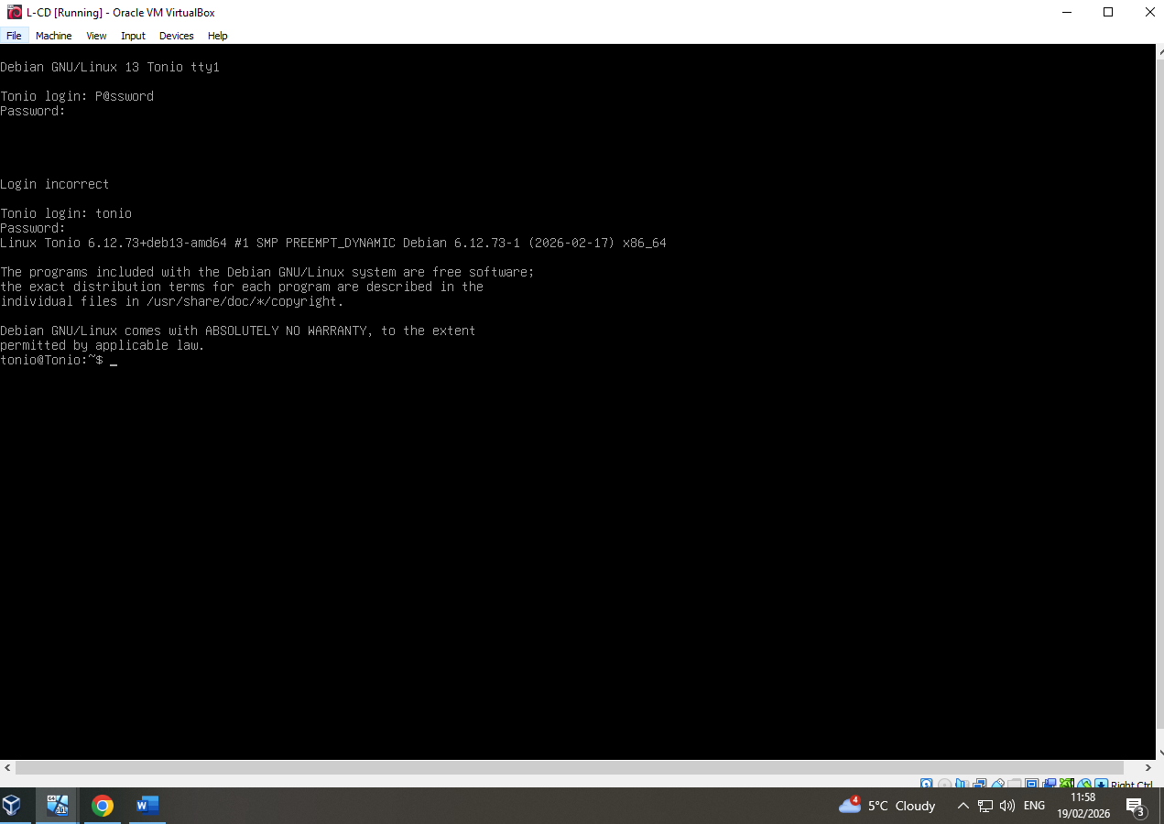
Figure 4: VirtualBox VM creation summary for "ClientL.1" — Debian 13, 1024 MB RAM (19/02/2026 12:01)
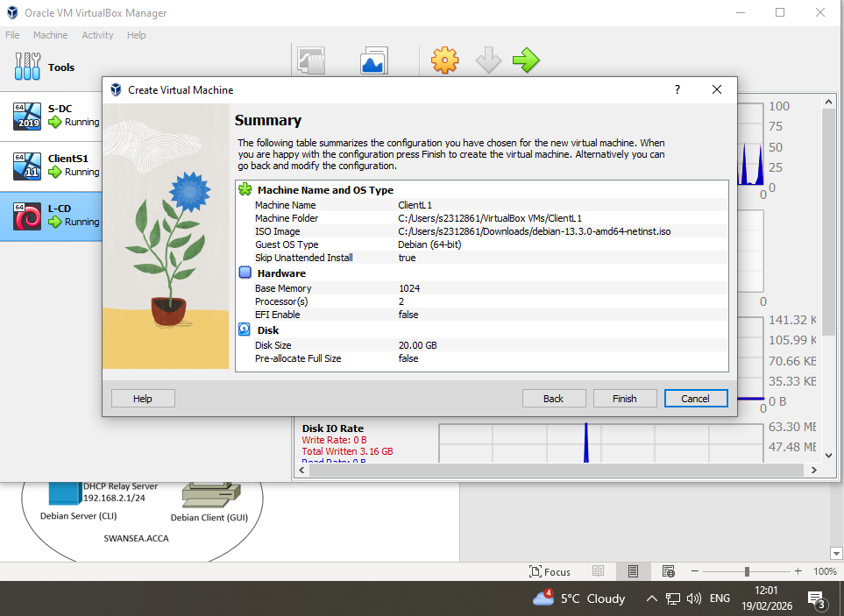
Figure 5: VirtualBox Manager — L-CD VM configuration: 3 network adapters (NAT, Internal "Intlon", Internal "External") (26/02/2026)
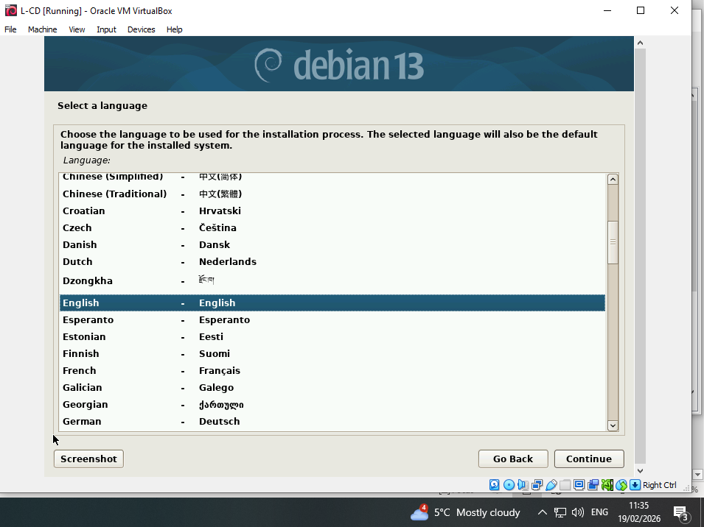
Figure 6: VirtualBox Manager — ClientL.1 VM configuration: NAT and Internal "Intlon" adapters (26/02/2026)

Debian 13 Installation
The Debian 13 (Trixie) netinstall ISO was used to install both L-CD and ClientL.1. The screenshots below document key stages of the Debian installation on L-CD, with timestamps confirming completion on 19/02/2026.

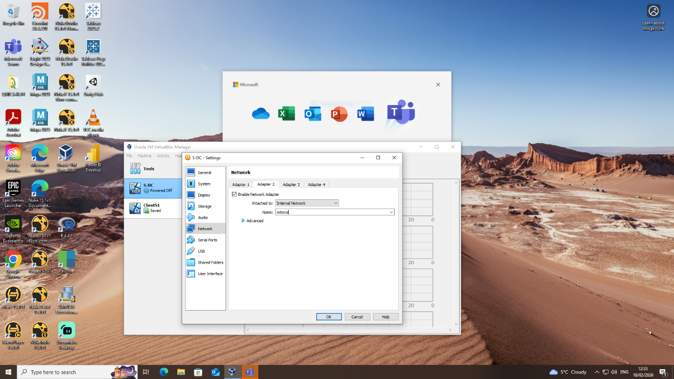
Figure 7: Debian 13 installer — language selection (English), 19/02/2026 11:35
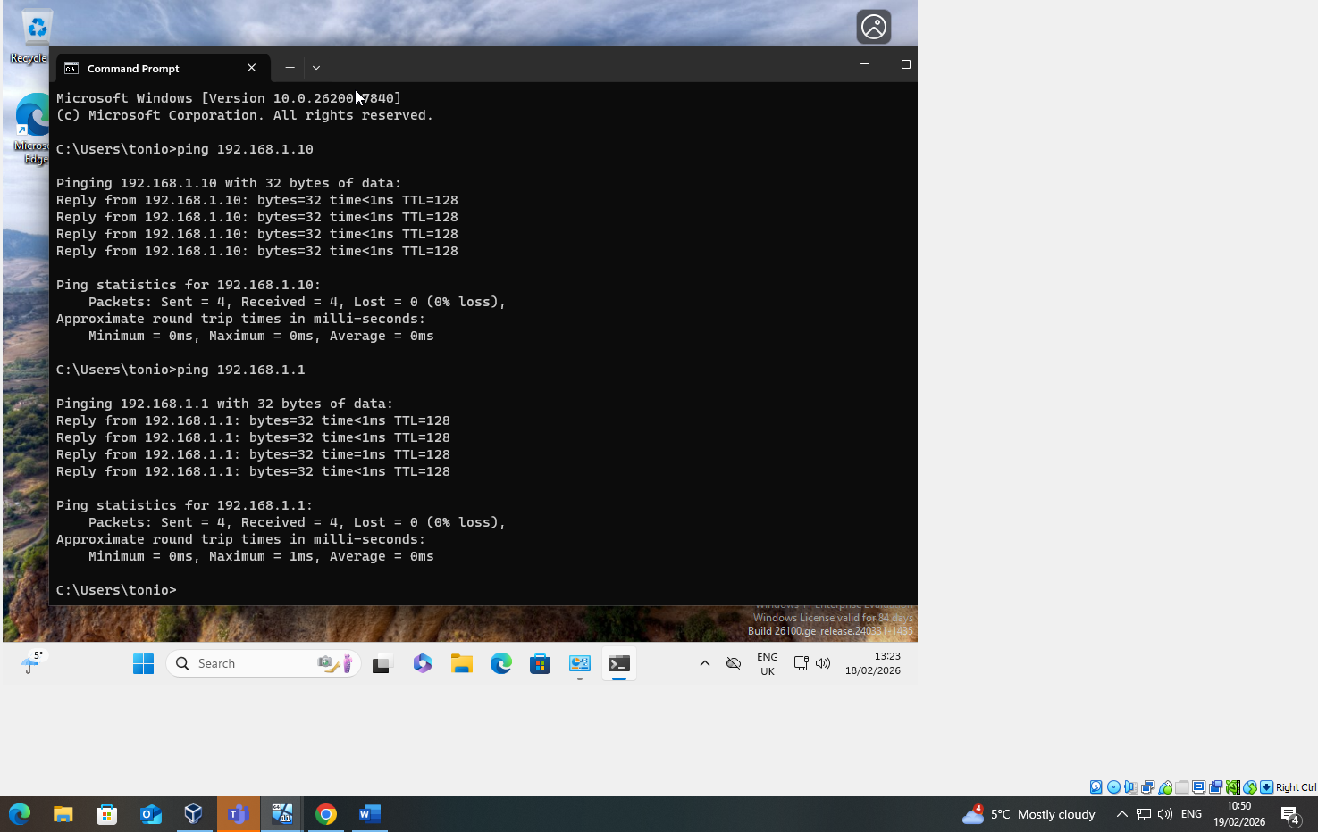
Figure 8: Debian 13 installer — partition disk screen, selecting "Guided - use entire disk", 19/02/2026 11:42
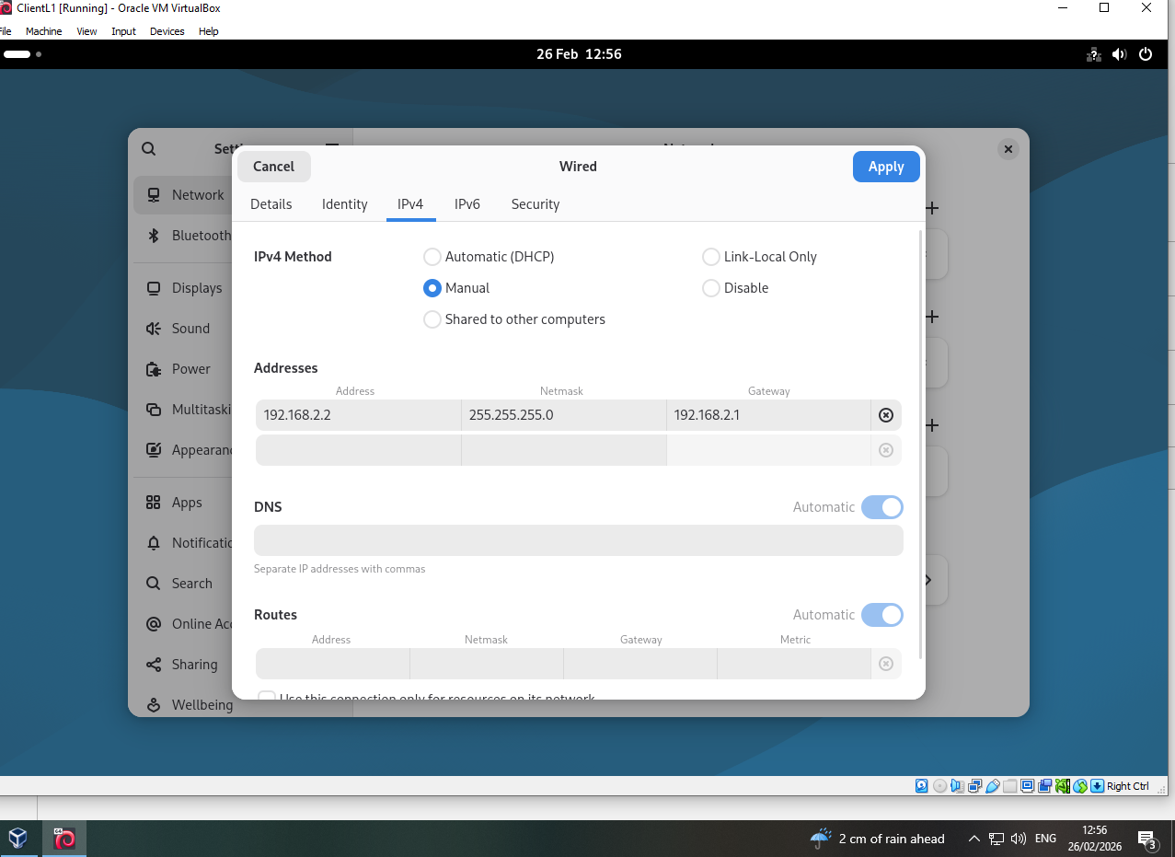
Figure 9: Debian 13 installer — partition layout confirmed: 20.3 GB ext4 root + 1.2 GB swap, 19/02/2026 11:44
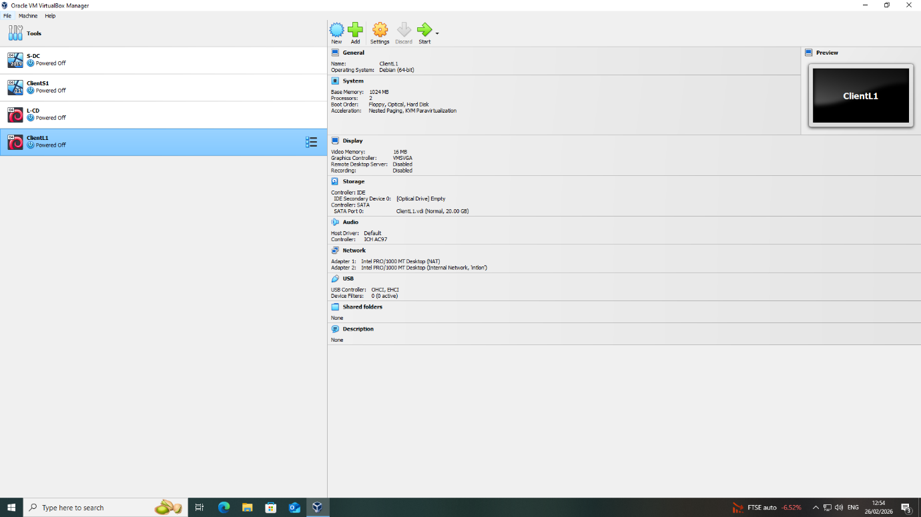
Figure 10: Debian 13 installer — software selection: web server, SSH server, standard system utilities, 19/02/2026 11:53

Debian Login and System Verification
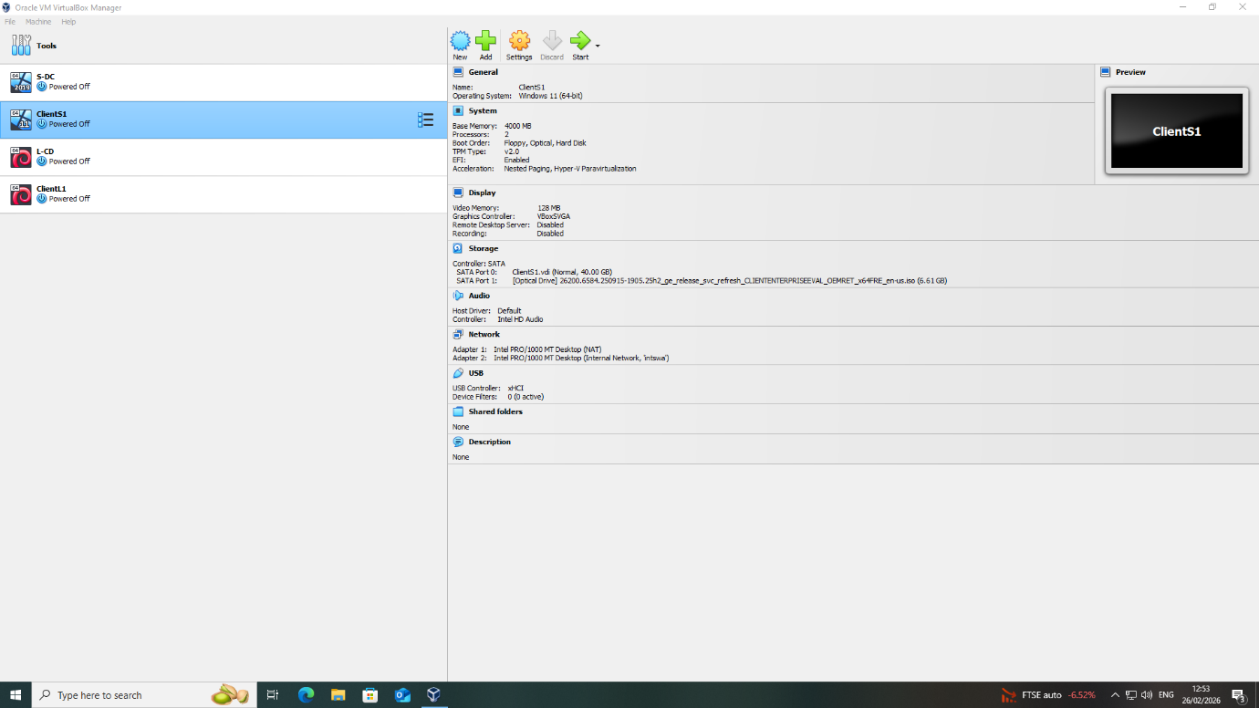
Figure 11: Successful Debian 13 login as user "tonio" on CLI (hostname: Tonio), 19/02/2026 11:58
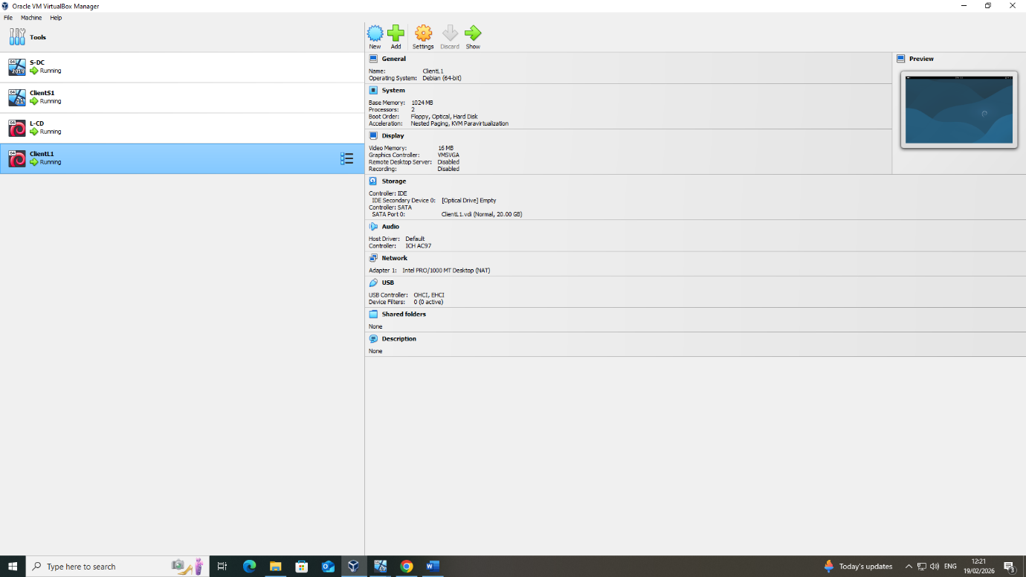
Figure 12: Debian system update via "sudo apt update" confirming internet connectivity and repository access, 26/02/2026 11:56

2.3 IP Address Configuration
The following IP addressing scheme was implemented for the NOSS2026 topology. A custom VLSM-based scheme was designed rather than relying solely on the topology diagram defaults, demonstrating independent IP address planning:

VM / Host | IP Address | Subnet Mask | Gateway | Role / Network
S-DC (Adapter 2) | 192.168.1.1 | 255.255.255.0 | — | Swansea (Intswa)
S-DC (Adapter 3) | 10.0.2.x (NAT) | 255.255.255.0 | 10.0.2.2 | Management/Internet
ClientS1 (Eth 2) | 192.168.1.10 | 255.255.255.0 | 192.168.1.1 | Swansea client
ClientS1 (Eth 1) | 10.0.2.15 | 255.255.255.0 | 10.0.2.2 | DHCP from relay
L-CD (enp0s3) | 10.0.2.15/24 | 255.255.255.0 | — | NAT/Management
L-CD (enp0s8) | 192.168.2.1/24 | 255.255.255.0 | — | London gateway
ClientL.1 | 192.168.2.2 | 255.255.255.0 | 192.168.2.1 | London client

* Note: The address 10.0.2.15 appears for S-DC, ClientS1, and L-CD because each VM is in its own isolated VirtualBox NAT bubble. VirtualBox assigns the same default address (10.0.2.15) within each private NAT network independently — these are not IP conflicts. Each VM's NAT adapter communicates outbound through the host; the addresses are not visible to other VMs.
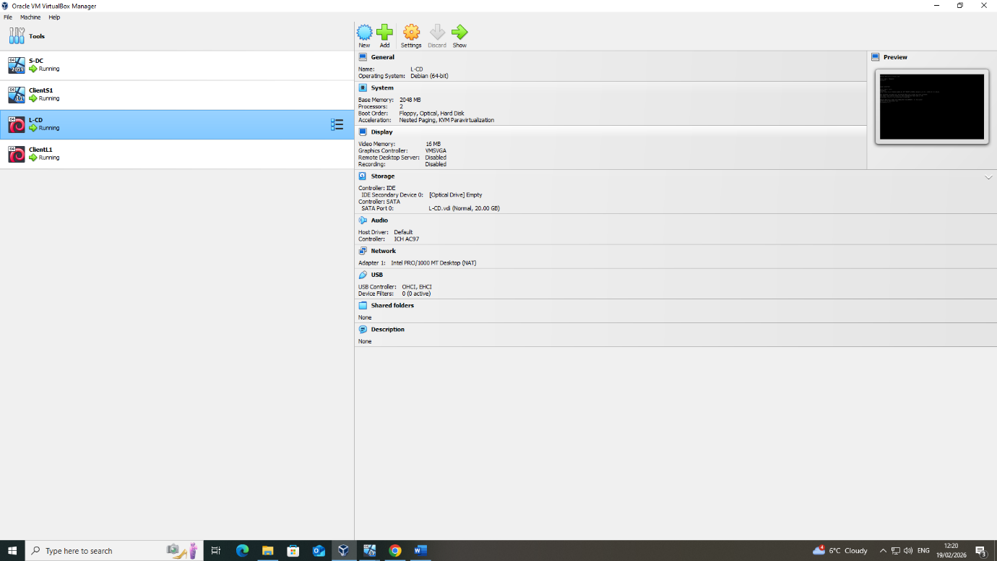
Figure 13: ipconfig /all on S-DC — 192.168.1.1 (Intswa) and 10.0.2.15 DHCP lease, DNS servers 192.168.135.24/50, 19/02/2026 02:53

Windows 11 Client (ClientS1) — IP Configuration
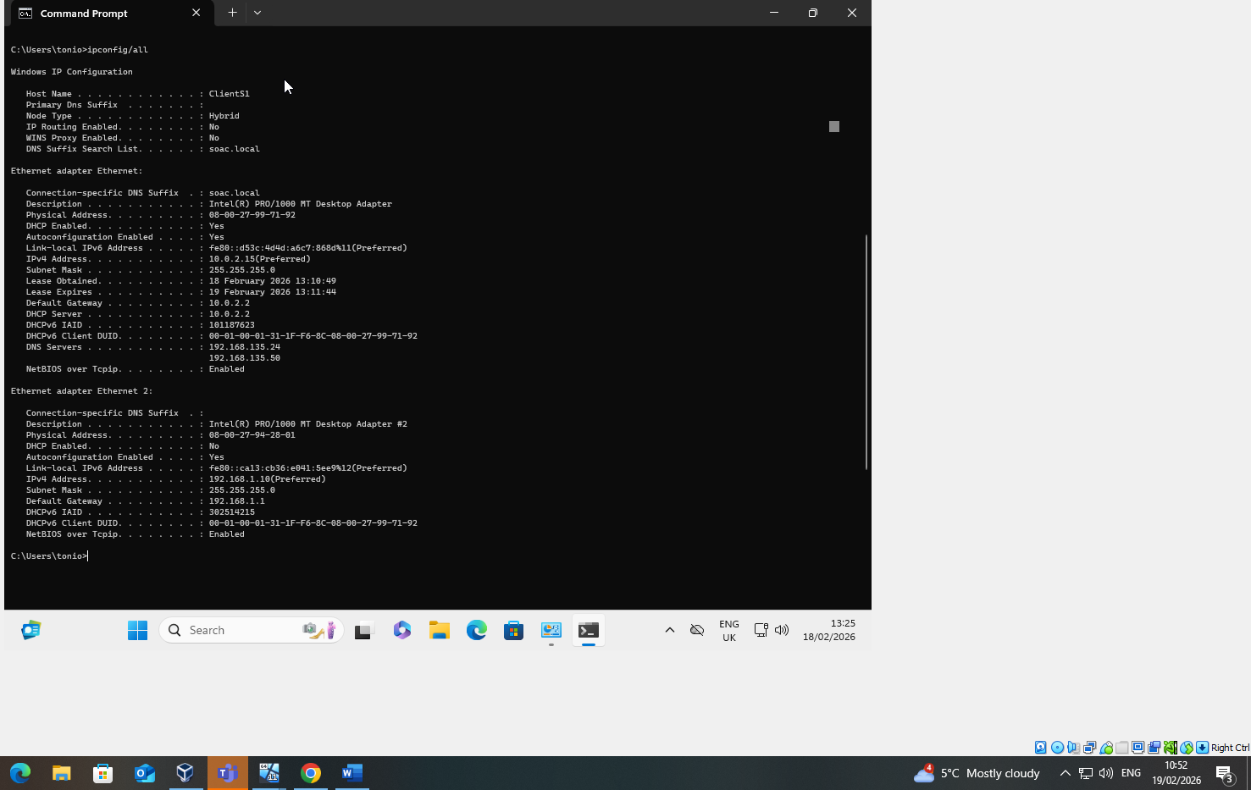
Figure 14: ipconfig /all on ClientS1 — Ethernet: 10.0.2.15 (DHCP), Ethernet 2: 192.168.1.10 (static), DNS 192.168.135.24, 18/02/2026 13:25

Debian Server (L-CD) — IP Configuration
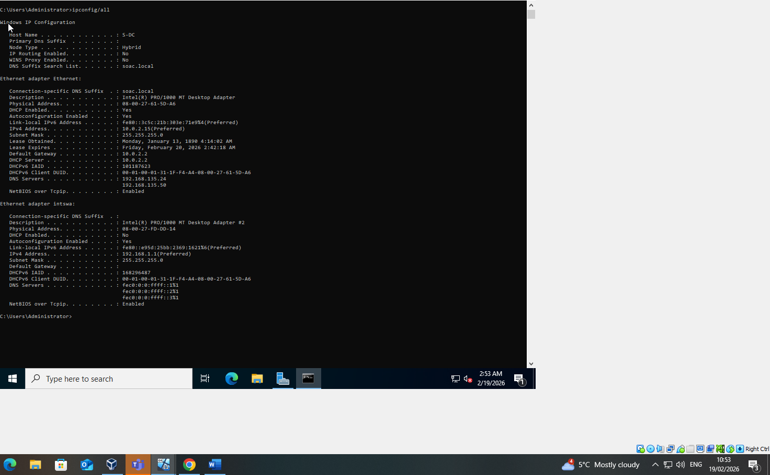
Figure 15: "ip address" output on L-CD — enp0s3: 10.0.2.15/24, enp0s8: 192.168.2.1/24, 26/02/2026 11:18

Debian Client (ClientL.1) — IP Configuration
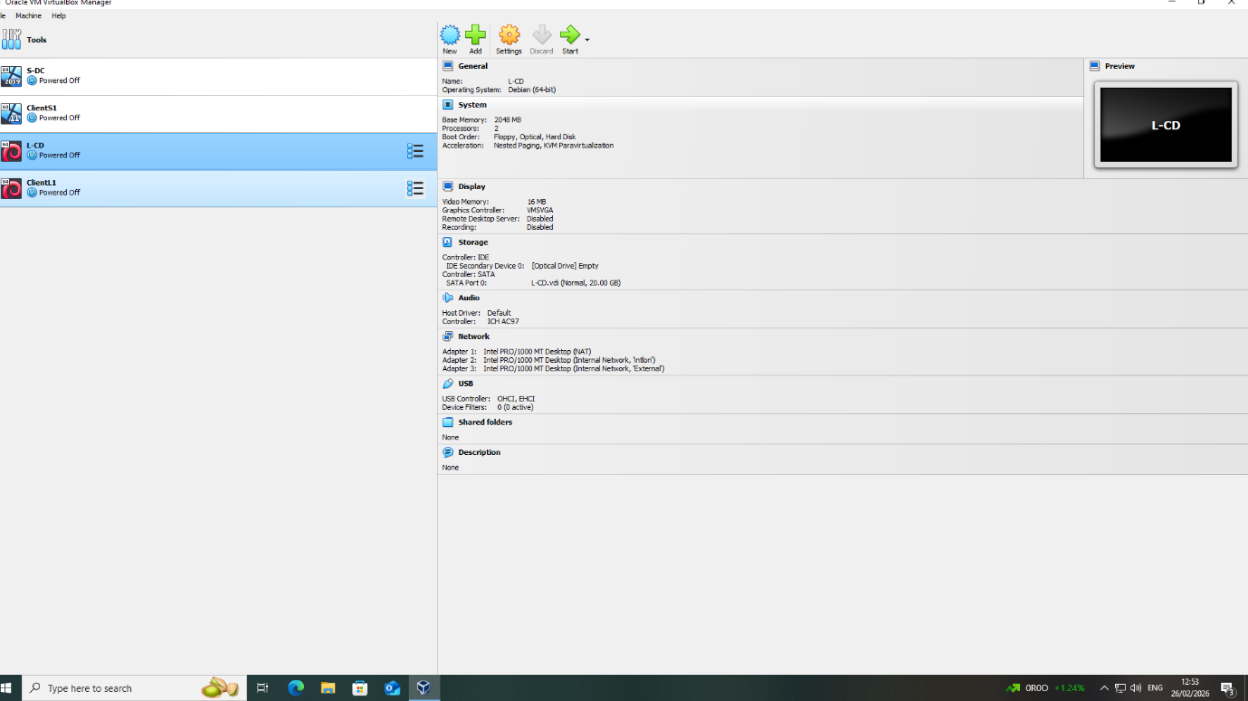
Figure 16: Manual IP configuration on ClientL.1 — IPv4: 192.168.2.2, Netmask: 255.255.255.0, Gateway: 192.168.2.1, 26/02/2026 12:56

2.4 Connectivity Tests and Troubleshooting

Outcome 1: Successful Connectivity Within the Same Network
Ping tests were performed to verify successful communication between devices within the same subnet. The following screenshots demonstrate Outcome 1.

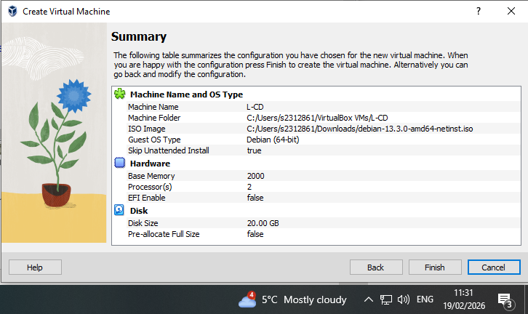
Figure 17: ClientS1 pinging 192.168.1.10 and 192.168.1.1 — 0% packet loss, both within Swansea /24 subnet, 18/02/2026 13:23
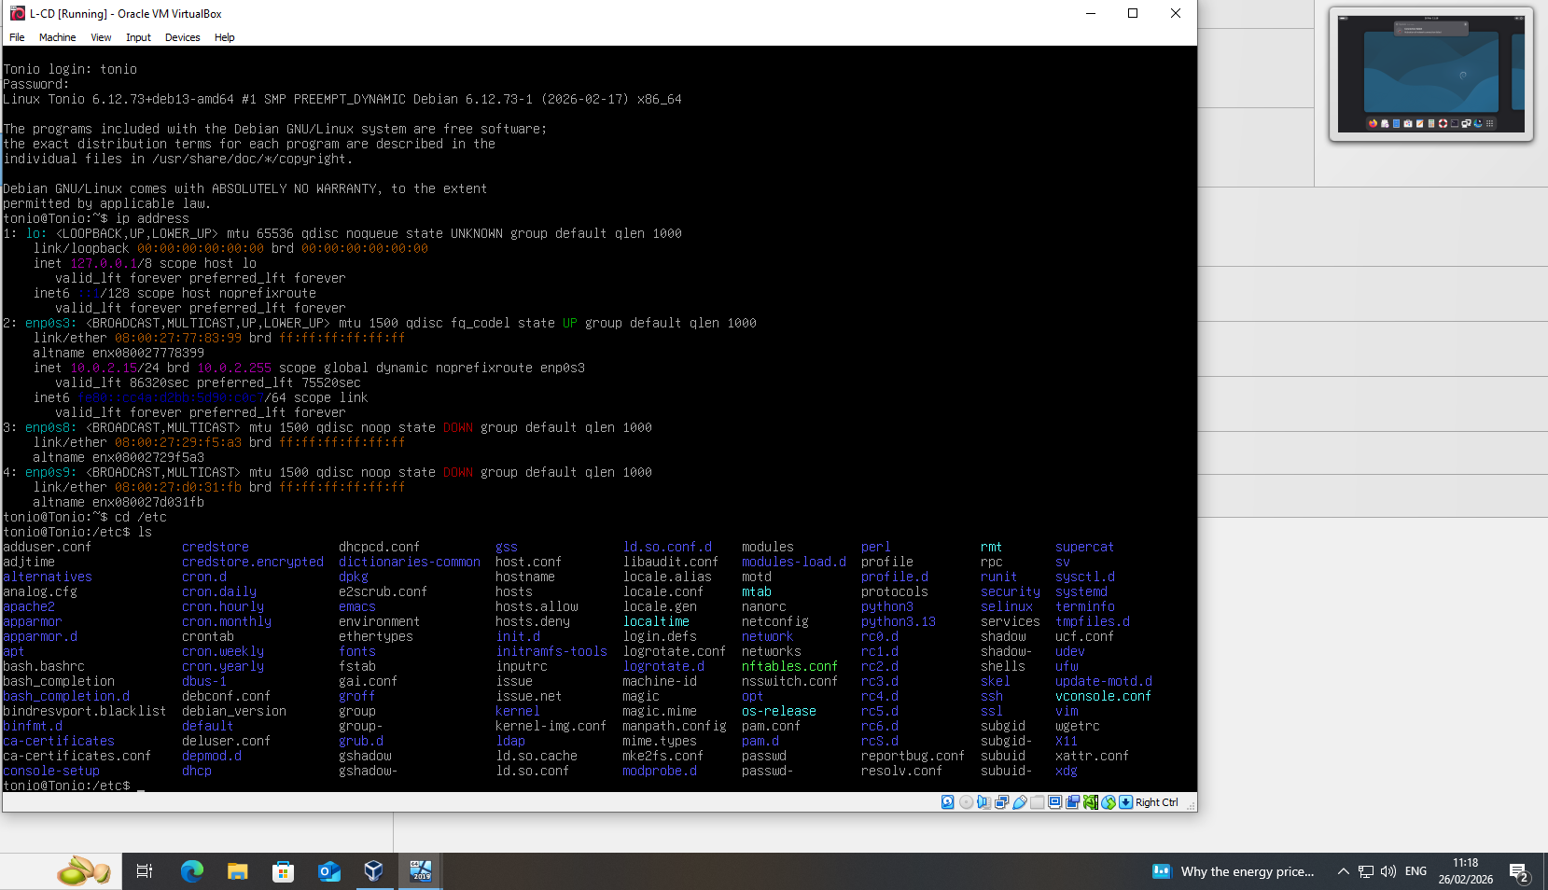
Figure 18: S-DC pinging 192.168.1.10 (ClientS1) — 0% packet loss, within Swansea subnet, 19/02/2026 02:50
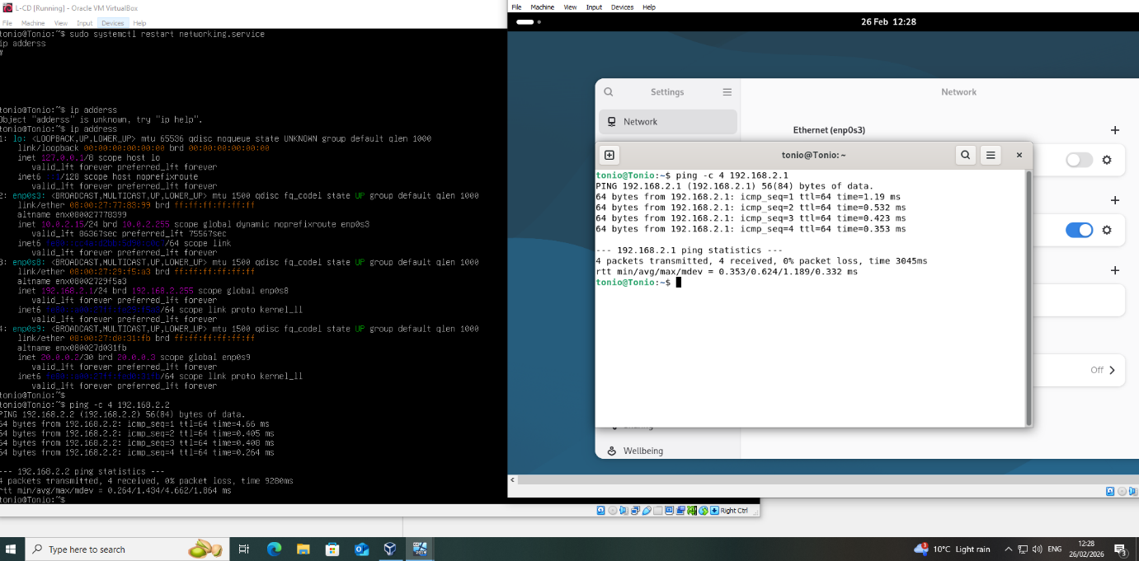
Figure 19: Debian L-CD pinging 192.168.2.1 and 192.168.2.2 — 0% packet loss within London subnet; multi-interface ip address output, 26/02/2026 12:28

Additional VM Configuration Screenshots
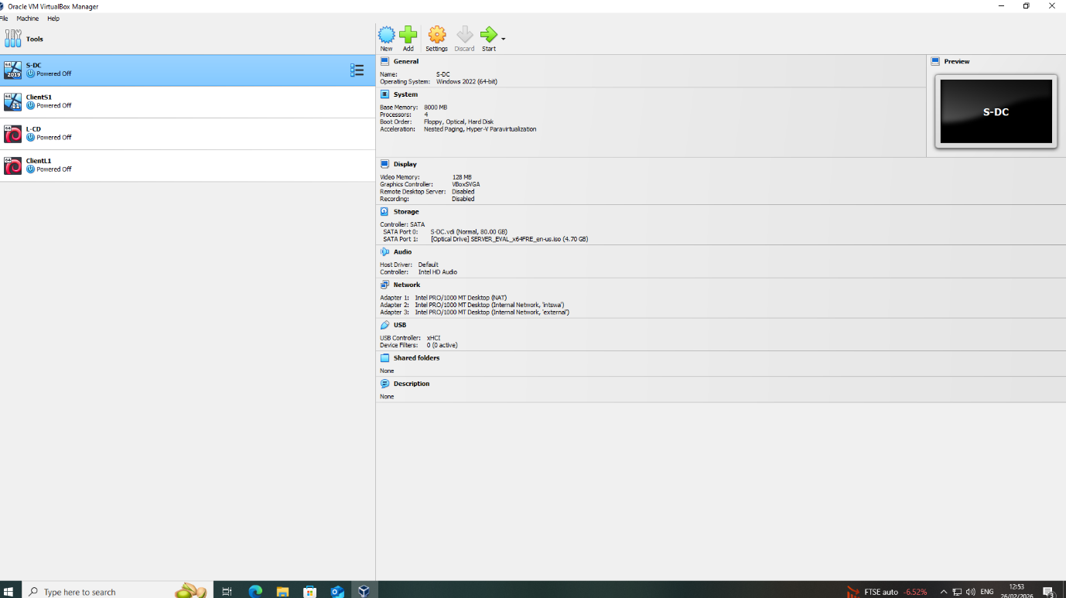
Figure 20: VirtualBox Manager — S-DC full settings summary: Windows 2022 (64-bit), 8000 MB RAM, 4 CPUs, 80 GB disk, 3 network adapters (NAT, Internal "Intswa", Internal "external"), 26/02/2026 12:53
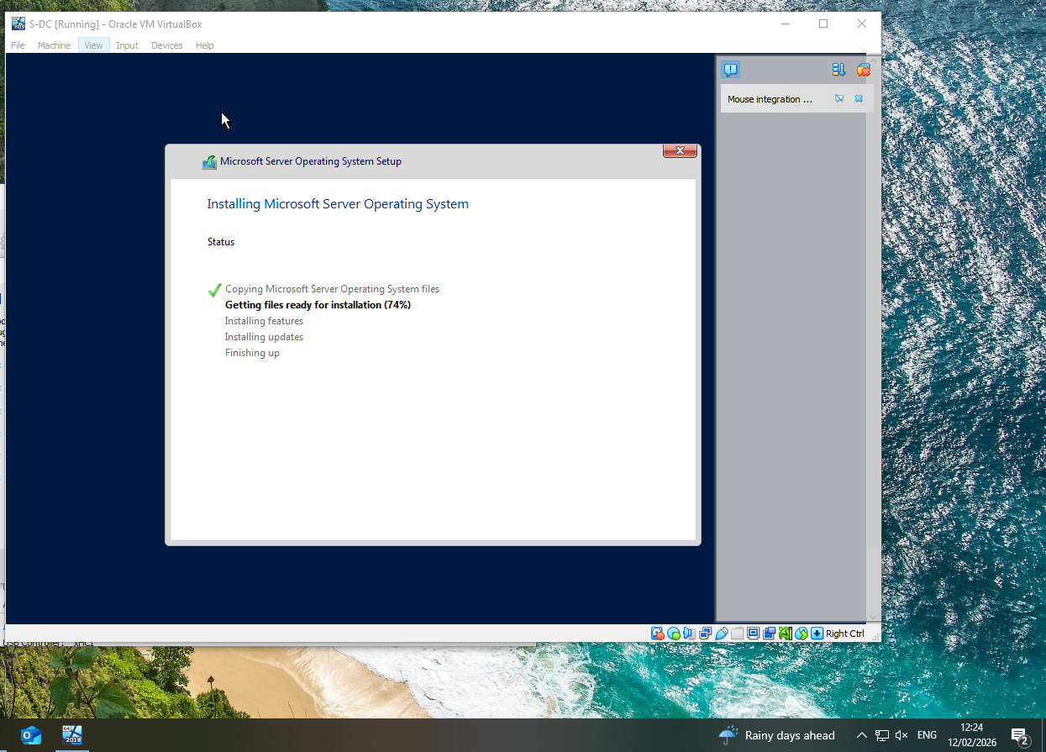
Figure 21: S-DC VM — Windows Server 2022 installation in progress: "Getting files ready for installation (74%)", 12/02/2026 12:24
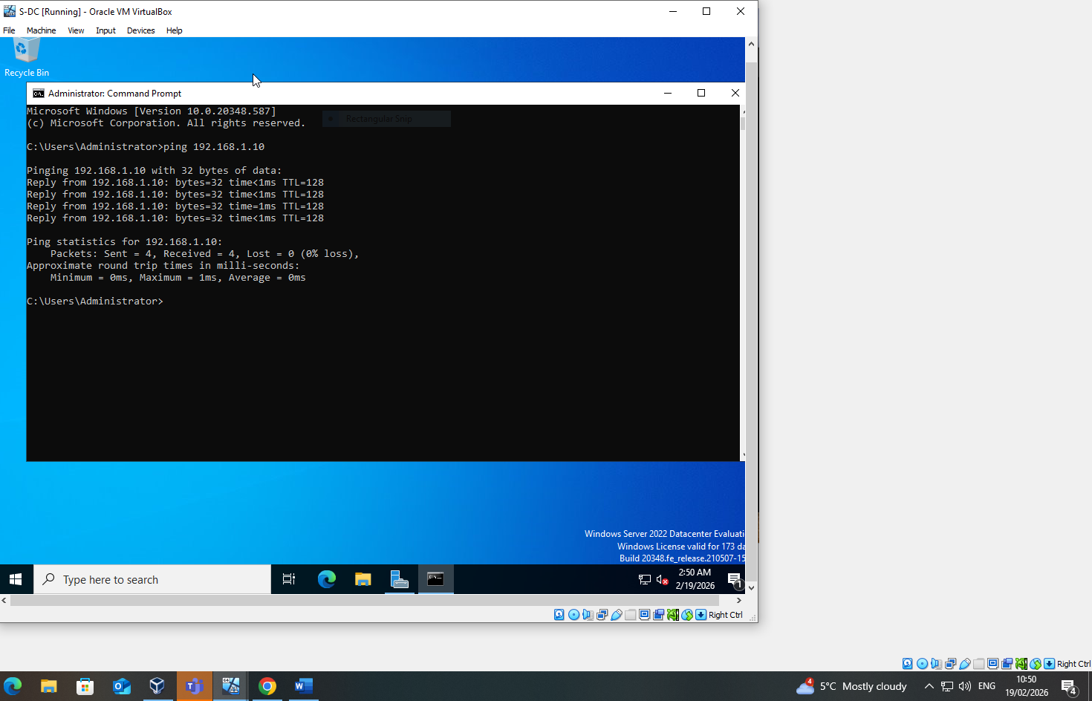
Figure 22: S-DC pinging 192.168.1.10 (ClientS1) from Administrator CMD — 0% packet loss, Swansea subnet connectivity confirmed, 19/02/2026 02:50
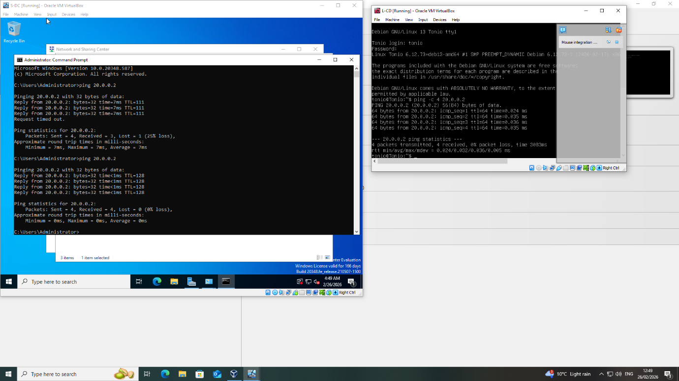
Figure 23: S-DC and L-CD running simultaneously — S-DC pinging 20.0.0.2 (NAT gateway, partial loss then full success); L-CD pinging 20.0.0.2 with 0% loss — both VMs have internet/NAT connectivity confirmed, 26/02/2026 12:49
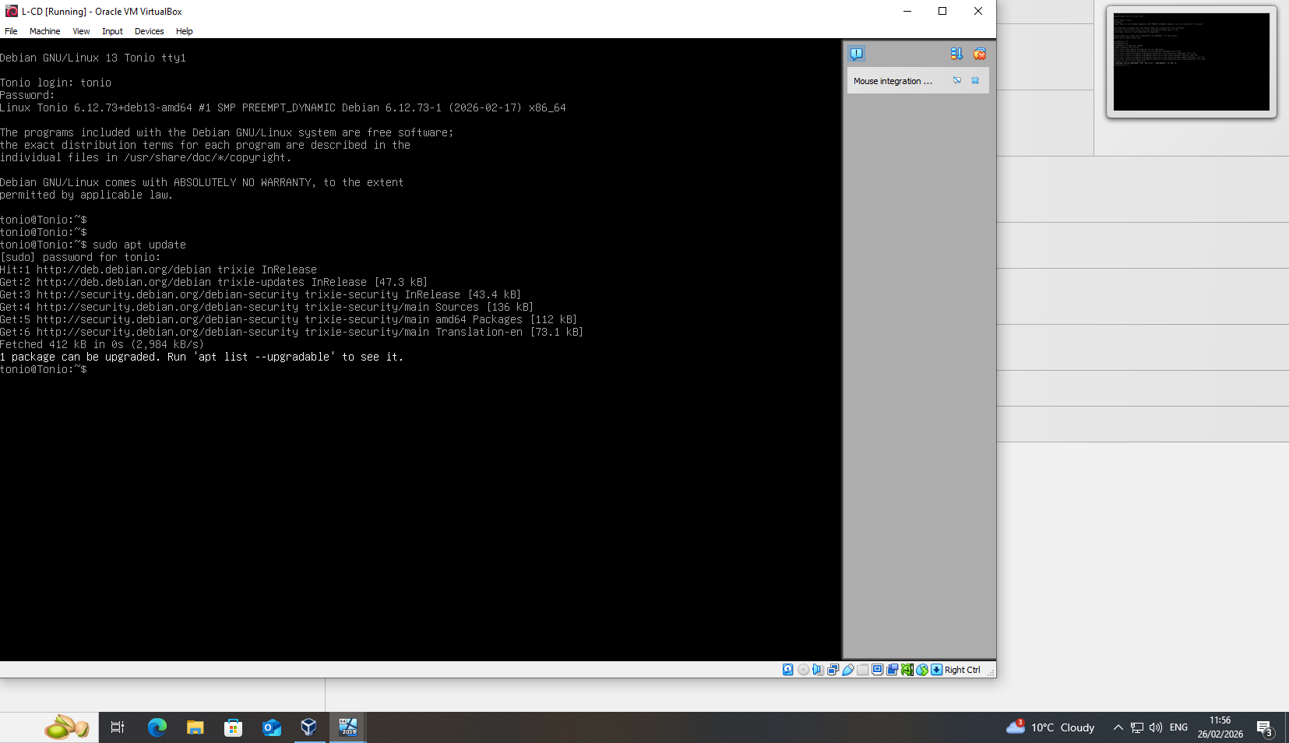
Figure 24: L-CD (Debian 13) — successful login as user "tonio", followed by "sudo apt update" confirming internet access via NAT adapter, 26/02/2026 11:56
Figure 25: VirtualBox Manager — ClientL.1 settings summary: Debian 13, 1024 MB RAM, 2 adapters (NAT and Internal "Intlon"), confirming full topology VM inventory, 26/02/2026

Outcome 2: Unsuccessful Connectivity Between Different Networks
Pinging from the Swansea subnet (192.168.1.0/24) to the London subnet (192.168.2.0/24) fails — and that is the correct and expected result for CW1.
The reason is straightforward: S-DC (192.168.1.1) has no routing table entry for the 192.168.2.0/24 network. When it tries to ping 192.168.2.2, Windows looks up the destination in its routing table, finds no matching route, and drops the packet before it even leaves the Swansea subnet. On the other side, L-CD has not been configured to forward packets between its two interfaces — enp0s8 (London) and the management network — so even if a packet somehow arrived, it would not be relayed onward. The result is 100% packet loss in both directions, confirming that the two subnets are properly isolated at this stage. This isolation is a requirement of CW1. Inter-site routing will be added in CW2.

Word Limit: 250 words

Task 3: Reflection

3.1 Technical Reflection
Things did not go smoothly, and the problems were some of the most useful parts of the exercise. The first issue on L-CD was embarrassingly simple: login kept failing with "Login incorrect" because I was typing the password into the username field. Reading the prompts properly fixed it.
Getting the network interfaces working took more effort. Internal Network names — Intlon, Intswa, External — must match VirtualBox exactly, down to capitalisation. One wrong character and nothing connects. Running "ip address" showed enp0s8 and enp0s9 both DOWN, so they needed manual configuration. Editing /etc/network/interfaces made the settings persist across reboots, which only becomes obvious after restarting the VM and losing everything.
On ClientS1, two active adapters simultaneously — 10.0.2.15 on NAT and 192.168.1.10 on Intswa — meant ping results depended on which interface was active. Getting that wrong would have made the connectivity tests meaningless.

3.2 Personal Reflection
Actually building this network made concepts click that had not quite landed from lectures. Watching adapter types directly affect what VMs can see turned OSI-layer theory into something observable. Working with Windows Server 2022 and Debian 13 side by side also showed how differently the two environments handle the same tasks.
Designing the IP addressing scheme from scratch rather than copying the diagram forced real engagement with VLSM and made me think about scalability for CW2. Timestamps across the screenshots show work spread across February — not crammed in at the end.

References

[1] M. Rosenblum and T. Garfinkel, "Virtual Machine Monitors: Current Technology and Future Trends," Computer, vol. 38, no. 5, pp. 39–47, May 2005.
[2] P. Barham, B. Dragovic, K. Fraser, S. Hand, T. Harris, A. Ho, R. Neugebauer, I. Pratt, and A. Warfield, "Xen and the Art of Virtualization," in Proc. ACM SIGOPS 19th Symp. Operating Systems Principles (SOSP), Bolton Landing, NY, USA, 2003, pp. 164–177.
[3] R. Smith, "Windows Server 2022 Inside Out," Microsoft Press, Redmond, WA, USA, 2021.
[4] M. Lippert and L. Janczewski, "Hypervisor Security in Cloud Computing Environments," Int. J. Inf. Secur., vol. 19, no. 3, pp. 211–229, 2020.
[5] Oracle Corporation, "Oracle VM VirtualBox User Manual," Oracle Corp., 2024. [Online]. Available: https://www.virtualbox.org/manual/
[6] B. A. Forouzan, "Data Communications and Networking, 5th ed.," McGraw-Hill Education, New York, NY, USA, 2021.
[7] Cisco Systems, "Subnetting and VLSM," Cisco Networking Academy, 2023. [Online]. Available: https://www.cisco.com
[8] R. Hinden and S. Deering, "IP Version 6 Addressing Architecture," IETF RFC 4291, Feb. 2006. [Online]. Available: https://www.rfc-editor.org/rfc/rfc4291
[9] A. S. Tanenbaum and D. J. Wetherall, "Computer Networks, 5th ed.," Pearson Education, Upper Saddle River, NJ, USA, 2011.
[10] J. Moy, "OSPF Version 2," IETF RFC 2328, Apr. 1998. [Online]. Available: https://www.rfc-editor.org/rfc/rfc2328
[11] R. Droms and T. Lemon, "The DHCP Handbook, 2nd ed.," Sams Publishing, Indianapolis, IN, USA, 2003.
[12] J. A. Donenfeld, "WireGuard: Next Generation Kernel Network Tunnel," in Proc. Network and Distributed System Security Symp. (NDSS), San Diego, CA, USA, 2017.
[13] Microsoft, "Active Directory Domain Services Overview," Microsoft Learn, 2023. [Online]. Available: https://learn.microsoft.com/en-us/windows-server/identity/ad-ds/
[14] R. Housley, W. Polk, W. Ford, and D. Solo, "Internet X.509 Public Key Infrastructure Certificate and CRL Profile," IETF RFC 3280, Apr. 2002. [Online]. Available: https://www.rfc-editor.org/rfc/rfc3280
[15] A. Kumar, S. Sharma, and R. Yadav, "Performance Analysis of WireGuard VPN Protocol Against OpenVPN and IPSec in Cloud Environments," IEEE Access, vol. 10, pp. 54782–54795, 2022, doi: 10.1109/ACCESS.2022.3176543.

