distinctiveness and development of blaenavon throughout the industrial revolution
Katarzyna White (1905801)
Module Title: Distinctiveness and Regeneration (BMSP 4005) Tutor: Anthony Burns
2020
Introduction
An assignment was given to students to report on the distinctiveness and development of Blaenavon throughout the industrial revolution. On the 11th of February 2020, students visited the Big Pit National Coal Museum based in Blaenavon. During the visit, students had a chance to take an underground tour to the coal mine. Secondly, the museum was explored, where several photos and notes were made about historical and geological facts of the Big Pit and surrounding area. Moreover, lastly, a virtual tour was provided where students had a chance to survey different machinery used to extract the coal throughout the decades. Students were advised to visit the ironwork site; however, the site was closed on that day; therefore, all the information within this report in regard to the ironworks were obtained from other sources.
The aim of this trip was for students to have a better understanding of the relation between the ironworks and the coal mines and their contribution toward the industrial revolution but also to define the distinctiveness of Blaenavon.

The Industrial Revolution
The Industrial Revolution in the UK began in the 1780s; however, the opening of Ironworks in Blaenavon in 1789 marked the significant changes and boom of the industrial revolution in Wales. Blaenavon was very fortunate as it had rich mineral deposits in surrounding areas, making it a perfect place for setting up ironworks, as all three ingredients needed to make pig iron were found in Blaenavon. Another significant fact in regard to the industrial revolution was the discovery made in the mid-1870s by Gilchrist and Thomas, whose dephosphorised pig iron to produce steel (Carpenter, 1936). Industrialisation contributed to new technologies such as steam power, machine tools, textile manufacturing, but also better infrastructure. Coal mining was also thriving in Wales during the industrial revolution as new machinery and technologies were introduced to extract coal (Hughes, 1994).
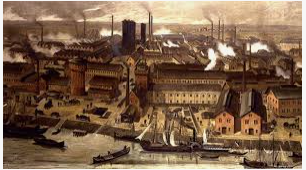

Blaenavon history
Blaenavon history dates way back before the 18th century; however, before the industrial revolution, Blaenavon did not exist on the map and consisted of forestry and scattered farms (Blaenavon World Heritage Site, 2020). In 1789, the Blaenavon Ironworks opened which allowed Blaenavon to make a mark on the map. Within a few years, the ironworks was one of the biggest ironwork sites in the world, attracting thousands of migrants in search of work. Blaenavon became a bustling town with new houses, pubs, churches built around the ironworks to accommodate newcomers. The Ironworks grew from strength to strength, bringing more wealth and people to the area. In 1860, new steelworks opened at Forgeside. The Big Pit coal mine opened in 1880, although the peak production was reached in 1913 as a result of a decline in the ironworks industry. By that time the coal mine was employing 1,300 workers. In 1947, the Big Pit was nationalised and expanded despite employment rates falling and people leaving Blaenavon. In its peak, about 12,500 people lived in Blaenavon and by 1980 when the Big Pit was closed that number halved. The Big Pit reopened in 1983 as a National Coal Museum. The ironworks ceased production in 1904. In 2002, Blaenavon town, Big Pit and Ironworks were put on the UNESCO list for the industrial landscape (Big Pit National Coal Museum, 2020).
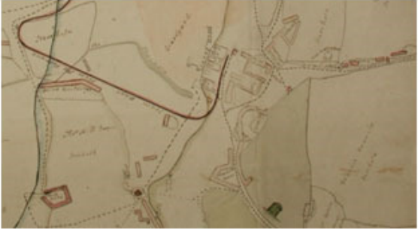

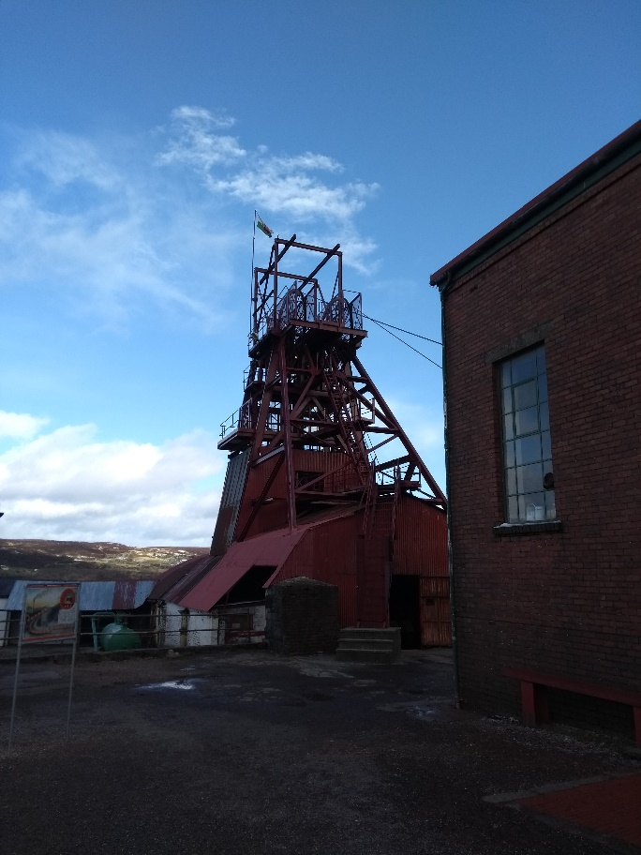
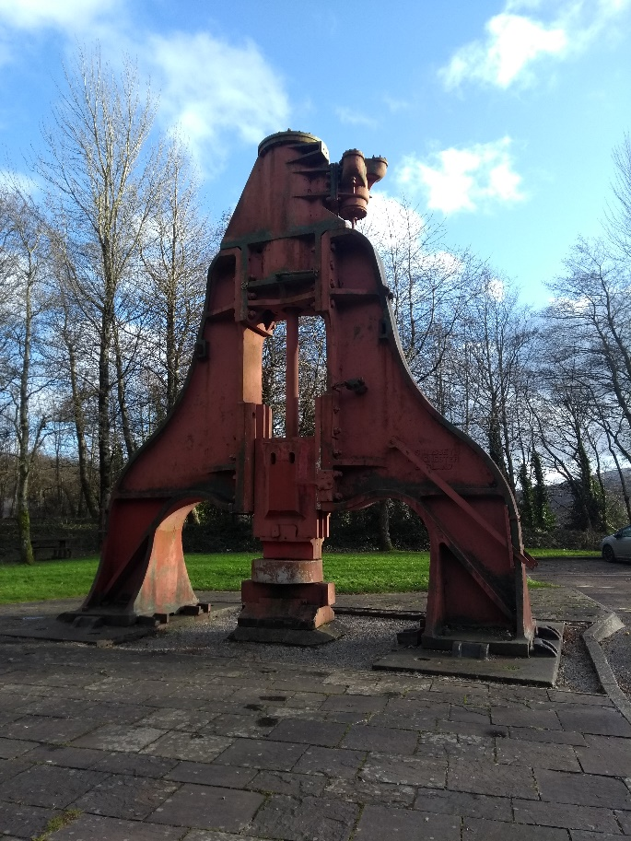
Smelting process – Pig iron
The main three ingredients that make pig iron consists of iron ore, coke (heated coal) and limestone. The smelting process is performed in a blast furnace where all three components are melted, and as a result, molten pig iron is poured into casts. All three elements were readily available in the Blaenavon area, making the whole process relatively straight forward. The pig iron was not of outstanding quality as it had many impurities. However, since the discovery of the Gilchrist-Thomas process, pig iron was turned into high-quality steel by using basic-lined Bessemer convertor (Carpenter, 1936) and therefore distinguished Blaenavon as a birthplace of steel.

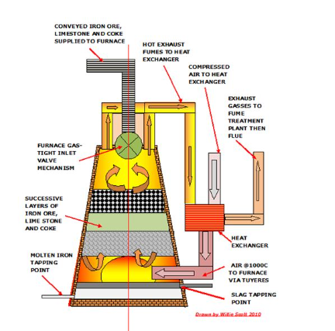

Limestone, ironstone and coal formation
“Limestone is a naturally occurring mineral that consists principally of calcium carbonate” (Oates, 1998). The calcium carbonate comes from algae, corals and brachiopods that died about 330 million years ago and formed a layer of sediment that turned into limestone. From the information gathered at the National Coal Museum, farmers where using limestone long before the opening of ironworks. Within the Blaenavon are few quarries were established, which prompted the need for better transport links for easier shipment of limestone from quarries to the ironworks. During the Industrial Revolution limestone was primarily used as a flux in iron production.

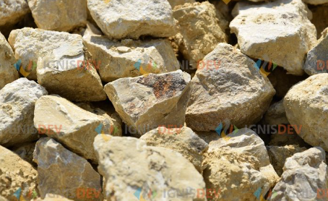

According to the National Coal Museum, Blaenavon had the best quality of ironstone. Mining for ironstone in Blaenavon stopped in the 1880s, but it was produced as a by-product of coal mining until 1903. Ironstone is a sedimentary rock, which formation started 1.8 billion years ago. Ironstone is made by chemical reaction of iron and oxygen mixed in the marine and freshwater (A Geology Outreach Website, 2020) also sands and clays.

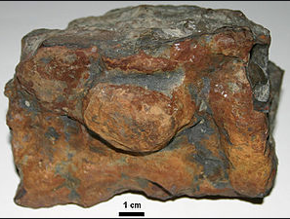

Miller (2005), states that “coal is found in deposits called seams that originated through the accumulation of vegetation that has undergone physical and chemical changes. The creation of coal would start around 300 million years ago. It is believed that Blaenavon coal was of an outstanding quality. The “steam coal” made South Wales recognised around the world (National Coal Museum, 2020).
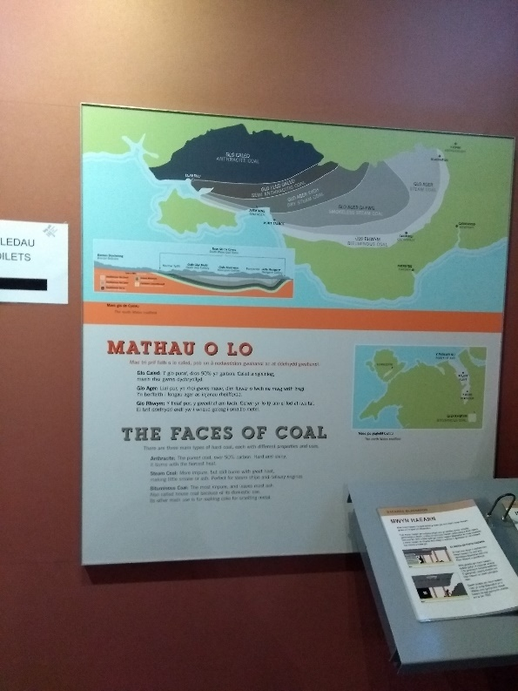
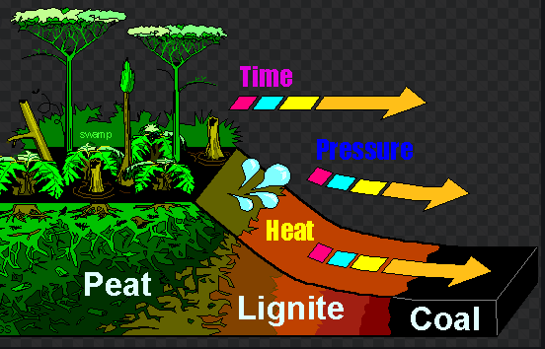

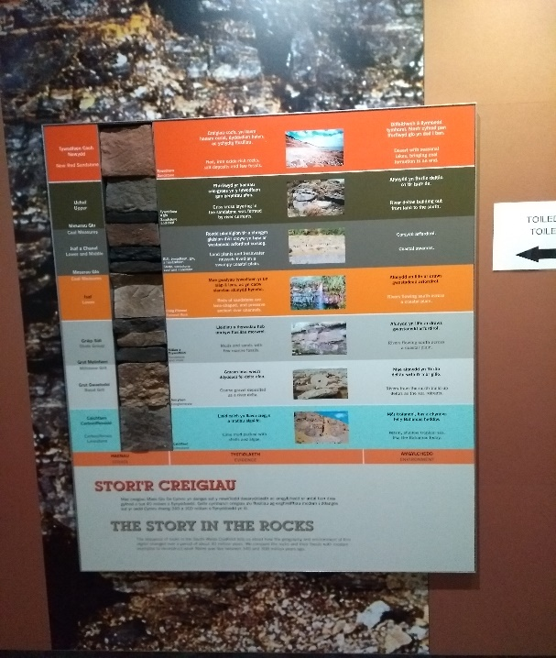
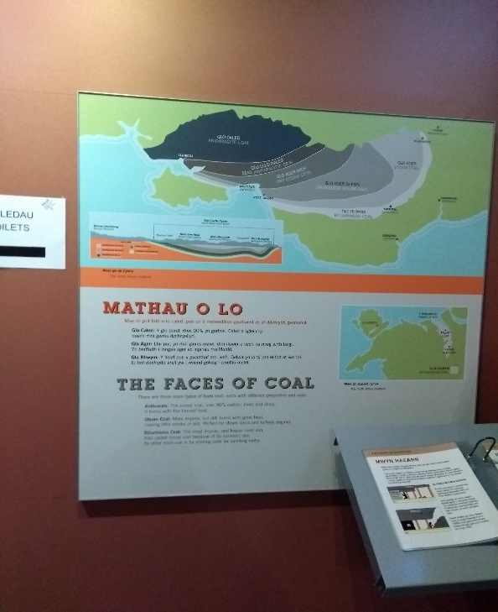

Conclusion
It is apparent that Blaenavon and surrounding areas were affected by the Industrial Revolution, which exploited the natural resources available in the area. By doing so, the Blaenavon landscape had changed from rural to industrial, bringing thousands of people to the area and more wealth to the rich of the country. The distinctiveness of Blaenavon is distinguished by the Big Pit, the Ironworks, the Forgeside, but also what lays underground, the mineral deposits like limestone, coal and iron ore all available in one place. Wales and in particular the Ironworks where Gilchrist and Thomas performed scientific experiments to dephosphorised pig iron shaped the world we know. Creation of steel allowed many new inventions that are now a necessity in a modern world. Blaenavon has made history in more ways than we can comprehend.

Reference list:
- A Geology Outreach Website, 2020. Available at http://geologylearn.blogspot.com/2015/03/iron-ore.html
- Big Pit National Coal Museum, 2020. Available at https://museum.wales/bigpit/
- Blaenavon World Heritage Site, (2020). Available at https://www.visitblaenavon.co.uk/en/Homepage.aspx
- Carpenter, H. (1936). Percy Carlyle Gilchrist. 1851-1935. Obituary Notices of Fellows of the Royal Society, 2(5), 19-24. Retrieved March 4, 2020, from www.jstor.org/stable/769125
- Hughes, S. R. (1994). Collieries of Wales: Engineering and Architecture. Aberystwyth: Royal Commission on the Ancient and Historical Monuments of Wales. pp. 8–9. ISBN 978-1-871184-11-2.
- Miller, B.G. (2005). Coal energy Systems, Elsevier Academic Press.
- Oates, J.A.H., 1998. Lime and Limestone: Chemistry and Technology, Production and Uses. WILEY-VCH publication.

