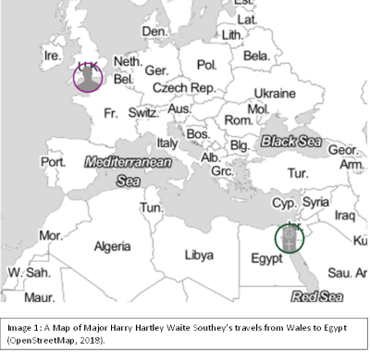
Egyptian Paddle Doll

Museum number: CCM187.996
Place of Origin: Ancient Egypt
Period: Sixth-thirteenth Dynasty (ca. 2200 – 1700 BCE)
Medium: Painted wood
Gift of: Major Harry Hartley Waite Southey and family.

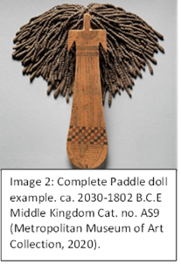
Handheld female torso. Approximately three to four thousand years in age. Missing its head, hair, and possibly short arms.

Placed inside male or female tombs for the deceased to take into the afterlife.

Associated with Hathor (the Egyptian goddess of love), magic, dancers, concubines, midwives, fertility rituals, festivals, and funerals.
By Julia Jones 2007994 01-11-2022.

