Name: Morgan jones

Student number: 1706863

Module : (ACDA4004)

Course: Electric and Electronic Engineering

Contents
Name: Morgan jones 1
Student number: 1706863 1
Module : (ACDA4004) 1
Course: Electric and Electronic Engineering 1
Introduction 2
Section 1: 7
Section 2: 11
Bibliography 14

Introduction
What is a PIC ?
PIC microcontrollers are an electrical circuit that can be programmed to carry out a variety of tasks. They can be programmed to be clocks or to control a construction line and much more. They are in most electronic devices such as alarm systems, computer control systems, phones, in essence they can be in any electronic device. [1]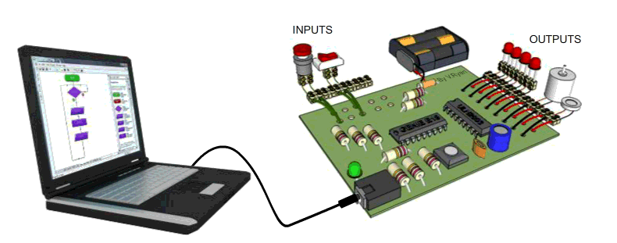

[1]

There are many types of pic board, here are some:
Curiosity pic microcontroller Development board
The curiosity program development board is designed by microchip for 8-bit pic microcontrollers. It is cost effective and fully integrated with 8-bit microcontrollers. It is figure is shown below: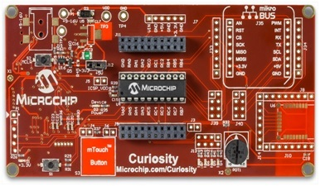
Features of Curiosity pic Development board:
- It supports the 40 pin 8-bit microcontroller with low voltage.
- It has USB interface with integrated programmer or debugger.
- It has RN 4020 Bluetooth foot print.
- It has physical switches and analogue potentiometer.
- It has wide interface options such as m touch button.

Ready for PIC microcontroller development Board
Reay of pic is the development board which is used for development of 28 and 40 pins pic microcontrollers such as PIC 18F45k22 by connecting the 8MHz crystal oscillator. It is shown in figure below: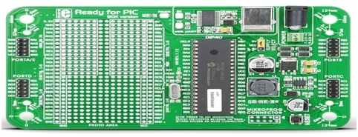
Features of Reay for PIC development Board:
- It is fully supported by mikro c mikro basic and mikro pascal complier for pic compiler.
- It has 10 IDC headers for available microcontroller ports.
- It has USB-UART module, prototyping area and power supply circuit.
- It has fast UART bootloader for on board pic programming.
It is designed on white plastic casing so each component could be sold separately

XLP 8-Bit pic microcontroller Development Board
XLP 8-Bit Development Board is designed by microchip for a very low power and have a very low sleep current such as 20 nA.It is very sustainable for prototype very low power applications such as energy harvesting, temperature sensors ,electronics door locks, smart cards , security sensors. For extensive low power applications, the extensive line of daughter cared is interfaced with this microchip development board. It is very low cost board and is very ideal for providing the development environment to the pic 16F and 18F microcontrollers. This XLP 8-Bit Development Board is shown below.
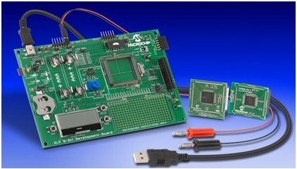
Microchip XLP 8-Bit Development Board
Features of XLP 8-Bit pic microcontroller Development Board:
- It supports the Pic 18F87k22, which have 80 pins and 128KB flash memory.
- It also supported the microcontroller such as 6LF194PIC17 which 64 pins and 28KB flash memory.
- It also has current and voltage measurements facility.
- It has USB interface for power and PC communication.
- It has LEDs for identifications.
- It has LCD interface facility.
- It has analogue temperature sensor and CTMU based diode temperature sensor.
- It has power options such as energy harvesting, AAA, USB, CR2032, external or 9 V power supply.
- It has very easy connection with MPLAB PICKIT3, ICD3 or RESL ICE for input debugging and programming

XLP 16-Bit pic microcontroller Development Board
XLP 16-Bit Development Board is also designed by microchip and is used for very low power applications. It is very ideal for low power motor control, digital power conversion, advanced integration and low power security systems. This XLP 16-Bit Development Boards shown below.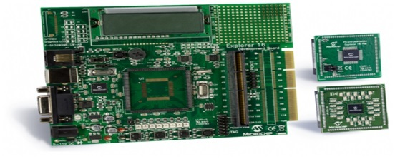
Features of XLP 16-Bit pic Development Board
- It has 20 and 28 pins shared footprints sockets with associated headers for PIC 24F microcontroller.
- It has 8 MHz and 32.768KHz oscillator circuit for PIC 24F microcontroller.
- It has power LED.
- It has power control switch IC (IC PWR).
- It has adjustable regulator (LDO).
- It has temperature sensor, potentiometer and serial EEPROM.
- It also has capacitive touch pads and capacitive measurements points
XLP 32-Bit pic microcontroller Development Board
XLP 32-Bit Development Board is also designed by microchip, which provides the very lowest and easiest method to experience the 32 bit pic microcontrollers. It was developed by microchip first time. It has all the features such write, debug and execute the program for high performance 32bit microcontroller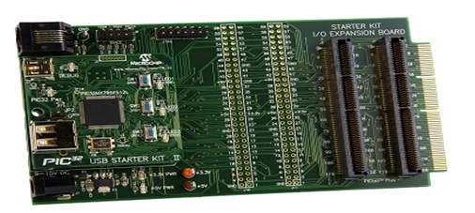
Features of XLP 32-Bit pic microcontroller Development Board
- It has free MPLAB IDEX and MPLABXC32 compiler.
- It has 512K flash,32K ram and 4 channel DMA.USB powered board.
- It has 3 users switched and 3 LEDs.
- It has full source based debugging in MPLAB XIDE.
- It run and verify the program in 9 seconds.
Easy PIC V7 8-Bit pic microcontroller Development Board
Easy pic v7 8-bit development board is designed by mikroelektronia development tools company and is designed for experienced the 8-bit microcontroller such as PIC 18F78K22 microcontroller. It is shown in figure below: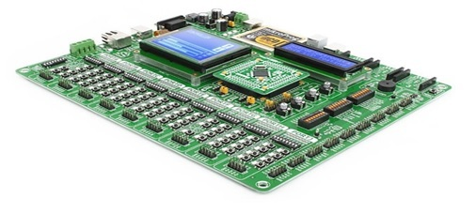
Features of Easy PIC V7 8-Bit pic Development Board
- It could be used for variety of applications such as Ethernet, USB, temperature measurements and including graphics.
- It also supports the PIC18F, PIC18FJ, and PIC18FLK.
- It has the special function registers (SFR).
- It has CODE, RAM, and EEPRM along with code execution hardware.
- It also 80 Pins MCU card that could be sold separately.
PIC KICK Development Board with PIC16F877A
PIC kick development board is designed for pic 16F and 18F microcontrollers. It is low coat and kick start development board for pic 16F877A and is used for low power applications. It is shown in figure below
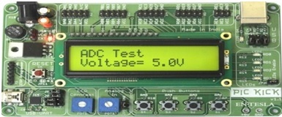
EASY PIC Development Board for PIC18f4520
Easy pic development board for pic 18F4520 is the starter board for 40 and 28 pin microcontrollers. It is low and is only designed for pic it figure is shown below:
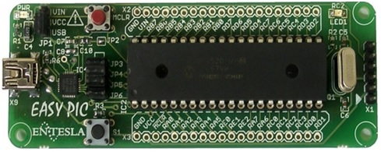
Features of EASY PIC Development Board for PIC18f4520:
- It has serial a bootloader with on board microchip 18F4520 microcontroller.
- It is powered up externally or USB port.
- It has on board USB to serial communication converter
- It 12 MHZ replaceable crystal to clock the microcontroller.
- It also has reset push button.
PIC-P26J50 Porto pic Development Board
PIC-P26J56 Porto development board is designed for pic 18F26J56 microcontroller and it has developed by the using the high speed low power CMOS flash memory technology. Its figure is shown below: 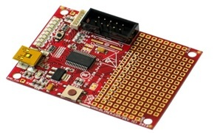
Features of PIC-P26J50 Porto Development Board:
- It has 64 K flash with pic microcontroller.
- It has UBS connector with 8 LEDs.
- It has user button and reset button.
- It has UEXT connector.
- It has dimensions 61*45mm.
[2]

what the purpose of MPLAB is, and what are its general features.
MPLAB is produced by Arizona Microchip. MPLAB IDE is a integrated toolset for the development of embedded applications on PIC Microchips and microcontrollers. It is called an Integrated Development Environment because it provides a single integrated environment to develop code for implanted microcontrollers.

Features
MPLAB IDE is a Windows OS based IDE for the PIC MCU families and dsPIC Digital Signal Controllers. The MPLAB IDE provides the ability to create and edit source code via the built-in editor. Assemble, compile and link source code. Debug the executable logic by watching program flow with the built-in simulator or in real time with in-circuit emulators or in-circuit debuggers. Make timing measurements with the simulator or emulator. View variables in Watch windows and Program firmware into devices with device programmers.
[3]

Circuit Designing
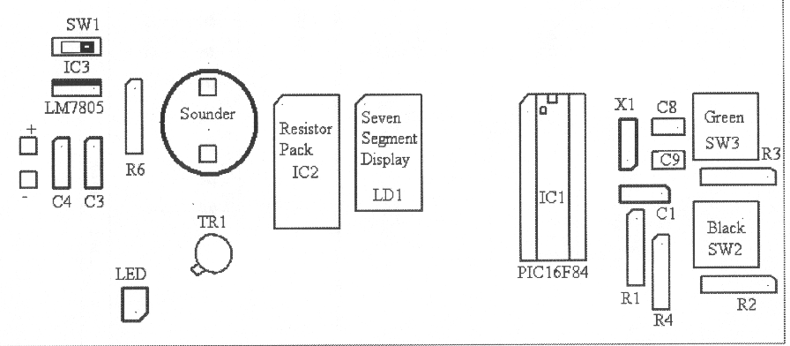
Figure 1 diagram of the physical device
The PIC microcontroller transmits as well as receives data with electrical pulses, the PIC microcontroller can operate with a 4MHz crystal. Two capacitors are connected to the crystal oscillator which is used to stabilize the electrical signals. Sometimes the PIC microcontroller goes to a block state or has a missing time calculation, at that time we need to reset the microcontroller. If a microcontroller is reset for with a time delay, the resistor and the capacitor are connected to the respective pins.

Circuit Components
Reset device, A power-on reset generator is a microcontroller that generates a reset signal when power is applied to the device. [4]
Capacitors are used in power supplies where they smooth the output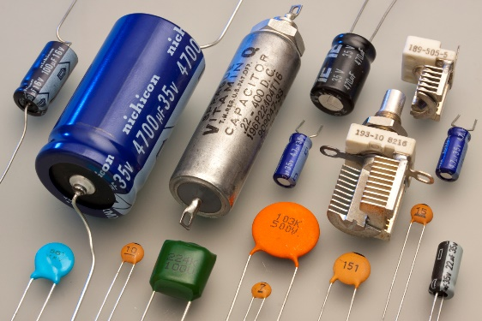
[5]

Resistors are used to reduce current flow, adjust signal levels, to divide voltages, bias active elements, and terminate transmission lines, among other uses.
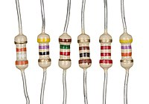
[6]

As you can see the diagram shows the physical components on the PIC board there are two button one black and one green these can be used to control the actions of the sounder or seven segment display.
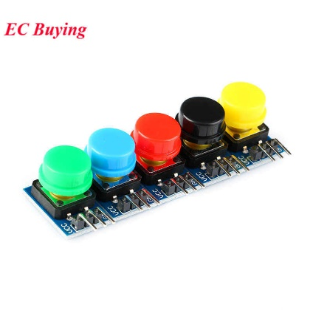
Buttons [7]
There is a switch which helps control whether the board receives power in essence turn on or off there is also a led connected to the switch which helps verify that there is power going to the components
There is a sounder this is used to create a sound for example if the pic is programmed so that the sounder creates a tune or plays a piece of music
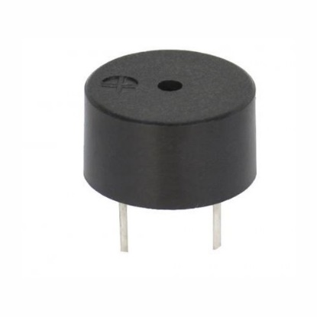
Piezo Buzzer [8]
There is a seven segment led display this is used to show any particular letters or numbers that the pic has been program to show for example “H” “E” “L” “P” or “S” “T” “O” “P”
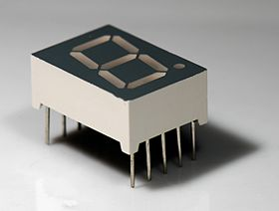
Seven segment display [9]
There is also the PIC microcontroller which can be connected and disconnected from the board mean it is easier program with a set of instructions as if it was stuck on you would not be able to program the PIC as there will be feasible way or uploading the program code. 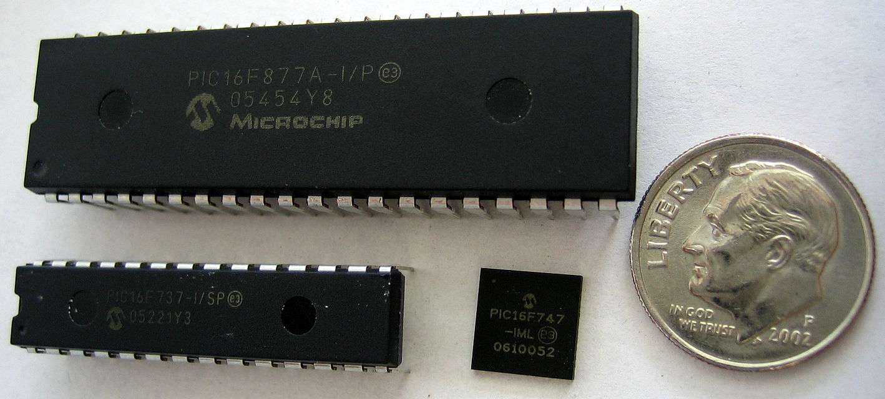
[10]
There is crystal oscillator which is used for the resonance of a vibrating crystal of piezoelectric material. It will create an electrical signal with a given frequency.
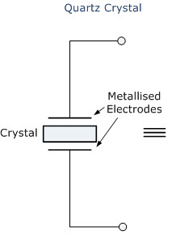
crystal oscillator

[11] [12]

Section 1:

Error 1
Error[113] C:\USERS\ERGO\DOWNLOADS\COUNT.ASM 30 : Symbol not previously defined (status)
Error[113] C:\USERS\ERGO\DOWNLOADS\COUNT.ASM 31 : Symbol not previously defined (status)
Error[113] C:\USERS\ERGO\DOWNLOADS\COUNT.ASM 33 : Symbol not previously defined (status)
Error[113] C:\USERS\ERGO\DOWNLOADS\COUNT.ASM 36 : Symbol not previously defined (status)
As you can see from the above lines there are multiple line with the same error these lines however are not the issue line 17 is as there is a mistype as the word Status should be lowercase not uppercase as it is in the count file an easy way to fix this is go to line 17 and change the word to lowercase letters.
Error 2
Error[113] C:\USERS\ERGO\DOWNLOADS\COUNT.ASM 57 : Symbol not previously defined (get_count)
The above error is not with line 57 specifically but line 41 as get_counnt should match line 57 however due to a mistype there is a discrepancy of get_count having an extra n in the word count to rectify this just remove the extra n.

Error 3
Warning[202] C:\USERS\ERGO\DOWNLOADS\COUNT.ASM 74 : Argument out of range. Least significant bits used.
The error for this line is another mistype as the line shows movlw 0xfff
When it should show movlw 0xff as this indicates what is show on the segment board as 0xfff will either make the program not work or cause it to act different to the programmer’s intentions so to fix this issue remove an f making it 0xff

Error 4
Error[113] C:\USERS\ERGO\DOWNLOADS\COUNT.ASM 75 : Symbol not previously defined (mCont)
The error for this line is that there is a mistype as the word mcont this is not the correct instruction and should really be mcount as it works as the outer loop counter and to correct it you should add a u in between the o and n making the correct instruction
Error 5
Warning[207] C:\USERS\ERGO\DOWNLOADS\COUNT.ASM 89 : Found label after column 1. (en)
The error that the full word should be end instead of en but there was a mistype as there was a gap between the en and d so this can be corrected by removing the gap making the word end instead of en d
Error 6
Error[122] C:\USERS\ERGO\DOWNLOADS\COUNT.ASM 89 : Illegal opcode (d)
The error that the full word should be end instead of d but there was a mistype as there was a gap between the en and d so this can be corrected by removing the gap making the word end instead of en d
Error 7
Error[129] C:\USERS\ERGO\DOWNLOADS\COUNT.ASM 98 : Expected (END)
This error is a mistyped word as there should be the word end instead of en d but there was a mistype as there was a gap between the en and d so this can be corrected by removing the gap making the word end instead of en d
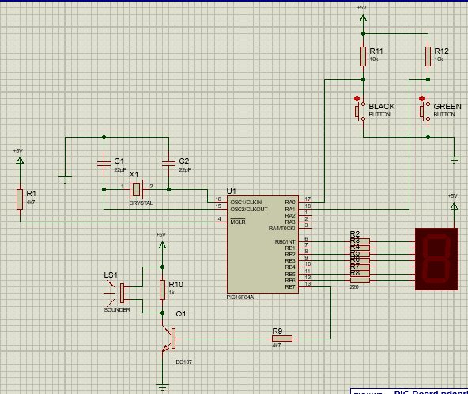
Figure 2 proteus schematic of the PIC board

Description of the purpose and general operation of each component in MAPLAB.
The MPLAB IDE possesses both built-in and plug-in components to set up the system for an assortment of software and hardware tools.
Project Manager, the project manager offers integration and communication between the IDE and the language tools.
Editor, the editor is a full-featured programmer's text editor that also serves as a window into the debugger.
Assembler and Language Tools, the assembler can be used stand-alone to assemble a single file or can be used with the linker to build a project from separate source files, libraries and recompiled objects. The linker is responsible for positioning the compiled code into memory areas of the target microcontroller.

Debugger: The Microchip debugger allows breakpoints, single stepping, watch windows and all the features of a modern debugger for the MPLAB IDE. It works in conjunction with the editor to reference information from the target being debugged back to the source code.
Execution Engines: There are software simulators in MPLAB IDE for all PIC devices. These simulators use the PC to simulate the instructions and some peripheral functions of the PIC devices. Optional in-circuit emulators and in-circuit debuggers are also available to test code as it runs in the applications hardware.
[3]

You should perform additional research of your own to in this area and include data/diagrams from your research sources to aid in your explanations.
Note - using internet-based resources is perfectly acceptable for this task, but make sure you reference any sources using the correct numeric format as covered in the Academic and Employability Skills module.

Section 2:

- Modify “Count.asm” so the seven segment display shows “H” “E” “L” “P” at a rate that is easy to read.

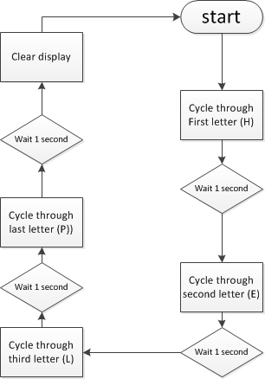
Figure 3 flowchart design for count.asm
The flowchart shows that the when the power switch is turned on the PIC will light the led with the first letter H then it will wait 1 second then proceed to the next letter E then it will wait 1 second then proceed to the next letter P then it will wait 1 second then proceed to the next letter P then it will wait 1 second then proceed to clear the led display and then restart the program

Modify “Count.asm” so that the piezo sounder produces a 440Hz tone while the Green button is pressed.
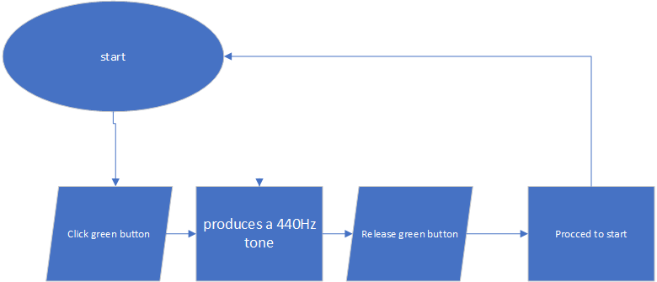
Figure 4
The flowchart shows that the when the power switch is turned on you can press the green button as the sounder produces a 440 hz tone then you release the green button then the program will reset so that you can repress the green button and the activate the sounder .

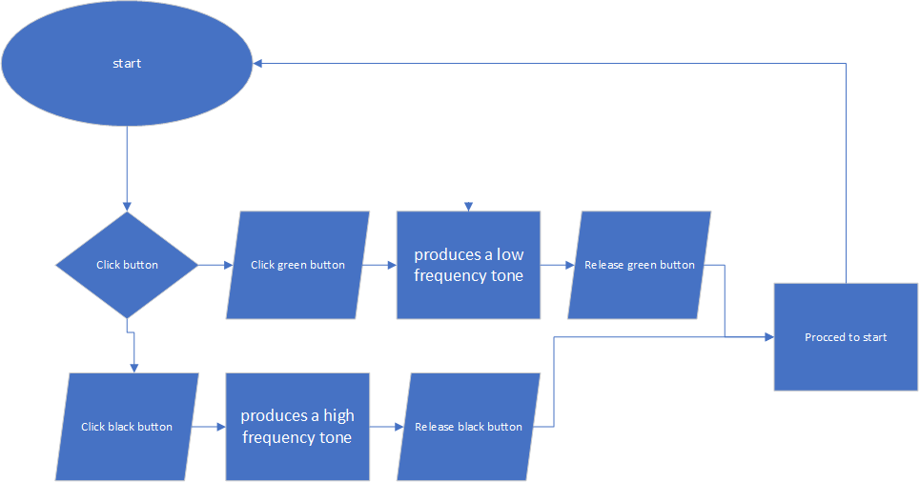
Modify “Count.asm” so that the piezo sounder produces a low frequency tone while the Green button is pressed and a high frequency tone while the Black button is pressed.
figure 5
The flowchart shows that the when the power switch is turned you will have to decide which button to press if you press the green button the sounder will produce a low frequency tone once the button is released the program will restart and if you press the black button the sounder will produce a high frequency tone once the button is released the program will restart.

Bibliography

[1] | V. Ryan, " WHAT IS A PIC MICROCONTROLLER? WHAT CAN IT DO?," [Online]. Available: http://www.technologystudent.com/pics/picgen1.html. [Accessed 1 january 2019].
[2] | "Pic Microcontroller Development Boards with Their Features," [Online]. Available: http://microcontrollerslab.com/pic-microcontroller-development-boards-features/. [Accessed 21 january 2019].
[3] | A. Tomar, "Microchip: MPLAB Integrated Development Environment (IDE) Overview," [Online]. Available: https://www.element14.com/community/docs/DOC-39318/l/microchip-mplab-integrated-development-environment-ide-overview#anchor1. [Accessed 1 January 2019].
[4] | "Power-on reset," [Online]. Available: https://en.wikipedia.org/wiki/Power-on_reset. [Accessed 11 January 2019].
[5] | "Applications of capacitors," [Online]. Available: https://en.m.wikipedia.org/wiki/Applications_of_capacitors. [Accessed 12 january 2019].
[6] | "Resistors," [Online]. Available: https://en.m.wikipedia.org/wiki/Resistor. [Accessed 12 january 2019].
[7] | "Aliexpress buttons," [Online]. Available: http://www.aliexpress.com/i/32851421040.html. [Accessed 11 january 2019].
[8] | "robomart.com piezo-buzzer-b-10n," [Online]. Available: https://www.robomart.com/piezo-buzzer-b-10n. [Accessed 11 january 2019].
[9] | "Seven-segment display," [Online]. Available: https://en.wikipedia.org/wiki/Seven-segment_display. [Accessed 1 January 2019].
[10] | "PIC microcontrollers," [Online]. Available: https://en.m.wikipedia.org/wiki/PIC_microcontrollers. [Accessed 13 january 2019].
[11] | "Crystal Oscillator Circuit and Working," [Online]. Available: https://www.elprocus.com/crystal-oscillator-circuit-and-working/. [Accessed 1 january 2019].
[12] | "How to Program a PIC Microcontroller to Build a Project," [Online]. Available: https://www.elprocus.com/pic-microcontroller-programming-using-c-language/. [Accessed 1 january 2019].

Appendices
Count.asm corrections
MPASM 5.51 COUNT CORRECTIONS.ASM 1-31-2019 9:53:36 PAGE 1

LOC OBJECT CODE LINE SOURCE TEXT
VALUE

00001 ; FILE: count.asm
00002 ; AUTHOR: JMY
00003 ; DATE: 24th March 2005
00004 ; DESCRIPTION: Count to 255 at 1 second intervals and display on a seven
00005 ; segment display in binary.
00006 ; The pause subroutine takes apx. 0.2 sec.
00007 ; Pause is called 5 times
00008
Warning[215]: Processor superseded by command line. Verify processor symbol.
00009 list p=16F84 ; select processor type
00010 radix hex ; define radix as hexadecimal
00011 ; #include "p16f84.inc"
00012 ;----------------------------------------------------------------------
00013 ; cpu equates (memory map)
00000006 00014 portB equ 0x06 ;port B address
00000006 00015 trisb equ 0x06 ;trisB address in register bank 1
00016
00000003 00017 status equ 0x03 ;status register lower case s no captital
00000005 00018 RP0 equ 5 ;bit 5 of status register
00000006 00019 RP1 equ 6 ;bit 6 of status register
00020
0000000C 00021 count equ 0x0c ; counter 0 to 255
0000000D 00022 nCount equ 0x0d ; pause routine inner loop counter
0000000E 00023 mCount equ 0x0e ; pause routine outer loop counter
00024
00025 ;----------------------------------------------------------------------
00026
000000 00027 org 0x000
00028
000000 00029 start
000000 9A03 00030 bcf status,RP0 ; clear bank selection bits in the status reg
000002 9C03 00031 bcf status,RP1
00032
000004 8A03 00033 bsf status,RP0 ; select bank 1
000006 0E00 00034 movlw 0x00 ; load w with 0x00
000008 6E06 00035 movwf trisb ; load it into trisb to make portb all outputs
00000A 9A03 00036 bcf status,RP0 ; reselect bank 0
00037
00000C 6A06 00038 clrf portB ; clear all lines low
00000E 6A0C 00039 clrf count ; initialize counter to 0
00040
000010 00041 get_count
000010 500C 00042 movf count, w ; move count to W
00043
00044
000012 6E06 00045 movwf portB ; move W to port B to update the display
00046
000014 0F01 00047 addlw 1 ; add +1 to W
00048
000016 6E0C 00049 movwf count ; save W in count
00050
000018 EC18 F000 00051 call pause ; delay 200ms by subroutine
00001C EC18 F000 00052 call pause
MPASM 5.51 COUNT CORRECTIONS.ASM 1-31-2019 9:53:36 PAGE 2

LOC OBJECT CODE LINE SOURCE TEXT
VALUE

000020 EC18 F000 00053 call pause
000024 EC18 F000 00054 call pause
000028 EC18 F000 00055 call pause ; five pause executions equals ~ 1 second
00056
00002C EF08 F000 00057 goto get_count ; repeat forever
00058
00059 ;--------------------------------------------------------------------
00060 ;subroutine pause: lets waste some time....
00061 ;
00062 ;inputs: nothing
00063 ;outputs: nothing
00064 ;
00065 ;does: nothing but waste some time
00066 ;corrupts: register W
00067 ;
00068 ;description: two loops using "mCount" and "nCount" register files
00069 ; "mCount" is the outer loop counter (255 down to zero)
00070 ; "nCount" is the inner loop counter (255 down to zero)
00071 ;
00072 ;--------------------------------------------------------------------
000030 00073 pause
000030 0EFF 00074 movlw 0xff ; set w = 255 decimal to f no three
000032 6E0E 00075 movwf mCount ; mCount = w: outer loop counter count not cont
000034 00076 loadN
000034 0EFF 00077 movlw 0xff ; set w = 255 decimal
000036 6E0D 00078 movwf nCount ; nCount = w: inner loop counter
000038 00079 decN
000038 2E0D 00080 decfsz nCount, f ; nCount--
00003A EF1C F000 00081 goto decN ; if nCount != 0 then repeat nCount--
00082
00003E 2E0E 00083 decfsz mCount, f ; else decrement Count
000040 EF1A F000 00084 goto loadN ; if mCount != 0 then
00085 ; reload nCount to 255 and decrement
000044 0012 00086 return ; else exit subroutine
00087
00088
00089 end; no space between en and d
MPASM 5.51 COUNT CORRECTIONS.ASM 1-31-2019 9:53:36 PAGE 3

SYMBOL TABLE
LABEL VALUE

RP0 00000005
RP1 00000006
__18F452 00000001
count 0000000C
decN 00000038
get_count 00000010
loadN 00000034
mCount 0000000E
nCount 0000000D
pause 00000030
portB 00000006
start 00000000
status 00000003
trisb 00000006

MEMORY USAGE MAP ('X' = Used, '-' = Unused)

0000 : XXXXXXXXXXXXXXXX XXXXXXXXXXXXXXXX XXXXXXXXXXXXXXXX XXXXXXXXXXXXXXXX
0040 : XXXXXX---------- ---------------- ---------------- ----------------

All other memory blocks unused.

Program Memory Bytes Used: 70
Program Memory Bytes Free: 32698

Errors : 0
Warnings : 1 reported, 0 suppressed
Messages : 0 reported, 0 suppressed

Modify “Count.asm” so the seven segment display shows “H” “E” “L” “P” at a rate that is easy to read.

MPASM 5.51 HELP.ASM 1-8-2019 17:10:20 PAGE 1

LOC OBJECT CODE LINE SOURCE TEXT
VALUE

00001 ; FILE: count.asm
00002 ; AUTHOR: JMY
00003 ; DATE: 24th March 2005
00004 ; DESCRIPTION: Count to 255 at 1 second intervals and display on a seven
00005 ; segment display in binary.
00006 ; The pause subroutine takes apx. 0.2 sec.
00007 ; Pause is called 5 times
00008
00009 list p=16F84 ; select processor type
00010 radix hex ; define radix as hexadecimal
00011 ; #include "p16f84.inc"
00012 ;----------------------------------------------------------------------
00013 ; cpu equates (memory map)
00000006 00014 portB equ 0x06 ;port B address
00000006 00015 trisb equ 0x06 ;trisB address in register bank 1
00016
00000003 00017 Status equ 0x03 ;status register
00000005 00018 RP0 equ 5 ;bit 5 of status register
00000006 00019 RP1 equ 6 ;bit 6 of status register
00020
00021
0000000D 00022 nCount equ 0x0d ; pause routine inner loop counter
0000000E 00023 mCount equ 0x0e ; pause routine outer loop counter
00024
00025 ;----------------------------------------------------------------------
00026
0000 00027 org 0x000
00028
0000 00029 start
0000 1283 00030 bcf Status,RP0 ; clear bank selection bits in the status reg
0001 1303 00031 bcf Status,RP1
00032
0002 1683 00033 bsf Status,RP0 ; select bank 1
0003 3000 00034 movlw 0x00 ; load w with 0x00
0004 0086 00035 movwf trisb ; load it into trisb to make portb all outputs
0005 1283 00036 bcf Status,RP0 ; reselect bank 0
00037
0006 0186 00038 clrf portB ; clear all lines low
00039
0007 00040 write_stop
00041
0007 3009 00042 movlw 0x09 ;load LED states for letter 'H' into W reg
0008 0086 00043 movwf portB ; put W reg onto Port B
0009 2020 00044 call delay1s
00045
000A 3006 00046 movlw 0x06 ;load LED states for letter 'e' into W reg
000B 0086 00047 movwf portB
000C 2020 00048 call delay1s
00049
000D 3047 00050 movlw 0x47 ;load LED states for letter 'l' into W reg
000E 0086 00051 movwf portB
000F 2020 00052 call delay1s
00053
MPASM 5.51 HELP.ASM 1-8-2019 17:10:20 PAGE 2

LOC OBJECT CODE LINE SOURCE TEXT
VALUE

0010 300C 00054 movlw 0x0c ;load LED states for letter 'P' into W reg
0011 0086 00055 movwf portB
0012 2020 00056 call delay1s
00057
0013 307F 00058 movlw 0x7f ;load LED states for letter ' ' into W reg
0014 0086 00059 movwf portB
0015 2020 00060 call delay1s
00061
00062
0016 2807 00063 goto write_stop ; repeat forever
00064
00065 ;--------------------------------------------------------------------
00066 ;subroutine pause: lets waste some time....
00067 ;
00068 ;inputs: nothing
00069 ;outputs: nothing
00070 ;
00071 ;does: nothing but waste some time
00072 ;corrupts: register W
00073 ;
00074 ;description: two loops using "mCount" and "nCount" register files
00075 ; "mCount" is the outer loop counter (255 down to zero)
00076 ; "nCount" is the inner loop counter (255 down to zero)
00077 ;
00078 ;--------------------------------------------------------------------
0017 00079 pause
0017 30FF 00080 movlw 0xff ; set w = 255 decimal
0018 008E 00081 movwf mCount ;mcount = w outer loop counter
0019 00082 loadN
0019 30FF 00083 movlw 0xff ; set w = inner loop counter
001A 008D 00084 movwf nCount ; nCount != 0 then
001B 00085 decN
00086
001B 0B8D 00087 decfsz nCount,f
001C 281B 00088 goto decN
00089
001D 0B8E 00090 decfsz mCount,f
001E 2819 00091 goto loadN
00092
001F 0008 00093 return
00094
00095
0020 00096 delay1s
00097
0020 2017 00098 call pause ; delay 200ms by subroutine
0021 2017 00099 call pause
0022 2017 00100 call pause
0023 2017 00101 call pause
0024 2017 00102 call pause; five pause executions equals ~ 1 second
00103
0025 0008 00104 return
00105
00106
MPASM 5.51 HELP.ASM 1-8-2019 17:10:20 PAGE 3

LOC OBJECT CODE LINE SOURCE TEXT
VALUE

00107 end
MPASM 5.51 HELP.ASM 1-8-2019 17:10:20 PAGE 4

SYMBOL TABLE
LABEL VALUE

RP0 00000005
RP1 00000006
Status 00000003
__16F84 00000001
decN 0000001B
delay1s 00000020
loadN 00000019
mCount 0000000E
nCount 0000000D
pause 00000017
portB 00000006
start 00000000
trisb 00000006
write_stop 00000007

MEMORY USAGE MAP ('X' = Used, '-' = Unused)

0000 : XXXXXXXXXXXXXXXX XXXXXXXXXXXXXXXX XXXXXX---------- ----------------

All other memory blocks unused.

Program Memory Words Used: 38
Program Memory Words Free: 986

Errors : 0
Warnings : 0 reported, 0 suppressed
Messages : 0 reported, 0 suppressed
Modify “Count.asm” so that the piezo sounder produces a 440Hz tone while the Green button is pressed.
MPASM 5.51 440 HZ.ASM 1-30-2019 15:50:53 PAGE 1

LOC OBJECT CODE LINE SOURCE TEXT
VALUE

00001 ; ; FILE: count.asm
00002 ; AUTHOR: JMY
00003 ; DATE: 24th March 2005
00004 ; DESCRIPTION: Count to 255 at 1 second intervals and display on a seven
00005 ; segment display in binary.
00006 ; The pause subroutine takes apx. 0.2 sec.
00007 ; Pause is called 5 times
00008 ; AUTHOR: MJGJ
00009 ; DATE: November 2018
Warning[215]: Processor superseded by command line. Verify processor symbol.
00010 list p=16C84 ; select processor type
00011 radix hex ; define radix as hexadecimal
00012 ; #include "p16f84.inc"
00013
00014 ;----------------------------------------------------------------------
00015 ; cpu equates (memory map)
00016
00017
00000005 00018 portA equ 0x05 ; port A address
00000005 00019 trisa equ 0x05 ; trisA address in register bank 1
00020
00000006 00021 portB equ 0x06 ;port B address
00000006 00022 trisb equ 0x06 ;trisB address in register bank 1
00023
00000003 00024 Status equ 0x03 ;status register
00000005 00025 RP0 equ 5 ;bit 5 of status register
00000006 00026 RP1 equ 6 ;bit 6 of status register
00027
00000000 00028 black equ 0 ; black button conncets to bit 0 port A (count up)
00000001 00029 green equ 1 ; green button connects to bit 0 port A (count down)
00030
00031
0000000D 00032 nCount equ 0x0d ; pause routine inner loop counter
0000000E 00033 mCount equ 0x0e ; pause routine outer loop counter
00034
00035
00036 ;----------------------------------------------------------------------
00037
000000 00038 org 0x000
00039
000000 00040 start
000000 9A03 00041 bcf Status,RP0 ; clear bank selection bits in the status reg
000002 9C03 00042 bcf Status,RP1
00043
000004 8A03 00044 bsf Status,RP0 ; select bank 1
00045
000006 0E00 00046 movlw 0x00 ; load w with 0x00
000008 6E06 00047 movwf trisb ; load it into trisb to make portb all outputs
00048
00000A 0E03 00049 movlw 0x03
00000C 6E05 00050 movwf trisa ; setting RA0 and RA1 as inputs
00000E 9A03 00051 bcf Status,RP0 ; reselect bank 0
00052
MPASM 5.51 440 HZ.ASM 1-30-2019 15:50:53 PAGE 2

LOC OBJECT CODE LINE SOURCE TEXT
VALUE

000010 6A06 00053 clrf portB ; clear all lines low
00054
00055
00056
000012 00057 loop
00058
000012 A205 00059 btfss portA,green ; is green button pressed
000014 EC0E F000 00060 call sounder
00061
00062
000018 EF09 F000 00063 goto loop ; repeat forever
Warning[207]: Found label after column 1. (sounder)
00001C 00064 sounder
00001C 8E06 00065 bsf portB,7 ; turn on sounder
Warning[203]: Found opcode in column 1. (call)
00001E EC15 F000 00066 call pause
000022 9E06 00067 bcf portB,7 ; turn off sounder
Warning[203]: Found opcode in column 1. (call)
000024 EC15 F000 00068 call pause
Warning[203]: Found opcode in column 1. (return)
000028 0012 00069 return
00070
00071 ;--------------------------------------------------------------------
00072 ;subroutine pause: lets waste some time....
00073 ;
00074 ;inputs: nothing
00075 ;outputs: nothing
00076 ;
00077 ;does: nothing but waste some time
00078 ;corrupts: register W
00079 ;
00080 ;description: two loops using "mCount" and "nCount" register files
00081 ; "mCount" is the outer loop counter (255 down to zero)
00082 ; "nCount" is the inner loop counter (255 down to zero)
00083 ;
00084 ;--------------------------------------------------------------------
00002A 00085 pause
00002A 0E13 00086 movlw 0x13 ; set w = 19 decimal
00002C 6E0E 00087 movwf mCount ;mcount = w outer loop counter
00002E 00088 loadN
00002E 0EFF 00089 movlw 0xff ; set w = inner loop counter
000030 6E0D 00090 movwf nCount ; nCount != 0 then
000032 00091 decN
00092
000032 2E0D 00093 decfsz nCount,f
000034 EF19 F000 00094 goto decN
00095
000038 2E0E 00096 decfsz mCount,f
00003A EF17 F000 00097 goto loadN
00098
00003E 0012 00099 return
00100
00101
MPASM 5.51 440 HZ.ASM 1-30-2019 15:50:53 PAGE 3

LOC OBJECT CODE LINE SOURCE TEXT
VALUE

000040 00102 delay1s
00103
000040 EC15 F000 00104 call pause ; delay 200ms by subroutine
000044 EC15 F000 00105 call pause
000048 EC15 F000 00106 call pause
00004C EC15 F000 00107 call pause
000050 EC15 F000 00108 call pause ; five pause executions equals ~ 1 second
00109
000054 0012 00110 return
00111
00112
00113 end
MPASM 5.51 440 HZ.ASM 1-30-2019 15:50:53 PAGE 4

SYMBOL TABLE
LABEL VALUE

RP0 00000005
RP1 00000006
Status 00000003
__18F452 00000001
black 00000000
decN 00000032
delay1s 00000040
green 00000001
loadN 0000002E
loop 00000012
mCount 0000000E
nCount 0000000D
pause 0000002A
portA 00000005
portB 00000006
sounder 0000001C
start 00000000
trisa 00000005
trisb 00000006

MEMORY USAGE MAP ('X' = Used, '-' = Unused)

0000 : XXXXXXXXXXXXXXXX XXXXXXXXXXXXXXXX XXXXXXXXXXXXXXXX XXXXXXXXXXXXXXXX
0040 : XXXXXXXXXXXXXXXX XXXXXX---------- ---------------- ----------------

All other memory blocks unused.

Program Memory Bytes Used: 86
Program Memory Bytes Free: 32682

Errors : 0
Warnings : 5 reported, 0 suppressed
Messages : 0 reported, 0 suppressed

Modify “Count.asm” so that the piezo sounder produces a low frequency tone while the Green button is pressed and a high frequency tone while the Black button is pressed.
MPASM 5.51 LOW HIGH FREQUENCY.ASM 1-8-2019 17:40:54 PAGE 1

LOC OBJECT CODE LINE SOURCE TEXT
VALUE

00001 ; ; FILE: count.asm
00002 ; AUTHOR: JMY
00003 ; DATE: 24th March 2005
00004 ; DESCRIPTION: Count to 255 at 1 second intervals and display on a seven
00005 ; segment display in binary.
00006 ; The pause subroutine takes apx. 0.2 sec.
00007 ; Pause is called 5 times
00008 ; AUTHOR: MJGJ
00009 ; DATE: November 2018
Warning[215]: Processor superseded by command line. Verify processor symbol.
00010 list p=16C84 ; select processor type
00011 radix hex ; define radix as hexadecimal
00012 ; #include "p16f84.inc"
00013
00014 ;----------------------------------------------------------------------
00015 ; cpu equates (memory map)
00016
00017
00000005 00018 portA equ 0x05 ; port A address
00000005 00019 trisa equ 0x05 ; trisA address in register bank 1
00020
00000006 00021 portB equ 0x06 ;port B address
00000006 00022 trisb equ 0x06 ;trisB address in register bank 1
00023
00000003 00024 Status equ 0x03 ;status register
00000005 00025 RP0 equ 5 ;bit 5 of status register
00000006 00026 RP1 equ 6 ;bit 6 of status register
00027
00000000 00028 black equ 0 ; black button conncets to bit 0 port A (count up)
00000001 00029 green equ 1 ; green button connects to bit 0 port A (count down)
00030
00031
0000000D 00032 nCount equ 0x0d ; pause routine inner loop counter
0000000E 00033 mCount equ 0x0e ; pause routine outer loop counter
00034
00035
00036 ;----------------------------------------------------------------------
00037
0000 00038 org 0x000
00039
0000 00040 start
0000 1283 00041 bcf Status,RP0 ; clear bank selection bits in the status reg
0001 1303 00042 bcf Status,RP1
00043
0002 1683 00044 bsf Status,RP0 ; select bank 1
00045
0003 3000 00046 movlw 0x00 ; load w with 0x00
0004 0086 00047 movwf trisb ; load it into trisb to make portb all outputs
00048
0005 3003 00049 movlw 0x03
0006 0085 00050 movwf trisa ; setting RA0 and RA1 as inputs
0007 1283 00051 bcf Status,RP0 ; reselect bank 0
00052
MPASM 5.51 LOW HIGH FREQUENCY.ASM 1-8-2019 17:40:54 PAGE 2

LOC OBJECT CODE LINE SOURCE TEXT
VALUE

0008 0186 00053 clrf portB ; clear all lines low
00054
00055
00056
0009 00057 loop
0009 1C05 00058 btfss portA,black ; is black button pressed
000A 200E 00059 call sounder
00060
000B 1C85 00061 btfss portA,green ; is green button pressed
000C 200E 00062 call sounder
00063
00064
000D 2809 00065 goto loop ; repeat forever
Warning[207]: Found label after column 1. (sounder)
000E 00066 sounder
000E 1786 00067 bsf portB,7 ; turn on sounder
Warning[203]: Found opcode in column 1. (call)
000F 2013 00068 call pause
0010 1386 00069 bcf portB,7 ; turn off sounder
Warning[203]: Found opcode in column 1. (call)
0011 2013 00070 call pause
Warning[203]: Found opcode in column 1. (return)
0012 0008 00071 return
00072
00073 ;--------------------------------------------------------------------
00074 ;subroutine pause: lets waste some time....
00075 ;
00076 ;inputs: nothing
00077 ;outputs: nothing
00078 ;
00079 ;does: nothing but waste some time
00080 ;corrupts: register W
00081 ;
00082 ;description: two loops using "mCount" and "nCount" register files
00083 ; "mCount" is the outer loop counter (255 down to zero)
00084 ; "nCount" is the inner loop counter (255 down to zero)
00085 ;
00086 ;--------------------------------------------------------------------
0013 00087 pause
0013 3013 00088 movlw 0x13 ; set w = 19 decimal
0014 008E 00089 movwf mCount ;mcount = w outer loop counter
0015 00090 loadN
0015 30FF 00091 movlw 0xff ; set w = inner loop counter
0016 008D 00092 movwf nCount ; nCount != 0 then
0017 00093 decN
00094
0017 0B8D 00095 decfsz nCount,f
0018 2817 00096 goto decN
00097
0019 0B8E 00098 decfsz mCount,f
001A 2815 00099 goto loadN
00100
001B 0008 00101 return
MPASM 5.51 LOW HIGH FREQUENCY.ASM 1-8-2019 17:40:54 PAGE 3

LOC OBJECT CODE LINE SOURCE TEXT
VALUE

00102
00103
001C 00104 delay1s
00105
001C 2013 00106 call pause ; delay 200ms by subroutine
001D 2013 00107 call pause
001E 2013 00108 call pause
001F 2013 00109 call pause
0020 2013 00110 call pause ; five pause executions equals ~ 1 second
00111
0021 0008 00112 return
00113
00114
00115 end
MPASM 5.51 LOW HIGH FREQUENCY.ASM 1-8-2019 17:40:54 PAGE 4

SYMBOL TABLE
LABEL VALUE

RP0 00000005
RP1 00000006
Status 00000003
__16F84 00000001
black 00000000
decN 00000017
delay1s 0000001C
green 00000001
loadN 00000015
loop 00000009
mCount 0000000E
nCount 0000000D
pause 00000013
portA 00000005
portB 00000006
sounder 0000000E
start 00000000
trisa 00000005
trisb 00000006

MEMORY USAGE MAP ('X' = Used, '-' = Unused)

0000 : XXXXXXXXXXXXXXXX XXXXXXXXXXXXXXXX XX-------------- ----------------

All other memory blocks unused.

Program Memory Words Used: 34
Program Memory Words Free: 990

Errors : 0
Warnings : 5 reported, 0 suppressed
Messages : 0 reported, 0 suppressed

