L4 - Workshop Skills ACDA4022
Logbook

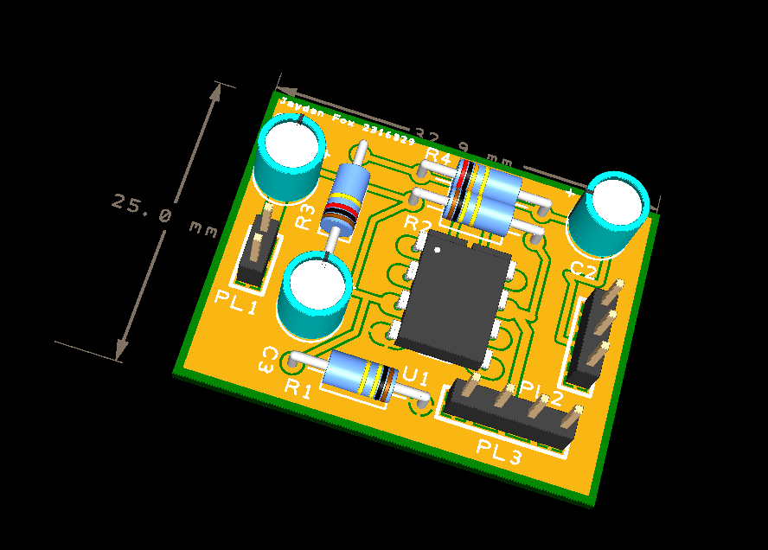

Jayden Fox - 2316329
Electrical & Electronic Engineering Degree Apprenticeship
Contents

Op Amp Schematic (Proteus) 2
Breadboard Circuit 5
Breadboard Circuit Testing 7
PCBs & Easy-PC 9
Building physical PCB 11

Op Amp Schematic (Proteus)
Firstly, I had a brief introduction to Proteus. I spent some time on the basics such as finding components and connecting them. Then, I started creating an op-amp circuit using a LM741 amplifier, 3 capacitors and 4 resistors. I tested this amplifier using an oscilloscope and function generator in Proteus and then used the graph feature to create a frequency response graph.
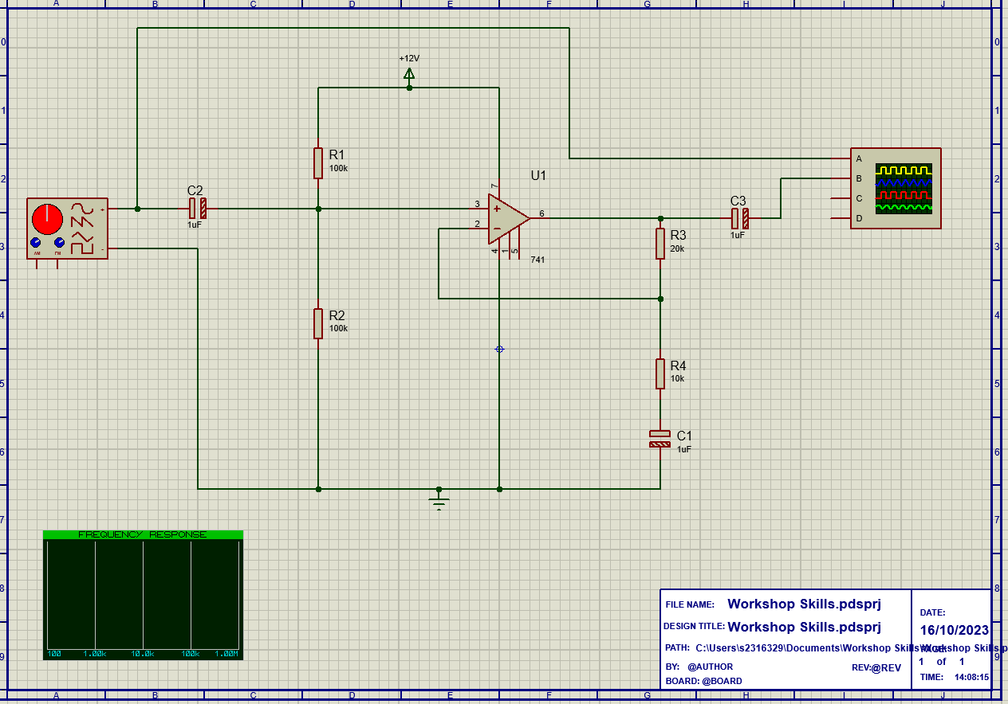
Figure 1: A schematic for a non-inverting amplifier, created in Proteus.
To find the gain of the amplifier, I used the function generator to generate different frequencies, increasing on a logarithmic scale. The voltage was set to 2V peak to peak. I started with a frequency of 1Hz and stopped testing at 200kHz. I gained the following results:
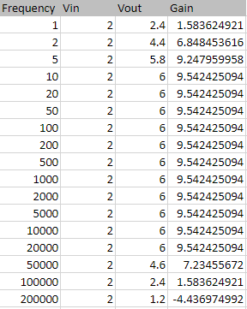
Table 1: Results showing the gain of the non-inverting amplifier at different frequencies.
I found that the gain started to decrease at higher frequencies, and this was due to the op amp not being able to keep up. The amplifier doesn't have a high enough slew rate. Slew rate is defined as the rate at which a device can switch its output.
These results gave me the following graph:
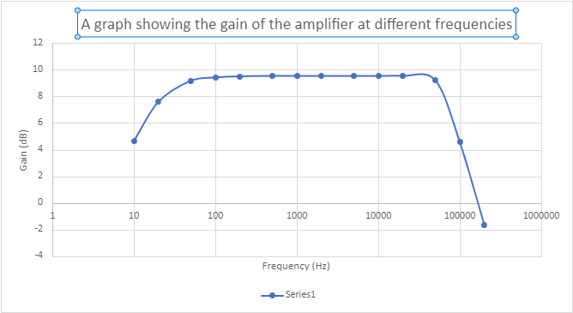
Figure 2: A graph to show the relationship between gain and frequency.
The function generator I used in Proteus looks like this and I used it to change the frequencies. The left knob allowed me to adjust the centre frequency and the second knob is to change the range of it. To get a frequency of 100kHz, you would place the first knob to 1 and the second knob to 0.1MHz (shown below). To achieve a sine wave, I used the top right button to change the waveform of my input and output traces.
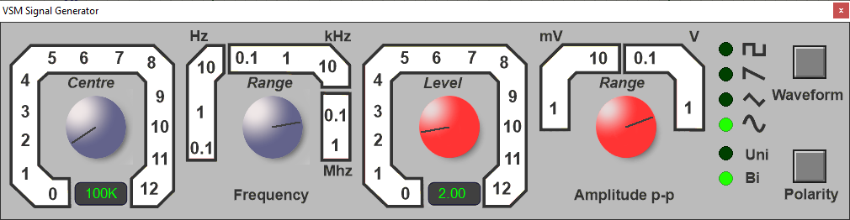
Figure 3: The function generator in Proteus set at 100kHz and 2V for my circuit.
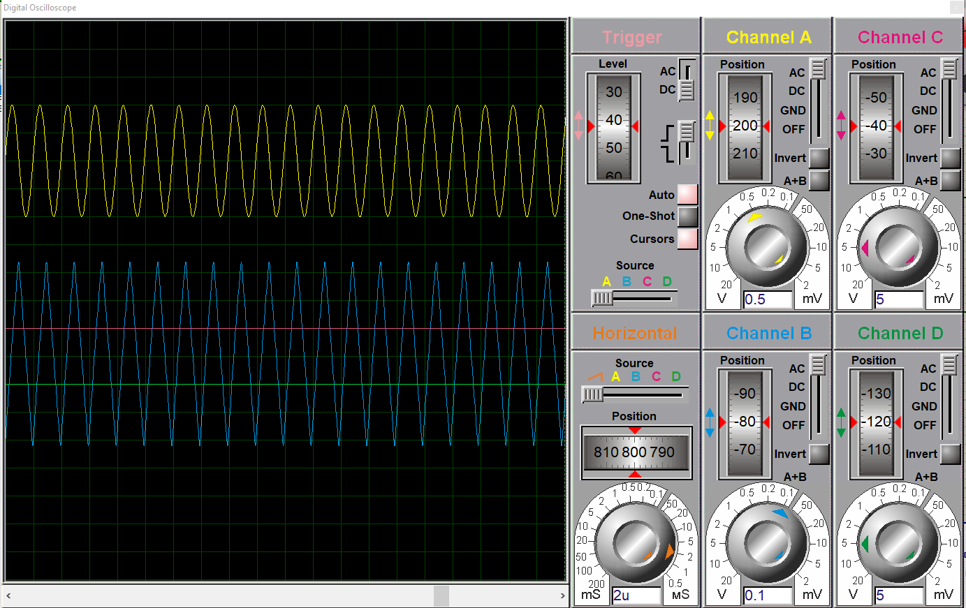
Figure 4: The resulting graph of the circuit with the settings mentioned in figure 3.

Breadboard Circuit
Then, I began creating a physical version of the circuit. I used a breadboard template on paper to plan where I was going to place each component and sketch out my connections.
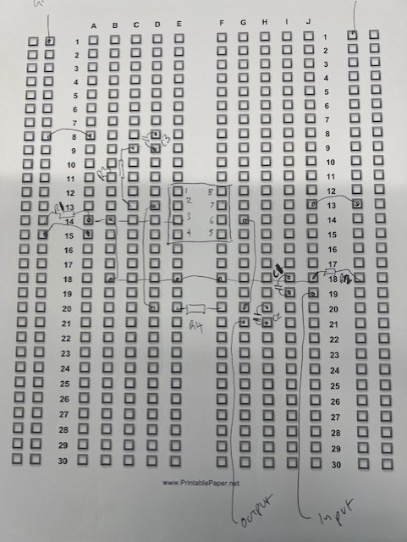
Figure 5: A planning sheet used to design my op-amp circuit to create it on a breadboard.
When building the circuit, I had to gather the appropriate components. I needed 3 capacitors, 4 resistors, LM741 amplifier and some wire. I experienced some confusion with resistor sizes as some were mixed up. I had to learn the colour codes of each band and what they meant to ensure I had the correct resistor sizes and the correct resistor placement. I used the following grid to ensure they were correct:
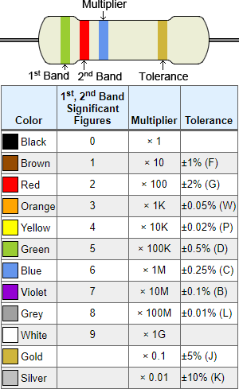
Figure 6: Table showing how to calculate the value of a resistors.
I also had to ensure that the middle capacitor was placed correctly according to the polarities to avoid damage. Using a breadboard was extremely simple as there are no permanent connections required so if a mistake was made like a component being placed incorrectly, then this could be easily corrected.
Component List
- LM741 Op-Amp
- 2 x 100kΩ resistor
- 1 x 20kΩ resistor
- 1 x 10kΩ resistor
- 3 x 1 µF capacitor
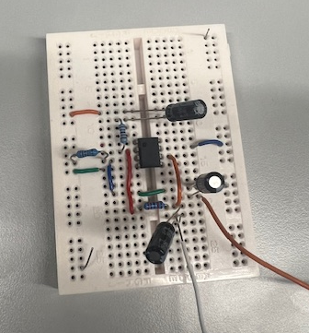
Figure 7: Created op-amp breadboard circuit.

Breadboard Circuit Testing
After building the op amp on an actual breadboard, I was able to use the equipment in my area to test it. I used a DC power supply, function generator and an oscilloscope. I used test probe leads to connect my circuit to the oscilloscope. On the oscilloscope, I had to change the position of the channel traces, so they did not overlap. Channel A was my input channel and channel B was my output. The oscilloscope was easy to read due to the way I set it. I was able to see the peak-to-peak voltage in the corner of the screen and this was 2V. At first, I was getting unusual/incorrect readings and I found this was due to the probe lead switch not being set to the same attenuation as the oscilloscope. Once this was changed, the readings were accurate.

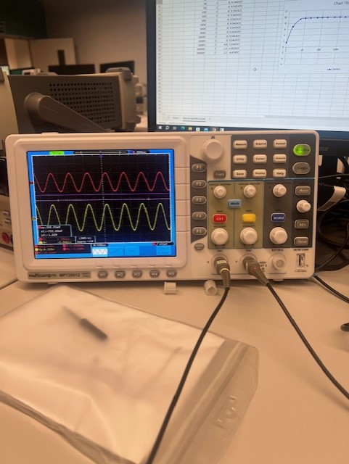
Figure 8: Oscilloscope results when testing breadboard circuit.

This is how my circuit was connected to the power supply:
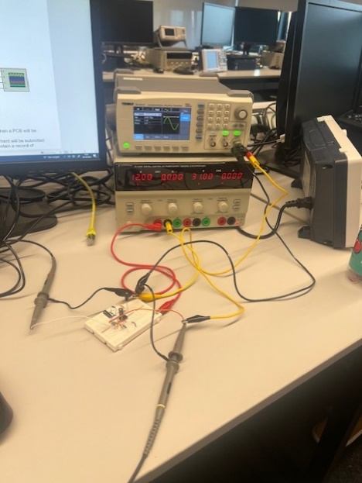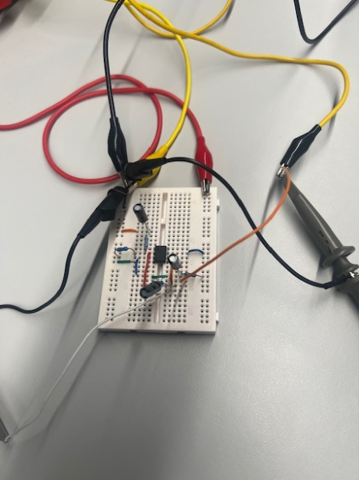
Figures 9 & 10: Testing equipment and how I set it up to test my circuit.
The power supply had to be current limited to ensure that it did not burn in the event of incorrect wiring. The black cables are all used as ground connections. There are 2 black wires used as the ground reference for the oscilloscope. The yellow cable is connected to the signal generator. The scope probe connected to the yellow cable (seen in figure 10) is measuring the input signal of the circuit, whilst the other scope probe is measuring the output.
By changing the frequency on the function generator, I carried out another similar test on the circuit to find the gain of the amplifier. The gain was calculated by using the formula:
$$20\log_{10}\left(\frac{Vout}{Vin}\right)$$
I gained the following results (table 2) which allowed me to obtain the gain and frequency graph (figure 11). The gain was measured in decibels and the frequency was measured in Hertz.
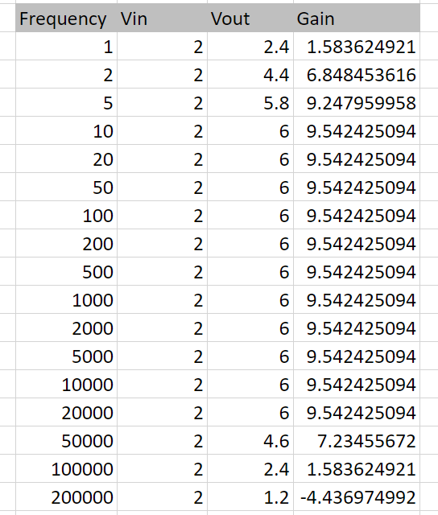
Table 2: Displays the gain at different frequencies for the breadboard circuit.
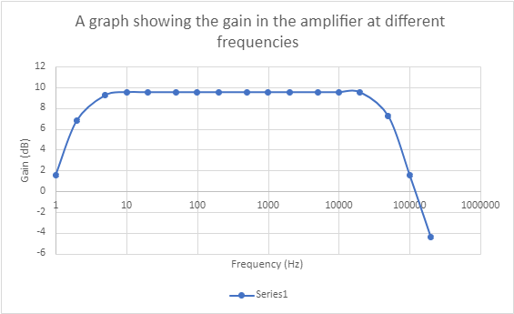
Figure 11: A graph showing the gain of the amplifier at different frequencies in my breadboard circuit.
The graph shape shows that at low frequencies, the gain starts off smaller and stays at 9.54dB when the frequency gets to 5Hz. This is due to the circuit being designed to have a constant gain.

PCBs & Easy-PC
Before creating my op amp schematic, we were shown a short video to introduce us to PCBs and give us an insight to how they are made.
I used Easy-PC software to start creating a PCB for my op amp circuit. I had to create the schematic and carefully place my components as close together as possible without any complications. I used the measuring tool to see the size of my PCB and kept moving components around to make it as small as possible.
Component List used for schematic.
- 1x LM741 Amplifier
- 3 x 10µF capacitor
- 2 x 100kΩ resistor
- 1 x 20kΩ resistor
- 1 x 10kΩ resistor
- 1 x 2-input connector
- 1 x 3-input connector
- 1 x 4-input connector
I used the add-track feature to connect all the components on my board. I came across some problems with creating the tracks as sometimes they were too close to the edge of the board. This meant I either had to find a new route for the track or increase the size of the board. Once I had connected all the components with tracks, I started changing the thickness of the tracks to give myself even more room on my PCB. I also initially had tracks for ground connections, but I later realised these were unnecessary as once I finished off my PCB schematic, I spent some more time moving components around to make it as small as possible and poured copper onto both layers as ground. To pour the copper, I had to create a new layer by drawing a box around the circuit. Then, I converted my schematic into Gerber files and sent all my work off for creation.
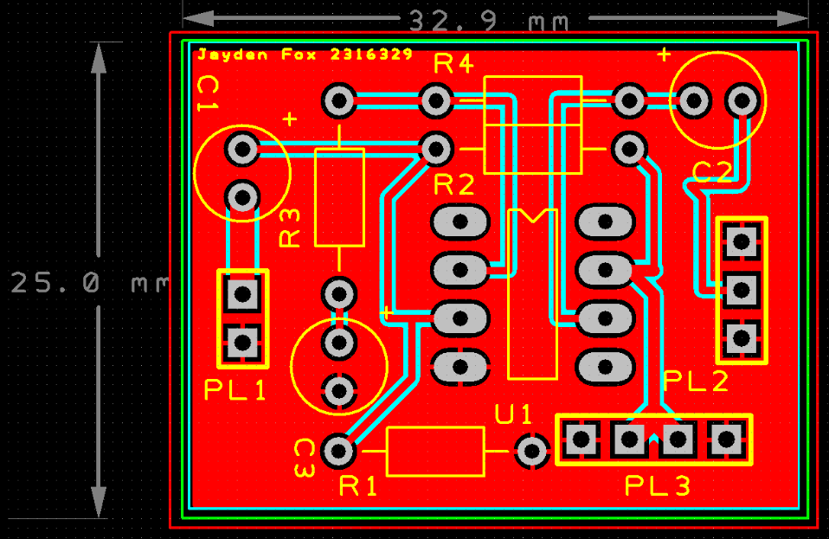+
Figure 11: The PCB schematic of the op-amp
Figure 12: Image of my finished PCB in 3D view

Building physical PCB
After a brief introduction to soldering, I was able to practice on a test PCB. It was explained that soldering is an essential skill for electrical engineers as it is commonly used to join components to circuit boards. Soldered connections are known to be more reliable and durable than other methods like using breadboards. Soldering is a fundamental skill for aspiring electrical engineers like myself as it used across all areas of electronic device/circuit creation.
Tools used:
- Soldering iron
- Extractor fan
- Soldering iron holder (to tin the solder and clean using sponge)
- Lead-free solder
I used lead-free solder and a soldering iron to connect my components to the board.
This practice session focused only on attaching resistors to the PCB but was helpful in practicing for the real PCB soldering. I had some feedback on this and was told some of the resistors needed more solder and this will be taken into consideration when assembling the final PCB.
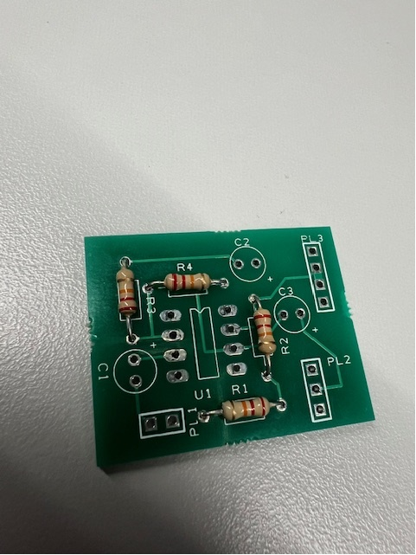
Figure 13: Top of first solder attempt on a PCB
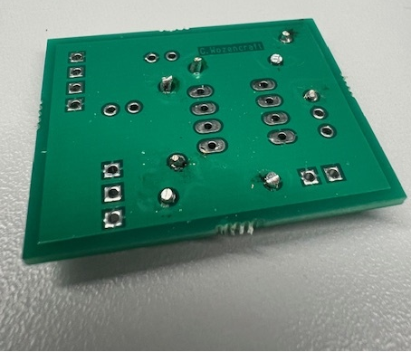
Figure 14: Bottom of practice solder on PCB

After receiving the actual PCB I designed, I started to solder the components on. I used the components off my breadboard circuit to ensure there were no mix-ups with component values etc. I also tested each component to prevent any incorrect components being used.
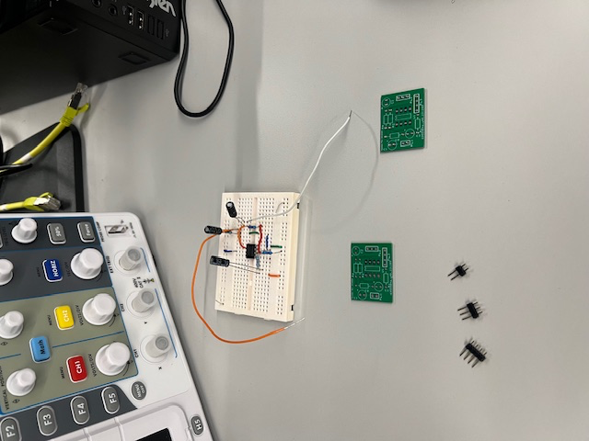
Figure 15: PCB and components

To start the assembling process, I decided to attach the resistors first as these were the only components that were not the same value for each one. I was able to look at the created schematic and create a table showing the component values to find the corresponding resistor numbers and values.

Component Name | Component Value
R1 | 100kΩ
R2 | 100kΩ
R3 | 20kΩ
R4 | 10kΩ
C1 | 1µF
C2 | 1µF
C3 | 1µF
Table 3: Component names and values

To attach the components, I again used the solder iron and lead-free solder. The tools were set up correctly and the whole soldering processed was carried out in a safe manner. I had few problems with the process, only having to resolder sometimes as there was not enough solder to attach the component to the PCB. There was also a problem with the tip of my soldering iron where it was black and would not heat up the solder. In this situation, I had to clean the tip of the iron until the solder would heat up correctly.
Once soldered on, both legs of the component were cut to make the PCB look tidier and ensure there were no electrical contacts to the other surrounding components, as contacts would cause a short circuit. This process was repeated for each component, along with the three power connectors. As the amplifier was the most damage prone component, I decided to leave this as the last component to be soldered. All the components were placed correctly according to the right polarities and the pinouts of the amplifier. I was able to see the polarity signs on the capacitors on the component itself and on the PCB. I was also able to use the circle in the top-left of the amplifier to know which way it had to be placed and ensure each component lined up the correct pin of the amplifier.
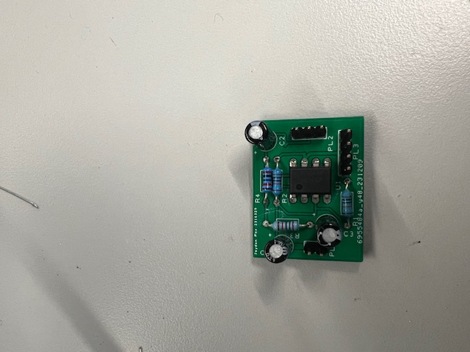
Figure 16: Completed PCB with components attached.

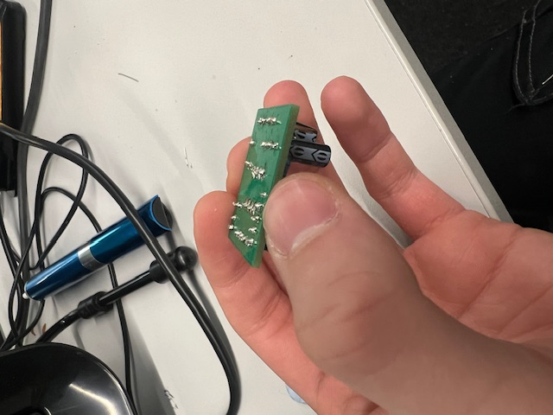
Figure 17: Reverse of completed PCB.
The PCB was then connected to the oscilloscope and function generator through the use of the power connectors and probe clips. Again, the channels of the input and output were moved so they could be read clearly, and the problem with the probe clip attenuation not being the same as the oscilloscope did not reoccur.
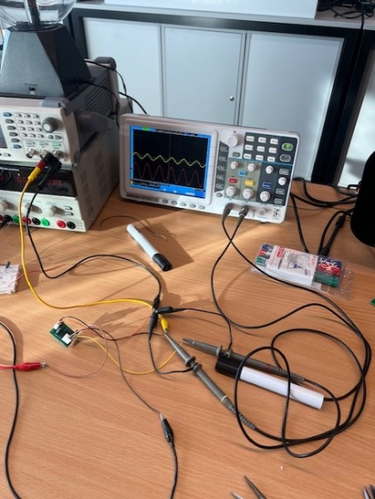
Figure 18: PCB connected to function generator and oscilloscope.
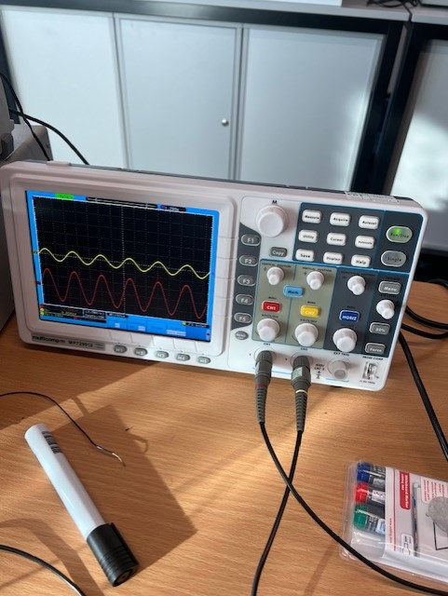
Figure 19: Oscilloscope results

After testing, it was shown that the PCB worked as it was supposed to meaning there was no errors with the schematic or assembling of the PCB. An input voltage of 1V was used and an output voltage of 3V was returned. The successful testing of the physical PCB confirmed the accuracy of the schematic and shows my soldering skills were improved on to create a PCB that successfully works as required.

