University of Wales Trinity Saint David

Wales Institute of Science & Art



Study Skills Assignment
Study Skills (ACMA 4039)

Callum Smith
2515673
December 2025

Table of Contents
Wales Institute of Science & Art 1
1. Abstract 2
2. Introduction 3
2.1. Scope of the report 3
2.2. Importance of Risk Management 3
2.3. Aims and Objectives 3
3. Literature Review 4
3.1. Overview of Risk Management in Manufacturing 4
3.2. Tools of Risk Management 4
3.3. Legal and Ethical Considerations 4
4. RCA Results 5
4.1. Methodology of RCA 5
4.2. Rankings and Justifications 5
4.3. Proposed Corrective Actions 5
4.4. Residual Risks 6
5. Conclusion 6
6. References 7
7. Appendix 8

1. Abstract

This report explores the use of Root Cause Analysis (RCA) in engineering risk management, focusing on a Z-axis tracking fault in a Coordinate Measuring Machine (CMM). The report outlines the RCA process, evaluation on the impact of a Z-axis tracking issue and further proposes corrective actions such as frequent calibration and guide rail cleaning to improve and mitigate the issues. Legal an Ethical consideration including the IMechE Code of Conduct and Health and Safety Legislation are also mentioned. The RCA demonstrates its effectiveness within system operations and managing residual risks through continuous monitoring, though RCA effectiveness depends on data quality and thorough implementation.

2. Introduction

2.1. Scope of the report

In engineering, risk management is a fundamental aspect of engineering practice within manufacturing environment where precision, reliability and safety are essential. This report looks at the use of Root Cause Analysis (RCA) as a method used for identifying and mitigating faults within engineering systems. The focus of this report looks at the Z-axis tracking fault found on a coordinate Measuring Machine (CMM).

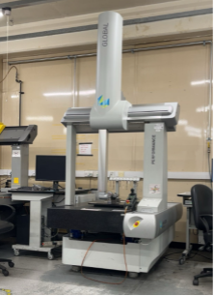
(Image 1 Smith, C 2025a)

“A CMM is a device used to measure the geometry of physical objects. It employs a probing system to detect points on the surface of an object, providing precise measurements.” (Measuremetrology.com, 2025). This report will evaluate the use of RCA and how it can be applied to diagnose the CMM fault, assess and resolve for the benefit of performance and reliability.

2.2. Importance of Risk Management

Manufacturing processes rely on consistent system performances to maintain quality and operational efficiency. Failures in equipment can lead to significant downtimes including scrap or delays to production. An effective risk management is important for engineers to identify potential risks, evaluate their severity, and mitigate any potential issues from recurring. Using a Root Cause Analysis (RCA) will be important for this process as it is used to ensure engineers to respond earlier rather than when equipment fails.

2.3. Aims and Objectives

The primary aim of this report is to investigate the effectiveness of RCA as a tool for identifying and mitigating risk within the CMM. The objectives are to examine how RCA will contribute to fault detection and resolution in engineering systems, assess legal and ethical considerations involved in risk management including the IMechE Code of Conduct and the UK Health and Safety legislations, the finally evaluate the effectiveness of RCA in improving reliability and performance of CMM.

3. Literature Review

3.1. Overview of Risk Management in Manufacturing

Risk Management is the process within management which includes identifying, evaluating, and mitigating certain risks that can occur. In terms of Engineering, it is the process of identifying, assessing, and mitigating any risk to performance, safety or reliability of systems and operations. (Venkatesh Gandham, 2025). Manufacturing environments are particularly vulnerable to a wide range of issues such as internal or external problems. These problems can include technology or system failures, equipment failures, supply chain disruptions, and regulatory non-compliances. These issues can cause serious problems to a company financial situation depending on how severe the outcome is. An effective risk management will help maintain operational control, reduce downtime, and ensure compliances will legal and ethical standards. (McGrath, 2025).

3.2. Tools of Risk Management

When a company or individual is looking for a tool to use for risk management, a common one is a Root Cause Analysis (RCA). An RCA is a well-structured problem process of finding and eliminating the cause which can prevent a problem from returning or recurring. The RCA will aim to uncover the true source of a problem so that long term effective solutions can be put into place. (Taylor & Francis, 2021). A few common techniques for RCA include the 5 why’s, fishbone diagrams or Effective Analysis (FMEA). The 5 whys method is effective to identifying simple, linear issues through constant questioning (Croft, 2025). The method of choice is going to be the FMEA method which is more systematic as it is a structured and initiative-taking approach used to identify and evaluate the potential failures based on severity, occurrence, and detection. These machines are crucial for dimensional accuracy as even a slight deviation can lead to quality issues. Using RCA provides engineers with corrective actions, maintenance protocols, and overall improved system reliability. RCA although effective at mitigating issues, can be very time consuming especially if the data of the operation is considerable. The issues are the reactive issues after they occur rather than preventing them. Mitigating the drawbacks is what a tool like FMEA is for as it allows a more comprehensive risk management approach. (e Oliveira, Miguéis and Borges, 2022)

3.3. Legal and Ethical Considerations

In Engineering, risk management is not only a technical fundamental but also a legal and ethical obligation. Engineers must follow these laws and professional standards to ensure safety and positive contributions to society. The Institution of Mechanical Engineers (IMechE) Code of Conduct outlines the responsibilities of engineers in maintaining a professional integrity (The Mandatory Training Group, 2025). Alongside the IMechE Code of Conduct engineers need to follow the Health and Safety legislation which provides legal requirements for protecting workers, the public, and the environment. (Health and safety Executive, 2024)

4. RCA Results

4.1. Methodology of RCA

When conducting an RCA, the method chosen in the report is FMEA. First you will first define the problem by clearly describing where, when and what happened, and the impact followed. Next, you would gather any data related to the issue like logs or reports to understand the context and timeline. Following this you would brainstorm all practical solutions with tools mentioned previously like the 5 whys or FMEA. Next, you would analyse the causes and see which problem had the most effect on the issue. Pinpointing the reason the problem occurring not just its symptoms. Then corrective actions will be put into place to prevent any recurrence of the problem. And finally, you will track the effectiveness of the solution and make any adjustments if necessary. (Learn Lean 6 Sigma, 2025)

4.2. Rankings and Justifications

The rankings for this RCA are related to the CMM and more specifically the CMM system operations. The issue at hand was the CMM losing tracking on the Z-axis when taking measurements near the bottom limits. An issue like this leads to the machine being out of use and requiring proper analysis. From a company's stand it will slow down the rate of quality checks meaning parts will not be produced as efficiently. For rankings on the RCA, they will be conducted on a scale of 1-10 following a FMEA rating scale found in table 1.

First looking at the severity, the rating given was a 6 which ranks near the medium/high range. If the loss in tracking affects measurement accuracy or machine stoppage, it can severely affect quality control and productive timelines, making the severity a 6.

Second is the Occurrence which is given a 3 which ranks in the low/medium range. As its only happening on the Z-axis and infrequently, it gets a low rating but as it is a new issue it can occur which would increase the risk.

Lastly, the detection which is given a rating a 4 which ranks it in the medium range. With the failure being detected during the measuring it improves the score, but the program itself does not show any problems and neither does the machine itself making the score increase. The Risk priority number for this problem will be 72. The RPN was calculated by using the formula (Severity x Occurrence x Detection) resulting in the RPN of 72 (6 x 3 x 4). The RPN indicates a moderate risk level requiring corrective action to prevent recurrence. (Engineer Fix, 2025) The score relative to RPN score standards can be found in table 2.

4.3. Proposed Corrective Actions

Following the rankings, corrective actions need to be put into place to mitigate or permanently remove the issue of occurring again. Previously, the machine was calibrated infrequently to address the issue. Now to best mitigate any issues on the CMM there are a few corrective actions put into place. First, there is a full restart on the machine as well as more frequent calibration it to check the firmware is up to date and that there are no issues with probes or etc. Next is cleaning the machine more often to get rid of any build-up of debris or dust that can be found along the guide rails preventing any misreading’s or alignment issues. And finally, there are conducted tests on the CMM specifically at the Z-axis which is important can be done by taking measurements and comparing data with current performance charts to ensure that the CMM is operating with high accuracy.

Overall, the RPN score following the corrective actions brings it down to an 8. The severity score is now a 4 as the risk is still severe if occurred, the chances are lower from the mitigation actions. The occurrence is now a due to constant calibration and cleaning of the CMM, the score could be lower but due to the risk being new, unknown issues similar can occur in the future. Finally, Detection is also a 2 likewise with occurrence as constant monitoring with mitigate the issue best going forward to look at any early signs that can occur.

4.4. Residual Risks

Although implementing these corrective actions such as full calibrations and frequent cleaning, residual risks can still occur. This can include issues with the software that are not being detected during calibration, hardware faults with the Z-axis sensor and temperature fluctuations on parts or the machine which can affect measuring accuracy. Additionally, the detection system may not identify early signs of failure as the fault can happen sporadically. Although in the RCA the readings suggest the risk is manageable, no risk can be permanently removed. This means that there will be constant monitoring through performance checks, firmware audits and comparing data against baseline measurements. With the current mitigation methods used, the residual risk is considered acceptable within operational tolerances with the if maintenance and monitoring method are consistently used.

5. Conclusion

In summary, this report demonstrates how the RCA was used to mitigate issues within engineering districts and more specifically looking at a CMM machine and its system operations. Through using the RCA method, the issue of the Z-axis issues was analysed, ranked using FMEA and addressed with corrective actions such as frequent calibration cleaning and performance testing.

The ratings indicated that although the RCA was effective in improving reliability and operational efficiency, residual risks remain and require ongoing monitoring. This includes the integration of legal and ethical standards including the IMechE Code of Conduct and Health and Safety Legislation, showing the importance of engineering controls.

6. References

Measuremetrology.com. (2025). What is a CMM Machine? – Made to Measure. [online] Available at: https://measuremetrology.com/what-is-a-cmm-machine/.

Venkatesh Gandham (2025). Risk Management in Engineering. [online] School of PE. Available at: https://schoolofpe.com/blogs/news/risk-management-in-engineering-html?srsltid=AfmBOooDWxaDKfuiPTfgx4jbHc_cwQ4Dygr3N_MJWRXKUzs_HkHgsIJh [Accessed 27 Oct. 2025].

McGrath, A. (2025). Risk management. [online] Ibm.com. Available at: https://www.ibm.com/think/topics/risk-management.

Taylor & Francis. (2021). Root cause analysis - Knowledge and References | Taylor & Francis. [online] Available at: https://taylorandfrancis.com/knowledge/Engineering_and_technology/Engineering_support_and_special_topics/Root_cause_analysis [Accessed 27 Oct. 2025].

Croft, D. (2025). How To Perform A 5 Whys Analysis: Step-by-Step Guide. [online] Learn Lean 6 Sigma. Available at: https://www.learnleansigma.com/root-cause-analysis/how-to-do-a-5-whys-analysis/.

The Mandatory Training Group. (2025). Role of the Institution of Mechanical Engineers. [online] Available at: https://www.mandatorytraining.co.uk/blogs/complyplus/role-of-the-institution-of-mechanical-engineers?srsltid=AfmBOoqhXEKjKJes-Hh1mQy2f7dFSB1M2CXZDYfALjT9yH8WF06HD8BU [Accessed 27 Oct. 2025].

Health and Safety Executive (2024). Health and Safety at work act 1974. [online] Hse.gov.uk. Available at: https://www.hse.gov.uk/legislation/hswa.htm.

Institution of Mechanical Engineers (2023). Code of Conduct explained - IMechE. [online] www.imeche.org. Available at: https://www.imeche.org/about-us/imeche-governance/governance-and-finance-reviews/code-of-conduct-explained.

Learn Lean 6 Sigma. (2025). Master Root Cause Analysis In 6 Steps. [online] Available at: https://www.learnleansigma.com/root-cause-analysis/how-to-do-root-cause-analysis-rca-like-a-pro/.

Engineer Fix. (2025). How to Calculate a Risk Priority Number (RPN). [online] Available at: https://engineerfix.com/how-to-calculate-a-risk-priority-number-rpn/ [Accessed 11 Nov. 2025].

Ronen, M., Weissbrod, R., Overdyk, F.J. and Ajizian, S. (2016). Smart respiratory monitoring: clinical development and validation of the IPITM (Integrated Pulmonary Index) algorithm. Journal of Clinical Monitoring and Computing, 31(2), pp.435–442. doi: https://doi.org/10.1007/s10877-016-9851-7

e Oliveira, E., Miguéis, V.L. and Borges, J.L. (2022). Automatic root cause analysis in manufacturing: an overview & conceptualization. Journal of Intelligent Manufacturing, 34. doi: https://doi.org/10.1007/s10845-022-01914-3.

7. Appendix

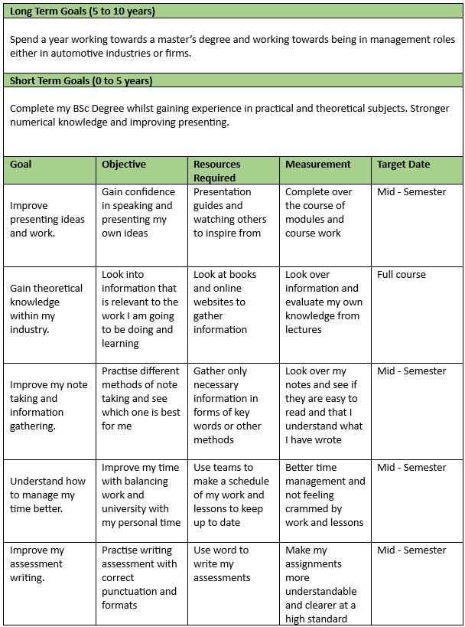
Image (Smith, C 2025b)

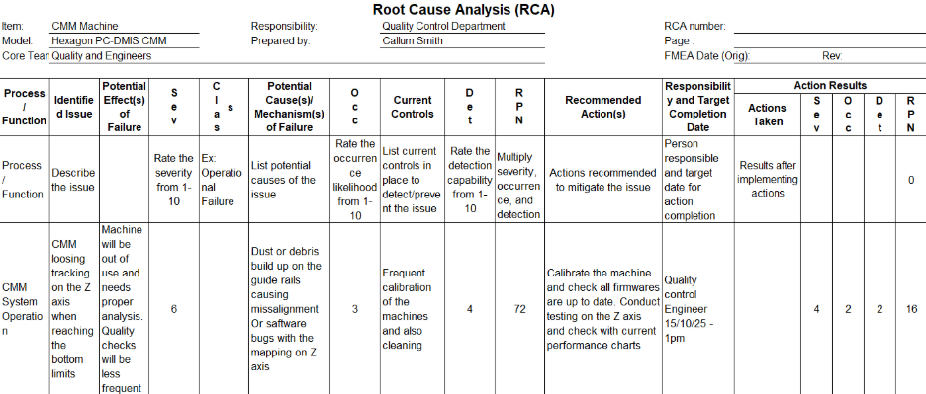
Table 1 (Smith, C 2025c)

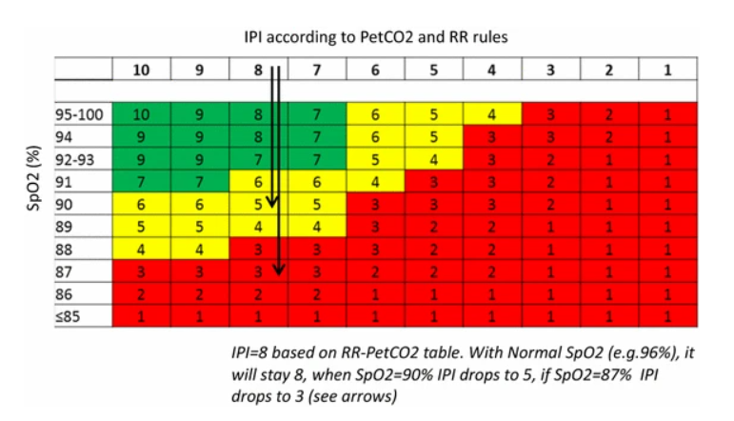
Table 2 (Ronen et al., 2016)

