Steps to Record Audio in PowerPoint
There are a number of ways you can do this.
One of these is outlined below. Please contact IT if you are having any issues in recording your audio successfully.
Step 1: Open Your Presentation:
Launch PowerPoint and open the presentation where you want to add audio. If you are starting from scratch, make sure to complete the slides with design and interactive elements (make sure your presentation is engaging!) before adding your audio.
Step 2: Choose the Starting Position
- Go to the ‘SlideShow’ tab and click on the arrow next to ‘Record Slide Show.’
- Choose between ‘From Current Slide’ or ‘From Beginning’ based on your requirements.
- This will open the recorder window, where you can make necessary adjustments to the settings.
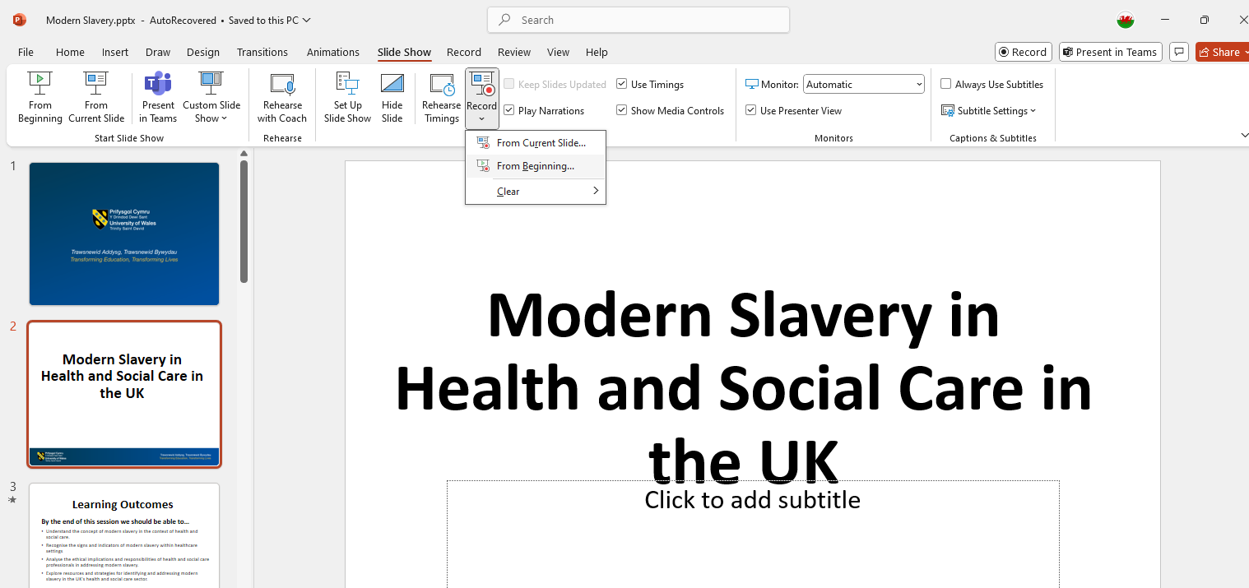

Step 3: Adjust Settings
You can select the microphone, view your notes, and toggle your camera on or off. REMEMBER- for this submission you do NOT need to use the camera to record VIDEO. Only AUDIO recording is required.
Before you start recording, ensure your microphone is set up correctly.
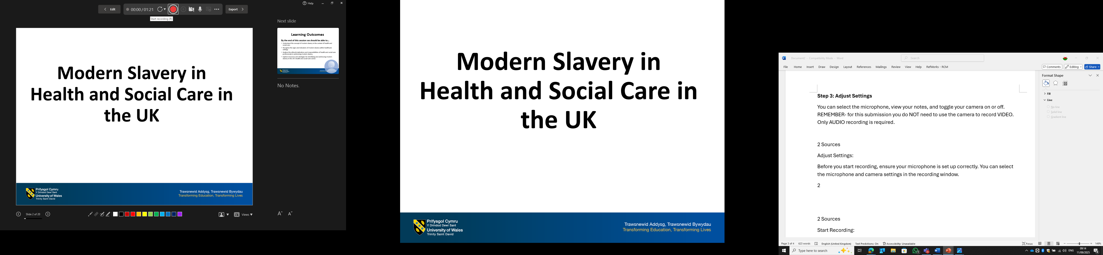
Step 4: Start Recording
Click the Record button to begin. A countdown will appear, and then you can start narrating your slides. Use the navigation arrows to move between slides as you record.
Step 5: Pause or Stop Recording
You can pause the recording at any time and resume when ready. To stop recording, click the Stop button (in many cases the record button).
Timing Your Recording:
Either at the top of the screen, (as in my example above) or at the bottom left, depending on the device you are using, you will find two timers: one for the entire presentation and one for the specific slide, helping you keep track of the recording length.
Review and Save:
After recording, you can replay the audio to ensure it sounds good. Each slide will now have your recorded audio attached. Save your presentation as usual ready for submission to Turnitin.

