Therapy Assistant Practitioner:
Demonstrating Practice Logbook

Name: Helen Jones
Supervising Therapist/ Mentor: Jo Norris
Date commenced: 01/02/2024

The content page includes a check list of evidence to be collected with columns to help correspond the continents.

Contents | Pages | Appendix
- Log of supporting documents from mentor:  - Log of assessments and goal setting.  - Log of a wide range of assessments.  - Log of clinical interventions within scope of practice.  - Log of risk a risk assessment and how it informs practice.  - Report on learner’s time and workload management.  - Log of compliance with mandatory training.  - Copy of a recent Personal Development Appraisal Review (PDAR).  - Copy of recent supervision records (at least two).  - Completed peer review sheet. | Page 6-8  Page 9  Page 10-12  Page 13-14  Page 15  Page 16  Page 17-23  Page 23-27  Page 28-30 | Appendix A  Appendix B  Appendix C  Appendix D  Appendix E  Appendix F  Appendix G  Appendix H  Appendix I

The Therapy Assistant Practitioner (TAP) demonstration of competencies in the following areas:
- Log of supporting documents from mentor: | Details to include: | Date of completion: | Mentors signature:
- Log of assessments and goal setting. | A completed initial assessment or detailed screening form, including evidence of patient centred goal document. | 31/01/2024 | J.Norris
- Log of a wide range of assessments. | A minimum of three assessments completed, demonstrating a range of skills and tools. | 01/02/2024 | J.Norris
- Log of clinical interventions within scope of practice. | A minimum of three interventions completed, demonstrating a range of skills within scope of practice. | 05/02/2024 | J.Norris
- Log of a risk assessment and how it informs practice. | A completed risk assessment within the workplace, which can include clinical practice or department procedure. This can include case notes, reports, DATIX or professional discussion, which consists of risk identified, how the learner managed the risk and informed progress. | 05/02/2024 | J.Norris
- Report on learner’s time and workload management. | A completed report with mentor’s feedback of the learner’s time and workload management. The report can be completed on a word document and will need to be signed and dated. The report will need to include an example of how the learner demonstrates good time and workload management. | 05/02/2024 | J.Norris
- Log of compliance with mandatory training. | A copy of the learner’s compliance with mandatory training. Compliance is required to be 80% or above. | 07/02/2024 | J.Norris
- Copy of a recent Personal Development Appraisal Review (PDAR). | A copy of the most recent PDAR document completed with supervisor / mentor. | 08/02/2024 | J.Norris
- Copy of recent supervision records. | A minimum of two supervision records, demonstrating attendance and contribution to supervision and agreement to actions. | 08/02/2024 | J.Norris
- Copy of peer review document. | An attached copy of the peer review document completed following observations of others presentations. | 08/02/2024 | J.Norris
This logbook was completed by: Mentor’s name: Jo Norris…… Mentor’s signature:……J.Norris………………Date: 16/02/2024……………. Learner’s name: Helen Jones………………………. Learners’ signature:…H.Jones………………….. Date:…16/02/2024……

Appendix A.
I have used initial assessments that I have carried out and have highlighted the analysis part to demonstrate how I agreed with patient a personalised set of goals as demonstrated in here.
Analysis part of initial assessment with patient where we discussed how Prehabilitation can fit around patients life and how we can look at improving activity levels in a way that works for the patient and finding solutions together.
Assessment Session
Date of Session: 12/01/2024 Time of Session: 11:30
Session Summary:
S/ Patient attended Screening Clinic today via Microsoft Teams, with husband present. Explicit consent gained to engage with Prehab. See Prehab Questionnaire PROMs form in patient file for details. Patient stated she had her surgery to remove lump 18th December and she states that she is expecting to have a hysterectomy, having an MRI Monday, awaiting results of biopsy and has a CT scan this afternoon. Patient states her period has not stopped and she has stopped bleeding 2 weeks ago for the first time in a while.
NUTRITION : Patient states she is unsure how much she weighs and stated that she put in 95kg but is unsure of how much it actually is and that this was a guess. Patient states that she has been desperately trying to lose weight after coming off the HRT therapy which she feels made her put on weight. Her bowels are either loose or she is constipated and they tend to eat one big meal a day on average. Patient states she avoids the weighing scales because she feels quite conscious about trying to lose weight and became quite emotional when discussing this. Patients husband stated that she has not had any change in clothing sizes so does not feel that there is any weight loss. Reported bowels fluctuate between constipation and diarrhoea.
ACTIVITY : Patient became quite emotional discussing this and stated that she had been going to spin classes and has not been as active lately at all and feels that she wants to be doing a lot more. Both her husband and herself are members of the gym. Patient stated that she has completed pelvic floor exercises and feels confident with these but feels that she has always had issues with being able to engage her core with exercise since having surgery and feels that support with this could be beneficial to her. Lives in a 5 storey house and spends a lot of time using the stairs. Gets out into the park opposite her house for a walk once or twice a week. Spends a lot of time sitting throughout the day due to her job being quite sedentary as a solicitor. Did not complete STS as not deemed as appropriate at this time as patient quite emotional and upset so deemed discussion more appropriate and to follow up with discussion with physio.
WELLBEING : Patient became quite emotional during session and states she feels her mood is around a 6/10 and this fluctuates often. Patient feels very supported by husband and friends but also states she really struggles with being able to motivate herself to manage tasks. She states she is an organised person and likes to plan things but states she is struggling since her diagnosis and she feels she is faced with the unknown and is unable to plan for this. Energy fluctuates due to this. She feels she gets very low at times.

O/ PGSGA administered and clinical discussion around aspects of exercise and wellbeing - see Screening Clinic PROMS form in patient file for details. Advised patient regarding having weighing scales and regularly weighing herself and discussed dieting and issues around losing muscle and not fat. Advised to increase activity and increase protein intake also to support this and not to cut down too much on food and look at moderation in her diet. Asked patient if she would like to increase her activity, patient stated she would. Discussed how prehab could support with this and stated that we can support with Actif Anywhere as patient works at present and patient stated she would like to get back to the gym as well. Also discussed how we can possibly cater exercise and activity to her and look at core exercise and speaking with the physio may be able to support with this. Patient agreed. Discussed thinking of positive things that have happened throughout that day and possibly writing these down so she can end the day on a positive note. Discussed counselling services and availability of support services such as Maggies, Macmillan and counselling but patient feels at present she has enough support from husband.

A/ Patient appears targetted from a Physiotherapy perspective and may require further involvement and may need monitoring as agreed with patient from a Dietetic and OT perspective. Patient may like to use Actif Anywhere and may benefit from this. Discussion regarding issues with engaging core and having attempted exercise previously feels she struggles with strengthening this area and would like further advice on how to achieve this. To discuss Actif Anywhere further with her to see if appropriate and possibly relaxation sessions if agreed with patient.

P/ List patient for Band 7 Triage clinic for further discussion. Send out appointment as agreed with Jo Norris Physio and with patient.

MS form completed and saved in patient folder [ X ]
Scoresheet completed and saved in patient folder [ X ]

Signed: H.Jones Name: Helen Jones Profession: TAP
Date: 12/01/2024 Time: 14:28

Highlighted section below demonstrates discussion with patient of what they feel their Prehabilitation needs are at present and patient anxious about surgery and what to expect so discussed a separate session as arranged for a peri op to go over aspects of going into hospital and discussing further in detail what to expect which patient felt reassured about.

Assessment Session
Date of Session: 29/12/2023 Time of Session: 13:30
Session Summary:
S/ Patient attended Screening Clinic today via Microsoft Teams, no issues with logging on, wife in background but not on camera. Explicit consent gained to engage with Prehab. See Prehab Questionnaire PROMs form in patient file for details. Patient reports he is awaiting date for surgery but Debra his CNS has told him it should be in the next week or so. Patient reports he is going away in his motorhome with his wife and dogs to Pembrokeshire this weekend for a weekend away.
ACTIVITY: Patient reports he walks the dog Winston twice a day in morning and afternoon for around 40 minutes each time. Reports he has a sit down job giving courses online but when he is not at work is always moving around and does not like to sit still for long. Patient reports he feels he is an active person generally. Completed 21 STS.
WELLBEING : Patient feels that he just wants to get surgery over with and has not worried too much, no issues with sleep or fatigue reported. No issues with mood or anxiety reported. Patient feels he copes well with his wifes support and is still managing work/life balance with no issues or concerns and feels he can contact CNS with any issues he has.
NUTRITION : Patient does not weigh himself and does not have scales at home and stated that he has had comments that in the past few months he looks like he has lost weight and feels it may only be a pound or 2. Patient has no issues with his appetite and reports he likes to eat everything, no issues with bowels and has been given no specific dietary advice.

O/ Standard measures of IPAQ, 30 sec STS and PGSGA completed - see Screening Clinic PROMS form in patient file for details. Discussed ways of increasing activity at home and patient stated he would like to think of ways. He has been discussing with his wife going swimming and also has a bike that he was discussing he may use. Discussed with patient Actif Anywhere membership, gave him description and if he would like it also and stated that he can think about this and email us to let us know. Offered reassurance that patient was managing his prehabilitation needs very well at present and if we can support with any desire to increase activity we will. Patient understands the importance of increasing activity. Discussed getting scales to enable him to monitor his own weight and notice if any weight loss and weigh same time every week. Discussed increasing protein and ways to do this.
A/ Patient appears Universal from a Physiotherapy, Dietetic and OT perspective. Discussed with patient having peri op booked for next week at same time to discuss tips for surgery and patient happy with this and would like all the information discussed in appointment sent out to him also and is aware of how to contact us if he needs any further guidance following this.

P/ List patient for Band 7 Triage clinic for further discussion. Send universal booklet out to patient and book in peri op agreed with patient on Friday 05/01/2024 @ 13:30 and discharge if no further needs.

MS form completed and saved in patient folder [ X ]
Scoresheet completed and saved in patient folder [ X ]

Signed: H.Jones Name: Helen Jones Profession: TAP
Date: 29/12/2023 Time: 14:28
Assessment Session
Date of Session: 28/11/2023 Time of Session: 14:00
Session Summary:
S/ Patient attended Screening Clinic today via Microsoft Teams, with husband in background. Explicit consent gained to engage with Prehab. See Prehab Questionnaire PROMs form in patient file for details
Patient reports that she was diagnosed in March with rectal tumor and has since had 2 lots of chemo but was found she was neutrophenic and resulted in her having 5 weeks of chemo/rad up until July. Patient reports that she was down for Elap surgery before xmas but states that because of the procedure and she has a 9 year old at home that she looks after she has opted to have the surgery after xmas on the 3rd or 4th on January. Patient reports that she was admitted to hospital twice in the past year due to being unwell and caught HAI pneumonia and covid and was very unwell during that period. Patient reports that her iron and feratin levels are low and she is due to go in for an iron infusion soon. Patient reports that she has not been working since March.
ACTIVITY: Patient reports that she has not been able to take long walks like she used to in the past year and reports that since radiotherapy she has found that she has a lot of weakness in her hips and this joint pain has slowed her down a lot so when carrying out any kind of activity she really has to pace now and take her time. Patient does general household chores around the home but needs to take her time doing any of these things. Patient reports that she wears crocs most of the time as this seems to ease her joint pain slightly when walking.
NUTRITION : Patient reports that she has lost a lot of weight in past year due to being unwell in hospital and during period of radiotherapy where she felt that she lost her appetite. Patient is currently taking Aymes shakes once a day but has not felt like so much in last week. Patient is managing 3 balanced meals a day and although she lost a stone and half in last year she has managed to put a stone back on since but states that this fluctuates and she does weigh herself weekly.
MOOD/ANXIETY/FATIGUE/SLEEP : Patient reports that she feels that she is not having any issues with mood at present but feels very worried regarding the surgery and feels that this is affecting her wellbeing. Patient reports she has a very good support network within her family and is able to talk to them but feels that she struggles to relax at times and reports that her sleep is affected. Patient reports that she has issues with sleep and naps in the day and does not feel that this is restorative and has broken sleep managing to sometimes go to sleep at 9:30 and awake at 2am to go to toilet and cannot go back to sleep and states that she feels that this is due to worry but also due to menopausal symptoms of night sweats.

O/ Standard measures of IPAQ, 30 sec STS and PGSGA completed - see Screening Clinic PROMS form in patient file for details. Discussed Actif Anywhere with patient as an option for her to try possibly and due to her inability to feel she has the strength the undertake any activity to arrange a meeting with physio to discuss personalised options for her. Discussed options of possibly trying mindfulness as an activity to reduce her worry. Patient agreed that she would like to try these options.

A/ Patient appears Universal from an Occupational therapy perspective although could benefit from offering further techniques for managing sleep and fatigue if required and to try mindfulness and Tai Chi to reduce worry as agreed with patient. Is triggering for further involvement from a Dietetic and physiotherapy perspective.

P/ List patient for Band 7 Triage clinic for further discussion.

MS form completed and saved in patient folder [ ]
Scoresheet completed and saved in patient folder [ ]

Signed: H.Jones Name: Helen Jones Profession: TAP
Date: 28/11/2023 Time: 15:15
Highlighted section above where needs identified in initial consultation with patient included further contact with dietetics to assess nutritional needs due to weight loss and inability to tolerate fortification supplements as identified in assessment, contact with physiotherapy to discuss a more personalised plan as patient felt she had lost a lot of core strength and wanted to focus more on this. Utilising our Tai Chi resource and trying mindfulness techniques with her was agreed with patient at that stage.

Appendix B.

Assessments including PROMS questionnaire on initial assessment, PGSGA nutrition assessment and IPAQ activity assessment filled out with a patient.

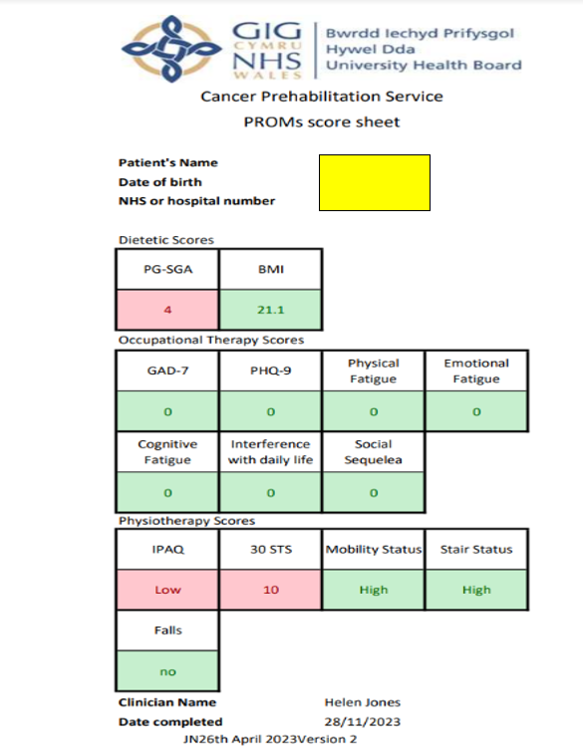
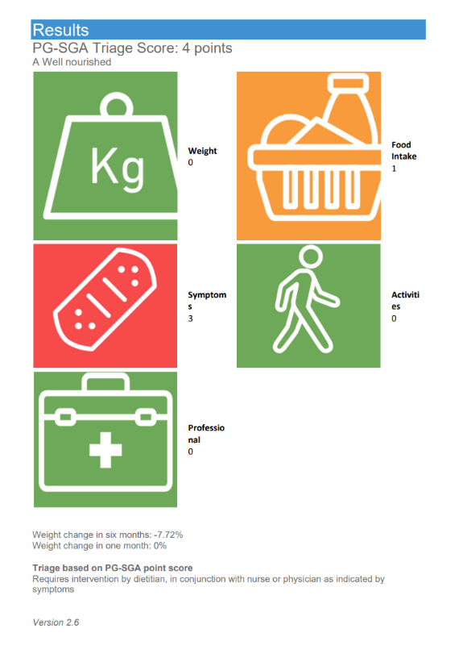
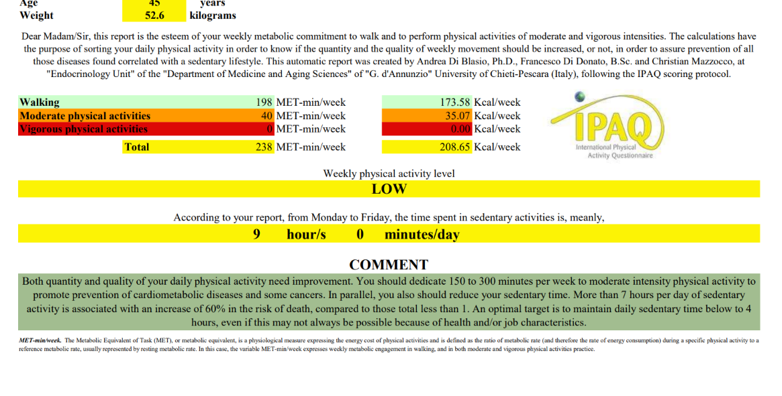

Appendix C.
Highlighted section below to show details of completion of peri op to prepare patients with general advice prior to surgery.
Session 1
Date of Session: 05/01/2024 Time of Session: 13:30
Session Summary:
S/ Patient attended session via Microsoft Teams with wife Annette in background. Patient stated he is feeling well and has no concerns since screening session. Patient has not yet had a date confirmed. Prehab service has had email to state that his date is 17/01/2024. Reassured patient that they should be contacting within the next week with a date. VCG to engage with service. Has recieved and printed off and read through universal booklet.
ACTIVITY : Patient states he feels that he is not getting out as much and would like to try to Actif Anywhere month subscription.
WELLBEING : Patient states he feels well supported and has no concerns at present regarding surgery.
NUTRITION : Patient has taken on board the information regarding increasing protein from booklet and is trying to do this with each meal.

O/ Confirmed we will complete referral for Actif Anywhere and send him the details through of this. Confirmed we will send the peri op information through and patient feels that he will not need any further support at present. Patient is happy to have PREM sent out to email address.
Completed peri op information with patient, ERAS protocols, breathing exercises and supported cough.

A/ Patient feels that at present he will not need any further support and is aware of how to contact service if needed.

P/ Send out peri op leaflet, complete referral to Actif Anywhere and send details of this through to patient, send out PREM and D/C from service

Signed: H.Jones Name: Helen Jones Profession: TAP
Date: 05/01/2024 Time: 14:47

Highlighted section below to show details of relaxation session completed with a patient.
Session 2
Date of Session: 12/01/2024 Time of Session: 10:00
Session Summary:
S/ Patient attended relaxation session via Microsoft Teams. VCG. Patient reports she has had first lot of chemo treatment last week and did not have such a good week because of this, patient stated she believes she is having a course of intensive radiotherapy after chemo has finished and that she has a fitness test next week in the hospital.

O/ Relaxation session completed – patient engaged throughout. Discussed if patient feels that these would be beneficial for her and also discussed Maggies online sessions and apps that can support at any time from NHS – Calm and asked if patient wanted to check NHS online for mindfulness apps to support her.

A/ Patient feels she would benefit from weekly relaxation sessions with prehab and happy to have an appointment next week.

P/ Teams appointment sent out for Friday 19/01/2024 @ 10:00 with Helen Jones for further relaxation session – discuss Tai Chi sessions with her and monitor fatigue to see if further fatigue management strategies needed.

Signed: H.Jones Name: Helen Jones Profession: TAP
Date: 12/01/2024 Time: 13:05

Highlighted section below to show details of exercise prescription gone through with patient and wellbeing call.
Session Summary:
S/ AA anywhere appointment VCG. Patient reported feeling well in herself and feeling stronger today. Patient stated that she felt she did well in CPEX and had no issues. Patient stated she is due to go for an ECG soon.

O/ Patient was sat up right in the chair with her red theraband ready for todays session.

Practiced set of exercises as given out to patient in her patient notes for reference.
Rx/ Exercise session in sitting
- Bicep curl with red theraband anchored under hips (sitting on band) 10 x each side
- Up right row with red theraband AA 10 x each side
- Forward punch without band 10 x each side
- Lateral punch without band 10 x each side
- Foot stepped forward on toe and returned 10 x each side
- Foot step out to side (verbal cue of lifting foot over tuna can given) 10x each side
- Trunk twists with arms crossed 4 times verbal cue needed to slow down movement.
- Side bends with arms by side 4 times.

A/ Patient coped well with the exercises. She reported that she felt she managed the exercises well and did not feel that she struggled today with any fatigue. Patient seems to remain engaged with the classes and has agreed to attend a session tomorrow.

P/ Session arranged for tomorrow at 10:00 with Erin Fitzjohn and Helen Jones
Signed: H.Jones
Name: Helen Jones Profession: TAP
Date: 4th July 2023
Time: 11:49

Details of plan below in highlighted section to follow up with wellbeing call as discussed when finding out more about treatment options.
Session 2
Date of Session: 17/01/2024 Time of Session: 14:30
Session Summary:
S/ Spoke to patient on phone when patient called office as e-mail sent out regarding no contact made and patient requested we call him back. Patient reported that he had seen the surgeon in Port Talbot who reported that due to issues with his heart he may have to go the Rx route. Patient stated he really wants to not go this route if possible and wants to have surgery and this has been worrying him. Had an ECG in Carmarthen today and has an appointment in Heath Cardiff for more tests on 25/01/2024. Patient stated he has had contact from CISS service and is preparing to complete the forms tomorrow. He has not claimed benefits before and feels like he does not want to claim but feels this is necessary at present to prepare.
ACTIVITY : Patient reports there has been no change since last contact in December and he is still managing the same levels of activity and feels that he is active enough and does not require any further support with this at present.
NUTRITION : Patient reports that there has been no weight loss and remains stable weight of 12 and a half stone. No changes in appetite.
WELLBEING : Patient states he feels he will know more and will feel better prepared when he has appointment in Cardiff and he will know what his treatment will be. Has people he can reach out to and discuss how he feels if required.

O/ Discussed with patient about increasing protein levels and not losing any weight at present. Discussed if Rx needed it can give him more time to prepare for surgery if necessary and discussed reframing thoughts and organising such as filling in forms for benefits if needed. Discussed support from prehab and patient stated he would like to continue having support from prehab to monitor for any changes after he knows more about his treatment plan.

A/ Patient feels that he may need some support if there is any changes when he knows more regarding his treatment options. Discussion next week on if patient feels the prehab service has anything to offer him then he can get back in contact.

P/ Agreed to contact patient beginning of next week when he has more idea of treatment plan.

Signed: H.Jones Name: Helen Jones Profession: TAP
Date: 17/01/2024 Time: 15:37

Appendix D.
I have highlighted in Appendix D where I identified with patient during a wellbeing call may need dietician support with regards to some issues with food and identified risk.
Risk identified for further intervention in highlighted section.
My mentor has also written up to evidence when I identified risk within my workplace:
Risk assessment professional discussion.
Background:
Prehab patient was screened as universal following the initial questionnaire. Helen completed the initial assessment due to this. During the assessment Helen risk assessed that the patient was at risk nutritionally due to a loss of weight.
Risk assessment:
Helen used the assessment tool PGSGA to identify a risk of malnutrition with a score of 4. Helen brought this patient to triage meeting the following day and was able to discuss this with the registered staff. Helen was able to identify the risk, discuss that the score was due to weight loss over a number of months but that she was currently stable and on supplement drinks.
Outcome:
Helen was able to identify the potential risk and demonstrate what steps were already in place to mitigate this risk. Helen was able to identify and offer to monitor this risk by continued contact with the patient and requesting weekly weights to assess if further input would be required.
Signed : J.Norris Name : Jo Norris Profession : Physiotherapist Date : 05/02/2024

Session 1
Date of Session: 05/01/2024 Time of Session: 10:30
Session Summary:
S/ Contacted patient via telephone call. VCG for wellbeing call. Husband in background and patient passenger in car while on call. Patient reports that she has had meeting with surgeon yesterday and she is aware that she will need a pre op medical in Bronglais but has had no further dates at present. Patient reports she is in the car at present with husband planning their route to Bronglais. Patient reports having received the Universal booklet and has read through this and another booklet she has received from Macmillan around understanding colon cancer and found that both of these has been useful but since reading has some questions around nutrition.
ACIVITY : Patient reports that she is managing her normal levels of activity and feels there has been no changes in energy levels at present.
NUTRITION : Patient reports that she has some concerns regarding her diet and that she has been told that she may need to be put on high carb diet pre and post op and has concerns around this. Patient reports that since having bariatric surgery she has no stomach and instead has a pouch and that she does not tend to produce stomach acid. She reports that she has resorted to a sort of “diabetic diet” as she finds that most carbs give her severe IBS symptoms and she feels this is unmanageable.
WELLBEING : Patient reports that yesterday she felt very flat following appointment at the hospital and felt quite scared also. Patient felt she managed this by planning as best she can at present without having any dates and this is why she is planning route to Bronglais, she feels that reading all the info she can has helped. Patient feels that she has fatigue and has read up more about strategies to manage cancer related fatigue also and feels comforted in the knowledge that this is common and she is not alone. She feels she has a lot of support around her.
O/ Discussed with patient any issues she may feels she has at present and she reports uncertainty of having a date is making her worry but feels she has lots of coping strategies to help manage and is happy with the advice in universal booklet which she has read. Patient has requested to speak with dietician to have more of an understanding and reassurance around her diet and what choices she can make during meals.

A/ Contact to Hannah Johnston dietician to follow up with patient – patient has agreed that she can be available on Wednesday 10/01/2024 @ 10:30.

P/ Schedule appointment and handover to HJ for 10/01/2024 @ 10:30 telephone call

Signed: H.Jones Name: Helen Jones Profession: TAP
Date: 05/01/2024 Time: 11:42

Appendix E.

My mentor has completed written information regarding time and workload management:
Helen is always on time for work and prompt to any meetings and appointments that she has within her diary. Aside from pre-arranged, regular team meetings Helen is in control of her own diary and efficiently prioritises her time to allow for all tasks to be completed in a timely manner. Helen manages a mixed workload including her own case load of patients and administrative tasks. Helen enjoys being busy and offers to accept further tasks when her own diary is quieter. This includes taking on further appropriate patients and supporting other members of staff in their workload. Helen has shown excellent skills in prioritising her own workload and being able to reason what tasks are urgent to allow for excellent workload management. This has included prioritising tasks when covering for other members of staff for the benefit of the team. Through excellent team work Helen is able to support other Therapy Assistant Practitioners to manage their work load thus supporting others to develop skills.
Helen understands the importance of managing her time to maintain mandatory training through ESR, currently on 96%, and includes training opportunities to develop her role in allocating and planning her time.
Helen’s confidence has grown in being able to delegate work when her workload is larger or when on leave. Helen is an asset to our team.
Signed : J.Norris Name : Jo Norris Profession : Physiotherapist Date : 05/02/2024

Appendix F
I have included details of my ESR and evidence of certificates in Appendix F.

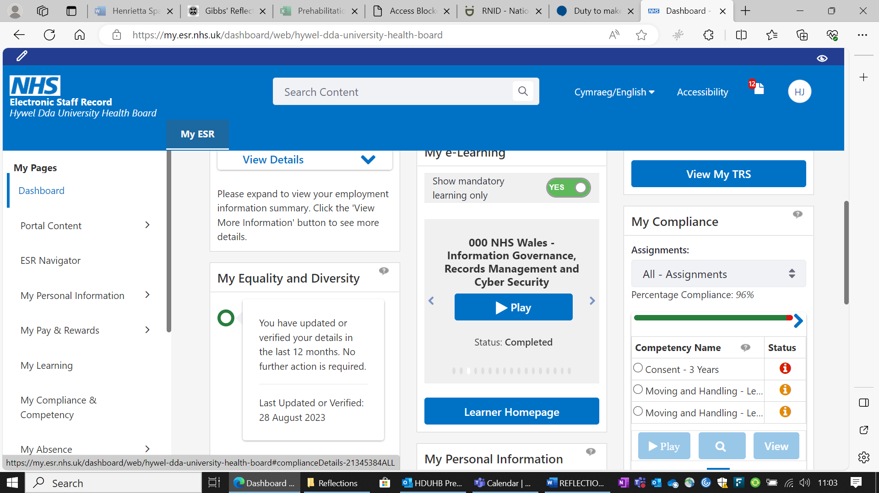
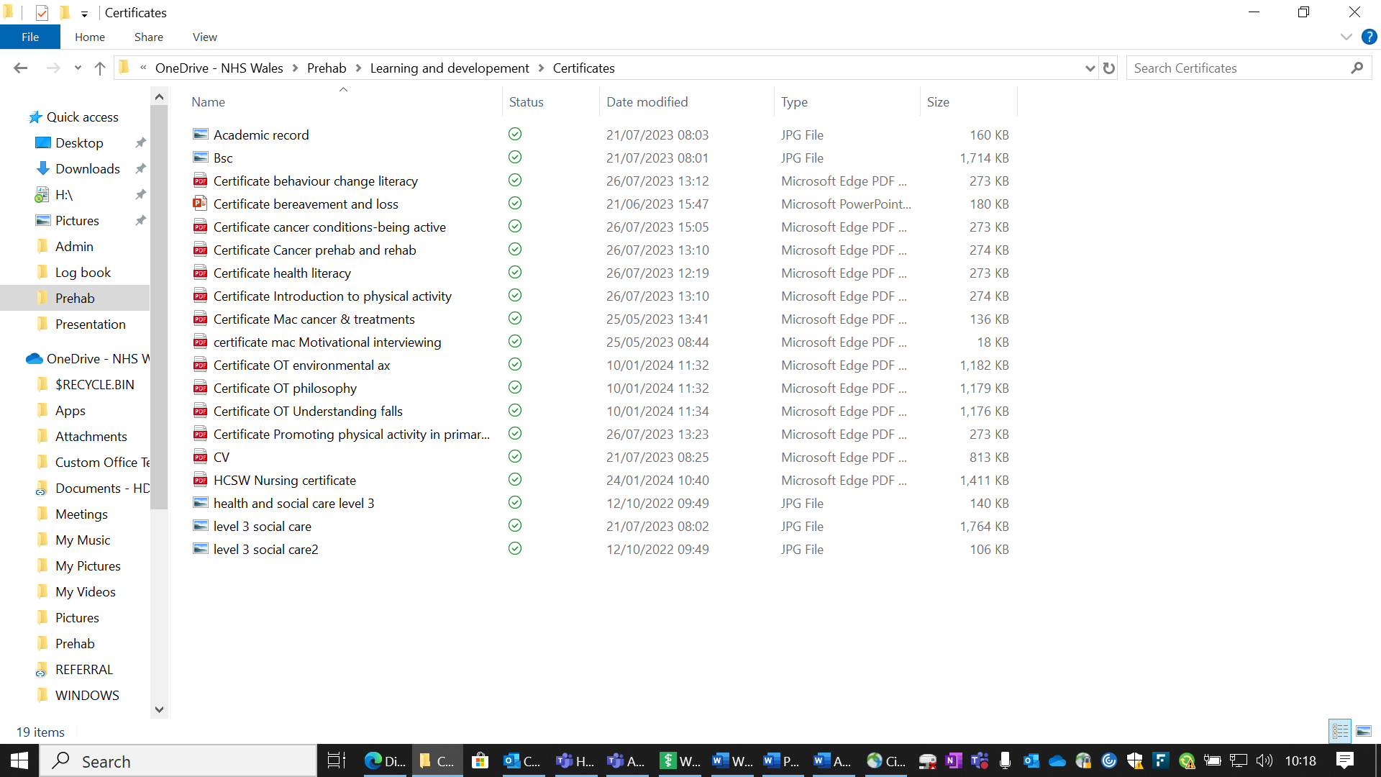

Appendix G.
My Details / My Appraiser’s Details
My Name: | Helen Jones | My Job Title: | Therapy assistant practitioner
Department: | Cancer Prehabilitation service | County: | Carmarthenshire covering Hywel Dda area
Review Period Start Date: | May 2023 | Review Period End Date | Jan 2024
Appraiser Name:: | Rachel Lewis | Appraiser Job Title | AHP Cancer Lead
Date: | 24/01/2024 | My Pay Number: | 10593673-3
Personal Review of Objectives– to be completed by the appraisee during the discussion
a) What has gone well for me this year?
Have increased in confidence using all admin systems, have formed good working relationships with the team. Have grown in confidence to be able to discuss ideas for development within the team. Have progressed well through training and understanding my role better and how I can make positive contribution to the team and patients I work with. Have completed all competencies to date except for group work competencies where I have been unable to due to number of patients. I feel I have settled in to my role well at present and feel more confident.
b) What could have gone better for me this year?
Have struggled a little with finding the balance of working from home and feels that I should be coming in to the office more to get more social aspects from work and to improve wellbeing. Getting used to working from home and finding the balance of ensuring I have a good workspace at home to manage myself and my role better. Struggled with Agored level 4 initially and managing my time but I am beginning to enjoy it more as time goes on and think more positively about it after reflecting.

Objective Setting
What are my SERVICE objectives for the next year?
2024 vision:

- Service review for 2023
- Face to face assurance
- Expand to further cancer sites
- Prehab to rehab model
- Virtual group sessions

What are my TEAM objectives for the next year?
Evolving team objectives 14/02/2024:

2024 vision:

- Prehab groups - launch exercise ‘mindful movement’ and universal group
- Face to face assurance – start with clinic appointments for telephone screenings
- Expand to further cancer sites in Urology (Penial/ kidney/ testicular/ bladder)
- Launching new service changes – spreadsheet/ record cards/ questionnaire

What are my PERSONAL objectives for the next year (Max 8 objectives)? Use SMART Guidance (Appendix 3). How do they relate to the Organisational Values? (click here Hywel Dda University Health Board | Values - Introduction for further guidance)
  Working together to be the best we can be |   Striving to Develop & deliver excellent services |   Putting People at the heart of everything we do

Core Objectives
Objectives | Expected outcome/measure of achievement | Target date | Support/action by Manager/others | Progress Review date
1.Complete mandatory training | 100% compliance on ESR | Progress to be reviewed in monthly 1:1’s | Currently at 96% Time allocated within working day to undertake training as required | Monthly
2. Engage with & complete yearly PADR | ESR data compliance | Jan 2024 | Progress with agreed objectives to be reviewed in monthly 1:1’s | Monthly
3. Ensure compliance with the Welsh Language Standards and promote and facilitate the use of the Welsh Language in the workplace | WLS compliance |  | Time allocated within working day to undertake Welsh courses as required
Personal Objectives
4. Becoming more confident in managing groups and implementing more ideas for groups | Implementation of Universal group/class interventions | Progress to be reviewed in monthly 1:1’s | Time allocated to meet up with Cardiff TAP’s to look at management of groups and gain ideas/skills with this and PACT team  Wider team support to take more groups and becoming used to it and looking into ways to improve my skills by shadowing others. | Monthly
5. Work through completing Agored level 4 | Qualification achieved | Progress to be reviewed in monthly 1:1’s | Study leave time allocated with current role. Support provided by wider team as required.  24/06/2025 marks release date. | Monthly
6. Identify and lead on 1 service change idea using QI methodology learnt in Agored qualification | Pathway improvements, resulting in efficiencies | Progress to be reviewed in monthly 1:1’s | Wider team support to identify and implement QI project. | Monthly
7.
8.
9.

Personal Development Plan
Identify below the learning & development needs required to fulfil/maintain your personal objectives
Development to meet objectives (click here for Hywel Dda e-Prospectus) Refer to Appendix 5
- Continue and complete Agored qualification.
- Identifying opportunities to shadow and participate in group sessions

Nursing Midwifery Council (NMC) Revalidation
Are you on the NMC register? Yes No X

If ‘yes’ please refer to Appendix 1

NMC Standards for Education 2018: Practice Supervisor / Practice Assessor (Nursing & Midwifery Staff only)
Please refer to Appendix 2

Clinical Supervision – A guidance plan for nurses in Hywel Dda University Health Board
Please refer to Appendix 3

General Comments
What are my career aspirations for the next 12 months?
Would like to continuing developing in my role and where possible skill up in taking groups by taking up opportunities in courses that will be beneficial to the client groups we work with and shadowing other services to enable me to offer the best possible service. Would like to continue to develop and work through my level 4 agored.
Summary (To be completed by Appraiser)
Provide a summary of your overall assessment of the individual’s performance during the review period, including any areas requiring improvement.
Helen is a valued member of the cancer prehab team. She has embraced new ways of working and always looking at ways to build and strengthen current pathways.
It has been a pleasure watching her confidence growing. Always seeking advice and guidance as required, but you can see the breath of new knowledge and experience that this new role has brought.

Thank you for all your hard work and dedication, really is appreciated.
Pay Progression (To be completed by Appraiser)
Step 1
Is this PADR a pay affecting progression appraisal? Yes NoX (if yes go to Step 2 below)
(See the All Wales Pay Progression Policy)
Step 2
Has the appraisee achieved their objectives for the previous year and met the standards of the pay progression policy, see below?

1 | Appraisee has achieved their objectives | Yes |  | No
2. | The appraisal process has been completed within the last 12 months and outcomes are in line with the organisation’s standards | Yes |  | No
3. | The appraise has achieved 100% compliance for mandatory training | Yes |  | No
4. | There is no formal capability process in place for the appraisee | Agree |  | Disagree
5. | There is no formal disciplinary sanction live on the appraisee’s record | Agree |  | Disagree
6. | The appraiser must complete the Pay Affecting Progression Appraisal on ESR (See ESR MSS41 online training) | Completed

I am committing to this by signing : Helen Jones | Date: 24/01/2024
My appraiser agrees by signing : R Lewis | Date: 7th Feb 24
Date of Next Review: 22/07/2024

Appendix H.
Supervision Record
Supervisor: Hannah Johnston
Supervise: Helen Jones
Date: 17/11/2023
Agenda Item | Discussion points | Agreed Action / By Whom/By when
Training/ Competencies  Level 4 Agored  Supervision  Wellbeing | Online ESR training up to date, Completed a few more PROSPer training units and have uploaded certificates for them. Checked competencies band 4 and finished the ones I can do – some of the dietetics competencies needing to be signed off. Completing screenings, peri ops and wellbeing calls frequently when having universal patients. Feeling competent with admin systems. Continue to liaise with peer group and involve Lach as much as possible. Completed Macmillan training courses recommended. Working through competencies – 1 month and overall – need to get exercise class signed off.  Completing assignments as set. May need to plan better to avoid last minute stress from handing in work. Look at letting other TAPs complete admin jobs while working on weeks when work needs to be handed in and take a step back where necessary. Delegate jobs between us TAP’s so not getting overwhelmed and schedule in working on Agored when having any free time in the week  Monthly supervision sessions.  No issues at present but aware that this may change as coming into the winter months and if not very busy – have come into the office today and plan to do this at least once every 2 weeks to get social contact. Have some issues with family illness and may need time off for that in near future. | Check any training opportunities  Update supervisor when needing support and communicate with Jo Agored lead  Supervision as requested and agreed with supervisor  Keeping in touch with supervisor regarding this
Date time next supervision
Has this been entered in supervision log?

Signature Supervisor …………H.Johnston………………… Supervisee……………Helen Jones……….......
Copy taken and filed in supervision folder?

Supervision Record
Supervisor …………
Supervisee ……………Helen Jones …………………
Date ……………17/11/2023 ……………………

Agenda Item | Discussion points | Agreed Action / By Whom/By when
Training/ Competencies  Feedback | Feeling competent in all admin systems. Feel I can competently complete all details on spreadsheet. I feel I can competently complete and update active patients records. I am looking forward to being involved in delivering virtual exercise classes as soon as possible and starting Universal groups. Am working with Tei fellow TAP to arrange time in week to go over slides and practice this. Also scheduling in time with Tei to go over relaxation sessions to perfect these and spreadsheet updating all discharged when possible to support with data collection.  Peer support and supervision sessions going well.  Helen continues to meeting competencies for TAP role, some further education and training needed for DT.  Supporting fellow TAP’s in her role, and escalating any concerns as needed. She is planning a head for Agored work and thinking ahead for the winter months to support own wellbeing. | N/A – monitor ongoing training and await 2 month competencies  Ongoing  Supervisor to feedback and apply to sessions
Date time next supervision
Has this been entered in supervision log?

Signature Supervisor ……HJohnston ……………………… Supervisee……H.Jones……….......

Supervision Record
Supervisor: Hannah Johnston
Supervise: Helen Jones
Date: 15/12/2023
Agenda Item | Discussion points | Agreed Action / By Whom/By when
Training/ Competencies  Level 4 Agored  Supervision  Wellbeing | Online ESR training up to date, Have joined new TAP’s All Wales Cancer support group which I feel has been very beneficial for networking and pooling resources. Completing screenings, peri ops and wellbeing calls frequently when having universal patients. Feeling competent with all admin systems. Have been working to support fellow therapy assistant to catch up with systems and to provide guidance on planning throughout the day.  Completing assignments as set. Needing to plan to avoid last minute stress from handing in work. Look at letting other TAPs complete admin jobs while working on weeks when work needs to be handed in and take a step back where necessary. Delegate jobs between us TAP’s so not getting overwhelmed and schedule in working on Agored when having any free time in the week. Scheduled in weekly update sessions with mentor to review where I am with the work and to keep me on track.  Monthly supervision sessions.  No issues at present but aware that things have been busy lately due to staff absences and needing to adapt quickly and prioritise, I feel I have managed well when these challenges have happened – still to plan more face to face office time | Check any further training opportunities  Update supervisor when needing support and attend weekly updates  Supervision as requested and agreed with supervisor  Keeping in touch with supervisor regarding this
Date time next supervision
Has this been entered in supervision log?

Agenda Item | Discussion points | Agreed Action / By Whom/By when
Training/ Competencies  Feedback | Feeling competent in all admin systems. Feel I can competently complete all details on spreadsheet. I feel I can competently complete and update active patients records. I am looking forward to being involved in delivering virtual exercise classes as soon as possible and starting Universal groups. This has been difficult due to the fact that we have not had the numbers of patients required. Have been supporting PACT team with Wellbeing sessions and have planned to support when new group starts in January. Also looking at connecting with Cardiff TAP groups to support learning and development. Completing small sessions where necessary to keep updated and refresh on skills.  Peer support and supervision sessions going well although many have been cancelled this month due to sickness and holidays and covering other duties.  Helen is balancing Prehab team tasks and Agored Level 4 well, she is organised and supports the Team well.  Helen regularly contacts myself to request advice and reflects well for her learning.  Helen is seeking further learning with groups and meeting other Tap’s which will really benefit her role. | N/A – monitor ongoing training and await 2 month competencies  Ongoing  Supervisor to feedback and apply to sessions
Date time next supervision
Has this been entered in supervision log?

Signature Supervisor ………HJohnston…………………… Supervisee……H.Jones……….......
Copy taken and filed in supervision folder

APPENDIX I.
Appendix:


Therapy Assistant Practitioner:
Demonstrating Practice
Peer Review Feedback form

This peer review feedback was completed by: Helen Jones Date: 01/02/2024

The following tables will contain peer review feedback on presentations demonstrating quality improvement projects, using a PDSA cycle.

Feedback one: | Presentation topic: Improve the identification of lower limb post operative DVT symptoms and to improve referral process.
Congratulations | What does the presenter do well? What were the presenters’ main points?  Very clear and very well explained, excellent presenting skills, a lot of detail and well laid out and flowed well.
Ask for clarifying questions. | What aspects of the presentation were confusing or unclear? Why? Some of the information about standardised data I found quite hard to follow at times.  What suggestions (at least 2) do you have for the presenter, in order to improve this presentation?  Maybe slowing it down a bit when speaking as we could miss some things especially with the understanding for someone like me about standardised data but I thought it was just perfect.  Quite complex at times to someone who knows absolutely nothing about the subject but well explained throughout.
Request more. | What would you like to know more about the topic?  It has really interested me in knowing more about DVT and would like to know more about how the data was collected.
Evaluate its value. | What specific details would you take forward into your own practice?  The specific collection of data and how they managed it.
Summarize | What new information have you learnt? Has this influenced you to think differently?  I have learnt a lot more about the signs and symptoms of DVT and how to refer

Feedback two: | Presentation topic: Nutrition and Hydration championing in nursing homes.
Congratulations | What does the presenter do well? What were the presenters main points?  Clearly put out points in each slide and about the PDSA cycle and reasons why you were completing. A lot of detailed analysis and information gathered in this and really showed a lot of work had been put into completing it and really thought about what the aims were of completing it. Really good at looking at why the problems could be happening and staffing levels.
Ask for clarifying questions. | What aspects of the presentation were confusing or unclear? Why? It was all presented very clearly.  What specific suggestions (at least 2) do you have for revising the unclear parts of this presentation?  Lot of details on some of the slides so could have been shorter and discussion around some of the points instead and more colourful but the poster and all the details and solutions were excellent.  Could have had more detail on how they are measuring results after – could they do this monthly? Yearly? Maybe timescales for plans for the future?
Request more. | What would you like to know more about the topic?  Would love to have more details about the themed events
Evaluate its value. | What specific details would you take forward into your own practice?  Using more questionnaires to obtain data and making comparisons with other services as you used more than one care home and really stretched out your gathering of the data.
Summarize | What new information have you learnt? Has this influenced you to think differently?  Have learnt a lot about how common an issue this can be in care homes.

Feedback Three: | Presentation topic: PDSA on moving and handling prompt sheet in stroke ward
Congratulations | What does the presenter do well? What were the presenters main points?  Very clearly spoken and slides followed along very clearly when speaking, well presented and clearly identified the issues. The abbreviations part was excellent as well in identifying the issues very clearly. You could see a lot of work had gone in to it. Really had considered all the reasons why things were going wrong.  Some real dedication to following through and maintain consistency.
Ask for clarifying questions. | What aspects of the presentation were confusing or unclear? Why? Very clearly set out.  What specific suggestions (at least 2) do you have for revising the unclear parts of this presentation?  Making the slides a bit more colourful and interactive possibly?  Could have had more discussion around the personalisation part of the “I like and I need”
Request more. | What would you like to know more about the topic?  How you came to the ideas about the chart and what influenced your decision to have that particular chart. Did you have any other information that influenced your prompt charts? You went into a lot of detail about this already and just wanted to ask if there was anything that made you think about what parts you needed to keep as well and why this was important.
Evaluate its value. | What specific details would you take forward into your own practice?  Clearly presenting aims of project and what I would like to achieve in my own practice and really taking that forward in my own workplace. Having clear goals and being able to be clear about these goals and communicate this to everyone.
Summarize | What new information have you learnt? Has this influenced you to think differently?  Yes the issues with abbreviations are something we sometimes take for granted and could really cause issues. Would love to know more about how this has been taken forward and if any other wards are now using it as well.

