Using a Research Approach in Human Resources

Report Title: Using a Research Approach in HR – Activity 1

Name: Sarah Measday

Student Number :- 1910137
CIPD – Student Member No:- 55478518

Date: 14th November 2019

Signed:
Date: 14th November 2019

What is Research in HR?

There are lots of different ideas as to what Research actually is?

Research is a key element of many organisations. It can be used for purely gaining information and analysis or on a deeper study, when organisations want or need to make changes or develop ideas.

A general definition of Research is finding out things in a systematic way to increase knowledge (Yin 2009, Silverman 2009).

In HR in order to have the best understanding of our organisation we need to have the most up to date information available to us. We can only produce this information through up to date research. This will allow us to make informed decisions as to what changes to make, whilst also considering other stakeholders of the business, which includes employees, trade unions and maybe other service providers.

A definition for Research in HR is the systematic enquiry into HR issues to increase knowledge and underpin effective action (Bamber etal 2004, Therborn 2006).

Identifying an Area for Research

The first step in any Research is identifying the area for research. Horn (2009) highlights four ways to identify an area:

- “Burning Desire” – personal interest in a particular area
- Replication – applying previous research in a new context
- Practical problem – a highlighted key area of concern within the organisation already identified.
- Convenient access – an area whereby the professional already has access.

Anderson (2013) also suggests that before any HR professional’s finalise the topic for research they should also take into consideration the various stakeholders opinions. Anderson (2013, p41) also suggests that from an organisational perspective it is worth asking these 3 questions;

- What is currently bothering me / my boss / my department / my organisation?
- What changes may be occurring in the near future?
- What HR developments may impact on the organisation in the next few weeks and months?

Map or Plan

Once a Research Project has been identified, the next step is to Plan the journey of the project.

Helpfully Anderson (2013) has produced a Roadmap. This lists the various stages of a research project. See Fig 1 below. Not all projects will include every step of the roadmap, so this map is given as a guide rather than a must complete every step.

Fig 1

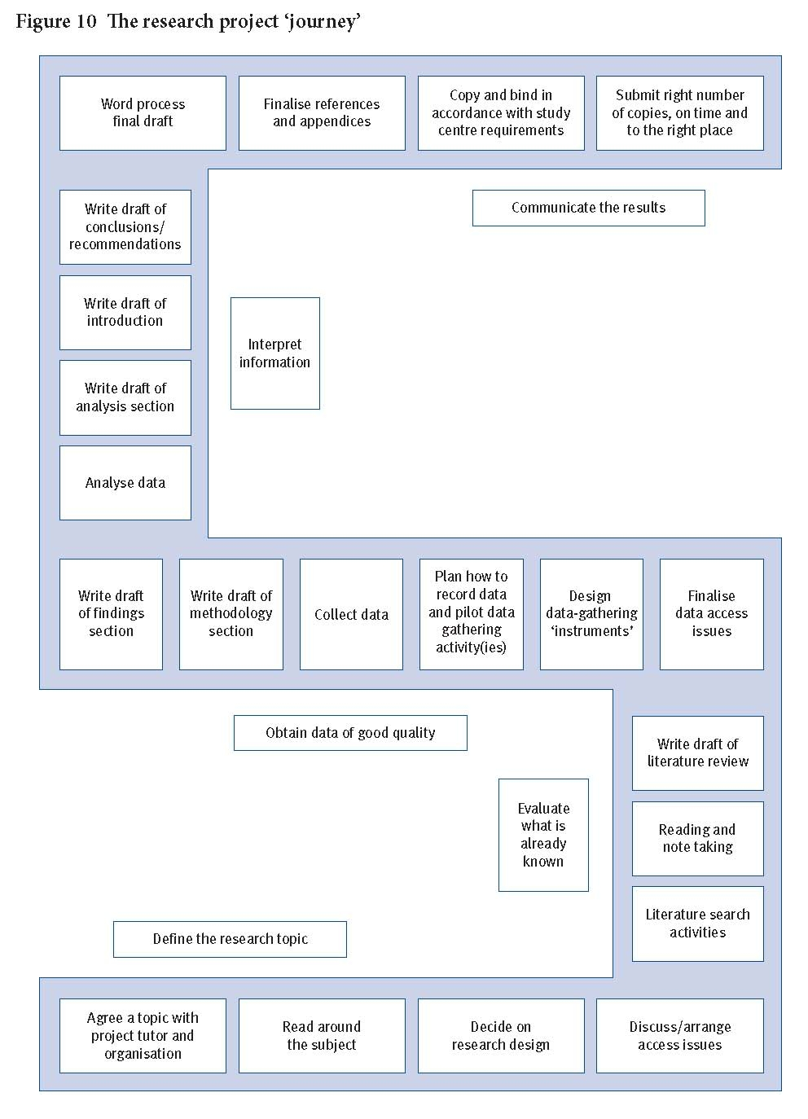

Source: Anderson 2013, p71

Once a topic is agreed. We can then follow the Roadmap of research. We should look firstly at what information already exists. Reading around the subject chosen, looking at various sources such as the CIPD online website and previous studies or journals on the topic exist. We then need to move forward by deciding how data should be collected for our own research.
What Data should be used?

We will need to look at Data that is specific to the Area of Research that has been decided upon. (Perkins and Woodhams, 2016, p.92)Suggests that Data falls mainly into two categories:

- Primary or Secondary
- Qualitative or Quantitative

Horn (2012) suggests that Primary Data is actually new data gained for the study and that Secondary Data is data that already exists which has been gained for previous studies.

Primary data for example would be gained from a new questionnaire, observations, interviews with employees at the time of study, whilst secondary would be data gained two years previously for a study conducted at that time or a similar published study outcomes from a valid source such as the CIPD website, academic journals and market research etc.

Bryman and Bell (2015, quoted in Taylor and Woodhams, 2016, p.94) “points out that qualitative data is usually based around words and meanings, rather than the collection and analysis of numbers. In contrast to this, quantitative data usually contains numbers and can be analysed through statistical analysis software.”

An example of quantitative data would be figures of employee’s terminating for the past 12 months, whilst qualitative data would be Exit interviews from those terminations. It is only with the qualitative data that we can analyse the reasons for leaving.

Methods of Research

There are a number of factors to consider when deciding on how your research is to be conducted. Bryman and Bell (2015) suggest that you should ask yourself these Questions:

- Is it Reliable?
- Is it Replicable?
- Is it Valid?

Keeping the above in mind Anderson (2013) suggests four ways that Research can be conducted in HR:

- Cross Sectional –Collection of data from a group of individuals e.g. – issuing a questionnaire or survey on flexible working to a specific service area of employees within a particular organisation.
- Case Study – an in depth study of a particular area or situation in a small number of cases. Interviews are particularly useful in this method as they can be used to gain similar details as surveys would but it is the skill of the interviewer that is paramount here as they can draw out further information that may be key to the study.
- Action – Action Research – Problem Solving is a key part here as this would be of particular use in solving a specific problem area. Focus Groups would be a great tool here as for example you could be analysing the effectiveness of a particular way of working so it would be useful to have a team approach to this. So that ideas can be shared.
- Comparative – making comparisons between different groups or situations – e.g. comparing levels of staff engagement at different locations within the same organisation.

When thinking about the way in which your research will be conducted it is important to remember that more than one of these ways can be chosen. For example you may need to issue a questionnaire to two specific areas to gain a Cross section of data from each area. This will allow you to compare the two areas data to give a comparative response.

Once data has been collected, it will needs to be sorted, analysed and Conclusions drawn. The data should be presented in a Business Case or Report which can then be distributed to Stakeholders, Unions and HR manager’s for feedback, consideration and / or action.

Bibliography

Anderson, V. (2013). Research Methods in Human Resource Management: Investigating a Business Issue. (3 ed.). London: CIPD.

Horn, R. (2012). Researching and Writing Dissertations - A Complete Guide for Business and Management Students. London: CIPD

Perkins, G and Woodhams, C (2016) “Using Information in Human Resources” in Taylor, S., & Woodhams, C. (ed.). Studying Human Resource Management (2 ed.). London: CIPD.

Taylor, S., & Woodhams, C. (ed.). Studying Human Resource Management (2 ed.). London: CIPD

