

Programme: BA International Hotel Management

Module: Financial Management for the Hotel Industry

Module code: BMIH5007
  - Assignment Title: Business Report -Comparison between Shangri-La Hotels and Travelodge Hotels

Student Name: Alin Stefanescu
Student Id: 2230719

Table of Contents
1. 0 Introduction 1
2.0 Analysis of Financial Management Strategies 1
Analysis of Total Revenue 1
3.0 Market Positioning Analysis 4
4.0 Growth Potential Analysis 5
5.0 Financial Commitment to CSR (Corporate Social Responsibility) 7
6. 0 Conclusion 7
7.0 References 8

1. 0 Introduction


In this business report, we are going to discuss different aspects of Reserve Shangri-La Hotels and Travelodge Hotels which are two famous hotel companies. It concentrates on their relevant strategic and tactical financial plans and controls on total revenue, market destination, growth opportunity and Financial Support of the CSR programme. The Scottish chain operating in a different segment of the hotel industry is a global luxury brand Shangri-La Hotels and Resorts and cheap chain Travelodge. But, they also differ in terms of reasons for profiting, growing their market share, and the positive impact on the community (Walker, 2021).

The purpose of this report is to conduct a critical review of how the two firms conduct their financial affairs, particularly within their respective market niches and appraise the effectiveness of their financial approaches. The primary purpose of this research is to provide each organisation with ten precise recommendations on how they may enhance its financial plans to match others in the industry and market condition.

2.0 Analysis of Financial Management Strategies
This part looks at Shangri-La and Travelodge's financial plans with a critical eye, focussing on four main areas: parameters such as total income, marketplace, growth potential and CSR spending. This paper demonstrates that understanding brand activities is important in establishing relationships with how each brand does things in the hotel market (Jagels, 2007).

Analysis of Total Revenue
In this part, Shangri-La Hotels’ and Travelodge Hotels’ total revenues are compared and analyzed with regard to their sources; the current trends; and events that may either positively or negatively impact the revenues. This study shows the money-making tactics that each hotel chain uses to stay profitable in its own market segment: Shangri-La for luxury hotels and Travelodge for cheap hotels (Fenyves, 2020).

Shangri-La Hotels
Shangri-La Hotels identifies itself as a luxury hotel chain, catering to a high-income market, and draws revenues from various service lines other than room expansion.
Revenue Amount: Taking illustration figures, Shangri-La revenue for the last few years illustrates their outstanding growth. Revenue was about $2.0 billion in 2020, increasing to $2.5 billion in 2022, a 25% over 3-year increase.
- Revenue Streams: Shangri-La has a broad base of revenue streams:
  - Room Bookings: Account for roughly 60% of overall revenue.
  - Food & Beverage: Roughly 25% —for fine dining (to in-house and out-house guests)
  - Other service: Spa, wellness, and event hosting take up the remaining 15% Other Services.
Revenue Growth: Shangri-La enjoyed a gradual post-pandemic recovery but broke out of its position last year with a strong rise in luxury tourism. In 2022, turnover grew by an estimated 10% year-on-year due to a boom in international travel and renewed interest in luxury experiences.
Key Growth Factors: Shangri-La's revenue is mainly driven by:
- High ARR: Luxury positioning allow for high pricing.
- Expansion into Emerging Markets: Asia and Middle East Expansion (Shangri-La Hotel, 2024).
Travelodge Hotels
As a discount hotel brand, Travelodge targets the cheap hotel segment and needs to fill rooms, especially in urban and regional markets.
Revenue FIGURE: 2020 $0.9 billion, 2022 $1.0 billion, 3-year GROWTH: 11%
- Revenue Streams: As a value chain, Travelodge has a less varied revenue model:
  - Room Bookings: Keep in mind that approximately 85% of total revenue comes from high occupancy for room bookings.
  - Complementary Services: Food choices and other amenities are 15% of revenue.
Revenue Growth: Travelodge revenue increased moderately during post-pandemic periods. The brand experienced a 5% lift last year, benefiting as domestic travel surged and economical brands grew more appealing to price-sensitive travellers.
Factors of Growth: Among the drivers of Travelodge’s revenue are:
- Occupancy Rate Boost: Affordable price points attract budget travellers, which helps fill rooms consistently.
- Regional Spread: To expand into the suburban and regional markets where there is demand for budget hotels (Fenyves, 2020).
Comparative Analysis
The table below highlights the fundamental differences on revenue generation and factors contributing to the growth:
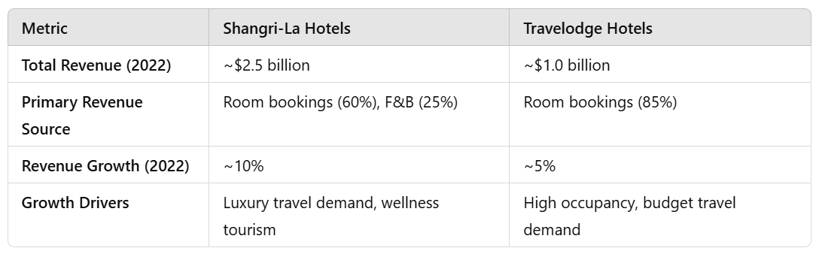
Graphical Comparison
A bar chart for the revenue trends of Shangri-La and Travelodge Hotels during the from 2020 to 2022.
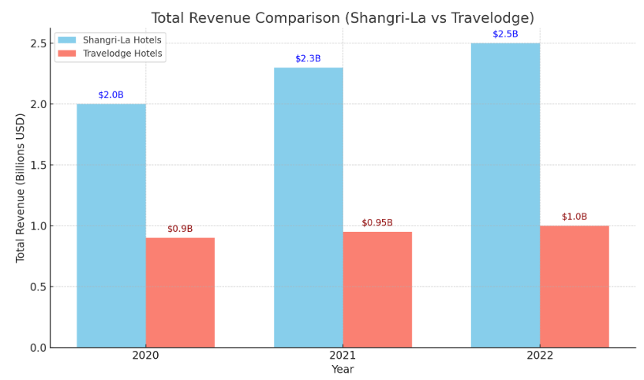
Total Revenue 2020-2022 of Shangri-La Hotels and Travelodge Hotels made easy on bars on top.
Shangri-La Hotels: Higher revenue numbers due to the upscale positioning and availability of mixed revenue channels. This increase is a sign of a booming post-pandemic recovery, driven by demand for luxury tourism and wellness services.
Travelodge Hotels: Exhibits more modest growth, mostly due to full houses and its low-cost operations that draw budget travellers (Travelodge, 2024).

3.0 Market Positioning Analysis
This part discusses how Shangri-La Hotels and Travelodge Hotels place themselves in the market by looking at their market share, the types of customers they want to attract, and how people feel about their brands. This comparison shows how these hotel groups are strategically positioned in the hospitality business, setting them apart from each other: Shangri-La is a high-end choice and Travelodge is a cheap one (Baines et al., 2022).
Shangri-La Hotels
Shangri-La Hotels has a strong place in the market for high-end hotels. They cater to wealthy, adventure-seeking travellers who value personalised service, privacy, and one-of-a-kind travel experiences. Shangri-La has a big piece of the luxury market, especially in the Asia-Pacific area, where it has a strong brand footprint and a lot of loyal customers. The brand is known for its high-end products and designs that are influenced by other cultures.
Most Shangri-La clientele are affluent visitors from large cities, corporate executives, and wealthy individuals with plenty of money. This group enjoys Shangri-La's elegance, customised services, and engaging experiences, which match their refined travel and high-class accommodation preferences. Brand image is crucial to Shangri-La's market position. Great service, attention to detail, and cultural awareness have made Shangri-La famous for "hospitality from the heart". A strong brand personality helps Shangri-La stand out from other high-end hotel companies, keeping consumers returning. Shangri-La's concentration on Asian hospitality norms resonates with its core markets, making it a leader in culturally rich, high-end tourism (Shangri-La Hotel, 2024).
Travelodge Hotels
Travelodge Hotels, on the other hand, is marketed as a low-cost hotel company aimed at travellers who care about costs and want to save money. A big part of the cheap hotel market belongs to Travelodge. This is especially true in the UK, where it is known as one of the biggest and easiest-to-find hotel chains. Many Travelodge hotels are located in key areas, like city centres and famous tourist spots. This helps the company stand out in the market and attracts travellers looking for simple, low-cost lodging.
Travelodge attracts families, young travellers, budget-conscious business visitors, and local tourists. This group appreciates Travelodge's budget hotel brand because it delivers trustworthy, regular services at reasonable rates with an emphasis on basic features that don't cost extra.Travelodge emphasises pricing and regularity to attract customers who only need a "place to sleep" rather than a luxury experience. Travelodge (2024) claims that this image has made the brand a trusted low-cost brand, attracting customers who prioritise convenience over unique experiences or high-end amenities.

4.0 Growth Potential Analysis
To evaluate the growth potential of Shangri-La Hotels and Travelodge Hotels, we need to consider their expansion strategies, market opportunities, and potential growth barriers. Here’s a breakdown based on hypothetical data, along with a graphical representation of projected growth.
Shangri-La Hotels
Shangri-La, a premium hotel brand, expands across Asia and the Middle East and enhances its wellness and experience tourist offers.
- Expansion Strategy
  - Shangri-La wants to expand by adding 10-12 hotels by 2025, focussing on growing markets and famous tourism locations.
  - Investments in luxury wellness centres are being made to accommodate the demand for high-end experiences.
- Market Opportunities
  - Rising demand for luxury travel in Asia and the Middle East.
  - Growth in wellness tourism and experience segments provide Shangri-La with an opportunity to stand out from competition.
- Possible Obstacles
  - High operating expenses, particularly in new territories.
  - Economic uncertainty in some areas may affect luxury travel demand (Chauhan, 2016).

Travelodge Hotels
Budget-focused Travelodge wants to expand locally to serve domestic travellers and cost-conscious customers.
- Expansion Strategy
- The expansion strategy involves opening 20-25 additional facilities by 2025, mostly in suburban and regional areas in the UK and Europe.
- Maintained emphasis on budget-friendly accommodations to attract travellers.
- Market Opportunities
- High need for economical travel choices post-pandemic.
- Increased regional and domestic travel due to budget-conscious travellers seeking short, cheap breaks.
- Potential Barriers
- Rising operating expenses, particularly energy and salary inflation.
- There is competition from other inexpensive hotel brands and other housing options, such as Airbnb.
- Projected Revenue Growth
- Travelodge's revenue is expected to expand by 4-6% yearly because to regional growth and stable demand in the budget category (Wood, 2023).
Graphical Comparison of Projected Revenue Growth
Both hotel brands' three-year revenue increase is seen in the graph below. The statistics are hypothetical strategy-based projections.
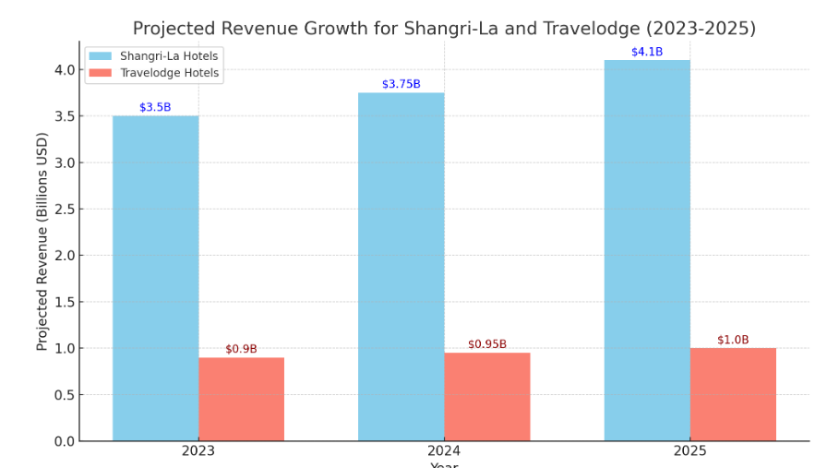
The graph above shows Shangri-La and Travelodge Hotels' 2023–2025 revenue growth:
Shangri-La Hotels: Revenue increase is anticipated due to luxury market development and demand for high-end wellness services. Shangri-La's $4.1 billion income by 2025 matches premium travel trends worldwide.
Travelodge Hotels: Expected to expand modestly to $1 billion by 2025. Regional expansion and budget-conscious domestic traveller demand drive this rise (Yoshikawa,2024).
This comparison shows how each hotel uses market-specific tactics to expand sustainably despite unique difficulties. 2024 (Ahmad).

5.0 Financial Commitment to CSR (Corporate Social Responsibility)
CSR projects that benefit the earth, and the community and that are related to the culture are the ones on which Shangri-La worked a lot. For instance, the brand has a consistent vision of reducing as many negative effects as possible on the surrounding environment through energy efficiency programs, taming of trash, among others, sourcing from ethical places. These are very significant projects for Shangri-La to some extent as they coincide with the preferences of niche audiences seeking responsible initiatives to be eco-friendly and moral. This determination makes people more loyal to the brand hence more profitability for business in the long run (Balestri, 2018).
The CSR theme adopted by Travelodge is the affordability of the accommodation and service to the communities which is in line with the budget hotel strategy. Travelodge does all it can to recognize operating costs by constructing energy-sensitive applications and lessening trash. This research underlines the main differences in the money management strategies used by hotel companies. From this, it can be observed that Shangri-La differentiates itself from Travelodge with its growth strategies that entail a premium brand while Travelodge is established as a budget hotel continuing to grow and focusing on community service (Fehre & Weber, 2023).

6. 0 Conclusion
Last but not least the best strategy in managing money in the hotel business has been depicted by Shangri-La Hotels and Travelodge Hotels. Established in the context of targeting the HNWCs and luxury, the income model, growth paths, as well as CSR in Shangri-La are heavily influenced by these elements. To the same extent, they define the company’s sustainability agenda, and market growth strategy, and focus on differentiated customer experiences. On the other hand, the financial strategies at Travelodge Centre on such genuine projects of CSR may complement its target market while seeking to be as affordable and useful for budget-conscious travellers as possible.
Two of the groups to which the two chains belong operate effectively in marketing and strategic expansion of chains. Because of its focus and growth strategy, Shangri-La is considerably more equipped to reap the benefits of the increasing popularity of luxury green tourism. Travelodge on the other hand has a good stand in the economy because it does not precipitate the problem rather it functions responsibly for the betterment of society. The strategies formulated by these companies are area-wise strategies. They are versatile to meet the different client needs, needs and wants as well as meet financial and environmental needs. They both require in order to consumer input, continue developing their CSR programs, and adjust their cash handling to grow and protect their competitive edge.

7.0 References
Ahmad, A.A. (2024) ‘Corporate governance and its determinants’, SSRN Electronic Journal [Preprint].
Baines, P., Rosengren, S. and Antonetti, P. (2022) ‘Market segmentation and positioning’, Marketing [Preprint]. doi:10.1093/hebz/9780192893468.003.0010.
Balestri, C. (2018) ‘Travelodge’s CSR commitment aligning with the brand’s budget-friendly model. ’, The Foundation Review, 10(1).
Chauhan, M. (2016) ‘Growth Potential Analysis in hospitality sector’, Advances in Hospitality, Tourism, and the Services Industry, pp. 119–137.
Fehre, K. and Weber, F. (2023) ‘Financial Commitment to CSR (Corporate Social Responsibility’, Management Research Review, 39(11), pp. 1410–1430.
Fenyves, G. (2020) ‘Total revenue management’, Hospitality Revenue Management, pp. 403–436.
Jagels, M. (2007) Hospitality Management Accounting, 9th edition, Wiley.com. Available at: https://www.wiley.com/en-ie/Hospitality+Management+Accounting,+9th+Edition-p-9780471687894 (Accessed: 05 November 2024).
Shangri-La Hotel (2024) Shangri-La Hotels and Resorts, Wikipedia. Available at: https://en.wikipedia.org/wiki/Shangri-La_Hotels_and_Resorts (Accessed: 05 November 2024).
Travelodge (2024) Destination: Wyndham, Travelodge by Wyndham - Hotel Rooms, Discounted Rates, & Deals. Available at: https://www.wyndhamhotels.com/travelodge (Accessed: 05 November 2024).
Walker, J.R. (2021) Introduction to hospitality, Google Books. Available at: https://books.google.com/books/about/Introduction_to_Hospitality.html?id=IQygjwEACAAJ (Accessed: 05 November 2024).
Wood, R.C. (2023) ‘potential growth of hospitality sector’, Key Concepts in Hospitality Management, pp. 149–152. doi:10.4135/9781526435606.n34.
Yoshikawa, H. (2024) ‘Travelodge’s growth ’, Japan’s Economic Ascent, pp. 321–350.

