Essay
Student Name: Nnabuike Onyemauwa
Student Number: 2120203
Lecturer Name: Rachael Rivers
BMHP5004_BIRM
Children, Young People and Families

The main purpose of this essay is to argue the consequences of SARS-CoV-2, regarding the life standards of rather heavily affected groups such as family and the elderly, but also younger people e. g. children and emphasise on the positive and negative impacts arising from the pandemic. A year after the virus’s first outbreak in December 2019 hypothesises of the World Health Organization and the Republic of China failed in determining an explanation behind the disease and it’s spread among humans. Subsequently, a few months later the WHO suggests a transmission from animals to humans to be reason for the spreading of the contagious disease. After a year and half, in September 2020 findings of due to the dire global situation resulting, International Scientific Advisory Group for Origins of Novel Path by the WHO detected three viruses of high similarity with COVID-19 in bats coming from Laos. This event underpins the explanation behind the natural origin and emergence of SARS-CoV-2 and also alerts for future unprecedented coronaviruses e. g. variants of the disease. According to Webster, every medical attention leads to side effects, making no exception for vaccines. Many northern European countries including Norway or Denmark for instance prohibited the use of the vaccine AstraZeneca as it’s injection involved heightened risks of blood clots. However, comparing the risk of possible side effects due to the vaccination and the risk of a rather heavy infection, Webster suggests the latter to be a greater threat to the human population (Webster, 2021).

“Over a third of low income families with children increased their spending during 2020, while 40% of high income families without children reduced theirs” (Whitehead, Taylor-Robinson, Barr, 2021, p.1)

Prior to the pandemic outbreak concerning issues around poverty like rising food and child poverty were registered which in turn led to growth in infant mortality. In the midst of restricted provision of governmental resources in terms food and shelter and reduction in government finances the pandemic in England arrived, worsening living conditions for women in poverty. Likewise, deterioration in health took place as well, especially affecting communities of worse health standards because pre-existing health conditions makes those groups more sensitive to a bad disease process. Higher infection rates consequently led to a loss of jobs and especially poorer income for the reason that mandatory quarantine or lockdowns resulted in severely negatively impacting families of low income and small children. Missing access to

beneficial services provided by the government associated with keeping children at home, thereby introduced increasing overall costs of living such as higher food or heating expenses. Additionally, keeping children indoors for longer time periods socially challenged households too as young children had to be constantly kept busy. Due to immense poor economic effects a future trend of unemployment and lost earnings long-term indicate a growing number of adults, especially parents into poverty. The authors Whitehead, Taylor-Robinson and Barr suggest the disease outbreak to have an impact on employment worse than the financial crisis of 2008 which raised the emergence of mental health issues and committed suicides. The party affected most by the heavy economic challenges would be the children of today as those same young children will shape, build and develop a currently long-term affected economy. As child poverty seems to be the greatest pressing risk factor for growth and child health in the United Kingdom this prediction of events is alarming. The mixture of financially struggling low income families with children and government policies encouraging the British population to remain at their homes causes mental health of children to perform worse and hampers the development of young people too. Children’s month-long absence from school expects thousands of pounds worth of lifetime finances going to waste, particularly focusing on children coming from underprivileged backgrounds (Whitehead, Taylor-Robinson, Barr, 2021).

Emphasizing on what happened in the UK before the coronavirus outbreak is highly recommendable as the therefore the resulting developments should come as no surprise. The Office for Budget Responsibility Analysis, suggests that in 2020 upon entering the pandemic England already spent thirty-six billion pounds annually less on social security of the population as in the year 2010. To decrease the deficit at that time eighty billion pounds of budget cutbacks to benefits were announced. All in all, more than fifty different cutbacks and constraints to the working class were implemented, completely restricting then available government resources for struggling families and their children. The government encouraged this behaviour with assuring it’s citizens that they were “all in this together”, when large parts of the population were in this situation deeper than others. By 2020, more food banks were established in the United Kingdom than there were stores of McDonalds across the country. Simultaneously, the negative development of child poverty took place as it increased by seven-hundred thousand to four point three million, with seventy-five per cent of those children living with parents earning a low income. What the virus outbreak therefore exposed should really not come as a surprise to anybody. Children had to get hungry, legal guardians faced

additional living costs, like school equipment and more heating, food, and lighting etc. Parents missed hours they could have spent working on their jobs, faced increasing debt, and fought poor states of mental health. That life in poverty leads to many children falling behind in education, to have deteriorating health and low self-esteem comes as quite natural. However, to have to deal with peculiar isolation and hardships induced by the pandemic additionally, was overwhelming for many people in England. Garthwaite et al. argues that (2022) endeavours to help families through food vouchers and government policies to provide digital devices, though gratefully received, were not received by everybody and could often be difficult to access or hard to operate when comparably all that was really needed was more money.

Blundell et al. (2022) suggests that arriving in the COVID-19 pandemic, low income families that were already suffering from financial hardships were most affected by the economic and social repercussions of the virus as a result of years of austerity by the British government. One of the greatest challenges introduced by the pandemic crisis were the sudden closures of schools which ended in a major change of education and developed itself to be a huge novelty for parents and families. School interruptions became common in the world at that time, though to different amounts and in different countries. In the United Kingdom there were two long time periods of closed schools, with the first taking place during spring 2020 which lasted for ten weeks and the second time period at the start of 2021 and lasted for nine weeks. All other periods of school showed schools open irregularly and at times merely for a selected group of children. On top of that kids spent shorter daily hours in schools and also incomplete registered attendance resulted of a shutdown of schools.

According to Holt and Murray, children in the United Kingdom severely suffer from the impacts of the pandemic as England was one of a couple countries that went through the most long-lasting covid-lockdowns worldwide. Moreover, children and young people underwent harsh experiences, including injustice for the reason that the governments response to tackling issues such as closures of schools or cancellation of exams was handled deficiently. These social imbalances and hardships during that time were exposed and would come as quite surprising internationally speaking since the United Kingdom is seen as prestigious and known for a fair relative amount of wealth and prosperity (Holt & Murray, 2022).

“7% of people from the poorest 20% of UK households live in overcrowded housing, a risk factor for lower respiratory tract infections” (Patel et al., 2020, p. 110)

People of financially lower status frequently find themselves working in jobs that do not provide or offer working from home, which would be professions such as grocery store workers, warehouse workers and professions in public transport in general, e. g. bus drivers. The people in England who suffer from poverty are at a greater risk of exposure because Patel et al. suggests that they are more likely to reside in congested shelters. Bad living conditions, restricted access to space in the outside world and overcrowded homes all only negatively contribute to execution of social distancing.

According to Blundell et al. (2022) the coronavirus crisis caused sudden changes to the working agenda of many workers and employees and the activity of many firms. In most wealthy nations, social distancing regulations required the closure of entire sectors of the economy. In the UK there were three lengthy lockdown periods between March 2020 and June 2021, where in the meantime businesses asked workers who are able to work from home to do so. Moreover, the necessity for people to stay in their homes also affected the demand for new goods and services. For example, online shopping registered a rise while physical stores reported revenue losses. Subsequently, this development resulted in direct consequences and abrupt changes of irregular work schedules due to wavering and lacking demand and lockdown measures. Simultaneously, others like key workers in the health sector lived through a particularly busy working period. In order to prevent the worst possible outcome of the crisis, governments quickly realized policies to protect job security of workers. Policies that proved successfully in countries low safety nets. The UK and the US are major examples of this, even though they took different ways. The US strengthened aid for unemployed workers to guide and support them through the worst of the crisis, however the UK issued the Coronavirus Job Retention Scheme, also known as the furlough scheme. In a huge endeavour to protect incomes, safe jobs, and support firms at the same time. Through the furlough scheme, the government paid eighty percent of salaries to furloughed employees up to a cap of two-thousand five hundred pounds per month between the time period March 2020 and September 2021. Moreover, the employer was initially not required to make any contributions. It greatly helped providing more support to employees who would have lost their jobs instead. This

success would not have been achieved if the same problem was tackled under the UK’s pre-pandemic welfare system, which provides out-of-work means-tested benefits that are not related to individuals’ previous levels of earnings

A major policy in public health is the provision of free school meals in the UK for the reason that there is a small percentage of children suffering from rising acute food insecurity during COVID-19, which is connected to health deteriorations such as hospitalisations or asthma. Therefore, the practice of free school meals was put in practice so lowering and combating food insecurity but also balanced diets among students across England can be realized. With the pandemic outbreak the way that service was distributed, which was at the educational institutions, had to be adjusted. Hence why electronic vouchers worth fifteen pounds were introduced to assure students continued access to food provision even outside of school.
Patel, et al. (2020) suggests that ever since the implementation of the free school meal scheme in the UK there have been recipients reporting that they have no access to meals. When especially in those challenging times for economically disadvantaged families, continuing support through this policy should have been guaranteed and was failed to do so.

According to Sinha, et al. (2020) the World Food Programme estimates that following directly on the pandemic the dire need for food globally may skyrocket as their predictions say that figures could double from around hundred thirty-five million to two-hundred thirty-five million people around the world. Non-existing policies to lessen poverty induced food emergencies are expected to harm the respiratory health of an entire generation of children. Rising levels of poverty and food insecurity have been a pressing issue in the United Kingdom even prior to the disease outbreak in 2019. Records say that before the year of 2010 there were next to no charities present giving away food free of charge. Nearly a decade later with England coming a long way Trussell Trust, a non-governmental organisation and charity which coordinates more than half of all foodbanks in the UK, supplied sixteen million emergency ration packages. Unexpected outcomes of the pandemic affected deprived children mainly with many young people going hungry during the pandemic as reliance on school meals proved to be the main reason behind this development.

Efforts to reduce food insecurity are explained through tackling child poverty directly as researches in England and the United States show the measure to be cost-effective as costs across the economy as a whole could be saved.

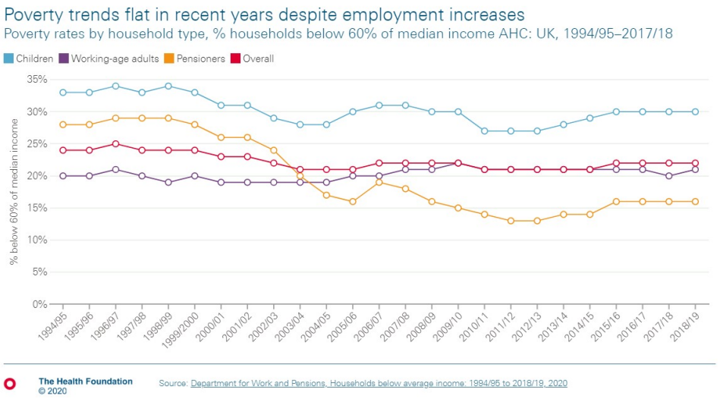

Picture 1: Trends of Poverty

The author Tinson of The Health Foundation suggests that before the event of the pandemic a slight increase in income could be registered due to the rise in employment. The above figure shows how poverty barely changed in recent years. For instance, poverty levels were at twenty-one percent in 2010/11 and at twenty-two almost a decade later. Overall, a quite similar development can be seen as a trend of stagnation dominantly prevails over the time period between 1994/95 and 2018/19 (Tinson, 2020).

People residing in the most deprived areas of the United Kingdom have been registered to be significantly harsher affected by the contraction of covid compared to the areas of least deprivation. Additionally, these people doubled in numbers of admission to intensive care units and risk of death very likely for the reason that the state of poverty and deprivation, equally means higher risk of exposure to the virus and an overall deteriorating health condition. People living in communities of lower health standards are more likely to catch the disease as they most often operate in jobs that require them to be outside such as support workers, security

forces, workers in public transport or employees in the retail industry. Furthermore, overcrowding of housing is a common phenomenon in underprivileged communities. The risk of possible infection with the disease is doubled as the number of residents rises above six people in a household, compared to households of one or two persons (Pagel, 2021). Most people in England that work in jobs essential for the populations maintenance of day-to-day life in other words key workers receive low income and can therefore only afford housing in deprived areas. Moreover, they also have probable reliance on public transport compared to overprivileged people which then again makes them more vulnerable to contraction of the disease as then contact with possibly infected people is made. Additionally, poor areas are more likely to be densely inhabited hence why chances are high for an individual in those areas to encounter or contact another individual with an infection, when doing groceries or going to the pharmacy for example. The denser the population in an area the higher the difficulty of sustaining social distancing (Pagel, 2021).

There are a number of risk factors that increase the likelihood of infection and possible death with SARS-CoV-2 if there are pre-existing health conditions like cancer or diabetes for example. Poor people affect these bad health conditions worse than the rich for the reason that disadvantaged people live in places of higher stress-, pollution- and inflammation levels (Gordon, 2020).

On consideration of the above research, it can be concluded that many negative impacts stemmed from the occurrence of the coronavirus and especially starving children should have received the support they needed during those difficult times. Moreover, better government policies could have been put in place to combat public health issues. Nevertheless, the UK did good in introducing the furlough scheme as it saved many citizens jobs.

Blundell, R., Costa Dias, M., Cribb, J., Joyce, R., Waters, T., Wernham, T. and Xu, X. (2022) 'Inequality and the COVID-19 Crisis in the United Kingdom', Annual Review of Economics, 14, pp. 607-636.
Garthwaite, K. Patrick, R.; Power, M.; Tarrant, A.; and Warnock, R. (2022) COVID-19 Collaborations: Researching Poverty and Low-Income Family Life during the Pandemic. Bristol: Policy Press.
Gordon, D. (2020) Bristol Poverty Institute. [Online]
Available at: https://www.bristol.ac.uk
[Accessed 24 March 2023].
Holt, L. & Murray, L. (2022) 'Children and Covid 19 in the UK', Children's geographies, 20 (4), pp. 487-494.
Pagel, C. (2021). 'There is a real danger that covid-19 will become entrenched as a disease of poverty', The British Medical Journal, p. 373.
Patel, J. Nielsen, F.B.H.; Badiani, A.A.; Assi, S.; Unadkat, V.A.; Patel, B.; Ravindrane, R.; Wardle, H. (2020) 'Poverty, inequality and COVID-19: the forgotten vulnerable', Public Health, 183, pp. 110-111.
Sinha, I. Lee, A.R.; Bennett, D.; McGeehan, L.; Abrams, E.M.; Mayell, S.J.; Harwood, R.; Hawcutt, D.B.; Gilchrist, F.J.; Auth, M.K.; Simba, J.M. (2020) 'Child poverty, food insecurity, and respiratory health during', The Lancet Respiratory Medicine, 8(8), pp. 762-763.
Tinson, A. (2020) The Health Foundation. [Online]
Available at: health.org.uk
[Accessed 22 March 2023].
Webster, P. (2021) 'COVID-19 timeline of events', Nature medicine, 27(12), pp. 2054-2055.
Whitehead, M., Taylor-Robinson, D. & Barr, B. (2021) 'Poverty, health and covid-19', The British Medical Journal, Issue 372.

