Module | Children, Young People and Families
Module code  Assignment Title | BMHP5004_BIRM  Essay
Module lecturer | Dr Crisford Chogugudza
Student Name | Sabah Kauser
Student I.D Number | 2026079

Contents

- Introduction ………………………………………………………………… Pg 3
- Children Safeguarding ……………………………………………………. Pg 3-4
- The Case of Baby P ………………………………………………………. Pg 4-6
- The Case of Khyra Ishaq ………………………………………………… Pg 7-8
- The Importance of Safeguarding Policies and Procedures ……………Pg 8 -9
- Conclusion ………………………………………………………………… Pg 10
- References ………………………………………………….Pg 11-12

INTRODUCTION

The significance of child safety regulations and practices in the UK will be covered in this essay. The cases of Baby P and Daniel Pelker will be discussed because of how their deaths were caused by neglect. These two cases generated a great deal of interest from both media and the public. These cases demonstrated how widespread child abuse has grown in society, with serious consequences, and how easily it goes unrecognised. In the past few years, concerns about families and children's concerns regarding their safety have increased.

Safe Guarding
Every organisation that works with or interacts with children should have safeguarding policies and procedures to ensure that every child has the same right to protection from harm, regardless of age, disability, gender reassignment, ethnicity, religion belief, sex, or sexual orientation. Children are protected from adults and other children who might be a risk by setting up and adhering to appropriate safeguarding rules and procedures. This includes charitable and community organisations, religious institutions, businesses in the private sector, as well as establishments like schools, hospitals, and sporting events. (NSPCC Learning, 2022).

Abuse
Children may be vulnerable to abuse, neglect, or exploitation from members of their own families as well as outsiders they come into contact with on a daily basis. Sexual, physical, and emotional abuse, neglect, domestic violence, including controlling or coercive behaviour, exploitation by criminal gangs and organised crime groups, trafficking, online abuse, sexual exploitation, and the influences of extremism that can lead to radicalization are just a few of the threats that can be present. Practitioners should prioritise the needs of children when deciding what course of action to follow in cases of abuse or neglect, regardless of the form it takes. (Gov.UK, 2018).
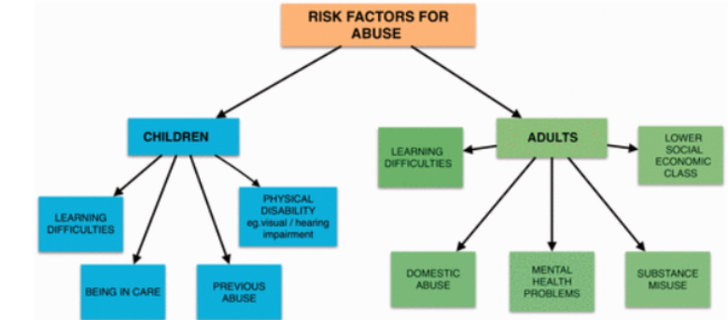(Shaikh, S. et al, 2021).

Children abuse investigation units (CIAU)
All forces have child abuse investigation units (CIAU), and while they typically take responsibility for investigating such cases, safeguarding children is a fundamental part of the duties of all police officers. The police recognise the fundamental importance of interagency working in combating child abuse as illustrated by well-established arrangements for joint training involving police and social work colleagues. A criminal offence should be reported to the police as soon as it has been committed or is suspected of having been committed since they are committed to sharing information and intelligence with other organisations. (Great Britain.Department for Education, 2006).

The children’s Act 1989
The main principle of the 1989 Act is that, unless forcible intervention in the family is required, children are best cared for within their families, with their parents actively involved in their lives. The children’s Act 1989 is in place to ensure children are safeguarded. The law now imposed new obligations on local authorities to support disadvantaged children and families in their communities in order to increase protection for children. As a result of its statutory guidelines, public care services have become more specialised. (Department for education, 2021).
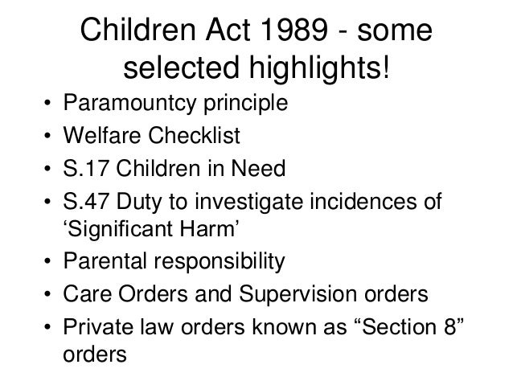 (Loynes, N, 2014)

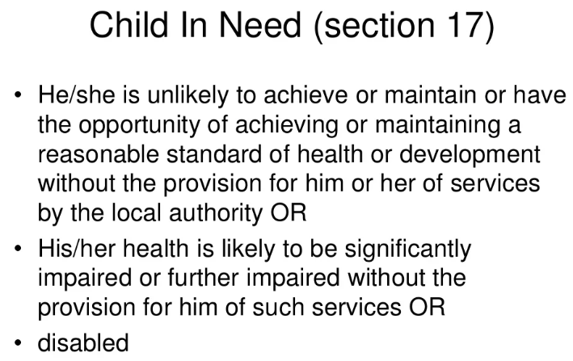 (Loynes, N, 2014)

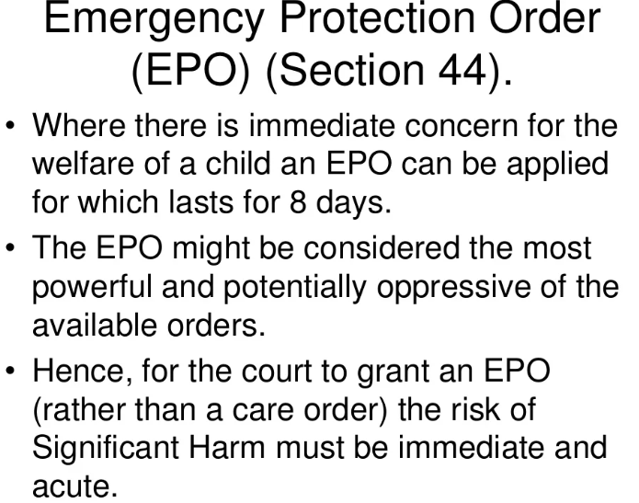
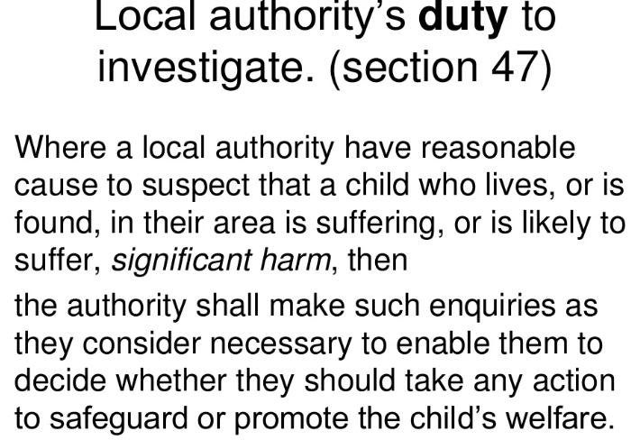
(Loynes, N, 2014)

The children and family Act 2014
The primary goal of the legislation is to safeguard at-risk or vulnerable children. Since these children will deal with local governmental organisations and bodies more frequently, how professionals communicate with them needs to be outlined. Children now have new rights to rapid and equitable procedures, and the legal system must give them more care. (Rushton, J, 2020).

Children and Young people Act 2008
The Act outlines criteria for choosing where and with whom a child in care should reside. It is made clear that placement with a parent is the top priority. Placements with relatives should continue to take precedence over placements with strangers. The Act also stipulates that placements for children should be as convenient as possible and should not interfere with their education. (Family rights group, 2022).

Case 1 : Baby P
Peter Connelly (Baby P), who was 17 months old when he tragically died in August 2007, he had been subjected to months of violence by his mother, her new partner, and a lodger at the family home. In the eight months prior to his murder, Peter had been visited by the authorities 60 times and had more than 50 injuries. There were ten organisations working with Peter and his family. Peter was placed on "child protection/at danger" on the 22nd December 2006, however poor interventions and efforts by professionals and authorities left him unprotected.
On November 11th, 2008, two men, Baby Peter's stepfather Steven Barker and Jason Owen, Barkers brother were found guilty of causing or permitting the death of the 17-month-old baby. The mother of the infant Tracey Connelly had already plead guilty. During the trial, the court heard of how Baby Peter had been used as a punching bag, and his mother had lied, manipulated and deceived professionals, and in her favour on one occasion, she had covered his bruises by smearing chocolate on him. He was declared dead 48 hours after a hospital doctor missed the fact that he had a shattered spine. He was the focus of a child protection plan with the London local authorities of Haringey, which was also the cause of Victoria Climbie's lack of protection in 2000. (Parton, N. et al , 2011).
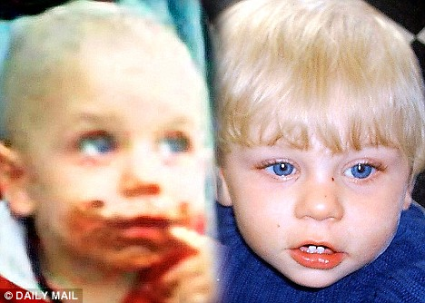 (Dailymail, 2008).
A brief summary of what unfolded in the case of Baby Peter
1 March 2006: Tracey Connelly gives birth to Peter.
June 2006: Connelly starts dating new boyfriend Steven Barker.
November 2006: Connelly welcomes Barker into her house.
December 2006: G.P notices bruises on the boy's face and chest, and Connelly is then arrested.
January 2007: Five weeks after being left in the care of a family friend, Baby P is brought back home.
February 2007: Former social worker Nevres Kemal writes to the Department of Health about her concerns regarding potential shortcomings in child protection in Haringey.
12 March 2007: Inspectors from the Commission for Social Care Inspection (CSCI) speak with representatives from Haringey to address the issues mentioned by Ms. Kemal in the letter written by her lawyer and dated February 16, 2007.
April 2007: Baby Peter is admitted to North Middlesex hospital with bruises, two black eyes and swelling on the left side of his head.
1 April 2007: The CSCI transfers inspection duties for children's services to Ofsted.
May 2007: A social worker transports Baby Peter to the North Middlesex after noticing marks on the boy's face, where 12 areas of bruises and scratches are discovered. Connelly is detained again.
June 2007: Barker's brother, named Jason Owen, moves into the home with a 15-year-old girl.
30 July 2007: A social worker overlooks Baby Peter's hand and face injuries after the child is purposefully covered with chocolate to conceal them.
1 August 2007: Baby P is examined at a child development clinic.
2 August 2007: Police tell Connelly she will not be prosecuted after her case is considered by the Crown Prosecution Service.
3 August 2007: Baby Peter is found dead in his cot.
(BBC News, 2013).

Case 2 : Daniel Pelker
Daniel Pelka, a four-year-old boy from the West Midlands, died as a result of malnutrition, neglect, and physical abuse. He was a "bag of bones," according to an assistant teacher, the trial heard that he was "wasting away." Daniel weighed only 10 kg at the time of his death. He was killed by his mother and her partner. The Coventry Local Safeguarding Children Board (LSCB) released an overview report of the Serious Case Review (SCR) of the circumstances surrounding his death that highlighted missed opportunities for his protection by a number of agencies. In light of what they knew about Daniel's circumstances, it is said in the conclusion that "No one professional suspected or could have foreseen that he would be killed”. However, after evaluating the sequence of events that resulted in Daniel's death from an inflicted head injury, the SCR highlighted several instances where system failures or individual errors led to a failure to protect Daniel. Daniel's mother and her partner were judged responsible for his murder and given terms of imprisonment that must include at least 30 years. (Wonnacott, J., et al, 2019).
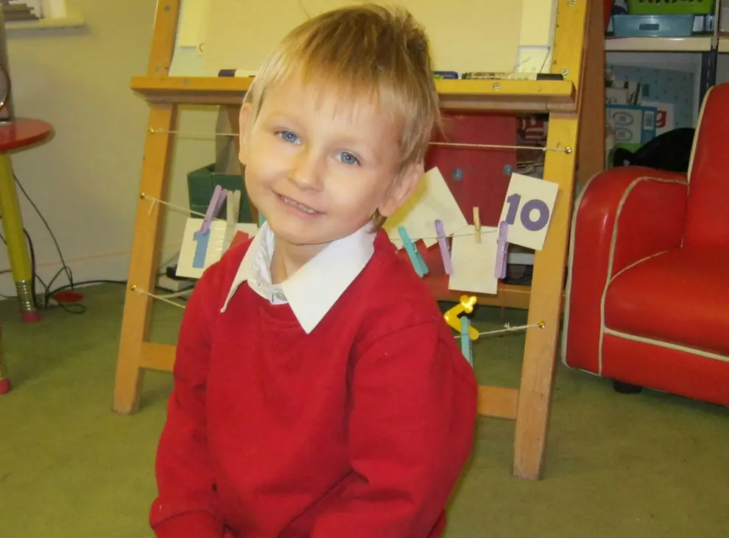(Independent,2013)

22nd January 2009
Following the most recent instance of domestic violence, which was documented in November 2008, a health visitor refers the child to children's social services, also known as Children, Learning and Young People Directorate (CLYP).
On January 29, a social worker conducts an assessment at the residence, it is considered that Ms. Luczak could protect the child, no further action is taken.

5 July 2010
When a health visitor visits the family, Daniel is found to have a bruise on the side of his head, with the claim that he "fell over," according to the health visitor. It has been reported that Ms. Luczak doesn't speak much English.

8 August
Following an altercation between Ms. Luczak and Mr. Krezolek, police are called to a domestic abuse incident involving knives. Ms. Luczak claims to have experienced a minor cut from a knife and to have lost consciousness as a result of an attempted strangulation.
She said that Mr. Krezolek was intoxicated at the time and that the kids had seen everything. Police never mention looking into the welfare of Daniel and his brother, who are 3 and 5 years old, respectively. Mr. Krezolek is detained and then freed on the same day.

27 December
both adults fight in front of the children while intoxicated, a neighbour calls the police to report domestic abuse. According to the police report, the children did not see the incident and were "none the wiser." CLYP is not referred in any way.

6 January 2011
Daniel is taken to A&E by Ms Luczak and Mr Krezolek, A fracture is found on his left arm also multiple bruising to his arm, left shoulder and stomach. Daniel is noted to be interacting well with his mother and Mr Krezolek.

7 January
After a meeting to discuss the history of domestic violence occurrences at the family home, it is decided to conduct a "in-depth assessment." CLYP agree to participate in a Core Assessment and allowing the results to be shared with all professionals.

November
The school expresses to Ms. Luczak its worries regarding Daniel's persistent fascination with food and the fact that he steals food from other kids' lunchboxes. According to reports, he was constantly focused on eating and would frequently take four or five pieces of fruit from the "fruit corner" in the classroom. According to school staff, Ms. Luczak gave the impression that he should only consume what was in his lunchbox, which contained the absolute minimum.

January 2012
The deputy head teacher schedules a meeting with Ms. Luczak after becoming concerned that Daniel isn't developing and that he has a food preoccupation. She claims that Daniel was taking food from home and waking up in the middle of the night to raid the refrigerator, but as a result, he had diarrhea.
Daniel "searched for food everywhere," according to evidence from school staff, and "he would eat whatever he could get his hands on,"

Between December 2011 and February 2012
Daniel occasionally showed up to class with facial injuries. What injuries were seen and when are unknown due to improper recording within the school, however they include:
- "Approximately four spot bruises down the neck from the ear to the shoulder" seen by the class teacher and recorded in the concerns book (for the reception class).
- "Fresh blue/black bruises on the eyes and a scratch across the nose" seen by the class teacher who told the head teacher.
- "A bruise to the centre of the forehead" seen by a teaching assistant.
- "A large bump on the left hand side of his forehead about the size of a two pence piece" seen by another teaching assistant.
- "A graze to the top/front of his forehead" seen by the head teacher. When asked, Daniel's sibling said Daniel had been pushed over by another child outside of school.
Although Daniel was said to have "black eyes," other members of the teaching staff claimed they had no recollection of seeing such injuries. These injuries were not referred to CLYP or the police.

2 March
The computer at the family home was used to search up information on salt poisoning and of a child not responding.
Text messages sent from Ms Luczak to Mr Krezolek are later sent saying "he'll get over it" and that there was no point in calling an ambulance because it would "cause proper problems".

3 March
At just after 03:00hrs a telephone call made to the emergency ambulance service and Daniel is admitted to hospital at 03:28 having suffered a cardiac arrest, from which he could not be resuscitated. He was pronounced dead at 03:50.

Conclusion
As illustrated in the incidents above, child abuse and neglect can have very serious consequences, including death. The systems have been failing innocent children for many years. If the local authorities had conducted their responsibilities to the best of their powers, they could have allowed to save the children and stop horrific mistreatment, but they weren't, which led to the worst outcome for the children. No child should suffer.

References

BBC News. 2013. Timeline: Missed opportunities in Daniel Pelka case, available at
Timeline: Missed opportunities in Daniel Pelka case - BBC News
BBC News. 2013. Timeline of Baby P case, available at Timeline of Baby P case - BBC News
BASW. 2009, Serious case review baby Peter available at Draft (basw.co.uk).
Dailymail. 2008. Baby Ps social worker overloaded with 18 child protection cases available at Baby P's social worker was 'overloaded' with 18 child protection cases | Daily Mail Online
Department for education. 2021, The children act 1989 guidance and regulations available at The Children Act 1989 guidance and regulations (publishing.service.gov.uk).
Family rights group. 2021, Children and young persons act 2008, available at Children and Young Persons Act 2008 - Family Rights Group (frg.org.uk).
Great Britain. Department for Education, 2006. Working together to safeguard children: A guide to inter-agency working to safeguard and promote the welfare of children. The Stationery Office.
Gov.UK. 2018, working together to safeguard children, available at Working together to safeguard children - GOV.UK (www.gov.uk)
Independent. 2013, available at Daniel Pelka: Four-year-old was tortured, starved and invisible to police, teachers and care workers | The Independent | The Independent
Loynes, N. 2014, The children’s act 1989 available at The children act 1989 (slideshare.net)

NSPCC Learning. 2022. Safe guarding children and child protection, available at Safeguarding children and child protection | NSPCC Learning
Parton, N. and Berridge, D., 2011. Child protection in England. Child protection systems: International trends and orientations, pp.60-88.
Rogers, M. 2013, CSN Policy briefing available at Daniel-Pelka-Serious-Case-Review-Coventry-LSCB.pdf (lgiu.org)
Rushton, J. 2020, The children’s and family act 2014. Available at The Children and Families Act 2014 | Summary, Important Parts (cpdonline.co.uk).
Shaikh, S. and Ali Malik, R., 2021. Safeguarding children. InnovAiT, 14(5), pp.279-286.
Wonnacott, J., Watts, D. and Safeguarding, I.S.C.V., 2014. Daniel Pelka Review: Deeper Analysis and Progress Report on Implementation of Recommendations. Coventry Safeguarding Children Board, Online document, available online at: https://edemocracy. coventry. gov. uk/documents/s15753/Retrospective% 20Deeper% 20Analysis% 20and% 20Progress% 20Report. pdf (accessed November 21, 2019).

