Light
and
Shadow Art
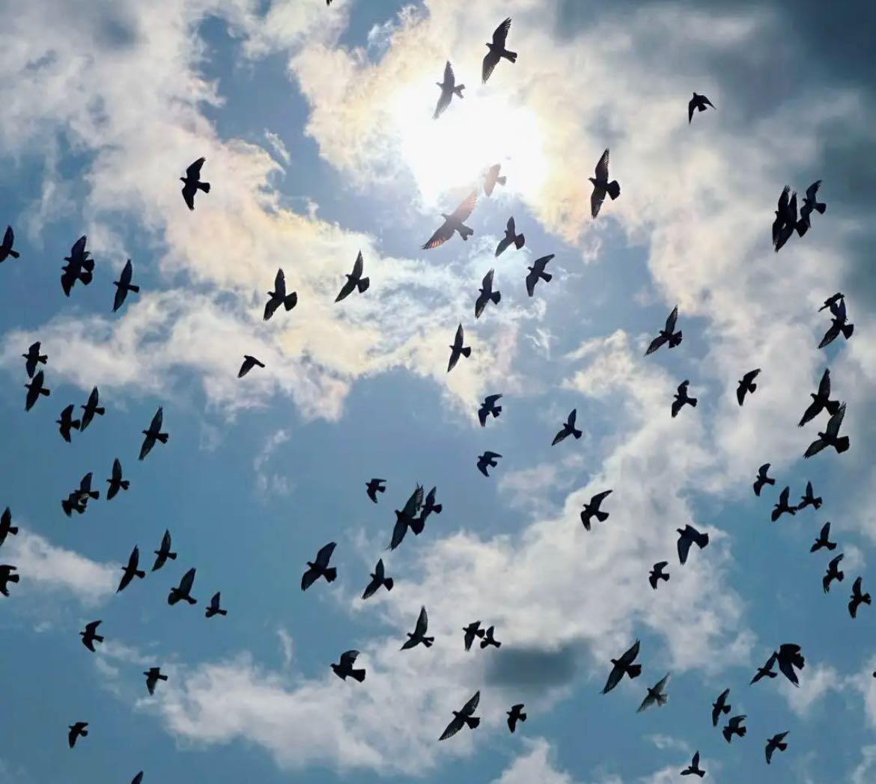
Is light and shadow art a contemporary topic?

Light and shadow art is a form of contemporary art that creates works of art through the use of light and shadow.
Although light and shadow art is not traditional painting or sculpture, it holds a certain position in the contemporary art world. In short, the boundaries of art are subjective and will continue to evolve over time.
The ontological stance of light and shadow art:
Ontology is concerned with the question of 'existence', which is the essence or authenticity of things. In the ontology of light and shadow art, the main discussion is whether light and shadow have their inherent 'existence' or whether they are just a phenomenon in objects and the environment. Most artists and scholars believe that light and shadow do not have an inherent existence, but rather are generated by the interaction between objects, light sources, and observers. But there are also some viewpoints that light and shadow have their independent existence and significance, and they are not just attributes of objects。

Exploring thinking and summarizing
- Light and shadow art has various forms of expression in contemporary times, using light and shadow to create artistic works. In my past MA course studies and research, as well as my exploration and thinking in the past two weeks, I have personally made five common classifications for the entire light and shadow art, including the following common forms.
- Light and shadow installation art:
Artists use lighting, reflective materials, and the arrangement of objects to create visual effects, allowing the audience to immerse themselves and interact with the work.
Example: On various video websites, we can find art designs, such as the arrangement and combination of various objects, which is currently one of the mainstream light and shadow arts.
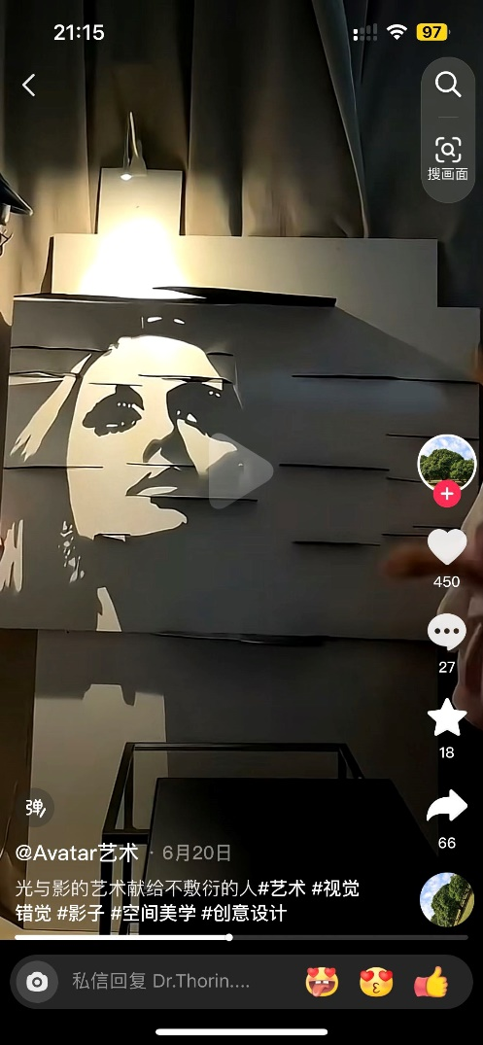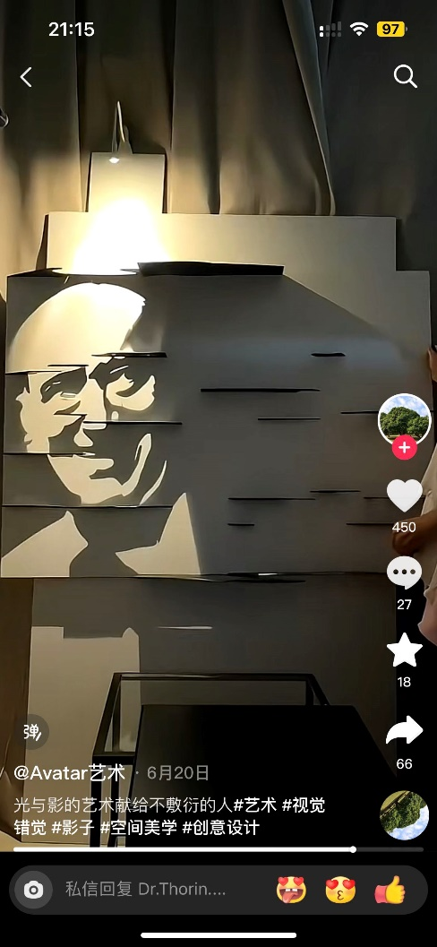
- Projection Art:
Artists use projectors to project images onto different surfaces, creating dynamic images or vis
For example, the Tindall effect, which was also the most interesting thing for me during my time at MA and the one I explored the most outdoors. Of course, this is also the help that nature has given me. Light and shadow always bring some artistic inspiration to people.
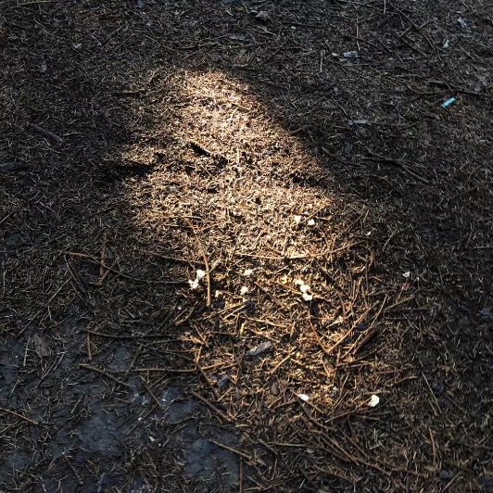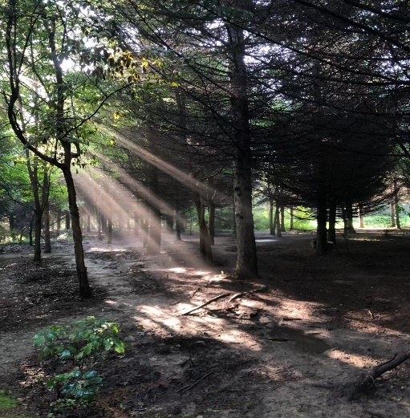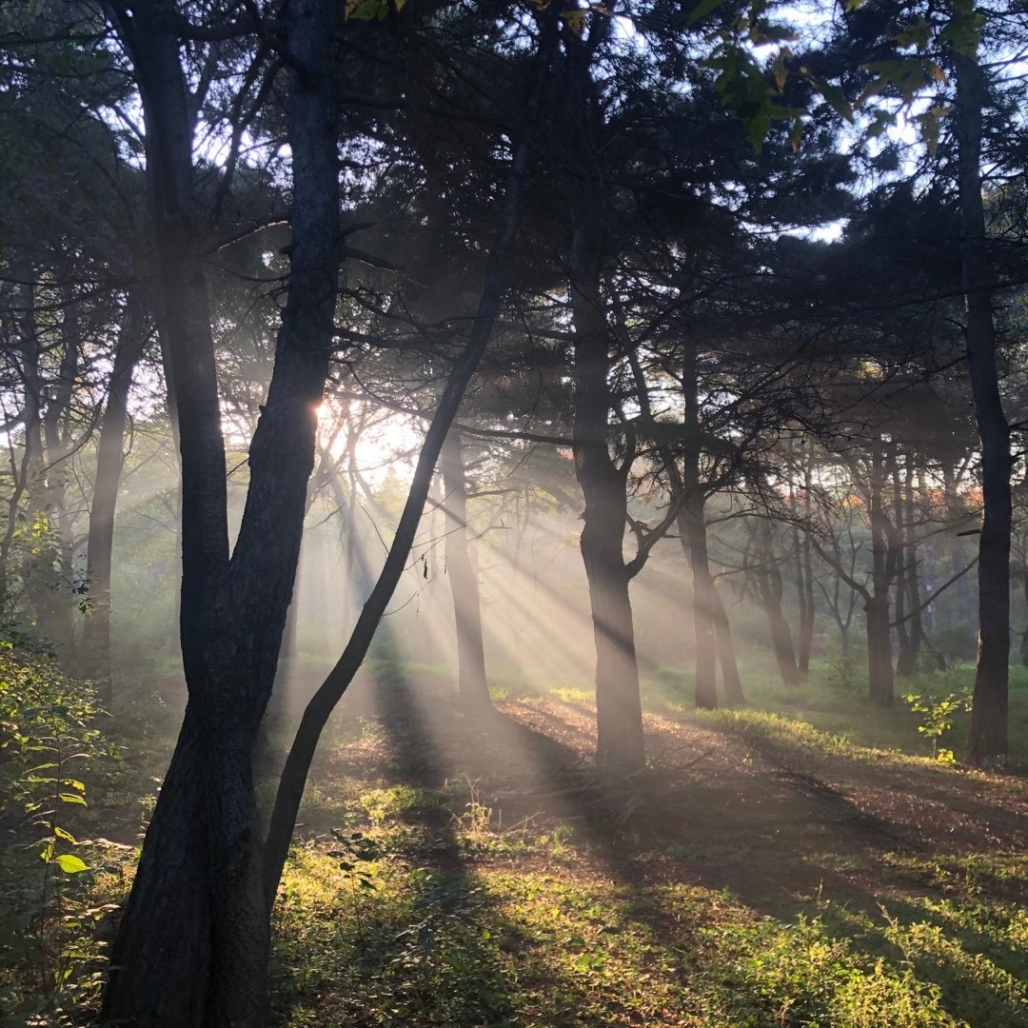
- Photography and Film Art:
Photography and film are the most common forms of light and shadow art, and artists capture and edit light and shadows through photography and film production to express their creativity.
This is also one of my favorite ways during my time at MA.
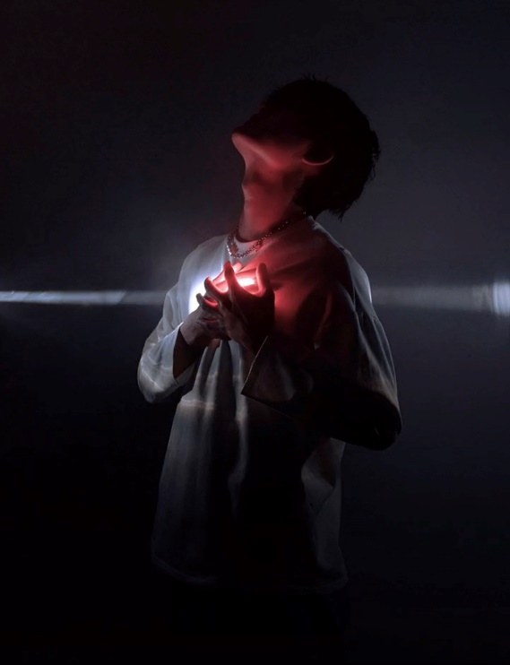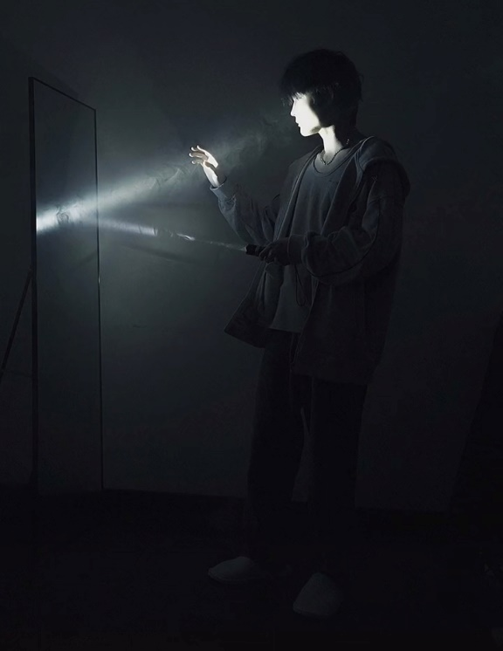
- Real time interactive device:
Some light and shadow art works have interactivity, and the audience's actions or sounds can trigger different light and shadow effects, making the art works more vivid and participatory.
For example, light and shadow art piano.
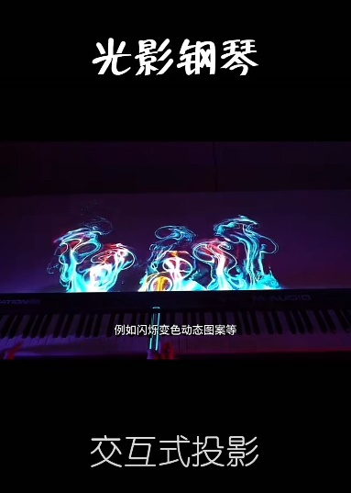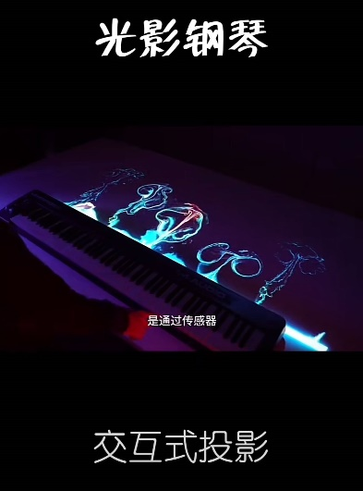
- Projection mapping:
Artists project images or animations onto buildings, sculptures, or natural landscapes to change their appearance and meaning.
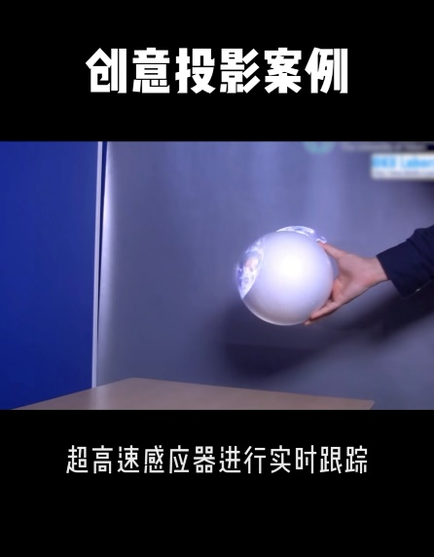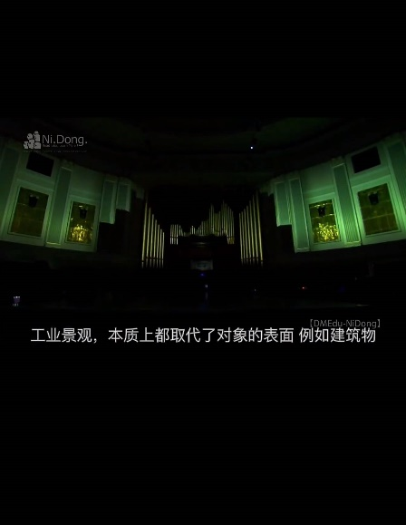
Summary:
Light and shadow art provides rich creative possibilities in contemporary art, breaking through the limitations of traditional art media, creating unique visual experiences, and triggering audience thinking and emotional resonance.

