How can we improve involvement through the use of positive specific reinforcement?

A critical reflection and analysis of a small-scale Lesson Study, with the intention of refining personal Primary School practice.

The Enquiring Teacher (TET)

Level 6 • ECPP6001

Word Count: 6100

Group 5 • P123348



Contents

Introduction Page 4

Literature Review Page 6

Lesson Study Design Page 9

Ethical Considerations Page 13

Lesson Study Analysis Page 14

Lesson 1 Page 14
Lesson 2 Page 19
Lesson 3 Page 22

Discussion of Research Findings Page 25

Conclusion and Recommendations Page 27

References Page 29

Appendix Page 33

A note
This small scale Lesson Study was one of the most informative pieces of research I have undertaken. Although it didn’t go completely to plan, the questions it raised were astounding. A tool I will carry with me always, into my future career.

Introduction

Aims, focus and purpose: Having worked in a variety of schools, the difference in attitudes towards how Positive Reinforcement (PR) is utilised is interesting. In my experience, one school in particular has moved away from the standard behaviourist model of reward, incentive and praise and instead focuses more on ideals such as Carol Dweck’s ‘Growth Mindset’ and resilience building. Removing the behaviourist model completely is supported by one of USA’s best teachers, Raife Esquith (2012) who (despite recent controversy) teaches his children to internalise moral values and to become involved in their learning not because of PR, but because it’s the right thing to do.

This experience of contrast has sparked a personal interest in the link between specific PR (praise) and the affect it has pupil’s involvement and overall wellbeing. The purpose of this short research project is to investigate: can refining and carefully selecting how we positively reinforce have the most impact on a child’s desire to be involved in the learning process? Additionally, is PR a pedagogical principle that has a place in Donaldson’s Curriculum 2022 and my own professional repertoire and if so, how can I employ it most effectively to improve my own practice?

Setting the scene: To execute the research project, I collaborated with two of my colleagues from UWTSD who were in a similar geographical area, same phase but in a contrasting school. Together we discussed our shared interests and concluded our research question: How can we improve involvement through the use of positive specific feedback? We were all in agreement that the way that we positively reinforce is something that needs to be developed and would be beneficial to our future careers. The specific feedback we would initially look at was praise, towards behaviour and work – then we advanced, through feedback and reflection, to peer praise and incentives. Having looked at the research, there is a wealth of information that shows that PR/praise has a positive impact on a child’s involvement, especially those who are low achievers, and have a Additional Learning Needs (ALN). With this knowledge, I want to find out, through my own personal research, how we can optimise positive reinforcement to have its greatest impact, so that I can use it to its advantage.

Following the Lesson Study model, we collected data ethically using the Leuvan Scale, non-participant observation, a focus group interview and a collective ARC (Assisted Reflective Conclusion). Then we refined, reflected and refocused. This will be discussed in more depth in the Lesson Study Design.

Literature Review

“Human connection is powerful”

Yr Athrofa, 2018.

Intention: Before starting the research, it is imperative to become familiar with profound and up to date research around the focus. Therefore, this literature review will highlight the themes of positive reinforcement and children’s involvement and will explore the relationship between them, in a classroom context. It will attempt to paint a balanced and unbiased picture.

Positive Reinforcement: PR is derived and well expressed through the Behaviourist paradigm. Malott and Shane (2015) describe PR as ‘the response contingent presentation of a reinforcer, resulting in an increased occurrence of that response’. Likewise, Skinner, (in Grey and Macblaine, 2015; Scott and Marshall, 2009) explains that positive reinforcement is a type of operant conditioning, which is used to create a preferred outcome, that is normally pleasurable. This notion is supported by Pavlov’s stimulus and response concept, arguing that (in his experiments with dogs) a given stimulus can create a preferred response (Grey and Macblaine, 2015). Furthermore, Skinner believes that positive reinforcement is far more effective than negative reinforcement for shifting and preserving a given behaviour, though it must be used in balance to retain its effectiveness (Adibsereshki et al. 2015).

The notion of encouraging positive preferred actions and discouraging negative activities in children continues to apprise classroom practice. Grey and MacBlaine (2015) highlight that in a classroom context, a range of strategies must be used to encourage an outcome. These include, verbal praise, cues (thumbs up, smile) star charts, pictorial calendars and stickers. In addition, the Welsh Government (2012) would add peer praise and incentives to this list. Additionally, it seems that almost every school’s behaviour management policy in Wales will include an element of the behaviourist model, to which it is compulsory (DfE, 2011). Praise is an effective way to encourage children to engage in the wanted behaviour as it scopes in on the child‘s effort rather than on what is actually accomplished (Welsh Government, 2012).

Verbal feedback, praise: Regarding positive verbal feedback, or praise, Aziz (2018) conducted a small-scale study in Tehran with children who had a disability, to explore the correlation between PR and student success. The study was small-scale, involved two control groups (half receiving PR and half without it) of 45. The results demonstrated that the children who had received the praise had achieved higher results than those that did not receive feedback, suggesting that they were more involved in their work. The limitations of this are great, as the sample size was so minimal. In contrast to this, Donaldson (2015 p.64) states that praise is essential, however the opportunity to make and learn from errors in the pursuit of challenging goals builds confidence and resilience. In other words, having robust intrinsic motivation is more desirable that being reliant on extrinsic motivation. More recently Yr Athrofa: Institute of Education (2018), believe that ‘Pupils make better sense of verbal feedback because I can explain the point and emphasise aspects more clearly than through a written comment. I can show them exactly what I mean, and that is powerful’.

Praise, (the verbal nod of expected appropriate social conduct displayed by children (super job! You’re sitting nicely!) is one of the most effective school-based strategies to decrease problem behaviour and raise positive behaviour and attitudes (Cavanaugh, 2013), which is in line with behaviourist theory. On the other hand, Dweck (2014) argues that praise is an effective tool, but it needs to be facilitated in the right way. In a study that involved 400 children that were given an IQ test. Some were praised for their intelligence and others for their effort. They were then offered a more challenging test. The children who were praised for their effort showed a greater desire (92%) to take more risks, worked harder and longer and were more intrinsically involved in their work as the focus, was on the process of growth rather than an external reward.

Involvement: in an educational context focuses on the extent children are operating to their full potential. It is important to recognise the array of influences a child has on their wellbeing and therefore involvement (assuming that a child with higher wellbeing is more likely to partake in an activity). Bronfenbrenner, demonstrates this by explaining that children have five major influences on them, ranging from micro-level (friends, family) to macro-system (the child’s beliefs and ideas, culture and values) (Psychology Notes, 2013).

Its important not to assume however, that a children’s desire to engage is wholly down to external influences. Deci et al. (2001) entails that if a child feels competent at what their aiming for, and the challenge is high enough for them, they will become intrinsically motivated to overcome that task whether or not PR is present. Mihaly Csikszentmihalyi (2004), agrees with Deci et al, arguing in his 2004 TED Talk, that if the conditions are correct, and the child has a high challenge matched with a high skillset, one will become intensely immersed in an activity and reach a state of flow, which creates intrinsic reward. Combining the thoughts of Dweck and Csikszentmihalyi, in a classroom context this means that giving children the right amount of meaningful challenge, with a resilient mindset, a child will become intrinsically motivated to overcome the challenge without the need for praise or an incentive. Csikszentmihalyi (2004) warns that too much external reward can contribute to a lower state of wellbeing and involvement.

In 2014, the Welsh Government released the Welbieng of Future Generations act, that highlighted the pressures that affect wellbeing and involvement. These included social, economic, environmental, and cultural. The issues that face children in Wales especially are poverty, global warming, and health inequalities (Welsh Government, 2014). This issues are present in schools and is likely to affect our children.
Conclusion: Although this review of literature is brief, it is evident that positive reinforcement can have a positive impact on a child’s desire to be involved and achieve. It will be interesting to see whether how tailoring the way we use PR will optimise involvement, or will the children be more affected by their intrinsic innate motivation to overcome a task. I hope to develop the way I use PR to improve my own teaching.

Lesson Study Design

Lesson Study: To gain valuable data and find out how most effectively we could improve our practice, it was necessary to consider our own independent research. The Lesson Study Design section provides justification for the methodology that was decided upon when preparing for our project (Tomlinson, 2010). My two partners and I carefully selected tools we thought would most best fit the environment and context we were going into. After careful consideration, a lesson study design was selected.

The Lesson Study design is a type of action research that was packaged by Peter Dudley, though has been in use in Japan since the 1890’s. Its purpose is to give teachers an unusual insight into their practices from an outside perspective, to develop and improve their craft (Dudley, 2011). The conventional structure of Lesson Study Design involves practitioners collectively organising, delivering a lesson, observing and analysing learning and teaching in ‘research lessons’. Over the course of several lessons, they may adapt and improve their approach and pedagogy. Three focus children are usually chosen. Lee (2007), claims that the benefits of using a lesson study is that it allows teachers to gain insights into how to improve their practice. Lee (2007) indicates that the limitations of a Lesson Study is that they are time consuming and adds to the intense workload a teacher already has. With this knowledge, the possibility for impact and positives outweigh the negative, therefore we were willing to invest the energy. Having my own perspective challenged will ensure that I am accountable and confident with my future use of pedagogy. Having information from my peers and the children I will teach will create a sound platform for professional decision making.

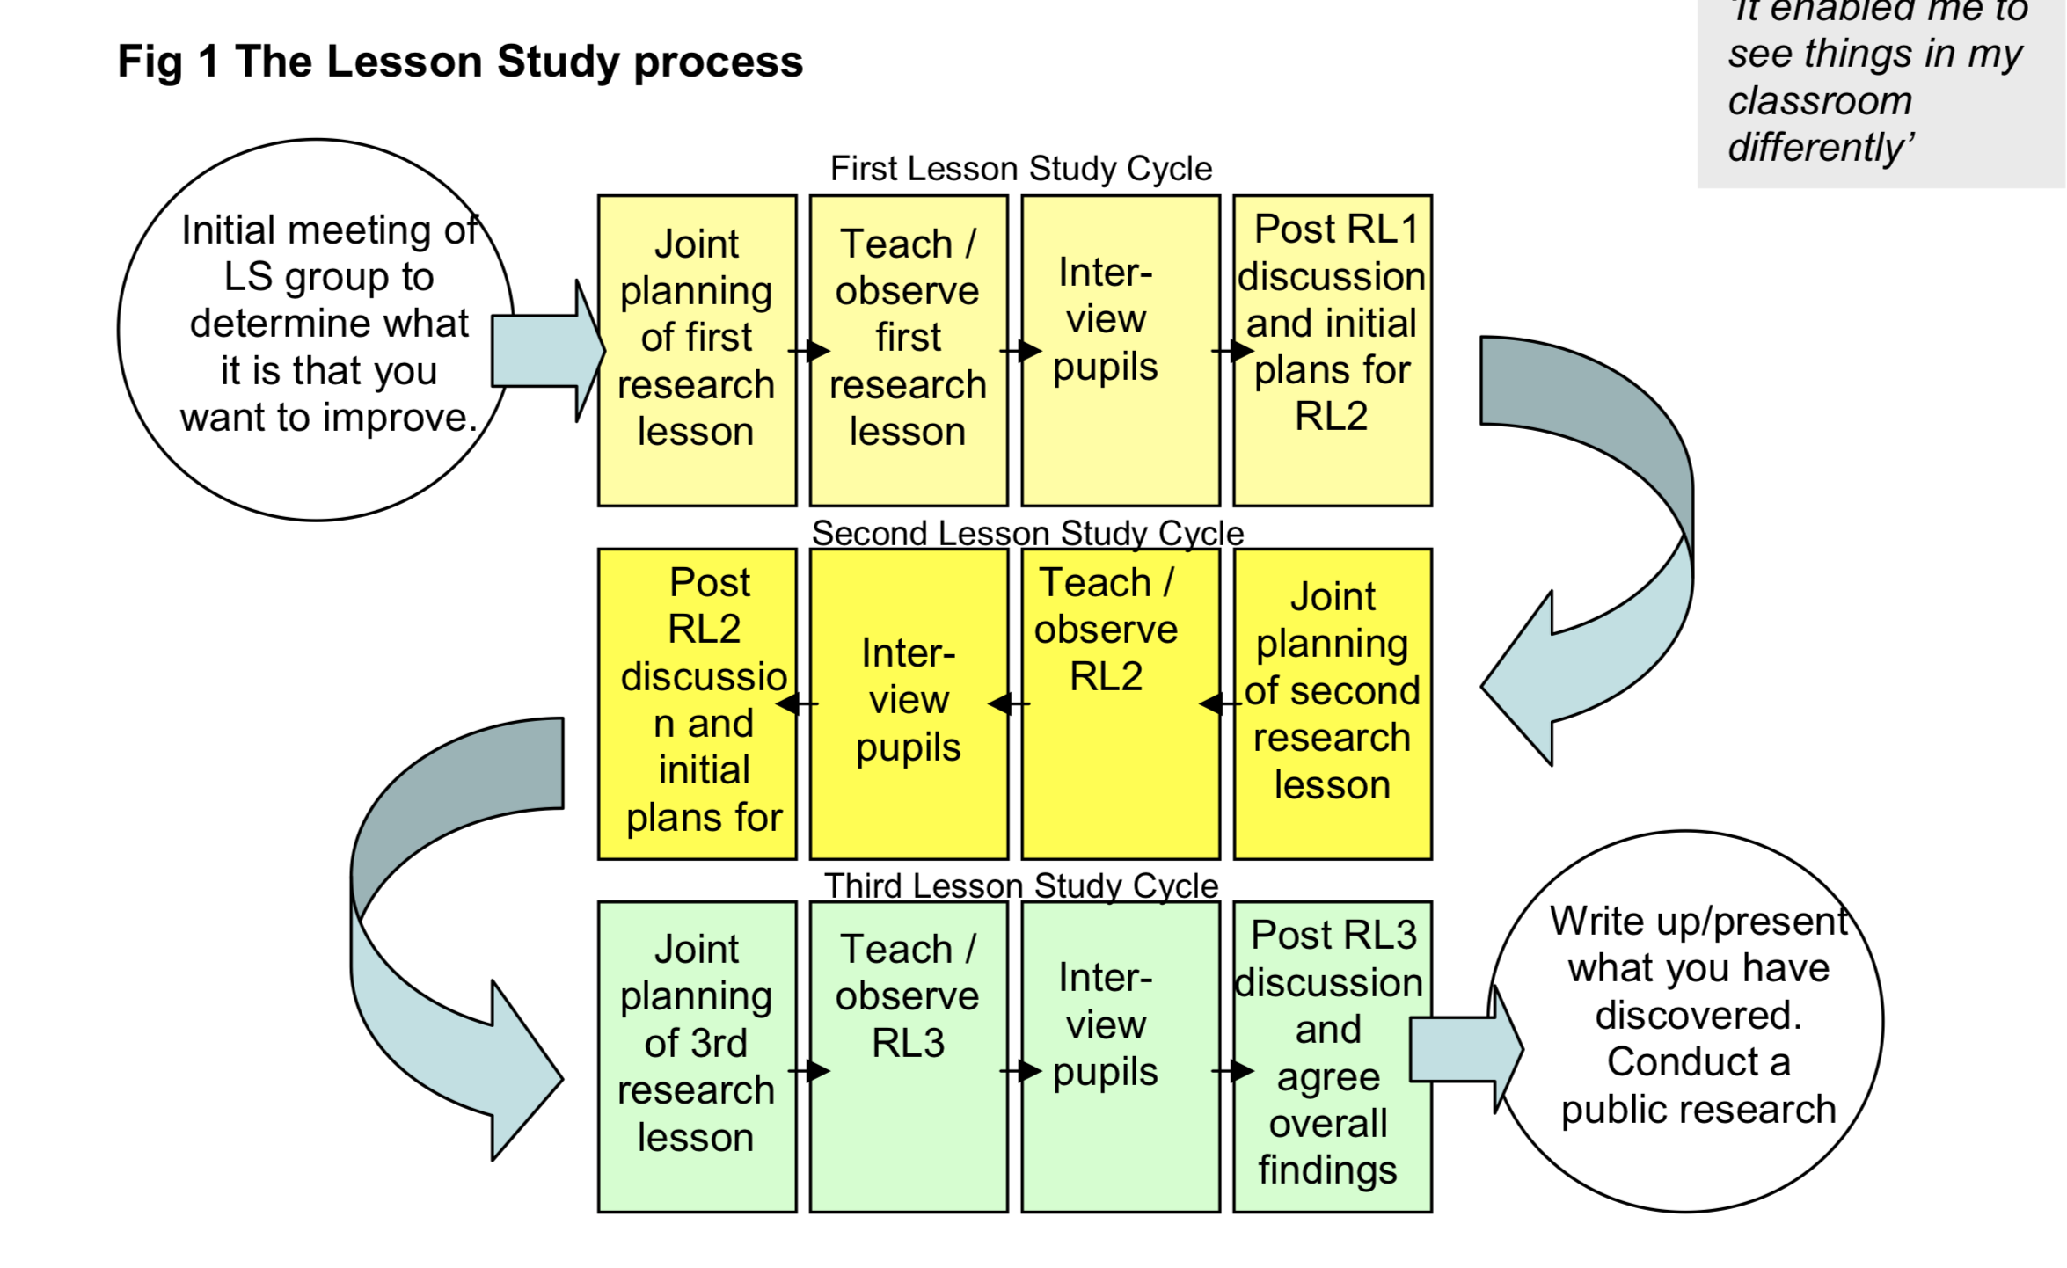

Image 1: Lesson Study Cycle

As our research project was focused upon Positive Reinforcement, we did not feel that the content of the lesson was important, therefore planned our lesson in line with the class teacher. It happened by chance that lesson 1 differed from lesson 2 and 3, which in retrospect, may have affected the data.

Context and overview : The Lesson Study took place across two schools in a similar geographical area, the first school a faith school and the second a school with high levels of EAL. Additionally, both schools had a FSM level of around 35%. Having considered and deployed the necessary ethical procedures, we began to create our methodology. Our research involved three separate lessons, each with three focus children. We observed the children using a non-participant observation method, and the Leuvan Scale for involvement which was adapted. We were hoping to capture the impact positive specific reinforcement (in this case, praise) would have on the child’s involvement in the lesson. Being aware of the likelihood that the praise would have a positive impact, we were looking at ways to optimise that praise for maximum effect. Praise would initially be given for behaviour and work.

After the lesson had ended, we created an interview schedule and interviewed the children using selected questions. One of the team would ask the questions and the others would scribe. The purpose of this was to get the child’s perspective and to generate qualitative data. With this collection of information, we collectively reflected on the experience, raised any issues and questions and refined and adapted our scope. Justification of these methods are discussed below. Our sample was collected to attempt to give a fair representation, therefore we chose one higher ability, one middle ability and one lower ability child for each lesson. This gave us a total of nine ‘sample’ children across three lessons (Dudley, 2011). In reflection, I did not decide to use the data of Child I as I did not feel they gave significant assent, therefore eight children partook.

Non-participant observation: Scott, J and Marshall (2009) state that this method of observation is when the researcher observes his or her study, with their agreement, without taking part in the lesson. The limitation of this is that the children may have experienced the Hawthorne Effect, and therefore acted differently under the pretence of being watched. Nevertheless, the benefits of using this method to collect data is that you have an outside view of what is happening, and will allow you to see the reaction more clearly. In terms of the research, being able to clearly observe, measure and document a child’s reaction to praise would arguably be more effective if the observer is passive. Moreover, it can offer a more "nuanced and dynamic" appreciation of situations that cannot be as easily apprehended through other methods. (Liu & Maitlis 2010).

Leuvan Scale for involvement: Using the Leuvan Scale model , we adapted the scale to be more tailored towards involvement (see Appendix F), and created our observation schedule for each participant. We would use this scale (1-5) to capture the child’s involvement level after praise was given in different areas (see Appendix C). We discovered upon starting the research, that it appeared that a child was naturally on the scale of 1-5 before the praise was given, and that it was imperative to give a baseline level of involvement prior, therefore we adapted our schedule and added in a baseline section. This gave us something to measure from.

Focus interview to collect qualitative data: We designed several questions as a team that would give us more information about children’s attitudes towards PR, and their feelings about being praised (see Appendix D). As we were dealing with experiences and emotions, it didn’t feel right to use quantitative data, as it would exclude the degree of the research and restrict free response (Goddard, 2000), therefore we decided on a qualitative approach. Qualitative research needs to be ‘open ended and flexible enough for the emergence of new, unanticipated categories of meaning and experience’ (Willig, 2008), with this knowledge, we took this into account when designing our interview schedule (see Appendix D).

ARC Model for reflection: Being a reflective practitioner is essential for overcoming challenges so that we can constantly improve. The Welsh Government (2016) state that ‘Evidence from other OECD countries tells us that practitioners learn best when they reflect rigorously on the outcomes achieved.’ Reflective practice can be seen as far back as Dewey (1933) who defined reflection as engaged, precise attention to current beliefs and thought. Therefore, we deemed the Assisted Reflective Conclusion (ARC) as the best tool for our reflection as we were most familiar with using it. We modified it to best fit the research, and added a section for our collective response (Appendix G1.2).

Ethical Considerations

As we were working with children, it was vital to seek thorough ethical approval from UWTSD. This process was considered with my partners, who I conversed with about the possible issues we would need to tackle. Below is an overview of the ethical issues considered and actions taken. Firstly, in accordance with United Nations Convention on the Rights of the Child (UNCRC) all children would be treated as equals and would not be discriminated according to their race, culture, gender, sexuality, class, political belief or faith (BERA, 2011; UNCRC, 1989).

Prior to the research project and observation, consent forms were sent to the parents of the participants, which can be found in Appendix B. The consent from which outlined the intentions of the research. We made clear the expectation that all children would remain anonymous and that their confidentiality would be respected. This consent was voluntary informed consent (BERA, 2011). In addition to this, I made myself aware of the safeguarding principles and policy set out by the school. Luckily, I received consent forms back from every child. The next step was gaining assent from the children.

The ‘preamble’ is the brief verbal explanation given to all of the present children before beginning the research. This can be found in Appendix A. It is outlines the purpose and aims of the research in child friendly terms, with a consideration of ethics. Essentially, it is a reflection of the assent form. Time was taken to ensure all terminology was understood via the use of questioning. Assent was then gained from the selected children before the lesson began. I made this from as accessible to the children and was sure to respond to any questions afterwards. The classroom teacher then countersigned the three Assent Form as a witness that the children understood what they were partaking in. Those children who were not partaking in the research still partook in the lesson, as this is legal requirement and received the same amount of praise.

In adherence to the BERA (2011) guidelines, we ensured that the children were aware that they could withdraw from the research at anytime, without consequence. I understood that I was in a position of power and did not offer incentives that could have created bias. All data was stored on a password protected cloud, and all names were removed to protect confidentiality and anonymity.
I ensured that I was seated away form the lesson when I was observing, so that I did not interfere with the lesson being taught. Also I ensured I was never alone with a child. The focus group took place in a classroom that had an open window and an unlocked door. A DBS check was also update by myself and colleagues. I ensured that the universities outstanding status was upheld, or did anything that would endanger the relationship between the school and the UWTSD.

Lesson Study Analyses

Lesson 1

Context and aims of Lesson 1: The purpose of the lesson was to create an advert using the Apple iPad in two groups of six children. This lesson was child led, as the children had to assign roles, work as a team and collectively complete the challenge ready to present at the end of the lesson. As the teacher in this lesson, it was my role to teach the lesson. I would intentionally, but often naturally deliver PR in the way of verbal praise towards the child’s behaviour and their work. We were especially interested to see the immediate effects this would have on the child’s involvement. We then wanted to find out prior to the lesson their attitudes and thoughts of the tools that we had used. The other two researches in the group observed the lesson using Appendix G. The children are colour coded in line with the results, as it was easier to track them when analysing all of the results.

Child A

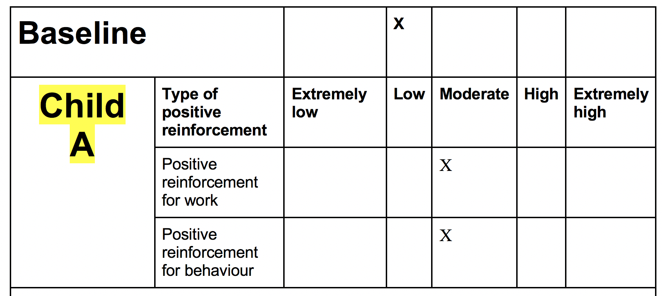

See Appendix G1.0

Moments of interest: At the start of the lesson, the baseline involvement assessment of Child A was ‘low’, therefore the child was regularly distracted (note that this was assessed after the lesson, and did not appear in the original observation schedule). As the lesson unfolded, the child was moderately engaged. It was evident that the child’s level of involvement increased upon receiving verbal praise, for both his behaviour and work. Child A seemed to become less engaged however, when partnered with someone with more confidence, as the leadership role was given up. Interestingly, prior to the lesson, Child A stated that ‘as we worked in pairs, this made me feel keen to find out what other pairs researched. I felt very involved in this lesson because it was fun and interesting’.
Something really interesting that naturally occurred in the lesson, and was not planned was peer praise. Child A responded to peer praise with joy and told us in the post interview that ‘the feeling reciprocates when he witnesses his peers ‘doing well’ also that . When asked how verbal praise made Child A feel, he stated that ‘I felt engaged and wanted to do more and give more when others got praised, it encourages me to do better when I see my friends get praised’. Child A believes that PR needs to be kind, positive and age appropriate. Stickers are not appropriate because of our age, however, ‘Class Dojo would be fun as it gives points and provides challenge’. Child A told us that a game at the end would make them work harder throughout the lesson and would be excited because it ‘consolidates the learning’.

Child B
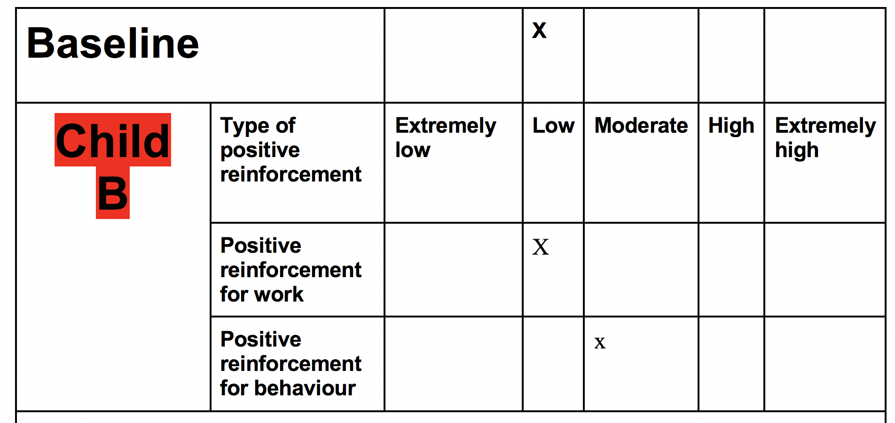

Appendix G1.0

Moments of interest: Like Child A, Child B had a baseline assessment of low, due to moments of distraction. However, it appeared that when the child was praised for their behaviour, the child became engaged and energised momentarily, before becoming distracted again. Interestingly, when Child B was given a role of responsibility, their involvement level became high, as they became intensely involved. The child becoming distracted appeared to be due to the choice of person they were engaging with.

In the post lesson interview (see Appendix G1.1) Child B stated that they felt more involved because of the grouping and gave an involvement rating of 4/5 (1 being low, 5 being high). Like Child A, Child B claimed that when praised me for my effort in a ‘nice’ way, they felt more motivated to do better. Regarding behaviour, Child B respected the fact that they were positively reinforced in ‘a kind way’. Child B stated that praise ‘makes me feel good about myself, because I know I’m on the right track’. Child B stated that a game at the end, such as a quiz, would make them work harder throughout the lesson.

Child C
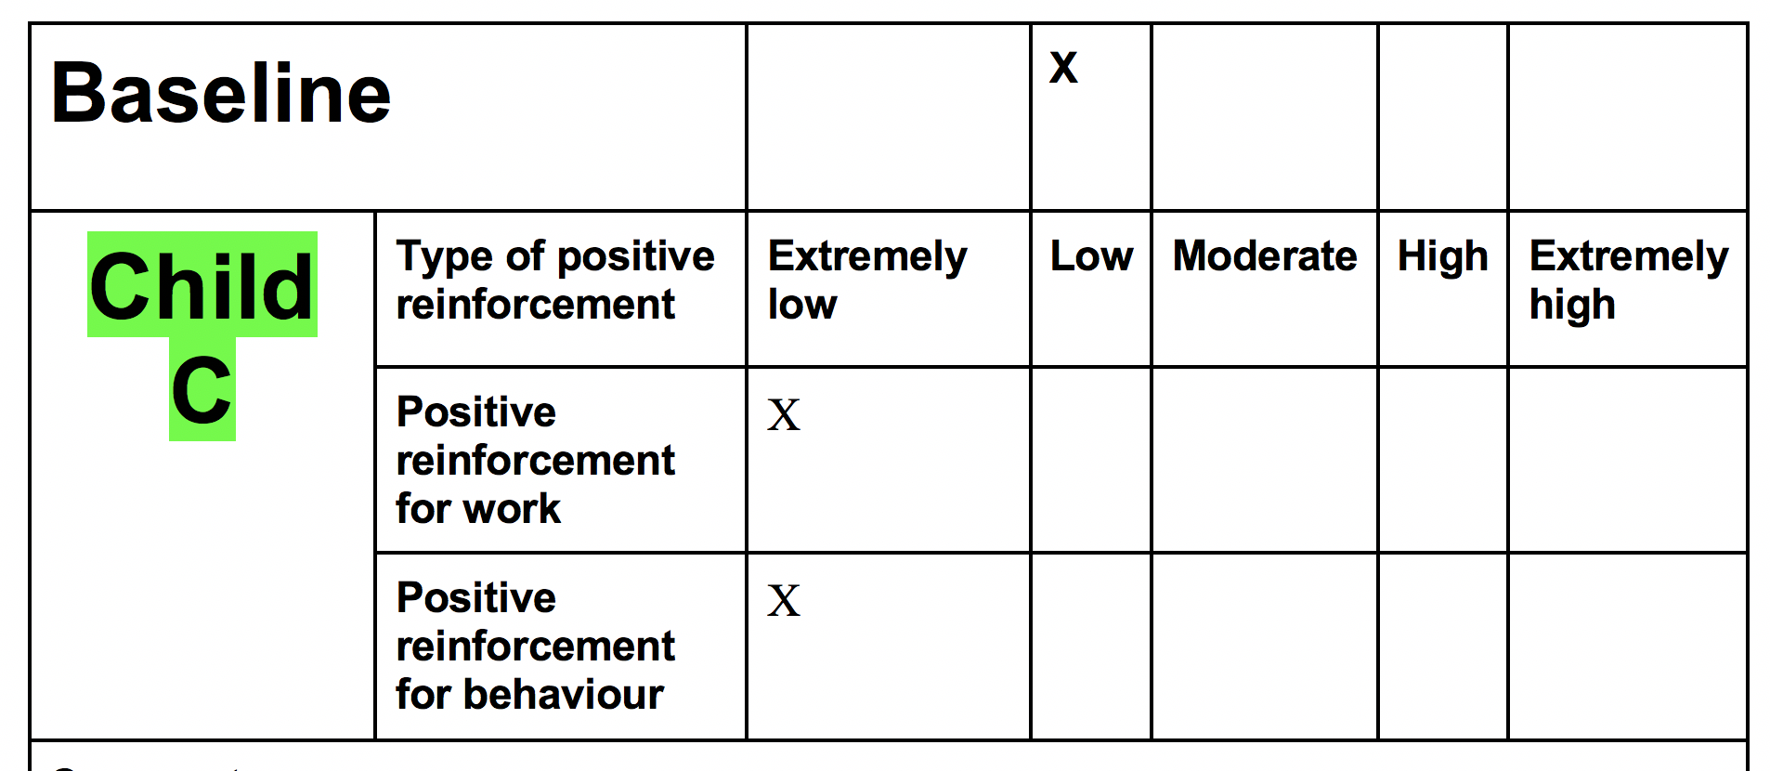

Appendix G1.0

Moments of interest: After hearing other children be praised the child become more engaged however quickly got distracted following the praise. The observer deemed the child ‘extremely low’ on the involvement scale as the child seemed distant or absent. PR had little effect on the child’s work or behaviour. Other comments that arose were ‘Very quiet throughout lesson’ and ‘Anxious throughout the lesson’ Possibly due to the two new adults in the room. During the post interview, the child claimed that they felt good about praise, however gave blunt responses, almost as if they were complying and not thinking for themselves. Child C did not give a constructive response.

Critical Reflection of Lesson 1:

Going into this lesson was exciting because I was returning back to my previous school. I felt that the children were keen to get involved with the research and understood its purpose and benefits. I was really happy with the post interview as this provided us with a base to reflect upon.

Being present in the post interview may have impacted the data, as the children may have given an embellished or illegitimate response, therefore it was decided that next time, we would exclude the ‘teacher’ from the post interview process. Collectively, we agreed that verbal praise alone is not enough to raise a child’s involvement. On the other hand, positive feedback can be useful if it is specific and genuinely ‘kind’. There seemed to be other factors at play, such as the environment and the child’s individual interests. The use of specific positive feedback needs be a collection of peer, child led and incentive based, not just verbal. Therefore, an agreement was made to adapt our schedule and include peer praise as well as work and behavior. A toolbox needs to be created to prompt certain type of praise, towards a child’s effort. We decided it needed to be prescriptive and kind.

Amendments to approach
- Introduction of baseline assessment
- Assess and purposefully include peer assessment, adapting observation schedule
- Introduction of a toolbox, to try and praise children for their effort in a prescriptive, kind way (Appendix E).
- Ensure that the teacher is not present in the post interview.

Lesson 2

Context and aims of Lesson 2: As PR was given, we introduced a PR toolbox to enable us to be more prescriptive with our praise. Care would be taken to deliver praise in an authentic and kind way in hope to maximise its effectiveness. The purpose of Lesson 2 was to give specific verbal feedback (using our natural initiative and the Appendix E toolbox) regarding behavior and work and to ensure that this feedback was descriptive and prescriptive. Also, we would measure the involvement of the children after facilitating peer praise.

There were 14 children whose task it was to create a poster for a holiday from a pack of information they had been given. Again, teamwork was essential here.

Child D
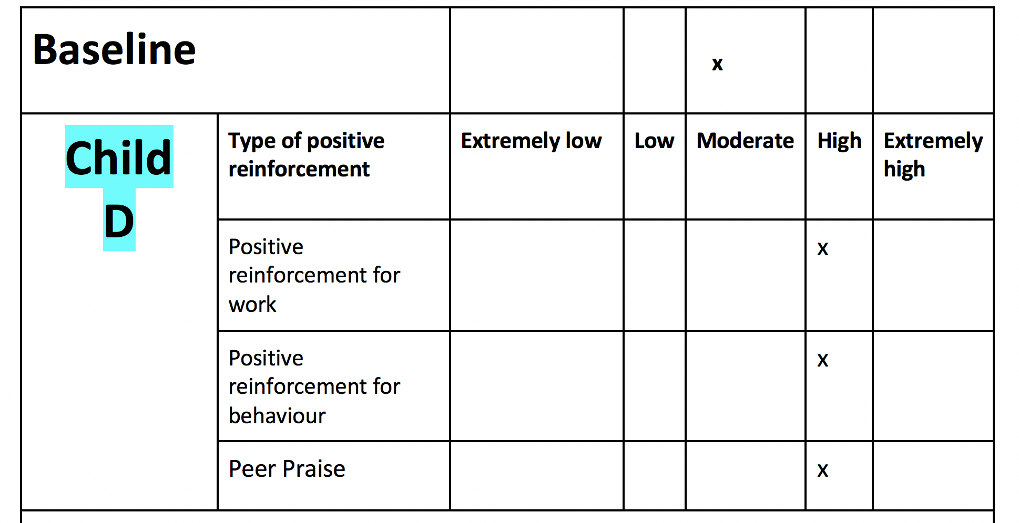

Appendix H1.0

Moments of interest: Child D was consistently well behaved and engaged. Positive effect after praise for behaviour especially. This raised the question, is the child’s engagement the natural nature of the child or due to the praise? Use of peer praise definitely showed a positive response with motivation and willingness to learn. Child D felt involved in the lesson because it was interesting, and they were given the responsibility of leading their group. Praise was seen as something that inspired Child D to work more and do more. PR, made Child D feel excited and happy. Despite Child A’s response, Child D would happily receive a sticker as a method of PR perhaps because Child D was younger. When other children praised child D, made them happy because ‘I am motivated to do more’.

Child E
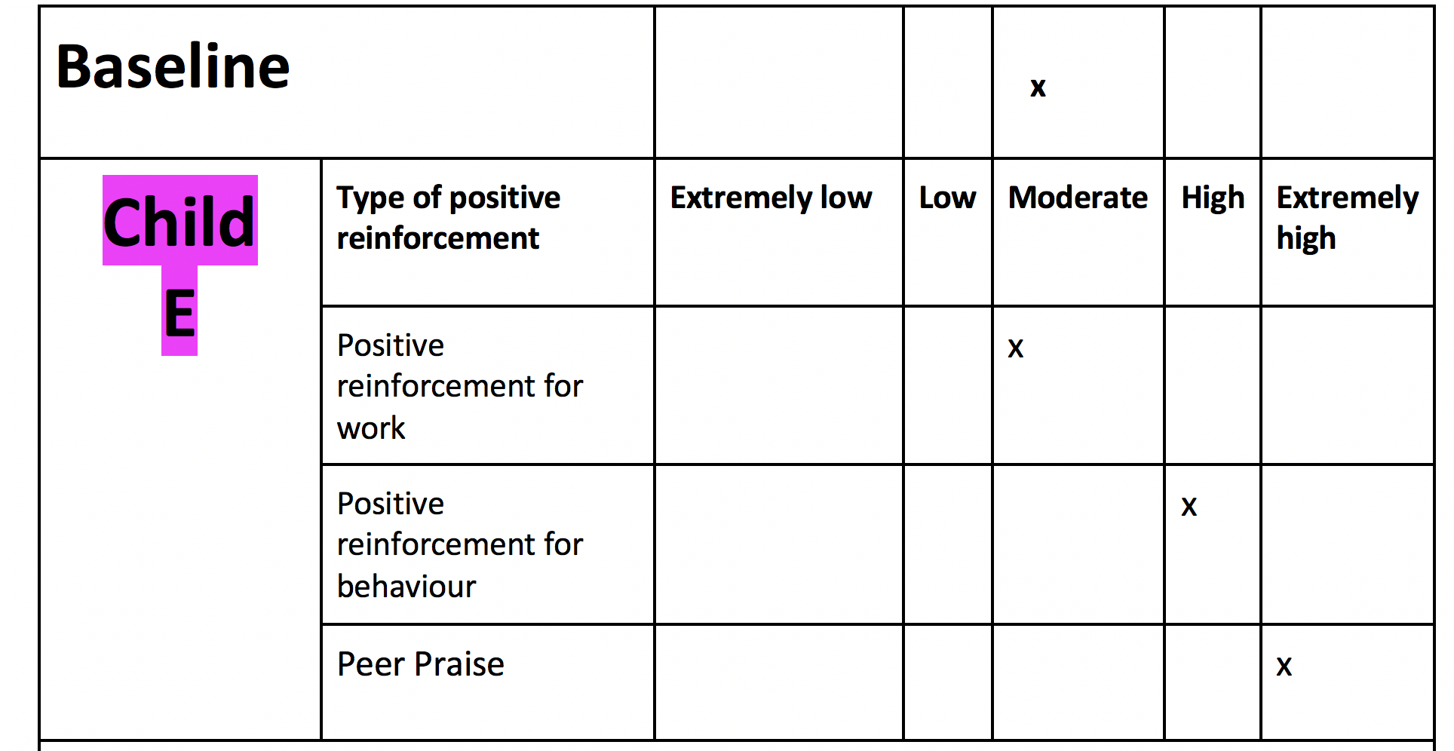

Moments of interest: Became intensely involved when praised by a peer, you could see that they were concentrated and persistent to learn. Different types of PR seems to work for different children therefore tailoring your PR is imperative to ensure that it has the most impact. It was evident that when giving Child E genuine feedback, such as eye contact and a soft tone, they became consistently more engaged.

In the post interview, it was interesting to note that Child E gave 3/5 for their involvement score, because they got ‘little help from the group’. Child E agreed with Child D that they feel motivated to do more when they are peer praised.

Child F

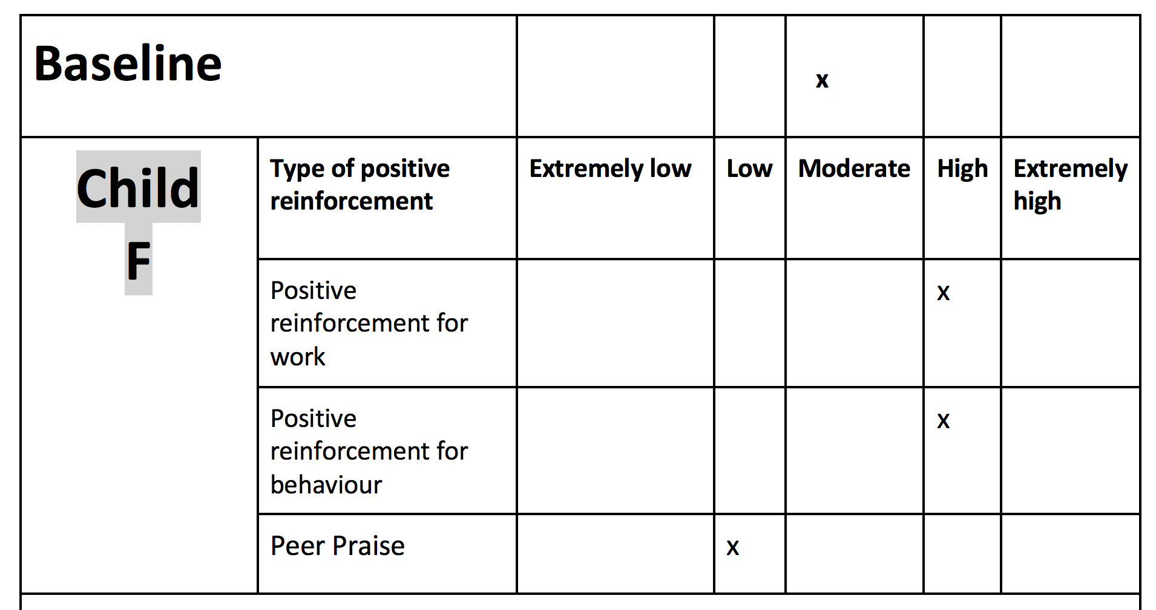

Appendix H1.0

After praise that was specific and expansive, there was a positive response, suggesting that the quality of feedback matters. The fact that the child was engaged seemed to be out of interest rather than the praise directly. Child seemed to be ‘in flow’ or engrossed with what he was doing. It raises the question, are some children more engaged in some subjects rather than others? Peer praise wasn’t received very well and negatively impacted the child’s involvement level, perhaps due to a lack of concentration. Child F could relate to the task and found it relevant, therefore making them feel more involved.

Critical Reflection of Lesson 2: Peer feedback was positively portrayed within the interview however the observation showed mixed effectiveness. The children enjoyed the lesson and the majority met the learning outcome. The delivery of peer praise was fantastic, especially when targeting behavior. Of the 6 children we’ve asked, all asked for an incentive.

Research suggests that children’s attention naturally declines therefore observe the child at the start of the lesson therefore we decided to make our measurements at the beginning of the lesson (Mazarno, 2011).

Amendments to approach

- Take measurements at the start of the lesson
- Ensure that everyone’s attention is gained when giving peer praise
- Amend the observation schedule to include an incentive
- Observe how an incentive could affect involvement
- Praise children for their effort

Lesson 3

Context and aims of Lesson 3: The aims of this lesson were identical to Lesson 2 with the focus shifting to an incentive. Our plan is to inform the Instilling an incentive at the beginning of the lesson to then

Child G
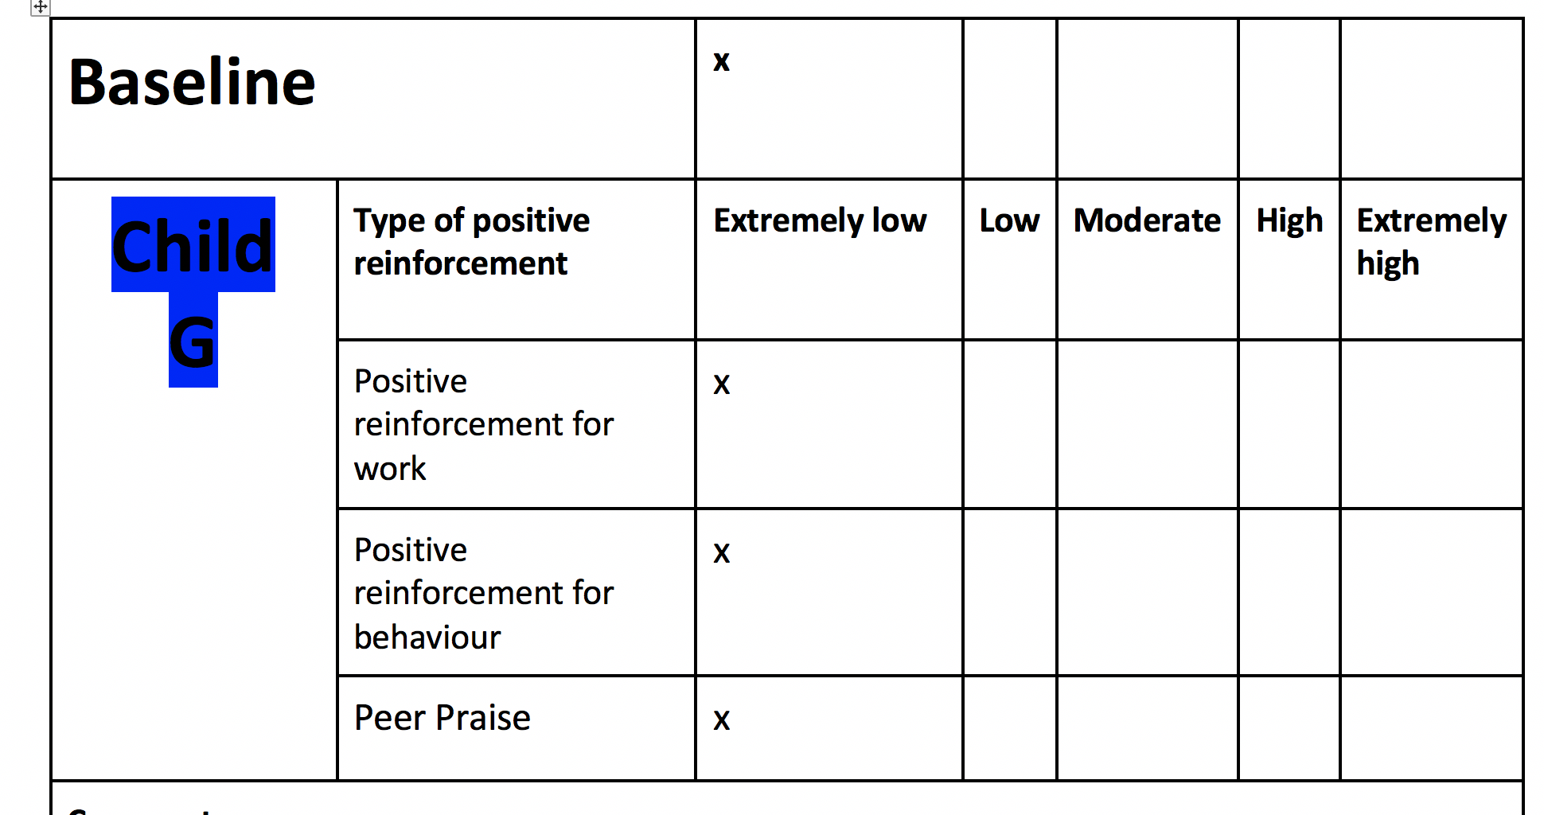

Moments of interest: The praise given to this child did not seem descriptive, therefore had little effect on the child’s involvement. I do think other factors at play also, such as a lack of interest or a lack of stimulus. There was no obvious change of involvement throughout the lesson. Also, I feel that the peer praise element of this lesson was not properly deployed, as the child was disengaged during the process.

Child H
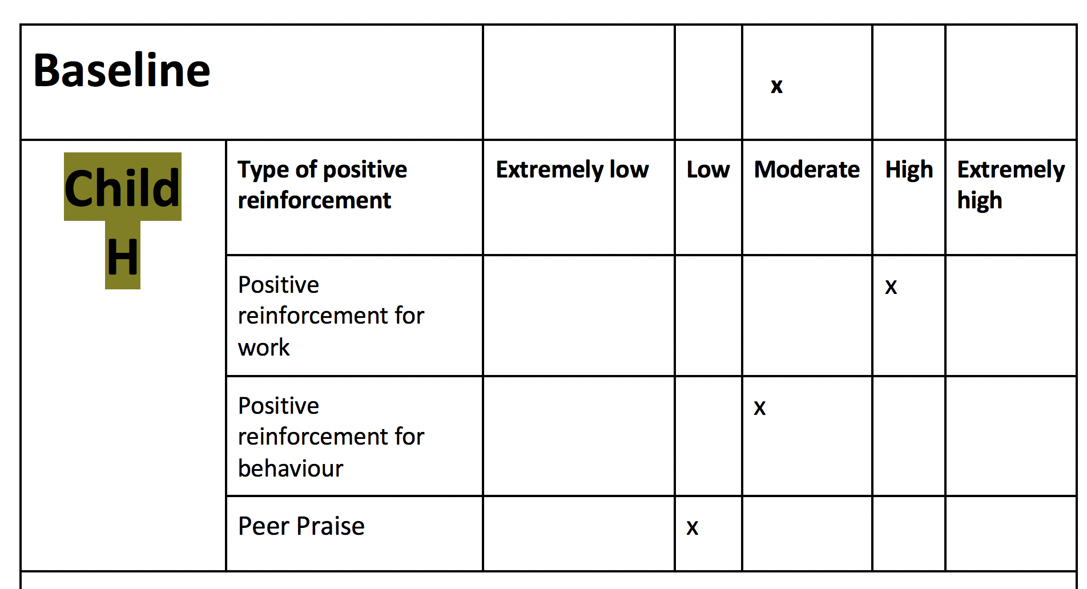
Moments of interest: I feel that this child was more affected by the role of responsibility he was given rather than the specific PR. I feel that the praise was not specific enough and therefore had little effect on the child’s involvement. The incentive aspect was not apparent enough therefore it is hard to comment on that element.

Critical Reflection of Lesson 3: Unfortunately, the incentive did not have an effect on the children, because it wasn’t made exciting or extraordinary enough for them. Also, I feel that there were sampling issues as the age range of the children was too broad from Lesson 1-3. In addition, the children’s involvement level seems to fluctuate, therefore perhaps a graph would have been better to track their involvement over a timescale. The method that we used seems to be too fixed and only allows us to document one occasion. Often we would second guess whether it was the PR having the impact on the child’s involvement, or other exterior factors such as challenge or wellbeing.

Amendments for future research

- Ensure that incentive is made exciting and extraordinary, and explained to the children prior.
- Adapt form to include an incentive section

Discussion of research findings

Using a thematic approach, connections and patterns were taken from the data in order to present the findings and compare them to other pieces of literature in the field. Nowell et. al (2017) suggests that the approach is used for identifying, analysing, organizing, describing, and reporting themes found within a data set.

Our first finding was that 75% of children showed an immediate increase in involvement when praised for their behaviour. This data echo’s the work of Cavanaugh (2013) To maintain attention however, seemed to depend on additional factors, such as challenge and the grouping dynamics of the children. Grey and MacBlaine (2015) highlight that in a classroom context, a range of strategies must be used to encourage an outcome, and this is evident here. For instance, Child F did not feel as involved in the lesson as we thought, because ‘he did not receive the support of his team’. Interestingly, when the children were questioned about involvement, their responses related to challenge, interest and relatability rather than specific praise. It appears then, that positive praise does have an impact, though needs to work with other aspects to retain its effectiveness.

Our data showed that 50% of the children responded to positive reinforcement aimed towards their work. In retrospect, it appears that the quality of this feedback is what matters. In a study by Dweck (2014) The children who were praised for their effort showed a greater desire (92%) to take more risks and to interact with their work. Frustratingly, Lesson 3 did not gain the data that we had intended (we had planned to praise children for their effort).

The idea of encouraging children to praise each other was surprising, due to the amount of response and impact that was displayed. In our data, the involvement level of peer praise showed the biggest increase in level (see Appendix H1.0 child E). For the future classroom, this means that peer praise will be a central part of my practice. However, there also showed a decrease in peer praise affected involvement (see Appendix 1.0 Child F), but arguably because the child was not engaged in the first place. This data suggests that when peer praise is delivered in an environment where everyone’s attention is gained, this type of praise can dramatically improve wellbeing and involvement.

Interestingly, Child A stated that stickers would have little effect on their involvement. However, an incentive that consolidates learning and provides competition would be a better alternative. Class Dojo (2016) is a technological incentive that builds a community and provides challenge for children, also it allows for individual feedback. This also provides competition. 100% of the participants believed that a way to better PR would be to introduce a game at the end of the lesson. It would be interesting to see this impact in future research.

Conclusion and Recommendations

The Lesson Study method has been an eye opener as it has brought to the surface questions that will allow for meaningful reflection and positive change. The issue with independent personal reflection for me is that I am limited to my own perspective, therefore gaining my peers and the children’s insights will challenge my bias and misconceptions. All children are different in complex ways and are influenced by different things, therefore what works for one, may not work for others.

Regarding the methodology, we were limited by only being able to plot a single result, but frustratingly knowing that a child’s involvement level fluctuates throughout a lesson. Next time we would include a graph that would allow us to plot several results and then draw an average that would give a more reliable result.

To raise a child’s involvement level through the use of positive reinforcement, we should;
- Be adaptive practitioners – regularly gain the child’s feedback to find out what works for them and adapt your approach to meet their needs
- Peer Praise – as recommended by the Welsh Government, combine peer praise with verbal praise, and ensure all children are engaged when delivering it
- Be authentic and kind
- Be prescriptive with verbal feedback
- Praise children for their effort to increase intrinsic motivation
- Provide an occasional incentive that is extraordinary
- Have reward systems that are age appropriate and provide challenge
Positive reinforcement is essential for children as it positively affects their wellbeing, gives them reassurance and motivates them to do more and give more. Keep in mind that the PR needs to be combined (verbal and peer praise) and used in balance to maximise its effectiveness. Getting to know your children, building rapport, being kind, consistent and authentic in your approaches will inspire children to be more involved in their work and therefore increasing their chances of success. It appears that positive specific feedback has a positive effect on most children, though is just one puzzle piece that underpins involvement.

As the technological age develops, its imperative that we retain teacher to child positive reinforcement because “connection is powerful” (Athrofa, 2018).

References

Adibsereshki, N., Abkenar, S. J., Ashoori, M., & Mirzamani, M. (2015) The effectiveness of using reinforcements in the classroom on the academic achievement student with intellectual disabilities. Journal of Intellectual Disabilities, 19(1), 83-93.
among Students with Learning Disabilities in Primary School. Journal of ICSAR, [Online]. 2,32-35.

Andreou, T. E., McIntosh, K., Ross, S. W., & Kahn, J. D. (2015) Critical incidents in the sustainability of school-wide positive behavioural interventions and supports. Journal of Special Education, 49, 157-167.

Aziz, N. (2018) Token Economy to Improve Concentration
BERA. (2011) Ethical Guidelines for Educational Research. [ONLINE] Available at: https://www.bera.ac.uk/wp-content/uploads/2014/02/BERA-Ethical-Guidelines-2011.pdf. [Accessed 6 April 2018].

Burden, P. R. (2013) Classroom Management: Creating a successful learning community. New York: John Wiley and Sons.

Cavanaugh, B. (2013) Performance Feedback and Teachers' Use of Praise and Opportunities to Respond: A Review of the Literature. Education & Treatment of Children.

Class Dojo. (2016) Turn your classroom into a community with ClassDojo. [ONLINE] Available at: https://www.youtube.com/watch?time_continue=39&v=RYeKBOMr5Mo. [Accessed 12 April 2018].

Deci, E. L., & Ryan, R. M. (1985) Intrinsic motivation and self-determination in human behavior. New York: Plenum. https://doi.org/10.1007/978-1-4899-2271-7

Deci, E.L, Koestner, R., Ryan, R.M, Cameron, J. (2001) Extrinsic rewards and intrinsic motivation in education: Reconsidered once again: Comment/Reply. Review of Educational Research, 71(1), 1-51.

Department for Education (2011) Training Our Next Generation of Outstanding Teachers: Implementation Plan. London: DfE.

Donaldson, G. (2015) Successful Futures: Independent Review of Curriculum and Assessment Arran)gements in Wales Cardiff: Welsh Government
Dudley, P. (2011) Lesson Study: a handbook. [ONLINE] Available at: http://lessonstudy.co.uk/wp-content/uploads/2012/03/Lesson_Study_Handbook_-_011011-1.pdf. [Accessed 2 April 2018].

Esquith, R. (2012) Teach Like Your Hair's On Fire. [Online Video]. Available from: https://www.youtube.com/watch?v=jK-1T0geEIk&t=217s. [Accessed: 6 April 2018].
Goddard, J. (2000) Research review: The education of looked after children. Child and Family Social Work, 5, 79-86.

Gray, C, and Macblain, S. (2015) Learning Theories in Childhood. 2nd ed. California: Sage Publications.

Hadfield, M. (2016) Problematising lesson study and its impacts: Studying a highly contextualised approach to professional learning. Available at: https://www.sciencedirect.com/science/article/pii/S0742051X15300056. (Accessed 5th April 2018).

Jiang, Z. (2018) Effects of Physical Education Teachers’ Leadership Styles and Classroom Climate on Learning Motivation for Basketball Course. EURASIA Journal of Mathematics, Science and Technology Education, [Online]. 14, 1352 -1357. Available at: http://www.ejmste.com/Effects-of-Physical-Education-teachers-leadership-styles-and-classroom-climate-on,81296,0,2.html [Accessed 2 April 2018].

Lee, J. (2007) A Hong Kong case of lesson study—Benefits and concerns. [ONLINE] Available at: https://ac-els-cdn-com.ezproxy.uwtsd.ac.uk/S0742051X07001357/1-s2.0-S0742051X07001357-main.pdf?_tid=31528161-968a-4fa6-8eac-c05d98b45577&acdnat=1523293594_93d156058fa16c36965bdd9d919bc7af. [Accessed 9 April 2018].

Liu, F., & Maitlis, S. (2010) Nonparticipant Observation. In Albert J. Mills, G. Durepos, & E. Wiebe (Eds.), Encyclopedia of Case Study Research. (pp. 610-612). Thousand Oaks, CA: SAGE Publications.

Malott, R., & Shane, J. T. (2015) Principles of behaviour. New York, NY. Psychology Press.
Marzano, R., Pickering, D., & Heflebower, T. (2011). The highly engaged classroom. Bloomington, IN.

Mihaly Csikszentmihalyi. (2004) Flow, the secret to happiness. [Online Video]. 2 February 2004. Available from: https://www.ted.com/talks/mihaly_csikszentmihalyi_on_flow. [Accessed: 1 April 2018].

Nowell, L, S et al. (2017) Thematic Analysis: Striving to Meet the Trustworthiness Criteria. International Journal of Qualitative Methods, [Online]. Volume 16 Issue: 1, 1-10. Available at: http://journals.sagepub.com/doi/full/10.1177/1609406917733847 [Accessed 12 April 2018].

Psychology Notes. (2013) What is Bronfenbrenner’s Ecological Systems Theory?. [ONLINE] Available at: https://www.psychologynoteshq.com/bronfenbrenner-ecological-theory/. [Accessed 9 April 2018].

Scott, J and Marshall, M. (2009). A Dictionary of Sociology. 3rd ed. Oxford: Oxford University Press.

Simon Sinek. (2009) How great leaders inspire action. [Online Video]. 15 September 2009. Available from: https://www.ted.com/talks/simon_sinek_how_great_leaders_inspire_action. [Accessed: 4 April 2018].

Tomlinson, A. (2010) A Dictionary of Sports Studies$ A Dictionary of Sports Studies. 1st ed. Oxford: Oxford University Press.

UNCRC. (1989.) Convention on the Rights of the Child. [ONLINE] Available at: https://downloads.unicef.org.uk/wp-content/uploads/2010/05/UNCRC_united_nations_convention_on_the_rights_of_the_child.pdf?_ga=2.39104227.1742625317.1523286710-1030017664.1523286710. [Accessed 4 April 2018].

Welsh Government (2012) Practical approaches to behaviour management in the classroom. [ONLINE] Available at: http://learning.gov.wales/docs/learningwales/publications/140822-behaviour-management-handbook-for-primary-schools-en.pdf. [Accessed 4 April 2018].
Welsh Government.(2016) Masters in Educational Practice: Professional learning. [ONLINE] Available at: http://learning.gov.wales/resources/learningpacks/mep/professional-learning/teachers-as-researchers/how-are-reflection-and-research-linked/?lang=en. [Accessed 9 April 2018].

Willig, C.(2008) Introducing qualitative research in psychology. 2nd ed. Maidenhead: McGraw-Hill Open University Press.
Yr Athrofa: Institute of Education. (2018) Changing feedback to benefit pupils and teachers. [ONLINE] Available at: http://athrofa.cymru/2018/03/29/changing-feedback-to-benefit-pupils-and-teachers/. [Accessed 12 April 2018].

Appendix

  - Appendix A Pre-amble and Assent form

The ‘preamble’ is the brief verbal explanation given to all of the present children before beginning the research. It is outlines the purpose and aims of the research in child friendly terms, with a consideration of ethics. Essentially, it is a reflection of the assent form. Time was taken to ensure all terminology was understood via the use of questioning. Assent was then gained from the selected children before the lesson began.

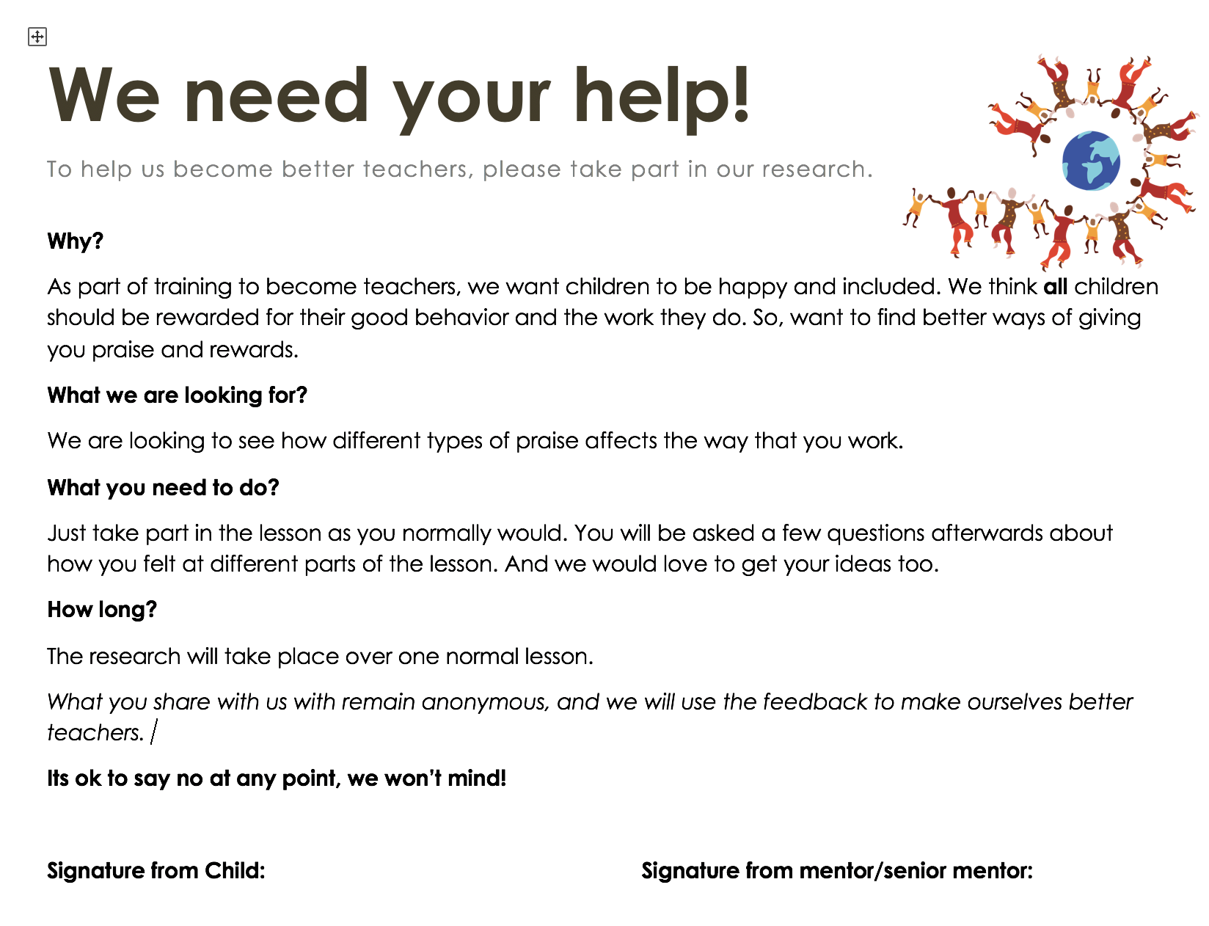

  - Appendix B Consent Form



  - Appendix C Observation Schedule examples

Appendix C.0 - Initial schedule example
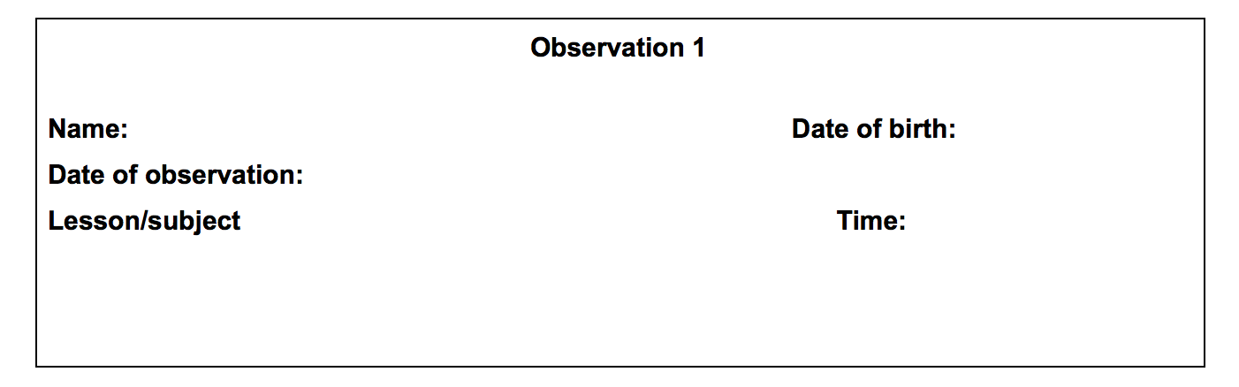

Baseline
Child  A | Type of positive reinforcement | Extremely low | Low | Moderate | High | Extremely high
Child  A | Positive reinforcement for work
Child  A | Positive reinforcement for behaviour

Appendix C.1 - Refined schedule (Used for D onwards).

Baseline
Child  D | Type of positive reinforcement | Extremely low | Low | Moderate | High | Extremely high
Child  D | Positive reinforcement for work
Child  D | Positive reinforcement for behaviour
Child  D | Peer praise
Comments:

  - Appendix D Post Interview Schedule

D1.0 Interview Schedule for Lesson 1
- How involved did you feel in this lesson? (ask them to score out of 5). 1 being extremely low, 5 being very high.

- Did you feel encouraged to work harder when you were praised by the teacher/peer?

- How does positive reinforcement make you feel?

- What other types of positive reinforcement do you enjoy?

D1.1 Interview Schedule for Lesson 2 (Amendment 1).

- How involved did you feel in this lesson? (ask them to score out of 5). 1 being extremely low, 5 being very high.

- Did you feel encouraged to work harder when you were praised by the teacher/peer?

- How does positive reinforcement make you feel?

- What other types of positive reinforcement do you enjoy?

- How do you feel about peer praise?

- When other children in your class praise you, how do you feel?

D1.2 Interview Schedule for Lesson 3 (Amendment 2).

- How involved did you feel in this lesson? (ask them to score out of 5). 1 being extremely low, 5 being very high.

- Did you feel encouraged to work harder when you were praised by the teacher/peer?

- How does positive reinforcement make you feel?

- What other types of positive reinforcement do you enjoy?

- How do you feel about peer praise?

- When other children in your class praise you, how do you feel?

- Do you feel more involved in some subjects rather than others?

- Did the possibility of having a reward help you to work harder during the lesson?
Appendix E Positive reinforcement toolbox

Positively reinforcing behaviour
I like the way that Joe Bloggs is sitting, he’s got his hands on his lap, he’s not talking, and he’s got his eyes on me.
Super/fantastic/brilliant sitting/effort
Be specific.
It's great how you…. Look at the way Joe B isn’t talking… be like Joe.

Positively reinforcing work
I like the way you’ve used capital letters….
This is amazing… Fantastic effort!
Look how much effort… has put into the presentation of their work. Well done!
See how …. has followed the Success Criteria

Peer Praise
During a mini plenary, praise a child's work. Or… request that the children find positives of each other’s work.
Thumbnail clap, marshmallow clap, WHOOSH, firework

Appendix F Refined Leuven Scale
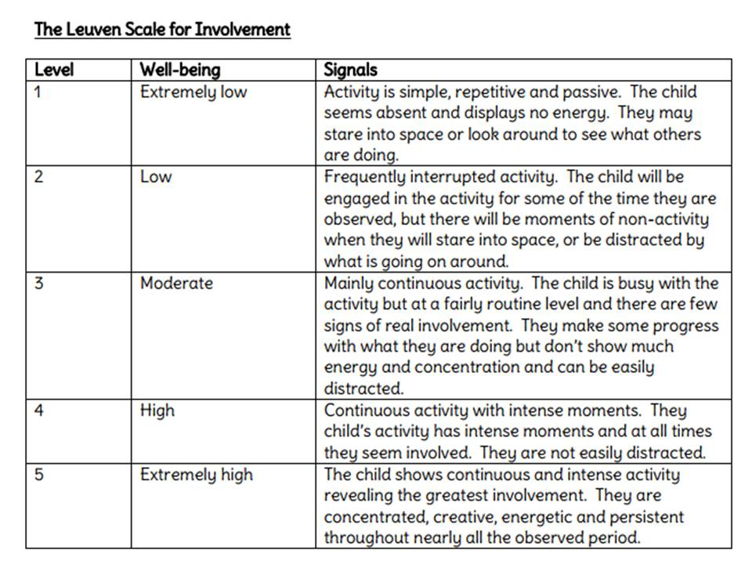

Appendix G Lesson 1 Data

G1.0 Lesson 1 Observation Results

Baseline |  |  | X
Child  A | Type of positive reinforcement | Extremely low | Low | Moderate | High | Extremely high
Child  A | Positive reinforcement for work |  |  | X
Child  A | Positive reinforcement for behaviour |  |  | X
Comments:
Moderately engaged throughout the lesson.
Became more engaged when given praise.
Became less engaged when partnered with someone that took control over the work.
When given peer praise ‘woosh’ child became more engaged. Next step?

Baseline |  |  | X
Child  B | Type of positive reinforcement | Extremely low | Low | Moderate | High | Extremely high
Child  B | Positive reinforcement for work |  | X
Child  B | Positive reinforcement for behaviour |  |  | x
Comments:
Distracted easily
Engaged more when given a role in the task

Baseline |  |  | X
Child  C | Type of positive reinforcement | Extremely low | Low | Moderate | High | Extremely high
Child  C | Positive reinforcement for work | X
Child  C | Positive reinforcement for behaviour | X
Comments:
After hearing other children be praised the child become more engaged however quickly got distracted following the praise.
Very quiet throughout lesson.
Anxious throughout the lesson- Possibly due to the two new adults in the room however became more comfortable and engaged as the lesson went on.

G1.1 Lesson 1 Interview transcript

Question 1 – How involved did you feel in this lesson? (ask them to score out of 5). 1 being extremely low, 5 being very high. How does praise make you feel?

Child B – I felt really involved and being split into groups made it easier to be involved. 4/5.
Child C – 5/5
Child A – As we worked in pairs and this made me want to find out what the other pairs researched. I felt very involved in this lesson because it was interesting and fun. 5/5.

Question 2 – Did you feel encouraged to work harder when you were praised by the teacher/peer?

Child B – Yes, I feel that when Mr Gardner praises me, I am motivated to do better. This is because of the way the praise is given, I know I wasn’t supposed to be doing something, and I was told not to do it, in a kind way.
Child A – I felt engaged and wanted to work harder when others got the praise. I am really pleased for my friends when I see them get praised, this encourages me to do better.
Child C – *Nods* I agree.

Question 3 – How does positive reinforcement make you feel?

Child B – I feel really good about myself when I get praised, because I know I’m on the right track.
Child C – Amazing.
Child A – Being praised makes me want to give more and do more. I know I am doing it for myself and the team. I feel really happy.

Question 4 – How can we make positive reinforcement better?

Child B – Letting us know about a game at the end, would be amazing.
Child C – Game at the end
Child A – I agree with Child B, a game at the end as it helps you use and revise the knowledge from the lesson. Also, giving praise that

Question 5 – Child A, how do you feel about stickers in Key Stage 2

Child A – Stickers aren’t for older children. Something which gives points like Class Dojo is more suitable as we like to be given a challenge.

G1.2 Lesson 1 Reflection

Experience

Feelings | Going into this lesson was exciting because I was returning back to my previous school. I felt that the children were keen to get involved with the research and understood its purpose and benefits. I was really happy with the post interview as this provided us with a base to reflect upon.
Remember and Understand | The purpose of the study was to give specific verbal feedback (using our natural initiative and the Appendix E toolbox) and to measure the effectiveness this had on a child’s involvement. There were 14 children whose task it was to create an advert using iMovie, in pairs.
Evaluate and analyze | Interesting points the data showed us about verbal praise:  Child A became more engaged when given specific verbal praise, because the praise was ‘kind’ and authentic. This had a positive impact on engagement. Child A responded to peer praise with joy and told us that the feeling reciprocates when he witnesses his peers ‘doing well’. However, we felt that partnering Child A with a more confident child negatively impacted upon his involvement, which asks: Does the way we group children affect their involvement?  Factors affecting data:  I feel that the fact I was there and had been absent for a while may have caused an exaggerated effect on involvement. During the interview, I was present in the room which may also have embellished data.
Collective Conclusion | Collectively, we agreed that verbal praise alone is not enough to raise a childs involvement. However positive feedback can be useful if it is specific and generically ‘kind’. There are other factors at play, such as the environment and the child’s individual interests. The use of specific positive feedback needs be a collection of peer, child led and incentive based, not just verbal. Therefore, an agreement was made to adapt our schedule and include peer praise.

Appendix H Lesson 2 Data

H1.0 Lesson 2 Observation results
Baseline |  |  |  | x
Child  D | Type of positive reinforcement | Extremely low | Low | Moderate | High | Extremely high
Child  D | Positive reinforcement for work |  |  |  | x
Child  D | Positive reinforcement for behaviour |  |  |  | x
Child  D | Peer Praise |  |  |  | x
Comments:

Consistently well behaved and engaged. Positive effect after praise for behaviour especially. Is the child’s engagement the natural nature of the child or due to the praise? Use of peer praise definitely showed a positive response on motivation and willingness to learn.
Baseline |  |  |  | x
Child  E | Type of positive reinforcement | Extremely low | Low | Moderate | High | Extremely high
Child  E | Positive reinforcement for work |  |  | x
Child  E | Positive reinforcement for behaviour |  |  |  | x
Child  E | Peer Praise |  |  |  |  | x
Comments: Child E became intensely involved when praised by a peer, you could see that they were concentrated and persistent to learn. Different types of PR seems to work for different children therefore tailoring your PR is imperative to ensure that it has the most impact.

Baseline |  |  |  | x
Child  F | Type of positive reinforcement | Extremely low | Low | Moderate | High | Extremely high
Child  F | Positive reinforcement for work |  |  |  | x
Child  F | Positive reinforcement for behaviour |  |  |  | x
Child  F | Peer Praise |  | x
Comments:

After praise that was specific and expansive, there was a positive response, suggesting that the quality of feedback matters. The fact that the child was engaged seemed to be out of interest rather than the praise directly. Child seemed to be ‘in flow’ or engrossed with what he was doing. It raises the question, are some children more engaged in some subjects rather than others? Peer praise wasn’t received very well and negatively impacted the child’s involvement level.

H1.1 Lesson 2 Interview

Question 1 – How involved did you feel in this lesson? (ask them to score out of 5). 1 being extremely low, 5 being very high.

Child D – I would say a 4/5 because I did some research and that interests me.
Child E – 3/5 because I drew pictures and got a little help from other members in my group.
Child F – 4/5 because I done some research. I really found the task useful and enjoyed it because I cannot wait to go on holiday in the summer.

Question 2 – Did you feel encouraged to work harder when you were praised by the teacher/peer?

Child D – Yes, very much so, it makes you want to do more and encourages you to be better.
Child E – makes you feel like you done something good and makes you proud of yourself.
Child F – Mm, Happy.

Question 3 – How does positive reinforcement make you feel?

Child D – Yes it makes us feel excited and happy.
Child E – Yes it makes you feel you should do more good things. It makes you feel happy and nice.
Child F – Happy.

Question 4 – What other types of positive reinforcement do you enjoy?

Child D – would feel good with stickers and a reward would make you happy.
Child E – would be happy with stickers as I like stickers or Class Dojo.
Child F – would like a game at the end of the lesson to look forward to.

Question 5 – What could we do to make the lesson better?

Child D – would work harder if there was a game at the end.
Child E – I agree with Child D, I would like a game at the end.
Child F – Me too, I like games at the end and we would work harder also.

Question 6 - When other children in your class praise you, how do you feel?

Child E – I feel really happy because they are my friends and want to see me do well.
Child D – I am pleased when I get praised, it makes me feel motivated to do more.
Child F – I feel happy.

H1.2 Lesson 2 Reflection

Experience

Feelings | With a sense of nostalgia going back to another school I had previously been too, I was excited to see my partner teach and the effect peer praise would have on the data.
Remember and Understand | The purpose of the study was to give specific verbal feedback (using our natural initiative and the Appendix E toolbox) and to ensure that this feedback was descriptive and prescriptive.  There were 14 children whose task it was to create a poster for a holiday from a pack of information they had been given. Again, teamwork was essential here.  Child D - Consistently well behaved and engaged. Positive effect after praise for behaviour especially. Is the child’s engagement the natural nature of the child or due to the praise? Use of peer praise definitely showed a positive response on motivation and willingness to learn.  Child E - became intensely involved when praised by a peer, you could see that they were concentrated and persistent to learn. Different types of PR seems to work for different children therefore tailoring your PR is imperative to ensure that it has the most impact.  Child F - After praise that was specific and expansive, there was a positive response, suggesting that the quality of feedback matters. The fact that the child was engaged seemed to be out of interest rather than the praise directly. Child seemed to be ‘in flow’ or engrossed with what he was doing. It raises the question, are some children more engaged in some subjects rather than others? Peer praise wasn’t received very well and negatively impacted the child’s involvement level.
Evaluate and analyze | Interesting points the data showed us about verbal praise:  Child D showed the most response to PR, however this child was also given a level of responsibility, to lead the group. This begged the question, does responsibly effect involvement? It was really interesting and difficult to see whether the effect of the child’s raise in involvement level was down to the PR or other factors such as interest in the subject, or their natural involvement level. I believe that some children are more engaged than others naturally hence the baseline section of the observation schedule. Peer feedback was positively portrayed within the interview however the observation showed mixed effectiveness.  The delivery of peer praise was fantastic, especially when targeting behavior.
Collective Conclusion | The next steps we made here was to continue to refine the way we praise, to ensure it is more specific, genuine, kind and prescriptive. The past two interviews have highlighted the use of an incentive at the end therefore we will combine verbal praise, peer praise and an end of lesson incentive to see how affective this will be on involvement.

Appendix I Lesson 3 Data

I1.0 Lesson 3 Observation
Baseline |  | x
Child  G | Type of positive reinforcement | Extremely low | Low | Moderate | High | Extremely high
Child  G | Positive reinforcement for work | x
Child  G | Positive reinforcement for behaviour | x
Child  G | Peer Praise | x
Comments:

The praise given to this child did not seem descriptive, therefore had little effect on the childs involvement. I do think other factors at play also, such as a lack of interest or a lack of stimulus. There was no obvious change throughout the lesson. Also, I feel that the peer praise element of this lesson was not properly deployed.

Baseline |  |  |  | x
Child  H | Type of positive reinforcement | Extremely low | Low | Moderate | High | Extremely high
Child  H | Positive reinforcement for work |  |  |  | x
Child  H | Positive reinforcement for behaviour |  |  | x
Child  H | Peer Praise |  | x
Comments:

I feel that this child was more affected by the role of responsibility he was given rather than the specific PR. I feel that the praise was not specific enough and therefore had little effect on the child’s involvement. The incentive aspect was not apparent enough therefore it is hard to comment on that element.

I1.1 Lesson 3 Interview

Question 1 – How involved did you feel in this lesson? (ask them to score out of 5). 1 being extremely low, 5 being very high.

Child G- 4/5
Child H – 4/5

Question 2 – Did you feel encouraged to work harder when you were praised by the teacher/peer?

Child G – I definitely felt like I wanted to work harder after being praised by my teacher. It makes me feel happy and good.
Child H – I agree with Child G, I makes me want to work harder and I feel really good.

Question 3 – How does positive reinforcement make you feel?

Child G – it makes me feel involved, especially when I am given responsibility.

Question 4 – What other types of positive reinforcement do you enjoy?

Child H – Giving us something to look forward to like ‘googly eyes in jelly’ or a fun game at the end of the lesson.
Child G – I feel we are too old for stickers, but a school trip could be fun.

I1.2 Lesson 3 Reflection and collective response.

Collective Conclusion | To be honest, I do not feel that this lesson and observation went to plan. I feel that our aims of giving quality praise and peer praise were not effective enough to have data that we could properly analyze. Assent was given however we had to intervene to ensure that the children understood their part in the research. Also, the preamble was not given initially by the teacher, but was then later rectified. I was discouraged that the agenda was not followed.  However, the data we did collect allowed us to think about what we could do next.  We had planned to excite the children at the start of the lesson with an incentive/quiz, however we do not feel that this was ‘sold’ to them enough. We would have then measured their involvement with the knowledge of a game. Next time we will ensure that the reward at the end is extraordinary and made exciting which will hopefully allow for more insight.

