

Student name: Cynthia D Costa E Afonso
Student ID:2437224

Module name: Introduction to Health and Social care
Module code: LCHS4003_LON
Lecturer name: Oluwadamilola Tayo

Table of Contents
Element 1: Poster 4
Introduction 4
Brief History of the Service 4
Current Time Functioning of the Service 4
Two Challenges Faced by the Service 5
Challenge 1: Workforce Recruitment and Retention 5
Challenge 2: Increasing Complexity of Need 5
Conclusion 5
Element 2 Essay: 6
Introduction 6
Critical Evaluation of Current Functioning 6
Significance in Enhancing Quality of Life 7
Conclusion 7
References 8

Challenges
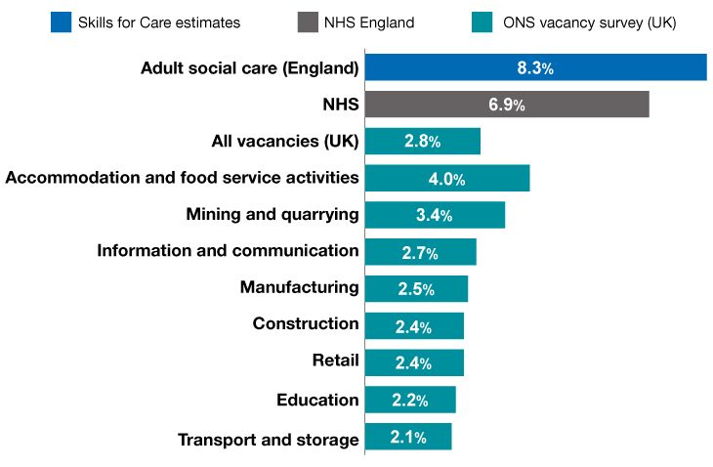
Figure 3: Skills for Care 2023. The workforce in Adult Social Care today
Challenge 1 Workforce Recruitment and Retention: The current crisis in the recruitment and retention of the workforce is one of the most critical challenges the domiciliary care sector has to encounter today. Care staff turnover is ever high, which is usually due to low pay and demands of the work (NMC 2024). Most of the experienced professionals are lost to other areas with more funding, leaving the sector with a shortage of skilled carers who would be available to support service users all the time. This is because of its unpredictability, which complicates the continuity of care that agencies invest so much in to establish trust with their clients. The sector is finding it hard to attract a new generation of workers without the competitive pay and improved career advancement opportunities (WHO, 2021). This workforce disparity causes the surviving employees much stress, which is usually followed by burnout and worsening the staffing crisis within the community.
Challenge 2 Increasing Complexity of Need: The second significant issue is that the needs of persons under care at home have become more complex. The ageing UK population is also increasing in the number of people with various long-term conditions and diseases that incur complex medical and social care (NHS and Community Care Act, 1990). Specifically, the high increase in the number of dementia patients has radically altered the demands in the context of home-based support. A case of domiciliary care is no longer merely a matter of simple housekeeping help but it demands a higher level of expertise in cognitive health, behavioural control and advanced care. The existence of these complicated needs requires more intensive training and time per visit which tends to conflict with the available limited funds (Equality Act, 2010). The challenge of delivering high-quality and specialised care to such vulnerable populations is unchanging since the providers have to balance the increase of medical needs and the limited operational budgets.
Conclusion
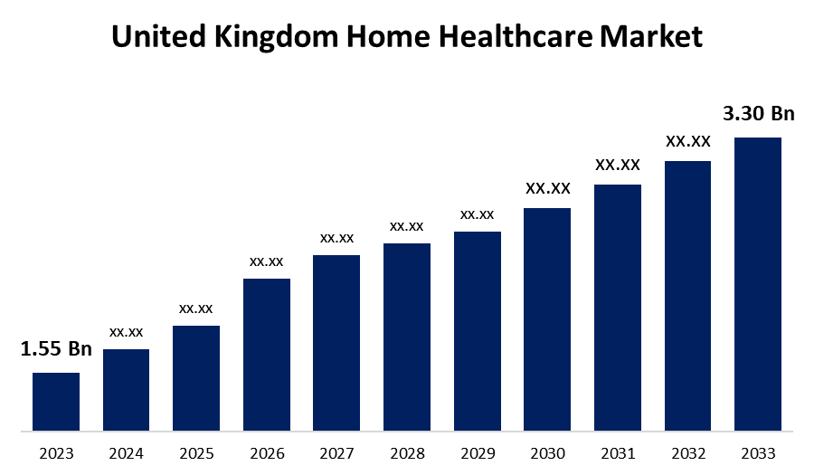
Figure 4: Spherical Insight 2024. United Kingdom Home Healthcare Market Size 2033, Spherical Insights
In conclusion, domiciliary care has proved to be an important pillar of the current social care system in that it has filled the gap between the clinical intervention and individual independence. This service is indispensable since it will respect the basic human need to be in a home-like and comforting place with required assistance. Home-based care is a long-term solution to an ageing population by relieving the huge burden on both hospital beds and residential care (NMC 2024). After all, it is not simply about helping people with their day-to-day chores, but rather the saving of dignity, safety, and emotional comfort of the members of their respective communities.

Current Time Functioning of the Service
The contemporary domiciliary care is a highly synchronised service that is aimed at addressing the needs of specified physical and emotional requirements of people at home. The daily tasks as offered by the care workers are diverse, including basic personal care including bathing and dressing to the complicated process of medication management and overall household assistance (WHO, 2025). In a bid to make sure that such services are of high standards of safety, the industry is rigidly regulated by authorities such as the Care Quality Commission (CQC, 2024). This control will keep the providers accountable and maintain an effective and compassionate care delivered. Moreover, domiciliary care is not an independent unit; it is dependent on a multidisciplinary approach of teamwork. Care workers are an essential connection between the service user and the broader healthcare system and often work in collaboration with GPs and District Nurses to track health shifts and revise care plans.
History

Homecare Gurus Ltd.
The history of domiciliary care in the UK is a milestone in humanitarian change of how society takes care of its most vulnerable members (NMC 2024). During the Victorian times, the poor who could not take care of themselves were usually sent out to the miserable state of the Workhouse. Nevertheless, in the post-WWII welfare state, the establishment started giving more emphasis on societal security and home-based assistance. One of the critical events was the 1990 NHS and Community Care Act that essentially reorganised the system (NHS and Community Care Act, 1990). This act triggered a sharp shift towards care in the community, and that institutionalisation was a final option.
Introduction

Homecare Gurus
Domiciliary care can be defined as the various forms of professional assistance services that are offered at the home of a client (NMC 2024). This model of care is meant to help elderly individuals, as well as those who have illnesses or disabilities and need help to perform their everyday activities, thus they stay in a familiar environment. The main aim of the service is to lead to personal autonomy and retain the dignity of the service user. Through the personalised support, domiciliary care can delay or even avoid the more intensive residential care, which keeps the people of a very high standard of life and community involvement.
Domiciliary Care Services within the Community

Element 1: Poster 1 Domiciliary Care Services within the Community

Introduction
Domiciliary care can be defined as the various forms of professional assistance services that are offered at the home of a client (NMC 2024). This model of care is meant to help elderly individuals, as well as those who have illnesses or disabilities and need help to perform their everyday activities, thus they stay in a familiar environment. The main aim of the service is to lead to personal autonomy and retain the dignity of the service user. Through the personalised support, domiciliary care can delay or even avoid the more intensive residential care, which keeps the people of a very high standard of life and community involvement.

Brief History of the Service
The history of domiciliary care in the UK is a milestone in humanitarian change of how society takes care of its most vulnerable members (NMC 2024). During the Victorian times, the poor who could not take care of themselves were usually sent out to the miserable state of the Workhouse. Nevertheless, in the post-WWII welfare state, the establishment started giving more emphasis on societal security and home-based assistance. One of the critical events was the 1990 NHS and Community Care Act that essentially reorganised the system (NHS and Community Care Act, 1990). This act triggered a sharp shift towards care in the community, and that institutionalisation was a final option.

Current Time Functioning of the Service
The contemporary domiciliary care is a highly synchronised service that is aimed at addressing the needs of specified physical and emotional requirements of people at home. The daily tasks as offered by the care workers are diverse, including basic personal care including bathing and dressing to the complicated process of medication management and overall household assistance (WHO, 2025). In a bid to make sure that such services are of high standards of safety, the industry is rigidly regulated by authorities such as the Care Quality Commission (CQC, 2024). This control will keep the providers accountable and maintain an effective and compassionate care delivered. Moreover, domiciliary care is not an independent unit; it is dependent on a multidisciplinary approach of teamwork. Care workers are an essential connection between the service user and the broader healthcare system and often work in collaboration with GPs and District Nurses to track health shifts and revise care plans.

Two Challenges Faced by the Service

Workforce Recruitment and Retention
The current crisis in the recruitment and retention of the workforce is one of the most critical challenges the domiciliary care sector has to encounter today. Care staff turnover is ever high, which is usually due to low pay and demands of the work (NMC 2024). Most of the experienced professionals are lost to other areas with more funding, leaving the sector with a shortage of skilled carers who would be available to support service users all the time. This is because of its unpredictability, which complicates the continuity of care that agencies invest so much in to establish trust with their clients. The sector is finding it hard to attract a new generation of workers without the competitive pay and improved career advancement opportunities (WHO, 2021). This workforce disparity causes the surviving employees much stress, which is usually followed by burnout and worsening the staffing crisis within the community.

Increasing Complexity of Need
The second significant issue is that the needs of persons under care at home have become more complex. The ageing UK population is also increasing in the number of people with various long-term conditions and diseases that incur complex medical and social care (NHS and Community Care Act, 1990). Specifically, the high increase in the number of dementia patients has radically altered the demands in the context of home-based support. A case of domiciliary care is no longer merely a matter of simple housekeeping help but it demands a higher level of expertise in cognitive health, behavioural control and advanced care. The existence of these complicated needs requires more intensive training and time per visit which tends to conflict with the available limited funds (Equality Act, 2010). The challenge of delivering high-quality and specialised care to such vulnerable populations is unchanging since the providers have to balance the increase of medical needs and the limited operational budgets.

Conclusion
In conclusion, domiciliary care has proved to be an important pillar of the current social care system in that it has filled the gap between the clinical intervention and individual independence. This service is indispensable since it will respect the basic human need to be in a home-like and comforting place with required assistance. Home-based care is a long-term solution to an ageing population by relieving the huge burden on both hospital beds and residential care (NMC 2024). After all, it is not simply about helping people with their day-to-day chores, but rather the saving of dignity, safety, and emotional comfort of the members of their respective communities.

Element 2 Essay: Ambulance Services

Introduction
Ambulance Service is the most important front line of the NHS which offers emergency health care and essential transportation to the community. The service historically developed out of crude stretchers bearer systems and 19th-century horse-pulled carriages that were mainly created to take an injured person as fast as possible to a hospital (NHS,2017). The transformation changed with the establishment of the service through the 1946 National Health Service Act and consolidated these divided units into a national system. The role has changed over the decades since it was a basic utility of transportation, to an advanced concept of mobile medicine. It is currently a clinical powerhouse where life-saving interventions are initiated immediately a paramedic reaches the side of a patient before reaching a hospital ward (Newton, 2021).

Critical Evaluation of Current Functioning
The current ambulance services have a stringent triage system that classifies calls into Categories 1 to 4 in order of clinical urgency. This is to ensure that life threatening conditions are responded in the shortest time possible like cardiac arrests. One of the main advantages of the existing model is that the paramedics have a high degree of expertise, and now they are trained to be able to conduct more complicated life-saving interventions at the site. These are airway management via intubation and thrombolysis administration to stroke or heart attack patients which has led to a substantive increase in survival (Knowles, Long and Turner, 2020). Nevertheless, the system has serious flaws which undermine the efficiency of the system. A significant issue in Accident and Emergency departments is the delay in handover since more frequently than not, ambulances get stuck in hospitals, hence they are unable to answer new calls of emergency. Moreover, there is a huge flow of non-emergency calls that put the system under severe pressure and should have been handled by primary care services (Lawn et al., 2020). This imbalance between resources and demand can result in more response time, which reveals a dire need to further integrate emergency services with community health environments to be able to maintain the high-acuity resources to be at the disposal of the people in the most need.

Significance in Enhancing Quality of Life
The ambulance service contributes transformatively towards the improvement of the general population in terms of life quality since it will greatly minimise long-term disability. The idea of the Golden Hour is central to this, as it proposes that, with regard to a traumatic injury or an acute illness such as a stroke or a heart attack, medical intervention within the first sixty minutes is the only way to significantly increase the survival rate and recovery (Ablard et al., 2023). Reaching the scene with the equipment required to provide high level clinical care in rapid conditions, paramedics are able to stabilise the patients and provide them with special treatment that would avoid irreversible organ or brain injury. The service also offers an indispensable psychological peace of mind to the whole community in addition to the physical health benefits (Knowles, Long and Turner, 2020). The knowledge that professional medical help is within their reach through a phone call will make people, especially those with chronic illnesses or the aged, to feel safer and more supported in their respective households, which will eventually create a stronger and more confident society (NHS 2017).

Conclusion
In conclusion, the history of the ambulance service is an impressive transformation of a simple means of transport to a high-tech clinical organisation it is today. It has shifted its role of transporting patients to hospitals to providing complex life-saving healthcare at the front-line of the health system. Modern pressures of handover delays and high calls notwithstanding, the service is still one of the pillars of the UK healthcare (NHS,2017). It has been able to keep saving lives and delivering the necessary security by ensuring that the neediest patients get the best care they need them the most by putting clinical excellence and quick response on priority.

References
Care Quality Commission 2024. The state of health care and adult Social Care in England 2024/25, The state of health care and adult social care in England 2024/25 - Care Quality Commission. Available at: https://www.cqc.org.uk/publications/major-report/state-care/2024-2025
Equality Act 2010. Equality act 2010, Legislation.gov.uk. Available at: https://www.legislation.gov.uk/ukpga/2010/15/contents
NHS and Community Care Act 1990. National Health Service and Community Care Act 1990, Legislation.gov.uk. Available at: https://www.legislation.gov.uk/ukpga/1990/19/contents
NMC 2024. Standards of proficiency for Community Nursing Specialist Practice Qualifications (SPQ), The Nursing and Midwifery Council. Available at: https://www.nmc.org.uk/standards/standards-for-post-registration/standards-of-proficiency-for--community-nursing-specialist-practice-qualifications
WHO 2021. Decade of healthy ageing: Plan of action, World Health Organization. Available at: https://www.who.int/publications/m/item/decade-of-healthy-ageing-plan-of-action
WHO 2025. Providing access to long-term care for older people, World Health Organization. Available at: https://www.who.int/activities/providing-access-to-long-term-care-for-older-people
Ablard, S., Miller, E., Poulton, S., Cantrell, A., Booth, A., Lee, A., Mason, S. and Bell, F., 2023. Delivery of public health interventions by the ambulance sector: a scoping review. BMC Public Health, 23(1), p.2082. https://doi.org/10.1186/s12889-023-16473-2
Knowles, E., Long, J. and Turner, J., 2020. Reducing avoidable ambulance conveyance in England: interventions and associated evidence. University of Sheffield, pp.2-19. https://aace.org.uk/wp-content/uploads/2020/08/ScHARR-report-SRAC-Final-020320-.pdf
Lawn, S., Roberts, L., Willis, E., Couzner, L., Mohammadi, L. and Goble, E., 2020. The effects of emergency medical service work on the psychological, physical, and social well-being of ambulance personnel: a systematic review of qualitative research. BMC psychiatry, 20(1), p.348. https://doi.org/10.1186/s12888-020-02752-4
Newton, A., 2021. Lord Carter's report into NHS ambulance service efficiency; will its findings make a difference and stimulate the service to escape “the mediocrity trap?”. International Journal of Emergency Services, 10(1), pp.77-92. https://doi.org/10.1108/IJES-08-2019-0045
NHS 2017. NHS choices. Available at: https://www.england.nhs.uk/urgent-emergency-care/improving-ambulance-services/

Figure References
Figure 1: Care UK 2024. Care homes in and around Harrogate, Care UK. Available at: https://www.careuk.com/care-homes/locations/harrogate
Figure 2: Julie 2025. Essential skills every domiciliary carer should have, Homecare Gurus Ltd. Available at: https://homecaregurus.co.uk/essential-skills-every-domiciliary-carer-should-have/
Figure 3: Skills for Care 2023. The workforce in Adult Social Care today. Available at: https://www.skillsforcare.org.uk/Workforce-Strategy/Introduction/The-workforce-in-adult-social-care-today.aspx
Figure 4: Spherical Insight 2024. United Kingdom Home Healthcare Market Size 2033, Spherical Insights. Available at: https://www.sphericalinsights.com/reports/united-kingdom-home-healthcare-market

