

STRATEGIC MANAGEMENT AND SUSTAINABILITY

LCBB 6015: COMPONENT 2: STRATEGIC PLAN – ACADEMIC REPORT
Student Name: Mihaela Hermeneanu
Student Number: 2310013

Executive Summary
This report provides strategic formulation analysis of Aston Martin Lagonda Global Holdings plc in the dynamic automotive sector, which is progressively influenced by electrification, digital transformation, and sustainability pressures. It describes the background and strategic intent of the company, as well as its present performance, presenting its strong brand heritage and the financial issues faced by the company. The competitive environment is evaluated using the Five Forces and SWOT analysis, suggesting that the competition is intense, the supplier power is high, and the threats posed by electric and technology-based competitors are increasing.. At the internal level, such strengths as craftsmanship and exclusivity are matched with the weaknesses of small scale and poor profitability. Three levels of strategic directions indicated in these insights are electrification, digital innovation, and strategic partnerships, as proposed in the report. An additional Digital Luxury Ecosystem approach should be proposed to boost customer experience and generate long-term value by providing connected services. In general, the report arrives at the conclusion that implementing innovative and sustainable solutions will help Aston Martin to strengthen its competitiveness, enhance its financial results, and become a sustainable entity in the dynamic global car market.

Table of Contents
1. Introduction to the Strategy 4
2. Background of the firm 4
3. Strategic Intent (vision, mission, objectives) 5
4. The company’s current performance (250 words) 5
5. Strategy Analysis 7
5.1 External Environmental Audit using Porter’s 5 Forces 7
5.2 Internal Environmental Audit using SWOT analysis 8
6. Strategy Formulation 9
7. Conclusion and Recommendation 10
Reference List 11

1. Introduction to the Strategy
Strategic management is the process of strategising, analysing, executing and appraising organisational strategies to attain long-term objectives and maintain competitiveness. It is significant because it lets firms respond aptly to fluid market environments, technology, and competition. The advantages are better decision-making, effective utilisation of resources, and better organisational performance. The purpose of this report is to create an all-encompassing plan for the development of Aston Martin in the shifting automotive industry. The report is organised to cover the background of the company, strategic intent, performance analysis, environmental analysis, strategy development, and recommendations to ensure sustainable growth.

2. Background of the firm
Aston Martin Lagonda Global Holdings plc is already a well-known British automotive manufacturer that deals with designing, engineering, manufacturing, and marketing ultra- luxurious and high-performance cars across the world (Astonmartin, 2026). The company was founded in the UK, and it exists in the luxury automotive industry that is classified under the consumer discretionary industry, especially automobiles and parts. Aston Martin manufactures various models of luxury vehicles, which include sports cars, grand tourers, hypercars and luxury SUVs. The major models it offers are the DB12, Vantage, Vanquish and the DBX707 SUV, which have become known by the three features of being performance-driven, innovative, and crafted.
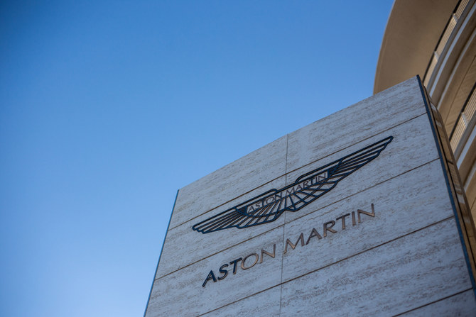
Figure 1: Aston Martin
(Source: Astonmartin, 2026)
Besides the production, Aston Martin also provides after-sales services across the board. These are specialised maintenance services by certified specialists, utilisation of original parts with a 12-month warranty and high-level diagnostics that are based on updates to software and the electronic service interface (Astonmartin, 2026). It is also a company that offers standardised service packages like the 5-year Excellence Service Plan to improve customer experience and retain vehicle value. Aston Martin is globally active with authorised service centres and dealer networks, exporting its cars worldwide with a significant volume in both developed and emerging markets.

3. Strategic Intent (vision, mission, objectives)
At Aston Martin Lagonda Global Holdings plc, the company has a strategic intent which is fuelled by the vision, mission, and long-term goals (Astonmartin, 2026). The mission of the company is to create sports cars and grand tourers that are luxurious, exude beauty, performance, and exhilaration. This mission shows the determination to provide the world with the highest quality of workmanship, new technology and unique design, mainly focusing on the high-net-worth population (Pestel-analysis, 2026). The value proposition of the brand is its fusion of aesthetics and high-performance features that make it a leader in the luxury automotive market segment.
Aston Martin's vision statement is to be the most desirable ultra-luxury brand of British performance cars with exquisitely designed cars that are emotionally engaging to the consumer (Astonmartin, 2026). It is highly progressive, and its strategy is oriented towards electrification and sustainability. The company plans to design a wholesome portfolio of front-engine, SUVs and mid-engine cars, which are backed by a unique specialised programme called Specials. The major targets are to become the leader in the global ultra-luxury segment and change to electrified mobility, with proposals of plug-in hybrid (PHEV) and battery electric vehicles (BEVs) between 2025 and 2030 and the first battery electric vehicles (BEV) being launched in 2026.

4. The company’s current performance (250 words)
The past years have been characterised by both positive and negative results of Aston Martin Lagonda Global Holdings plc as it has been undertaking internal restructuring and external market forces. Both the operating and net profit in the company increased by 21% in FY2025 to reflect losses of about £1.26 billion, which indicates a drop in the total revenue by 21% against the previous year; this was explained by fewer high-margin models under the Specials category and reduced wholesale levels (Astonmartin, 2025). The wholesale sales of the vehicles as a whole decreased by approximately 10% to 5,448 vehicles, too, suggesting a reserved production policy in agreement with the demand situation.
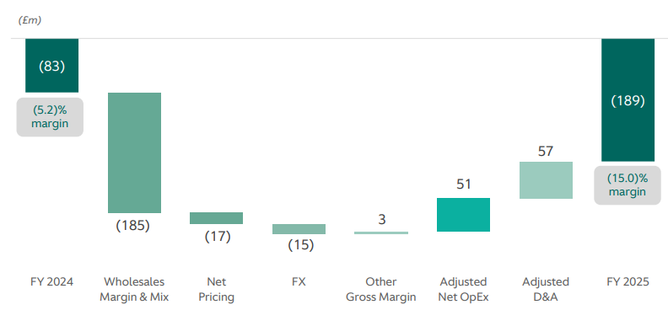
Figure 2: EBIT of Aston Martin
(Source: Astonmartin, 2025)
Another important issue is profitability because the company had an adjusted EBIT loss of £189 million that was heavily affected by macroeconomic forces, such as U.S. tariffs, cost escalation and a decline in demand in the major markets such as China (Astonmartin, 2025). As well, net losses expanded as a result of escalated warranty payments and unrelenting investment in product quality and transformation efforts. Nonetheless, by the end of 2025, the company showed indicators of increased functionality in the second half due to the introduction of new products, including the Valhalla PHEV, and the increase in its product mix. Financial stability has also been facilitated by the cost optimisation schemes, such as the lowering of operating costs and capital expenditure (Astonmartin, 2025). In general, despite the challenges related to profitability and demand, Aston Martin can recover and achieve a higher level of performance in the near future due to its current transformation programme, innovations on products, and attention towards electrification.

5. Strategy Analysis

5.1 External Environmental Audit using Porter’s 5 Forces
Porter's Five Forces model can be successfully used to analyse the competitive environment of Aston Martin Lagonda Global Holdings plc, as this model underlines the competitive rivalry within the luxury car segment.
Threat of New Entrants (Moderate): New entrants' threat is being moderated because of the heavy capital needs, stringent regulations and presence of strong brand heritage. Luxury performance vehicles need considerable amounts of research, development, and high engineering efforts (O’Driscoll and Barron, 2022). Besides, there is brand loyalty and exclusivity, which can be used as barriers to entry.
Bargaining Power of Supplier (High): The automotive industry has high supplier power, especially because of the use of specialised semiconductors, advanced electronics and high-performance engines. Low supplier power exists because of the lack of supplier options, and switching costs are high because companies can adopt AI and digital technologies into their vehicles (King and Cnop, 2025).
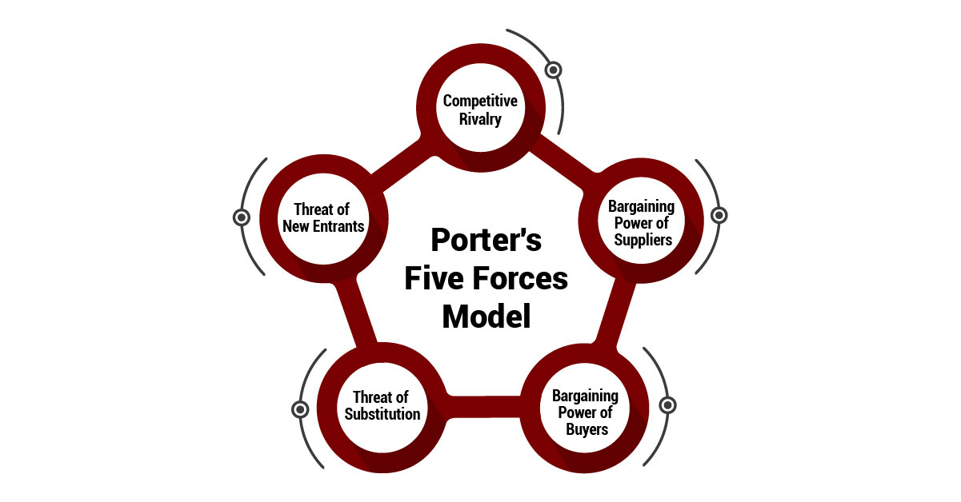
Figure 3: Porter's Five Forces
(Source: King and Cnop, 2025)
Bargaining Power of Buyers (High): The power among luxury segment customers is high because of the existence of high-end substitutes like BMW, Ferrari and Tesla. Customers require a higher-quality level, innovations, and sustainable characteristics, which make Aston Martin persistently develop their products and customer experience (Dcfmodeling, 2023).
Threat of Substitutes (High): Substitute threat is high, since the consumers are able to switch to other luxury modes of transportation, like electric cars, high-end utility vehicles or even alternative ways to move around. This is enhanced by the growing move towards sustainable mobility (King and Cnop, 2025).
Competitive Rivalry (High): The level of competitive rivalry is very high as there are established brands in the luxury automobile industry that compete on innovation, performance, and brand image. The ongoing innovations in the area of electrification, AI, and autonomous technologies only exacerbate rivalry in the industry (Dcfmodeling, 2023).
Overall, Aston Martin is working in a highly competitive and changing technological world, and it needs to be innovative and adaptive to its strategic needs in order to maintain its competitive standing.

5.2 Internal Environmental Audit using SWOT analysis
Strengths | Weaknesses
Strong global brand image and luxury heritage | Continuous financial losses and declining profitability
High-quality craftsmanship and design excellence | Reduced investment in research and development
Exclusive product portfolio (sports cars, SUVs, hypercars) | High dependency on external suppliers (e.g., Mercedes-Benz)
Strong customer loyalty in the ultra-luxury segment | Limited production scale compared to competitors
Opportunities | Threats
Growing demand for electric luxury vehicles | Intense competition from brands like Ferrari and Tesla
Expansion in emerging markets such as India and China | Changing environmental regulations (EV mandates)
Strategic partnerships for technology development | Shift in consumer preference towards sustainability
Adoption of AI and digital technologies | Supply chain disruptions and geopolitical risks
Table 1: SWOT analysis
(Source: Self-developed)
Aston Martin Lagonda Global Holdings plc is a company with a high brand equity and craftsmanship which offer sustainable competitive advantage in the luxury car industry. Nonetheless, its innovation potential and market expansion are limited due to internal limitations like the decreasing level of profitability, low production capacity, and decreasing R&D investment (Feng et al. 2022). Though there is potential in the areas of electrification and new markets, the company should work on its inefficient operations and its financial performance. Also, the growing competition and regulatory forces imply the necessity of strategic change in order to preserve long-term growth and competitiveness in the changing automotive sector.

6. Strategy Formulation
Aston Martin Lagonda Global Holdings plc needs to use a multi-dimensional approach in order to stay relevant in the quickly changing auto industry. Another important strategic decision is to increase its electrification through increasing its hybrid and battery electric cars (BEVs). This is in line with the transition in the industry towards sustainability and low-emission mobility, of which the technological innovation, as well as cleaner production, are becoming crucial to future competitiveness (Ziegler and Abdelkafi, 2023).
The other strategic path is the digital transformation by means of implementing Industry 4.0 technologies, including AI, IoT, and data analytics. The technologies can be used to make the manufacturing more efficient and facilitate predictive maintenance, as well as create additional features enabling the customers to have a better experience because of connected vehicle services (Furr et al. 2022). These technologies can also be enhanced by reinforcing green business strategies to help companies boost their environmental performance and brand value (Alkaraan et al. 2024).
Moreover, Aston Martin needs to seek strategic cooperation with technology companies to cut the cost of development and increase the innovation potential. Joint methods prove especially useful when having to cope with heavy investments in R&D and constructive capacities in unpredictable markets (Basu et al. 2022). Growing into new markets and designing its product, especially in the luxury electric SUV market, is also an expansion opportunity.
One of the new strategies that has been proposed to the company is the creation of a Digital Luxury Ecosystem. The given approach is aimed at combining electric cars with customised digital experiences, such as AI-enhanced in-car experiences, subscription packages, and connected mobility services. The strategy reverses the value model, which is not based on product ownership, but rather the service offerings are a put-on-ongoing model, which would boost customer interaction and revenue in the long run. On the whole, through the merger of electrification, digital innovation, and innovative strategic alliances, Aston Martin will be able to enhance its competitive advantage and build sustainable growth.

7. Conclusion and Recommendation
In conclusion, Aston Martin Lagonda Global Holdings plc acts in a competitive and fast-changing motoring sector influenced by electrification, digitalisation, and sustainability pressures. Although the company enjoys the advantages of strong brand heritage, skill and niche, it has serious issues to deal with in matters of financial performance, stiff competition and technology shift. The strategic review reveals that it has to be constantly innovative and efficient in its operations to remain in the market.
It has been recommended that Aston Martin hastens the process of electrification and diversifies its BEVs and investments in sustainable technologies. Enhancement of strategic alliances with technology companies effectively contribute to innovation as well as minimises the cost of development. Therefore, the company is also recommended to concentrate on digital change through personalised and connected customer experiences. It is also necessary to expand into the emerging markets and enhance resilience in the supply chain. These strategies will allow Aston Martin to grow and increase its profits in the long term and retain its status as one of the top ultra-luxury automotive brands in the market.

Reference List
Alkaraan, F., Elmarzouky, M., Hussainey, K., Venkatesh, V.G., Shi, Y. and Gulko, N., (2024). Reinforcing green business strategies with Industry 4.0 and governance towards sustainability: Natural‐resource‐based view and dynamic capability. Business Strategy and the Environment, 33(4), pp.3588-3606. https://onlinelibrary.wiley.com/doi/pdf/10.1002%2Fbse.3665
Astonmartin, (2025). Aston martin 2025 result. Available at: https://www.astonmartin.com/-/media/corporate/documents/fy-results-2025/aston-martin-lagonda-fy-2025-results-presentation.pdf?rev=745245b6412249599a23ac5844889073 [Accessed on: 18/03/2026]
Astonmartin, (2026). Company informations. Available at: https://www.astonmartin.com/en [Accessed on: 18/03/2026]
Astonmartin, 2026. Company services. Available at: https://www.astonmartin.com/en/corporate/about-us [Accessed on: 18/03/2026]
Basu, S., Munjal, S., Budhwar, P. and Misra, P., (2022). Entrepreneurial adaptation in emerging markets: Strategic entrepreneurial choices, adaptive capabilities and firm performance. British Journal of Management, 33(4), pp.1864-1886. https://eprints.whiterose.ac.uk/id/eprint/180300/1/BJM-2021.pdf
Dcfmodeling, 2023. Available at: https://www.dcfmodeling.com/products/amll-porters-five-forces-analysis?srsltid=AfmBOooqi8tdUxMjz_BuHg36oAlMfT7TMbbNvlMa-v3NlMJGM2jHpy_O [Accessed on: 18/03/2026]
Feng, D., Hu, M., Zhao, L. and Liu, S., (2022). The impact of firm heterogeneity and external factor change on innovation: Evidence from the vehicle industry sector. Sustainability, 14(11), p.6507. https://www.mdpi.com/2071-1050/14/11/6507
Furr, N., Ozcan, P. and Eisenhardt, K.M., (2022). What is digital transformation? Core tensions facing established companies on the global stage. Global Strategy Journal, 12(4), pp.595-618. https://onlinelibrary.wiley.com/doi/full/10.1002/gsj.1442
Globaldata, 2026. Available at: https://www.globaldata.com/company-profile/aston-martin-lagonda-global-holdings-plc/ [Accessed on: 18/03/2026]
King, K.A. and Cnop, A., (2025). Transformation in the automotive sector: the management challenges of AI and the digital revolution. In Navigating the 21st Century Business World. LSE Press. https://press.lse.ac.uk/chapters/25/files/0d5be932-2b53-4929-879e-e40103d33542.pdf
O’Driscoll, T.P. and Barron, A.R., (2022). CFD analysis of the location of a rear wing on an Aston Martin DB7 in order to optimize aerodynamics for motorsports. Vehicles, 4(2), pp.608-620. https://www.mdpi.com/2624-8921/4/2/35
Pestel-analysis, (2024). Aston-martin mission and vission. Available at: https://pestel-analysis.com/blogs/mission/astonmartin [Accessed on: 18/03/2026]
Ziegler, D. and Abdelkafi, N., (2023). Exploring the automotive transition: A technological and business model perspective. Journal of cleaner production, 421, p.138562. https://re.public.polimi.it/bitstream/11311/1268987/1/Exploring%20the%20automotive%20transition%20A%20technological%20and%20business%20model%20perspective.pdf

