Electronic Engineering

ACDA5002

Matt Haycock
2012802

Design of a prototype bicycle computer
Date 07 May. 2021

Abstract
This is a report on the design of a circuit in its completion and the functionality of the building blocks to create it. It also demonstrated and analysed the use of a microcontroller and the required discrete components therein.
The report will show the prototype design for a cycle computer and how the components were selected within the system. The design had to be based on a PIC microcontroller, and be able to read and display speed, cadence, elapsed time and distance.
Justification was included in the decisions of the components selected, and some alternatives were also given.
The circuit was also required to connect via a USB port which would also be capable of charging the battery via the USB.
The decision early on in the design was to connect all the discrete sensors using I2C protocol. By using this method of connectivity only two pins were taken up on the microcontroller. As the design had to include a display, the LCD chosen had already taken up ten of the pins.
Also, two pull up resistors had to be attached to these two I/O lines of communication. This was due to the SDA and SCL lines used were open drain, and the resistor would aid in Logic 1 at output when the logic from the component is not driving a low output.
Due to the PIC having to be powered by a rechargeable battery and also have a USB port for data transfers the decision was made to increase the standard 5V from the USB connection via a step up converter. This would give an output of around 12V, which was required to charge the battery up.
This 12V of the battery would then have to be dropped down via a 7805 voltage regulator to give a nice smooth 5V to power the PIC.

Introduction

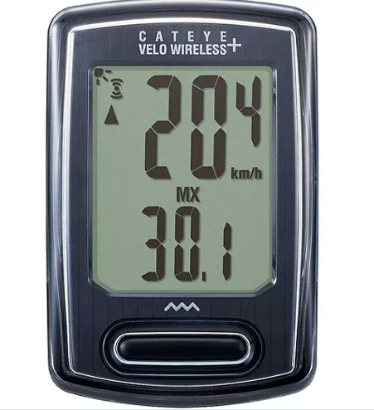
Figure 1 Cat eye Velo Wireless Plus
As biking is such a huge sport for either recreation or fitness, the modern age and technology hasn’t been left behind in this discipline. [2]
The cycle computer is now an essential piece of equipment, as it tracks your routes which can be uploaded to maps. It tracks your fitness level with added devices such as heart monitors and calorie loss. The cadence and speed can also play a part in maintaining the correct rhythm which is crucial in professional biking. [3]
Figure 1 is already on the market and is an off the shelf design of the bike computer that was designed. This device records the current and average speed, elapsed time, trip and total distance. [4]
It was powered by a CR2032 3V battery. This is a Lithium coin cell, which has a capacity of 210mAh. This battery is not rechargeable, so would have to be replaced when drained. [5]
The batteries lifespan is 1 year if used an hour a day. [6]
A hall sensor kit is used to attached to the bracket of the bike and then a magnet is attached to the wheel spoke in order to measure the speed of the wheel turning. This is a very similar set up to the bike computer that was designed. [7]
For the computer, the tire size has to be entered. This is to calculate the speed the wheel is travelling.

I2C
The decision to opt for using the I2C method of communication was used due to the fact that it allowed the microcontroller to have less pins and could therefore be a cheaper MCU.
The ease of connectivity was also a deciding factor. The sensors connecting to the microcontroller were run of the same line and only had to have to pull up resistors, one on each of the lines.
SCL – Serial Clock
SDA – Serial Data
SCL was the clock line. This was used for the action of data transfers with the I2C. SDA was used for the data line. These two lines were connected to all the sensors on the circuit. The lines also need may have a ground or 0V. Due to both the SCL and SDA being open drain drivers, they needed pull-up resistors, one on each line. These were used to pull up the voltage as being open drained the voltage passing through was low as seen in figure 10. [8]

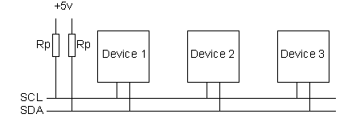
Figure 9 shows daisy chained slave’s devices connected to SDA/SCL lines
The devices used with the I2C system were either master or slaves. The component that initiates and governs the drive was always the master. The component that responds to this dominant component was the slave. [8]
In a comms set up, there was only one master, but many slaves. In the circuit, the master was the microcontroller and the sensor were the slaves.
Data transferred between master and slave was done in 8 bit sequences. These are put on the SDA line. The SCL line starts pulsing low and high. Standard speed for this is around 100KHz. [8]
All components with I2C protocol will have their own unique 7bit address. This is for the master to understand which component is sensing the signal, as it only has two lines connecting. [8]

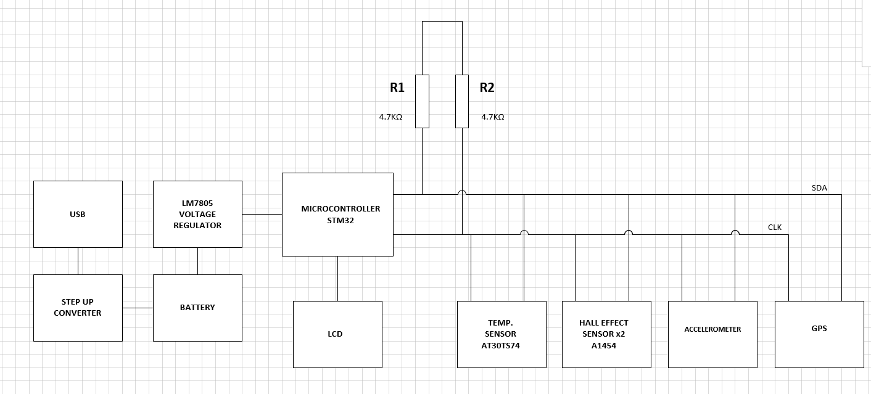
Figure 10. Block Diagram of prototype bike computer

As shown in figure 11, the initial design showed that the USB port was connected to a PC to give an initial 5V. The 5V had to be increased to charge the set of batteries to 12V. This range of voltage was required to power the microcontroller.
A step up converter was required to increase this 5V from the USB port. The increased voltage would then be sufficient to charge the batteries up.
The battery used in the design was an 18650 Lithium rechargeable battery. This would give a voltage of about 3.7V. Six in total was used in series and parallel to give a total output of around 10.8V.
This increased voltage from the batteries would be too high to go directly into the microcontroller, so a voltage regulator(LM7805), was used to drop the voltage to a steady 5V. This would be perfect to power the microcontroller.
The decision was made early on to use the I2C protocol of communication between the sensors and the microcontroller. This was due to keep down the usage of pins going into the microcontroller. By using this methodology, the sensors would be “daisy chained” of the same two lines, SDL and SDA lines.
By using this way of connection, in the future, more sensors or devices could be added. And by only using two pins, there was more room to connect directly or just add more to the two I2C lines.
To display all the data from the sensors, an LCD screen was used. The LCD took up around ten pins. So just by using this one component, the benefits of using the I2C connection would already be seen.
Two hall sensors was used with additional magnets on the wheel and crank respectively. The wheel sensor would measure the speed of the bike travelling, the sensor on the crank would measure how fast the rider would pedal and this would be an indication of how efficient the riders is and find their optimum pace. [11]
An odometer was also included in the design. This was to measure the distance travelled during a trip on the bike. [12]
A GPS sensor was included to the circuit, this was to upload the trail taken when on the bike, and also to obtain the global position at any one time.
The module chosen was able to also display a RTC (Real Time Clock), and also included an odometer. This could have been used as a back up to the standalone odometer.
An additional temperature sensor was added to measure the climate during the bikers ride.
The following was the microcontroller and all the components and devices incorporated in the design of the circuit for the bike computer.
Included within this section were reasons for picking the hardware used and some alternatives that was left out.
Software would also have to be used in order to compile and program the PIC. MPLAB XC8 could be used.

MICROCONTROLLER

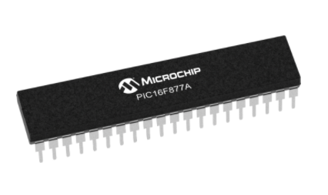
Figure 14 PIC 16F877A Microcontroller
This microcontroller has been used for many years, on various projects. And has been a staple of stability and reliability within electronics. [13]
Due to it having Flash memory technology, it can write erase on an infinite basis. [13]
The pic will also run up to 20MHz of frequency. The operating voltage is around 5V. The sink or source each ports current is around 100mA, so the maximum limit of current of the GPIO pin is 10mA.
The pic does not have an internal oscillator, so one would have to be connected externally. This is to provide a clock to the microcontroller. This is to determine the oscillation between the low and state of any one device connected. [14]
The PIC16F877A contains an ADC (Analogue to Digital Convertor), which would be used to change the signals from the sensors into digital signal to read. There are three timers in the pic. [15]
It has 40 pins, so connection of our LCD screen won’t be compromised, as the LCD would take up a number of pins. By having this number of pins future expansions could also be achieved.
The data bus width is 8-bit, so is large enough for our data transfers. It has 8 ADC channels, so could keep up with analogue signals from any sensors connected before converting into digital to read out on the display. [15]
The supply voltage is a normal 5V. And it has I2C protocol to help keep the number of pins down for the connection for the sensors that was used in the circuit. By just connecting the LCD, 10 pins of the microcontroller were taken up. [15]

Software to run with the PIC would have to be used. This would be a flow chart based system to determine the voltages that would be entering the PIC from the other sensors to give out their respective readings to display on the LCD. It will be programmed using an SPI (Serial Programming Interface). [15]
The cost of the PIC16F877A was fairly low on RS at £4.01 [16]
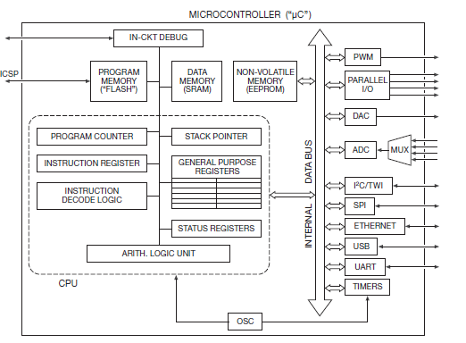
Figure 17 Block Diagram of a standard PIC

The current from the sensor was converted into a voltage, this was done with a feedback resistor and an operational amplifier. The ADC device inside the PIC then converted this signal into a digital version for the register to read. [18]
If future more sensors were to be added in the future. There would be enough for the expansion.

HALL EFFECT SENSOR
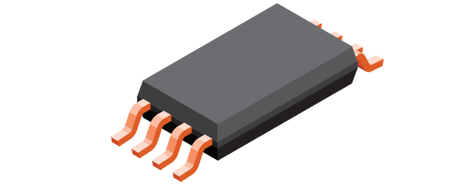
Figure 19 A1454 3V Hall Effect Sensor
This sensor was chosen for the circuit design due the component being I2C compatible. It was also chosen because of it had 26 bits’ user information to get more accurate readings.
It had 12 bits of digital output, and an ADC was integrated within the component. So it could feed a digital input into the microcontroller. [20]
Magnets attached to the wheel and gear cog respectively measured the speed and cadence when passed through the sensor. This determined the speed of each parts of the bike at any one time. [20]
This is done by the sensor measuring the change of voltage when the magnetic field is in the vicinity of the sensor. The sensor has a semiconductor device inside that generates a field of magnetism. When the external magnet passes through the sensor and electrons in the sensor to react and this makes a measurable voltage which can be read. [20]
In the bike computer circuit, the voltage would at 0V. When the bike wheel or crank starts rotating, the magnet coming into the region of the sensor will change the polarity in the sensor and the voltage will change to a higher state. This switching will be clocked by the microcontroller and change from a 0 state to a 1. Software within the microcontroller will work out the time of the switching that occurs and will give a number back into the display. The circumference of the wheel was inputted into the software to enable to work out the rotation speed. [21]
The logic input current was 1mA and the clock frequency was 400kHz which is low but would have less current drain on the battery. It had a sleep mode through the I2C command, so would minimize power drain in battery when not in use [21]
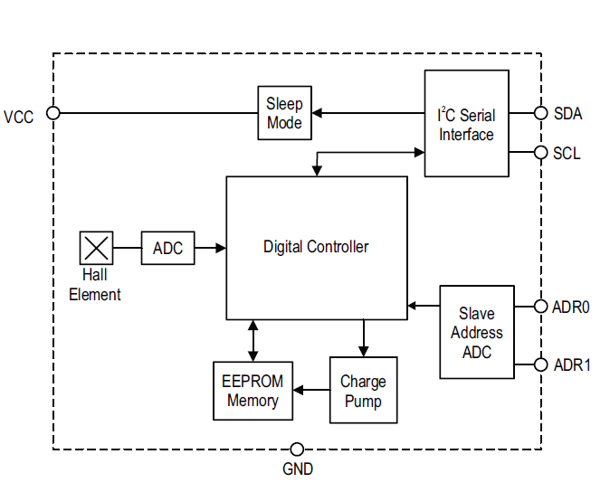
Figure 22 Functional Block Diagram of Hall Sensor

An alternative to the Hall sensors would have been to use reed switches. This could be done by placing Reed Switches on the bike frame, in the same positions that the hall sensors were placed.
A magnetic placed on the inner chain cog will measure the cadence and one on the wheel spoke will measure wheel rotation [23]
The reed switch stays open until the magnet passes through which closes the switch. This will change the signal (voltage) being sent to the MCU. And with software, determine how fast the wheel/cog is turning. [24]
The disadvantage of using these switches are that they will not be able to detect high speed. So it would not be very effective when determine the speed of the bike cog and wheels at high speed. [25]
The hall sensor would be more beneficial to measure the speed. These are more reliable and will detect high speed such as a washing machine speed. They give higher reliability and precision sensing. It is also solid state. So no moving parts. [25]
Also, a reed switch wouldn’t have I2C protocol. So would have to connected a to microcontroller, taking up one of the I/O ports.
Alternatively, an accelerometer could be used to measure the speed you are travelling on the bike. But this would not monitor cadence as it would not be measuring the rotation of the cogs.

TEMPERATURE SENSOR

An I2C temperature sensor was used in the circuit. This was to keep down the price and complexity of the connection between the number of sensors that was used and also the number of pins that was taken up on the microcontroller.
An Adafruit MCP9808 Precision I2C Temperature Sensor was looked at to measure the temperature on the bike computer.
This was due to it being a very accurate sensor. It had accuracy of +/- 0.25 °C to go with the sensors range of -40°C to +125°C. [26]
It worked with any microcontroller using I2C technology. And had 3 address pins, so it could be connected to up to 8 of an I2C bus and would not have to issue of collisions with addresses. Operating current is low and efficient at 200Ma. So less drain on the battery. The sensor is also digital, so no need for conversion. [26]
It also had a good voltage range, so could be used with 2.7V to 5.5V logic. The price was around £3.56 [26]
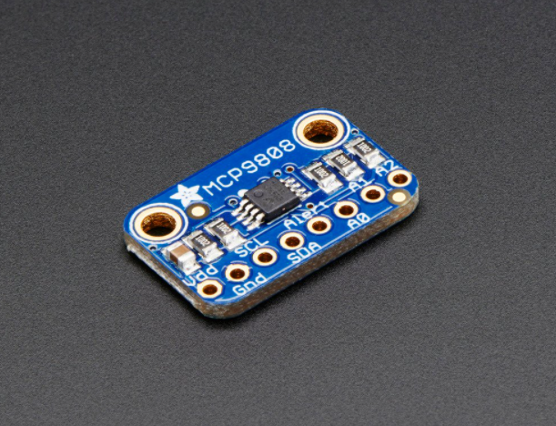
Figure 27. Adafruit MCP9808 Precision I2C Temperature Sensor

Alternative Sensor
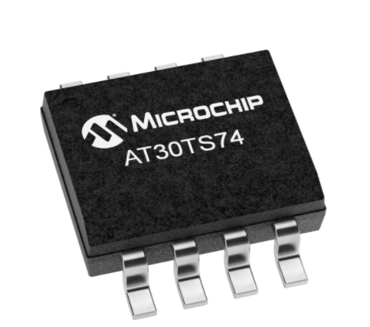
Figure 28. Image of AT30TS74
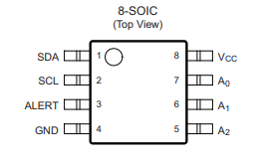
Figure 29. Pin out of AT30TS74
In comparison, the Microchip AT30TS74 temperature sensor was looked at. This also had I2C technology. Allowing to only use the clock and data pins to connect to one 1 pins of the microcontroller.
The temperature range was from -20°C to +100°C. And had configurable resolution of 9 to 12 bits. High and low temperature range could also be adjusted. The active current dissipation was 85µA. This was lower than the MCP9808 current drain of 200µA when active. It has a maximum clock frequency of 3.4MHz, which will allow the data to calculate quicker to the microcontroller. [30]
The AT30TS74 price was considerably lower at 48p compared to the MCP price of £3.98
In the circuit design the temperature sensor, using I2C technology was connected to the microcontroller using the data and clock line. Two pull up resistors were used in-between the components. [30]
The temperature sensor will take a reading of temperature and send this as a voltage from to the ADC. This digital reading will be stored in the register until the microcontroller asks for the data. This is then feed into the control and logic reading to send to the microcontroller. [31]
The sensor will act as a slave to the master microcontroller. The sensor will have its own unique 7-bit address to send data too using the SCL and SCD lines. [30]
The sensor also has maximum and minimum levels which will trigger an alarm if reached. This will shut the sensor down as a safety measure. [30]

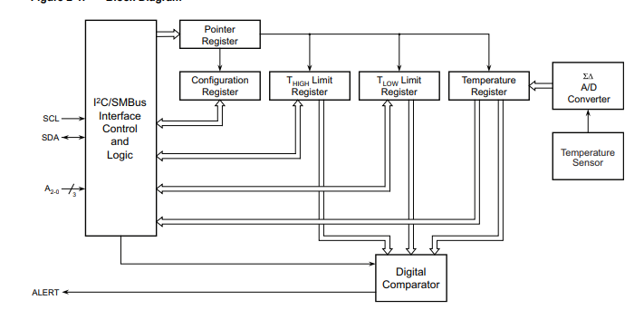
Figure 32 Block Diagram of the AT30TS7A

GPS
A GPS was added to the circuit for the bike computer. This would have obvious benefits. It could act as a route finder if lost in a location. It could also act as a speedometer as the device will bounce of various satellites and will determine how fast you are travelling. [33]
But this will not measure how fast the wheels or cog is travelling. It will be based on how long you are taking to get from one location to another.
The signal to a satellite can be compromised by atmospheric conditions and signal blockage. [33]
This component was chosen due to not only it having I2C connection, so once again, brings down the number of pins connecting to the microcontroller, but it has 16Mb of Flash embedded for logging data. And it can predict satellite data, so if there is a temporary drop out the positon will not be lost. [34]
There is also an odometer function on this component. This will measure the distance travelled through the GPS module. The odometer will not be configured in the data block. It will have to be configured using commands when running.
The GPS also has a RTC built in to display the time and has an odometer too. This will be able to track the distance travelled on the bike.
The receiver in the GPS will connect with a satellite to determine the location of the device. The data will then be transferred via the I2C lines to the microcontroller. Then this will be sent to the LCD for a reading. The GPS will send positions in real time in NMEA (National Marine Electronics Association) format. [34]
The 32 KHz RTC will also be able to display the current GMT to display. The price of this component is £12.52. [35]
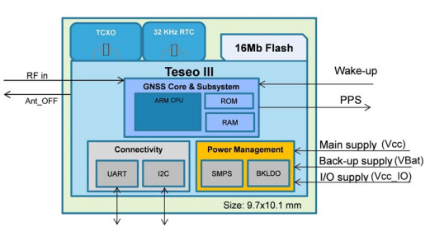
Figure 36 Block Diagram of Teseo-LIV3F

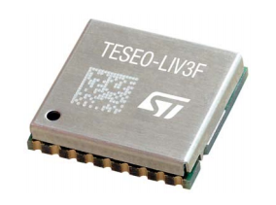
Figure 37 Teseo-LIV3F

Alternative GPS

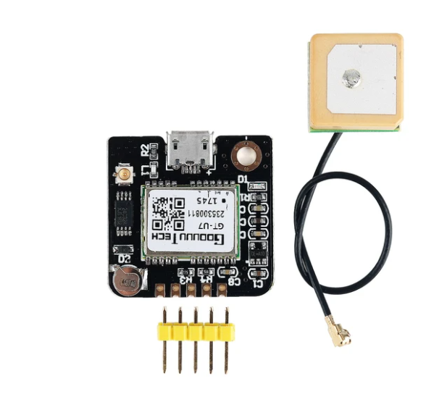
Figure 38 Teseo-LIV3F

This GPS has an external USB port, so can connect externally to another device. But it doesn’t have any I2C protocol. So would have to be connected to the microcontroller separately. There is also no odometer or real time clock included with this. Even though this component was cheaper than the Teseo. Price £9.43 [38]

ACCELEROMETER

This sensor will measure the acceleration on more than one axis. This is done by measuring the orientation with relation to the gravity of the earth. The sensor will use MEMS (Micro Electro Mechanical Systems), to use a miniature mass of conductivity on a spring. When the sensor is accelerated, the spring will then stretch and the then the mass can be measured with a capacitance change. [39]
The measurement is then amplified in order to be at a readable level. This reading is then converted from analogue to digital signal in order for the microcontroller to read the data sent to it. When the microcontroller is ready for the data to be sent via the I2C protocol it will ask for the unique bus address of the sensor to start sending the data to it. [39]
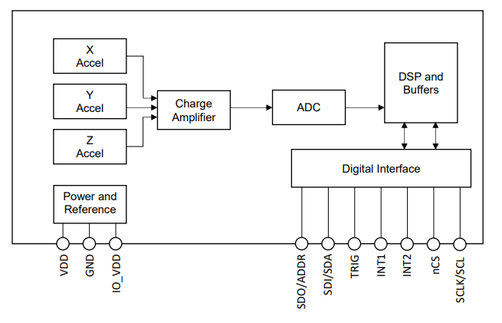
Figure 40 Block Diagram of KX132-1211
This accelerometer was chosen was a KX132-1211. This was due to it having a low operating voltage of 2.5 V and a current consumption of 0.5mA., The communication rate of the I2C was 3.4MHz which gave it a decent speed to transmit its data. The price of the component was £8.66 [41]

LCD
An LCD was used to display all the data gathered from the different sensors on the circuit. The LM016L was used due to its low power drain of 0.6mA and its supply voltage of 5V. It will also give out 16 characters’ x 2 lines [42], so gives a good balance of display and doesn’t drain the battery too much.
This LCD was used to display numbers, alphabets and special characters. It will also work with 8-bit systems.
The only issue is that it took up 14 pins of the microcontroller. An I2C expander could have been used, and connected the LCD through this which would have taken up less pins on the microcontroller. But, since all the other sensors used I2C protocol, there was plenty of pins left to use.
The pins D0-D7 were used to pass information back and fore the microcontroller. These were data and control. The pins had to be connected with consistency, e.g. PIN1 on the microcontroller to PIN1 on the LCD. [43]
The LCD had to not be in a busy state, if it was, the data sent it was ignored. Sending the command to the LCD was done from a signal sent from the sensor to the microcontroller then to the display to give to required reading of that sensor. [44]
Pins were turned on and off that sent or received the data that was being transferred.
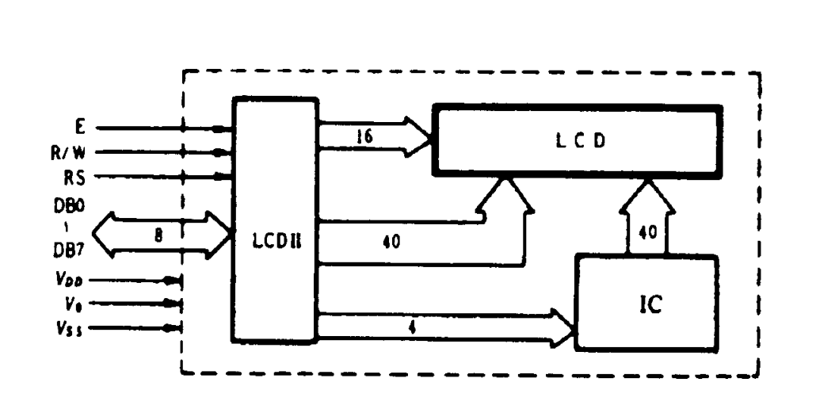
Figure 43 Block Diagram of LCD
The microcontroller needed to send data and commands to the LCD. The data determined the bits of the character that was displayed. The command decided the position of the display. Both of these actions were multiplexed using the Register Select.
When HIGH, data was displayed. When LOW, the command was triggered. [45]
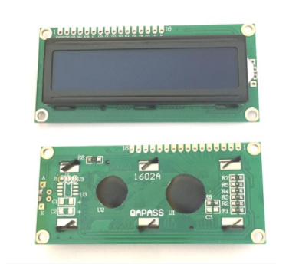
Figure 44 Image of LCD

USB PORT
The bike computer had to be able to connect via a USB for either charging or data transfer. These USB ports are very standard, and will give out 5V DC standard. This 5V had to be stepped up to a higher voltage to charge up a number of batteries that would power the microcontroller.
The USB port could be soldered onto a PCB that also incorporates the step up converter and the resistors that would be required to keep the current overloading and damaging the components, and the capacitors that would change the choppy signal produced and smooth out the voltage to be more regulated.
These modules can be bought quite cheap, around £1.50, and incorporate all the components required on a PCB board [45]

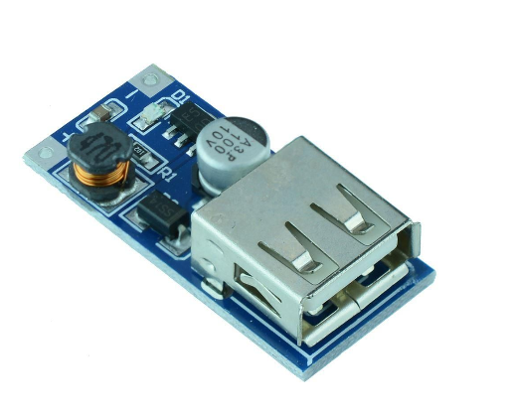
Figure 46 Image of a typical DC USB Step up Boost Power Supply

The board would also include an LED indicator to show power connected to the device. A typical module like this can output a current of 30mA. [45]
Due to the PIC used, there wasn’t Data +/- lines to connect directly from the USB to the PIC itself. The data lines coming out of the USB was connected into a USB transceiver component. These lines then fed out of the RX/TX lines and connected into the PIC’s RX/TX lines to transfer the data. [47]
The CH330 is a serial chip that was used to convert the Data lines from the USB port and convert the TTL into readable RX/TX lines that the PIC would read.

STEP UP CONVERTOR
The standard voltage coming from the USB out of a PC is 5V. As the power for the microcontroller is being supplied from the rechargeable battery, the voltage has to be stepped up in order to charge the battery. For that to happen, a step up converter was used between the USB port and the batteries. 5V would come in and this would be increased to around 12V.
A FP6291 step up converter component was chosen to use for this action in the circuit. This was due to the large swing of adjustable output, ranging from 3V – 12V. The pulse width frequency was 1.0Mhz. It had a 0.2Ω power MOSFET included inside, which made the switch very efficient. [48]
The soft start circuitry that is embedded would stop the initial surge of current when turning on. The soft start locks in the output of the error amplifier and made the pulse width modifiers pulse to slowly increase.

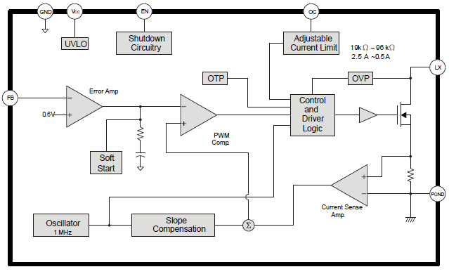
Figure 48 Function Block Diagram of Step up Convertor
The FET seen on the right of the circuit is effectively the switch on the output. There was an input of 5V DC, next to that is the inductor coil.
So 5V input through the coil and the diode. The output is through the capacitor. The voltage that is coming out to the output is feedback.
The feedback was going into a fixed voltage reference diode. The output voltage was being compared to the fixed voltage reference. This was then going into a circuit which drove the logic. The logic circuit generated a PWM signal. The driver then drove the FET switch inside.
So, to recap, the logic drove the FET, which switched on/off repeatedly.
The inductor and the capacitor are the things that caused the voltage to be produced across the capacitor giving a higher voltage output. The voltage was monitored in the chip and adjusted the driving of the switch to maintain the constant level at the output. [49]
Battery
6 X 3.7V 18650 Lithium Ion rechargeable batteries were used for the power for the circuit. These had 2.6Ah.
They were configured both in series and parallel. This was to give out an average voltage of 11V, and having them parallel would allow double the amount of mAh. This would allow the circuit to run for longer. [50]

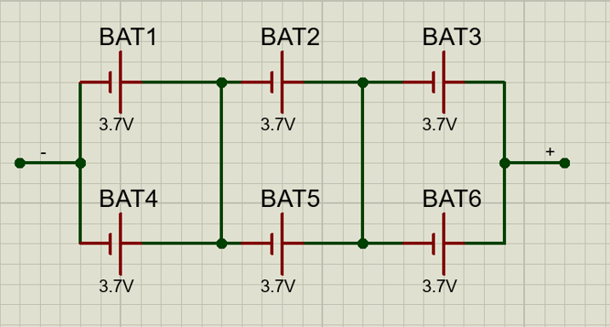
Figure 51 Shows battery pack set up

7805 Voltage Regulator
Due to the voltage coming from the batteries of around 12V, going straight into the microcontroller would damage the chips internally. Therefore, the voltage would need to be dropped down to around 5V. This was so that the activation voltage and would not harm the device.
A voltage regulator was added. A common one is the 78xx series. These would come in different current capacities. [52]
There would also be another capacitor on the other side of the volt reg. This would be to cut down on the ringing produced from the volt regulator. [52]
The volt reg. was a kind of regulator circuit. It was like a kind of transistor which would include regulatory circuit within it. The regulator would be a feedback loop that looks at the output and monitoring it and will change how the transistor conducts. This was to keep a constant voltage. [52]
If a transistor that was in its middle linear range, heat would be generated. To get a smooth regulated DC, there would have to have a higher voltage in the input then what would be required in the output. The input voltage can regulate, but due to feedback loop in the semi-conductor circuit within the volt regulator, it would continually vary the way the transistor is conducting. And give a nice steady voltage.

Method
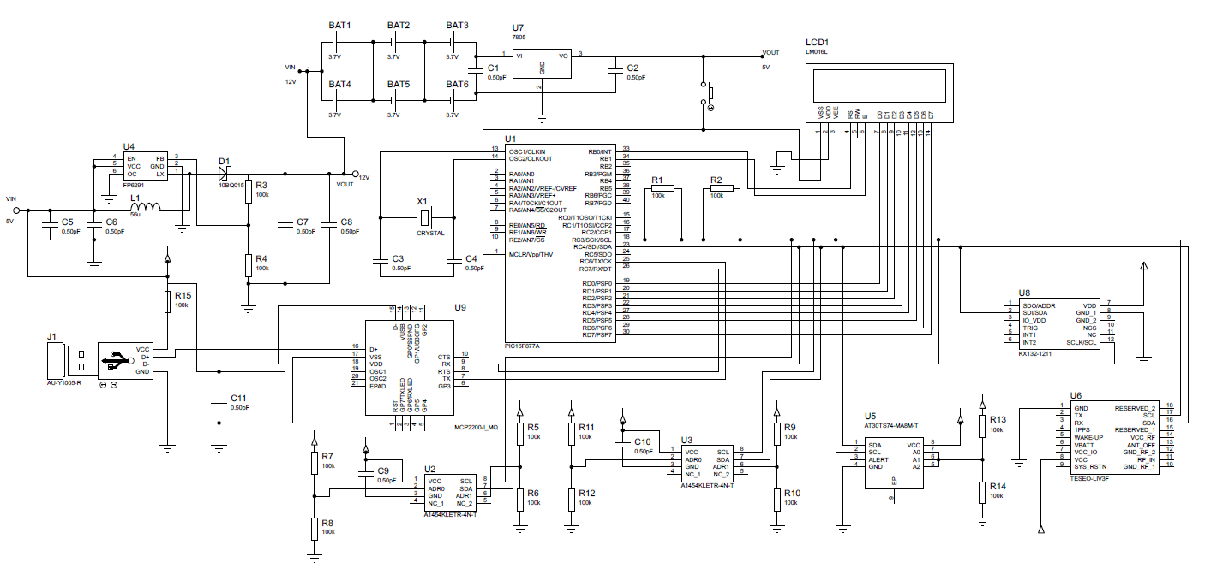
Figure 53 Circuit Diagram of bike computer

USB to Transceiver
USB port connected to a PC. The D+/- lines on the USB connected into the USB transceiver (CH330), +/- lines respectively. This will give the UART synchronous communication with the microcontroller. [54]
C11 was used to smooth out the voltage level and keep to “noise” from the high to low states to a minimum, this line was also grounded. [55] R15 was used as a pull up resistor. It limited the current passing through the circuit.
USB to Step up Convertor
5V from the USB port, C5 & C6 was used to smooth out the input voltage through L1, the inductive coil, and D1, the reference diode. Under 5V, nothing conducts, over 5V it will start to conduct. The more it tries to go over 5V, the more the current will conduct through the diode. But the more current is going through, the more the voltage is being dropped across the resistor. This will allow for a constant 5V across. So the diode acts like a volt reg.
R3 and R4 were the potential dividers to drop the voltage. The output was fed back to maintain a steady level. C7 and C8 was used as smoothing capacitors.12V was then produced at the output. This was required to charge up the battery pack.
Battery pack to Voltage Regulator
12V from the step up convertor charged up the parallel/series battery set up. By having this set up the right amount of Voltage and current was created. Six 3.7v batteries in series and parallel gave out 11V & 78000mAh. C1 was to smooth the applied voltage at input. C2 was to smooth out the output voltage.
The output from the voltage regulator to the microcontroller was isolated with a push switch. This would have to be pressed on to allow the power to flow to the microcontroller.
Hall Effect Sensors to Microcontroller
The two hall effect sensors for the wheel and crank speed where triggered by magnets on their respective parts. When the magnet came into the sensors field the state changed and sent out a signal. C9 was to smooth out the power, this was also connected to ground. R5 – R8 was connected to the Address pins. This was because you can only have one device at a time on the shared I2C lines. These addresses set the bottom bits of the address. These are the pull down resistors. [56]
SCL and SDA pins are used to communicate to the master microcontroller. The sensors are the slaves. The SDA will send the data to and from the hall sensor. The SCL is governed by the microcontroller and is bi-directional. Each line is connected to a pull up resistor. This is due to the line being open drained. The lines are synchronous, so the sampling will be synchronized by the clock signal that is between the slave and master. The microcontroller will send for the address it requires. When the slave matches the address sent, the master will let the slave know if it wants to read or write the data. This will be determined by a low or high signal. The data will then be sent in 8bits. [57]
Temperature Sensor to Microcontroller
R13 & R14 were connected to the address pins of the temperature sensor and connected to ground to ensure a known state of address. These were used to identify when the microcontroller called for the signal and then data to be sent. [58]
The same SDA &SCL lines were connected to the microcontroller, with a pull up resistor on each line. This was the same set up as the previous hall effect sensor, and was daisy chained on the same lines.
GPS to microcontroller
VCC and ground pins connected for their respective operation. SCL and SDA lines connected to microcontroller via the pull up resistors in the same method as the hall sensors. The Global Navigation Satellite System (GNSS), receiver pulled the location of the GPS will pass this into the NMEA protocol, where it will wait until the microcontroller sends out the unique address for the module. The location data will send in its bit’s configuration over the I2C line. [59]
The odometer and RTC function are also available through the GPS. It will track the distance covered on the GPS. The odometer has two states, activated and reset. This will be achieved by using interrupts. [60]
Accelerometer to microcontroller
The acceleration is sensed on the capacitance difference of the increase in speed in the sense element. The sensor will be powered and grounded with its respective pins. The SDA and SCL lines will communicate the data via the pull up resistors and each line. The microcontroller will pull the line of data low; this is to maintain the stability when the clock pulse is in the high period. When the data has been transferred, the microcontroller will send a stop signal. This will be done by transferring the SDA to high from a low state. This is done when the SCL is in a high state. [61]

Microcontroller to LCD
The LCD has an 8-bit data bus. This is referenced in the pins D0 –D07. The data will be sent on these lines in bytes. There are two types of register, data and command. The register Select (RS) Logic 0 was used to instruct the command register. Logic 1 for data register. Data that has to be sent to the LCD for display will be written to the register. When the signal is low the LCD will see the 8-bit data as a command and in turn will be written as a command register. When the signal is high, the LCD will see the data and replicate in to data register. The LCD will decipher this data and generate and display on the screen. [62]
Logic 0 to write to the LCD. Logic 1 is to read for LCD. Pins 5 is for the Read/write signal. This will read the busy flag of the display. To write this pins should be low, high for read. [62]
Pin 6 is for the enable command to the LCD. A pulse of high to low will be sent on this pin and then send the data ready to be displayed via the register and triggers the display to react. [62]
Pin 2 is the VCC and is powered by 5V from the battery pack. Pin 1 is the ground.

FLOWCHARTS
I2C PROTOCOL
The flow chart for the I2C protocol was followed for all the sensors in the circuit.
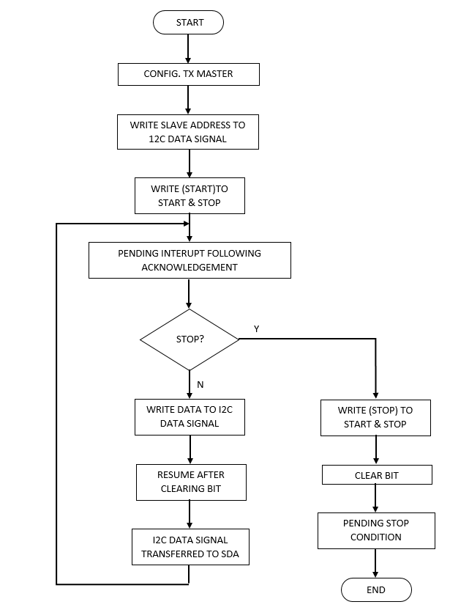
Figure 63. I2C protocol flowchart

HALL EFFECT SENSORS
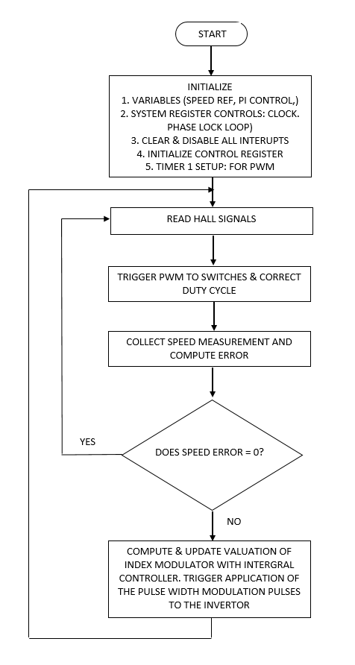
Figure 64. I2C Hall effect sensor flowchart
TEMPERATURE SENSOR
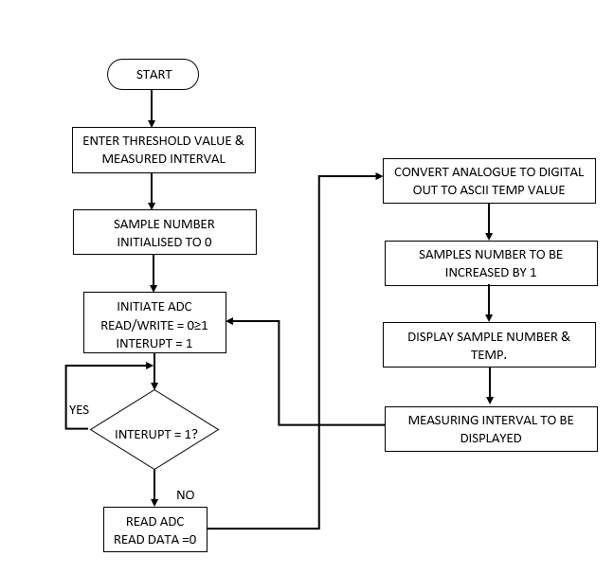

Figure 65. I2C temperature sensor flowchart

GPS
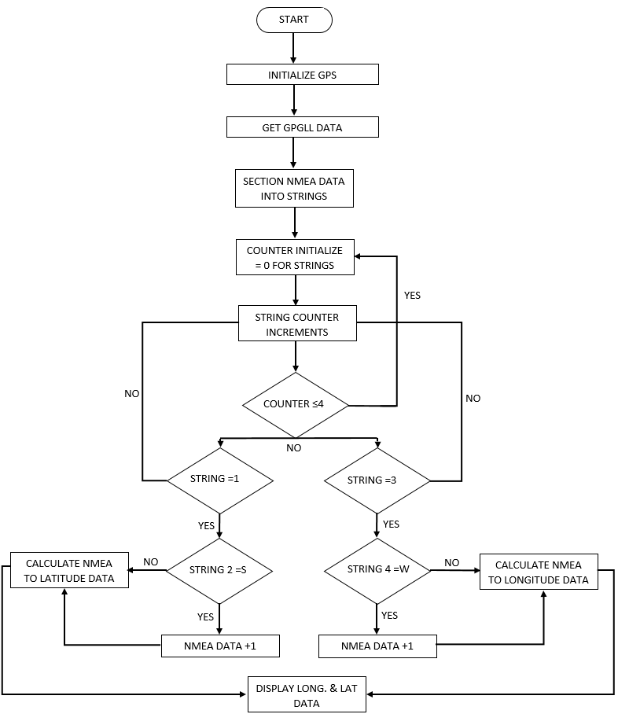

Figure 66 GPS flowchart

ACCELERATOR
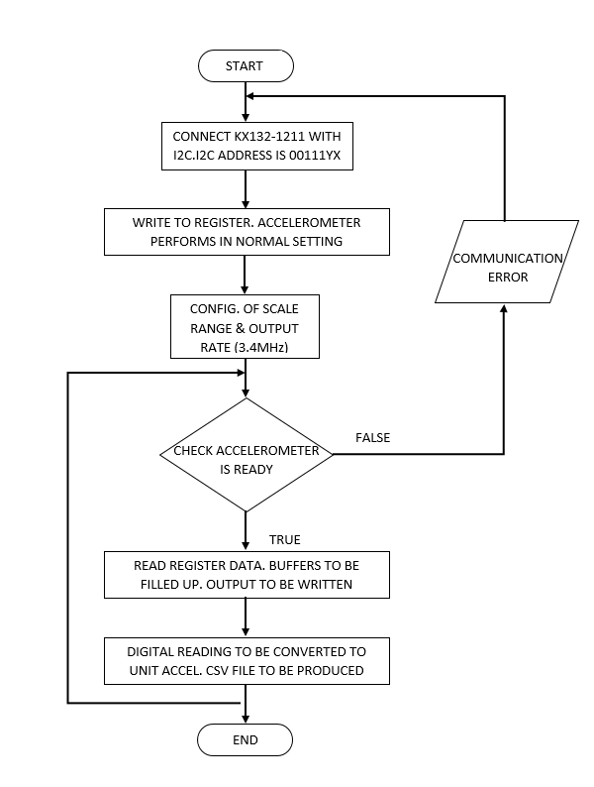

Figure 67 Accelerator flowchart

LCD
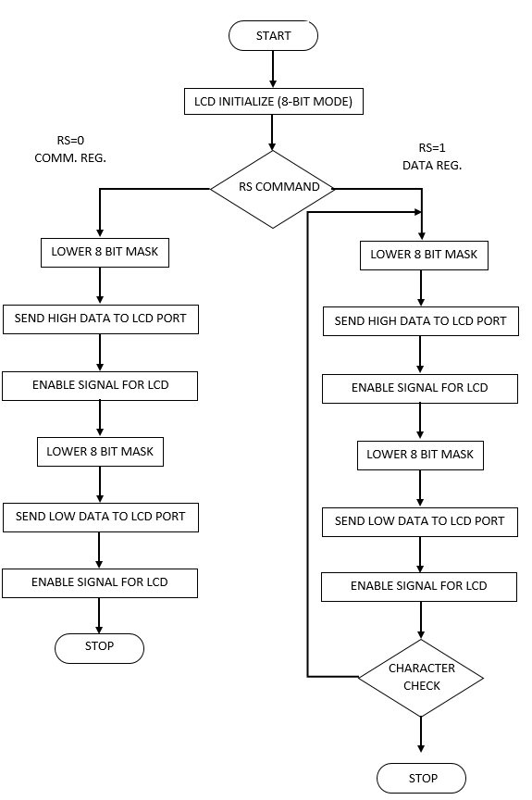
Figure 68 LCD flowchart

Discussion
With the decision to use the I2C protocol for the bike computer circuit, a smaller microcontroller could have been used. As by using the I2C protocol, only two pins are used. But for this prototype assignment, a bigger chip was used. By using a chip this big more components could be added in the future, such as Bluetooth device to send the data wireless. This would eliminate a messy wiring system and make the system more compact to further development the package to design for production.
An I2C expander could have been used to interface the LCD to the microcontroller and aid in the choice to choose a smaller microcontroller.
Heart or pulse sensors could also be added to monitor the wearers vital signs and how many calories are being burned up. This could also be linked to an app which could be accessed to record all the data being captured. And this then could be compiled into graphs and spreadsheets to compare and contrast for all kinds of comparisons. E.g. fitness, locations, speed trials, etc.
The only down side of adding more components would be the current drain on the batteries. Lowering the charge time of the battery pack. This could be rectified by adding more batteries to prolong the offset of the bigger drain on the circuit.

References
1. Chain Reaction Cycles, " Cateye Velo Wireless Plus Cycling Computer?”, Chain Reaction Cycles, Oct. 26, 2020 [Online]
Available: https://www.chainreactioncycles.com/cateye-velo-wireless-plus-cycling-computer/rp-prod164529
[Accessed Apr. 6, 2021]

2. P Norman, " Garmin Edge bike computers: buyer’s guide to all the models”, Bike Radar, Oct. 26, 2020 [Online]
Available: https://www.bikeradar.com/advice/buyers-guides/garmin-edge-bike-computers-buyers-guide-to-all-the-models/
[Accessed Apr. 7, 2021]

3. D Whinnery, " Wiggle's guide to the bike computer”, Wiggle, Jul. 3, 2020 [Online]
Available: https://guides.wiggle.co.uk/bike-computers-buying-guide-0
[Accessed Apr. 4, 2021]

4. Chain Reaction Cycles, " Cateye Velo Wireless Plus Cycling Computer?”, Chain Reaction Cycles, Oct. 26, 2020 [Online]
Available: https://www.chainreactioncycles.com/cateye-velo-wireless-plus-cycling-computer/rp-prod164529
[Accessed Apr. 6, 2021]

5. Multicomp, " Lithium Battery Coin Cell”, Farnell Datasheet, Published date unknown [Online]
Available: http://www.farnell.com/datasheets/1671733.pdf
[Accessed Apr. 3, 2021]

6. Cateye, " Cateye Velo Wireless”, Cateye Datasheet, Published date unknown [Online]
Available: https://www.cateye.com/intl/support/manual/data/doc/CC-VT230W_HP_ENG_v4.pdf
[Accessed Apr. 12, 2021]

7. Cateye, " Cateye Velo 9/Velo 7”, Cateye Datasheet, Published date unknown [Online]
Available: https://www.cateye.com/intl/support/manual/data/doc/CC-VL820520_Odo_HP_ENG_v1.pdf
[Accessed Apr. 12, 2021]

8. Robot Electronics, " Using the I2C Bus”, Robot Electronics, Published date unknown [Online]
Available: https://www.robot-electronics.co.uk/i2c-tutorial
[Accessed Apr. 12, 2021]

9. Robot Electronics, " Using the I2C Bus”, Robot Electronics, Published date unknown [Online]
Available: https://www.robot-electronics.co.uk/i2c-tutorial
[Accessed Apr. 4, 2021]

10. Visio, " Block Diagram of prototype bike computer”, Microsoft Viso Standard, Oct. 12, 2013
[Accessed Apr. 20, 2021]

11. RS, " The Guide to Hall Effect Sensors”, RS, Published date unknown [Online]
Available: https://uk.rs-online.com/web/generalDisplay.html?id=ideas-and-advice/hall-effect-sensors-guide
[Accessed Apr. 18, 2021]

12. K Nice, " How Odometers Work”, How Stuff Works? Published date unknown [Online]
Available: https://auto.howstuffworks.com/car-driving-safety/safety-regulatory-devices/odometer.htm
[Accessed Apr. 22, 2021]

13. Microcontrollers lab, " PIC16F877A Microcontroller Introduction and Features”, Microcontrollers lab, Published date unknown [Online]
Available: https://microcontrollerslab.com/pic16f877a-introduction-features/
[Accessed Apr. 22, 2021]

14. AS Duggal, " Why do microcontrollers need a clock?”, Quora, Published date unknown [Online]
Available: https://www.quora.com/Why-do-microcontrollers-need-a-clock
[Accessed Apr. 4, 2021]

15. Microchip, " PIC16F18446”, Microchip, Published date unknown [Online]
Available: https://www.microchip.com/wwwproducts/en/PIC16F18446
[Accessed Apr. 12, 2021]

16. RS, " PIC16F18446”, RS, Published date unknown [Online]
Available: https://uk.rs-online.com/web/cp/1449157,4671684,4671684P/?pst=PIC16F877A-I%252FL
[Accessed Apr. 14, 2021]

17. Microchip, " PIC16F18446”, Microchip, Published date unknown [Online]
Available: https://www.microchip.com/wwwproducts/en/PIC16F18446
[Accessed Apr. 14, 2021]
18. P Horowitz W Hill, " Microcontrollers”, The Art of Electronics, Jul. 27, 2015
[Accessed Apr. 15, 2021]

19. DigChip.com, " Details, datasheet, quote on part number: A1454”, DigChip.com, Published date unknown [Online]
Available: https://www.digchip.com/datasheets/parts/datasheet/2/029/A1454.php
[Accessed Nov. 4, 2020]

20. Allegro Microsystems, " 3 V Hall-Effect Linear Sensor with I2C Output”, Digichip, Published date unknown [Online]
Available: https://www.digchip.com/datasheets/parts/datasheet/2/029/A1454-pdf.php
[Accessed Apr. 16, 2021]
21. A Raj, " Digital Speedometer and Odometer Circuit Using PIC”, Circuit Digest, Jul. 27, 2017 [Online]
Available: https://circuitdigest.com/microcontroller-projects/digital-speedometer-odometer-circuit-using-pic16f877a
[Accessed Apr. 15, 2021]

22. Allegro Microsystems, " 3 V Hall-Effect Linear Sensor with I2C Output”, Digichip, Published date unknown [Online]
Available: https://www.digchip.com/datasheets/parts/datasheet/2/029/A1454-pdf.php
[Accessed Apr. 16, 2021 [Accessed Nov. 12, 2020]

23. BBE, " Reed switches in Gear speed and direction sensing”, RRE, Published date unknown [Online]
Available: https://www.reed-sensor.com/applications/automation/gear-speed-direction-sensing/
[Accessed Apr. 22, 2021]
24. D Whinnery, " Wiggle's guide to the bike computer”, Wiggle, Jul. 3,2020 [Online]
Available: https://guides.wiggle.co.uk/bike-computers-buying-guide-0
[Accessed Apr. 22, 2021]

25. J Bausch, " Reed vs Hall vs VR”, Electronic Products, Sep. 28,2011 [Online]
Available: https://www.electronicproducts.com/reed-vs-hall-vs-vr/#
[Accessed Apr. 22, 2021]

26. T Dicola, " Adafruit MCP9808 Precision I2C Temperature Sensor Guide”, Adafruit, Apr. 3,2014 [Online]
Available: https://learn.adafruit.com/adafruit-mcp9808-precision-i2c-temperature-sensor-guide
[Accessed Apr. 22, 2021]

27. T Dicola, " Adafruit MCP9808 Precision I2C Temperature Sensor Guide”, Adafruit, Apr. 3,2014 [Online]
Available: https://learn.adafruit.com/adafruit-mcp9808-precision-i2c-temperature-sensor-guide
[Accessed Apr. 22, 2021]

28. Microchip, " ±1.0°C Accurate Digital Temperature Sensor”, Microchip, Published date unknown [Online]
Available: https://www.microchip.com/wwwproducts/en/AT30TS74 [Accessed Apr. 22, 2021]

29. Atmel, " 9- to 12-bit Selectable, ±1.0°C Accurate
Digital Temperature Sensor”, Atmel, Published date unknown [Online]
Available: https://ww1.microchip.com/downloads/en/DeviceDoc/Web_AT30TS74_0217.pdf [Accessed Apr. 22, 2021]

30. Atmel, " 9- to 12-bit Selectable, ±1.0°C Accurate
Digital Temperature Sensor”, Atmel, Published date unknown [Online]
Available: https://ww1.microchip.com/downloads/en/DeviceDoc/Web_AT30TS74_0217.pdf [Accessed Apr. 22, 2021]

31. Maxim Integrated, " How to simplify the interface between microcontroller and temperature sensor”, Maxim Integrated, Aug. 2020 [Online]
Available: https://www.maximintegrated.com/en/design/technical-documents/tutorials/6/685.html
[Accessed Apr. 22, 2021]

32. Atmel, " 9- to 12-bit Selectable, ±1.0°C Accurate
Digital Temperature Sensor”, Atmel, Published date unknown [Online]
Available: https://ww1.microchip.com/downloads/en/DeviceDoc/Web_AT30TS74_0217.pdf [Accessed Apr. 22, 2021]

33. GPS.gov, " GPS Accuracy”, GPS.gov, Published date unknown [Online]
Available: https://www.gps.gov/systems/gps/performance/accuracy/
[Accessed Apr. 29, 2021]

34. ST Augmented, " Teseo-LIV3F”, Mouser Datasheet, Published date unknown [Online]
Available: https://www.mouser.co.uk/datasheet/2/389/dm00396647-1799158.pdf
[Accessed Apr. 23, 2021]

35. Farnell, " Teseo-LIV3F”, Farnell, Published date unknown [Online]
Available: https://uk.farnell.com/stmicroelectronics/teseo-liv3f/rf-receiver-1-57542ghz-40-to-85deg/dp/2980958?CMP=KNC-GUK-GEN-KWL-MAN-L5Pages-New-Structure-Test731-STMICROELECTRONICS&mckv=_dc|pcrid|517308823437|&gclid=EAIaIQobChMI9oKxwaCw8AIVTAWiAx0X_QN2EAAYAiAAEgL_sfD_BwE
[Accessed Apr. 23, 2021]

36,37. ST Augmented, " Teseo-LIV3F”, Mouser Datasheet, Published date unknown [Online]
Available: https://www.mouser.co.uk/datasheet/2/389/dm00396647-1799158.pdf
[Accessed Apr. 23, 2021]

38. MakerHawk, " GPS Module”, MakerHawk, Published date unknown [Online]
Available: https://www.makerhawk.com/products/makerhawk-gps-module-gps-drone-compatible-microcontroller-for-neo-6m-51-microcontroller-stm32-uno-r3-with-ipex-antenna-high-sensitivity-for-navigation-satellite-positioning
[Accessed Apr. 29, 2021]

39. Silicon Labs, " Chapter 10.1: Control an accelerometer over I2C Part 1 - Connect the breakout board”, Silicon Labs, Feb. 03, 2016 [Online]
Available:https://www.silabs.com/community/blog.entry.html/2016/03/02/chapter_10_1_contro-dTof
[Accessed Apr. 29, 2021]

40,41. Kionix, " ± 2g / 4g / 8g / 16g Tri-axis Digital Accelerometer Specifications”, Kionix, Published date unknown [Online]
Available: https://www.mouser.co.uk/datasheet/2/348/KX132-1211-Specifications-Rev-1.0-1659721.pdf
[Accessed Apr. 29, 2021]

42,43. Hitachi, " LM016L”, Hitachi Datasheet, Published date unknown [Online]
Available: http://www.farnell.com/datasheets/305035.pdf
[Accessed Apr. 29, 2021]

44. L George, " Interfacing LCD with PIC Microcontroller – Hi Tech C”, Electrosome, Published date unknown [Online]
Available: https://electrosome.com/interfacing-lcd-with-pic-microcontroller-hi-tech-c/
[Accessed Apr. 30, 2021]

45. MCUHQ, " How to interface 16X2 LCD with PIC16F877 microcontroller”, Electrosome, Apr. 05, 2016 [Online]
Available: https:// http://mcuhq.com/18/how-to-interface-16x2-lcd-with-pic16f877-microcontroller
[Accessed Apr. 30, 2021]

46. Switch Electronics, " DC-DC USB Step-up Boost Power Supply Module 0.9V-5V to 5V”, Switch Electronics, Published date unknown [Online]
Available: https://www.switchelectronics.co.uk/dc-dc-usb-step-up-boost-power-supply-module-0-9v-5v-to-5v?gclid=EAIaIQobChMI4JXk5oiI8AIVwp-zCh1gxADaEAYYAyABEgKAsPD_BwE
[Accessed Apr. 30, 2021]

47. Hackaday, " USB to serial chip CH330”, Hackaday, Published date unknown [Online]
Available: https://cdn.hackaday.io/files/1623896947650976/CH330DS1.zh-CN.en.pdf
[Accessed Apr. 20, 2021]

48. Feeling Technology, " 1MHz, 2.5A Step-Up Current Mode PWM Converter”, Feeling Technology, Published date unknown [Online]
Available: https://datasheetspdf.com/pdf-file/826407/FeelingTechnology/FP6291/1
[Accessed Apr. 4, 2021]

49. P Horowitz W Hill, " Microcontrollers”, The Art of Electronics, Jul. 27, 2015
[Accessed Apr. 15, 2021]

50. Battery University, " Series and Parallel Battery Configurations”, Battery University, Jun. 18, 2018 [Online]
Available:https://batteryuniversity.com/learn/article/serial_and_parallel_battery_configurations
[Accessed Apr. 12, 2021]

51. Proteus Software, " Shows battery pack set up”, Labcenter Electronics Ltd, Oct. 12, 2012
[Accessed Apr. 20, 2021]

52. ST, " Positive voltage regulator ICs”, ST, Published date unknown [Online]
Available: http://www.farnell.com/datasheets/2307057.pdf
[Accessed Apr. 4, 2021]

53. Proteus Software, " Circuit Diagram of bike computer”, Labcenter Electronics Ltd, Oct. 12, 2012
[Accessed Apr. 23, 2021]

54. Hackaday, " USB to serial chip CH330”, Hackaday, Published date unknown [Online]
Available: https://cdn.hackaday.io/files/1623896947650976/CH330DS1.zh-CN.en.pdf
[Accessed Apr. 28, 2021]

55. Components 101, " Decoupling Capacitors and Bypass Capacitors – Working, Applications and Differences”, Components 101, Oct. 23, 2019 [Online]
Available: https://components101.com/articles/decoupling-capacitor-vs-bypass-capacitors-working-and-applications
[Accessed Apr. 12, 2021]

56. Particle Docs, " ABOUT I2C”, Particle Docs, Published date unknown [Online]
Available: https://docs.particle.io/tutorials/learn-more/about-i2c/
[Accessed Apr. 14, 2021]

57. S Campbell, " BASICS OF THE I2C COMMUNICATION PROTOCOL”, Circuit Basics, Published date unknown [Online]
Available: https://www.circuitbasics.com/basics-of-the-i2c-communication-protocol/#:~:text=I2C%20is%20a%20serial%20communication,the%20master%20and%20the%20slave
[Accessed Apr. 16, 2021]

58. Atmel, " 9- to 12-bit Selectable, ±1.0°C Accurate
Digital Temperature Sensor”, Atmel Datasheet, Published date unknown [Online]
Available: https://ww1.microchip.com/downloads/en/DeviceDoc/Web_AT30TS74_0217.pdf [Accessed Apr. 16, 2021]

59. S Gupta, " Interfacing GPS Module with PIC Microcontroller”, Circuit Digest, Apr. 20, 2018 [Online]
Available: https://circuitdigest.com/microcontroller-projects/gps-interfacing-with-pic16f877a
[Accessed Apr. 16, 2021]

60. ST Augmented, " Teseo-LIV3F”, Mouser Datasheet, Published date unknown [Online]
Available: https://www.mouser.co.uk/datasheet/2/389/dm00396647-1799158.pdf
[Accessed Apr. 23, 2021]

61. Silicon Labs, " Control an accelerometer over I2C Part 1 - Connect the breakout board”, Mouser Datasheet, Feb. 03, 2016 [Online]
Available:https://www.silabs.com/community/blog.entry.html/2016/03/02/chapter_10_1_contro-dTof
[Accessed Apr. 23, 2021]

62. Explore Embedded, " Interfacing LCD with PIC16F877A 8-bit mode”, Explore Embedded, Published date unknown [Online]
Available: https://exploreembedded.com/wiki/Interfacing_LCD_with_PIC16F877A_8-bit_mode
[Accessed Apr. 23, 2021]

63 - 68. Microsoft Word, " Flow Charts”, Microsoft Word, Oct. 12, 2013
[Accessed Apr. 20, 2021]

