Report to identify and critique the professional standards in place for Advocacy Support Cymru.
This report focusses on Advocacy Support Cymru (ASC) (see Appendix 1) and identifies and critiques the professional standards they have in place as an organisation. It begins by examining the Advocacy Charter, then the context of ASC as an organisation, and finally critiques 3 key elements, namely- equality, diversity and accessibility; confidentiality and safeguarding; and independence.

Rationale of Professional Standards: The Advocacy Charter
The advocacy charter was published in 2002 by Action for Advocacy and was updated in 2014 (National Development Team for Inclusion, 2018). They decided to publish it because they felt there was a need for more guidance for the growing number of professional advocacy services, and the role of independent advocates. There was also a raised awareness of advocacy in general and it was felt that moving forward into the future there needed to be clearer guidance (National Development Team for Inclusion, 2018; Pembrokeshire People First, 2018).
The Advocacy Charter is a code of practice for people working as independent professional advocates to follow. It covers clarity of purpose, independence, person-centred approach, empowerment, equal opportunity, accessibility, supporting advocates, accountability, and safeguarding (National Development Team for Inclusion, 2018; Pembrokeshire People First, 2018).
The Advocacy Charter provides professional advocates with guidelines they can follow to make sure they are advocating properly and giving them the power to help people. It provides both the advocates and their clients with protection in terms of their rights. It helps both the advocates and their clients understand what is expected from an advocate and the delivery of the advocacy service (National Development Team for Inclusion, 2018; Pembrokeshire People First, 2018).
The Advocacy Charter meets professional standards by helping advocates ensure that they are practicing fairly and safely. The Advocacy Charter helps to explain what advocacy is by outlining the key principles and practice of advocacy. It does this by clearly defining what advocacy is, and what its benefits and limitations are. It also promotes good and fair practice by explaining clearly what advocacy is and outlines what advocacy services set out to achieve so that both the practitioner and client understand and manage their expectations (National Development Team for Inclusion, 2018; Pembrokeshire People First, 2018).

Context of the organisation:
“Advocacy Support Cymru (ASC) is a registered charity based in Wales”. They have offices in Swansea and Cardiff and provide services to help with independent mental health advocacy, independent mental capacity advocacy, under 18s advocacy, and community advocacy for all those eligible for their services. They are funded by Abertawe Bro Morgannwg University Health Board, Aneurin Bevan University Health Board, Cardiff & Vale University Health Board, and Cwm Taf University Health Board (Advocacy Support Cymru (ASC), 2023a).
ASC offer professional advocacy services to help provide information and support to clients. They help inform people about their rights and support them to explore their options in any situations they find themselves in. ASC also help their clients ensure that their own personal views and wishes are taken into consideration when decisions are being made about them, so that they fully understand the wider context and feel empowered. ASC are not able to advise on what decisions people should make, they just help them to reach their own decisions about things. They also do not offer counselling, mediation services, or befriending opportunities, they are only there to support (ASC, 2023a).
One of the organisations ASC are involved with is the Child and Adolescent Mental Health Services (CAMHS). CAMHS is run by the National Health Service (NHS) and has been set up to help support young people who are struggling with their mental health. Young people who are under CAMHS are able to access advocacy services provided by ASC and get the help they need (ASC, 2023a).

Report
In this section of the report there is a focus on 3 key elements of the advocacy charter and how they link to the work carried out by Advocacy Support Cymru and their link to CAMHS. The 3 key elements examined are: equality, diversity and accessibility; confidentiality and safeguarding; and independence.

- Equality, Diversity and Accessibility
According to the University of Oxford (no date, no page) equality means that everyone deserves the same help and treatment with their mental health. Whatever age they are they should not be discriminated against and children and young people are the future and deserve to have help.
There are 9 ‘protected characteristics’ under the Equality Act 2010, but when working with children the following need to be considered:
- age
- disability
- pregnancy and maternity
- race (including colour, nationality and ethnic or national origins)
- religion or belief (including lack of belief)
- sex
- sexual orientation
Similarly, equity is about making sure that all young people are “treated fairly, by removing barriers to resources or opportunities” (University of Oxford, no date, no page).
“Diversity is about recognising, valuing and taking account of people's different backgrounds, knowledge, skills, and experiences” (University of Oxford, no date, no page). When people’s differences are seen as a positive thing, they can feel comfortable sharing their views, feel able to embrace any differences, feel empowered, and feel safe that “their opinions and ideas are valued” and this leads to inclusion (University of Oxford, no date, no page). In order for this to happen effectively, then it is important that people with additional needs are able to access information, resources, and services. For example, automatic doors and lifts for those with physical disabilities, or large clear font texts on leaflets in a format that can be read by most people. These types of considerations are known as accessibility.
Equality, Diversity and Accessibility are important considerations for Children and Adolescent Mental Health Services (CAMHS) when they are working with young people (Penfold, 2020). This is so that they ensure that service users feel empowered and that they are able to help them with their mental health, offering to support and find ways to talk with them (Penfold, 2020).
An inquiry into CAMHS in Wales looking into early interventions, admissions for treatment, services in different local regions for issues of safeguarding was conducted by The National Assembly for Wales Children and Young People and Education Committee (The Association for Child and Adolescent Mental Health Services (CAMHS), 2023). Their finds were that the provision of the services of CAMHS for children and young people who needed specialist services were very limited (CAMHS, 2023).
According to their leaflet, ASC provides professional help and support for children and young people with their mental health organisations, such as CAMHS, to help them get the help they desire and to support the organisation to give young people the help they need (CYPF, 2024; ASC, 2023a). Young people can be referred to CAMHS though their doctor, social worker, nurses, teachers, their parents/caregiver, or self-refer themselves depending on their age, but referrals can differ between area to area depending on where the young person lives (CAMHS, 2023). For those young people who have already been accepted into the CAMHS programme, they still face long waiting times to actually be seen and are having difficulties with appointments times too (CAMHS, 2023). However, once young people do get an appointment, if CAMHS think the young person does not fit their medical model then they will not accept them onto their support programme (CAMHS, 2023). Additionally, an inquiry in 2014 in Wales found that the data of CAMHS services for referrals and waiting for appointments “had increased from 1,204 in April 2014 to 2,410 in May 2014” (CAMHS, 2023, no page).
Therefore, whilst advocacy is all about helping children fight to be seen and heard and the advocate representing a child or young person, as defined by the Social Services and Wellbeing Act 2014, states that a “child” is aged 18 or under, but a child aged 0 to 5 has to supported on a case by case basis (Welsh Government, 2022). However, Grimm et al. (2022) say that the Health Foundation have found in their research that in all of the four nations of the UK there is a growing concern for children and young people’s mental health. Furthermore, although there has been an increase in service providers and workers, they are not supporting all of those who have been, or are waiting to be, referred by their doctor as there is such a high demand that it is just all just being backlogged (Grimm et al., 2022), and this includes by CAMHS.

Additionally, Children and young people who have a social worker will get the support they need to have help from CAMHS more quickly than a child or young person who does not, as they would already be recognised as having a mental health issues and indeed Oxfordshire County Council (2024) found that it is a lot harder for young people to get support if they have not already got a social worker; having a social worker means they can get fast-tracked through the system and get quicker access to mental health support. This is important as Mills (2022, no page) highlights how ‘Social workers [are] seeing record numbers of children with mental health problems’. Moreover, according to their website, it appears that Carmarthenshire County Council (2024) is the worst in Wales for funding at the moment and they struggling to meet the needs of the community, as a result they are having to cut the education funding to help support the NHS.

However, it is worth noting too, that there is a private CAMHS service delivered by the Priory clinic, so if families are wealthier and can pay, then their children can literally be put straight to the top of the waiting list (Priory, 2023). This situation can leave many young people with mental health issues without appropriate support as not only are the waiting lists long, but they have no other choices available to them unless they have money. It is at this point that an advocate could come in and help them to try and get the support they need.

- Confidentiality and Safeguarding
According to the Oxford Reference dictionary (2024, no page), confidentiality is defined as ‘The process of and obligation to keep a transaction, documents, etc., private and secret, i.e., confidential; the right to withhold information, e.g. medical information, from others’. To get referred to organisations such as CAMHS a person has to authorise your permission which requires a person’s consent of their information about themselves to be shared with appropriate staff (Mind, 2024a).
In the context of advocacy, confidentiality means that if it can be shown there is an immediate risk regarding a young person then relevant confidential information can be disclosed confidentially on a need to know basis and Advocacy (2023, no page) highlight the fact that there may be times when practitioners are unable to keep things confidential:
The only exception to sharing information is when there is a serious risk of harm to the child’s safety. When there are genuine safeguarding concerns for a child, the advocate should look to disclose information to local authorities, the police or the NSPCC.
(Advocacy, 2023, no page)
Moreover, the Advocacy Charter (Advocacy QPM, 2014, p. 6) states that:
The advocacy provider will have a written policy on confidentiality that is in line with the Data Protection Act 1998 and the Mental Capacity Act 2005. It should outline how information about a person accessing the service may be shared as well as the circumstances under which confidentiality might be breached. Advocates must also be aware of situations that would require making a child or adult safeguarding alert.
(Advocacy QPM, 2014, p. 6)
Safeguarding is defined by the Cambridge dictionary (2024) as ‘the protection of children and adults who could be easily hurt emotionally and physically’
The advocacy charter (2024, p.6) has clear guidelines on safeguarding stating that:
Clear policies and procedures will be in place to ensure safeguarding issues are identified and acted upon. Advocates will be supported to understand the different forms of abuse and neglect, issues relating to confidentiality and what to do if they suspect a client is at risk

(Advocacy QPM, 2014, p. 6)
Although confidentiality and safeguarding are different things, they are connected and interlinked, therefore it is very important that advocacy practitioners follow the advocacy charter carefully to ensure young people’s information is kept confidential. This is because a breach of confidentiality can turn into a safeguarding issue. For example if a young person is far away from their family and not communicating with their family, the advocate, or their case workers, this could interfere with their care plan as they are not participating in the process which might mean that some decisions are made for them, which may not be suitable for them and turn into a safeguarding issue (ASC, 2023b). Therefore, it is important that organisations such as ASC do their best to find ways to communicate effectively with young people, to ensure confidentiality and safeguarding in practice (ASC, 2023b).
The Information Commissioner’s Office (ICO) (2023) has put together a guide on the ten step data protection, when sharing data between everyone involved with a child or young person, to help with safeguarding. However, they do state that although it does not tell advocates how to do their job of safeguarding, it does help them to feel safer with knowing when and how to share information (ICO, 2023). The aim of these guidelines is to help support and protect everyone within the organisations, whatever rank, whether they are the advocates, social workers, or managers, or anyone involved in the safeguarding of children and young people (ICO, 2023). The ten steps suggested by the ICO (2023) are for advocacy organisations and advocates to:
- Be visible on how the information for safeguarding children and young people is disclosed and how their data is protected
- Restrict the information in order to clarify the importance of what is being shared
- Make sure polices and systems of information sharing are made clear and kept secure
- Clarity of the individual human rights of the person to be evident
- Evaluate what is being shared to minimise the risks
- Enrol into a data sharing contract
- Data protection codes need to be pursued
- Use the right legislation in line with the information being shared
- In an emergency information to be shared
- Code of Practice regarding data sharing to be read
According to Leeds for Learning (2023) the ICOs advice on data sharing for safeguarding children and young people may not tell advocates they exact ways they can protect young people, but it applies to information on how to process data or partially process data for safeguarding. Furthermore, they highlight that the information in the ICO’s guidance is about rights rather than the actual practices of safeguarding. Moreover, they show how regulation of data protection regarding the sharing of information of children and young people who may be exposed to harm is mandatory to safeguarding (Leeds for Learning, 2023). Therefore, it can be understood that the legalisation of data protection does not prevent safeguarding issues from arising, but it does help advocates and service users in a legal way, in that they can feel reassured and protected by the law (Leeds for Learning, 2023).
Leeds for Learning (2023) further suggest that sharing data, when appropriate to do so, is more important than not to share as it can protect a child or young person. This is a very important point, as many reviews have shown that there have been cases of children and young people who have died or been seriously injured through not being safeguarded via the proper procedures (Leeds for Learning, 2023). Also, the Welsh Government (2021c, no page) say that:
A Safeguarding Board must undertake a practice review in any case where the circumstances satisfy the criteria in Functions and Procedures Regulations. The Board is also required to undertake audits, case reviews, thematic reviews and investigations, and ensure that they are effectively managed, supported and resourced. The Board is also required to monitor the extent to which any recommendations made by such reviews, audits and investigations are being met and what has changed as a result.
(Welsh Government, 2021c, no page)
This means that advocacy organisations and local councils must ensure that their staff take appropriate training, so that when things happen in real life they know what they are doing and how to deal with things. Local councils must make sure that children and young people are able to access the appropriate advocacy services when they need the support (Welsh Government, 2021c).

- Independence
According to the Oxford Learner’s Dictionary (2024) ‘independence’ means being ‘independent (of somebody/something) not connected with or influenced by something; not connected with each other’. Similarly, the Cambridge Dictionary (2024) defines ‘independence’ as a ‘person independent (of somebody/something) confident and free to do things without needing help from other people.’
According to the Welsh Government (2019), advocates are there to help speak up for children and young people, to empower them to have their voices heard, and to help ensure that their rights, views, wishes, and feelings are being met within their care and treatment. Advocates should also help children and young people to make the appropriate decisions about their own care and independence when planning for themselves in the future by providing them with all the information they need to make good choices that are in their own best interests (Welsh Government, 2019).
Likewise, Advocacy Support Cymru (ASC) (2023c) know that by helping to maintain a young person’s independence by giving them a voice, this can help them to feel empowered and feel in control of any decisions being made about them and their life (Welsh Government, 2019).
ASC (2023c) works to offer children and young people who find themselves in challenging situations, with feelings of being overwhelmed and confused, to be heard, and also to help them have the skills for them to be able to express their thoughts, opinions, and feelings through effective communication, so that they feel strong and independent. Moreover, ASC (2023c) have been helping to give children and young people a voice for over 20 years and, through the use of experienced advocates, have delivered support for young people’s mental health helping them feel empowered.
ASC (2023c) support children and young people to have independence by giving them information about the choices regarding the situation they find themselves in. They also explain their rights and the current legislation that exists to protect them. All this helps young people in their decision making and helps prepare them for what they want to say and do about the situation they are in (ASC, 2023c). Young people may request ASC to speak for them, support and represent them in meetings as they may find it hard emotionally, and may not understand what the other professionals are saying, or what it might mean for them in terms of how they will be affected by the things being discussed about them (ASC, 2023c).

The Welsh Government (2016) have said that children and young people’s mental health is a top priority in all of Wales. The Welsh Government (2016) believe it is essential to help young people so they can be treated whilst they are young, so they do not end up as adults without having help with their mental health and making things worse later on in life.
CAMHS are the leading organisation for young people to seek support, and they can also provide them with an advocate for their voices to be heard, as it is not always easy for a child or young person to have the confidence, especially when they have mental health issues such as anxiety or depression, as they may be lacking their independence (Welsh Government, 2016).

Children and young people can feel that one day they can voice their opinions and feel independent, yet another day they may not be able to as mental ill health can have negative impacts at different times, and the help from advocates can help them understand how their mental health can act in this way (National Society for the Prevention of Cruelty to Children (NSPCC), 2021).

Children and young people may find it hard and might lack confidence and may not be aware of how to build their self-esteem (Childline, 2024). Childline (2024) also say it is important to help them to recognise how to build up their own confidence and self-esteem and how by doing this it can be beneficial to them and help them immensely with their mental health. This will take time and certain steps to help, but to try and teach them how to build their self-esteem will at the same time build up their confidence, for example, they may have different places at school they feel shy in, but out with friends and family in less formal settings they could start to express how they actually feel (Childline, 2024).

Summary of findings
This report focussed on the advocacy organisation known as Advocacy Support Cymru (ASC). It identified and critiqued the professional standards they have in place as an organisation. The report began by looking at the Advocacy Charter, then the context of ASC as an organisation, and finally examining the ways that ASC work in line with the Advocacy Charter, and how this helps protect their practitioners and service users. Finally, the report considered 3 key elements to focus in on and examine, namely- equality, diversity and accessibility; confidentiality and safeguarding; and independence.
The report found that, as an organisation, ASC closely follow the professional standards as set out in the Advocacy Charter. By doing this, it enables them to practice to professional standards, and maintain professionalism as an organisation whilst ensuring that all their individual advocacy practitioners are well trained and have a thorough understanding of their role and responsibilities to the organisation’s service users. In this case, the service users are children and young people, many of whom have been referred via CAMHS, due to behaviours linked to their mental health issues.
Therefore, professional practice that includes all the aspects of equality, diversity and accessibility, confidentiality and safeguarding, and promoting the independence of children and young people is all very important for the organisation themselves and for the children and young people they represent. This ensures the children and young people have the best care and service that ASC can deliver, which promotes positive mental health, gives them a voice, and helps build confidence in them from a young age which will hopefully carry them through to adulthood.

Reference list
Action for Children (2024) Our Work in Wales. Available at: https://www.actionforchildren.org.uk/our-work-and-impact/our-work-around-the-uk/our-work-in-wales/ (Accessed: 15 January 2024).
Advocacy QPM (2014) A Code of Practice for Advocates: Revised Edition 2014. Available at: https://qualityadvocacy.org.uk/wp-content/uploads/2018/05/Code-of-Practice-1.pdf (Accessed: 16 January 2024).
Advocacy Support Cymru (ASC) (2023a) Who are we? Available at: https://ascymru.org.uk/about/who-we-are/ (Accessed: 9 January 2024).
Advocacy Support Cymru (ASC) (2023b) IMHA Client L. Available at: https://ascymru.org.uk/client-story/imha-client-l/ (Accessed: 24 January 2024).
Advocacy Support Cymru (ASC) (2023c) Advocacy is vitally important. Available at: https://ascymru.org.uk/about/who-we-are/ (Accessed: 30 January 2024).
Barnardo’s (2024) Advocacy and Children’s Rights. Available at: https://www.barnardos.org.uk/get-support/support-for-parents-and-carers/childrens-rights-advocacy#:~:text=Some%20of%20the%20things%20an,situations%20or%20about%20foster%20 (Accessed: 16 January 2024).
CADMAS (2024) CADMHAS: mental health advocacy service. Available at: https://cadmhas.com/ (Accessed: 15 January 2024).
Cambridge Dictionary (2024) Independence. Available at : https://dictionary.cambridge.org/dictionary/english/independence (Accessed: 30 January 2024).
Cambridge Dictionary (2024) Safeguarding. Available at: https://dictionary.cambridge.org/dictionary/english/safeguarding (Accessed: 23 January 2024).
Carmarthenshire County Council (2024) Cost of living advice: have your say on the council’s plan to find budget savings. Available at: https://newsroom.carmarthenshire.gov.wales/2023/12/have-your-say-on-the-council-s-plan-to-find-budget-savings/ (Accessed: 23 January 2024).
Childline (2024) Building confidence and self-esteem. Available at: https://www.childline.org.uk/info-advice/your-feelings/feelings-emotions/building-confidence-self-esteem/ (Accessed: 5 February 2024).
CYPF (2024) Organisations across Cardiff and the Vale that support children and young people. Available at: https://cavyoungwellbeing.wales/support-services/ (Accessed: 23 January 2024).
Grimm, F., Alcock, B., Butler, J.E., Crespo, R.F., Davies, A., Peytrignet, S., Piroddi, R., Thorlby, R., and Tallack, C. (2022) Briefing: Improving children and young people’s mental health services- Local data insights from England, Scotland and Wales. Available at: https://www.health.org.uk/publications/reports/improving-children-and-young-peoples-mental-health-services (Accessed: 23 January 2024).
Information Commissioner’s Office (ICO) (2023) A 10 step guide to sharing information to safeguard children. Available at : https://ico.org.uk/for-organisations/uk-gdpr-guidance-and-resources/data-sharing/a-10-step-guide-to-sharing-information-to-safeguard-children/ (Accessed: 24 January 2024).
Leeds for Learning (2023) A 10 step guide to sharing information to safeguard children from the ICO. Available at: https://www.leedsforlearning.co.uk/Article/148429#:~:text=The%2010%20step%20guide%20on,person%20at%20risk%20of%20harm (Accessed: 30 January 2024).
Mind (2024a) Understanding confidentiality – for 11-18 year olds. Available at: https://www.mind.org.uk/for-young-people/your-rights/understanding-confidentiality/#WhatIsConfidentiality (Accessed: 23 January 2024).
Mind (2024b) Understanding CAMHS – for 11-18 year olds. Available at: https://www.mind.org.uk/for-young-people/camhs/understanding-camhs/#:~:text=Every%20CAMHS%20is%20different.,CAMHS%20until%20you're%2025 (Accessed: 15 January 2024).
National Development Team for Inclusion (2018) The Advocacy Charter. Available at: https://qualityadvocacy.org.uk/wp-content/uploads/2018/05/Advocacy-Charter-A3.pdf (Accessed: 9 January 2024).
National Society for the Prevention of Cruelty to Children (NSPCC) (2021) Promoting mental health and wellbeing: helpful strategies. Available at: https://learning.nspcc.org.uk/child-health-development/promoting-mental-health-wellbeing/ (Accessed: 5 February 2024).
Oxford Learner’s Dictionary (2024) Independent. Available at: https://www.oxfordlearnersdictionaries.com/definition/american_english/independent_1#:~:text=independent%20(of%20somebody%2Fsomething),independent%20of%20direct%20government%20control (Accessed: 30 January 2024).
Oxford Reference (2024) Confidentiality. Available at: https://www.oxfordreference.com/display/10.1093/oi/authority.20110803095631575 (Accessed: 23 January 2024).
Oxfordshire County Council (2024) Children with a social worker: Information and resources for social workers, education settings, parents/carers and other agencies. Available at: https://www.oxfordshire.gov.uk/residents/schools/our-work-schools/virtual-school-looked-after-children-and-care-leavers-0-25/children-social-worker (Accessed: 23 January 2024).
Pembrokeshire People First (2018) The Advocacy Charter for Advocacy Providers. Available at: The_Advocacy_Charter_Easy_Read.jpg (565×800) (uwtsd.ac.uk) (Accessed: 9 January 2024).
Penfold, I. (2020) Child and Adolescent Mental Health Services (CAMHS) Tier 4: A family survival guide. Available at: https://bringingustogether.org.uk/wp-content/uploads/2020/04/CAMHS-Family-Survival-Guide.pdf (Accessed: 15 January 2024).
Priory (2023) Private CAMHS and young people's services. Available at: https://www.priorygroup.com/young-peoples-services#:~:text=All%20of%20the%20treatment%20provided,the%20support%20that%20is%20required (Accessed: 16 January 2024).
Social Care Institute for Excellence (2022) Commissioning independent advocacy under the Care Act. Available at: https://www.scie.org.uk/advocacy/commissioning (Accessed: 16 January 2024).
The Association for Child and Adolescent Mental Health Services (CAMHS) (2023) CAMHS – Child and Adolescent Mental Health Services. Available at: https://www.acamh.org/topic/camhs/ (Accessed: 16 January 2024).
Welsh Government (2016) Collaborative working between CAMHS and the Counselling Service. Available at: https://www.gov.wales/sites/default/files/publications/2018-03/collaborative-working-between-child-and-adolescent-mental-health-services-and-the-counselling-service.pdf (Accessed: 5 February 2024).
Welsh Government (2019) Independent Professional Advocacy: National Standards and Outcomes Framework for Children and Young People in Wales. Available at: https://www.gov.wales/sites/default/files/publications/2019-08/national-standards-and-outcomes-framework-for-children-and-young-people-in-wales.pdf (Accessed: 30 January 2024).
Welsh Government (2020) Together for Mental Health: What action is the Welsh Government considering and why? Available at: https://www.gov.wales/sites/default/files/publications/2020-07/together-for-mental-health-childrens-rights-impact-assessment.pdf (Accessed: 15 January 2024).
Welsh Government (2021a) Welsh Government HR policies: Equality, diversity and inclusion. Available at : https://www.gov.wales/sites/default/files/publications/2021-04/atisn14991doc4.pdf (Accessed: 15 January 2024).
Welsh Government (2021b) Specialist Child and Adolescent Mental Health Services (sCAMHS) first appointment waiting times: quality report. Available at: https://www.gov.wales/specialist-child-and-adolescent-mental-health-services-scamhs-first-appointment-waiting-times-quality-report-html (Accessed: 15 January 2024).
Welsh Government (2021c) Law Wales: Safeguarding. Available at: https://law.gov.wales/safeguarding (Accessed: 30 January 2024).
Welsh Government (2022) Statutory Advocacy for Children and Young People. Available at: https://www.gov.wales/sites/default/files/publications/2022-07/statutory-advocacy-for-children-and-young-people.pdf (Accessed: 16 January 2024).
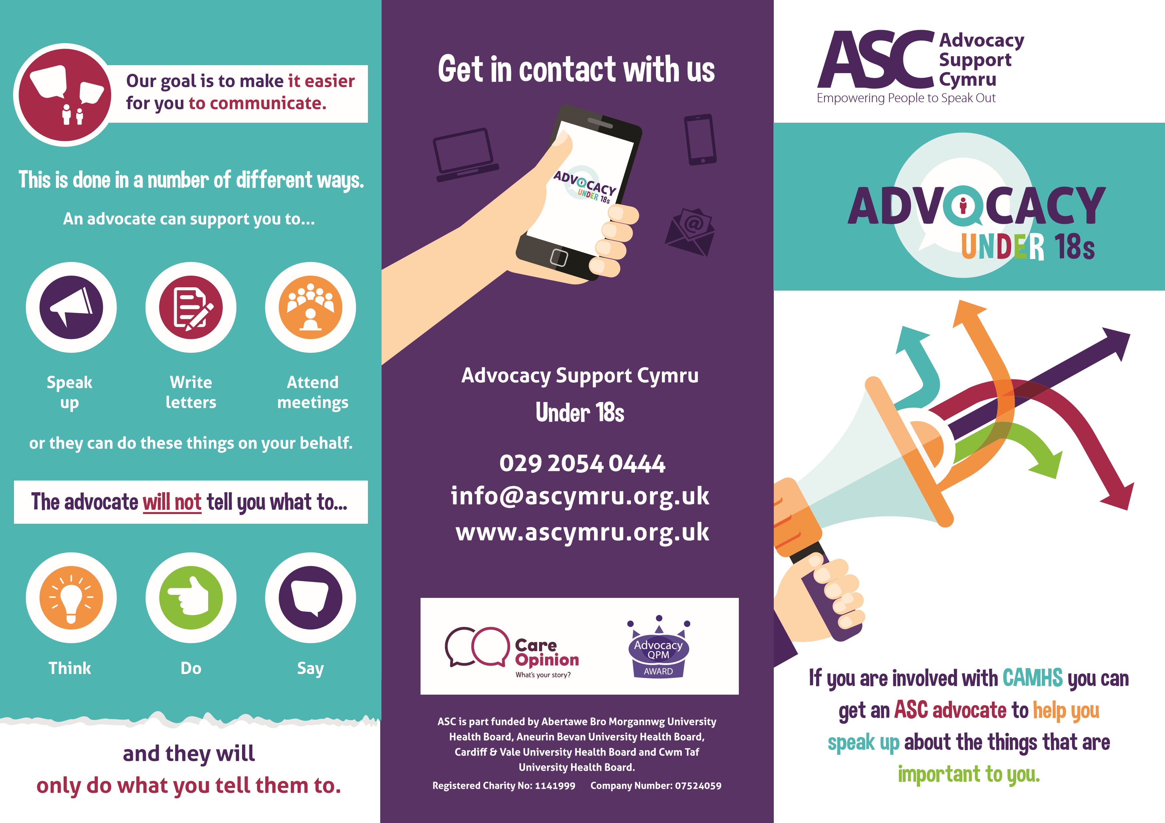
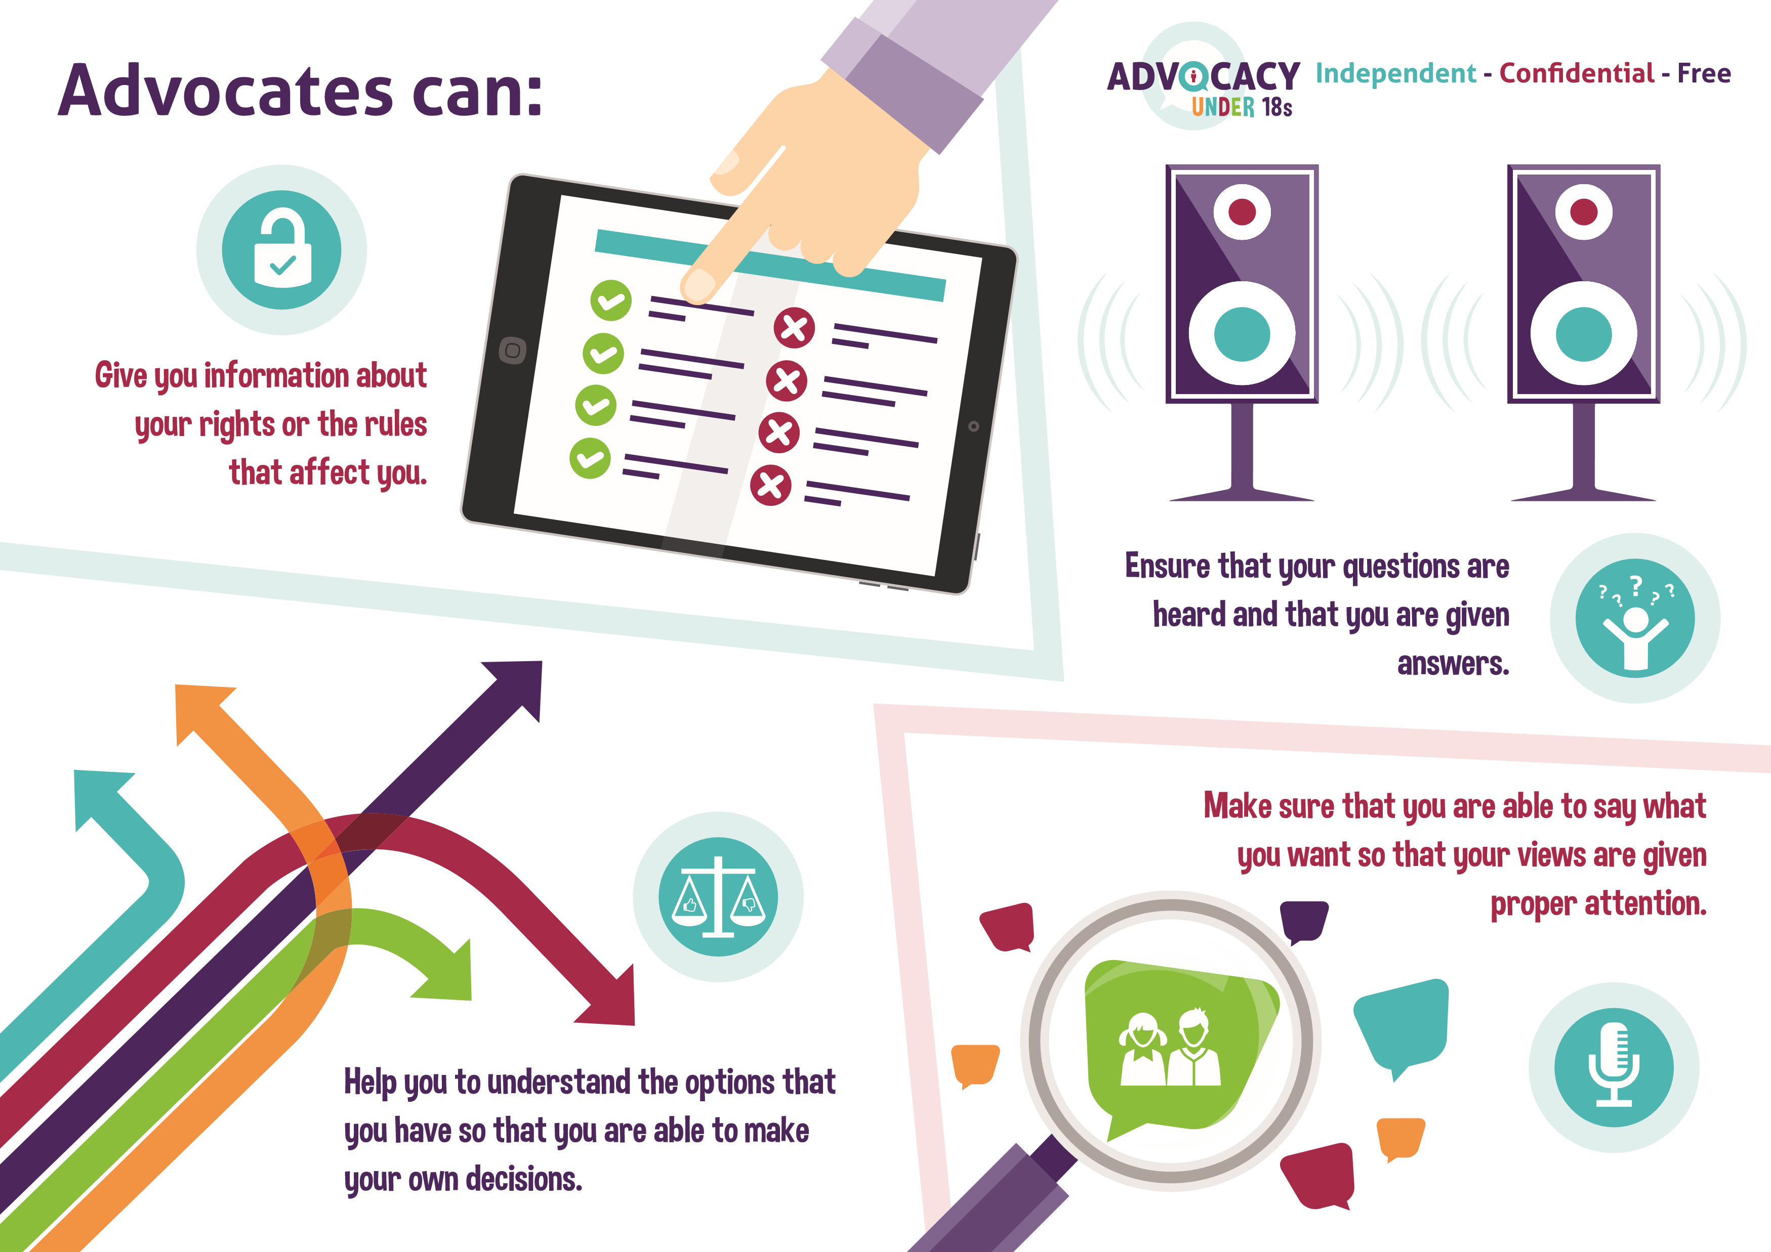
Appendix 1: Advocacy Support Cymru leaflet

