  Component One:  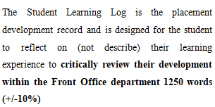 | Student No: | 2025111
 | Module Title: | Hotel Placement – Managing Hotel Administration
 | Module Code: | BMIH6004
 | Lecturer: | Lisa-Marie Bassler
The journey that I have completed in a dynamic part of food and beverage service at Delta Hotels by Marriott Nottingham Belfry has been a transformational and lifelong experience for me. In this report, I have reflected on the complexity of table drying cutlery service and the key skills that are required for that. Here I have used the Gibbs Model to analyze, appraise, and draw the multi-dimensional aspect of the journey (Akyazi et al, 2020).

Figure: Logo of the organization (Foris et al, 2020).

Discovering the Skills Critical to critically review their development within the Front Office department
As I was working in “Delta Hotels by Marriott Nottingham Belfry”, I embarked on a new journey in life. I have discovered several skills which are important in food and beverage service especially in table service, drying the cutlery part. Now I will describe the skills that I deemed to be important while working in table service and drying cutlery (Espellita et al, 2019).
Precision
Precision is one of the key skills that one must have while working on table service and drying cutlery. I only did food and beverage (table service, drying cutlery), I haven't been to the front desk and housekeeping department only one day during my placement. I have experienced while working at "Delta Hotels” that from arranging cutlery to setting glasses impacts overall customer experiences as it makes dining more appealing. The precision also impacts drying cutlery as all the utensils to plates need to be managed separately with precision (Tsui et al, 2020).
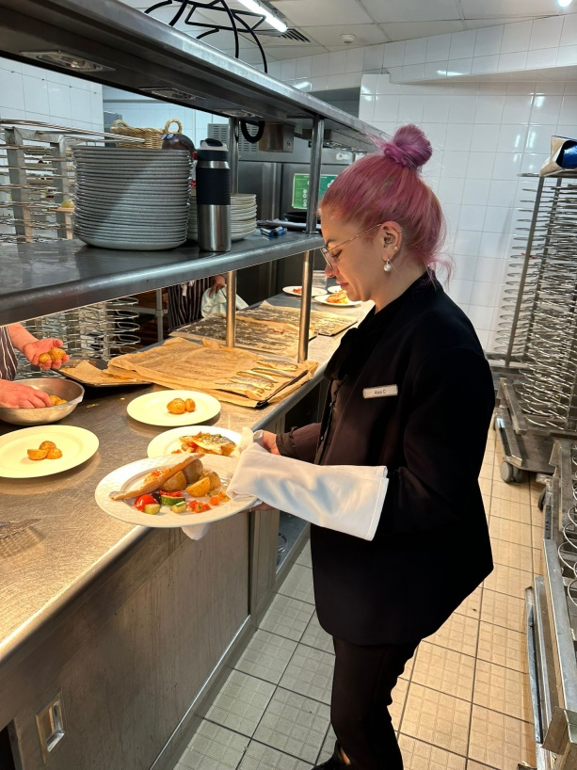

Efficiency
Another that I experienced that was very important is efficiency. I have seen while it was peak hours everybody needed to work at a fast pace and in sync. While working in Delta Hotels by Marriott Nottingham Belfry I have experienced that it is very much important to rationalize processes and prioritise tasks, need the right maître d’hôtel to give the right directions, for smoother service. This also helps a customer have speedy and attentive care (Walker, 2021).
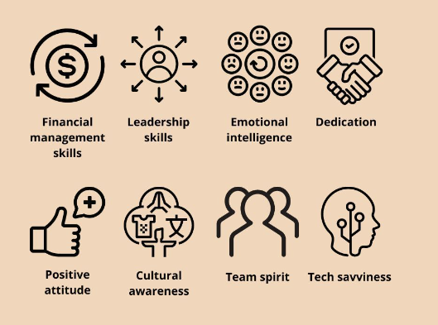
Figure: Skills (Tsui et al, 2020).
Flexibility
There are many unpredictable circumstances in the hospitality landscape and from what I have seen in "Delta Hotels by Marriott Nottingham Belfry”, flexibility is a key skill to manage those situations. One may need to adapt to special guests, many guests in a short time, unforeseen challenges and a flexible mindset can guide through it. Managing staff absences. This skill has helped me in many unexpected circumstances to keep my composure as well as give exceptional service (Foris et al, 2020).
Effective communication- Communication with other workers and customers is deemed to be a key element in having success in the hospitality business. I have experienced while working at "Delta Hotels” that from arranging cutlery to setting glasses impacts overall customer experiences as it makes dining more appealing. I have seen that clear and concise communication with the service team was essential, especially in busy times as it helped in providing flawless service. Lucky enough, during my placement, I manage to attend the last wedding of the year, it was a good source of accumulating experience for this type of service. I also experienced having proper communication with customers helped in understanding their preferences and concerns which helped in providing personalised and memorable service (Tsui et al, 2020).
Team collaboration
In the hospitality area, it is impossible to gain success without having proper collaboration from every person, team, and department. It is one of the key skills that one must have while working on table service and drying cutlery. The one day I covered the housekeeping sector, understood after five team members called in sick, the impact of having a good team collaboration is important. Two of the HK Supervisors and I manage to clean 68 room together. I realised success depends on the collective efforts of all team members that emphasised the importance of team collaboration. As I was working with colleagues from different departments it created a sense of unity and provided efficiency in whole operations (Foris et al, 2020).

Reflecting on the food and beverage service (table service, drying cutlery) Utilizing the Gibbs Model
Gibbs' Reflective Cycle is a structured model that helps stimulate a deeper understanding and examination of one's experience in a certain course of time. As I have applied this model it reflects learning, challenges as well as personal growth while working in food and beverage service, especially in table service, and drying cutlery.
Description
As I was working on “Delta Hotels” my work involved much activity regarding food and beverage service focusing on table service, and drying cutlery. One busy shift I helped other team members serving the drinks behind the bar. It was only for 30 min, but I understood how busy can be during events, and how important is for the manager when creating the rotas. Having the fully trained teams at the right department. It involved properly arranging the tables, precisely serving the guests, efficiently drying the cutlery and so on. The journey overall was very dynamic and needed overall excellence (Teng et al, 2021).

Feelings
I had some mixed feelings as I was working in such an arrangement which included excitement, nervousness, and disappointment. The hotel had high standards that created some pressure but it also gave me space to grow. The dynamic and fast-changing field made me excited as well as anxious at times. I was disappointed as there was a remark about my pink hair and everyone was present and I think they need to focus was staff training as it was unprofessional. As a solution, I will try to consider workplace has a dress code or appearance policy, as is such a strong request from Delta company to assure the message is understood by all new team members and students placement. As new manager, I will do my best not to make anyone feel the same way I felt, even for different scenarios cases. This could be explained in a private meeting or one to one meeting. (Koukpaki et al, 2020).
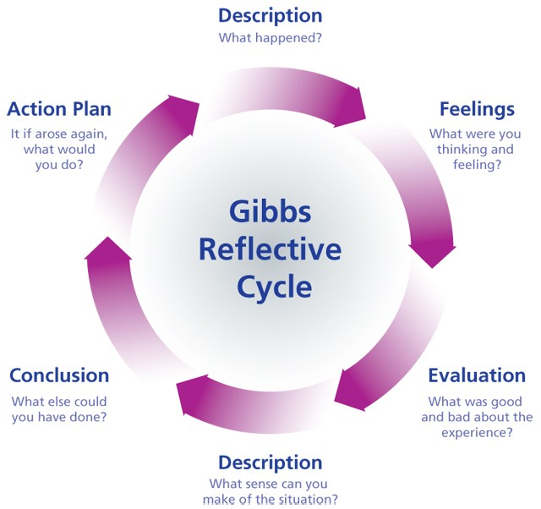
Figure: Gibbs Reflective Cycle (Teng et al, 2021)
Evaluation
Where I worked needed precision, the right way of setting tables and focusing on hygiene, was truly remarkable. I experienced that was very important is efficiency. I have seen while it was peak hours everybody needed to work at a fast pace and in sync. As the hotel believes in excellence it created a path for my continuous growth. But I faced difficulty in maintaining efficiency for the busy hours, because of the fast-paced nature of the organization (Gebbels et al, 2020).

Analysis
The analysis phase of this model helped me understand the key skills that are required in food and beverage service and for my further growth in the field. Skills like precision, team collaboration, communication, flexibility and efficiency are crucial for one's growth. The ability to adapt to the situation, precisely providing service with collaboration and effective communication is needed to better food and beverage service especially in table service and drying cutlery (Koukpaki et al, 2020)
Conclusion
If I reflect on my experience while working in food and beverage service (table service, drying cutlery), there’s no doubt it’s a multidimensional domain that requires a set of diverse skills. The field in which I worked is not just about providing food to guests but rather creating a memorable and personalised experience. And to create such satisfaction it's important to have a well-set table and seamless coordination of cutlery to the overall dining experience (Adeani et al, 2020).
Action Plan-My plan is to further my skills in precision and flexibility to overcome unexpected situations. I also will focus on my time management skills along with enhancing my efficiency. I changed my pink hair, to comply with company guidelines. This also helps a customer have speedy and attentive care. As I have seen the power of efficient communication I want to further my expertise in that field to handle and collaborate with my team members and customers (Gebbels et al, 2020).
As I reflect on my journey working in the food and beverage service significantly I have come to know the importance of skills precision, flexibility, efficiency, collaboration, communication, etc. to enhance guest experience. It is important to rationalize processes and prioritise tasks for smoother service.

This experience not only helped in my professional knowledge and growth but also committed me to continuous improvement. As I reflected on using gives model I have found that this learning will surely improve my approach and increase my dedication to improvement in such a field (Marneros et al, 2021).

References
Adeani, I.S., Febriani, R.B. and Syafryadin, S., (2020). Using GIBBS’reflective cycle in making reflections of literary analysis. Indonesian EFL Journal, 6(2), pp.139-148.
Akyazi, T., Goti, A., Oyarbide, A., Alberdi, E. and Bayon, F., (2020). A guide for the food industry to meet the future skills requirements emerging with industry 4.0. Foods, 9(4), p.492.
Espellita, Simplicio, and Vicente S. Maravilla Jr. "Employable skills for hospitality graduates as perceived among hotel supervisors in Cebu City." Journal of Economics and Business 2, no. 2 (2019).
Foris, D., Crihalmean, N. and Foris, T., (2020). Exploring the environmental practices in hospitality through booking websites and online tourist reviews. Sustainability, 12(24), p.10282.
Gebbels, M., Gao, X. and Cai, W., (2020). Let’s not just “talk” about it: reflections on women’s career development in hospitality. International Journal of Contemporary Hospitality Management, 32(11), pp.3623-3643.
Koukpaki, A.S.F. and Adams, K., (2020). Enhancing professional growth and the learning and development function through reflective practices: an autoethnographic narrative approach. European Journal of Training and Development, 44(8/9), pp.805-827.Kumar
Marneros, S., Papageorgiou, G. and Efstathiades, A., (2021). Examining the core competencies for success in the hotel industry: The case of Cyprus. Journal of Hospitality, Leisure, Sport & Tourism Education, 28, p.100303.
Teng, C.C. and Cheng, S.S., (2021). Hospitality ethics: Perspectives from hotel practitioners and intern students. Journal of Hospitality & Tourism Education, 33(2), pp.99-110.
Tsui, P.L. and Chen, Y.C., (2020). Sustainable development of hotel food and beverage service training: Learning satisfaction with the situated cognitive apprenticeship approach. Sustainability, 12(5), p.1951.
Walker, J.R., (2021). The restaurant: from concept to operation. John Wiley & Sons.

