

Student name: NGOZI JULIANA IGWEANYA
Student ID: 25114990
Module name: INTRODUCTION OF HEALTH AND SOCIAL CARE
Module code: LCHS003
Lecturer name: HEPHERD ZIKO

Content page
Title page……………………………………………………………. page2
Content page………………………………………………………… Page1
Poster ……………………………………………………………...... Page3
Element 2 ………………………………………………………….... Page4
Significance in Enhancing Quality of Life……………………… page5
Conclusion …………………………………………………………. page6
References …………………………………………………………. Page7

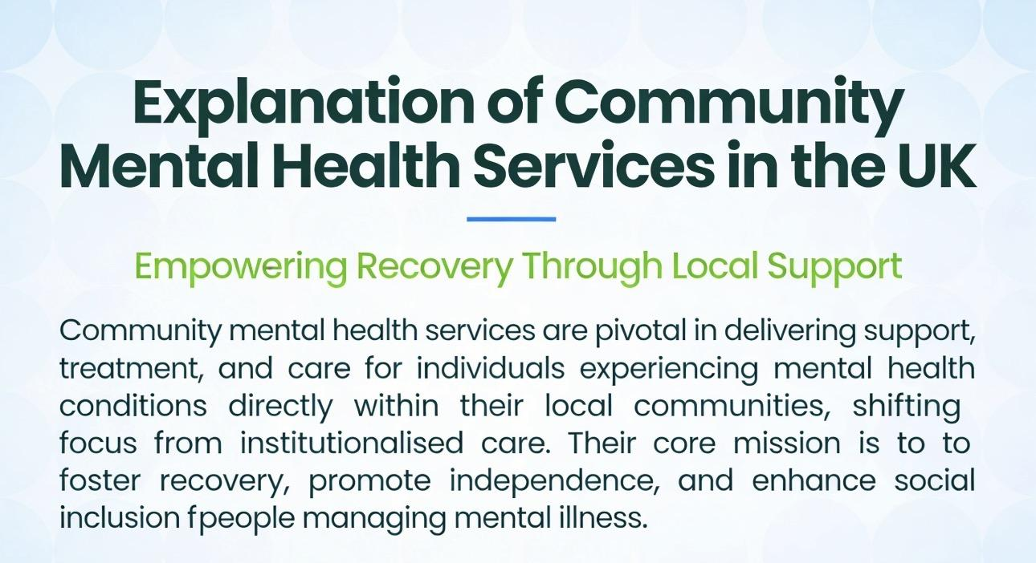
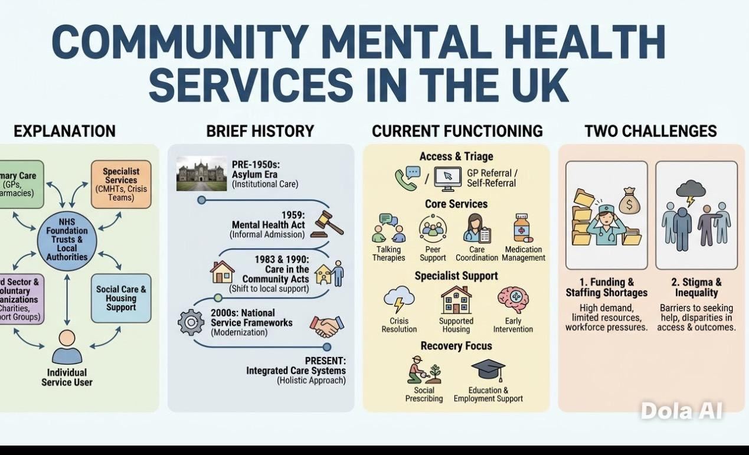
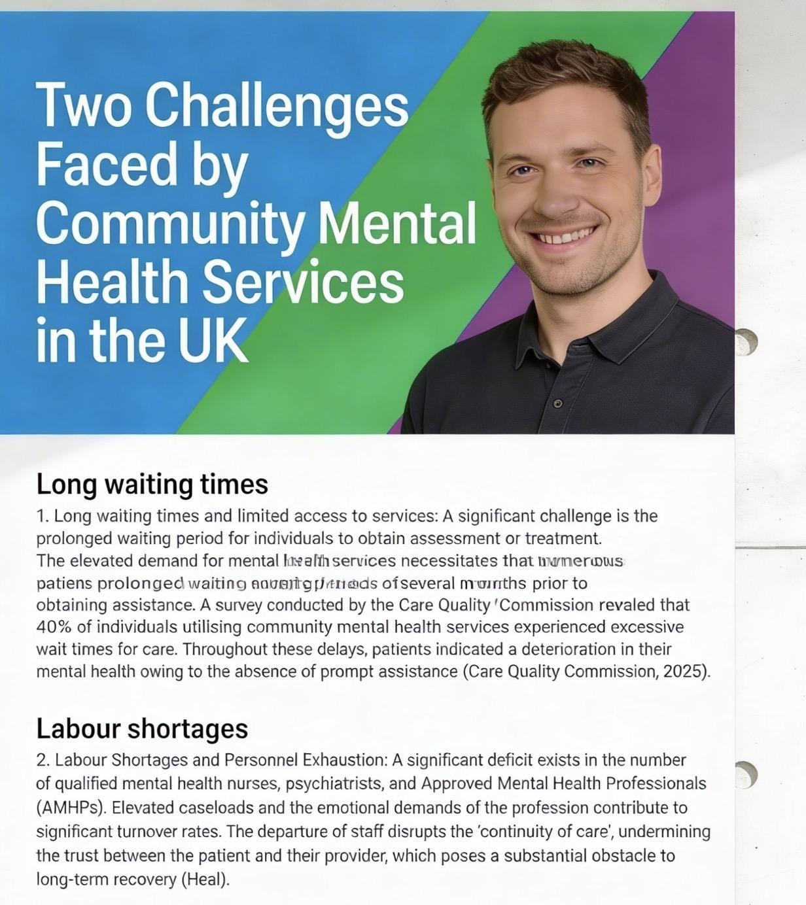
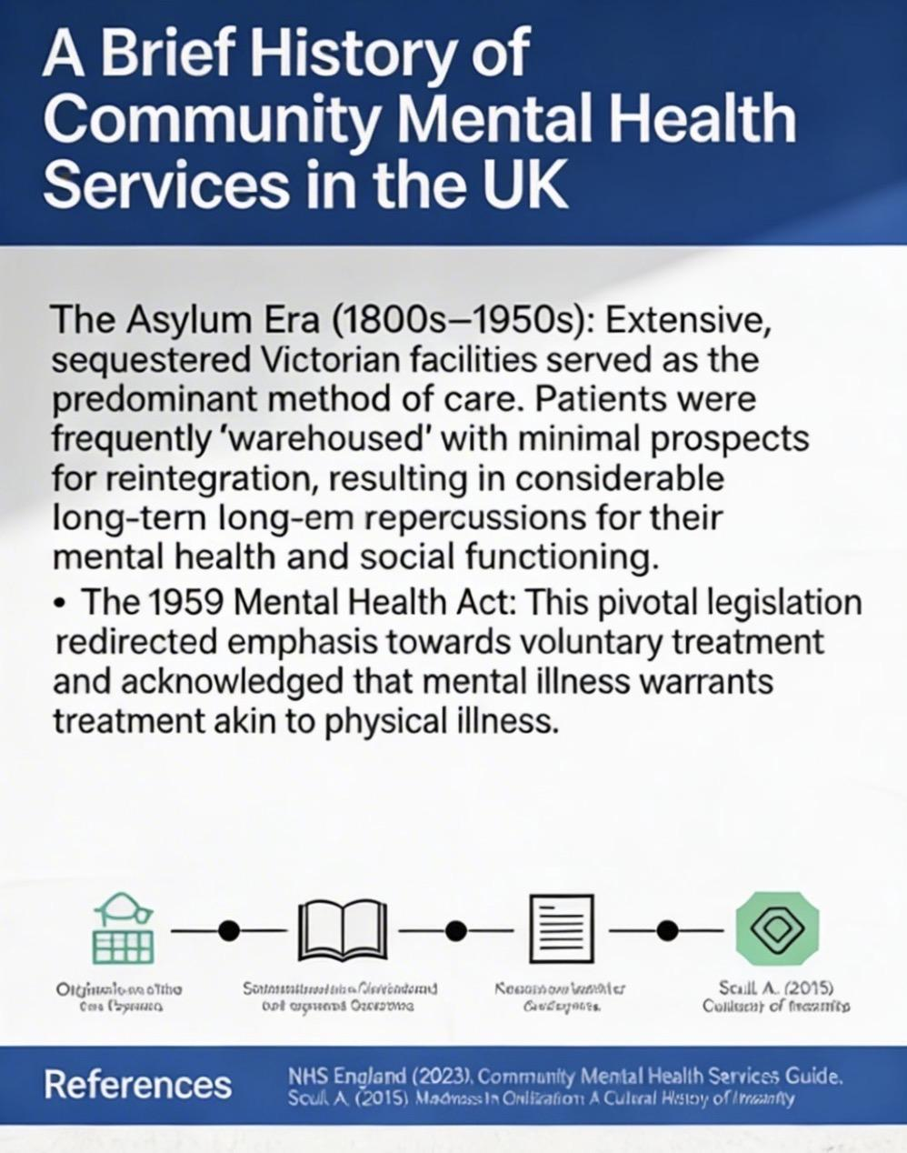
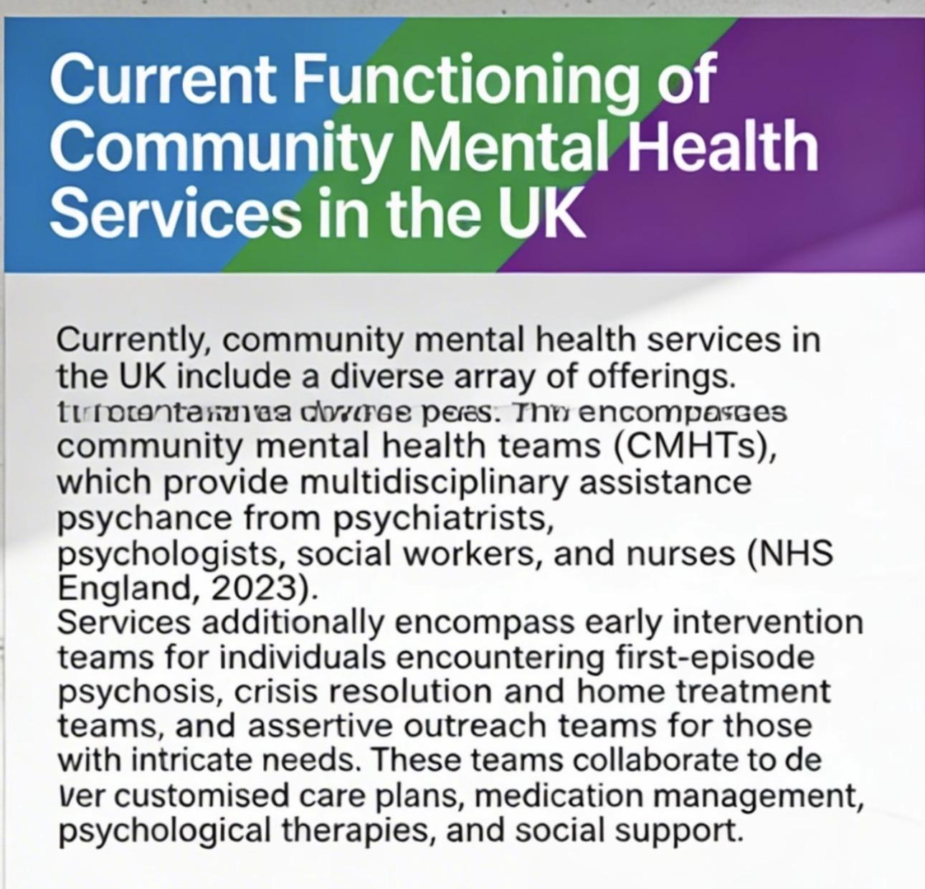
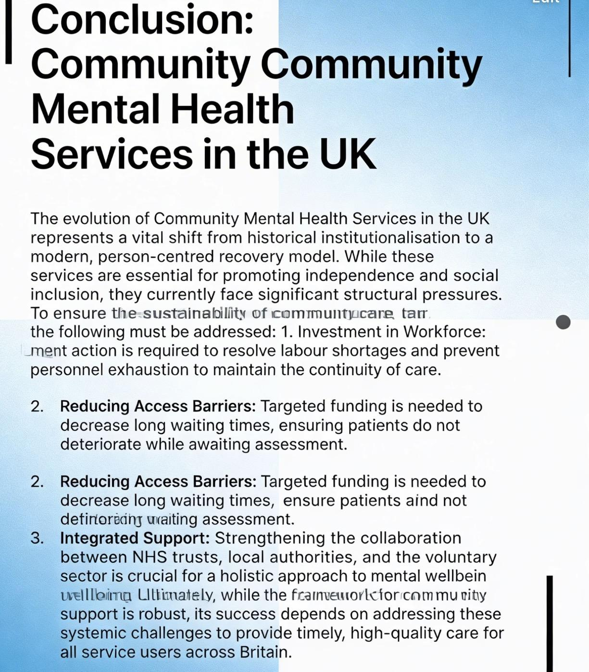
COMMUNITY MENTAL HEALTH SERVICES IN THE UK
Student Name: NGOZI JULIANA IGWEANYA
Course Name: INTRODUCTION OF HEALTH AND SOCIAL CARA

Section Head Here
Text or images here

Element 2
The Evolution and Impact of Community Antenatal Midwifery Services
Introduction
Community antenatal midwifery services are essential in assisting pregnant women prior to childbirth. These services are administered by qualified midwives who offer care, supervision, and counsel during pregnancy. The objective of antenatal care is to enhance the health and welfare of both the mother and the foetus. Community antenatal midwifery services have evolved over time in response to transformations in healthcare systems, advancements in medical knowledge, and shifts in public health policies. This essay examines the origins and historical evolution of community antenatal midwifery services, assesses their current operations, and analyses their significance in enhancing the quality of life for service users.

Historical Origins and Context
The origins of community midwifery are grounded in the "handywoman" tradition, wherein skilled local women delivered maternal care prior to the professionalisation of medicine. The Midwives Act 1902 in the United Kingdom represented a significant transformation, formalising midwifery as a regulated profession and acknowledging the value of community-based care (Carlyle, 2020). During the mid-20th century, the emergence of the National Health Service (NHS) further consolidated these services. The most notable contemporary transformation occurred after the "Changing Childbirth" report (1993), which underscored the importance of woman-centred care and the need for services to be offered in accessible, non-clinical environments to mitigate the "medicalisation" of standard pregnancy (NHS, 1993).

Contemporary Function and Evaluation
These days, community prenatal services operate using a multidisciplinary approach and are frequently found in GP offices, children's centres, or through home visits. These services are intended to offer continuous care, a model that has been demonstrated to enhance maternal satisfaction and clinical outcomes. Comprehensive screening, health education, and mental health monitoring are all part of modern practice.
Critically, despite the model's high theoretical effectiveness, it still has problems today. Due to frequent staffing shortages, the NHS finds it challenging to maintain "continuous" service. Accordingly, a pregnant woman may see multiple midwives (Royal College of Midwives, 2023). Additionally, even though digital health records have made communication easier, they can occasionally obstruct the intimate, in-person relationship that characterises community midwifery, which is crucial for fostering rapport and trust between midwives and the families they assist. Despite these obstacles, the move to "hubs" has effectively combined midwifery and social services, offering vulnerable families a comprehensive safety net.
Significance in Enhancing Quality of Life
The capacity of community-based midwifery to empower clients is what makes it so important. According to Sandall et al. (2016), midwives can establish a rapport with women by providing care in a familiar setting, which encourages them to disclose sensitive issues like anxiety or domestic abuse that might be overlooked in a busy hospital setting. Expectant mothers' psychological quality of life is greatly improved by this trust, which lowers stress and boosts confidence as they adjust to parenthood.

Furthermore, community services are essential in mitigating health disparities. By maintaining physical accessibility, they facilitate attendance at regular check-ups for women from lower socioeconomic backgrounds or those with restricted transportation options. This proactive surveillance facilitates the early identification of complications, such as pre-eclampsia or gestational diabetes, thereby enhancing health outcomes for both mother and infant.

Conclusion
In conclusion, community antenatal midwifery services have evolved from informal social support to a refined, professional component of contemporary healthcare. By integrating historical midwifery practices with modern clinical evidence, these services establish a crucial connection between the hospital and the home. Their principal importance resides in their capacity to humanise the clinical process, guaranteeing that care is accessible, equitable, and focused on the woman's individual needs. By prioritizing the psychological and physical well-being of mothers within their communities, their services not only manage pregnancy but also empower families and enhance long-term public health outcomes.
References
1. Department of Health. (2011). No health without mental health: A cross-government mental health outcomes strategy for people of all ages. The Stationery Office.

2. Carlyle, R. (2020). The History of Midwifery Regulation. London: Health Press.

3. Gibb, F. (2022) 120 years of the Midwives Act in England and Wales. Royal College of Midwives (RCM). Available at: https://rcm.org.uk/blog/2022/07/120-years-of-the-midwives-act-in-england-and-wales/ (Accessed: 27 February 2026).

4. Health and Social Care Act 2012. (2012). London: The Stationery Office. (This Act significantly shaped the structure of the NHS and social care in England).

5.Mental Health Act 1983 (and subsequent amendments). (Various years). London: The Stationery Office. (Provides the legal framework for mental health treatment in England and Wales).

6. NHS Providers (2025) Tackling inequalities in maternity care: Continuity of carer. Available at: https://nhsproviders.org/resources/bold-action-tackling-inequalities-in-maternity-care/2-continuity-of-carer (Accessed: 27 February 2026).

7. NHS England. (2019). The NHS Long Term Plan. Available at: www.longtermplan.nhs.uk (Outlines commitments to mental health services, including CMHS, and future funding).

8. Royal College of Midwives (2023). State of Maternity Services Report. [Online].

9. Royal College of Psychiatrists. (2018). Old problems, new solutions: improving the quality of mental health services in England. Available at: www.rcpsych.ac.uk (Offers insights into challenges and potential solutions for mental health services).

10. Reed, B. and Edwards, N. (2025) The Rise and Fall of the Albany Midwifery Practice (London 1997-2009). Maternity & Midwifery Forum. Available at: https://maternityandmidwifery.co.uk/the-rise-and-fall-of-the-albany-midwifery-practice-london-1997-2009/ (Accessed: 27 February 2026).

11. Sandall, J., Soltani, H., Gates, S., Shennan, A., and Devane, D. (2016). Midwife-led continuity models versus other models of care for childbearing women. Cochrane Database of Systematic Reviews.

12. World Health Organization (WHO). (2001). World Health Report 2001: Mental Health: New Understanding, New Hope. WHO. (Historically important document advocating for community mental health).

