

University of Wales Trinity Saint David

School of Engineering

Manufacturing Systems

Six Sigma Green Belt

Undertaking a Green Belt Project AMCB5005

Joseph Lancastle
2214707
29th April 2024

Word Count: 2889
Adjusted Word Count: 4930
Contents
List of Figures 4
Introduction 5
Define 6
Project Charter 6
Voice of the Customer/Critical to Quality 10
Stakeholder Analysis 11
Measure 13
Data Collection Plan 14
Collected Data 15
Camera Subassembly 15
Instrument Test 15
Historical Scrap Data Collection 16
Measurement System Analysis 17
Analyse 18
Normality Anderson Darling Tests 18
Process Capability Analysis (CPK) 19
Subassembly Timings 19
Test Downtime 21
Control Charts 22
Subassembly Timings 22
Test Downtime 23
23
Camera Rejects 24
Pareto 24
Improve 26
Generating Improvement Alternatives 26
Ishikawa Analysis 27
PFMEA 28
Ishikawa/PFMEA Analysis 29
Value Stream Mapping 30
Current State Future State 30
Improvement Opportunities 31
1 Reduce Subjectivity 31
2 Improve Subassembly Procedure 32
3 Improve Test Procedure 33
4 Remove Cardboard 33
5 5S Areas 34
6 Check Incoming Stock 35
7 Review Tooling 35
Control 36
Prevention 36
Detection 39
Cost-Benefit Analysis 40
Control Plan 41
Future Recommendations 42
References 43
Appendices 45
Appendix A 45
Appendix B 46
Appendix C 48
Appendix D 52

List of Figures
Figure 1: Project Charter 1/3 7
Figure 2: Project Charter 2/3 8
Figure 3: Project Charter 3/3 9
Figure 4: Normal Probability Plot for Subassembly Timings 18
Figure 5: Normal Probability Plot for Testing Downtime 18
Figure 6: Capability Analysis of Subassembly Timings 1 19
Figure 7:Capability Analysis of Subassembly Timings 2 20
Figure 8: Capability Analysis of Test Downtime 21
Figure 9: X Chart for Subassembly Timings 22
Figure 10: mR Chart for Subassembly Timings 22
Figure 11: X Chart for Test Downtime 23
Figure 12: mR Chart for Test Downtime 23
Figure 13: Defects Pareto for Camera Rejects 24
Figure 14: Variable Defects Pareto for Camera Rejects 24
Figure 15: Camera Rejects Variable as Supplied 25
Figure 16: Camera Rejects Variable in House 25
Figure 17: Ishikawa Analysis 27
Figure 18: Ishikawa/PFMEA Analysis 29
Figure 19: Current State Process Map 30
Figure 20: Future State Process Map 30
Figure 21: Camera Contamination Example 31
Figure 22: Technician Presenting Open Camera Lens Outside of Laminar Flow Cabinet 32
Figure 23: Technician Unboxing Camera on Workbench 33
Figure 24: Untidy Laminar Flow Cabinet 34
Figure 25: Dirty Laminar Flow Cabinet Filter 34
Figure 26: Damaged Coating on Camera Thread Reducer 35
Figure 27: Maintained Laminar Flow Cabinet 37
Figure 28: Weekly Technician Check Sheet 37
Figure 29: Stereomicroscope 38
Figure 30: Rubber Tipped Forceps (Buy Beadsmith Haemostats Clamp Coated Jaw, 2023) 38
Figure 31: Old Tightening Tool 39
Figure 32: Redesigned Tightening Tool 39
Figure 33: Positive Pressure Room Proposal 42
Figure 34: Individual Charts Constants (Tables of constants for Control Charts, No Date) 45
Figure 35: Severity Rankings (Ghasemian & Zeeshan, 2017) 46
Figure 36: Occurence Rankings (Ghasemian & Zeeshan, 2017) 46
Figure 37: Detection Rankings (Ghasemian & Zeeshan, 2017) 47
Figure 38: Laminar Flow Quotation 52

Introduction

The company in question manufacture instruments in the drug discovery pathway. The first step in this pathway is to use microplate readers, used to detect the concentration of a certain compound in a sample. Light is passed through the sample containing a drug and the amount of light absorbed indicates the concentration of the compound in the sample. The next stage is to use Live Cell Imaging equipment to observe the interaction between drug and pathogen.
This project focusses on the Live Cell Imaging instrument, where contamination of the imaging camera represents a risk to the customer from poor image quality and incurs a significant amount of downtime from cleaning operations on site. Using the DMAIC process improvement methodology, the objective of this project is to reduce camera contamination and its associated downtime.

Define

Project Charter

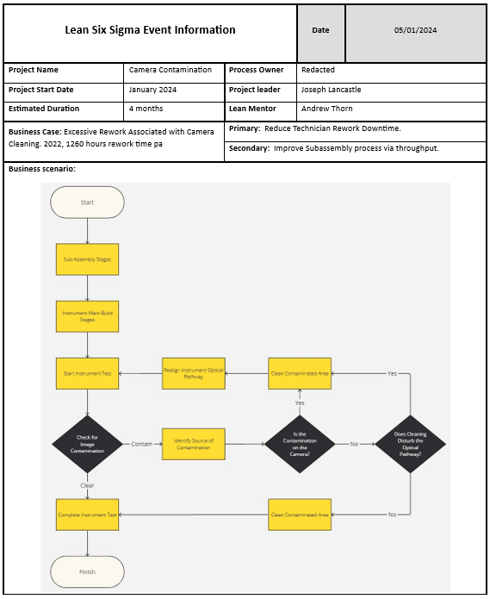
Figure 1: Project Charter 1/3
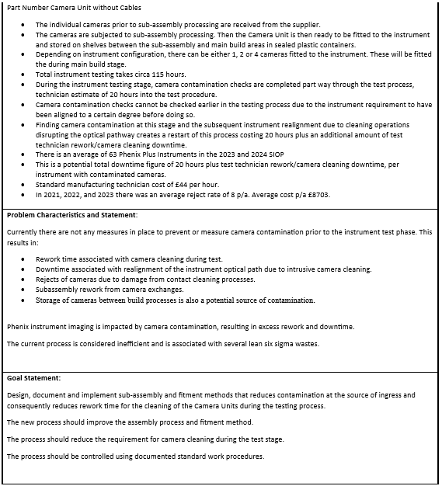
Figure 2: Project Charter 2/3
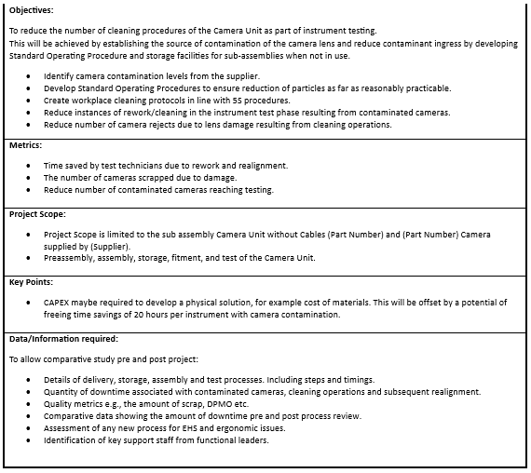
Figure 3: Project Charter 3/3

Voice of the Customer/Critical to Quality

Table 1: Voice of the Customer/Critical to Quality

Stakeholder Analysis

Table 2: Stakeholder Analysis

Measure
An effective sampling plan will ensure that there are repeatable metrics to compare the results of implemented measures to the original benchmark. Based on the Process Flow Roadmap and Stakeholder Analysis meetings, the Subassembly and Instrument Test phase were defined as areas of importance. This is due to the Cameras being built and sealed in the subassembly phase, meaning that the risk of contamination is likely induced at that point.
The data type for the camera subassembly timings is continuous and quantitative due to it being related to time and can be counted and not in whole integers. The test phase downtime is Binomial, discrete, and quantitative. I.e., it has a pass-fail specification of if there is contamination present or not. Camera contamination rework downtime is also included to capture the extent of the failures and adds a layer to investigate should a 0% First Time Through rate (FTT) occur.
To establish the sampling quantity, Bayes Success Run Theorem was employed with a confidence and reliability level of 80% selected. This was deemed appropriate as the risk of the data being inaccurate, carries a relatively small risk as the consequence of inaccuracies is the timing data being askew. There is no increased risk of the customer as the existing methodology for finding and rejecting cameras due to contamination is robust.
Where:
ln = natural log
n = Sample size
C = Confidence level
R = Reliability
$$n=\frac{ln⁡(1-C)}{ln⁡(R)}$$
$$n=\frac{ln⁡(1-0.8)}{ln⁡(0.8)}$$
$$n=7.21$$

Using the sample size equation above (Durivage, 2016), the figure should always be rounded up to the nearest whole integer (Luko, 1997). Resulting in a sample size of 8, a feasible timeframe-based instrument production throughput.
Subassembly timings will be taken from fixed points to minimise measurement variation. Instrument contamination during the test phase will be measured by the Technicians using the Quality, Cost, and Delivery (QCD) downtime tracker. To minimise measurement variation, the technicians were informed of the fixed points in which their timing measurements should be taken to ensure data reliability.

Data Collection Plan
- Subassembly
- The time taken to assemble one camera unit.
- Frame assembly is collected, 45-degree angle block is removed, and mirror is glued to the block (24-hour cure). Once cured, assembly is built then stored in its location in a sealed, plastic box and backflushed.
- Define start/finish for data collection (SOP). Operator training conducted.
- Start time - from the point of materials arriving to technician after mirror gluing and curing time.
- Finish time - Once complete, boxed assembly on shelf and backflushed.
- Sampling plan = 8
- Bayes Success Run Theorem N = 8, 80% reliability and 80% confidence that the results are correct.
- Instrument Test
- The time taken to remove contamination from camera(s) after first detection.
- Instrument is received by test technician; they start instrument test, check for image contamination, contamination is found, source of contamination identified, cameras cleaned, the instrument optical pathway is realigned, and instrument test procedure can be restarted.
- Define start/finish for data collection (SOP). Operator training conducted.
- Start time – When the source of contamination is identified as the camera(s)
- Finish time – Once the technician is ready to re-start instrument test after realignment of instrument optical pathway.
- Sampling plan = 8
- Bayes Success Run Theorem N = 8, 80% reliability and 80% confidence that the results are correct.

Collected Data

Camera Subassembly
Table 3: Camera Subassembly Timings
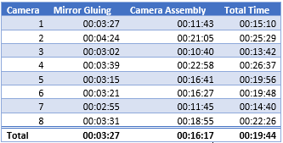

Instrument Test
Table 4: Instrument Test Downtime

Historical Scrap Data Collection

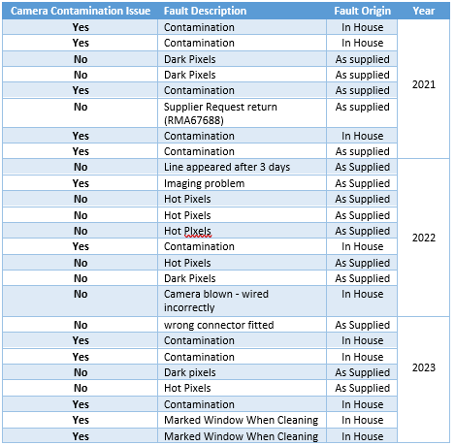
Historical scrap data also had to be recorded. As it cannot be planned for when camera rejects will occur, a data collection plan cannot be produced Therefore, historical scrap data from 2021-2023 was compiled to gather the reject data.
Table 5: Camera Rejects

Measurement System Analysis

A Measurement System Analysis (MSA) can be undertaken to ensure the methods used for gathering data are suitable. A Kappa is used to evaluate attribute, pass/fail type data, requiring a minimum of 40 sample items Maxey et al. (2004). As there was 0% First Time Through (FTT), the data types are not applicable to this method.
A Gauge R&R (Repeatability and Reproducibility) study is used for continuous data. However, this methodology suits larger sample sizes and is typically used to compare results with different variables applied. Such as, the environment and operators. Since the purpose of this project is to establish the extent of the effect of contamination in terms of downtime, a Gauge R&R does not apply.

Analyse

Normality Anderson Darling Tests
The timings indicate a normal distribution of results as the p value is greater than 0.05. Identifying the data’s Normality type, shows what statistical analysis tools are used as they will differ if the distribution is normal or not normal.
Figure 4: Normal Probability Plot for Subassembly Timings
Figure 5: Normal Probability Plot for Testing Downtime

Process Capability Analysis (CPK)

Subassembly Timings
The CPK distribution’s nominal was selected from the manufacturing database routing time of 0.96 hours. A USL and LSL (Upper and Lower Specification Limits) were set at +/- 10 times the routing time resolution of 36 seconds.
Figure 6: Capability Analysis of Subassembly Timings 1

Using the routing timings as the nominal far exceeds the actual measured timings giving no process capability insight. A nominal was based on the mean of the measured timings with the same USL and LSL range.
Figure 7:Capability Analysis of Subassembly Timings 2

Test Downtime
Figure 8: Capability Analysis of Test Downtime

Control Charts

An X-mR chart was selected to visualise continuous, variable data over time from data sets with a subgroup size of 1. The Centre Line, UCL and LCL formulae and Shewhart’s constants that are dependent on the subgroup size were used, as in Appendix A. (Stamatis, 2003; Rahardja, 2014; Grey, 2019; Woolf et al., 2023)
The defined UCL and LCL for X̄-R charts are +/- 3σ from the centreline (Grey, 2019; Hessing, 2023). These were not utilised as a subgroup of 2 – 9 is required to calculate the range of each subgroup which is not applicable to the data collected.

Subassembly Timings
Figure 9: X Chart for Subassembly Timings
Figure 10: mR Chart for Subassembly Timings

It is expected to see narrower Specification Limits as they are user defined. Whereas the Control Limits are calculated from the chart’s data points. Using Control Charts highlight out of control processes by showing timings exceeding the Specified Limits or visible trends, characterised by seven consecutive points on the same side of the centre line or continuously moving positively or negatively (Kiemele et al., 2000). Although, such trends may only become apparent with continuous monitoring and a larger sample size.

Test Downtime
Figure 11: X Chart for Test Downtime
Figure 12: mR Chart for Test Downtime

Camera Rejects

Pareto
To visualise the reject data, a Pareto diagram was utilised to identify how many of the camera rejects are due to contamination.

Figure 13: Defects Pareto for Camera Rejects
The diagrams highlight that the highest frequency failure is contamination. Although, an oversight of the dataset is that: “Marked Window When Cleaning” is a cleaning measure due to contamination. Furthermore, the 8 contamination rejections do not show if the faults are internal or external failures. Therefore, a Variable Pareto diagram was also used to ascertain if rejects are internally or externally borne and who bears the financial onus of repairs.
Figure 14: Variable Defects Pareto for Camera Rejects
Figure 15: Camera Rejects Variable as Supplied
Figure 16: Camera Rejects Variable in House

Improve

Generating Improvement Alternatives

To generate methods on how to reduce camera contamination occurrences in the test phase, a Brainstorming session with the key stakeholders was conducted where the comments and observations were fed into an Ishikawa Analysis. The points gathered were fed into a Process Failure Mode Effect Analysis. The scoring based on guidance from Chin et al (2009) and Ravi Sankar and Prabhu (2001), Appendix B. For example, point 3 of the PFMEA relates to camera windows being scratched during cleaning, as there was a failure rate of 2 in 25, or 8% this returned an Occurrence score of 7.

Ishikawa Analysis

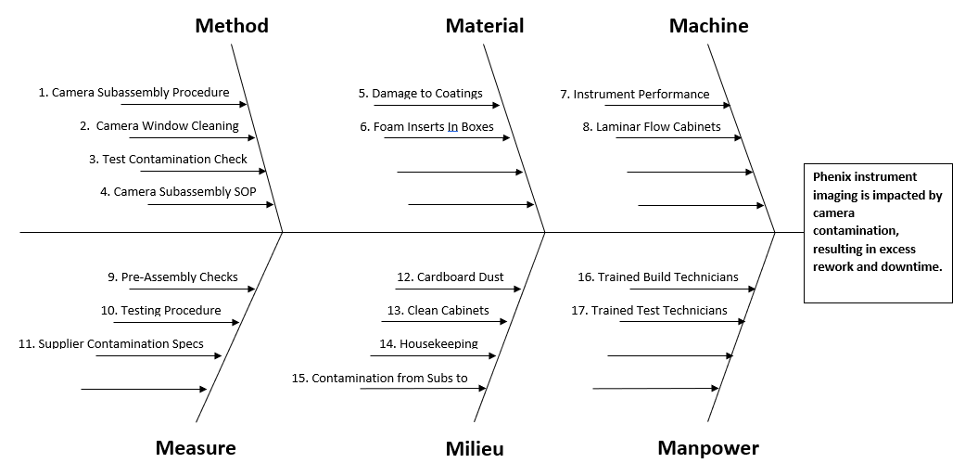
Figure 17: Ishikawa Analysis

PFMEA
Table 6: PFMEA

Ishikawa/PFMEA Analysis

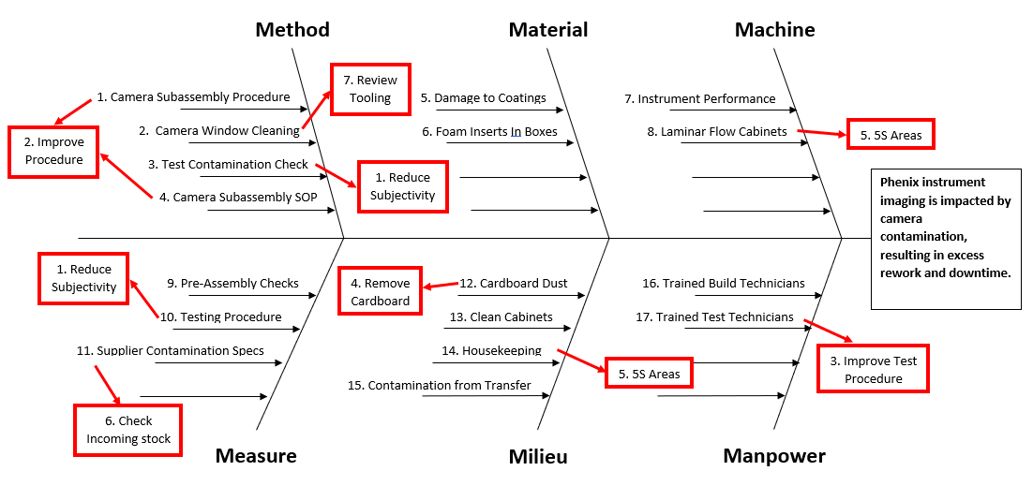
Figure 18: Ishikawa/PFMEA Analysis

Value Stream Mapping
Value Stream Mapping (VSM) is typically used in the Define phase for scoping a project. It can also be used during the Measure phase to outline the current and future state of processes. These maps will observe the increase in camera subassembly timings from process changes compared to the decrease in instrument test downtime. A SIPOC also provides an overview of a process, as the acronym suggests, Suppliers, Inputs, Process, Outputs and Customers (MacNeil, 2024). However, these methods are too meticulous for this project, requiring significant time investment. Furthermore, items such as Time (C/T), Setup Time (S/T) and Uptime required for a VSM (Nallusamy and Ahamed, 2017), were not measured or in the scope of the data collection plan. Therefore, a Current State and Future State Process Flow Map was produced to highlight process changes.

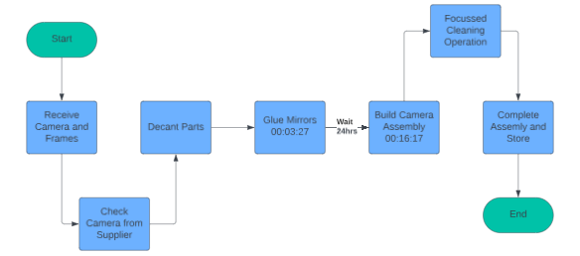
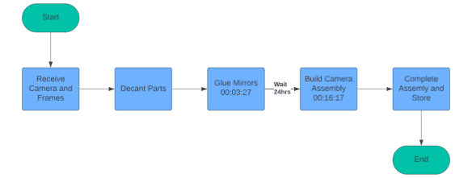
Current State
Future State
Figure 19: Current State Process Map
Figure 20: Future State Process Map

Improvement Opportunities

There were seven key points highlighted from the PFMEA and Ishikawa analysis to focus on:

1 Reduce Subjectivity
Missing contamination during testing poses a high risk to the customer, thus scored highly in the PFMEA. In Figure 21, the dark contamination circled in yellow is pronounced and seldom overlooked. However, this is less of a risk to the customer than the contamination circled orange which also fails specification and is in the Region of Interest (ROI) where the customer will conduct their imaging. This contamination type can be missed by using dirty computer monitors that hiding contamination or draw the eye to other areas of the image.
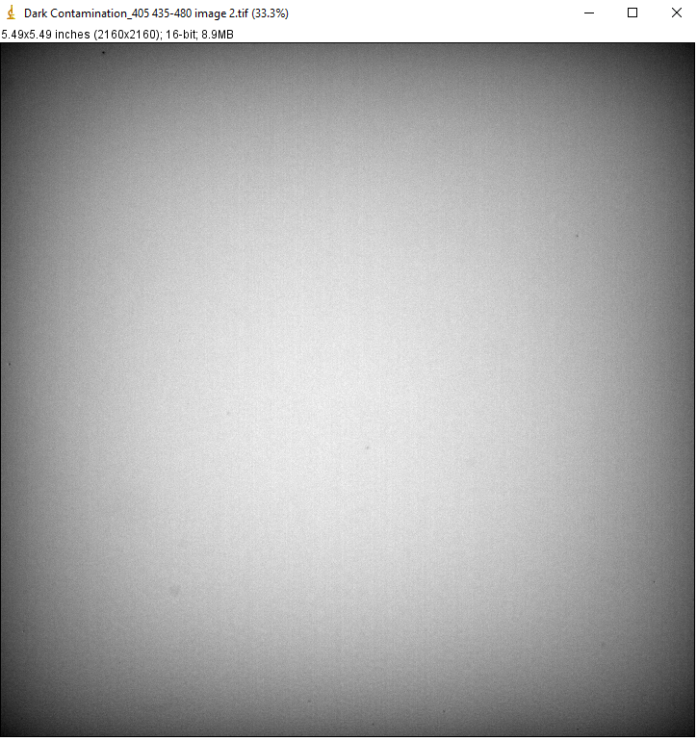
Figure 21: Camera Contamination Example

2 Improve Subassembly Procedure
Upon review and the results of the brainstorming sessions and observation of the camera subassembly procedure, the issues of note were:
- Technicians were not using the Laminar Flow cabinets during subassembly, Figure 22.
- The technician was not concentrating air dusting to the camera lens, the area of interest.
- There is no pre-subassembly check of the cameras for contamination.

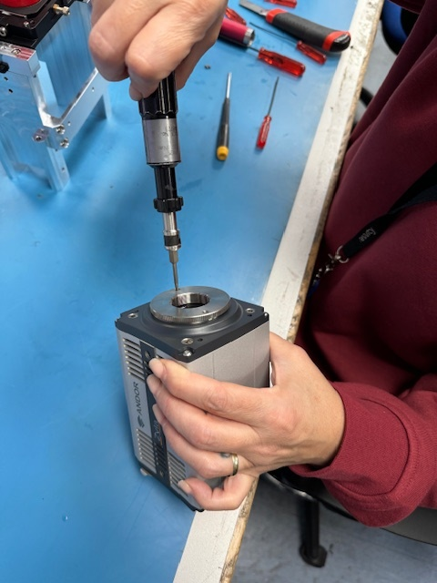
Figure 22: Technician Presenting Open Camera Lens Outside of Laminar Flow Cabinet

3 Improve Test Procedure
Reducing downtime from cleaning contaminated cameras, will be controlled at source during the subassembly procedure. Furthermore, the Reducing Subjectivity opportunity highlights a disparity in technician methods of contamination analysis, due to the variation in technician training

4 Remove Cardboard
Cardboard is a key contributor to dust particles in clean manufacturing environment (Munro, 2019; Berestina and Bakhvalov, 2021). The cameras were delivered lineside in cardboard boxes and decanted as in Figure 23.
To benchmark the extent of the issue, environmental particle counts were taken in key areas in the manufacturing area, shown in Appendix C.
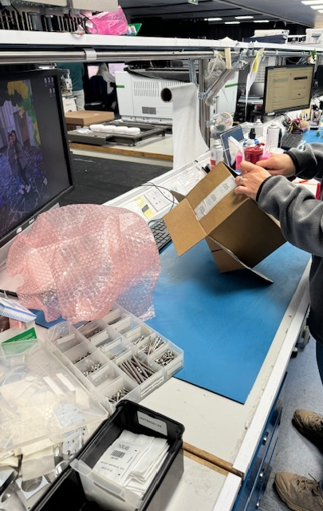
Figure 23: Technician Unboxing Camera on Workbench

5 5S Areas
Upon visual inspection, the Laminar Flow cabinet was unmaintained as in Figure 24, the air filter was caked in dust, Figure 25, and the build area was cluttered. A particle count test was conducted, that highlighted a failure.
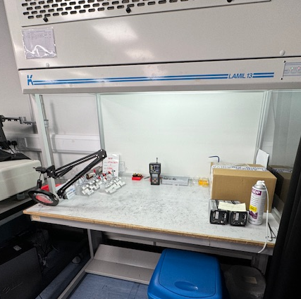
Figure 24: Untidy Laminar Flow Cabinet
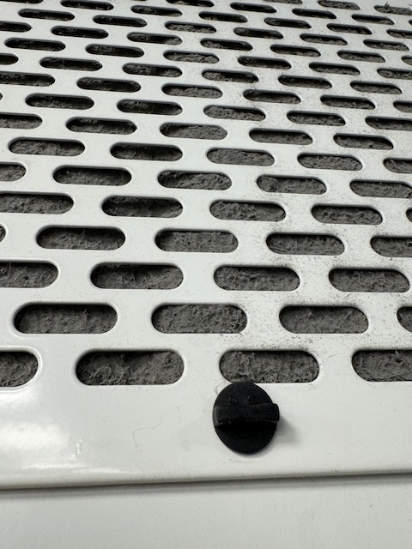
Figure 25: Dirty Laminar Flow Cabinet Filter

6 Check Incoming Stock
As the Pareto charts highlighted in Figure 15, some contamination rejects are manufacturer borne, and are only identified hours into the test phase. There is no current process defined step to check incoming stock quality.

7 Review Tooling
As per Figure 16, 2 rejects in 2023 result from camera windows being scratched by metal forceps, holding lens tissue, used during cleaning.
Observation of the subassembly procedure shows specialised tooling is damaging coated surfaces as in Figure 26, subsequently contaminating the camera lens.
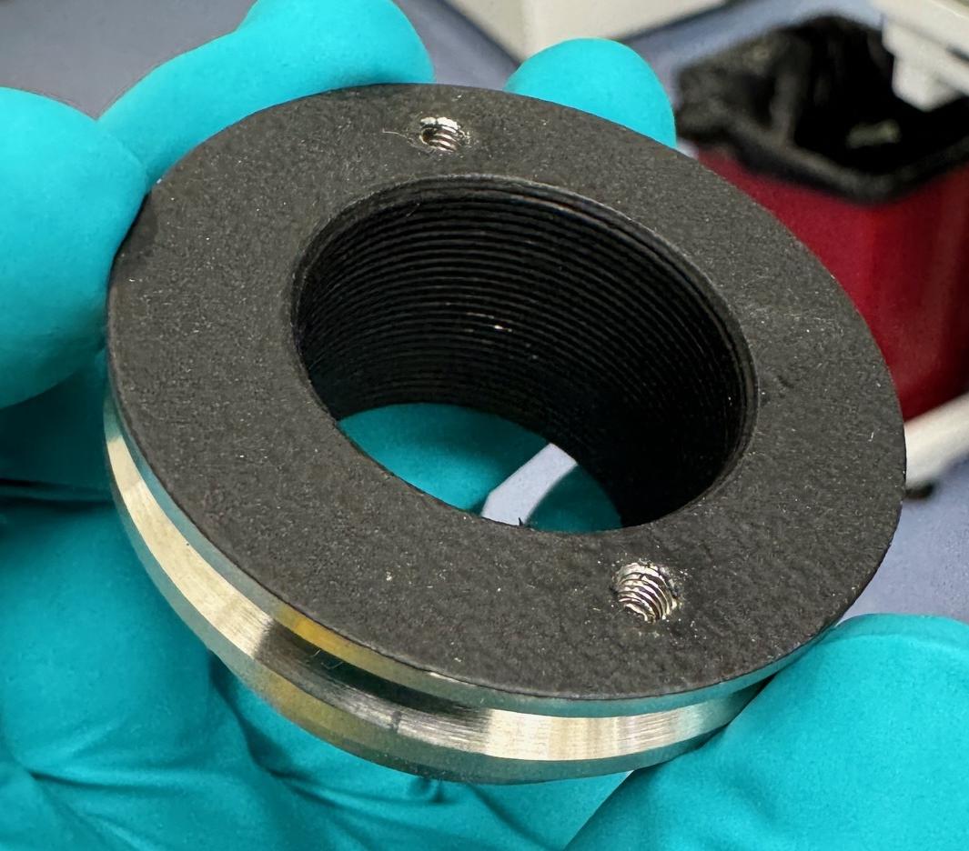
Figure 26: Damaged Coating on Camera Thread Reducer

Control

To reduce causes of variation, leading to significant downtime during the test phase, a control strategy was developed. Error proofing methods are characterised by prevention and detection.

Prevention

2 Improve Subassembly Procedure
A revised subassembly SOP will be introduced, detailing the use of Laminar Flow cabinets and detail specific cleaning activities, with the key changes being trained to the technician. The subassembly build time will increase after implementation of additional process steps. This increase will be justified by the reduction in testing downtime and monitored by additional timings and evaluation of its control chart.

3 Improve Test Procedure
AI image analysis of contamination will make the process more robust and increase throughput. The testing procedure improvement will be sustained by monthly QCD evaluations. After the control measures are introduced, a decline in contamination downtime is expected. Should an upward trend or special causes be observed from the Control Charts, the 5-Why root cause analysis tool will be used.

4 Remove Cardboard
To reduce cardboard dust, decanting of components must be done off-line, and the SOP defined use of the Laminar Flow cabinet will filter out environmental particulates creating a segregated environment.

5 5S Areas
The Laminar Flow cabinet was cleared with technician assistance. Unnecessary items were Red Tagged and kept off-line, and the cabinet filter was replaced, Figure 27. A technician was nominated to keep the area clean, focussing on checks including running weekly particle counts, which now have zero particulates of any size. Figure 28.
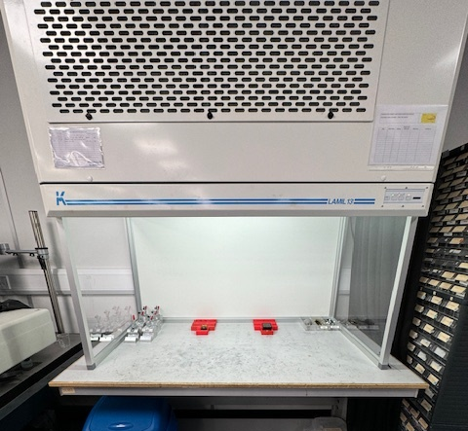
Figure 27: Maintained Laminar Flow Cabinet
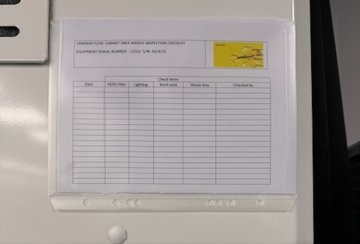
Figure 28: Weekly Technician Check Sheet

6 Check Incoming Stock
An SOP defined process step where the cameras are checked for contamination will be added into subassembly process prior to building activities validated using a stereomicroscope, Figure 29. The microscope will be kept inside the laminar flow cabinet reducing the ingress of contaminants.
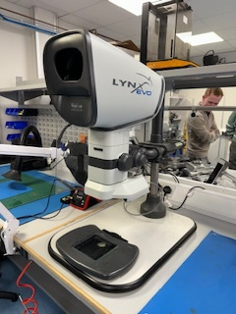
Figure 29: Stereomicroscope

7 Review Tooling
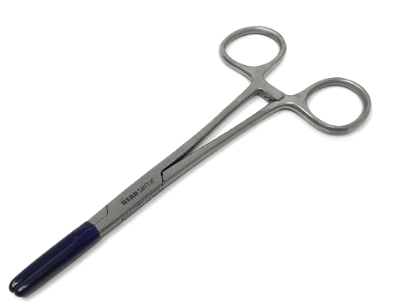
Camera windows being scratched from cleaning operations is reduced from replacing the metal forceps with rubber tipped variants. Fig 30.

Figure 30: Rubber Tipped Forceps (Buy Beadsmith Haemostats Clamp Coated Jaw, 2023)
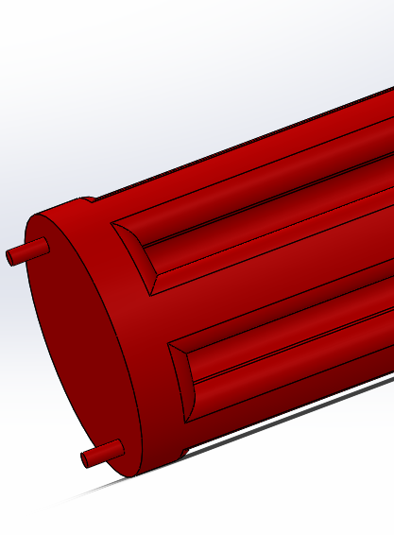
Furthermore, the 3D-Printed Camera tightening tool, was redesigned to ensure that the damage occurring to the coated parts from the protrusion in Figure 31, is removed, as in Figure 32.
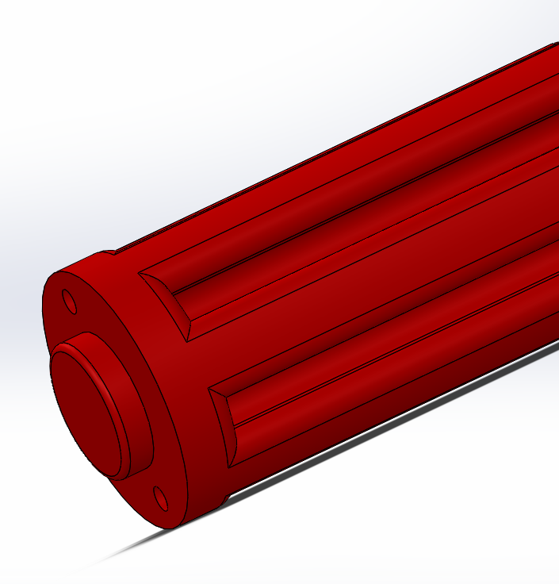
Figure 31: Old Tightening Tool
Figure 32: Redesigned Tightening Tool

Detection

1 Reduce Subjectivity
There is significant awareness around technician subjectivity and its control is encompassed by an ongoing software project due to be delivered in July 2024. The software utilises Artificial Intelligence (AI) for image analysis and detects contamination faster and to a finer degree than the technicians, removing subjectivity.

Cost-Benefit Analysis

As many of the required parameters of a full cost-benefit analysis are not available. S simplistic calculation of the main potential costs and benefits was produced. Li and Pizer (2021) state that industry used discount rates are either 3% or 7%. As the discount rates are not known for the company, 7% was used demanding higher returns.
Using the calculation methods outlined by Stobierski (2019) and Thakur (2023). The Cost-Benefit analysis produced a ratio of 2.79. A figure higher than 1 indicates that the project is worth undertaking based on the expected returns.

Table 7: Cost Benefit Analysis

Control Plan
Table 8: Control Plan

Future Recommendations

Test Fixtures
The use of the Stereomicroscope has an element of subjectivity and is not able to analyse relative intensity of particles. Using Poka-Yoke error proofing method, a test fixture that takes an image using the camera can utilise the automatic image analysis software and can be fed directly into the test procedure stage, removing the additional non-value-added process step of double handling data. Furthermore, taking an image in this manner will help to error-proof the process by highlighting supply issues of Dark and Hot Pixels.

SOP Update Findings
Using the stereomicroscope inside Laminar Flow cabinet and the camera assembly batch size being increased to 4 resulted in the Laminar Flow cabinet not being large enough to conduct subassembly activities. The supplier has provided a quote for a larger, dedicated cabinet, Appendix D, reducing risk of contamination of from other, uncontrolled processes. Its purchase is awaiting the result of Capex funding acceptance.

Cardboard Elimination
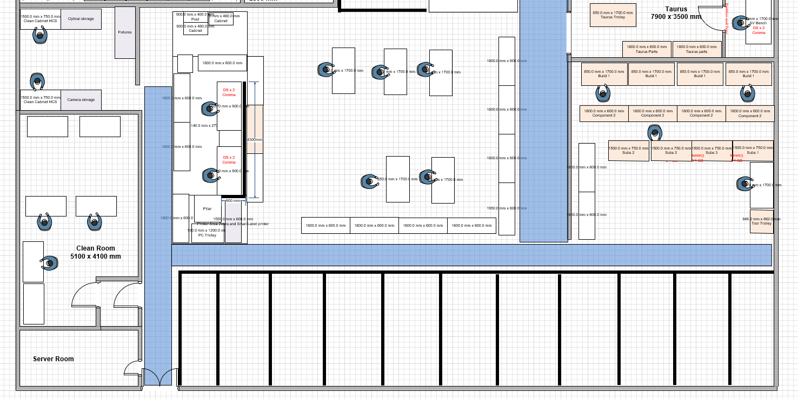
As the environmental particle count is high, a project to eliminate cardboard entering the manufacturing environment is ideal. However, the enormity of the task, including changing how goods are delivered lineside and stored is understood. The recommendation given, is to produce a clean area. This area will house all laminar flow cabinets where no cardboard may enter, and all assemblies are sealed before exiting. Figure 33.
Figure 33: Positive Pressure Room Proposal

References

(No date) Tables of constants for Control Charts. Available at: https://web.mit.edu/2.810/www/files/readings/ControlChartConstantsAndFormulae.pdf (Accessed: 20 April 2024).
Berestina, A.V. and Bakhvalov, A.V. (2021) ‘Monitoring of microbial contamination of the Educational and Scientific Cleanroom Facility’, Microbiology Independent Research Journal (MIR Journal), 8(1). doi:10.18527/2500-2236-2021-8-1-18-26.
Buy Beadsmith hemostat clamp coated jaw (2023) Maddisons UK. Available at: https://maddisonsofdurham.co.uk/jewellers-tools/beading-jewellers-tools/view-all-beading/beadsmith-hemostat-clamp-coated-jaw/ (Accessed: 19 April 2024).
Chin, K.-S. et al. (2009) ‘Failure mode and effects analysis using a group-based Evidential Reasoning Approach’, Computers &amp; Operations Research, 36(6), pp. 1768–1779. doi:10.1016/j.cor.2008.05.002.
Cost-benefit analysis (CBA) (2024) Wall Street Prep. Available at: https://www.wallstreetprep.com/knowledge/cost-benefit-analysis/#:~:text=Conceptually%2C%20the%20cost-benefit%20analysis%20ratio%20should%20exceed%201.0,that%20implies%20the%20expected%20benefits%20outweigh%20the%20costs. (Accessed: 21 April 2024).
Durivage, M. (2016) How to establish sample sizes for process validation using the success-run theorem, How To Establish Sample Sizes For Process Validation Using The Success-Run Theorem. Available at: https://www.bioprocessonline.com/doc/how-to-establish-sample-sizes-for-process-validation-using-the-success-run-theorem-0001 (Accessed: 24 March 2024).
Ford Motor Company (2008) Potential failure mode and effects analysis (FMEA): Reference manual. Erscheinungsort nicht ermittelbar: Chrysler LLC.
Ghasemian, H. and Zeeshan, Q. (2017) ‘Failure Mode and Effect Analysis (FMEA) of Aeronautical Gas Turbine using the Fuzzy Risk Priority Ranking (FRPR) Approach’, International Journal of Soft Computing and Engineering, 7(1), pp. 81–92. doi:2231-2307.
Grey, K. (2019) XMR chart: Step-by-step guide by hand and with R: R-bar, R-Bar. Available at: https://r-bar.net/xmr-control-chart-tutorial-examples/ (Accessed: 01 April 2024).
Guerriero, C. and Pacelli, A. (2020) ‘Discounting benefits and costs’, Cost-Benefit Analysis of Environmental Health Interventions, pp. 129–143. doi:10.1016/b978-0-12-812885-5.00007-x.
Hessing, T. (2023) Control Charts Study Guide, Six Sigma Study Guide. Available at: https://sixsigmastudyguide.com/control-charts-study-guide/ (Accessed: 08 April 2024).
Kiemele, M.J., Schmidt, S.R. and Berdine, R.J. (2000) ‘Graphical and Measurement Tools’, in Basic statistics: Tools for Continuous Improvement. Colorado Springs, CO: Air Academy Press, pp. 35–35.
Li, Q. and Pizer, W.A. (2021) Discounting for public benefit-cost analysis, Resources for the Future. Available at: https://www.rff.org/publications/issue-briefs/discounting-for-public-benefit-cost-analysis/ (Accessed: 21 April 2024).
Luko, S.N. (1997) ‘Attribute reliability and the success run: A Review’, SAE Technical Paper Series [Preprint]. doi:10.4271/972753.
MacNeil, C. (2024) The secret to Visualizing Your Business Processes, Asana. Available at: https://asana.com/resources/sipoc-diagram (Accessed: 12 April 2024).
Maxey, J. et al. (2004) The lean six sigma pocket toolbox. McGraw-Hill.
McDermott, R.E. (2009) Basics of FMEA.
Munro, D. (2019) ‘Working in a Cleanroom’, in DIY MEMS. Springer, Cham, pp. 21–30.
Nallusamy, S. and Ahamed, A. (2017) ‘Implementation of Lean Tools in an automotive industry for Productivity Enhancement - A case study’, International Journal of Engineering Research in Africa, 29, pp. 175–185. doi:10.4028/www.scientific.net/jera.29.175.
Rahardja, D. (2014) ‘Comparison of individual and moving range chart combinations to individual charts in terms of ARL after designing for a common “all OK” ARL’, Journal of Modern Applied Statistical Methods, 13(2), pp. 364–378. doi:10.22237/jmasm/1414815480.
Ravi Sankar, N. and Prabhu, B.S. (2001) ‘Modified approach for prioritization of failures in a system failure mode and effects analysis’, International Journal of Quality &amp; Reliability Management, 18(3), pp. 324–336. doi:10.1108/02656710110383737.
Stamatis, D.H. (2003) Six sigma and beyond: Statistical process control. Boca Raton, FL: St. Lucie Press.
Stobierski, T. (2019) Cost-benefit analysis: What it is & how to do it, Business Insights Blog. Available at: https://online.hbs.edu/blog/post/cost-benefit-analysis (Accessed: 21 April 2024).
Thakur, M. (2023) Cost benefit analysis formula: Calculator (example with Excel template), EDUCBA. Available at: https://www.educba.com/cost-benefit-analysis-formula/ (Accessed: 21 April 2024).
Woolf, P. et al. (2023) ‘SPC- Basic Control Charts- Theory and Construction, Sample Size, X-Bar, R charts, S charts’, in Chemical Process Dynamics and Controls. Ann Arbor, Michigan: LibreTexts Engineering.

Appendices

Appendix A

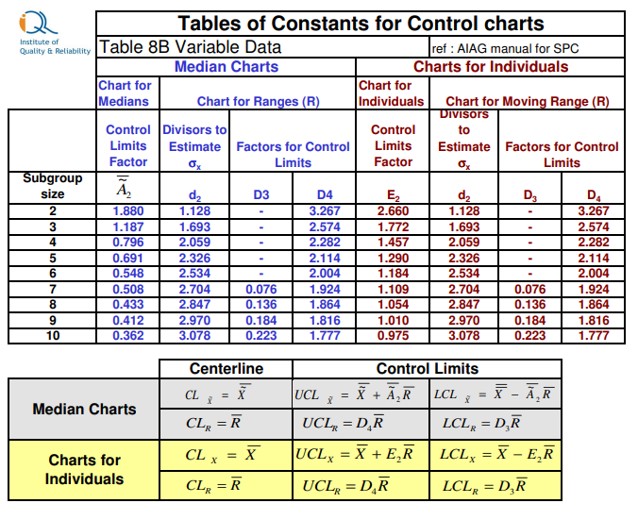
Figure 34: Individual Charts Constants (Tables of constants for Control Charts, No Date)

Appendix B

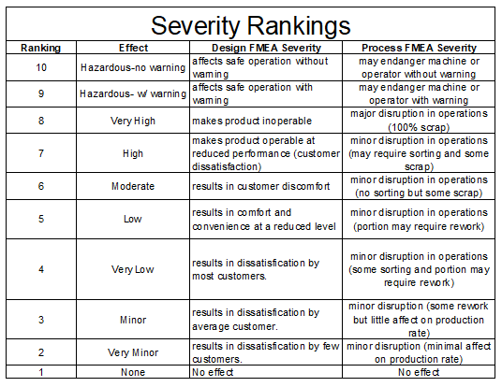
Figure 35: Severity Rankings (Ghasemian & Zeeshan, 2017)

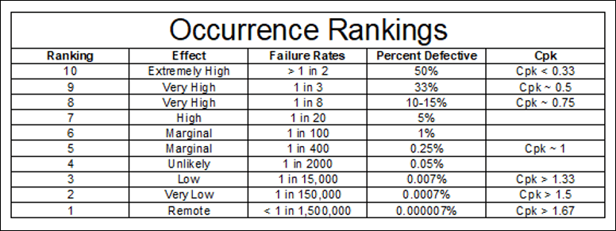
Figure 36: Occurence Rankings (Ghasemian & Zeeshan, 2017)

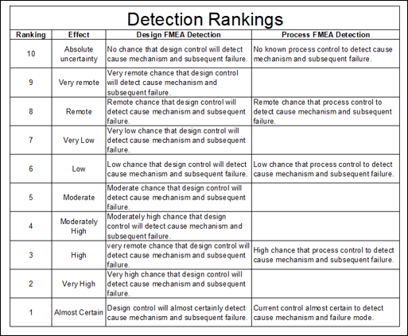
Figure 37: Detection Rankings (Ghasemian & Zeeshan, 2017)

Appendix C

Table 9: March Particle Readings
Date | Time | Particle size | Position 1 | P.P. rack | Position 2 | Centre | Position 3 | Subs rack
 |  |  | Σ | Δ | Σ | Δ | Σ | Δ
01/03/2024 | 10:45 | 0.5 | 493,347 | 451,322 | 599,997 | 524,777 | 622,599 | 545,260
 |  | 2.5 | 42,025 | 34,962 | 75,220 | 54,737 | 77,339 | 58,975
 |  | 5 | 7,063 | 7,063 | 20,483 | 20,483 | 18,364 | 18,364
04/03/2024 | 11:20 | 0.5 | 318,539 | 297,703 | 408,945 | 363,063 | 412,123 | 369,039
Monday |  | 2.5 | 20,836 | 16,598 | 45,909 | 40,259 | 43,084 | 37,787
 |  | 5 | 4,238 | 4,238 | 5,650 | 5,650 | 5,297 | 5,297
05/03/2024 | 10:15 | 0.5 | 515,242 | 483,459 | 506,766 | 466,154 | 507,473 | 472,158
 |  | 2.5 | 31,783 | 25,426 | 40,612 | 31,078 | 35,315 | 28,252
 |  | 5 | 6,357 | 6,357 | 9,575 | 9,575 | 7,063 | 7,063
06/03/2024 | 10:00 | 0.05 | 897,347 | 827,777 | 862,739 | 797,054 | 888,165 | 840,490
 |  | 2.5 | 69,570 | 53,678 | 65,685 | 51,912 | 47,675 | 39,493
 |  | 5 | 15,892 | 15,892 | 13,773 | 13,773 | 9,182 | 9,182
07/03/2024 | 10:00 | 0.05 | 783,987 | 746,553 | 563,623 | 515,948 | 840,844 | 785,400
 |  | 2.5 | 37,494 | 30,371 | 47,675 | 37,081 | 55,444 | 46,615
 |  | 5 | 7,063 | 7,063 | 10,594 | 10,594 | 8,829 | 8,829
08/03/2024 | 13:10 | 0.05 | 993,050 | 946,788 | 1,387,162 | 1,331,718 | 1,397,578 | 1,355,732
 |  | 2.5 | 46,262 | 42,731 | 55,444 | 49,087 | 38,846 | 38,668
 |  | 5 | 3,531 | 3,531 | 6,357 | 6,357 | 3,178 | 3,178
11/03/2024 | 11:15 | 0.05 | 652,969 | 614,123 | 1,100,760 | 1,027,305 | 999,407 | 927,365
Monday |  | 2.5 | 38,846 | 28,605 | 73,455 | 60,389 | 72,042 | 58,622
 |  | 5 | 10,241 | 10,241 | 13,066 | 13,066 | 13,420 | 13,420
12/03/2024 | 10:00 | 0.05 | 440,375 | 423,777 | 694,287 | 642,374 | 685,459 | 638,490
 |  | 2.5 | 16,598 | 15,539 | 51,913 | 40,259 | 46,969 | 37,787
 |  | 5 | 1,059 | 1,059 | 11,654 | 11,654 | 9,182 | 9,182
13/03/2024 | 10:05 | 0.05 | 282,518 | 252,147 | 581,280 | 531,133 | 570,686 | 523,011
 |  | 2.5 | 30,371 | 24,014 | 50,147 | 41,671 | 47,675 | 38,846
 |  | 5 | 6,357 | 6,357 | 8,476 | 8,476 | 8,829 | 8,829
14/03/2024 | 10:00 | 0.05 | 496,172 | 454,854 | 823,539 | 760,679 | 734,899 | 673,805
 |  | 2.5 | 41,318 | 33,549 | 62,860 | 54,031 | 61,094 | 52,265
 |  | 5 | 7,769 | 7,769 | 8,829 | 8,829 | 8,829 | 8,829
15/03/2024 | 10:30 | 0.05 | 2,644,367 | 2,575,150 | 2,029,890 | 1,971,621 | 2,298,282 | 2,226,240
 |  | 2.5 | 69,217 | 58,623 | 58,269 | 51,912 | 72,042 | 61,801
 |  | 5 | 10,594 | 10,594 | 6,357 | 6,357 | 10,241 | 10,241
18/03/2024 | 10:00 | 0.05 | 369,392 | 349,969 | 520,539 | 487,343 | 450,969 | 402,941
Monday |  | 2.5 | 19,423 | 15,185 | 33,196 | 25,780 | 48,028 | 37,080
 |  | 5 | 4,238 | 4,423 | 7,416 | 7,416 | 10,948 | 7,416
19/03/2024 | 09:55 | 0.05 | 717,595 | 678,043 | 950,672 | 893,462 | 950,319 | 904,763
 |  | 2.5 | 39,552 | 34,255 | 57,210 | 46,616 | 45,556 | 40,259
 |  | 5 | 5,297 | 5,297 | 10,594 | 10,594 | 5,297 | 5,297
01/01/1900 | 10:10 | 0.05 | 296,644 | 237,668 | 336,549 | 301,587 | 311,829 | 262,742
 |  | 2.5 | 58,976 | 43,438 | 34,962 | 27,899 | 49,087 | 38,493
 |  | 5 | 15,538 | 15,538 | 7,063 | 7,063 | 10,594 | 10,594
21/03/2024 | 10:00 | 0.05 | 440,021 | 393,406 | 760,326 | 701,350 | 679,455 | 620,479
 |  | 2.5 | 46,615 | 37,433 | 58,976 | 49,441 | 58,976 | 48,382
 |  | 5 | 9,182 | 9,182 | 9,535 | 9,535 | 10,594 | 10,594
22/03/2024 | 10:30 | 0.05 | 1,161,854 | 1,125,833 | 1,350,435 | 1,293,931 | 1,649,551 | 1,590,222
 |  | 2.5 | 36,021 | 31,430 | 56,504 | 48,028 | 59,329 | 51,209
 |  | 5 | 4,591 | 4,591 | 8,476 | 8,476 | 8,122 | 8,122
25/03/2024 | 10:05 | 0.05 | 506,413 | 452,028 | 606,001 | 535,372 | 719,008 | 616,948
Monday |  | 2.5 | 54,385 | 40,612 | 70,629 | 57,209 | 102,060 | 78,752
 |  | 5 | 13,773 | 13,773 | 13,420 | 13,420 | 23,308 | 23,308
26/03/2024 | 11:00 | 0.05 | 756,441 | 713,359 | 776,571 | 716,183 | 586,224 | 527,955
 |  | 2.5 | 43,084 | 38,493 | 60,388 | 50,853 | 58,268 | 49,087
 |  | 5 | 4,591 | 4,591 | 9,535 | 9,535 | 9,182 | 9,182
27/03/2024 | 10:50 | 0.05 | 240,846 | 211,182 | 353,500 | 324,189 | 383,165 | 351,382
 |  | 2.5 | 29,664 | 24,014 | 29,311 | 21,542 | 31,783 | 24,720
 |  | 5 | 5,650 | 5,650 | 7,769 | 7,769 | 7,063 | 7,063
28/03/2024 | 10:30 | 0.05 | 289,934 | 258,504 | 278,986 | 245,790 | 288,874 | 256,031
 |  | 2.5 | 31,430 | 24,014 | 33,196 | 25,780 | 32,843 | 25,427
 |  | 5 | 7,416 | 7,416 | 7,416 | 7,416 | 7,416 | 7,416

Table 10: April Particle Readings
Date | Time | Particle size | Position 1 | P.P. rack | Position 2 | Centre | Position 3 | Subs rack
 |  |  | Σ | Δ | Σ | Δ | Σ | Δ
02/04/2024 | 10:00 | 0.05 | 345,373 | 309,357 | 359,151 | 326,661 | 321,717 | 289,581
 |  | 2.5 | 36,021 | 29,311 | 32,490 | 26,486 | 32,136 | 27,545
 |  | 5 | 6,710 | 6,710 | 6,004 | 6,004 | 4,591 | 4,591
03/04/2024 | 10:00 | 0.05 | 357,385 | 316,420 | 502,529 | 446,732 | 451,322 | 410,710
 |  | 2.5 | 40,965 | 27,192 | 55,797 | 42,024 | 40,612 | 33,902
 |  | 5 | 13,773 | 13,773 | 13,773 | 13,713 | 6,710 | 6,710
04/04/2024 | 10:00 | 0.05 | 851,085 | 793,875 | 941,491 | 882,869 | 905,116 | 850,731
 |  | 2.5 | 57,210 | 52,619 | 58,622 | 50,500 | 54,385 | 48,735
 |  | 5 | 4,591 | 4,591 | 8,122 | 8,122 | 5,650 | 5,650
05/04/2024 | 10:00 | 0.05 | 1,240,253 | 1,192,225 | 1,770,680 | 1,718,414 | 1,981,862 | 1,925,712
 |  | 2.5 | 48,028 | 41,318 | 52,266 | 46,969 | 56,150 | 51,912
 |  | 5 | 6,710 | 6,710 | 5,297 | 5,297 | 4,238 | 4,238
08/04/2024 | 10:10 | 0.05 | 814,242 | 739,490 | 1,067,211 | 985,987 | 1,024,480 | 969,389
Monday |  | 2.5 | 78,752 | 54,385 | 81,224 | 67,804 | 55,091 | 46,615
 |  | 5 | 24,367 | 24,367 | 13,420 | 13,420 | 8,476 | 8,476
09/04/2024 | N/A
10/04/2024 | 10:00 | 0.05 | 586,378 | 542,081 | 823,893 | 768,802 | 891,364 | 827,777
 |  | 2.5 | 44,497 | 31,431 | 55,091 | 44,143 | 63,567 | 53,328
 |  | 5 | 13,066 | 13,066 | 10,948 | 10,948 | 10,241 | 10,241
11/04/2024 | 10:00 | 0.05 | 902,291 | 834,487 | 980,690 | 900,526 | 994,110 | 911,120
 |  | 2.5 | 67,804 | 58,975 | 80,164 | 66,038 | 82,490 | 65,686
 |  | 5 | 8,829 | 8,829 | 14,126 | 14,126 | 17,304 | 17,304
12/04/2024 | 10:00 | 0.05 | 1,215,180 | 1,135,016 | 1,383,984 | 1,203,113 | 1,429,893 | 1,341,606
 |  | 2.5 | 80,164 | 68,510 | 80,871 | 71,689 | 88,287 | 77,693
 |  | 5 | 11,654 | 11,654 | 9,182 | 9,182 | 10,594 | 10,594
15/04/2024 | 10:00 | 0.05 | 694,641 | 665,683 | 753,616 | 717,948 | 813,298 | 767,036
Monday |  | 2.5 | 28,958 | 22,954 | 35,668 | 29,311 | 46,262 | 38,140
 |  | 5 | 6,004 | 6,004 | 6,357 | 6,357 | 8,122 | 8,122
16/04/2024 | 10:00 | 0.05 | 631,427 | 591,168 | 662,504 | 577,098 | 744,788 | 701,704
 |  | 2.5 | 40,259 | 28,958 | 90,406 | 69,570 | 43,084 | 35,668
 |  | 5 | 11,301 | 11,301 | 20,830 | 20,836 | 7,416 | 7,416
17/04/2024 | 10:00 | 0.05 | 423,777 | 392,700 | 461,563 | 404,353 | 528,308 | 478,867
 |  | 2.5 | 31,077 | 20,129 | 57,210 | 40,612 | 49,441 | 40,612
 |  | 5 | 10,948 | 10,948 | 10,948 | 16,598 | 8,829 | 8,829
18/04/2024 | 10:15 | 0.05 | 247,909 | 218,951 | 300,175 | 262,741 | 327,721 | 292,406
 |  | 2.5 | 28,958 | 23,308 | 37,434 | 30,371 | 35,315 | 29,665
 |  | 5 | 5,650 | 5,650 | 7,063 | 7,063 | 5,650 | 5,650
19/04/2024 | 10:00 | 0.05 | 156,444 | 133,136 | 417,067 | 346,438 | 501,116 | 422,011
 |  | 2.5 | 23,308 | 19,423 | 70,629 | 60,388 | 79,105 | 68,864
 |  | 5 | 3,885 | 3,885 | 10,241 | 10,241 | 10,241 | 10,241
22/04/2024 | 10:05 | 0.05 | 997,994 | 892,756 | 1,510,764 | 1,372,683 | 1,367,442 | 1,219,064
Monday |  | 2.5 | 105,238 | 87,934 | 138,081 | 127,840 | 143,378 | 132,077
 |  | 5 | 17,304 | 17,304 | 10,241 | 10,241 | 11,301 | 11,301
23/04/2024 | 10:50 | 0.05 | 395,172 | 342,553 | 750,791 | 638,137 | 732,781 | 618,714
 |  | 2.5 | 52,619 | 42,025 | 112,654 | 96,056 | 114,067 | 98,882
 |  | 5 | 10,594 | 10,594 | 16,598 | 16,598 | 15,185 | 15,185
24/04/2024 | 10:00 | 0.05 | 570,333 | 531,134 | 687,225 | 635,812 | 740,903 | 678,749
 |  | 2.5 | 39,199 | 73,195 | 51,913 | 42,025 | 62,154 | 50,147
 |  | 5 | 6,004 | 6,004 | 9,888 | 9,888 | 12,007 | 12,007
25/04/2024 | 10:00 | 0.05 | 554,441 | 494,053 | 894,875 | 801,291 | 972,214 | 880,396
 |  | 2.5 | 60,388 | 50,147 | 93,584 | 78,399 | 91,818 | 76,633
 |  | 5 | 10,241 | 10,241 | 15,185 | 15,185 | 15,185 | 15,185
26/04/2024 | 10:40 | 0.05 | 1,060,501 | 882,162 | 953,144 | 773,039 | 932,309 | 757,148
 |  | 2.5 | 178,339 | 143,731 | 180,105 | 150,087 | 175,161 | 146,909
 |  | 5 | 34,608 | 34,608 | 30,018 | 30,018 | 28,252 | 28,252

Appendix D
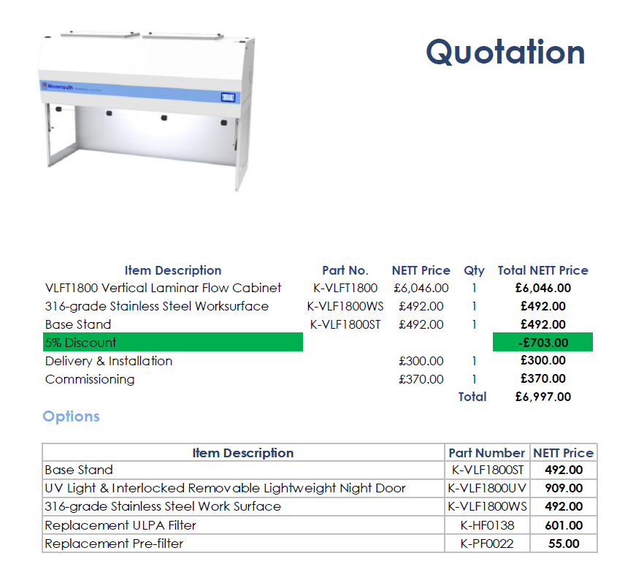
Figure 38: Laminar Flow Quotation

