Swansea Arena Report
Cellan Hill
2420468
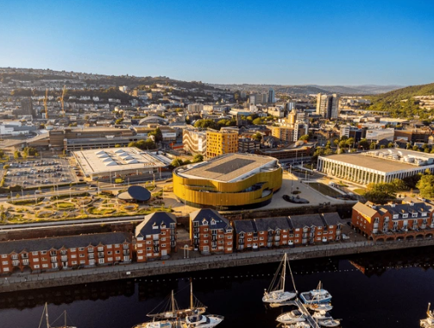
Roberts, P. (2022)

Introduction
This report is for the newly built ‘Swansea Arena’ also referred to as ‘Arena’ throughout, residing on Oystermouth Road near Swansea Waterfront. The project was designed to be a “multi-purpose entertainment and events space” (Swansea Arena 2024). My motivation behind this report was due to its innovative, ecological, and modernized architectural design, which intrigued me. This report aims to highlight the history, significance, construction process, and design.

Surrounding area:
- Several car parks located nearby including on the site of the Arena.
- Designed with transport access in mind (located near the M4 J47) and Swansea bus station.
- Located within walking distance of Swansea’s Wind Street – very popular for bars & restaurants.
- Swansea Castle the beachfront and Swansea Marina are in very close proximity.
- The Arena is located on the old site of Oystermouth Road car park next to the LC2 that used to host space for 95 cars.
The reason Swansea Council located there has been reported as “The arena sits as the crowing jewel…. connecting the city center to the budding community of restaurants, new builds, and local attractions”. (Swansea Arena 2024)
Type:
- The Arena is a controlled environment, referred to as a large, enclosed space surrounded by seating that is multi-purposeful. A modernized arena is achieved through a “fluid cladding of copper-colored panels and 100,000 LEDs, acting as a digital façade.” (Kriska Décor 2024). Famed for being the largest of its kind. It was built with the mindset of creating and pushing Swansea into a “digital district” (Swansea Council 2021). Whilst also considering the future of the building with intentions to reduce inefficient energy use by using “240mm thick Rainspan panels” (Euro Clad Group 2024)

The Arena is “8654m2” (AFL Architects 2024) and sits “within a 1.1-acre coastal park “(Swansea Arena 2024), including two multi-story car-park. The Arena has the “ability to host 3,500 people” (Swansea Arena 2024).

Purpose:
A multipurpose venue that will “cater for the music lovers, comedy enthusiasts, and musical theatre aficionados” (Swansea Arena 2024). The ecological footprint was taken into consideration by the addition of solar panels on the roof and “64% of…materials” (Youle, R 2022) were sourced locally from Wales.

Stakeholders
- Swansea Council
- Copr Bay
- ATG Tickets
- UWTSD (Swansea Arena 2024)
Owners:
Two main owners; ATG Entertainment who operates the arena on a day-to-day basis and Swansea Council are silent owners, however, they “get a share of the profits” (Youle, R 2023).
Architects Involved:
There were several architects involved in the design. AFL Architects designers “were appointed by ACME to assist… the front of the bar”. The Rest of the project was overseen by ACME (who took the project to stage 6 of RIBA) and AFL Architects who took “control of the design at the end of RIBA Stage 3” (AFL Architects, 2024)
Here is ACME’s “Section through Concourse Arena model”(ACME 2024) 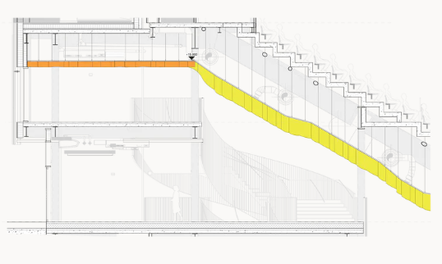

Engineers Involved:
The main engineers that were involved in the project were CMB Engineers carrying out the” Mechanical & Electrical services… and UPS Central Battery Systems”. However, Curtin’s Engineering also was involved, they “maximize the value of residential, retail, leisure and car parking development” (Curtins 2024). McCann and Partners similarly were involved specifically the “Mechanical, Electrical and Public Health Engineering Systems” (McCann 2024).
Contractors Involved:
The main contractor employed for the Arena project was “Buckingham Group, who is Swansea Council’s main contractor” (Swansea Bay News, 2023). However, Buckingham Group went into administration during the project, resulting in a new contractor; “Swansea Council's appointment of Willmott Dixon” (Swansea City Council, 2023) to complete the project.
Design principles:
- Strategic location of the arena “bringing people back to the city center who may not have been in Swansea for years.” (ACME 2022)
- Innovative Façade “dynamic lighting effects and integrated promotional screens to showcase…shows or public messaging” (Buro Happold 2024)
- Versatility “suitable for seated and standing performances, concerts, conferences, and exhibitions”. (Blueprint 2024).
- Preservation of heritage “Incorporating the old wall … base of a new concert arena” ACME (2022)

Architectural features:
Acoustic design systems “fixed acoustic foam and plaster …provides acoustic refraction and absorption.” (ACME 2022)
Employment of Glass for Transparency "entrance level is fully glazed on all sides"(ACME 2022)
Versatile and Customizable Interior Spaces “high degree of adaptability” (ACME 2022)
Revolutionary Interior Deising “tutu mesh ceiling above winding helical stairs” (ACME 2022)
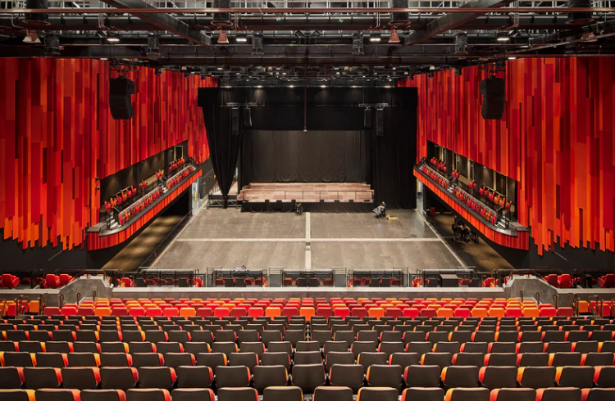

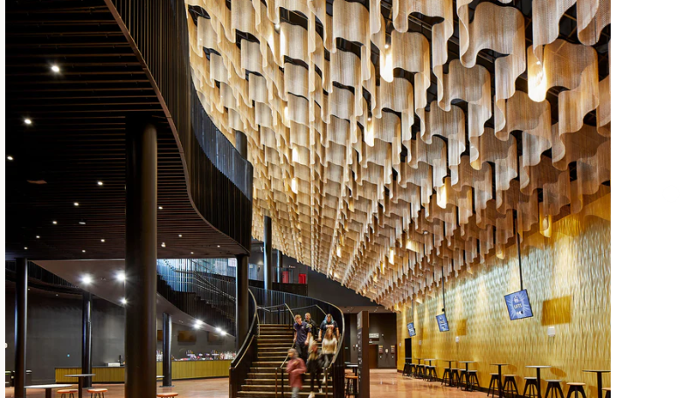

Engineering aspects:
Materials/ structural systems:
- Perforated Aluminium Panels with integrated LED’S as “Aluminium is naturally resistant to corrosion …many years with minimal maintenance” (SK Industries PTE Ltd 2024)
- Reinforced concrete (Increased load bearing) “The building is a reinforced concrete frame” (Thames Valley Construction2024).
- Prefabricated steel frame “on the huge steel frames” (Business News Wales2024)
- Electrical management systems (CMB Engineering 2024):

- “Fully automatic Building Management System”
- “Fire Alarm, CCTV, Access Control and Intruder Alarm Systems”
- “General Lighting/ Associated Control Systems”

CMB Engineering included many other innovative systems from drainage systems to Water systems

Construction timeline:
- Groundworks and preparation work started in May 2019
“Contractors arrive on site” (Swansea Bay City Deal 2019)
- The primary construction phase began in 2019 - March 2022 when the project was completed “ACME completed gold-colored arena in Swansea” (Architects' Journal 2024).
- The arena was completed and opened on March 4th 2024, the first act performed in the arena was “John Bishop's performance there on March 15.” (Swansea Council 2022).

Construction methods and techniques:
- Utilization of BIM “provided visualizations and 3D studies of the full façade” (Buro Happold 2024).
- Incorporation of surrounding heritage “revetment wall remained of the old Coal Drops” (ACME 2022).
- Prefabricated elements of the build including the steel frame and Facade panels “The custom-moulded body” (Darc Awards 2024)
- Perspective “optimize the seating so…minimum seats had restricted views” (AFL Architects 2024)

Challenges faced:
- Contractor stability “main contractor … filed for administration” (Editor 2023)
- Global pandemic (Uncertainty) “continues to be delivered despite the challenge of Covid” (Swansea Council 2023).
- Design/Innovation challenges “the building … key challenges” (Euroclad Group 2024)
- The location of the site “location .. materials had to be durable” (Euroclad Group 2024)

Conclusion:
This report exhibits the revolutionary arena, following the key components taken to create and finish the project. It is one unique to the area, working as a trailblazer for future work in Swansea. The key themes I covered are:
- Surrounding area
- Purpose
- Type
- Stakeholders
- Owners
- Architects
- Engineers
- Contractors
- Design Principles
- Architectural features
- Engineering aspects
- Construction timeline
- Construction Methods/ techniques
- Challenges faced

Reference list:
- ACME (2022), “Swansea Arena”, P.1. Available at: https://acme.ac/blogs/projects/swansea-arena (Accessed November 2024)
- AFL architects, (2024) “ Copr Bay”, P.1. Available at: https://www.afl-architects.com/projects/swansea-central#:~:text=The%20arena%20building%20is%20to,highly%20flexible%20to%20optimise%20revenue. (Accessed November 2024)
- Amron Architectural (2024). ‘Swansea Arena, Wales’, Amron Architectural Project. Available at: https://amronarchitectural.co.uk/project/swansea-arena-wales/#:~:text=We%20achieved%20the%20design%20intent,surface%20area%20of%201%2C647%20m2. Accessed: November 2024
- Architects' Journal, (2024). ACME completes gold-coloured arena in Swansea. Available at: https://www.architectsjournal.co.uk/buildings/acme-completes-gold-coloured-arena-in-swansea [December 2024].
- Blueprint, (2024). Swansea Arena. Available at: https://www.blueprintuk.net/project/swansea-arena/ (Accessed: 1 December 2024).
- Buro Happold, (2024). Swansea Arena. Available at: https://www.burohappold.com/projects/swansea-arena/ (Accessed: December 2024).
- Business News Wales, (2024). Swansea Skyline Changing as Arena Steel Structures Rise. Business News Wales. Available at: https://businessnewswales.com/swansea-skyline-changing-as-arena-steel-structures-rise/ (December 2024).
- CMB Engineering, (2024). “Project portfolio, Swansea Arena”, P.1. Available at https://www.cmbengineering.co.uk/swanseaarena#:~:text=CMB%20carried%20out%20the%20Mechanical,and%20UPS%20Central%20Battery%20Systems.(Accessed November 2024)
- CMB Engineering, (2024). Swansea Arena. Available at: https://www.cmbengineering.co.uk/swansea-arena [Accessed 8 December 2024].
- Curtins, (2024). Swansea Arena: Our experience. Available at: https://www.curtins.com/experience/swansea-arena/ [Accessed 21 November 2024].
- Darc Awards, (2024). Swansea Arena, UK. [online] Available at: https://darcawards.com/portfolio/swansea-arena-uk/ [December 2024].
- Décor, K (2024). ‘Swansea Arena’, Kriska Décor. Available at: https://kriskadecor.com/en-GB/swansea-arena#:~;text=The%20façade%20appears%20as%20a,the%20largest%20in%20the%20UK. (Accessed at: November 2024)
- Editor, (2023). Construction company behind Swansea’s new arena to go into administration. Swansea Bay News, 17 August. Available at: https://swanseabaynews.com/2023/08/17/construction-company-behind-swanseas-new-arena-goes-into-administration/ [December .2024].
- Euro Clad Group (2024). ‘Swansea Bay Arena, A powerful visual impact’, Euro Clad Group. Available at: https://www.eurocladgroup.com/gb/en/case-studies/swansea-bay-arena/ Accessed: November 2024
- McCann. (2024). About Us Mccan and partners, Available at: https://www.mccannp.com/about [Accessed November 2024].
- Roberts, P. (2022) Aerial View of Swansea Arena. Available at: Swansea Glamorgan Wales Uk 08110222 Aerial Stock Photo 2515478419 | Shutterstock (Accessed: November 2024).
- SK Industries PTE Ltd, (2024). The Benefits of Perforated Aluminium Panels in Facade Design. Available at: https://skind.com.sg/benefits-of-perforated-aluminium-panels-in-design/ (Accessed: December 2024).
- Swansea Arena 2024 “About us”, P.1. Available at https://www.swansea-arena.co.uk/about (Accessed November 2024)
- Swansea Arena: Official Box Office, (2024). Swansea Arena | Official Box Office. Available at: https://www.swansea-arena.co.uk/ (Accessed: November 2024).
- Swansea Arena. (2024). Partners. Available at: https://www.swansea-arena.co.uk/about-us/partners [December 2024].
- Swansea Arena, (2024). “The Venue”, P.1. Available at: https://www.swansea-arena.co.uk/about-us/the-venue (Accessed November 2024)
- Swansea Arena, (2024). “Visitors”, P.1. Available at: https://www.swansea-arena.co.uk/visitors#:~:text=Our%20stunning%203%2C500%20capacity%2C%20multi,%2C%20conferences%2C%20exhibitions%20and%20events.(Accessed November 2024)
- Swansea Bay City Deal, (2019). Contractors arrive on site for arena construction. Available at: https://www.swanseabaycitydeal.wales/news/contractors-arrive-on-site-for-arena-construction/ [9 December 2024].
- Swansea Bay News, (2023). Construction company behind Swansea’s new arena goes into administration. Available at: https://swanseabaynews.com/2023/08/17/construction-company-behind-swanseas-new-arena-goes-into-administration/ [Accessed 1 December 2024].
- Swansea Council, (2023). Closing date nears for views on major development plans for Swansea. Available at: https://www.swansea.gov.uk/article/11369/Closing-date-nears-for-views-on-major-development-plans-for-Swansea [December 2024].
- Swansea Council, (2021). Installation of gold-coloured panels nears completion at arena’, Swansea Government. Available at: https://www.swansea.gov.uk/GoldPanels?lang=en Accessed: November 2024
- Swansea City Council, (2023). New Coper Bay contractor appointed in Swansea. Available at: https://www.swansea.gov.uk/article/24718/New-Copr-Bay-contractor-appointed-in-Swansea [Accessed 1 December 2024].
- Swansea Council, (2022). Official opening for Swansea's £135m Copr Bay destination. [Available at: https://www.swansea.gov.uk/article/14045/Official-opening-for-Swanseas-135m-Copr-Bay-destination [Accessed 9 December 2024].
- Thames Valley Construction,(2024). Swansea Arena. Available at: https://thamesvalleyconstruction.com/portfolio_page/swansea-arena/ (Accessed: December 2024
- Youle, R. (2023). Swansea Council will have a share in the profits of the Swansea Arena, p.1. Available: At: https://www.walesonline.co.uk/news/wales-news/swansea-arena-gigs-economy-entertainment-27302023.(Accessed November 2024)
- Youle, R. (2022). Questions raised about the carbon footprint of new Swansea arena. Wales Online, p.1. Available At: https://www.walesonline.co.uk/news/wales-news/swansea-arena-council-carbon-emissions-24463595. (Accessed November 2024)

