

Module Title: Foreign Languages & Cultural Awareness
Programme: BA International Hotel Management
Name: Oana-Andreea Puscuta
ID number: 2232738
Module code: BMIH5003
Lecturer: Giulia Chifari, Antoinette Milne
Assignment Title: Intercultural Competence Report

Executive Summary
This report explains the comparison of culture between England and Italy and the results, which can help the Multicultural Hotel & Spa in London to apply the intercultural leadership. It provides essential aspects of the chosen countries according to Hofstede’s cultural dimensions and the GLOBE Project, including power distance, individualism, masculinity, uncertainty avoidance, long-term orientation, and indulgence. Hence, the results herald a higher power distance of Italian Culinary compared to England that entails a more hierarchical environment in Italy. Both the nations are individualistic but among the two, England harbors individualist value to a greater extent than that of Italy, which also shares strong collectivist value in the form of family bureaucracy. In this English masculine culture success, and competition are considered as a major theme while in Italy, quality of life, and cooperation. The index for Italy is high while for England it is relatively low; this is due to the fact that the situations avoid uncertainty in Italy however for English people, a certain level of uncertainty is welcomed, especially in any business matters. Neither country is short-term oriented, as both are concerned with the rewards of the future; however, England is self-indulgent and willing to work for fun, while Italy is more moderate. The issues covered in the report include communication pattern, decision-making, work/family interface, conflict management, and change accommodation. Some of the recommendations are culturally informed training, variations in communication, diversity in decision making, proper policies on work-life balance, and culturally sensitive conflict solving methods to enhance intercultural leadership and create an efficient multicultural environment.

Introduction
Since the newcomer appointed as the General Manager of the Multicultural Hotel & Spa in London, there is a need to establish the culture difference between England and Italy. This understanding will help in dealing with the multiplicity of the clients and the actually diversifying the team hence be useful for the management of the team and delivery of the services (Daskalaki, 2016; Marneros et al. 2021). Cultures of two countries would be compared in this report and this would identify some of the conflicts that are likely to occur in intercultural leadership (Javidan et al. 2016).

Main Body

Cultural Dimensions: England vs. Italy
Using Hofstede’s cultural dimensions and the GLOBE Project, Tung and Verbeke, (2010); Shi and Wang, (2011); Nedeljković et al. (2018) and Castillo-Palacio et al. (2020), several key differences between England and Italy emerge, as illustrated in the Figure below and the detailed analysis is available in the appendix section:

Power Distance
Italy has higher ratings in power distance meaning the people of Italy accept inequality in their society (Hofstede, 1980; House, 2001; Ongaro, 2008). On the other hand, England has low PDI which means that it respects equality unlike the high PDI countries (Borg, 2014; Hofstede, 2013; Ardichvili and Kuchinke, 2002).

Individualism vs. Collectivism
The English culture is significantly individualistic in that it is focused and recognizes achievements as well as individual minorities (Archer and Francis, 2006; Bhugra, 2005). Thus, Italy is individualistic to a certain extent but is more collectivistic in terms of values related to family and other close relationships (Caffaro et al. 2014; Mucchi-Faina et al. 2010).

Masculinity vs. Femininity
It could be said that England overshoots towards masculinity in the regards of competition and achievement (Wrigley, 1972; Gasser, 2019). Italy, however, is more conservative and has chosen to focus on the quality of life and working with the others (Putnam, 1994; Esping-Andersen, 1996).

Uncertainty Avoidance
In terms of Hofstede’s dimensions, Italy reaches the highest point in uncertainty avoidance, which means that people appreciate well-organized situations and clear regulations (Bronzoni, 2018; Altinkaya, 2006). In structure, the author was right in stating that England is more forgiving of an ambiguous context, while being more lenient with rules.

Long-Term vs. Short-Term Orientation
Both countries can be characterized as having a moderate overall orientation, which moderately favors a long-term orientation, emphasizing future benefits that come from hard work and saving.

Indulgence vs. Restraint
England is overindulgence, and the policies try to bring pleasure to the people’s lives. Italy is similarly hedonistic but is grounded more route to moderation.
Figure 1 Hofstede Cross Culture
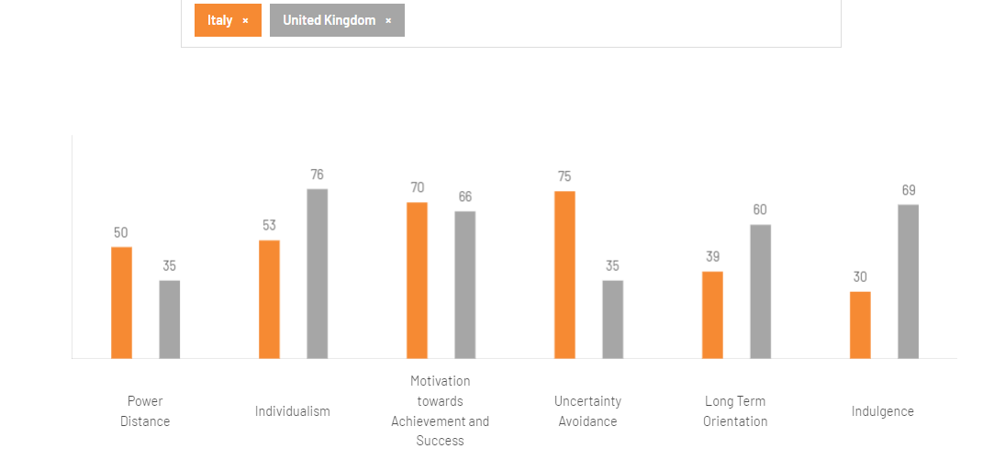
Source: (Hofstedo Insights, 2024)

Comparative Analysis Using the GLOBE Project
Thus, the GLOBE Project complements Hofstede’s dimensions in a more elaborate examination of leadership and organizational activities.
Figure 2 Globe Project
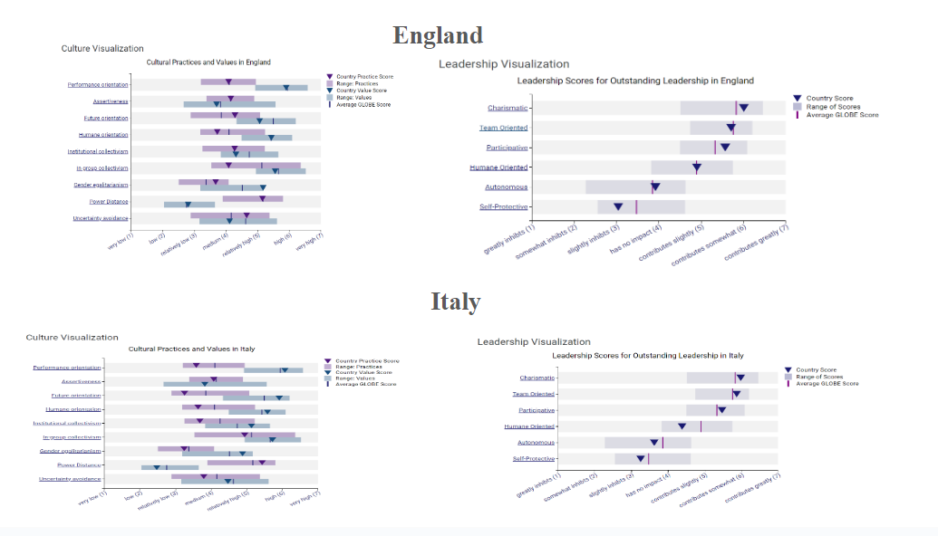
Source: (Globeproject.com, 2020)
Performance Orientation: Both countries appreciate performance, but in England its main focus is made on the individual –within the football team, Italy on the other hand concentrates on groups within a team that comprises of a family.
Assertiveness: England is more dominant and can be described as having a direct communication behavior. In the case of Italian people, people are moderately assertiveness with their communication tendency which is fairly verbal and non-verbal.
Humane Orientation: Italy is higher on this one, because care, generosity, and in this specific case, even kindness is what matters in a charity. Thus mild mannered England maintains the humane side but is equally business like and methodical about business and managing businesses.

Challenges of Intercultural Leadership in Hospitality
Intercultural workforce management implies dealing with a number of issues
Communication Styles: It therefore means that while Direct and Indirect communication are types of polar opposites as far as communication is concerned, the latter remains an area of high risk, given that misunderstandings are very common (Bowe et al. 2014). English managers have to accept increased contextual communication and decreased direct communication by their Italian subordinates.
Hierarchy and Decision-Making: The difference in organizational culture can also be difficult because whereas the English culture is informally supportive and inclinations towards democracy (Yu, 2005). The present situation could in one way or another influence decisions made as well as what workers were anticipating.
Work-Life Balance: The first distinction may relate to which approach of the work-life balance Italian employees are going to share with the English one; Italians may need a more time-off based schedule to be highly regardful of family time.
Conflict Resolution: As a result, communication in Italy can be said to be often indirect; therefore, if conflicts are not handled well, they may never be solved. English managers who wish to engage the Italians in this aspect have to discover ways and means of making it possible for the Italian employees to air their disagreement.
Adaptation to Change: The more directed and organized, rather than change-oriented, Italians might face an issue working under the relative mix-focus of the Anglo-Saxon Target’s employees.

Conclusion
As it is prerequisites of their work and for successful management of Multicultural Hotel & Spa in London that will function in the different culture country. This report posits that cultural competence is one of the significant determinants of the leadership processes at Multicultural Hotel & Spa in London because of the disparity in the English and Italian cultures. Due to the differences in power distance, individualism, masculinity, uncertainty avoidance, long-term orientation, and indulgence, there exists a need to adopt different approaches to mitigate for cultural difference. Consequently, cultural training, communication policies, multicultural participation in organizational decisions, work-life balance, and cultural conflicts’ procedures promote the hotel’s culture of providing cohesiveness at the workplace where everybody feels like a local. Through the incorporation of these processes into the culture of the organization, satisfaction and efficiency of the employees will be enhanced as well as the guest satisfaction which will lead to the high success and popularity of the hotel in the international market of hotel and tourism.

Recommendations
The following are measures that have to be undertaken to ensure good intercultural management in Multicultural Hotel & Spa in London:
- It is recommended that cultural training between the Italian and the English employees should be improved to help in minimizing some of the misunderstandings as a result of cultural diversity.
- It should therefore be possible to design decision-making frameworks that adhere to an organization’s formal structures and yet promote equality.
- It may be directly used while making announcements of the decisions and polices to the public while the two-way communication may be directly used in explaining the policies formulated by the different companies to prevent confusion.
- Promote measures for work-to-family conflict that will adequately meet the expectations set for the employees and the organization to enhance the employees’ well-being as well as the organization’s productivity.
- As it has been mentioned earlier, it is necessary to stress that there is a need to introduce conflict solving techniques which are compatible with various cultures that may be in conflict and solve them.

References
Altinkaya, A., 2006. Cultural differences in international projects. A research study at Ericsson.
Archer, L. and Francis, B., 2006. Understanding minority ethnic achievement: Race, gender, class and'success'. Routledge.
Ardichvili, A. and Kuchinke, K.P., 2002. Leadership styles and cultural values among managers and subordinates: a comparative study of four countries of the former Soviet Union, Germany, and the US. Human Resource Development International, 5(1), pp.99-117.
Bhugra, D., 2005. Cultural identities and cultural congruency: a new model for evaluating mental distress in immigrants. Acta Psychiatrica Scandinavica, 111(2), pp.84-93.
Borg, M.A., 2014. Cultural determinants of infection control behaviour: understanding drivers and implementing effective change. Journal of Hospital Infection, 86(3), pp.161-168.
Bowe, H., Martin, K. and Manns, H., 2014. Communication across cultures: Mutual understanding in a global world. Cambridge University Press.
Bronzoni, O., 2018. The aspect of culture in the human resources management's process within italian diplomatic organizations abroad and the case of the Consulate General of Italy in Chongqing.
Caffaro, F., Ferraris, F. and Schmidt, S., 2014. Gender differences in the perception of honour killing in individualist versus collectivistic cultures: Comparison between Italy and Turkey. Sex roles, 71(9), pp.296-318.
Castillo-Palacio, M., Batista Canino, R.M. and Zuñiga-Collazos, A., 2020. The cultural practices that Influence on the entrepreneurial activity: an empirical study from the globe project cultural dimensions. Scientific Annals of Economics and Business.
Daskalaki, E., 2016. Communication across cultures? An intercultural approach to customer service in the hotel industry: A study with globally branded hotels in the United Kingdom (Doctoral dissertation, University of Glasgow).
Esping-Andersen, G., 1996. Welfare states without work: The impasse of labour shedding and familialism in continental European social policy. Welfare states in transition, pp.66-87.
Gasser, E., 2019. Vexed with Devils: Manhood and Witchcraft in Old and New England (Vol. 6). NYU Press.
Globeproject.com. 2020. Italy Results - GLOBE Project. [online] Available at: https://globeproject.com/results/countries/ITA%3Fmenu=list.html#list.
Hofstede, G., 2013. Hierarchical power distance in forty countries. In Organizations alike and unlike (RLE: Organizations) (pp. 97-119). Routledge.
Hofstedo Insights 2024. Country comparison tool. [online] www.hofstede-insights.com. Available at: https://www.hofstede-insights.com/country-comparison-tool?countries=italy%2Cunited+kingdom [Accessed 3 Jun. 2024].
Hofstede, G., 1980. Motivation, leadership, and organization: do American theories apply abroad?. Organizational dynamics, 9(1), pp.42-63.
HOUSE, M.R.J., 2001. Lessons from project GLOBE. Organizational dynamics, 29(4), pp.289-305.
Javidan, M., Dorfman, P.W., De Luque, M.S. and House, R.J., 2016. In the eye of the beholder: Cross-cultural lessons in leadership from Project GLOBE. In Readings and cases in international human resource management (pp. 119-154). Routledge.
Marneros, S., Papageorgiou, G. and Efstathiades, A., 2021. Examining the core competencies for success in the hotel industry: The case of Cyprus. Journal of Hospitality, Leisure, Sport & Tourism Education, 28, p.100303.
Mucchi-Faina, A., Pacilli, M.G. and Verma, J., 2010. The two faces of familism: A cross-cultural research in India and Italy. Psychological Studies, 55, pp.365-373.
Nedeljković, M., Vukonjanski, J., Nikolić, M., Hadžić, O. and Šljukić, M., 2018. A comparative analysis of Serbian national culture and national cultures of some European countries by GLOBE project approach. Journal of the Geographical Institute" Jovan Cvijic", SASA, 68(3), pp.363-382.
Ongaro, E., 2008. Introduction: the reform of public management in France, Greece, Italy, Portugal and Spain. International Journal of Public Sector Management, 21(2), pp.101-117.
Putnam, R.D., 1994. Making democracy work: Civic traditions in modern Italy.
Shi, X. and Wang, J., 2011. Interpreting Hofstede model and GLOBE model: which way to go for cross-cultural research?. International journal of business and management, 6(5), p.93.
Tung, R.L. and Verbeke, A., 2010. Beyond Hofstede and GLOBE: Improving the quality of cross-cultural research. Journal of international business studies, 41, pp.1259-1274.
Wrigley, E.A., 1972. The process of modernization and the industrial revolution in England. The Journal of Interdisciplinary History, 3(2), pp.225-259.
Yu, M.C., 2005. Sociolinguistic competence in the complimenting act of native Chinese and American English speakers: A mirror of cultural value. Language and speech, 48(1), pp.91-119.

