Teaching and Observation Schedule – Lesson Study 1
Appendix 1 A

When they are signalling…..

Did the pupil….? | 1 | 2 | 3 | Additional Comments
Participate in the signalling when prompted? | Yes – thumbs up | Yes- thumbs up | Yes – thumbs up
hesitate before signalling? | No | Yes –  a little | Yes – quite a lot | 3 hesitated the most
look around at others before  signalling? | No | Yes | Yes | 3 did the most
change their mind after observing their peers responses? | No | No | No
signal openly or covertly? | Openly – up high | Covertly – by chest | Covertly- down low
make a comment if one of their peers  signalled differently? | No | No | No

DURING THE ACTIVITY

Did the pupil…? | 1 | 2 | 2 | Additional Comments
require scaffolding throughout the activity? | No –  Excellent  under-standing | A little – only as work got harder. | Yes - kept making mistakes | 2 said ‘I’m not smart’ when she was given help
work independently? | Yes – all the time | Mostly – did work with peers at times | No - kept asking for work to be checked | 3 – covered work as working
look around for help from their classmates/peers? | No | A little- again as work got harder | Yes – kept trying to see how much his peers had done

EVALUATION OF PUPIL’S WORK

Did the pupil…? | 1 | 2 | 3 | Additional Comments
complete the task? | Yes – quicker than peers and completed extension task | Yes | Yes – did make mistakes and have to redo a few q’s
meet the success criteria? | Yes | Yes | Yes
Self-assess their work? | Yes – Green | Yes – Green | Yes – Green

Focus Group 1 - Interview Questions
Appendix 1B
Does using the AFL strategy “Thumbs Up/Thumbs Down” give an accurate representation of children’s understanding?

- Can you explain what I mean when I ask you to signal with...

Thumbs up? – I understand the work

Thumbs across? – I understand the work a bit

Thumbs down? – I don’t understand the work

All children answered the same - Child 1 answered and the others agreed.

- How do you feel when the teacher asks you to show thumbs up / thumbs down?

They all said they were happy to do it. Child 2 said ‘it’s exciting because it’s bringing on a challenge’

- Why do you feel that way?

Child 1 – ‘it shows the teachers what we understand so they can help us’

Other 2 children agreed.

- Think back to when I asked you to signal using your thumbs, do you think that other children in the class look at how you have answered?

They all said no.

Child 1 – No they are all too busy thinking about how they will answer.

Child 2- No I think they are all looking at the work on the board.

Child 3 – No one looks at anyone else.
- Think back to when I asked you to signal using your thumbs, did you look at how other children in the class were answering?
They all said no they didn’t.

- Would you ever change your answer after seeing that someone else’s may be different?

They all said they would not change their answer.

They were then - what if everyone else answered differently to you? :

Child 2 and Child 3 both then said if they saw that everyone was different to them they would probably change their answer.

Child 1 stuck to it and said she wouldn’t change, if she needed help she would stick to her answer.

- How do you feel if someone signalled differently to you?

They all initially said they wouldn’t mind.

However, they were then asked what about if everyone was different?

Child 3 said he would feel left out and change his answer. Child 2 agreed.

Child 1 said she wouldn’t mind and would still stick to her answer.

- Can you think of another way that you would like the teacher to find out how you feel about the work?

They all said they couldn’t think of anything and were happy with the method.

It was then suggested how they would feel if everyone was asked to close their eyes?

They all said they would like this more.

Child 1 said she thinks some children would prefer this as she thinks they worry about what other people will think even though she doesn’t.

Child 3 was most enthusiastic and said ‘it would be good as no one could see how we answered’

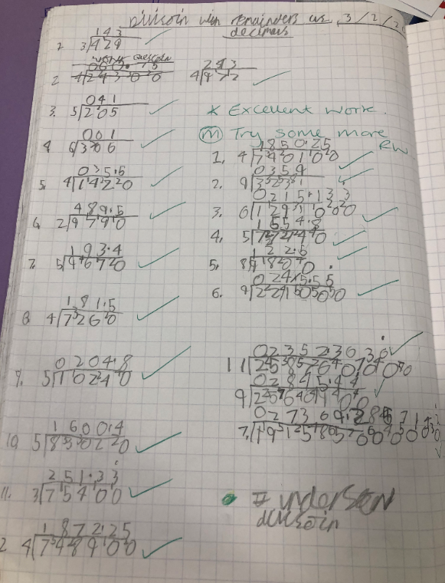
Appendix 1C

Appendix 1D

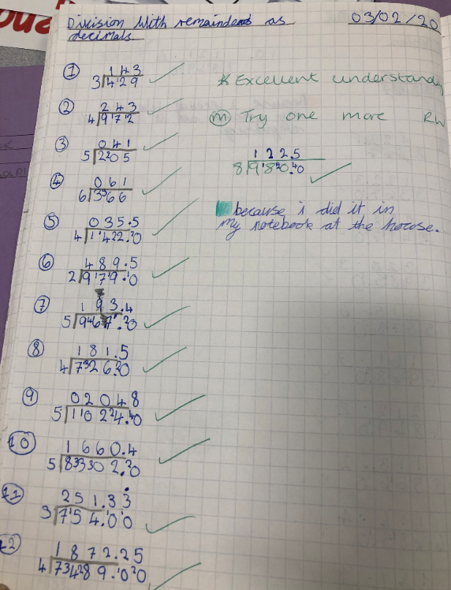

Appendix 1E
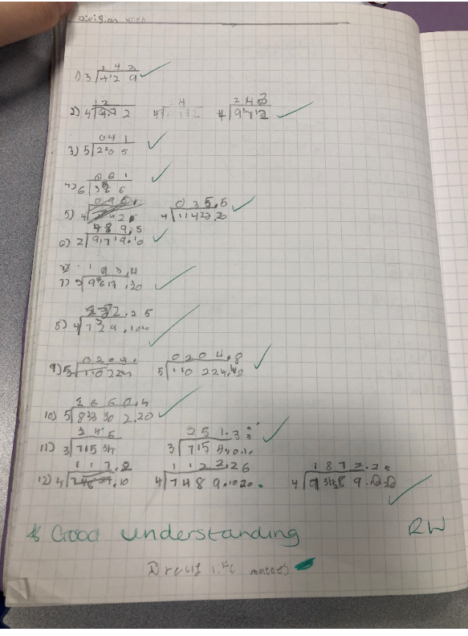

Reflective Model
Appendix 1F

Kolb (1984) and Brookfield (1998, 2005). | Concrete Experience  What did you see?  How did you feel?  What did you think? | Reflective Observation  What worked?  What failed?  Why did that happen? | Abstract Conceptualism  What could I have done better/ different?  How can I improve? | Active experimentation  After first lesson, what would you do in second lesson. If second lesson, what would you do differently?
Self | I used the thumb signal twice during lesson, during recap and after modelling. All 3 pupils used the strategy and signalled that they understood | The concept worked well. Their thumb self-assessment seemed accurate of their ability to do the task and consistent with their work and self-assessment on work | I could have asked them to thumb self-assess once they had started working independently to see if their opinions had changed | In second lesson we will call a pit-stop plenary during task to see if children’s self-assessment changes once they have started doing the work independently
Student | All said they were happy to do the self-assessment. They didn’t look at others and didn’t feel judged by their peers | They understood the concept and were able to display their level of understanding of the work which was consistent with how they completed the work | They all said nothing could be improved and they were happy with the method. However, when probed they did like the idea of everyone closing their eyes | To improve strategy we could get the children to close their eyes when doing Thumbs up/Thumbs down. However, as the next lesson is with younger pupils we want to see if they are as socially aware so will not change it for this lesson
Peers | They noticed that Child 1 was the most confident in signalling, Child 2 did so covertly and Child 3 was mot covertly and looked around a lot at others | It appeared to be an accurate representation of their ability. The lower ability were less confident in using the method so my not work well for them | Unable to compare how confident they felt when starting work as the thumbs up/thumbs down was not done again when they were working independently | Have a pit-stop plenary during the task to check the understanding and see if this has changed. This will allow us to compare answers to see if they change their self-assessment when work is easier/harder than expected
Scholarship | Donaldson (2015), Hattie (2012) and WG (2010) – Children likely to engage more in learning when they are involved in assessing their progress and learning | Brown (2019) not all children will answer honestly due to fear of being judged by peers. Self-assessment skills also need to be taught (Boyle and Charles, 2014) | Using strategy throughout lesson would have given change to adapt lesson/support and address any misconceptions – Boyle and Charles (2014) and WG (2010) | As per Boyle and Charles (2014) and WG (2010) using strategy in pit-stop could be beneficial. Also could include modelling and scaffolding of skills to ensure they can accurately self-assess. (Boyle and Charles, 2014 and Euade, 2011).

Teaching and Observation Schedule – Lesson Study 2
Appendix 2A

When they are signalling…..

Did the pupil….? | 4 | 5 | 6 | Additional Comments
Participate in the signalling when prompted? | Yes – thumbs up | Yes- thumbs up | Yes – middle | All same before and during task
hesitate before signalling? | No | No | Yes
look around at others before  signalling? | No | No | Yes
change their mind after observing their peers responses? | No | No | No
signal openly or covertly? | Openly | Openly | Openly
make a comment if one of their peers  signalled differently? | No | No | No

DURING THE ACTIVITY

Did the pupil…? | 4 | 5 | 6 | Additional Comments
require scaffolding throughout the activity? | Only a very small amount | A little - did ask for some help but just for reassurance | Yes - needed most support and prompting | 3 – did ask for help a lot but she knew the answers when prompted
work independently? | Yes | Mostly | No - as above
look around for help from their classmates/peers? | No | No | Yes

EVALUATION OF PUPIL’S WORK

Did the pupil…? | 4 | 5 | 6 | Additional Comments
complete the task? | Yes – quicker than peers | Yes | Yes
meet the success criteria? | Yes | Yes | Yes
Self-assess their work? | Yes – Green | Yes – Green | Yes – Green

Focus Group 2 - Interview Questions
Appendix 2B
Does using the AFL strategy “Thumbs Up/Thumbs Down” give an accurate representation of children’s understanding?

- Can you explain what I mean when I ask you to signal with...

Thumbs up? – Child 4 – ‘I’m confident to do the work.’

Child 6 – When it’s really good

Thumbs across? – Child 5 - When you know a bit

Child 6 – When its kind good

Thumbs down? – Child 5 – When you don’t want to do the work.

Child 6 – When it’s bad

Answers generally referred to them wanting to do the work or whether the think the work is good. Child 5 and Child 6 both said if they didn’t want to do the work they could do thumbs down and play instead.

- How do you feel when the teacher asks you to show thumbs up / thumbs down?

They all said they thought it was good and did not mind doing it

- Why do you feel that way?

Child 5 – ‘because the teacher can help you’

- Think back to when I asked you to signal using your thumbs, do you think that other children in the class look at how you have answered?

They all said no

- Think back to when I asked you to signal using your thumbs, did you look at how other children in the class were answering?

They all said no they didn’t.

Child 4 – ‘No I would just look straight at the teacher’.

- Would you ever change your answer after seeing that someone else’s may be different?

Child 4 – Said she wouldn’t change and would stay the same.

Other two agreed.
Answer stayed the same, even when probed what if everyone did different to you.

Child 5 – ‘I would always put thumbs up even if I was confused because I would just keep going like Amber.

- How do you feel if someone signalled differently to you?

They all said they would feel okay.

- Can you think of another way that you would like the teacher to find out how you feel about the work?

Child 4 – could not think of any another ways

Child 5 – ‘secret thumbs up’ she said you only put small thumbs up so people cant see, she demonstrated this by only putting up the tip of her thumb which all children then copied.

Child 6 – suggested shaking or nodding their heads

