i.) Literature Review
Introduction
With education currently subject to substantial reform in Wales, this literature review aims to explore and analyse effective curriculum design, drawing on historical and current research, debate and controversy. Including a brief historical overview, the review considers equity and teacher agency within curricula, as well as types of curriculum and the relevance of knowledge. National and international documentation and current guidance will be reviewed and discussed as well as an analysis of curriculum redesign in Scotland and New Zealand.

Historical Context
The effective design of curriculum has become a cause for much national debate and discussion over the last few years with the introduction of Curriculum for Wales (CfW) imminent in 2022.

Many words have been associated with the word curriculum, and with its dictionary definition as “the subjects studied in a school, college, etc. and what each subject includes” (dictionary.cambridge.org), narrowed connotations of knowledge and content become apparent.

The first parliamentary legislation dealing with education provision for England and Wales (1870 Education Act) was published following a commission by the British Government into the state of education in Wales and the Blue Books of 1847. Social disturbances including the Rebecca Riots in South Wales and unrest in Ceredigion over land issues meant Wales was a cause for concern for government officials in England (Carradice, 2011). The following Government enquiry, albeit concerned with the state of education in Wales, was scathing on the Welsh as a people. The Welsh language itself was described in the report as “a vast drawback to Wales, and a manifold barrier to the moral progress and commercial prosperity of the people” (Government,1847,prt 2,p.66), already establishing a link between education, culture and society. The absence of understanding of Wales, its people and its language by policy makers in England could be seen to impact future parliamentary legislation.

By 1880 schooling was made compulsory for five to ten year olds, then for eleven year olds before 1900, with compulsory school age increasing to fourteen by 1918. With the ensuing increase of pupils at schools in England and Wales, teacher capacity was raised in parliament in 1918. Sixty per cent of funding was subsequently provided by Central Government to improve professional standards and allow teachers pensions and greater salaries. (www.parliament.uk) . This ambition however, was not realised due to the economic depression of the 1920s. Significantly, teacher capacity remains a challenge and will be discussed throughout this work.

The Hadow Reports published between 1923 and 1933 gave many recommendations for the education system of that time, and for the first time differentiated schooling into primary and secondary phases. Whilst commenting on the education system following the First World War, the Hadow Reports can be seen as insightful and prescient of an education system yet to come. For instance, ‘The Primary School ‘ report of 1931 recommended that primary pupils be seen as individuals and their curriculum be one of project based learning; rich with activity and experience, as opposed to storing knowledge and facts alone, (Gillard, 2006), with other notable examples evident in the 1926 report, ‘The Education of The Adolescent’. Substance is given to the real life context and relevance of the curriculum, the importance of community, the leadership and ethos of a school and careful contemplation of the role of assessment. With mention of pupils beginning to think of their future careers and the experience and skills required (Hadow, 1926), similarities can be seen almost a century later in guidance on shaping a new curriculum for Wales:-
Young people should all leave school having experienced a broad education that equips them to thrive in an increasingly complex and rapidly changing world. (Donaldson, 2015, p. 28)

The sameness of the recommendations is significant, with preparing learners for an uncertain future fundamental to any curriculum. However, without realisation they are hollow words. Gillard (2006) analyses the legacy of the Hadow Reports and notes that although the committee’s comments on curriculum were innovative and forward thinking, they were widely disregarded. Those that were implemented were concerned with schooling structure such as the distinction of primary and secondary phases.

Furthermore, in a social climate which placed emphasis on scholarships, secondary education was highly regarded and primary education viewed as preparation phase only (Galton, Simon, & Croll, 1980). It could be said therefore, that the progressive and child-centred guidance published in these historical reports although undervalued at the time, is pertinent to consider when redesigning the curriculum in Wales.

The Education Act of 1944 saw the school leaving age rise to fifteen and then sixteen in 1972, and three tiers of secondary schooling commence; Grammar, Technical and Secondary Modern, according to aptitude. With this Act, more autonomy was created, as power was shifted from Central Government to the Local Education Authorities, whilst an examination at the age of eleven divided and determined where pupils were schooled. Although aiming to increase equity in education for working class children in the post war era, using attainment in the eleven plus as a means of sorting did not necessarily ensure more children from poorer backgrounds received their education at a Grammar School.

The introduction of the National Curriculum, with its programmes of study and attainment targets ensured major central government control over schools in England, Wales and Northern Ireland, determining what children should know and when they should know it (Education Reform Act, 1988). With the power over education removed from the Local Authorities and subsequently held by the Secretary of State, the notion of teacher autonomy with curriculum design was nullified; it is understandable therefore that Curriculum be seen as a product rather than a process, where curriculum design may be interpreted as changes to timetables or syllabus structure. Hence, it is understandable that there be a degree of confusion during historic and current debate on curriculum design and development.

The Education Reform Act (1988 Chapter 1, 1.2) describes the National Curriculum as:-

a balanced and broadly based curriculum which—
(a) promotes the spiritual, moral, cultural, mental and physical development of pupils at the school and of society; and
(b) prepares such pupils for the opportunities, responsibilities and experiences of adult life.

The establishment of the National Curriculum and the subsequent rigour of inspections by Estyn although perceived as extreme at the time was apparent in other countries also, (Kelly, 2004) with the task of curriculum design and planning the sole responsibility of politicians, thus reducing teacher autonomy, eradicating trust of the profession, and establishing a ‘them and us’ culture between teachers and policy makers.

On the contrary, current guidance and trends favour the more holistic and inclusive approach, focusing on working in collaboration and inclusivity, with a centrality of vision on what learners should look like at the end of their learning journey. (WG, 2017) Additional emphasis is placed on the teacher autonomy, with the noble aim of freeing up professionals to design a curriculum which realises the needs of their learners.

Curriculum and Knowledge

With its inference of teachers as curriculum designers, it is imperative that understanding of curriculum is gained. Both historical and current research on this subject is far too extensive to consider here; this review will focus therefore briefly on key ideas deemed relevant in the context of the Curriculum for Wales.

Stenhouse suggests that there are three key types of curriculum; - content, outcomes and process, (Stenhouse, 1977), with Kelly later equating these as models of transmission, instrumental and development respectively. (Kelly, 2009). Two curriculum idealogies of content (knowledge), and product (outcomes) are explored by Kelly and he argues that neither, as individual models, or when combined, are successful in the context of whole curriculum design as they fail to consider the learner’s autonomy. A process curriculum however focuses on the learners it creates, beginning with long term purposes of education, (Stenhouse, 1977) and correlates with current national and international curriculum reform trends. With pupil well-being at the forefront of current national policy, enabling learners to reach their full potential (WG, 2017), the attraction of a process curriculum ideology is easy to comprehend, however on its own, does not prioritise ‘knowledge’.

Nevertheless, a process curriculum does not nullify content or knowledge, it is merely deemed of secondary importance. Much debate has been given to a knowledge versus skills argument, with both observed as separate entities, yet as Donaldson states, this argument is ‘unhelpful’ since the contributions of both are vital to realise a curriculum’s purpose. (Donaldson, 2015). Priestley explores this notion further and considers three types of knowledge imperative to achieve balance in education:- “propositional knowledge (knowing that), procedural knowledge (knowing how) and epistemic knowledge (the approach to inquiry)” (Priestley, 2019). This is complementary to experiential learning, where authentic learning is planned within a relevant context, and reliant on teacher experience. Hence, the knowledge that is delivered is only as meaningful and competent as the experience of the one who delivers it.

Further, Young (2013) comments that there is onus on educators to pass on knowledge through the generations to ensure their historical context, in order that they may create new knowledge in the future (Young, 2013). The significance of this can be seen, notably where a process curriculum is aiming to creating citizens for the future. However, the ever changing nature of society requires the relevance of knowledge taught be frequently reviewed. The ongoing debate of what defines a curriculum and what knowledge should be taught, is both relevant and pertinent to discuss. The lack of consensus however, only compounds confusion for professionals who are expected to know and teach what children ought to learn and know.

Current national and international curricula trends emphasise the learner at the core and concern the “nature of the child and his or her development as a human being” (Kelly, 2009, p. 91). When considering this, the significance of learners’ environment is imperative. Deemed by Priestley as an ‘unconscious and unintended teaching’ (Priestley, 2019), the hidden curriculum considers the attitudes, ethos and values of a school as implicit to what is learnt. Further, Myatt comments on the ‘tone’ of productive organisations and profitable businesses who successfully communicate their messages, ideologies and values to their customers (Myatt, 2018). With the aim of schools as learning organisations in Wales ‘developing and sharing a vision centered on the learning of all students’, (OECD, 2016), due consideration to the significance of a hidden curriculum is required. The concept of a hidden curriculum therefore is significant in current curriculum redesign, as how it is enacted by all agents within a school enhances a learner’s development.

Equity of Curriculum

The effectiveness of previous curricula in relation to lower socio-economic groups is relevant to consider, with Coldron et al arguing that since the nineteenth century schooling has compounded the class divide, where those with wealth gained educational advantage for their children (Coldron, Willis, & Wolstenholme, 2008). Although concerned with the education system in England, the scorn of the Blue Books (1847) and the sorting of three-tier education system (1944) are pertinent when considering their consequence on Wales’ poorest learners historically.

Wales’ current reform of its education system aims to “raise standards, reduce the attainment gap and deliver an education system that is a source of national pride and confidence” (WG, 2017). Moreover, the Education Minister argues that Curriculum for Wales will make a difference to all children, specifically mentioning those from poorer backgrounds. (Williams, 2019). With twenty nine per cent of Welsh children living in poverty (Bevan Foundation, 2019), the notion of equity is more relevant than ever.

The Curriculum for Wales, a broad framework, has been the subject of some recent controversy, with concerns that its vagueness may leave poorer learners vulnerable. Recent research surveying six hundred teachers from Pioneer Schools found that only thirty per cent believed CfW would benefit pupils from disadvantaged backgrounds (Newton, 2019). Newton implies that disadvantaged learners were not the main consideration of teachers interviewed; and states more forward planning is needed to enhance parental engagement, transition and mixed ability classes when reducing the attainment gap. (Newton, 2019). Although Newton’s data is alarming, it is pertinent to consider the timing of this research; with curriculum development in its infancy, planning for this group of learners is crucial.

Current National Context

Whilst aspirational and ambitious, Wales’ curriculum aims stand in stark contrast to previous reforms, focusing on the engagement of its learners and enabling autonomy within the teaching profession. Education in Wales has experienced many changes in the last twenty years, with the country achieving devolution in 1999 and further legislative powers for the Assembly in 2007 and 2011. During this period, Wales’ performance in the Programme for International Student Assessment (PISA) has been consistently and significantly below average (OECD, 2014) which influenced previous policy changes, including the Written Statement of Performance and Standards (2011) where the then Minister for Children, Education and Lifelong Learning stated “performance will be our driver”, prioritising data to measure progress.(WG, gov.wales, 2011), thus exacerbating a data and accountability culture. Along with a later report in 2012 including an exhaustive twenty-point plan for better standards, and the legacy of the National Curriculum, it is unsurprising that a lack of trust between policy makers and teaching professionals may remain today.

Conversely, the tone of current guidance is softer, with emphasis on working in partnership and collaboration. This is illustrated and compounded by the continuous and extensive use of ‘we’ and ‘our’ by Welsh Government (WG) in many present publications and guidance, including ‘Our National Mission’ (2017), ‘Draft evaluation and improvement (accountability) arrangements for Wales’ (2019) and current assessment proposals. The linguistic style of such documents contradict the autocratic style of previous Government guidance, while in the same way fostering a sense of working together towards the same educational objective. Thus, WG aligns with Donaldson’s aspiration of “mobilising the education community around a common mission” (Donaldson, 2015, p. 21). Although aspirational in vision, and fair in intention, more effort, support and clarity is needed to restore trust in the profession and prevent empty talk.

However contrasting to previous curricula, CfW does build on one element of its precursor, extending the holistic aims of the Foundation Phase beyond the ages of three to seven years old. With the Four Purposes creating ‘ambitious, capable learners; enterprising, creative individuals; healthy, confident individuals; and ethical, informed citizens’ (WG, 2017, p.19) CfW places child development at its heart. Promoting engagement and relevance in learning, CfW is a framework which aims to prepare learners to prosper in an uncertain future. (Donaldson, 2019). Describing today’s learners as living through a historically significant period of change (Donaldson, 2018) Wales’ curriculum reform can be seen as a crucial transformation with many expectations to fulfil, providing opportunities to realise previous familiar recommendations of the Hadow Reports. Yet an ever changing world suggests ever changing educational needs, thus requiring an ever evolving curriculum that is suitable, accessible and effective for all.

Published in January 2019, the draft CfW separates itself from the previous over-prescription of the National Curriculum. Replacing subjects are six Areas of Learning and Expertise (AOLE), each with What Matters statements pertaining to what knowledge is relevant. As expressions of key concepts of learning for each AOLE, the statements aim to enable learners to make connections in their knowledge, experiences and skills, (WG, 2019), alluding somewhat to Priestley’s aforementioned balance of knowledge (Priestley, 2019). Progress is measured along the Progression Steps, a continuum of learning from three to sixteen years of age, with wide ranging expectations signposted for the ages of five, eight, eleven, fourteen and sixteen. Although assigned to age at certain points, the draft accentuates that the Progression Steps are not indicators for summative assessment at specified ages, instead they are used as a tool to inform and monitor. (WG, 2019) Realising this aim however is perhaps one of the greater challenges, considering previous climates of accountability linked intrisically to pupil performance. Attached to the Progression Steps are Achievement Outcomes, a series of ‘I can….’ and ‘I have….’ statements from the perspective of the learner, reinforcing their centrality in learning yet replicating the language of Scotland’s Curriculum for Excellence (CfE).

Scottish Context

The development of a learner’s attributes as core to education policy, whilst revolutionary in Wales, is not dissimilar to other national and international reforms. Scotland’s CfE places the Four Capacities of ‘successful learners, confident individuals, responsible citizens and effective contributors’ (Scottish Government, 2008, p. 13) as the aspirational values of its learners and citizens of the future. As Wales, its implementation followed the recommendations of Donaldson and hoped to give teachers flexibility in their teaching, yet CfE has not been without criticism or challenges in its development and rollout. Although implemented statutorily for pupils aged three to eighteen in 2010, the curriculum was initially published in 2004 as a broad framework. To provide teachers with further content, the structure of eight learning areas followed in 2006, with ‘I can’ and ‘I have…’ progress statements of experiences and outcomes published in draft in 2007. Within four years, CfE had evolved; from its mantra of four capacities to an overloaded curriculum with hundreds of objectives over six levels (Priestley & Hulmes, 2010), resulting in a prescriptive contradiction.

With no real pedagogical guidance evident in its curriculum document, CfE contains a real ambiguity for teachers, thus becoming a pitfall in which previous lesson plans and assessment routines maybe relied on. Caution is therefore required when designing the curriculum. Priestley and Hulmes argue that the lack of clarity within the broad framework of CfE, along with its confusion of various models of curriculum, is responsible for its failure in realising its innovative potential. (Priestley & Hulmes, 2010). Without a solid understanding of curriculum theory, any educational aims may be seen as a trend thus diluting the purposes, and widening the previously discussed attainment gap.
Initial engagement with CfE was high, and as alluded to earlier, Scotland’s new curriculum promised progressivity in teaching and learning. However, as Priestley and Minty state (2013), second order engagement with CfE was a complex and multi-layered issue. Their research conducted with primary and secondary teachers, whilst narrow in subject, recommends fuller understanding of curriculum philosophy along with professional learning to support teachers in their engagement (Priestley & Minty, 2013). There are gaps in this research however, with a sample of twenty one participants interviewed from one Local Authority only, during 2011, only one full academic year since statutory implementation of the curriculum. Given this, wider research would be beneficial in establishing perceptions of the profession.

Teacher Agency

The lack of professional training for schools and teachers were highlighted as concerns for CfE (Scottish Parliament, 2010) and are issues which Wales’ national mission aims to counter through the development of ‘effective learning organisations’ and “learning from excellence at local, national and international levels”. (WG, 2017 p.11). The challenges faced by Scotland should not prevent the success of a new curriculum in Wales yet as Priestley and Minty suggest, much could be gained from the development of “teacher agency”. (Priestley & Minty, 2013 p.22).

The notion of teacher agency, although debated by many in the past is particularly fitting currently, corresponding with the ongoing emphasis on teachers as curriculum designers and change makers. Enabling teachers to exercise autonomy and make decisions in their own practise is a heartening idea, yet as Priestley comments it is an “elusive concept” influenced by numerous factors including past experience, future expectations, environment and structure (Priestley, 2015) . Although perhaps understood as being pertinent to an individual’s capacity to act, Priestley argues an ‘ecological approach’ which requires the development and understanding of agency at various levels (Appendix i) within an educational system. (Priestley, Biesta, & Robinson, 2015). With previous curricula providing prescriptive constraint on the teaching profession, a sudden shift to autonomy presents an immense challenge, thus teacher agency must be encouraged from the top down. Macro policy makers confidently aspire to freeing teachers from previous curriculum confines (Williams, 2019), however clarification and further detail is needed on how this is to be executed. Without this, agency is unable to progress at Meso and Micro levels in the dark, resulting perhaps in teachers’ reliance on previous curriculum methods. It could be stated however, that agency may be developed within the Micro level regardless, dependant on school vision and ethos. Whilst ecology at a school level is possible to develop further, without Macro level direction and Meso level guidance and support, this would be ineffectual.

International Context

In alignment with international trends, New Zealand aims to prepare its learners for the future and respond to the needs of an ever-changing society. With its vision of creating “lifelong learners who are confident, creative, connected and actively involved” (NZG, 2010), New Zealand’s Curriculum Framework (NZC) became compulsory in 2010, following its initial inception in 2000.

In contrast to the frameworks of Wales and Scotland, more weight is given to the values of New Zealand’s curriculum (Appendix ii). Sitting alongside Key Competencies, the eight Areas of Learning and their Achievement Objectives, Values are required to “be evident in the school’s philosophy, structures, curriculum, classrooms and relationships” (NZC, 2007,p.10). Explicitly stating these values in the NZC, echoes the importance of the hidden curriculum; enabling a school to develop their ethos and curriculum accordingly, whilst working toward common national goal. Benade however states the implications of this, with the co-ordination required to ensure shared beliefs in pedagogy, causing problems for teachers and learners. (Benade, 2011)

That aside, the NZC does provide pedagogical guidance to ensure cohesion in teaching and learning. This guidance published as policy, engages with a range of teacher approaches and encourages teacher inquiry (NZC, 2007), thus emphasising professional learning and self reflection. Indeed, the curriculum document itself is detailed and sets direction for teachers and learners, through its achievement objectives. With significance placed upon teachers to build on this framework, such pedagogical and content guidance is relevant, giving clarity when beginning to design how to teach and what is taught.

Nevertheless there has been much debate on the dilution of knowledge in the NZC, with strong arguments voiced in national newspapers by educationists, including Professor Elizabeth Rata (New Zealand Herald, 2013). Concerned with a lack of ‘content knowledge’ in the NZC, Rata argues the importance of teaching children abstract knowledge, outside of a child’s experience so that he or she is able to apply this in the future. (Rata, 2013). Rata disputes the notion that knowledge is a process and argues that without content, teachers’ knowledge is invalidated. (New Zealand Herald, 2013). It could be said therefore that subject specific teaching provides more content knowledge, however, it is the knowledge of the teacher which is of crucial importance.

Indeed, ‘knowledge’ (along with ‘skills’, ’character’ and ‘meta-learning’) is acknowledged by The Center for Curriculum Redesign (CCR), as a fundamental dimension when deeply redesigning a curriculum that fully prepares learners for twenty first century needs. (CCR, 2015). A non-profit global organisation, that works to improve education at a Supra level, the CCR calls for a need to rethink the significance of what knowledge is taught (CCR, 2015), although the ambiguity in whose responsibility this is remains, and is open to further debate and research.

Priestley and Sinnema (2014) further explore the demotion of knowledge in the NZC and CfE, analysing in detail how the term is expressed in both curricula. (Priestley & Sinnema, 2014). Searching through both samples for the word ‘knowledge’ using Statistical Package for the Social Sciences (SPSS) their evidence found plenty mention of ‘knowledge’ and its derivatives. However, while emphasised in policy language, their research concluded a lack of specification, leading to therefore to superficiality. Consequently, what learners know is reliant upon user interpretation, encouraging further debate of teacher autonomy and professional learning. Benade describes previous New Zealand (and international) policy as having “had corrosive effects on teacher professionality” (Benade, 2011, p.151) ; the question therefore, of how best to support the profession and develop teacher agency when designing a curriculum is fundamental.

ii.) Contextual Study
Introduction
I am a Deputy Head teacher of a Welsh Medium Primary School having taught at the end of Key Stage Two (KS2) for over sixteen years. Within my setting I am a full time class teacher in year six, Literacy Leader as well as being responsible for Pupil Performance and Standards. I co-ordinate assessment and moderation procedures throughout the school, oversee target setting as well as analyse performance and assessment data. I present an annual performance data report to the Governing Body which forms part of our Self Evaluation Report; review progress against individual pupil targets and present this to the school’s Challenge Adviser throughout the year.

This study discusses the challenges and opportunities for implementations of the Curriculum for Wales, in the context of my setting. These are illustrated by a critical reflection of learning visits to two contrasting schools, and the lessons learned therein. The themes of ecology, capacity, collaboration, accountability and assessment are discussed in this section and were chosen for their relevance to my current role. Challenges and opportunities are explored at Macro, Meso, and Micro levels (Appendix i).

School A
School A is a four to eighteen state funded, free school built on a small school model. Situated in Stratford, East London, School A was founded in 2012 holding firmly the belief that the current education system was unfit for purpose. Its aims were to equip students for the twenty first century; - preparing children for a world we can’t predict and jobs that don’t exist yet. Interestingly, this aligns with Hadow’s recommendations of 1926 where the committee argues that learning be closely attuned to the ‘living texture’ of life. (Hadow, 1926)

School A’s success is growing – with a current three-from entry and one thousand, two hundred and thirty five pupils on roll, and recent Government approval for a further two schools in London.

The school’s core values of ‘Choose Kind, Step Up, Reflect and Grow, Above and Beyond and We Build Strong Circles’ align somewhat with the Four Core Purposes of Curriculum for Wales and focus on a holistic approach to teaching and learning, placing the learner at the centre. These core values are intrinsic to the school’s Head, Heart and Hand Curriculum, where oracy, project based learning and wellbeing are central to its pedagogy.

With the current curriculum redesign in Wales, much debate has been given to the knowledge versus skills argument. School A’s belief is that content and knowledge is fundamental (Head); that its application is engaging, relevant and practical (Hand) and complimentary to this is the deliberate development, empowerment and wellbeing of its learners (Heart).

Parental and community engagement is interwoven successfully by way of termly exhibitions of ‘Beautiful Work’, ‘Bring A Parent to School Week’ and a Community Choir. Developing links with parents and community is not seen as an add-on or something extra to the learning that takes place; instead it is an established and integral part of the learning. With the school being such an intrinsic part of the community, barriers between the school and its parents are few. This collaborative approach ensures that the school ethos becomes more of a community ethos, thus preparing learners for their future becomes a shared responsibility.

The development of oracy is paramount to the pedagogy of the school, with many pupils on roll having English as an additional language, speaking and listening is seen as fundamental in the empowerment of its learners. Similarly, the role of speaking and listening has been identified as an area for improvement in our current School Development Plan, with Welsh being the additional language in our context. Historically, much emphasis has been placed on writing in our own setting, and in a society where technology has replaced talk, opportunities for speaking and listening must be carefully planned. School A’s aim that every child finds their voice, metaphorically and literally, is a belief that definitely applies to our school priorities and to the current climate of curriculum development.

A barrier acknowledged by School A itself is the issue of data and assessment. Whilst their ethos is inseparable from all learning in Reception class to Year 10, School A acknowledges year 11 learning looks very different due to GCSE examinations. When questioned regarding data performance and accountability, it was stated that there is no culture of data whatsoever within the school and discussions related to data are scarce. It was mentioned however that the school performs within the top 8% of schools in England for progress at GCSE level, perhaps appearing dichotomous. The school has identified a challenge in finding an assessment model which captures all that their pupils achieve and how they learn, with funding for a way of assessing a current priority; possibly using PISA elements to support this. Given the school’s intentions of eradicating the ‘data culture’, and acknowledging the current state of education and examination as unfit, the measure of GCSE performance as an illustration of success remains. Thus it presupposes a challenge for CfW, notably between 2021 and 2022, and during the adaptation of GCSEs.

School A has rigorous Continuing Professional Development (CPD) in place for all staff. One teacher interviewed who started as Primary Oracy Lead at the school last year described her initial few weeks as ‘overwhelming’ and ‘like nowhere she had ever worked before’, with the school having a very different approach on pedagogy. The school’s ecology is fundamentally developmental – for both learners and the teachers, with a strong induction in place for new teachers, and ongoing working partnerships between inexperienced and experienced teachers across phases and subject. Regardless of subject specialism or age phase each teacher is a teacher of Oracy, Wellbeing and Beautiful Work. Underpinning everything is School A’s core belief and vision, which is enacted by all.

Although aspirational, this model does pose many barriers in a much smaller Welsh medium primary school such as ours. In contrast to School A, teacher capacity and time are significant issues which must be addressed at Micro, Meso and Macro levels to ensure effective professional development. The capacity of Welsh medium teachers is itself a barrier to effective CPD opportunities, perhaps affecting successful implementation of CfW. Nevertheless, our current CPD practices would benefit from developing an interdisciplinary and age phase collaborative approach.

The success of School A is that it indisputably knows itself, its learners, and its community, and adapts accordingly. It has developed a culture which is collaborative and community minded. By its own admission the school is still a work in progress and will continue to evolve, as our society, our world and what is expected of our learners is ever changing.

School B
School B is an eleven to eighteen community comprehensive school for boys located in Pengam, Caerphilly. Having received Pioneer School status in 2016, it is working with WG and other schools to take forward curriculum developments and professional learning. During the summer term of 2017, school leaders set out to form a ‘Challenge Curriculum’, with the vision of extending the project based learning of primary education into the secondary phase. Although innovative in concept, the school has faced many challenges and barriers, thus many lessons can be learnt from this school’s experience.

The objective of the school leadership team (SLT) was progressive; a former primary school teacher was appointed as Curriculum and Literacy Lead for years seven and eight, responsible for designing a thematic curriculum in year seven initially. With emphasis on real life context and collaborative learning, the five areas of Communication, Calculation, Construction, Creativity and Citizenship were born. Pupils when entering year seven were placed in mixed ability groups (with the exception of Calculation) and received lessons from five teachers only. Whilst many successes ensued in its first year, the challenges and barriers were multi-layered and complex, leaving the school’s curriculum in a subsequent state of confusion.

As noted, many positives arose in its first year; in a school where behaviour had previously been a problem, pupils’ behaviour logs significantly improved. This was attributed by the Curriculum Lead to pupils being taught by fewer teachers, thus developing better working relationships. Collaborative learning between mixed abilities raised confidence in learners and pupil engagement was high, (Estyn, 2018) due in part to cross curricular themes and the allocation of individual Chromebooks to improve Literacy. Notably, the only behaviour issues that arose were in Calculation lessons, where pupils were set according to ability and taught discretely. Interestingly, similar patterns have been seen in my setting where upper KS2 pupils are set for Literacy and Numeracy. Although designed to ensure everyone is learning at their appropriate level of challenge, learner engagement and confidence is higher when in mixed ability classes and individual needs are met by detailed differentiation. Some caution is required therefore when considering streaming pupils according to ability, as doing so may very well be detrimental to wellbeing and behaviour.

Complimentary to the Challenge Curriculum was the removal of levels. Pupils were tracked according to ‘I Can’ skills across areas of learning, and as a result Assessment for Learning was strengthened. Progress was recorded by use of colour coding on the School Information Management System (SIMS), which although thought to be given a positive response by Estyn initially, caused confusion when their report noted a lack of ‘progressive development of pupils’ skills across the curriculum.’ (Estyn, 2018) . Ensuing visits from the school’s challenge advisor recommended a full removal of the ‘I Can’ system with the SLT returning to sublevel tracking as an interpretation of this. Ironically, the lack of coherence between Macro, Meso and Micro levels affected the progression of the curriculum into its second year, and poses challenges for the future which I will explore later.

Although learner engagement was strong, teacher engagement posed a barrier. Initial communication regarding the new curriculum was met with some reluctance according the Curriculum Lead, who, on reflection, believes the implementation of the new curriculum was rushed and forced. As Donaldson recommends, any revision of curriculum and assessment arrangements be introduced at a ‘measured pace’ alongside supportive methods that establish understanding (Donaldson, 2015). This aligns directly with the rollout timeline published by WG in its National Mission (Appendix iii) where the timeline rollout of the curriculum is graduated over nine years, especially towards the latter end of the continuum. Any curriculum changes at the Micro level therefore, should seek to correlate.

Conversely, subject teachers directly involved with teaching the Challenge Curriculum reported a growth in confidence and versatility at the end of its first year, with three subject teachers gaining posts in the primary sector. The connection between primary and secondary phases must not be overlooked, with more collaborative work between both phases required, thus ensuring a greater knowledge within the profession of a three to sixteen learning continuum. In my role of year six teacher, current transition arrangements place increasing focus on thematic projects with year seven teachers in the summer term. There is great scope to develop this beyond these year groups to ensure deeper understanding.

It was noted by the Curriculum Lead that ‘those who teach it love it, and those who don’t, don’t’, which is testament to the professional learning undertaken by the curriculum teachers, and the support of their mentor, while conversely illustrating the lack of understanding by others. This highlights the relationship between professional learning and curriculum implementation, yet at its foundation must be the vision of the school, communicated to all.

Ethos and Ecology
In comparison to School A, School B’s intended curriculum is not dissimilar – with creative thinking, community links, wellbeing and interdisciplinary learning common factors of both. Nevertheless, the biggest difference observed, and possibly the most significant when evaluating success, is the overall ethos and ecology of both schools. Whilst School A’s philosophy and vision is intrinsic in all it does, School B’s curriculum could be described as a misfit – an innovative pedagogy sitting alongside an old system, underpinned by an unsustained vision. It is only when the school’s ethos is enacted within an effective ecology that its curriculum is realised.

The notion of ecology as the “relationship between people, and their environment, and the balances between these relationships” (Collins) is pertinent when exploring the opportunities for developing CfW. Although a challenge, it is one that must be implemented at Micro level, through strong leadership and a fundamental understanding of our learners’ needs. Further to this, as Myatt comments “the curriculum should be done with the pupils, not to them” (Myatt, 2018) perceiving all teaching and learning as holistic, and viewing all school stakeholders, our environment and our community as one single system. When there is clear communication of vision by school leaders, strong foundations of core values and pedagogy may be built. Executing this in a smaller Primary setting such as ours, could prove less of a challenge than in the Secondary setting of School B.

Whilst the curriculum is a broad framework, its development in detail is the responsibility of teachers, as Donaldson alludes (Donaldson, 2019). Given this, CfW will only be as competent as those who establish and enact it, informing many implications for CPD. In theory, this could be realised in our setting where mentoring is embedded as a way of developing teachers and sharing experience in a supportive environment. On the larger scale of whole curriculum redesign, where professional development is a necessity for all school leaders, teachers and teaching assistants, the issues of capacity must be broached.

Capacity and Collaboration

The aim of CfW to free up professionals from an overstuffed and overprescribed curriculum (Williams, 2019) is a noble one by our Education Minister, yet easier to transmit than enact. Developing teacher agency, described as teachers’ “active contribution to shaping their work and its conditions” (Priestley, Biesta, & Robinson, 2015, p.1) provides opportunity to raise the status and confidence of our profession and is inherent in realising our curriculum’s potential.

As discussed earlier, the expectation upon teachers as curriculum designers surely calls for a deepened understanding of curriculum by all involved in its design development. Without this, we encourage a risky autonomy, relying solely on teacher’s experience and individual interpretation to shape the future. Developing a high-quality teaching profession is a national objective (WG,2017, p. 25) with the Education Minister designating over forty million pounds over two years for curriculum rollout (Williams, 2019). Considering also the launch of the new Professional Standards for Teaching and Leadership, and a commitment to lifelong learning, the intent to build capacity appears well intentioned at Macro level. Despite this however, the question of how funding will be allocated and, what, in an already busy timetable, lifelong learning will look like remains to be seen.

Much focus is given to school-to-school collaboration when building our professional capital (OECD, 2014, p.65), and with reason as this is one aims we hope to foster in our learners, yet the barriers of funding and time remain. An essential point to consider is the role of the Pioneer Schools in this process. Having been allocated funding by WG to lead the development of Wales’ new curriculum, a challenge now at Macro and Meso levels is to ensure this work is disseminated to non-Pioneer Schools. With teacher collaboration within the Micro level effective for CPD, extending purposeful opportunities between learning organisations is paramount.

It is a truism that CfW will look different in every school; providing opportunites to ensure a bespoke curriculum and equity for the broad range of schools in our country. However, consideration must also be given to an inevitable variety of teacher capacity in each setting, possibly leading to inconsistency and inequity within the profession. Barriers already exist with regards finding supply staff to release teachers for CPD activities in my own Welsh medium setting at the top of a South Wales valley. In addition to this, attracting applicants for teaching and senior management roles has proved challenging in our school during previous years, due in main to the geographical issues. Despite the establishment of the Education Workforce Council and reforms in Initial Teacher Education to “draw the most capable people into the profession” (OECD, 2014, p.65), any future impact is certain to take a number of years, perhaps widening equity, capacity and attainment gaps between schools.

Accountability and Assessment

Previous accountability structures have formed the backbone of our education system in Wales for many years, with our system being concerned more with performance indicators than the performance of individual learners themselves. This has been acknowledged by WG as having created competition in the place of collaboration, a constricting curriculum for learners as well as unneccessary workload for teachers (WG, 2019), and is addressed as part of the current reforms. The collaborative tone of the document focuses on all levels working together for school improvement, promising shared responsibility. Opportunities for the involvement of all school staff, stakeholders and peers during self evaluation are evident (in draft), with a welcome shift in focus to the progress of the individual learner. Whilst these intentions are promising, no model is given on exactly how this collaboration will be enacted, leaving a rather woolly and wordy set of guidelines, fundamentally lacking in specification.

Mention is also given to the wellbeing of learners and staff, an encouraging alternative to the pressure placed on both during times of national testing, formal assessment, moderation and data collection. The publishing of end of Key Stage and National Test data at Micro and Meso level will cease (WG,2019), providing opportunities to use teacher assessment as a tool to better inform teaching and learning. Again, a welcome shift in policy, yet the enactment is subject to a deep understanding by all teachers as what good learning looks like, how it should be measured, and how this is envisioned and supported by school leaders. Without this fundamentally in place, teachers and therefore schools, may revert to what they already know, thus relying on previously used assessment methods or an over reliance on Achievement Outcomes as a tick box list to measure progress.
As observed in School B, the role of Meso level advisers is wholly significant. Supporting schools during curriculum reform, is a priority for Estyn, proposing a partial suspension of formal inspections and visits focused on engagement (Estyn, 2019). Such commitment to support reiterates the theme of collaboration by WG, and it follows that the Meso level should emulate this also. Therefore, the previous role of challenge adviser, concerned with pupil targets, performance data and categorisation against these wouold benefit from aiding curriculum redesign, supporting professional learning and facilitating collaboration between schools.

Conclusion
Given the analysis of the above, and the synthesis of visits to School A and School B, the implementation of CfW in our schools is multi-faceted on all levels. Although freedom has been given to teachers to design their curriculum, this autonomy brings with it a greater responsibility of deeper professional learning. This trust of educators is a positive step forward, yet is a step onto dangerous territory if done without support. Clarity and firm leadership is imperative at Micro level; when a school has an established vision and agreed approach for curriculum implementation, the step forward is no longer as daunting. In the first instance, commitment must be made in school to a gradual implementation of CfW, where everyone is able to gain a thorough understanding of curriculum. Complementary to this is the allocation of time for teachers to make sense of the changes that are happening as well as identify needs in CPD. This undoubtedly requires further consideration and careful planning at Macro level.

Implications are also multi-layered at Meso level, predominantly in the areas of support and enabling collaboration. Support is essential, and should cascade from the top level down, in order that the data driven culture be fully eradicated. Macro policy may promise opportunities, yet these must be enacted at Meso level, to prevent these intentions becoming lip service only. With collaboration emphasised in national policy, the communication between Pioneer Schools and non-Pioneer Schools is crucial in any Meso support model. It is only when constructive support and cohesive guidance is established at consortia level, that school leaders become enabled to confidently adapt their curriculum and assessment methods according to individual needs of their learners.

iii.) Forcefield Analysis and Governors’ Report
Introduction

The Governing Body (GB) is inherent to any school and its vision. With a responsibilty of working with the headteacher to make strategic decisions, their role in ensuring clarity of direction is key. This element considers implications for our GB and school when managing the implementation of CfW in our setting. Forces for and against change are identified in the Force Field Analysis (fig.1), which forms the basis of a detailed report to Governors, stating the challenges, risks, justifications and recommendations for our school.
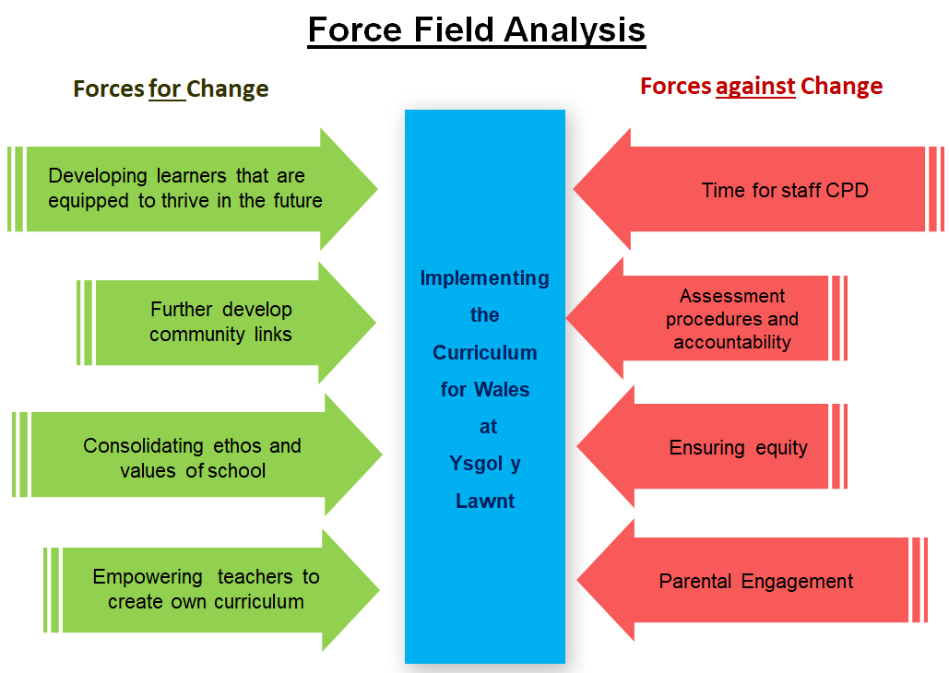
fig.1. Force Field Analysis of the reality of implementing the Curriculum for Wales at Ysgol y Lawnt.


Ysgol y Lawnt

“Wyf Gymro, mynnaf fy iaith yn ôl”

Governors’ Report:- Implementation of the Curriculum for Wales

The implementation of Curriculum for Wales in 2022 marks a significant change for all schools in Wales. With the Four Purposes of Ambitious, capable learners; Enterprising, creative contributors; Ethical, informed citizens; and Healthy, confident individuals, central to all, the current curriculum reform aims to ensure our learners thrive in an uncertain future, places trust on the teaching profession to create authentic learning opportunities and enables us to further fulfil our school vision and ethos.
This report considers the implications of its enactment at Ysgol y Lawnt, examining the challenges and risks we may face, as well as recommendations for our way forward.

Challenge  (when implementing Curriculum for Wales) | Risks and Justification  (what could prevent this challenge being overcome)
- Engagement of all stakeholders with Curriculum for Wales principles | - Lack of information on changes at National, Regional and School level could alienate and confuse parents, staff, governors and learners.  - Information presented by media could mislead and create culture of negativity and mistrust.  - Not enough time spent with learners themselves to develop the four core purposes,
- Staff professional development | - Not enough time allocated to schools to enable the enhanced Professional Learning required to realise the Curriculum for Wales  - Lack of capacity in Welsh primary teachers to release teachers from classrooms to work in collaboration and/or engage with CPD activities.  - Teaching Assistants may feel undervalued or have lack of clarity with regards their role in the curriculum implementation.
- Implementing ‘change’ | - Inexperienced teachers may feel overwhelmed by their autonomy and freedom to make changes to how they teach.  - Experienced teachers may fear change and rely on previous methods.  - Change may be executed too quickly, resulting in superficiality.
- Assessment procedures | - Change in focus to formative assessment - Lack of teacher understanding may lead them to revert to previous assessment procedures to measure progress  - Improper use of Achievement Outcomes in new Curriculum to measure outcomes, with risk of becoming a ‘tick box’ exercise.  - Continued use of national reading and numeracy tests (online) may not tally with progress measured by teacher assessment.  - Continued format of end of Key Stage moderation until 2022 could continue teaching to an old system, and hinder full realisation of curriculum.
- Accountability | - Change of role at comsortium level to support schools needs clarification.  - Over reliance on performance data to measure school may continue, with mention (draft) of school level indicators to drive improvement posing a risk  - Change in assessment may present further challenges when reporting to parents.
- Ensuring equity for all. | - Socio-economically disadvantaged learners may not achieve same learning as peers in other parts of Wales, thus widening the attainment gap.  - Difference in teacher capacity in Welsh medium education could lead to gaps in professional development, consequently affecting learner experiences.  - Contrast between resources and facilities from school to school may undermine equity aims.

Recommendations
Following analysis of the above challenges and risks, the following recommendations are presented for the way forward at our school:-

- Ensure school ethos underpins everything we do when enacting the Curriculum for Wales, and designing a bespoke curriculum that suits our learners’ needs.

- School to engage gradually with elements of Curriculum for Wales and monitor termly.

- Develop pupil voice when developing Curriculum for Wales and Self Improvement systems.

- Ensure information on Curriculum for Wales and our journey towards it is shared with parents; hold engagement afternoons.

- Continue to engage all staff in school improvement systems.

- Create professional learning opportunities within school ecology, which support collaboration between all teachers and teaching assistants.

- Involve GB with learning walks with Four Purposes as focus.

- Implement Professional Standards for Assisting Teaching with teaching assistants to further support their development.

- Develop ongoing understanding of formative assessment and assessment for learning, use as focus for staff meetings.

- Continue to create and develop more links with home life to engage more closely with parents.

- Continue to monitor performance of eFSM pupils and vulnerable groups more closely.

Conclusion
In conclusion, the Governors’ Report presents numerous challenges and risks, yet while there are many; all are relevant to the setting of our school. In summary, most challenges relate directly to how we, as a school express our overall vision, and further development within our school ecology will help to overcome them.

Similarities are evident when comparing the challenges for Ysgol y Lawnt and those identified at national and regional level in part two of this portfolio. It would be anticipated therefore that further guidance in future policy would minimise these challenges somewhat.
Converesely, the individual situation of our setting, as with others, raises its own challenges, and ongoing forethought and forward planning is needed, notably in the area of equity of curriculum for our disadvantaged learners. Although many recommendations are presented, it is hoped that a gradual and structured way forward would be implemented in accordance to these. In addition to this, the reports’ recommendations are not wholly new; some are already established and ongoing targets, however, all align with current school priorities.

First order engagement with the purposes of the Curriculum for Wales in our school is high, and the next steps on our journey must develop this even further. Admittedly, this reform will not or should not happen overnight, but clarity in vision of what the curriculum looks like in our school and for our learners is key. Sharing this vision, and intrinsic to our school ecology is the Governing Body. Their role in supporting this change therefore is crucial, with continued monitoring of our implementation of the Curriculum for Wales essential.

Appendix (i)

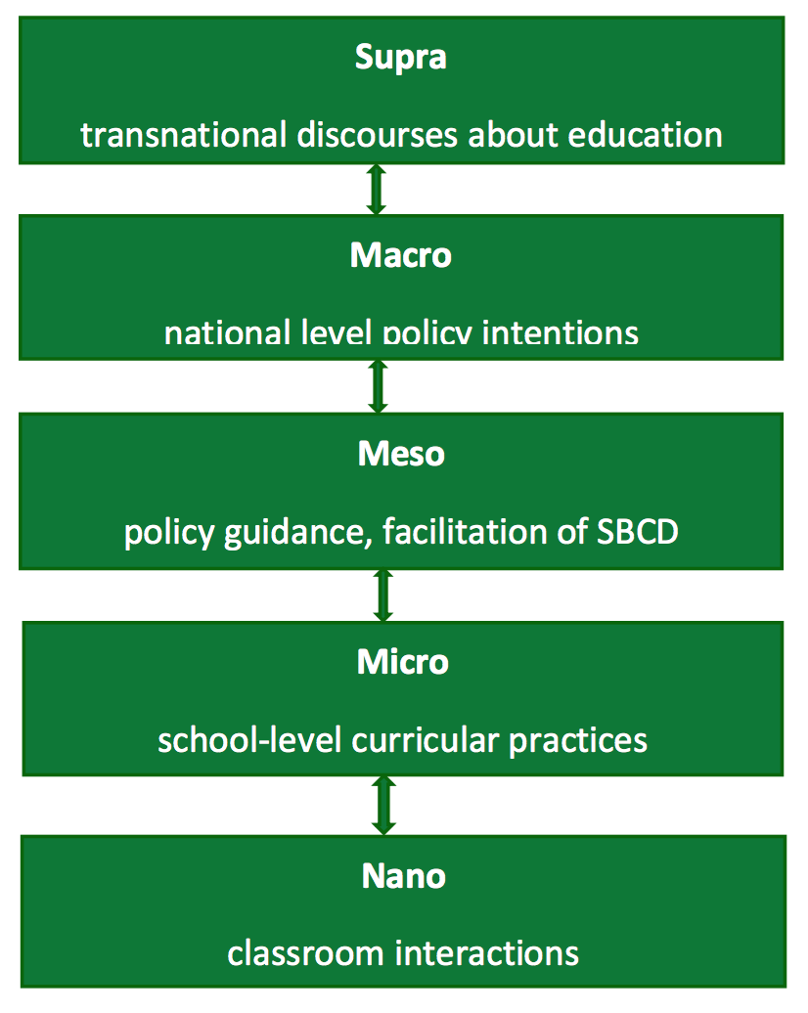
Strata – and curriculum development EA

Source: EAS / Mark Priestley (2016)

Appendix (ii)

Schematic Overview of the New Zealand Curriculum

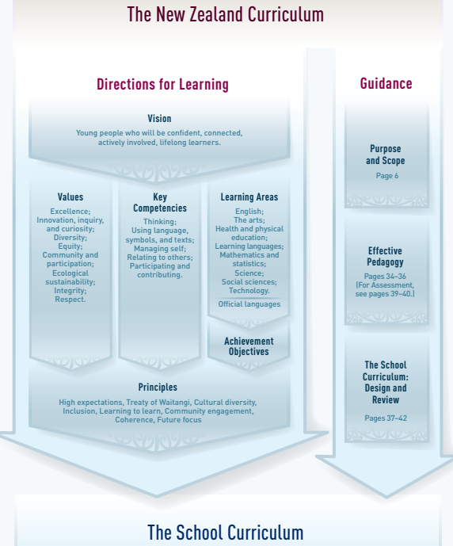

Source: http://nzcurriculum.tki.org.nz/The-New-Zealand-Curriculum
Appendix (iii)

Rollout of Curriculum for Wales and Qualifications Timeline

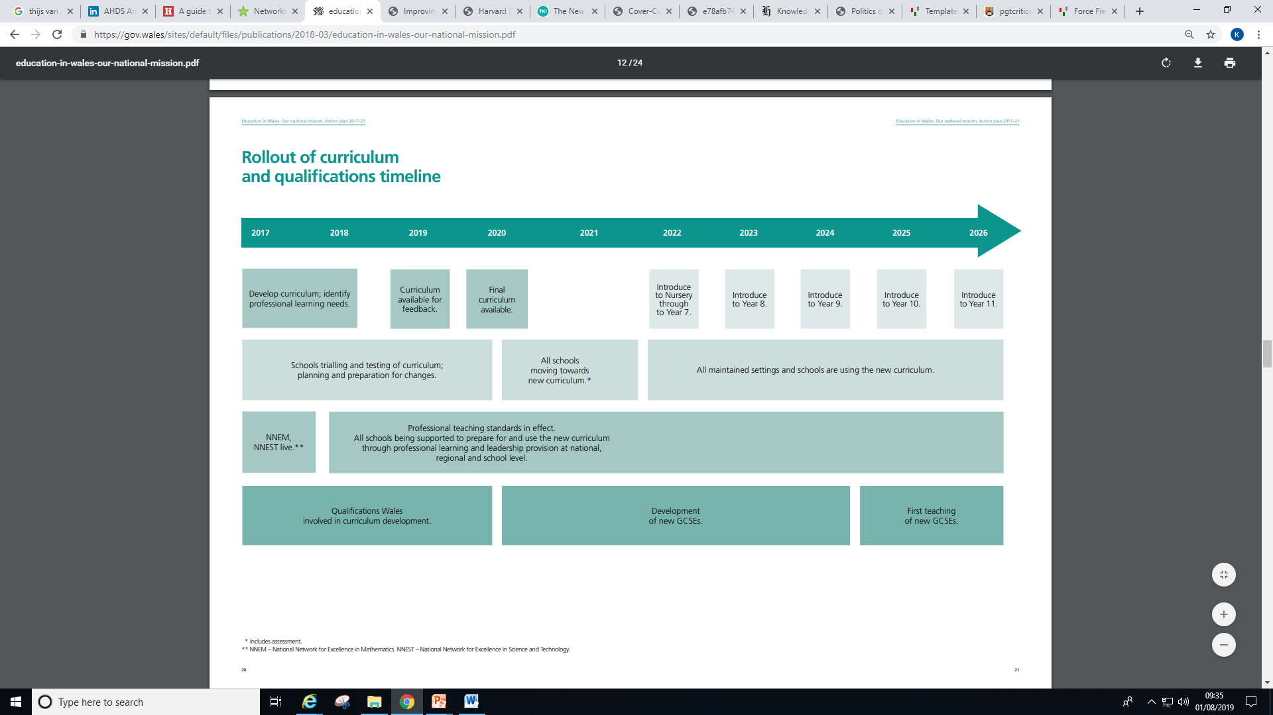

Source: Welsh Government (2017

