Programming in Python Assignment

A1. A variable is a placeholder usually identified by a name which is used to store values the value can change throughout a program based on conditions/information passed the program and the current value assigned can be referenced and used by the code.
We have used:
- Strings
- Lists
- Numbers

A2. An if/else statement is used to make decisions in a program based on the outcome of a particular condition. For example, imagine a program that checks the weather and suggests an appropriate outfit to wear. The program could use an if/else statement to check the temperature, and then suggest either a coat or a T-shirt based on the temperature

A3. Loops are needed in a program to perform repetitive tasks without having to write the same code multiple times. This can save a significant amount of time and make the code more organized and easier to read.

Exercise 1:
These solutions are a basic layout of code that I have used to allow the user to enter a multitude of values to answer these questions a while statement came to be very useful in my code as I could use it to allow for verification checks and make the sure enter an age in the correct range.
print("please enter your name")
myName = input()
print("please enter your age must be 18 or above")
myAge = int(input())
while myAge < 18:
print("that was out of range")
print("try again!")
myAge = int(input())
print("Please enter your national insurance number")
myNationalNumber = str(input())
print("please enter your pay per month")
myPay = int(input())
while myPay > 100000
print("that seems a bit high")
print("try again!")
myPay = int(input())
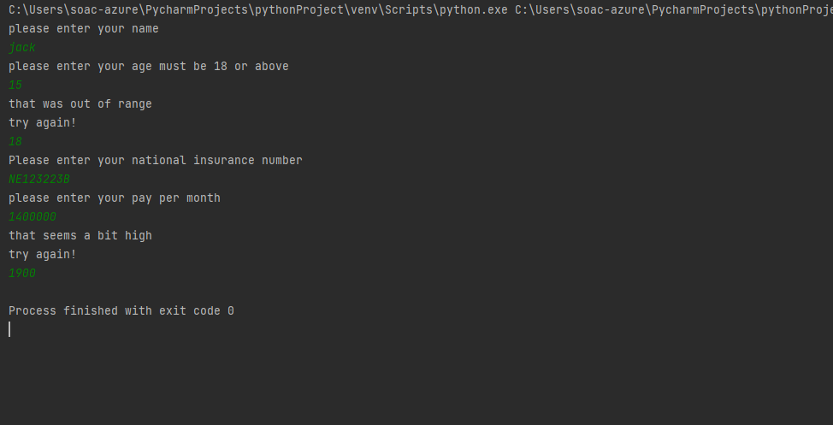

Exercise 2:

PI = 3.14
radius = float(input("Enter the radius of a circle:"))
area = PI * radius ** 2
side = int(input("Enter the side of square:"))
area = side * side
width = float(input("Enter the width of a rectangle:"))
length = float(input("Enter the length of a rectangle:"))
area = width * length
perimeter = (width + length) * 2
print("The shaded area is :", perimeter)
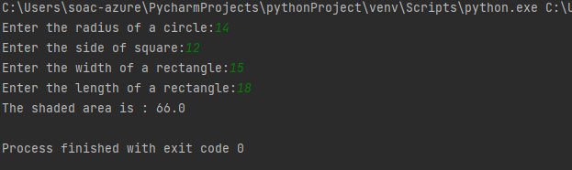

Exercise 3: This program will ask the customer to enter 10 items for their Christmas shopping list, and then it will print the list on the screen. Then it will ask the customer to enter the price of each item, and calculate the total price. Finally, it will generate a random raffle ticket number between 10 and 40, which represents a discount percentage. It will then calculate the discount and the new total price after the discount and print that on the screen.
import random
# empty list to store shopping items
shopping_list = []
# Allow customer to enter 10 items for the shopping list
for i in range(10):
item = input("Enter item {} for your Christmas shopping list: ".format(i+1))
shopping_list.append(item)
# Print the shopping list
print("\nYour Christmas shopping list:")
for item in shopping_list:
print(item)
# Calculate total of the shopping list
total = 0
for item in shopping_list:
item_price = float(input("Enter the price of {}: ".format(item)))
total += item_price
print("Total: £", total)
# Allocate a random raffle ticket with a number between 10 and 40
bonus_discount = random.randint(10, 40)
print("Your bonus discount percentage: ", bonus_discount, "%")
# Calculate new total after discount
discounted_total = total - (total * (bonus_discount / 100))
print("Total after discount: £", discounted_total)

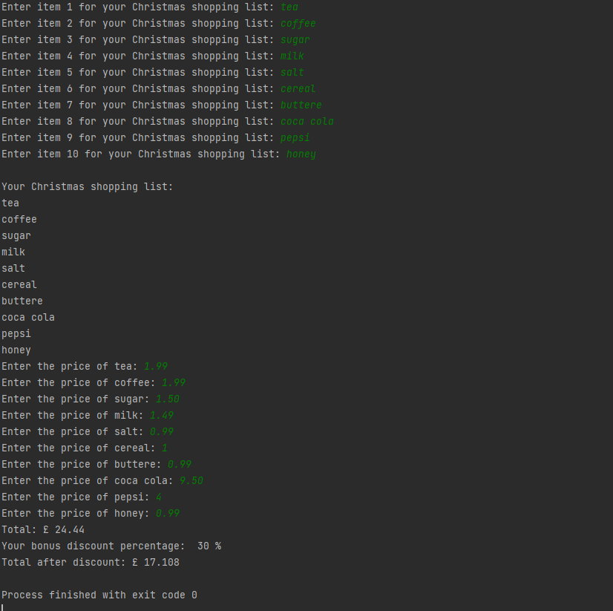

Exercise 4: This code will create a turtle object and set the font size. Then it will move the turtle to the starting position for each letter and draw the letter using the forward and right methods. At the end it will hide the turtle and keep the window open.
import turtle
# Create a turtle object
t = turtle.Turtle()
# Set the font size
t.pensize(5)
# Move the pen to the starting position for the first letter
t.penup()
t.goto(-50, 0)
t.pendown()
# Draw the first letter "Z"
t.forward(40)
t.right(90)
t.forward(40)
t.right(90)
t.forward(40)
t.left(90)
t.forward(20)
t.left(90)
t.forward(20)
# Move the pen to the starting position for the second letter
t.penup()
t.goto(0, 0)
t.pendown()
# Draw the second letter "O"
t.forward(40)
t.right(90)
t.forward(40)
t.right(90)
t.forward(40)
t.right(90)
t.forward(40)
# Move the pen to the starting position for the third letter
t.penup()
t.goto(50, -50)
t.pendown()
# Draw the third letter "O"
t.forward(40)
t.right(90)
t.forward(40)
t.right(90)
t.forward(40)
t.right(90)
t.forward(40)
#
t.hideturtle()
turtle.done()


