Student Name: Shabana Begum  Student ID: 2223853  Module Title: Foreign Languages & Cultural Awareness  Module Code: BMIH 5003  Lecturer: Lisa Bassler,  Heidi Prosser  Date: 31.1.2024 | 
ASSIGNMENT 1: PORTFOLIO
(4 Components)

Component 1: Professional Reflection (500 words +/- 10%)

Weighting: 25%
When I was working in the hotel, I have seen lots of tourists there. Though most of them are well versed in the common language, sometimes there might be a situation where tourist may not know the language at all. I have encountered family from Spain in Hotel Hilton Gateshead Newcastle one day. And then I have seen the problem of they are not well known in English and also do not have any guide to help them out. For this reason, they were having serious problem there. The main scenario goes at follows.
A Spanish-speaking family from Spain is overjoyed to check into our Hotel Hilton Gateshead Newcastle for the holiday. There may be language barriers since the hotel staff is all English speakers. On their first day, the family wanted park directions. Because the family has trouble expressing themselves in English, the hotel personnel assumes the wrong thing about their purpose and recommends an alternative park. In order to avoid any confusion, the family abides by the rules. The outing is ruined when the family heads to the wrong park. When they see an English-only menu and are unable to purchase a traditional breakfast dish from their home country, it becomes a source of frustration.
A mishmash of dinner options results from a failure to express tastes. The family's vacation is becoming increasingly less enjoyable due to the language barrier. Even mundane discussions and requests may lead to friction and misunderstandings. An unforeseen obstacle arises due to the absence of Spanish-speaking hotel staff, highlighting the need of multilingual help in enhancing visitor experiences.
I have tried to contact with them. But they don’t know any language beside Spanish. This kind of mishap has made them so much in trouble while they were travelling United Kingdom. In the heart of situation, they were facing this problem from hotel to everything. The main problem here lies with two main facts. The biggest fact is that not even a single person from their family knows about English. Even their children do not know English that will help them in conversation. For this reason, this is the kind of scenario where the proper techniques will not work. But there is also lack from our side too. If we check different kind of hotels and ask ourselves how many hotels have situation that, we will see this is fairly common scenario of most of the hotel that are receiving tourist from outside.
However, still we do not have that kind of hotel services where we are willing to help people by enabling translator machine or persons who are known for different kind of language. The lacking from our end is to lacks of meeting current problem due to fact that there are not persons who was well versed in different language. This caused the tourist to have unpleasant service in the hotel. So we need to fix them as fast as possible.
References:
- Zhang, Z., Han, X., Liu, Z., Jiang, X., Sun, M., & Liu, Q. (2019). ERNIE: Enhanced language representation with informative entities. arXiv preprint arXiv:1905.07129.
- Adger, C. T., Snow, C. E., & Christian, D. (Eds.). (2018). What teachers need to know about language (Vol. 2). Multilingual Matters.
- Gardner, M., Grus, J., Neumann, M., Tafjord, O., Dasigi, P., Liu, N., ... & Zettlemoyer, L. (2018). Allennlp: A deep semantic natural language processing platform. arXiv preprint arXiv:1803.07640.
Component 2: Training Plan (500 words +/- 10%)

Weighting: 25%

Identified cultural misunderstanding (in a few words) :
The cultural misunderstanding is about not understanding the language which is common for the current scenario for environmental changes happened in here. The main problem they faced is that our hotel was not culturally diversified enough to provide them good service.
Training plan (Why/What//Who/Where/When):
Promoting cultural diversity in a hotel's personnel, particularly in Spanish language and culture, requires strategic planning and commitment. In today's global hospitality sector, it's important to acknowledge and embrace diverse backgrounds. This may lead to better experiences for visitors and a more inclusive work environment.
Cultural diversity is more than just an HR need; it's critical for the satisfaction of visitors, the success of communications, and the attraction of a diverse clientele. In addition to different languages, different cultures also bring different customs, beliefs, and ways of life that might enrich the hotel's atmosphere.
Promoting cultural diversity begins with language teaching. It is as crucial to hire people who speak Spanish as it is to make it possible for present staff to do so. To achieve this goal, you may develop partnerships with language schools, hire instructors on-site, or use online language learning platforms. The hotel's variety is shown via these events, which also boost communication.
I will increase the workforce by strategically hiring individuals who speak more than one language. Join forces with neighbourhood organizations, run ads in Spanish-language publications, and show up at bilingual employment fairs. Staff members who are fluent in Spanish and familiar with the culture are guaranteed by this concerted effort.
Cultural awareness training is essential, perhaps more so than language training. Everyone on staff, not only those fluent in Spanish, has to undergo this training. The hotel fosters a welcoming environment for everyone by promoting cultural understanding and respect.
I will help foster a sense of community and appreciation for cultural diversity by forming staff resource groups with a Spanish emphasis. These groups may help out the Spanish-speaking employees, hold events, and share cultural information. Programs like this teach employees new skills and strengthen team spirit.
I will encourage multicultural collaboration that goes beyond linguistic competence. Team outings to cultural events, cultural potlucks, and language exchanges among employees may bring people together. By providing a space for different perspectives, these initiatives aim to foster peace in the workplace.
I will communicate effectively in a multilingual workplace. Provide Spanish translations of important documents, signs, and messages. Using technology, provide language translation services to both staff and visitors. This makes it easier for people of different language backgrounds to communicate with one another.
I will review and adjust policies to make them inclusive. This could include accommodating different festivals, ethnic celebrations, or different points of view while making decisions. The hotel's inclusive practices demonstrate its commitment to cultural diversity.
I will recruit staff members who must continue to provide feedback on this cultural diversity plan. When working on cultural initiatives, it's important to get input and be flexible. Using this iterative technique, the workplace may be adjusted to meet the evolving needs of a diverse workforce.
I will recognize and appreciate diversity in the workplace. The hotel's diversity commitment, cultural awareness events, and personnel highlights should all be prominently included in marketing materials. Supporting the premise that ethnic diversity is both a strategy and an integral element of the hotel's culture, this action generates a wide client base and instils pride in employees.
References:
- Sun, Y., Wang, S., Li, Y., Feng, S., Tian, H., Wu, H., & Wang, H. (2020, April). Ernie 2.0: A continual pre-training framework for language understanding. In Proceedings of the AAAI conference on artificial intelligence (Vol. 34, No. 05, pp. 8968-8975).
- Nie, Y., Williams, A., Dinan, E., Bansal, M., Weston, J., & Kiela, D. (2019). Adversarial NLI: A new benchmark for natural language understanding. arXiv preprint arXiv:1910.14599.
- Shen, T., Zhou, T., Long, G., Jiang, J., Pan, S., & Zhang, C. (2018, April). Disan: Directional self-attention network for rnn/cnn-free language understanding. In Proceedings of the AAAI conference on artificial intelligence (Vol. 32, No. 1).
Component 3: Student Self-Reflection (500 words +/- 10%)

Weighting: 25%
As societies and individuals interact on a global scale, their cultural awareness evolves. Experiences within one's own area and little contact with other cultures used to be the primary sources of cultural awareness. Culture is becoming more widely recognized as a result of modern technologies and globalization.
Cultural exposure has been steadily elevated throughout the years because to travel, more international engagement, and a variety of media. More people are able to communicate with one another, which breaks down barriers and fosters an understanding of cultural diversity throughout the world. Because they have grown up in such a multicultural and multiethnic society, today's youth are more tolerant of cultural differences.
Cultural awareness is shaped by technology, particularly by online platforms and social media. These forums facilitate the sharing of cultural narratives, practices, and ideas, fostering a sense of unity on a worldwide scale. As the world's cultures become increasingly diverse and interconnected, being more culturally aware allows us to adapt to new influences and creates a more linked and compassionate environment.
Cultural knowledge fosters comprehension, compassion, and connection in a diverse and linked world. Tolerance and a more nuanced understanding of human variation are two outcomes of cultural immersion. With more people paying attention, different communities are better able to collaborate for a peaceful world.
Cultural sensitivity is a must in today's interconnected globe. It facilitates communication and navigation in a wide range of contexts, including everyday life, travel, and the workplace. Being exposed to other cultures also promotes respectful and well-informed communication, which helps to lessen misconceptions and increase collaboration.
Being sensitive to other cultures is essential in today's global business. It promotes tolerance and acceptance, helps individuals from diverse backgrounds feel like they belong, and enhances communication. In order to foster positive global interactions, personal growth, and an appreciation for diversity, cultural awareness is essential.
Gaining an understanding of other cultures was invaluable throughout my time working for a multinational corporation. Picture a multiethnic group of people collaborating on a project. individuals who were culturally sensitive were able to read the mood in the office, the decision-making process, and the way individuals communicated. A colleague who is more comfortable with direct speech may take a different tack when faced with an issue than someone whose culture values indirect communication.
Open discussion, several perspectives, and creative, fruitful outcomes resulted from an appreciation of these cultural distinctions. In a global workplace, cultural awareness is more than just a buzzword, as this first-person account demonstrates. In our interconnected world, it transforms differences into strengths, paving the way for fruitful collaborations and better perspectives.
References:
- Song, K., Tan, X., Qin, T., Lu, J., & Liu, T. Y. (2020). Mpnet: Masked and permuted pre-training for language understanding. Advances in Neural Information Processing Systems, 33, 16857-16867.
- Yi, K., Wu, J., Gan, C., Torralba, A., Kohli, P., & Tenenbaum, J. (2018). Neural-symbolic vqa: Disentangling reasoning from vision and language understanding. Advances in neural information processing systems, 31.
- Li, J., Li, D., Xiong, C., & Hoi, S. (2022, June). Blip: Bootstrapping language-image pre-training for unified vision-language understanding and generation. In International Conference on Machine Learning (pp. 12888-12900). PMLR.
- Zhu, C., Cheng, Y., Gan, Z., Sun, S., Goldstein, T., & Liu, J. (2019). Freelb: Enhanced adversarial training for natural language understanding. arXiv preprint arXiv:1909.11764.
Component 4: Training Presentation (6 Slides)

Weighting: 25%
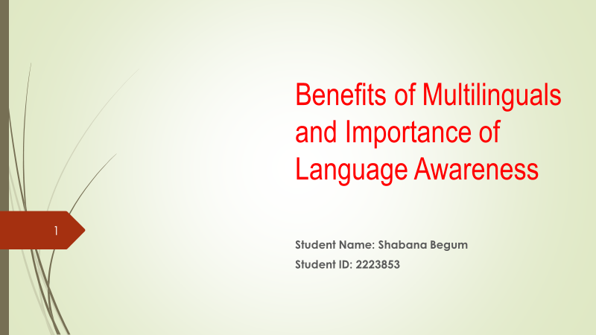
[Content Slide 1]
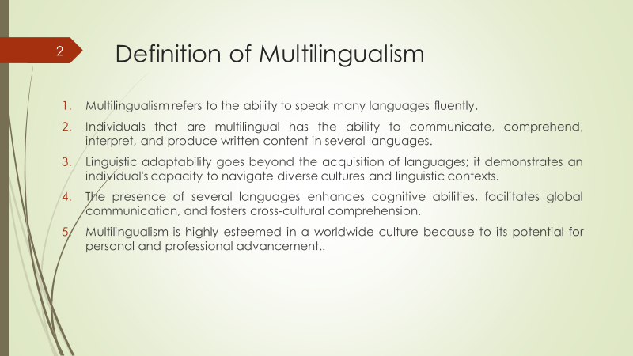
[Content Slide 2]
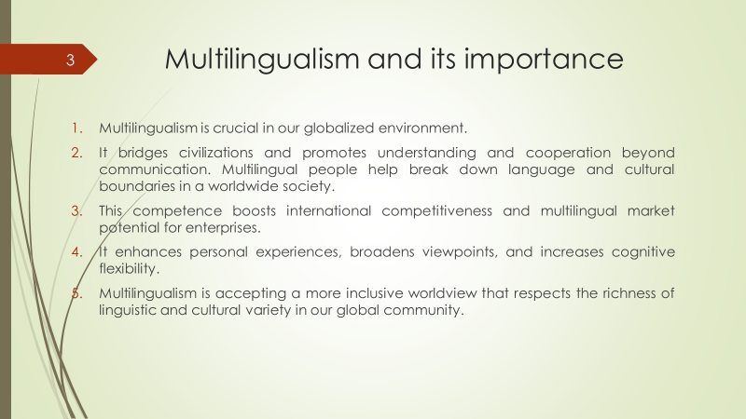
[Content Slide 3]
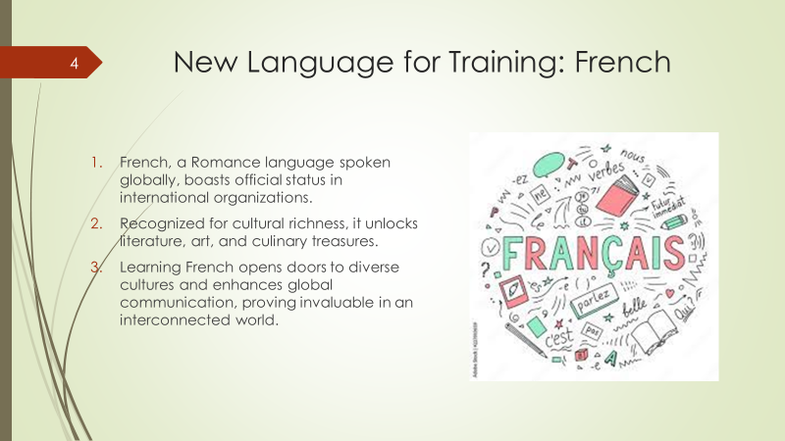
[Content Slide 4]
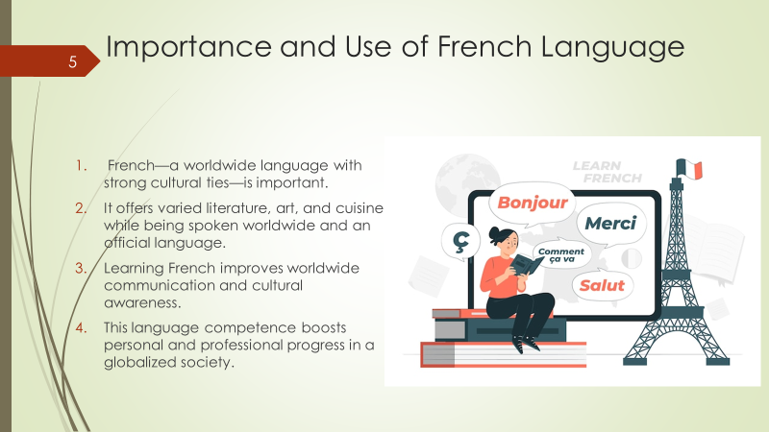
[Conte 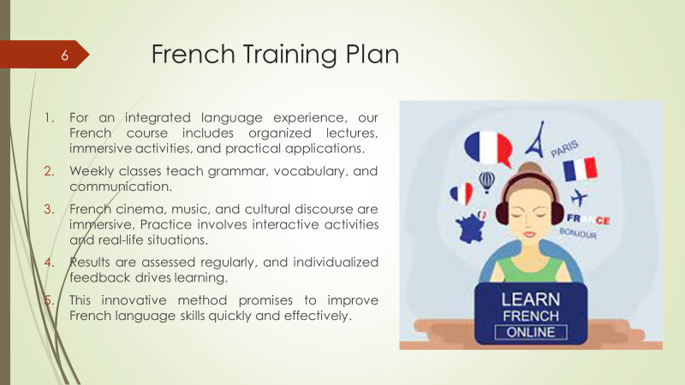nt Slide 5]
References (no screenshots):
- Wang, A., Singh, A., Michael, J., Hill, F., Levy, O., & Bowman, S. R. (2018). GLUE: A multi-task benchmark and analysis platform for natural language understanding. arXiv preprint arXiv:1804.07461.
- Saharia, C., Chan, W., Saxena, S., Li, L., Whang, J., Denton, E. L., ... & Norouzi, M. (2022). Photorealistic text-to-image diffusion models with deep language understanding. Advances in Neural Information Processing Systems, 35, 36479-36494.
- Antoun, W., Baly, F., & Hajj, H. (2020). Arabert: Transformer-based model for arabic language understanding. arXiv preprint arXiv:2003.00104.
- Jiao, X., Yin, Y., Shang, L., Jiang, X., Chen, X., Li, L., ... & Liu, Q. (2019). Tinybert: Distilling bert for natural language understanding. arXiv preprint arXiv:1909.10351.
- Radford, A., Narasimhan, K., Salimans, T., & Sutskever, I. (2018). Improving language understanding by generative pre-training.
- Yang, Z., Dai, Z., Yang, Y., Carbonell, J., Salakhutdinov, R. R., & Le, Q. V. (2019). Xlnet: Generalized autoregressive pretraining for language understanding. Advances in neural information processing systems, 32.
- Wang, A., Pruksachatkun, Y., Nangia, N., Singh, A., Michael, J., Hill, F., ... & Bowman, S. (2019). Superglue: A stickier benchmark for general-purpose language understanding systems. Advances in neural information processing systems, 32.

