
MSC PUBLIC HEALTH AND SOCIAL CARE IN PRACTICE
LCHS7006

QUALITY ASSURANCE AND SERVICE IMPROVEMENTS

COMPONENT 2: SERVICE IMPROVEMENT REPORT
LECTURER’S NAME: DR FAHAD KHAN

STUDENT NAME: VIDHI PRAJAPATI
STUDENT ID: 2506527

Table of Contents
1.0 Introduction 3
2.0 Main Body 4
2.1 Donabedian Model 4
2.2 Fishbone Diagram (Root Cause Analysis) 5
2.2.1 5 Whys Analysis 7
2.3 SWOT Analysis 8
2.4 PDSA (Plan-Do-Study-Act) Cycle 10
2.5 Kotter’s 8 Change Model 12
3.0 Recommendations 14
3.1 Benchmark Table 15
4.0 Conclusion 16
References 17

1.0 Introduction
Quality assurance is a very important factor. It helps to guarantee safe, effective and patient-centred healthcare services. Quality is fundamental in health and social care organisations in that. It mainly helps to advance clinical outcomes and enhance the confidence of the population in health care systems. This can be done by ensuring that the patients are under good care. The quality assurance describes the organised measures that are mainly designed to oversee, appraise and advance healthcare services. This align with a view of providing care that is both secure and constant in line with the stipulated standards (Srinivas et al., 2022). Sound quality assurance systems assist organisational bodies in finding out when services fail and making corrections. Moreover, in instilling a culture of lifelong learning and responsibility.
The Shrewsbury and Telford Hospital NHS Trust found out that one of the biggest failures in healthcare quality is. This was seen in the healthcare provision to the maternity ward. The investigations of the trust revealed that there were critical problems regarding patient safety, clinical governance and the organisational culture when it comes to maternity care services (Ockenden, 2022). Inadequacy in clinical practices, lapses in monitoring foetuses and lapse of escalation procedures were common aspects that were unravelled in the Ockenden Review and identified as the factors in the problem. It was observed in the review that many cases were not being investigated properly and the complaints that were addressed by the medical staff and the families were highly overlooked.
Review findings also indicated that the trust had serious leadership weaknesses and organisational culture. Inadequate systems of clinical governance implied that major events could be undermined or not properly dealt with. Moreover, patient safety concerns were not consistently addressed seriously by the staff. This preconditioned the creation of the environment in which unsafe practices continued to be tolerable (Pereira et al., 2024). Such failures indicate that quality assurance systems are important in healthcare organisations. It is especially in the high-risk sectors of health care, such as maternity services, where patient safety is an essential concern.
Quality assurance does not just help to detect failure. However, it also helps to direct the improvement of services and empower healthcare systems (Vaz and Araujo, 2022). Proper quality management models can make organisations examine the cause of service failures and devise a plan to deliver healthcare better. The Donabedian model, which is a type of model, tools of root cause analysis and strategic assessment are the models that are commonly utilised in healthcare quality improvement techniques to determine the structure of healthcare services, its processes and outcomes.
This report critically analyses the quality failures identified in the maternity services of Shrewsbury and Telford Hospital NHS Trust. It also explores the underlying causes of these issues. Using quality improvement frameworks, including the Donabedian model, Fishbone analysis and SWOT analysis, the report examines the structural, organisational and operational factors that contributed to the failures. Furthermore, the report proposes recommendations for service improvement using quality improvement methodologies such as the Plan-Do-Study-Act (PDSA) cycle.

2.0 Main Body

2.1 Donabedian Model
The Donabedian Model is a widely used framework. It mainly helps for evaluating healthcare quality (Chen et al., 2024). Developed by Avedis Donabedian, the model assesses healthcare services through three key components: structure, process and outcomes. These elements help organisations understand how the healthcare systems operate and how different factors influence the quality of care delivered to patients.
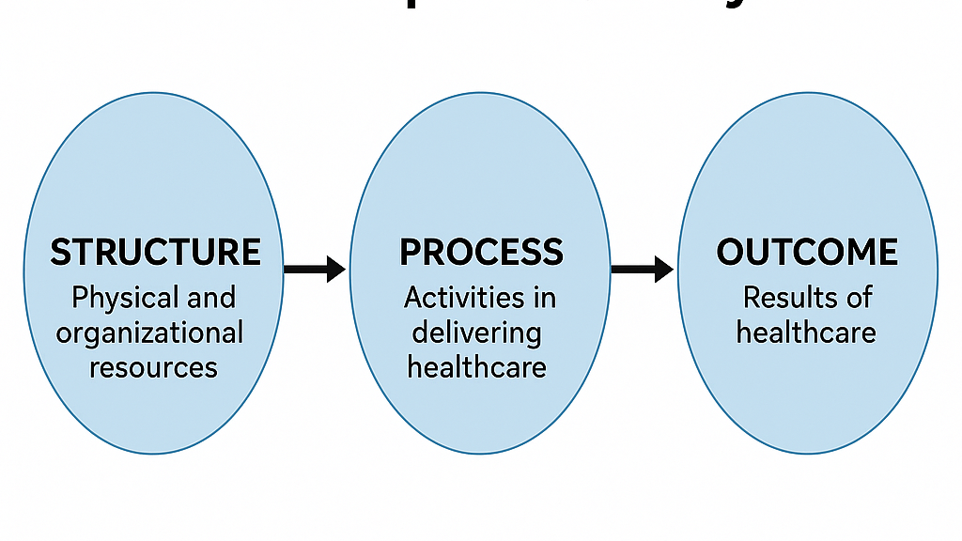
Figure 1: Donabedian Model
(Source: Zahoor, 2025)
The first item, structure. It is a reference to the organisational setting offering healthcare services. This encompasses material in the form of manpower, training, medical equipment’s, infrastructure and organisational policies. Among structural factors in the case of Shrewsbury and Telford Hospital NHS Trust, the training of the staff was insufficient, the systems of clinical governance and limited control over the maternity safety processes. Such weaknesses made it possible to have situations where unsafe practices can arise and remain within the maternity services.
The second one is the process. It concerns itself largely with the delivery of the healthcare. It entails clinical protocols, interpersonal communication among the medical practitioners in decision making and adherence to clinical protocols (Moayed et al., 2022). The Ockenden Review noted that there were major failures in clinical procedures in the trust. These were ineffective procedures to keep track of the fatal health, ineffective processes of escalation as well as the inefficient responses to the safety issues that had been brought up by employees and patients.
The final component, outcomes, refers to the results of the healthcare services and their impact on patient health and also wellbeing. Outcomes include patient safety incidents, maternal and neonatal mortality rates, and patient satisfaction (Guta, 2022). In this case, failures in both structural and procedural elements contributed to adverse outcomes. This mainly including avoidable harm to mothers and babies and a loss of public trust in maternity services.
The Donabedian Model proves to be quite applicable to the analysis of the given case as it offers a thorough framework, able to connect organisational influences, care provision, and patient outcomes. Unlike other models like PESTLE, the model particularly analyses the quality of delivery of health care.

2.2 Fishbone Diagram (Root Cause Analysis)
The Fishbone Diagram, also known as the Ishikawa Diagram, is a widely used quality improvement tool. It helps for identifying and analysing the root causes of complex problems (Sakdiyah et al., 2022). Developed by Kaoru Ishikawa, the model visually organises possible causes of a problem into different categories. These helping organisations understand how multiple factors contribute to service failures. In healthcare, the Fishbone Diagram is commonly used in root cause analysis. It also helps to investigate patient safety incidents and identify areas requiring improvement.
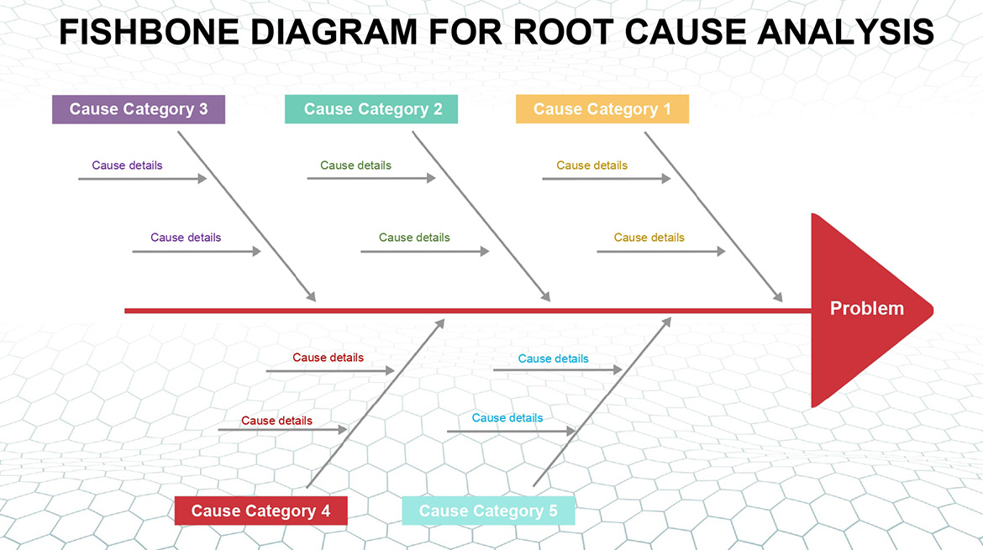
Figure 2: Fishbone Diagram (Root Cause Analysis)
(Source: Vaz, 2025)
In the context of maternity service failures at Shrewsbury and Telford Hospital NHS Trust, the Fishbone Diagram can be applied to explore the underlying causes of poor-quality care identified in the Ockenden Review. The model allows healthcare managers and policymakers to categorise and analyse different factors that contributed to the safety failures.
People are one of the important categories. Hence, it involves healthcare staff members involved in provision of maternity care. Poor training, insufficient communication between employees, and lack of response to the issues expressed by healthcare specialists by members of the leadership. These were some of the issues in this scenario that led to unsafe practices (Zulu et al., 2024). The other important category is the process which involves the processes and clinical practices involved in the provision of care.
The management and leadership category also played a significant role in the quality failures. Weak clinical governance systems and poor oversight allowed serious incidents to be downplayed or ignored. In addition, the organisational culture within the trust discouraged staff from raising safety concerns. This mainly prevented early identification of the problems (Mistri et al., 2023). Environmental factors, including heavy workloads and resource limitations, may also have influenced the quality of care delivered.
A fishbone diagram is especially effective in this analysis. This is because it helps to discover the various interacting factors that led to the problem instead of a single factor. In contrast to other models, like the Donabedian model. This evaluates the quality of healthcare services in terms of structure, process and outcomes. The Fishbone Diagram looks at the root causes of the ailures in service provision specifically.

2.2.1 5 Whys Analysis
The 5 Whys technique is used to identify underlying causes of problems through sequential questioning (Al-Rifai, 2025). The 5 Whys technique is particularly useful due to its simplicity and ability to identify root causes quickly without requiring extensive data. Compared to more complex tools such as Failure Mode and Effects Analysis, it is easier to implement. However, it may oversimplify problems and relies heavily on subjective judgement.
Problem: Ineffective fetal monitoring
- Why was fetal monitoring ineffective?
The monitoring of the fetuses did not work efficiently since the staff was under-trained to interpret the monitoring outcomes properly during labour.
- Why did staff lack sufficient training?
Staff had an insufficiency of training as training programmes were not congruent, up to date and not often strengthened across maternity units.
- Why were training programmes inconsistent and outdated?
The consistency and outdated training programmes were caused by the failure of the management to give importance to structured training and constant professional improvement.
- Why did management fail to prioritise staff development?
Weak leadership focus on quality improvement and unaccountability mechanisms led to an absence of prioritisation on staff development by the management.
- Why was leadership focus on quality improvement weak?
Leadership focus was weak because of ineffective clinical governance systems and poor organisational oversight within the trust.

2.3 SWOT Analysis
SWOT analysis is a strategic planning tool. It is used to evaluate the internal and external factors that influence an organisation’s performance. The model examines four key elements: strengths, weaknesses, opportunities and threats. In healthcare, SWOT analysis helps organisations identify areas of improvement. At the same time, it also recognising factors that may support or hinder service delivery (Piotie et al., 2022). Applying this framework to the maternity services at Shrewsbury and Telford Hospital NHS Trust provides a clearer understanding of the organisational conditions. This contributed to quality failures and highlights potential opportunities for improvement. SWOT analysis was selected over PESTLE because it focuses on both internal and external organisational factors directly linked to service performance. Unlike PESTLE, which broadly examines macro-environmental influences, SWOT enables a more practical evaluation of strengths and weaknesses within the healthcare organisation, making it more suitable for targeted service improvement.
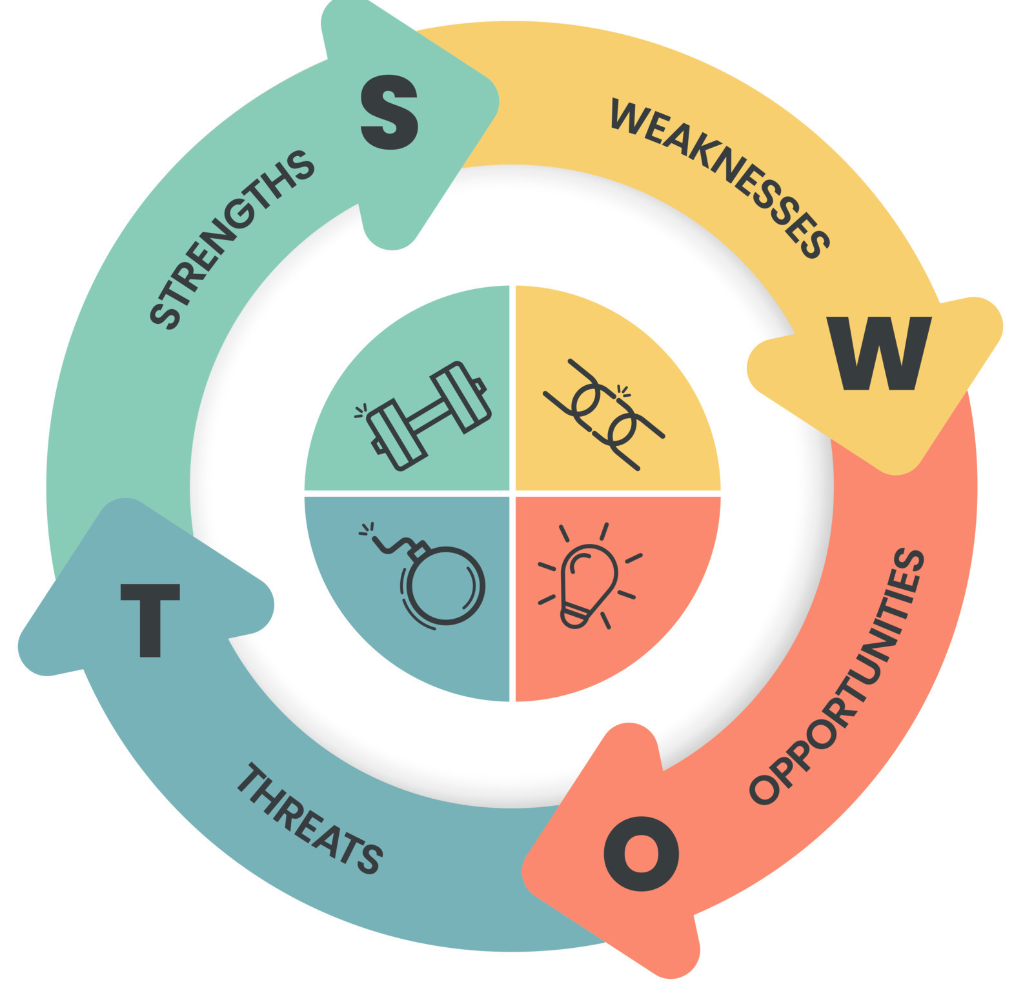
Figure 3: SWOT Analysis
(Source: Self-Developed)
The organisational strengths encompass the fact that it is a member of the NHS system. This comes with national clinical guidelines, regulatory supervision and access to professional healthcare personnel. The quality of care is provided as an essential background of the case of improving the quality of care by national maternity safety programs and clinical standards implemented in the framework of the NHS (McGowan et al., 2024). These structural supports present the healthcare organisations with the opportunities to harness the evidence-based practices to enhance patient safety.
The identified weaknesses in the case, however, were severe and contributed to the quality failures pointed out in the Ockenden Review. These areas of weakness were identified as poor clinical governance systems, weak leadership, a lack of staff training and culture where the safety concerns were not taken appropriately (Hibbert et al., 2023). Moreover, insufficient communication issues and escalation processes undermined the organisation to effectively respond to the incidents of patient safety.
The case also presents several opportunities for service improvement. The findings of the review have created greater awareness of maternity safety across healthcare organisations and emphasised the importance of strengthening governance and accountability. Opportunities include implementing improved training programmes for maternity staff, introducing stronger monitoring systems and adopting quality improvement initiatives to enhance patient safety (Falade et al., 2024).
Lastly, reputational damage and loss of trust and probable legal action following the maternity service failures are threats that the organisation will encounter. Moreover, the persistence of shortages of staff or resources may have further implications on the capacity of the organisation to offer effective and safe care (Butler et al., 2024). Thus, the key to overcoming these threats is to overcome the lack of confidence in maternity services.

2.4 PDSA (Plan-Do-Study-Act) Cycle
The Plan–Do–Study–Act (PDSA) cycle is a quality improvement framework. It is used to test and implement changes in healthcare services (Manandi et al., 2023). It was developed from the work of W. Edwards Deming and is widely used in healthcare organisations to improve patient safety and service quality through continuous evaluation and improvement. In relation to maternity services at Shrewsbury and Telford Hospital NHS Trust, the PDSA cycle can support the implementation of improvements following the issues highlighted in the Ockenden Review. The PDSA cycle is used instead of PDCA and Six Sigma because it is flexible and includes emphasis on learning in cycles in medical facilities. PDSA in comparison with Six Sigma which is complex and data intensive permits small scale testing of change. PDSA is based on reflection and learning as opposed to PDCA as the latter is more befitting to continuous clinical improvement.
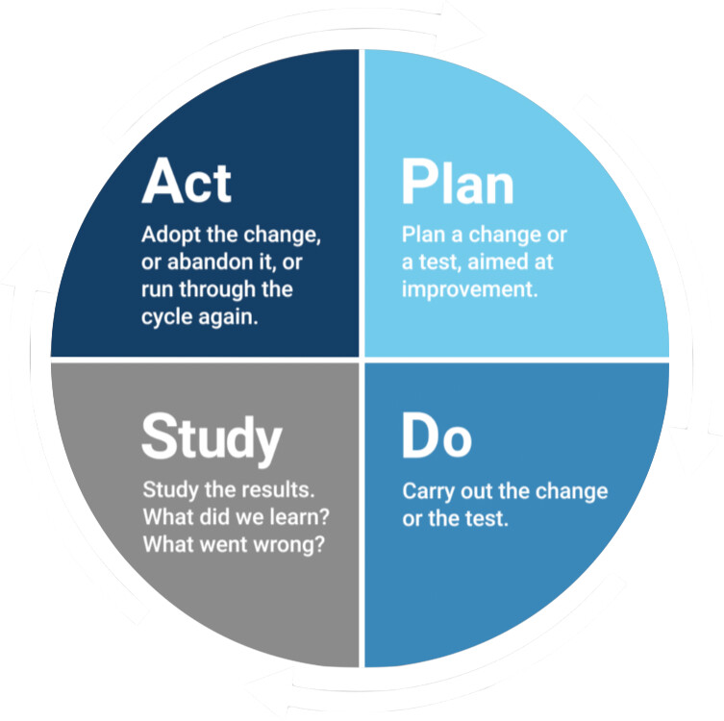
Figure 4: PDSA (Plan-Do-Study-Act) Cycle
(Source: Self-Developed)
Plan
Identify the key safety problems in maternity services and design improvement strategies. This stage involves setting clear objectives, developing the action plans and allocating the resources. For Shrewsbury and Telford Hospital NHS Trust, planning could include improving fetal monitoring training, strengthening clinical governance. This also establishing better incident reporting systems.
Do
Introduce the suggested improvements on a limited scale to check their efficiency. Skills and innovations are taught to healthcare workers and implemented in the maternity units (Evans et al., 2022). This step can involve the implementation of new clinical guidelines and monitor practices in response to challenges cited in the Ockenden Review.
Study
Evaluate the results of the implemented changes by analysing performance data, patient outcomes and staff feedback. This step will assist in establishing whether the new interventions have led to improved safety and quality of care. The assessment of the efficiency of the put-in strategies by reviewing the maternity outcomes enables the healthcare organisations.
Act
The results are that effective improvement is added to the practice on a regular basis and ineffective strategies are amended. The stage makes sure that there is continuous improvement through refining the processes and enhancing healthcare delivery. The adoption of effective measures can be used to enhance the safety of patients, thus restoring their confidence in maternity care.

2.5 Kotter’s 8 Change Model
Kotter’s change model, developed by John P. Kotter, provides a structured approach to implementing organisational change (Carreño, 2024). The 8-step model created by Kotter is a structured and effective tool in bringing about change in a medical facility. It values leadership and the role of communication as well as cultural integration and encourages sustainable betterment. Unlike models such as Lewin’s Change Model which is more simplistic Kotter provides detailed guidance for sustaining change. However, it can be time-consuming and less flexible in urgent situations.
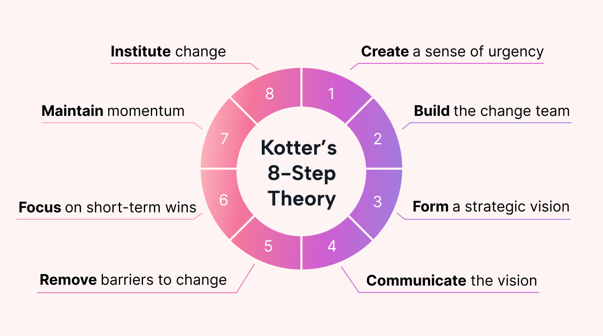
Figure 5: Kotter’s 8 Change Model
(Source: Self-Developed)
1. Create a Sense of Urgency: The healthcare leaders emphasize the gravity of maternity safety incidents and harm on the patient (Fuseini et al., 2023). Developing urgency motivates the staff and management to identify the urgency to take immediate action and endorse the service improvement programs.
2. Build a Guiding Coalition: A strong leadership team consisting of healthcare managers, clinical experts and senior staff is formed. This is an association that works together in leading the change process and making coordinated efforts towards safety of maternity.
3. Develop a Vision and Strategy: Leaders have a vision developed on how to make patient safety better, how to provide clinical control and improve and enhance maternity services. A strategic plan provides a way in which the organisation is going to realise sustainable quality enhancement.
4. Communicate the Vision: The vision for change is communicated clearly to all staff through meetings, training and organisational communication channels. This ensures employees understand the goals and their responsibilities in supporting improvements.
5. Empower Staff to Act: Healthcare staff are encouraged to contribute to improvements by removing organisational barriers and providing necessary training (Khurshid et al., 2022). Empowering employees enables them to follow safer clinical practices and improve service delivery.
6. Generate Short-Term Wins: The initial successes like the enhanced staff training, improved monitoring practices and safety accidents, are identified.
7. Consolidate Improvements: The organisation continues implementing the improvement strategies and builds on early successes.
8. Anchor Change in Culture: Long-term improvements are embedded within organisational culture through strong leadership, accountability and continuous learning.

3.0 Recommendations
1. Strengthening Clinical Governance: One key recommendation is strengthening clinical governance systems within Shrewsbury and Telford Hospital NHS Trust to ensure accountability and effective oversight of maternity services. Proper governance policies help organisations to monitor the clinical performance, investigate safety incidents and also implement remedial action with regard to it (Falade et al., 2024). The management teams should possess an efficient reporting system, frequency of the safety audits and open investigation processes on patient safety events. It also implies that even the top management should be involved in its work to a greater extent. Therefore, the fact that complaints made by employees would be taken into the consideration and appropriate actions would be taken as soon as possible (Haag and Eckhardt, 2024).
2. Improving Staff Training and Professional Development: Healthcare staff training is essential for ensuring the safe maternity care. The findings of the Ockenden Review highlighted gaps in clinical training. It is particularly in fetal monitoring and emergency response procedures. Thus, periodic training programmes are to be introduced to enhance the competency of the staff and clinical decision-making. The staff can be improved in their knowledge and skills by means of optional training sessions, simulation-based learning and an ongoing professional development programme (Abdool et al., 2025). Further, the mentoring system and supervision by senior clinicians can assist the staff in handling complex maternity cases better.
3. Strengthening Incident Reporting and Learning Systems: Increasing incident reporting systems is another important suggestion that would develop transparency and learning by doing. In the hospitals, they should have well-designed processes whereby officers are allowed to report the cases of patient safety without intimidation or punishment. By creating an optimal atmosphere in reporting, the foremost issues will be resolved over time, and severe accidents will be prevented (Shaffi et al., 2025). Incident data analysis should be performed periodically by having knowledge of patterns and devising means of quality improvement. The strategy of free communication between management and healthcare professionals is likely to work effectively.
4. Promoting a Positive Safety Culture: An effective patient safety culture is critical to providing healthcare services of the best quality. Organisations should be able to build a workplace in which the staff have the leverage to report about any safety issue of patients without fear of punishment. Leadership can promote open dialogue, cooperation and teamwork among medical workers in an active way (Meneses-La-Riva et al., 2025).
5. Implementing Continuous Quality Improvement Strategies: Healthcare organisations should adopt continuous quality improvement frameworks to ensure long-term service improvement (Bhaladhare and Rishipathak, 2025). Approaches such as the Plan–Do–Study–Act (PDSA) cycle allow organisations to test and refine the improvement strategies systematically. The effectiveness of improvement efforts can be a tracked with the help of regular audits, performance appraisals and feedback systems provided to the patient (Sarkies et al., 2023).

3.1 Benchmark Table
Benchmark Area | National Standards (Expected) | Trust Performance (Observed) | Excepted Outcome
Clinical Safety | Adherence to NICE maternity recommendations and intra-operative fetal surveillance. | Lack of adherence to national guidance; unsafe practices in terms of monitoring (Ockenden, 2022b) | Improved adherence to clinical guidelines and reduction in maternal and neonatal safety incidents.
Incident Reporting | There should be clear inquiries using the Patient Safety Incident Response Framework (NHS England, 2022). | Cases demoted; insufficient investigations; low learning. | Increased incident reporting, improved investigations, and enhanced organisational learning from errors.
Governance & Leadership | Good supervision of the board and responsibility. | Meagre questioning; inability to question low results (Govt. UK, 2022) | Strong leadership accountability, effective oversight, and improved decision-making processes.
Workforce & Training | Professional growth and adequate staffing. | Constant employee shortages; intermittent competencies and management. | Improved staff competency, adequate workforce levels, and better clinical performance.
Regulatory Compliance | Efficient external audit and quality assurance control. | Ongoing safety concerns identified (Care Quality Commission, 2024). | Enhanced compliance with regulatory standards and improved overall service quality and safety.
Table 1: Benchmark Table
(Source: Self-Developed)

4.0 Conclusion
The analysis of maternity service failures at Shrewsbury and Telford Hospital NHS Trust highlights the significant impact that weaknesses in clinical governance, organisational culture and healthcare processes can have on patient safety. The findings from the Ockenden Review demonstrate how inadequate training, poor communication and ineffective leadership contributed to serious failures in maternity care. The application of quality improvement frameworks such as the Donabedian Model, Fishbone analysis and SWOT analysis helped identify the structural and operational factors. This mainly led to these service failures.
Additionally, the report indicates the importance of using proper service improvement tools that will avoid such incidences in the future. The proportion of the recommendations that ought to be implemented to advance maternity is the increase of clinical governance, advancement of the staff, and reporting of incident and safety culture. The application of the continuous quality improvement techniques, including the PDSA cycle and systematic change models, can help healthcare organisations implement a sustainable change.

References
Al-Rifai, M. (2025). Unlocking insights: evaluating 5Whys methodology for root cause analysis and employee problem-solving skills in 91 case studies. International Journal of Lean Six Sigma, 16(5), 1276-1304.
Abdool, P.S., Voore, P., Antinucci, R., Soklaridis, S. and Sockalingam, S., (2025). Role of Simulation-Based Education in the Integration of Continuing Education, Quality Improvement, and Patient Safety. Academic Psychiatry, pp.1-5.
Bhaladhare, R. and Rishipathak, P., (2025). Strategies of quality improvement in healthcare organizations on sustainable healthcare system. Discover Social Science and Health, 5(1), p.74.
Butler, C.R., Webster, L.B. and Diekema, D.S., (2024). Staffing crisis capacity: a different approach to healthcare resource allocation for a different type of scarce resource. Journal of medical ethics, 50(9), pp.647-649.
Carreño, A.M., (2024). An analytical review of John Kotter's change leadership framework: A modern approach to sustainable organizational transformation. Available at SSRN 5044428.
Chen, C.C., Hsiao, C.T., Chang, D.S. and Lai, W.C., (2024). The delivery model of perceived medical service quality based on donabedian's framework. The Journal for Healthcare Quality (JHQ), 46(3), pp.150-159.
Evans, K., Moya, H., Lambert, M. and Spiby, H., (2022). Developing a training programme for midwives and maternity support workers facilitating a novel intervention to support women with anxiety in pregnancy. BMC Pregnancy and Childbirth, 22(1), p.662.
Falade, I.M., Gyampoh, G.K.S., Akpamgbo, E.O., Chika, O.C., Obodo, O.R., Okobi, O.E., Aguguo, J.C. and Chukwu, V.U., (2024). A comprehensive review of effective patient safety and quality improvement programs in healthcare facilities. Medical Research Archives, 12(7).
Falade, I.M., Gyampoh, G.K.S., Akpamgbo, E.O., Chika, O.C., Obodo, O.R., Okobi, O.E., Aguguo, J.C. and Chukwu, V.U., (2024). A comprehensive review of effective patient safety and quality improvement programs in healthcare facilities. Medical Research Archives, 12(7).
Fuseini, A.K.J., Teixeira da Costa, E.I.M., Matos, F.A.S.D., Merino-Godoy, M.D.L.A. and Nave, F., (2023), October. Patient-safety culture among emergency and critical care nurses in a maternal and child department. In Healthcare (Vol. 11, No. 20, p. 2770). MDPI.
Guta, N.M., (2022). Application of Donabedian quality-of-care framework to assess quality of neonatal resuscitation, its outcome, and associated factors among resuscitated newborns at public hospitals of East Wollega zone, Oromia, Western Ethiopia, 2021. BMC pediatrics, 22(1), p.605.
Haag, S. and Eckhardt, A., (2024). Dealing Effectively with Shadow IT by Managing Both Cybersecurity and User Needs. MIS Quarterly Executive, 23(4).
Hibbert, P.D., Stewart, S., Wiles, L.K., Braithwaite, J., Runciman, W.B. and Thomas, M.J., (2023). Improving patient safety governance and systems through learning from successes and failures: qualitative surveys and interviews with international experts. International Journal for Quality in Health Care, 35(4), p.0.
Khurshid, Z., De Brún, A. and McAuliffe, E., (2022). Factors influencing measurement for improvement skills in healthcare staff: trainee, and trainer perspectives. BMC Medical Education, 22(1), p.236.
Manandi, D., Tu, Q., Hafiz, N., Raeside, R., Redfern, J. and Hyun, K., (2023). The evaluation of the Plan–Do–Study–Act cycles for a healthcare quality improvement intervention in primary care. Australian journal of primary health, 30(1), p.PY23123.
McGowan, J., Attal, B., Kuhn, I., Hinton, L., Draycott, T., Martin, G.P. and Dixon-Woods, M., (2024). Quality and reporting of large-scale improvement programmes: a review of maternity initiatives in the English NHS, 2010–2023. BMJ Quality & Safety, 33(11), pp.704-715.
Meneses-La-Riva, M.E., Fernández-Bedoya, V.H., Suyo-Vega, J.A., Ocupa-Cabrera, H.G., Grijalva-Salazar, R.V. and Ocupa-Meneses, G.D.D., (2025). Enhancing healthcare efficiency: the relationship between effective communication and teamwork among nurses in Peru. Nursing Reports, 15(2), p.59.
Mistri, I.U., Badge, A. and Shahu, S., (2023). Enhancing patient safety culture in hospitals. Cureus, 15(12), p.e51159.
Moayed, M.S., Khalili, R., Ebadi, A. and Parandeh, A., (2022). Factors determining the quality of health services provided to COVID-19 patients from the perspective of healthcare providers: Based on the Donabedian model. Frontiers in public health, 10, p.967431.
Motion (2023). Kotter’s change model: 8 steps to successful change management. [online] www.usemotion.com. Available at: https://www.usemotion.com/blog/kotters-change-model [Accessed 16 Mar. 2026].
Ockenden, D., (2022a). Ockenden Report. [online] Ockenden Maternity Review. Available at: https://www.ockendenmaternityreview.org.uk/wp-content/uploads/2022/03/FINAL INDEPENDENT_MATERNITY_REVIEW_OF_MATERNITY_SERVICES_REPORT.pdf.
Pereira, S.C.D.A., Ribeiro, O.M.P.L., Fassarella, C.S. and Santos, E.J.F., (2024). The impact of nursing practice environments on patient safety culture in primary health care: a scoping review. BJGP open, 8(1), pp.BJGPO-2023.
Piotie, P.N., Filmalter, C., Mohlala, M.G., Zulu, N., Segale, A., Koenaite, C., Muchiri, J.W., Webb, E.M. and Rheeder, P., (2022). Factors affecting the implementation of a complex health intervention to improve insulin management in primary care: A SWOT analysis. African Journal of Primary Health Care & Family Medicine, 14(1), p.3467.
Sakdiyah, S.H., Eltivia, N. and Afandi, A., (2022). Root cause analysis using fishbone diagram: company management decision making. Journal of Applied Business, Taxation and Economics Research, 1(6), pp.566-576.
Sarkies, M., Francis-Auton, E., Long, J., Roberts, N., Westbrook, J., Levesque, J.F., Watson, D.E., Hardwick, R., Sutherland, K., Disher, G. and Hibbert, P., (2023). Audit and feedback to reduce unwarranted clinical variation at scale: a realist study of implementation strategy mechanisms. Implementation Science, 18(1), p.71.
Shaffi, N.S.M. and Sidhick, N.J.N., (2025). Real-time incident reporting and intelligence framework: Data architecture strategies for secure and compliant decision support. World Journal of Advanced Research and Reviews, 26(3), pp.110-118.
Srinivas, N., Mandaloju, N. and Nadimpalli, S.V., (2022). Ensuring Excellence in Medical Software: A Comprehensive Guide to Quality Assurance in Healthcare Technology. International Journal of Modern Computing, 5(1), pp.99-107.
Vaz , F. (2025). Fishbone diagrams: An easy, visually appealing root cause analysis tool for field workers. – IAPSM Blogs. [online] Iapsm.org. Available at: https://iapsm.org/blog/fishbone-diagrams-an-easy-visually-appealing-root-cause-analysis-tool-for-field-workers/ [Accessed 16 Mar. 2026].
Vaz, N. and Araujo, C., (2022). Failure factors in healthcare quality improvement programmes: reviewing two decades of the scientific field. International Journal of Quality and Service Sciences, 14(2), pp.291-310.
Zahoor, M. (2025). In the world of healthcare quality improvement, few frameworks have had as lasting and transformative an impact as Donabedian’s Model. Developed by Dr. [online] Linkedin.com. Available at: https://www.linkedin.com/pulse/donabedians-model-health-care-quality-management-muhammad-zahoor-qldsf/ [Accessed 16 Mar. 2026].
Zulu, S.L., Saad, A.M., Ajayi, S.O., Dulaimi, M. and Unuigbe, M., (2024). Digital leadership enactment in the construction industry: barriers undermining effective transformation. Engineering, Construction and Architectural Management, 31(10), pp.4062-4078.

