LOTTERY NUMBER GENERATION AND MANAGEMENT
Bartosz Galantowicz
1700994
Computer Programming
M4X01508
Gaynor Thomas

Contents:
- Introduction and Requirements – page 3
- Flowchart – pages 4-5
- Why uses a loop? – page 6
- Testing – pages 7-8
- User documentation – pages 9-13
- Introduction – page 9
- Requirements – page 9
- Starting the Program – page 9
- Game Instruction - pages 10-13
- Technical documentation - pages 14-18
- Introduction - page 14
- Requirements – page 14
- The Code Structure - pages 14-18
- Conclusions – page 19
- References - page 20
- Introduction and Requirements
The project main aim is to create a program – a lottery in C Language which is the ideal programming language for novice programmers due to its relatively uncomplicated character and functionality. Many other programming languages ​​are based or modelled on C Language like C ++ or C #. [1, p. 8] The Programming Environment used for coding was Visual Studio. The environment is so user-friendly that it has intelligent autocompletion of the code. Moreover, various code elements associated with it are highlighted in different colours, which makes better clarity of code, so crucial for programming. Another significant element of the environment is support for the debugger which allows easy and quick code analysis.
The created program consists many extra features, which are not demanded from the assignment. However, coding the program as a simple game, while maintaining the assignment aims, has polished the programming skills by revealed knowledge of solving problems and good programming practice.
The created lottery program has to:
- Invite the user to play by entering six random numbers
- Generate six random numbers and sort them in ascending order without duplicates
- Enter the result of the draw to the user and compare it with the numbers provided by the user
- Suggest repetition of the game
In the further part of this report, the flowchart of the program will be presented, and the logic of the program and examples of tests on the program will be given and discussed. Also, this report includes technical documentation and documentation for a new user that will help introduction to the program.
- Flowchart
No
Yes
No
Yes
Please, put another lucky number in the range:
End
Welcome to Lottery!
Start
The pool of numbers taking part in lottery:
Generating numbers from 1 to 10.
Printing generated numbers.
Do you want try your luck and play (y/n)
Are your lucky numbers in the range and are not duplicated?
Sorry, but your number is out of the range or it has been duplicated.
Shuffling numbers from 1 to 10.
Enter your six lucky numbers:
Sorting first six shuffled numbers in ascending order.
Yes
No
No
Yes
Printing your numbers and shuffled numbers.
End
Do you want play again?
You win!
You lost!
Are your numbers equal to shuffled numbers?
Sorting your numbers in ascending order.
- Why use a loop?
Programming loops are used in almost every program. They appear in all programming languages, and they do similar tasks in each. The primary task of a loop in a program is to perform an activity cyclically, a specified number of times. The three types of loops will be discussed below, the loops which allow repeating an action, unknown number of times and those that assume in advance a number of repetitions.
While Loop
The while loops are most often used in the case where the assumed number of repetitions is not specified, but we know the condition that must be met. When the condition is met, the instruction inside the loop is executed. If the condition is false, it may not be done once. Typically, a numeric variable is used, and then, thanks to increment or decrement, it changes until the condition becomes false. [2]
Do…While Loop
It differs from the while loop, mainly because what is inside of it takes place at least once, because the condition is checked in the second time. The instructions to be executed are enforced at least once, and then the condition checked when it is true, the instructions are repeated. [3]
For Loop

For the previous two, the “for” loop differentiates mainly the type of applications. In this case, we usually know exactly how many times we must repeat something. The initial expression is used to initiate a counter, which usually is in the same place declared integer variable. The condition checks whether to execute instructions from the inside of the loop, while the modifier changes the counter - this is usually an incrementation. [4]

- Testing the program
- Starting the program
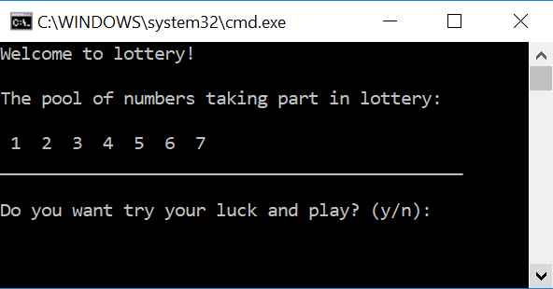
The program starts correctly.
- Making a decision in program
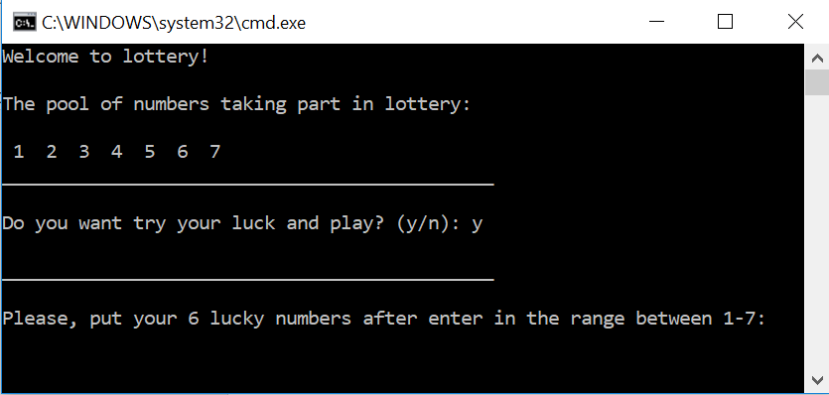
After pressing “y”, the program continues execution of the code.
- Checking duplication of the lucky numbers and their range.
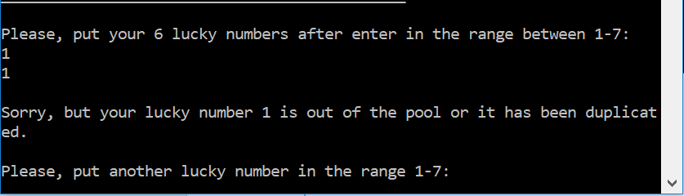
When numbers are duplicated the program asks the user again about the new lucky number.
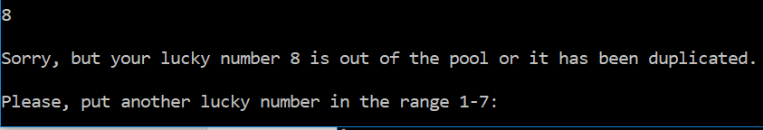
When a lucky number is out of range, the program asks a user again about the new number.
- Ordering lucky numbers.
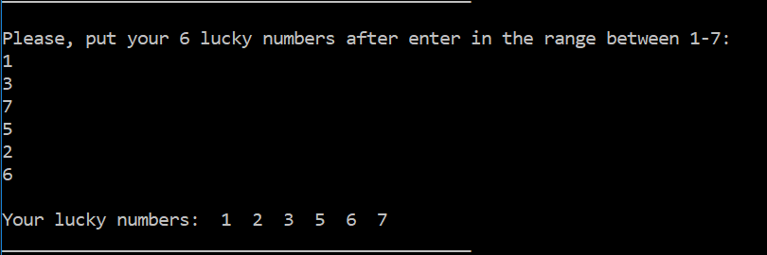
Players can use their lucky numbers in random order. The program sums up players decisions and shows the result in ascending order.
- Shuffling the pool of numbers and showing the result.
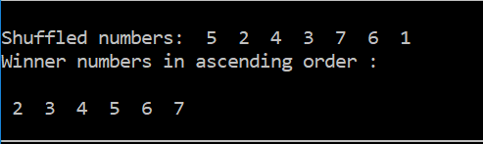
For the testing purpose to the code was added additional command, which shows shuffled numbers. From 7 shuffled numbers, the program displays only six first in ascending order.
- Comparing lucky numbers and random numbers.
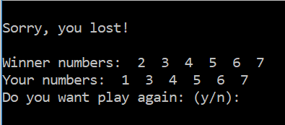
If winner numbers do not match to user numbers, the user is informed about lose.
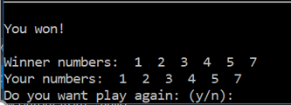
If winner numbers match user’s numbers, the user is informed about the win.

- User documentation

- Introduction
Welcome! The program is a lottery game, coded in c language. The game was created in Visual Studio - programming environment - and works on Windows Command Console.
The aim of the game is to guess six numbers by a user, which the program will draw from the range of 1-7.
The lottery is an excellent toolkit for people who like gambling but do not want to risk their properties! To play any money and appropriate age are not required, this is just for fun and entertainment.
- Requirements
The preferred operating system is Windows 10 and a programming environment to start the program is Visual Studio, which can be downloaded for free from:
https://www.visualstudio.com/
Please, choose Visual Studio Enterprise 2017 for Windows!
The instruction how to install the software pops up after clicking “Download” from the link:
https://www.visualstudio.com/thank-you-downloading-visual-studio/?sku=Enterprise&rel=15
- Starting the program

- Run Visual Studio
- Click – File > Open > Project/Solution
- In the window find the location where you installed Visual Studio – repos > Lottery Number Generation and Management

- Click - Lottery Number Generation and Management.sln
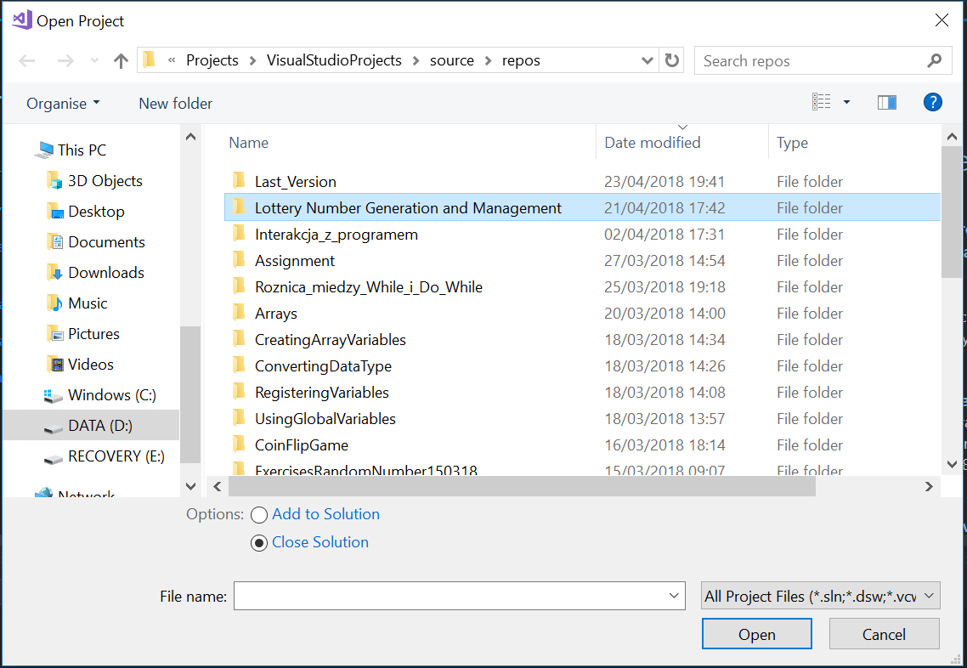
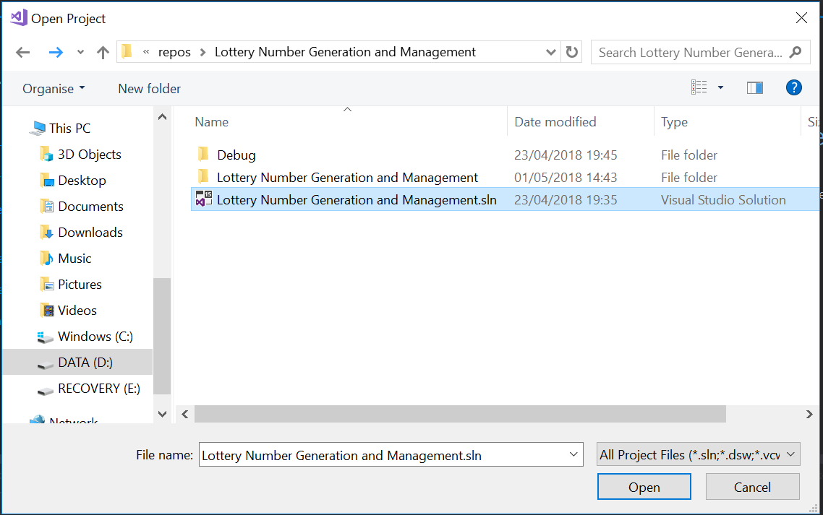

- After the program is loaded press ctrl and F5 keys. Then Windows Console Application starts to read the program.

- Game instruction
Welcome to the game! This is short instruction how to play.
- In the main game’s window, you can see the pool of numbers taking part in the lottery. You must decide on a game. If you want to play - press “y” (yes) or if you do not want to have fun - press “n” (no).
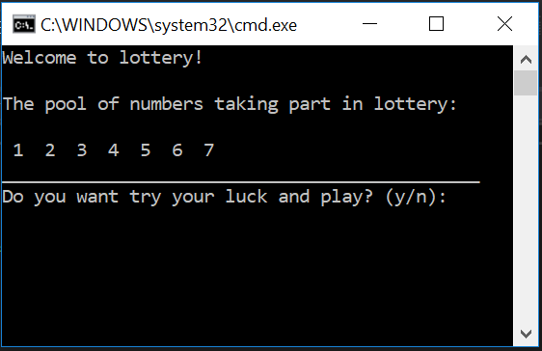
- The next step is to enter your six lucky numbers in the range from 1 to 7.
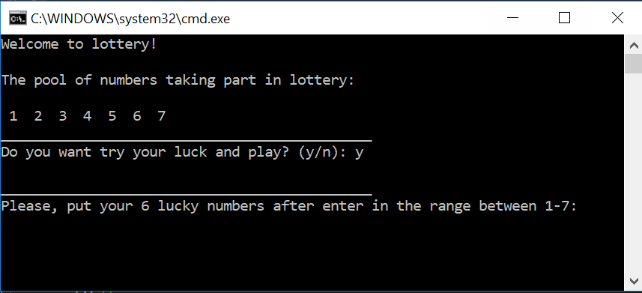
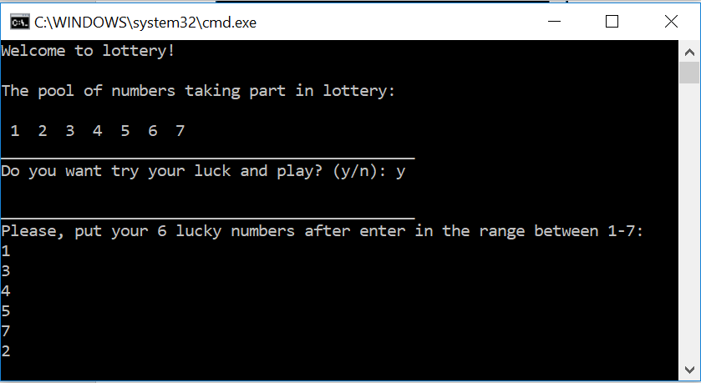
- In a situation when your lucky number is out of range, or it has been duplicated the program ask you again about a new lucky number in the range and not duplicated.
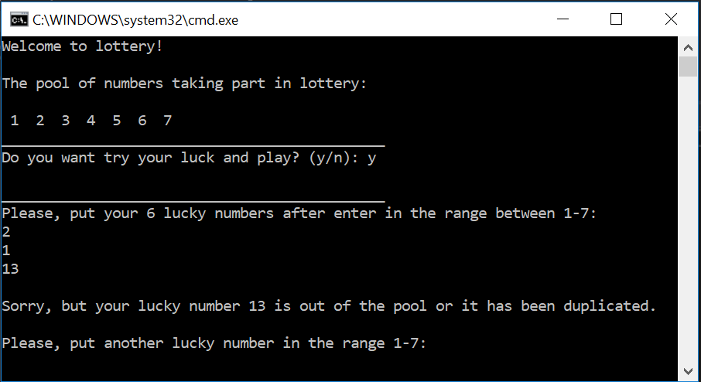
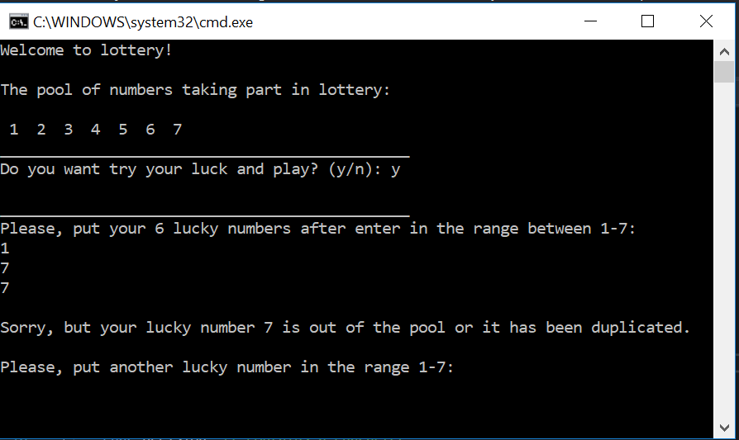
- When you have already chosen your lucky numbers, then the program draws six random numbers from the pool and show you a result in ascending order. If your lucky numbers are matched to random numbers, you win.
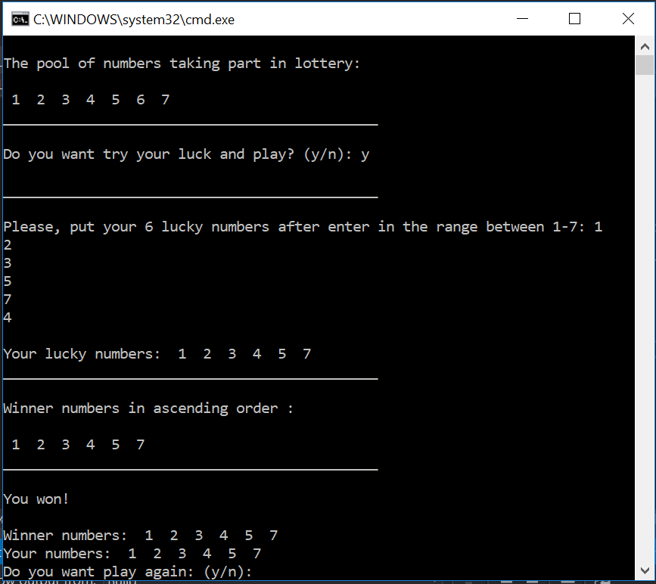
- If you want to play again press “y” (yes), if not press “n” (no)
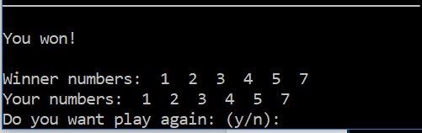

- Technical Documentation
- Introduction
This technical documentation contains information about the program and explains how it works. However, the documentation is designed for people who want to know more about the code and for those who will be back to the technical side of the program in the future.
The code was created in Visual Studio programming environment in C language on Windows operating system.
- Requirements
To work with the code is preferred to use:
- Visual Studio - programming environment which can be downloaded for free from: https://www.visualstudio.com/
- Windows 10 – operating system

- The Code Structure
In this section the program coding will be discussed, commented and analysed.
Before starting coding, the very first thought was required – choosing proper libraries for the program. Standard C libraries in C language are contained in “header files” that each have a file extension of “.h”. [1, p. 9] The libraries are a source of functions which are vital for each program.
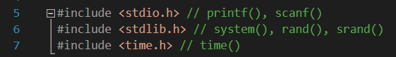
stdio.h – contains input and output functions, represents one third the entire c libraries
stdlib.h – contains utility functions for number conversion and storage allocation
time.h – contains functions for manipulating date and time components
When the libraries are specified, it is possible to create the main function. A function in C language is a piece of code that can be reused repeatedly and has some data like variables or statements.
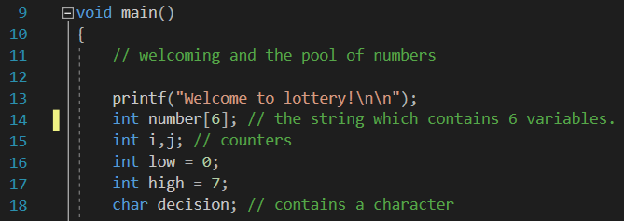
For requirements of the program some of the information was introduced to the main function such as some integers:
int number[6] – the array uses to hold a string which contains six variables
int i, j – uses as counters for “for loops”
int low, high – constitute the low and high limit of the amount of numbers that take part in the game
char decision – a variable for a character for “while loop”
printf() – uses for print text to the user
Thanks to the statement on the picture above it is possible to add a random element to the program.
srand() – uses to set starting value called “seed” for generating a sequence of pseudo-random integer values.
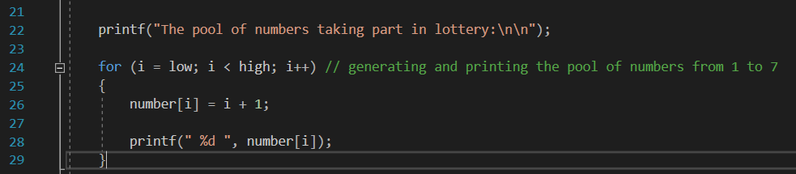
The first “for loop” in the program is used for generating and printing the pool of numbers. Simple equation “number[i] = i +1” is repeated “i” numbers of times and saved in an appropriate location in the array. In other words first equation will be look like “number[0] = 0 + 1” and from this moment variable number[0] = 1.
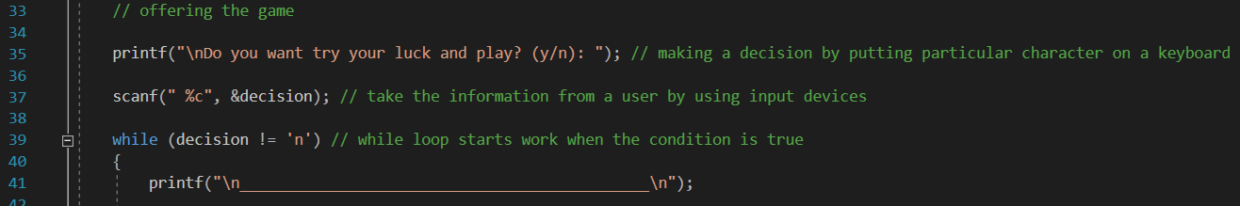
When a user sees an offer of the game they can make a decision – yes or no – by pressing “y” or “n” on a keyboard. In the code, the “while loop” is responsible for that.
while(decision != ‘n’) – the loop works if the statement inside the brackets is true. In this case when a user press “n” the program turns off.
scanf(“ c”, &decision) – takes a decision (play or not) from the user and save it.
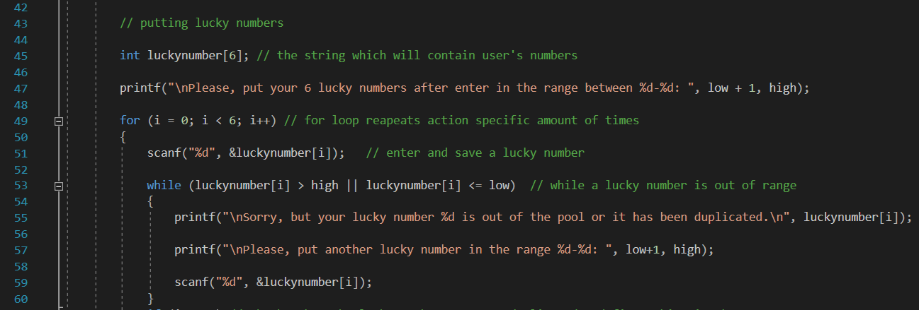
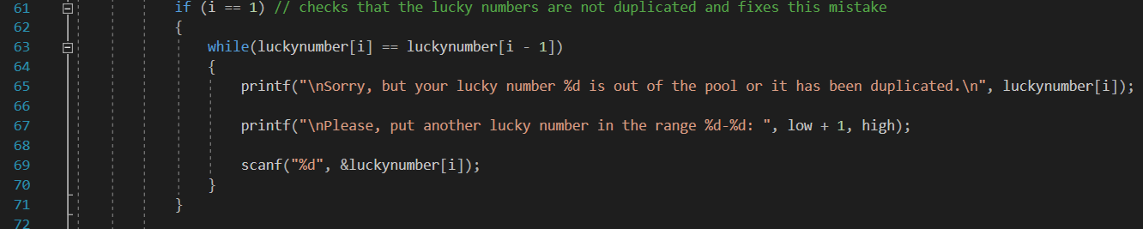
The created game requires numbers introduced by a user. Users must enter their six lucky numbers which must be in the range and cannot be duplicated. “For loop” is repeated six times until the moment when each number fulfil the conditions included in “while loop” and “if statement”. The conditions are said, that when a lucky number is out of the range and if the lucky number has been already typed, the program is invited a user again, to entering a new lucky number.
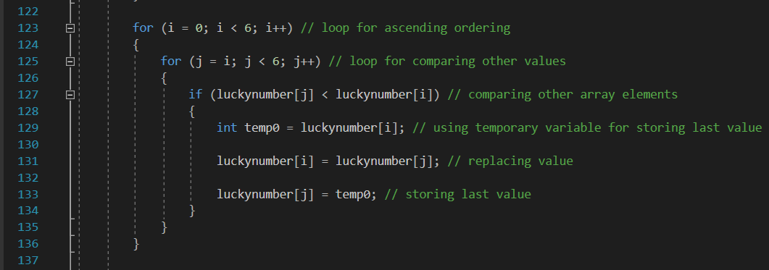
To obtain an ascending order of the lucky numbers, entered by a user, is needed to use two “for loops” and counters (“i” and “j”). The first loop makes operations six times when the second compares values of the variables referring to “if statement”. Variables are stored in a temporary location, then replaces and to saves last values.
int temp0 – uses as a temporary variable for storing last value
In further pieces of the code “ascending order” formula is repeated few times to achieve this same effect.
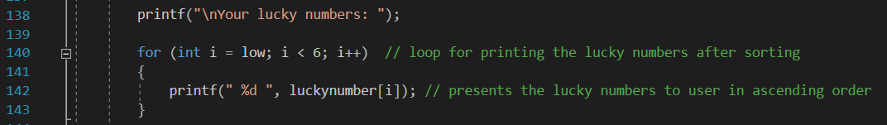
Next, the lucky numbers are printed in ascending order on a user screen as a result of “for loop” and texts instructions.
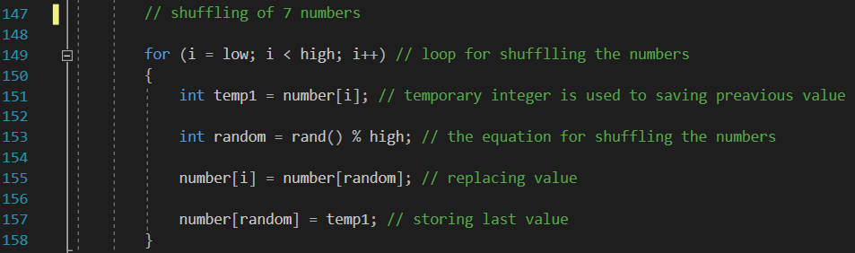
However, the generated numbers are shuffled at the beginning of the program, and 6 of 7 first shuffled numbers are shown to users as winning numbers. Similarly, to “ascending order” formula, this piece of the program involves temporary values. One of them is used for generating a random number in the specific range.
int temp1 – uses as a temporary variable for storing last value
int random = rand() % high – the equation for randomising generated numbers
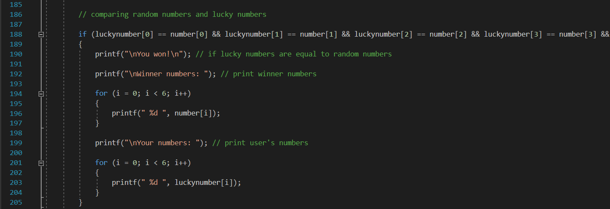
The game assumed that player is able to win or lose. If player’s lucky numbers are the same as numbers generated by the program, then it is a victory in other ways player is defeated. “If statement” checks that each element in lucky number array is equal to their equivalent in random number array and if all elements are matched right part of the text should be displayed to a user.
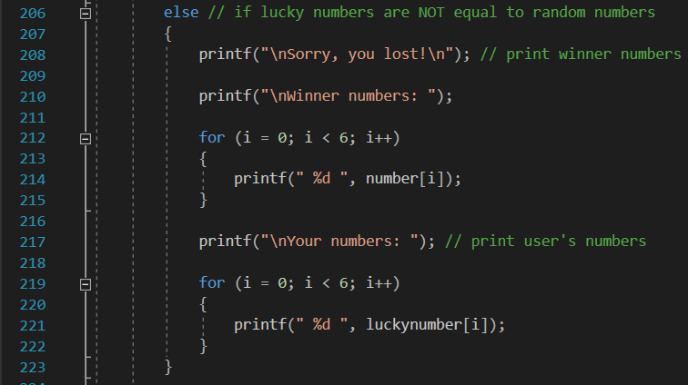
Moreover, when the condition is false then “else statement” run and inform a user about lose.
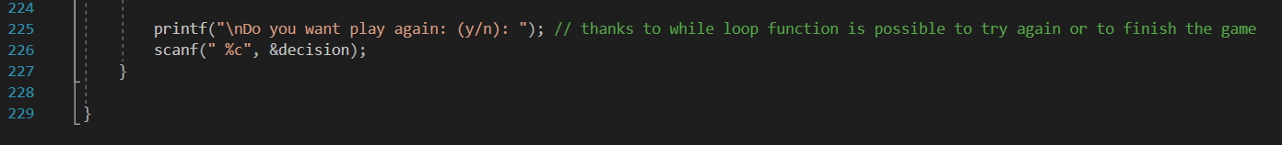
The last statement of the code is a proposition of a new game. Users have a choice to play as long as they want by pressing “y” character (yes) or “n” (no) owing to “while loop” and “scanf()” operations.

- Conclusions
Created the simple lottery game in C language has given more opportunities to develop programming skills and problem-solving thinking, rather than simple lottery number generator. Extra knowledge gained during work with the assignment such as creating flowcharts and different documentation has shown how to proceed in future projects. User documentation is an excellent method of presenting a program to non-specialists as well as making technical documentation is reasonable behaviour for programmers, because of learning and remembering coding keywords and features. Needles to say is that well-prepared documentation is a vital source for people who want to work with programmer’s code.

References

[1] | M. Mcgrath, C Programming in easy steps, 4th ed., Leamington Spa: In Easy Steps Limited, 2014.
[2] | Tutorials Point, "while loop in C," [Online]. Available: https://www.tutorialspoint.com/cprogramming/c_while_loop.htm.
[3] | Learn C Programming, "C Programming while and do...while Loop," [Online]. Available: https://www.programiz.com/c-programming/c-do-while-loops.
[4] | Learn C Programming , "C Programming for Loop," [Online]. Available: https://www.programiz.com/c-programming/c-for-loop.

