

School of Engineering

Reflective Project Report
Group Project (ACMA5009)

Paul Benbow
2014803
14/05/2022

Executive Summary
The Clydach refinery shutdown period lacked a dedicated project manager which created a gap which was filled by the three process superintendents. Each, used the refinery Gantt chart to outline tasks and lead a project for their individual plants with no concept of resource conflicts created in other areas of the refinery. This lead to work lists being created and additional labour arranged outside the “official” project schedule.
Without the authority and influence of a project manager a ‘Project scope freeze’ was not introduced and enforced. The scope freeze should have given enough time for the shutdown scheduler to build a schedule and then to confirm execution dates, task durations and resource requirements with all stakeholders and execution teams, instead adjustments were made with the introduction of additional tasks to the schedule continued after the project had started.
The subjective nature of the requests saw notifications being created in batch instead of being created immediately after a routine maintenance plan had drawn attention to an immanent failure or at the request of a reliability engineer. The presumptuous requests from the process superintendents overwhelmed the ‘MPC Department’, hindering their ability to function with the departments normal available resources.
Adjustment to the ‘Refinery shutdown’ maintenance window three weeks prior to the project start date caused conflict between maintenance technicians and their superintendents. The change, widened the shutdown window which reduced the requirement of overtime, this was a benefit to the refinery as it limited labour costs but, created animosity from the maintenance technicians as the opportunity to earn additional pay was removed without any adequate explanation.
The project team did not include members from departments such as; procurement; stores department; health and safety. A cross functional team, spanning a multitude of departments would have been able to identify issues sooner, effectively mitigating risks to the project i.e. material lead time concerns; budget constraints.
At present the overall project completion date has slipped by four days, the project team feel optimistic that the additional labour will help bring the forecasted completion date back to the original scheduled completion date.
A project review should be undertaken on completion of the project which, should include all stakeholders. It is important that the project team understands what caused the decrease in output from the 04/05/2022 so that lessons can be learned for the next project.

Table of Contents
Introduction 4
Main Findings 5
Conclusion 13
Bibliography 14
Appendix ‘A’ 18
Appendix ‘B’ 20

Figure 1, Bathtub hazard rate curve (Jeong, Y., Park, I. and Yoon, B, 2016) 6
Figure 2, Gantt Chart of management plan for the MPC department leading up to the shutdown (Gantt.com, n.d.) 7
Figure 3, A RACI Matrix Used to Define roles of the MPC Department During the Shutdown (Business Documents UK, n.d.) 8
Figure 4, Project sprint burndown chart (Agile Digest, 2022) 12
Figure 5, Milestone Tasks that Manage Subsequent Tasks 18
Figure 6, An Extract from the Refinery Gantt chart that shows the layout used. 18
Figure 7, The refinery Gantt chart's critical path 19
Figure 8, A resource sheet showing crew availability for each work group 20
Figure 9, An example of the calendar adjustment made to reflect available working hours of a resource 20
Figure 10, A resource graph that was used to monitor of allocation 20

Introduction
Vale Europe Ltd is a part of the global corporation Vale S.A is the world’s largest producers of iron ore and nickel (www.Vale.com, 2022). Their refinery in Clydach was founded by” The Mond Nickel Co” and has been in production since 1902 (Dalling, 2019). The refinery receives nickel oxide ore from vale mines that are based in Canada and Indonesia, the refining produces a high nickel purity powder or pellet product that is packed and shipped to customers (www.valeclydach.com, 2016).
The process at Clydach is distributed across three areas of the refinery; the ‘Process Extraction Plant’; the ‘Process Manufacturing Plant’; the ‘Process Gas Plant’. Each plant is managed by a ‘plant superintendent’, their responsibilities are to ensure that a safe and efficient process is maintained through the effective use of equipment and process procedures.
The Nickle oxide ore is processed in the ‘Process Extraction Plant’ at the refinery. The plant has two separate production lines, ‘Kiln 1’ and ‘Kiln 2’, both have identical feature’s and process functions. Each Kiln line consists of a series of three rotating kilns each having a different process to perform.
Nickel oxide ore is fed into each kiln simultaneously by a serious of inclined conveyors, a controlled dosing system will add a catalyst to the ore before entering each kiln. Once inside the kiln, the raw material is heated to a temperature of 600°c - 700°c and then conveyed to the next kiln, it will then be chemically primmed. After primming, the material passes onto the final kiln and warm Carbon Monoxide gas is passed over the product which extracts the nickel in a gaseous form. The gas produced is called Carbonyl, this is a highly toxic gas (Morrison, A. et al. 2018). The Carbonyl leaves the ‘Process Extraction Plant’ via a system of pipework which forms the ‘Carbonyl Circuit’. Through the ‘Carbonyl Circuit’ the gas can be directed into two process to produce either a powder product or a pellet product. The timeline of the process will depend on conditions such as; feed rates; temperatures but, will typically be twenty one days.
Every two years, Clydach refinery has a shutdown cycle for major maintenance work to be undertaken. The criteria of the maintenance work will include; statutory inspections by insurers; legislative inspections; maintenance work that is intrusive to the gas circuits; final capital project ‘tie-ins’ to the gas circuits.
During the shutdown period, one kiln line will be taken offline for major maintenance. Within this period the remaining processes at the refinery will be stopped and purged clear of all gases, and will create a seven day maintenance window that is known as the ‘Refinery Shutdown’.
This report is a reflective account from the ‘Refinery Scheduler’ and will detail the roles and responsibilities of the team engaged to manage the project, during the period between 24th April 2022 and 17th June 2022, when ‘Kiln line 2’ will be shut down for major maintenance. The refinery shutdown window will be between the 9th May and 16th May 2022. The report will explore the management techniques that were used to produce an efficient, accurate and cost effective project schedule.

Main Findings
A shut down period is a change from the status-quo for an organisation that must be managed (Barbalho, S.C.M., De Toledo, J.C. and Silva, I.A.D., 2019). Process shutdown procedures, engineering processes, and personnel attended the refinery during this period will differ from the ‘norm’ and once finished, will return. Identifying the body of work that needs to be completed during this period as a ‘Project’ invokes ‘Project Management’ techniques that can be utilised to produce a safe and efficient schedule of work. Project management can be divided into three process; planning; delegation; monitoring and control, to achieve the projects objectives it is vital that each process is effective (Managing successful projects with PRINCE2, 2009). At Clydach refinery it is the primary function of the ‘Maintenance Planning and Control’ department (furthermore to be known as MPC Department), to satisfy these three processes.
It is important that during conceptual stages of a project objectives are produced. This creates boundaries for the project team to work within, by identifying a scope of work. A detailed scope of work, according to Haniff, A, & Salama, M (2016), should be used to delegate responsibilities to the project team and produces accurate outputs such as; estimation of costs; resources required; work packages.
The project objectives were defined by the ‘Clydach Refinery Plant Manager’ and described the need for the project to be completed in a specific maintenance window; the refinery shutdown window would be as short as possible; labour costs were to be minimised with the restriction of non-productive premium rate overtime; start times of different work groups should be staggered to mitigate any bottle necks caused by plant sign-on procedures. The projects objective should remain constant throughout, according to Dhillion, B.S. (2020), this is to ensure that every member of the project team are working within the same constraints. However, a logistical issue caused a delay to the delivery of nickel oxide feed into the refinery this meant that the refinery’s objectives were changed and the ‘Refinery shutdown’ window was extended by ten days.
The project scope was determined by the three process superintendents and the ‘Maintenance Reliability Team’. The reliability team consists of a mechanical reliability engineer and, an electrical and Instrumentation engineer. A reliability engineer’s objective according to Dhillion, B.S. (2020), is to prevent equipment from failing, this is achieved by analysing data that has been derived from maintenance inspections; equipment run time counters; manufacturers engineering manuals. There was not an imposed ‘deadline’ for formally completing a “Project Scope Freeze” (www.praxisframework.org, n.d.), the scope was continually adjusted up to the date of execution.
The data collected is used to plot a ‘Bathtub Hazard Rate Curve’ (Figure 1) and, depicts the quantity of failures recorded over the equipment’s life span. The curve, typically passes through three distinct phases the first of which, represents the initial installation of the equipment and records a high number of failures that can be attributed to the commission process. The second phase shows, minimal failures recorded for a consistent period of time – the equipment’s functionality has been optimised through effective commissioning and ‘online’ maintenance regimes. The third phase, shows an increase in failures that can be associated with the equipment coming to the end of its usable life (Wang, K.., Hsu, F.. and Liu, P.. ,2002).
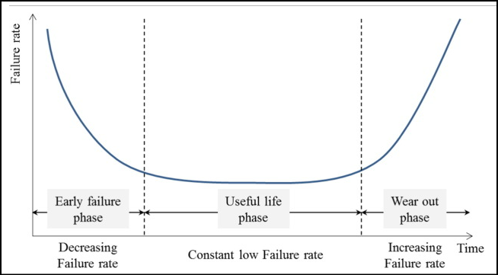
Figure 1, Bathtub hazard rate curve (Jeong, Y., Park, I. and Yoon, B, 2016)
Each ‘Plant superintendent’ should know the consequence to production and safety if equipment fails. Therefore, the ‘reliability team’ and the ‘plant superintendent’ should be able to make an informed decision, based on the data collected to create the ‘bathtub hazard rate curve’ as to whether intervention is required for maintenance (Yi Chen et al.,2011).
The MPC Department is the responsibility of the ‘Systems Department Supervisor’, who is accountable for ensuring that efficient planning and effective scheduling of maintenance requests from process plants. This is achieved with the delegation of work between four roles within the department, the ‘Mechanical Maintenance Planner’; the ‘Mechanical Maintenance Planner Apprentice’; the ‘Instrumentation & Electrical Planner’; the ‘Refinery Scheduler’.
The MPC department receives requests for maintenance via a computerised maintenance management system known as SAP. SAP is an ‘enterprise resource planning’ software and is used to integrate departments of the refinery into one system to allow for an holistically efficient work flow (www.SAP.com, 2022). Each request (furthermore to be known as a notification) details information such as, the ‘Main work Group’ required to complete the maintenance; unique equipment identification number; location of the equipment; ‘required end date’; a description of the fault or the maintenance required.
Notification are delegated to the relevant maintenance planner by the details of the ‘Main Work Group’ field. A maintenance planner’s role is to provide an adequate planning package of which, (Maintenance Planning and Scheduling: An Overview, n.d.), should detail; a specification of the work required; accurate labour resources; all materials required to complete the work; supporting documentation that includes risk assessments and permit to work Requests. Effective planning according to Perry, R. (2018) can increase productivity of labour by 60%, Kister and Hawkins, (2006) go further, and state that productivity can be increased by up to 77%. Once each notification has been planned, the maintenance planner will convert the notification into a ‘Work order’, this allows resources to be committed in SAP and for the maintenance request to be formally passed to the ‘Refinery Scheduler’. It is the ‘Refinery Scheduler’s’ responsibility to look for synergies between work requests, and to liaise with process teams to arrange and agree an adequate time for equipment to be released for maintenance. It is the schedulers priority to ensure that equipment downtime is minimised while, maximising the efficiency of the maintenance execution teams (Perry, 2018).
Management of the MPC department’s resources during the period leading up to the refinery shutdown is important, so that a consistent workflow is maintained. The maintenance planner’s and the scheduler have a weekly commitment to plan and schedule routine maintenance plans and corrective maintenance.
Maintenance plans are associated with a specific piece of equipment and define routine maintenance activities that a reliability engineer has deemed a necessity for the equipment to provide a reliable function, such activities include; inspections; services; calibrations (ERProof, n.d.). Corrective maintenance defines work that has been identified by a maintenance plan and requires additional work to be completed by a deadline (Stenström, C. et al, 2016). The deadline is an estimation of the date that the equipment might fail, if the work is not completed by this date then, the risk of equipment failure will increase.
Concerns were raised by members of the ‘MPC Department’ regarding their workload associated with the volume of additional notifications raised for the shutdown. The ‘MPC Supervisor’ met with members of the team to discuss the issue. The ‘Refinery Scheduler ‘ and ‘Mechanical Maintenance Planner’ confirmed that to produce an accurate and efficient shutdown schedule, both would need to be released from their week to week responsibilities. The ‘Electrical & Instrumentation Planner’ was confident that their additional work load could be managed as well as their week to week activities.
The ‘MPC Supervisor’ needed to react immediately because if not resolved, the departments objective would not be achieved which would jeopardise an effective execution of shutdown work by; not being able to quantify the duration of work accurately; critical paths might not be able to be calculated; materials with long lead times might not be delivered; resource availability might not be secured.
The leadership style adopted by the ‘MPC supervisor’ as Mullins, L.J. and McLean, J.E. (2019) describes, was participative with information shared and decisions made as a team. A meeting was arranged for the team with the purpose of creating SMART objectives, once the objectives had been decided upon, the team began to find solutions. Creating Specific, Measurable, Achievable, Relevant and time-bound (SMART) objectives (MindTools, 2016), helped the team focus on logical answers to the problem. A Gantt chart was produced as an output of the meeting which itemised the SMART objectives, this would be useful when escalating the problem, along with the solution to the stakeholders. The Gantt chart (Figure 2) was a visual display of the timeline, resources and the coordination needed for the ‘MPC Department’ to achieve it targets which was, to ensuring that all shutdown work was planned and scheduled effectively (APM, 2021).
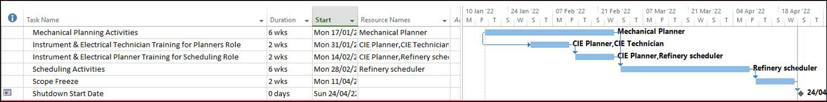
Figure 2, Gantt Chart of management plan for the MPC department leading up to the shutdown (Gantt.com, n.d.)
The ‘MPC supervisor’ then escalated the issue to the next line of management, this included the; ‘Engineering Manager’; the ‘Refinery General Manager’; the refinery’s process Superintendent’s; ‘Maintenance Superintendents’, the solution was also presented and detailed the requirement for additional resources.
Management decided that the ‘Mechanical Maintenance Planner’ needed to be released from week to week duties as soon as possible, and to save cost of additional resources, the ‘Mechanical Maintenance Planner Apprentice’ would Immediately assume the role.
Likewise, the cost to employ an external project manager to create and manage a schedule would have had a severe impact to the shutdown budget. A solution was found that saw the experienced ‘Instrumentation & Electrical Planner’ temporary assume the role of ‘Refinery scheduler’. This would allow the current ‘Refinery Scheduler’ to focus on building the schedule for the refinery shutdown. An experienced ‘Instrumentation & Electrical technician’ would then be given the opportunity to temporary assume the role of the planner.
The movement between roles would benefit the ‘MPC Department’ to overcome the short term issues and provide additional flexibility for the future by enhancing the knowledge and skills of each member, creating an environment for interchangeability between roles during sickness and annual leave.
Managing the change to minimise the impact of the “week to week” function of the ‘MPC Department’ was done by a staged approach which saw each employee assuming roles being trained by the current role holder for a period of two weeks. A RACI matrix (Figure 3), was created because of the disruption to duties of personnel within the department and was intended to ensure that roles and responsibilities Were redefined. A RACI matrix will show who is; Responsible for an action; Accountable for an action; needs to be consulted during an action; needs to be informed of the action (Model, 2021).
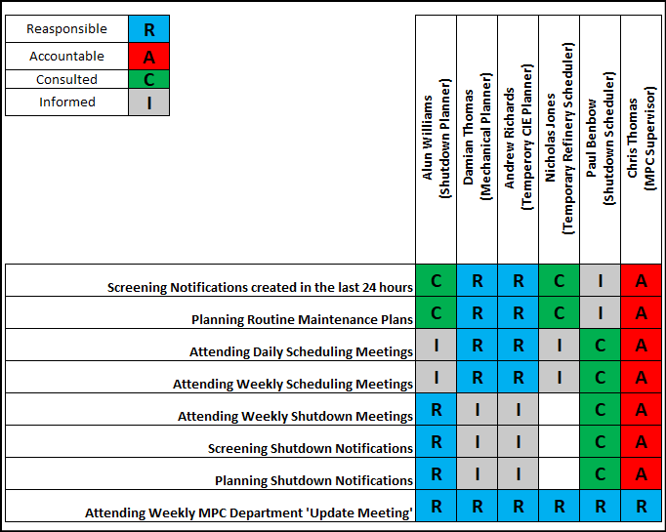
Figure 3, A RACI Matrix Used to Define roles of the MPC Department During the Shutdown (Business Documents UK, n.d.)
A ‘Shutdown Planning’ meeting was scheduled for Tuesday afternoons, this allowed the ‘Process superintendents’ to receive an update from each planner or project engineer responsible for work that was to be executed in the shutdown window. The agenda included; an update on planning milestones and the quantity of notifications that were left to be planned; materials with long lead times that could have jeopardised the execution of the associated work; Purchase requests issues that were preventing the purchase of services or materials. Attendees for this meeting included; both maintenance superintendents; the ‘MPC Department’; engineers controlling capital projects - there was no representative from the procurement department. Procurement is an important aspect of project management, the department ensures that funding is available for purchasing, existing contracts are monitored and additional contracts are secured (Apm, 2021). If delays or issues occur with any of the items above then, effective resolution of issues would have found more effectively if a member of the department had been present at the ‘Shutdown planning’ meeting.
A Gannt Chart was created by the scheduler (Appendix A), it’s purpose was to create a logical and sequential schedule of work to produce the desired deliverables by; managing resources; ensure the timeline specified by the ‘Refinery General Manager’ was maintained; calculating critical paths; controlling the execution of the project (Kidston, P. and Haward, K, 2015).
Meetings were scheduled between the ‘Scheduler’ and the ‘Process Coordinator’ of each plant to create a core to the Gantt chart that was based on Process shutdown tasks and process recommencement tasks of each plant. One out of the three process coordinators committed to investing their time to working with the ‘scheduler’. When logical relationships were created between each of these tasks a timeline for process operators to isolate and make equipment safe for maintenance would be produced. As suggested by Harris, (2019) milestones were derived from the core process tasks (Figure 5), to provide suitable start and finish points for collective bodies of work. Such milestones were relative to the systems that became available for maintenance i.e. ‘kiln line 2’ and were labelled as; “Maintenance Window Opens”; “Maintenance Window Closes”.
The construction of an efficient Gantt chart relies on accurate planning which includes the precise estimation of time required for a specific trade to complete each task (Kister and Hawkins, 2006). Identification of the relationships that exist between each task is also essential to ensure labour is in the right place, at the right time ensuring that waste is not incurred. An example being the construction of a house, first the walls must be built before the roof is formed, if tradesmen and materials for the construction of the roof arrived on site without the walls being built, this this would generate waste through; materials have to be stored securely until they are ready for the construction; the labour that has attended site in anticipation of the construction will still need to be paid a wage.
Capital project work was exclusively controlled by the allocated project engineer, tasks were not recorded in SAP, instead contracts were awarded directly to external companies. Issues would arise from this style of project management as, each project engineer would not request a Gantt chart to review the timeline and resources required to complete their project. Instead, the engineer would outline a time period the work must be completed in, the contractor would price accordingly assuming that all work faces were available at the same time hence, over resourcing the project and inadvertently inflating the project cost. Over resourcing projects also had an detrimental impact to other resources that included amenities; site induction facilities; occupational health staff; team leaders.
Creating relationships in Microsoft project between milestones and tasks allowed the scheduler to analyse the critical path of the project (Figure 7). The critical path (Figure 7), as described by, Management, (2015), is a series of tasks that if delayed, will have a direct impact to the overall project end date. After all maintenance task had been linked to the process milestones (Figure 5), the software would automatically find an available date for execution based on the availability of the required resource and the prioritisation associated with the task.
A risk evaluation exercise was completed on each task, this required the equipment owner to assess the implications on process recommencement tasks if, the maintenance task slipped from its original scheduled execution date (Prince2, 2009). Two prioritisation tables were created both itemising the types of maintenance that would be completed during the shutdown. Each item was assigned a numerical value that increased according to the risk posed to ensuring the maintenance window closed as soon as practical, allowing for process recommencement.
Table 1 shows the categorisation of maintenance task types and their associated priorities. Table 2 shows the same maintenance task types and their associated priorities, The numerical value placed on the priorities in Table 1 are lower than that of the priorities in Table 2, this is to ensure that all available labour is diverted to work associated with the refinery shutdown, ensuring that the shorter maintenance window closes as soon as practical. Once prioritisations are set, the software would scheduler higher priority work first, so long as the relationships built by the scheduler is an accurate representation of task being available for the labour to complete work on (Harris, 2019).
Table 1, Refinery shutdown task prioritisation table
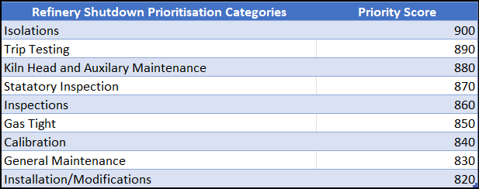
Table 2, Kiln 2 shutdown prioritisation table
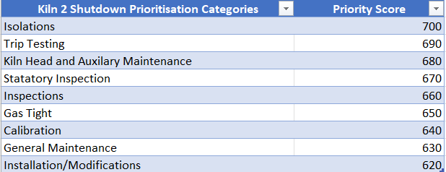
Resource modelling was performed by both maintenance superintendents and the scheduler. The object of this exercise was to simulate different levels of available resources (Figure 10), while monitoring the effect on the timeline of the project. This was to make sure that the quantity of resources required was minimal and overtime was limited while still ensuring that the project was completed within the specified maintenance window.
Maintenance execution during the refinery shutdown would be the responsibility of three maintenance departments; MMD (Mechanical Maintenance Department); CIE (Central Instrument & Electrical Engineering); CEW (Central Engineering Workshop), Management of MMD and CEW is the responsibility of the ‘Mechanical Superintendent’ while, the management of CIE is the responsibility of the ‘Electrical & Instrumentation Superintendent’. It was the responsibility of each maintenance superintendents to ensure that technicians within their team where available and able to complete work during the shutdown. Co-ordination of technicians working in a superintendents team was made by the ‘Maintenance team leader’, they would act as an interface between the ‘MPC Department’ and the team of technicians executing the schedule.
Once the required resource quantity and additional working hours had been decided, the Mechanical and CIE superintendent both reached out to their teams to notify them of the projects resource requirement’s. Conflict arouse once the project had begun, this was between the Mechanical superintendent and the mechanical technicians. The mechanical team refused to work the necessary overtime that was required by the Gantt chart required. A cooperative approach as suggested by Behfar, K.J. et al. (2008), could not be used to create a solution, this would have led to project delays instead, an integrating style of management was used whereby the ‘mechanical superintendent’ had to invested time to investigate the issue with the team to find a solution that was right for the project.
Tracking progress of the project, was important during the execution phase to ensure that all stakeholders were aware of any possible delays to tasks that could have had an impact to the project timeline. It also gives opportunity to the team (after the project has been completed) to review the original timeline against the actual timeline. If there were deviations between both timelines then further analysis could be completed to ensure that learning outcomes are published for increasing future project’s execution accuracy.
An update on the progress of work was given by each work group supervisor. The update would be received by the scheduler (in the presence of all stakeholders), at the beginning and the end of each day. The update would reflect on the progress of work that had been scheduled in the interim period between progress reports, and would be measured as ‘percentage complete’. Microsoft Project was then updated, this allowed the software to move uncompleted tasks that had a completion date prior to the ‘updated date and time’, to be brought forward to the present date and time. An accurate forecast of each teams work load could then be made. Resources were then ‘auto levelled, this resolved any ‘overload’ within the resource group.
At each project update meeting, after the review of progress, the scheduler reviewed targets that each execution team needed to achieve in the next period. The meeting created a forum for each execution team, process team and the ‘MPC department’ to raise any concerns regarding the forth coming workload i.e. material is yet to be delivered; work area is not safe; additional Personal protective equipment required. The scheduler would review the Gantt chart to ensure that the project milestones had not been delayed. If the project had drifted, the scheduler would analyse the Gantt chart and the sprint burndown chart to determine the reasons for any deviations. A sprint burndown chart trends the amount of tasks left to be completed against the timeline of the project (Burndown Chart: What Is It & How Do I Use It, 2019). The trend can also be referenced to the original baseline which was set at the beginning of the project and can indicate to the project manager if the project is starting to drift off schedule (Figure 4). Once the scheduler has completed the analysis, an updated Gantt chart with an executive summary informing the reader of; the progress to date; potential risks to the timeline; recommendations, is sent to the stakeholders.
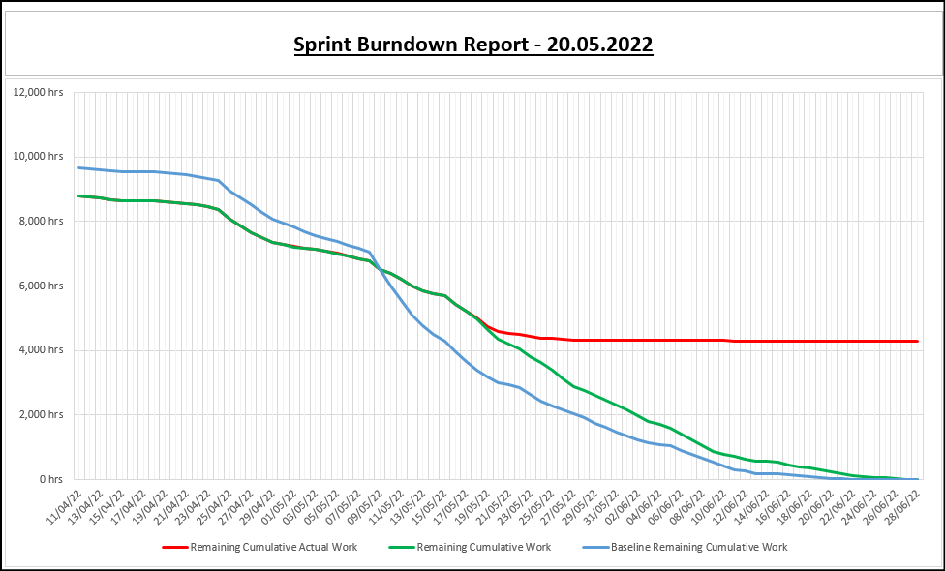
Figure 4, Project sprint burndown chart (Agile Digest, 2022)
Figure 4 shows three plots; the baseline; remaining cumulative work; remaining cumulative actual work. The baseline is a recording of the initial schedule of the project, the blue trend in Figure 4 represents the recorded sprint burndown of scheduled tasks. Remaining cumulative (represented by the green trend in Figure 4), is a projection of the sprint burndown after updates have been received and takes into consideration, tasks that haven’t been executed as per the scheduled date. The red trend in Figure 4, represents the actual work that remains to be executed, this is an accurate method for analysing the deviation between the initial project schedule and the real time progress reports from execution teams. This is an early indication to the project manager and the stakeholders if the project completion date alters (Haniff, a, & salama, m, 2016).
Project success is based on the review of key performance indicators during the project close out stage, and can produce learning outcomes to improve the implementation of future projects (Project Manager News,2020). The indicators that need to be analysed should include but, are not exclusive, metrics such as; Scope - did the project deliver what it said it was going to deliver; Schedule – was the work executed at the time the schedule said it was going to be scheduled; Quality – is the maintenance work completed to high standard and will ensure the equipment’s reliability; Budget – was the project completed within budget; Customer Satisfaction – are the customers satisfied with the service that they have received (Team, n.d.). It is important, according to Fahri, J., Biesenthal, C., Pollack, J. And Sankaran, S., (2015), that during the initialisation stage of the project the key performance indicators are defined by all stakeholders and the project team should define the scope and method of measuring the metrics. Contrary to theory, no formal agreement was made between the project team and the stakeholders for the refinery shutdown at Clydach.

Conclusion
The Project objectives were made clear by the refinery general manager however, this was the extent of the their input into the project. Delegation of the management of the project was made to three separate process superintendents, each having their own objectives and maintenance scope. The role of a project manager should not be confused with that of a stakeholder, it should be independent and focused on achieving the project objectives (Cobb, A. T. 2012). Giving three process superintendents (with equal status), the autonomy to delegate limited resources to tasks will create a conflict of interest, with work that it’s to take place in their own area always being the priority regardless of the agreed priority assigned.
A ‘process superintendents’ influence on requests for maintenance caused the project scope to be constantly adjusted which, contradicts Haniff, A, & Salama, M (2016), and the advantages that they state a specific project scope can bring to the execution and control of a project. Every adjustment to the project scope (work removed or added) produced either additional or wasted activities for the MPC department.
Contrary to Dhillion, B.S. (2020), work on methods of evaluating equipment maintenance strategies, assumptions were made by process superintendents on maintenance requirements of equipment. The requirements where subjective and based on the process experience as appose to the knowledge of equipment functionality. The maintenance scope should have been defined by the ‘reliability team’ and produced from analysing data on equipment failures. Poor systemisation of formalising a maintenance scope meant that ‘scope creep’ was observed, this was caused by additional work being added to the scope. ‘Scope Creep’ is acceptable so long as it is controlled by the project manager and does not impinge on the project execution date, this project failed on both of these points and likely sustained waste with regards to cost and time management (tommochal, 2005).
The ‘scope creep’ combined with the subjective maintenance requests from process superintendents, severely influenced the ability of the ‘MPC departments’ to react to the demand for planning and scheduling. Management of the situation was efficient and effective with a resolution found that mitigated addition cost and widened the knowledge base of the department.
The method used to prioritise tasks and to construct the refinery shutdown Gantt chart was conclusive with theory. The accuracy of the Gantt chart and its ability to analyse data by reviewing the ‘sprint’ burndown report and the project milestones enabled the scheduler to inform stakeholders of potential ‘project drift’, this allowed for solutions to be found and implemented swiftly.
Analysis of Figure 4 showed from that the rate of execution of work started well however, at approx. 04/05/2022 performance started to dip, which placed the success of the project in jeopardy. The trend was monitored by the scheduler, the process superintendents and the maintenance superintendents until 15/05/2022 in hope that performance would improve and the project completion date could be brought back to the baseline. However, the trends tracheotomy showed little improvement with a forecast placing the schedule ten days behind schedule. The decision was made amongst the team to engage additional labour, this proved to be success.
Agreed learning opportunities at ‘project close out’ will be difficult to establish because there was not an agreed strategy in place to record Key performance indicators (furthermore to be known as KPI’s). KPI’s adequate data for project deviations. KPI’s enable the growth of a business by reflecting on processes, analysing and establishing areas for improvement (Parmenter, 2015).

Bibliography
Agile Digest. (2022). Burn Down Chart. [online] Available at: https://agiledigest.com/burn-down-chart/ [Accessed 21 May 2022].

Apm (2021). What is a gantt chart? | apm. [online] apm.org.uk. Available at: https://www.apm.org.uk/resources/find-a-resource/gantt-chart/.

Barbalho, s.c.m., de toledo, j.c. And silva, i.a.d. (2019) ‘the effect of stakeholders’ satisfaction and project management performance on transitions in a project management office’, ieee access, 7, pp. 169385–169398. Doi:10.1109/access.2019.2955446.
Behfar, k.j. Et al. (2008) ‘the critical role of conflict resolution in teams: a close look at the links between conflict type, conflict management strategies, and team outcomes’, journal of applied psychology, 93(1), pp. 170–188. Doi:10.1037/0021-9010.93.1.170.
Block, n., 2015. Inco limitted. [online]
available at: https://www.thecanadianencyclopedia.ca/en/article/inco-limited?Msclkid=23ff9320c2fe11ec8d88b5972b800df2
[accessed 23 april 2022].
Burndown Chart: What Is It & How Do I Use It (2019). Burndown Chart: What Is It & How Do I Use It? [online] ProjectManager.com. Available at: https://www.projectmanager.com/blog/burndown-chart-what-is-it.

Business documents uk. (n.d.). Raci matrix template with 3 formats - excel. Google sheets compatible. [online] available at: https://business-docs.co.uk/downloads/excel-raci-matrix-template-with-3-formats/ [accessed 19 may 2022].

Chen et al. (2011) ‘adaptive bathtub hazard rate curve modelling via transformed radial basis functions’, in 2011 international conference on quality, reliability, risk, maintenance, and safety engineering. Ieee, pp. 110–114. Doi:10.1109/icqr2mse.2011.5976579.
Cobb, A. T. 2012. Leading Project Teams. In: 2012. Leading Project Teams: The Basics of Project Management and Team Leadership, 2nd edn, Thousand Oaks, CA: SAGE Publications, Inc. pp. 155-182 Available at: <https://dx.doi.org/10.4135/9781483349169.n8> [Accessed 24 May 2022].
Dalling, r. (2019). The refinery in a village that has kept a community alive for a century. [online] walesonline. Available at: https://www.walesonline.co.uk/news/wales-news/big-refinery-middl
Dhillon, b.s. (2020) reliability, maintainability, and safety for engineers. First edition. Boca raton: yi crc press.
Erproof. (n.d.). Sap maintenance plan tutorial - free sap pm training. [online] available at: https://erproof.com/pm/free-training/sap-maintenance-plan/ [accessed 18 may 2022].

‌FAHRI, J., BIESENTHAL, C., POLLACK, J. and SANKARAN, S., 2015. Understanding Megaproject Success beyond the Project Close-Out Stage. Construction Economics and Building, 15(3), pp. 48-58.
‌Gantt.com. (n.d.). Gantt.com. [online] Available at: https://www.gantt.com/#:~:text=What%20is%20a%20Gantt%20Chart%3F%20A%20Gantt%20chart%2C.
Harris, p. E., 2019. Planning and control using microsoft project 2013, 2016 or 2019 & pmbok guide sixth edition. First ed. Victoria: eastwood harris pty ltd.
Haniff, a, & salama, m (eds) 2016, project management, goodfellow publishers, limited, oxford. Available from: proquest ebook central. [16 may 2022].
Jeong, y., park, i. And yoon, b. (2016) ‘forecasting technology substitution based on hazard function’, technological forecasting & social change, 104, pp. 259–272. Doi:10.1016/j.techfore.2016.01.014.
Keup, m., 2022. What is microsoft project? Uses, features and pricing. [online]
available at: https://www.projectmanager.com/blog/what-is-microsoft-project
[accessed 02 may 2022].
Kidston, p. And haward, k. (2015) planning, scheduling, monitoring and control : the practical project management of time, cost and risk. Princes risborough, buckinghamshire: association for project management.
Lu, w. And wang, j. (2017) ‘the influence of conflict management styles on relationship quality: the moderating effect of the level of task conflict’, international journal of project management, 35(8), pp. 1483–1494. Doi:10.1016/j.ijproman.2017.08.012.
Managing successful projects with prince2. 5th ed. (2009). London: tso.
Mindtools (2016). Smart goals – how to make your goals achievable. [online] mindtools. Available at: https://www.mindtools.com/pages/article/smart-goals.htm.

Mullins, l.j. And mclean, j.e. (2019) organisational behaviour in the workplace. Twelfth edition. Harlow, united kingdom: pearson education limited.
Model, s. (2021). What is a raci matrix? Here’s everything you need to know. [online] slidemodel. Available at: https://slidemodel.com/what-is-a-raci-matrix/ [accessed 19 may 2022].

Maintenance planning and scheduling: an overview. (n.d.). [online] available at: https://www.reliableplant.com/read/30261/maintenance-planning-scheduling.

Morrison, a. Et al. (2018) ‘electrochemical dissolution of nickel produced by the mond method under alternating temperatures and nickel carbonyl gas pressures’, electrochimica acta, 260, pp. 684–694. Doi:10.1016/j.electacta.2017.12.016.
Perry, r. (2018). What is maintenance planning ? [online] world class planning. Available at: https://www.worldclassplanning.com/plan/maintenance-planning/#:~:text=in%20harmony%20with%20the%20definition%20of%20maintenance%20planning%2c [accessed 15 may 2022].
Perry, R. (2018). What’s the Difference between Maintenance Planning and Scheduling? [online] World Class Planning. Available at: https://www.worldclassplanning.com/schedule/maintenance-planning-and-scheduling/#:~:text=Maintenance%20Schedulers%20are%20responsible%20for%20identifying%20who%20will [Accessed 23 May 2022].
Stenström, c. Et al. (2016) ‘preventive and corrective maintenance - cost comparison and cost-benefit analysis’, structure and infrastructure engineering, 12(5), pp. 603–617. Doi:10.1080/15732479.2015.1032983.
Team, E. (n.d.). 5 Ways to Measure Project Success & What Metrics to Use. [online]

‌ tommochal (2005). Utilize a scope freeze during the drive toward implementation. [online] TechRepublic. Available at: https://www.techrepublic.com/article/utilize-a-scope-freeze-during-the-drive-toward-implementation/ [Accessed 24 May 2022].

‌Parmenter, D. (2015) Key performance indicators : developing, implementing, and using winning KPIs. Third edition. Hoboken, New Jersey: Wiley.
Project Manager News. (2020). 8 Project Success Factors Every Successful PM Knows. [online] Available at: https://projectmanagernews.com/news/project-success-factors/#:~:text=Project%20Success%20Factors%201%20Satisfaction%20of%20Stakeholders.%20Measuring.

ProjectPractical.com. Available at: https://www.projectpractical.com/5-ways-to-measure-project-success-what-metrics-to-use/#:~:text=%205%20Ways%20to%20Measure%20Project%20Success%20%26 [Accessed 21 May 2022].
‌Wang, K.., Hsu, F.. and Liu, P.. (2002) ‘Modeling the bathtub shape hazard rate function in terms of reliability’, Reliability engineering & system safety, 75(3), pp. 397–406. doi:10.1016/S0951-8320(01)00124-7.
‌Www.sap.com, 2022. What is erp?. [online]
available at: https://www.sap.com/uk/insights/what-is-erp.html
Www.vale.com, 2022. About vale. [online]
available at: http://www.vale.com/en/aboutvale/pages/default.aspx?Msclkid=fb10897fc2f811eca5345472c21b3208
[accessed 23 april 2022].
Www.valeclydach.com, 2016. About vale. [online]
available at: http://www.valeclydach.com/business/
Www.vale.com. (n.d.). About vale. [online] available at: http://www.vale.com/en/aboutvale/pages/default.aspx?Msclkid=fb10897fc2f811eca5345472c21b3208 [accessed 23 apr. 2022].

Appendix ‘A’
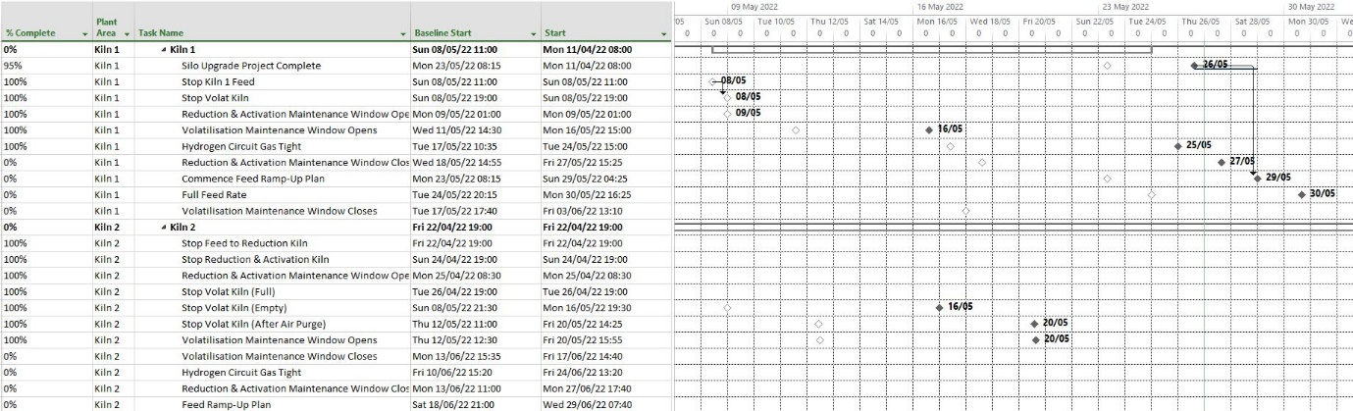
Figure 5, Milestone Tasks that Manage Subsequent Tasks
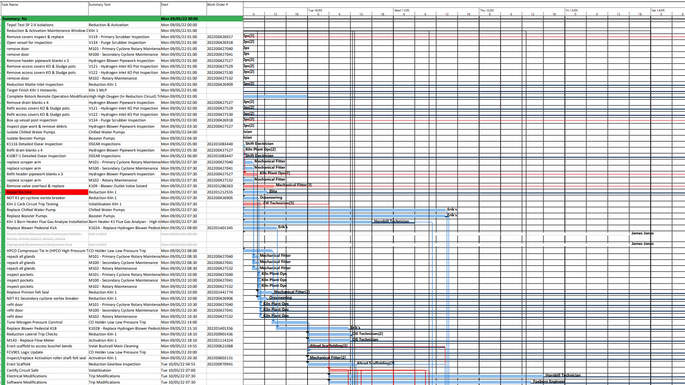Figure 6, An Extract from the Refinery Gantt chart that shows the layout used.
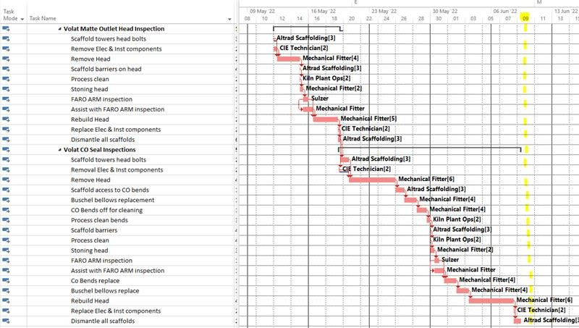
Figure 7, The refinery Gantt chart's critical path

Appendix ‘B’
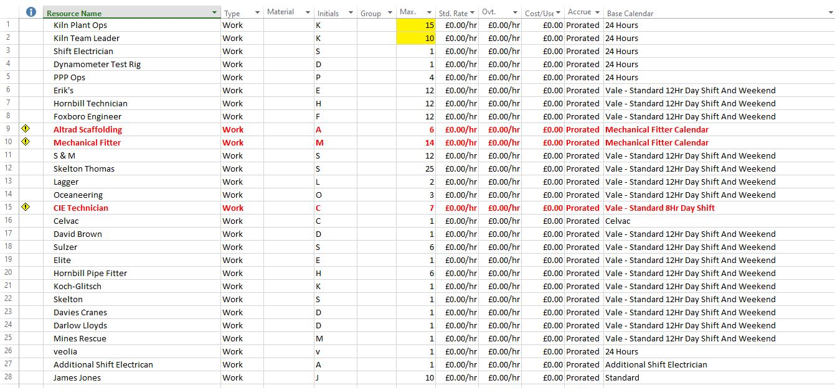
Figure 8, A resource sheet showing crew availability for each work group
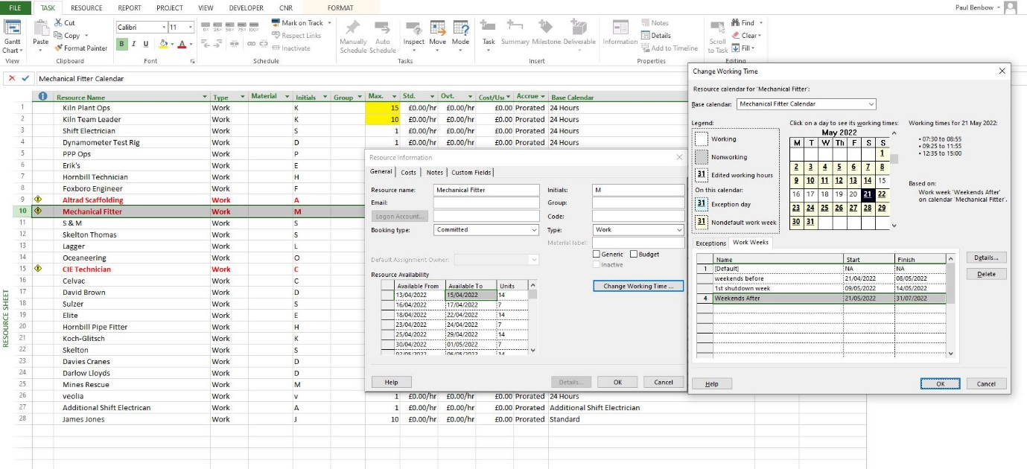
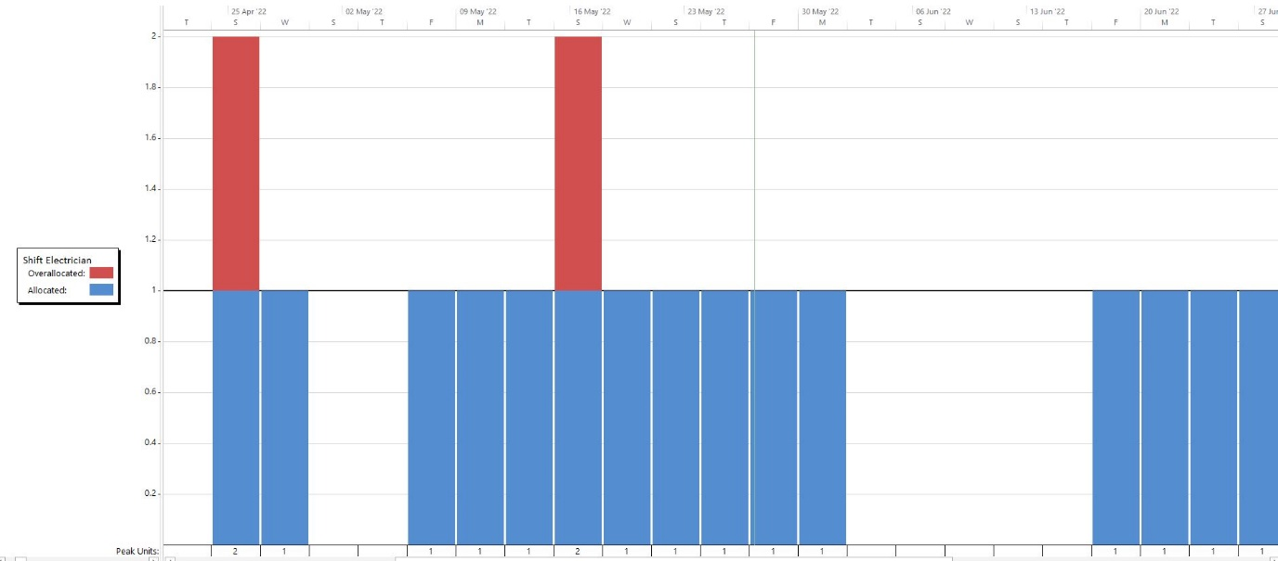
Figure 9, An example of the calendar adjustment made to reflect available working hours of a resource
Figure 10, A resource graph that was used to monitor of allocation

