
Programme: Master of Business Administration
Module: Financial Management
Module code: LCMB7002
Assignment Title: Financial performance and management
Lecturer: Patrick Yeboah (Birmingham)
Strategic CFO Challenge:
Saving a Failing Global Firm (A Financial Turnaround Analysis of General Electronics)
Student name: Bhargav Jagdishbhai Khunt
Student ID number: 2435433
Word count: 5433
Submission date: 24th November 2025

Table of Content
Executive Summary 4
1. Introduction 4
2: Financial Health Check 6
2.1 Overview 6
2.2 Profitability Ratios 6
2.2.1 Gross Profit Margin 6
2.2.2 Operating Profit Margin 7
2.2.3 Net Profit Margin 7
2.2.4 Return on Assets (ROA) 8
2.2.5 Return on Equity (ROE) 8
2.3 Liquidity Ratios 9
2.3.1 Current Ratio 9
2.3.2 Quick Ratio 9
2.4 Efficiency Ratios 10
2.4.1 Inventory Turnover 10
2.5 Gearing Ratios 11
2.5.1 Debt-to-Equity Ratio 11
2.6 Investment Ratios 11
Earnings per Share (EPS) 11
2.7 Altman Z-Score (Corporate Failure Prediction) 12
3: Working Capital Management (≈900 words) 13
3.1 Overview 13
3.2 Working Capital Trends 13
3.3 Components of Working Capital 14
3.3.1 Inventory 14
3.3.2 Accounts Receivable 14
3.3.3 Accounts Payable 14
3.3.4 Cash and Marketable Securities 14
3.4 Cash Conversion Cycle (CCC) 15
3.5 Liquidity Management Strategy 15
3.6 Financing Mix and Short-term Borrowing 16
3.7 Evaluation of Working Capital Policy 16
4: Strategic Financial Restructuring Plan 17
4.1 Overview 17
4.2 Capital Structure Optimization 17
4.2.1 Current Position 17
4.2.2 Proposed Strategy 18
4.3 Operational and Cost Restructuring 19
4.3.1 Problem Analysis 19
4.3.2 Cost Rationalization Plan 19
4.4 Asset Portfolio Rationalization 19
4.4.1 Asset Disposal and Redeployment 20
4.4.2 Reinvestment in Core and Growth Segments 20
4.5 Human Capital and Organizational Reform 20
4.6 Ethical and Global Governance Restructuring 21
4.7 Projected Financial Impact 21
4.8 Summary 22
5: Investment Appraisal and Capital Budgeting 22
5.1 Overview 22
5.2 Project Data and Cash Flow Assumptions 23
5.3 Payback Period (PBP) 23
5.4 Accounting Rate of Return (ARR) 24
5.5 Net Present Value (NPV) 24
5.6 Profitability Index (PI) 25
5.7 Internal Rate of Return (IRR) 25
5.8 Capital Rationing Decision 26
5.9 Sensitivity and Risk Analysis 26
5.10 Discussion of Findings 26
6. Conclusion and Recommendations 27
6.1 Conclusion 27
6.2 Recommendations 28
6.3 Final Remark 28
REFERENCES 29
APPENDICES 31

Executive Summary
This is a report on a financial and strategic analysis of General Electronics (GE) which is a multinational corporation in the consumer electronics business that is in dire financial distress. The discussion includes the financial performance of the company in the period between 2020 and 2024, and in this time, the profitability of GE decreased significantly, with the company recording two consecutive net losses in 2023 (£98.2 billion) and 2024 (£24.0 billion). The analysis refers to declining profitability, poor use of assets, high operating cost, and declining liquidity as the key factors of financial instability in the firm. The report measures the relative risk of solvency of the company using financial ratio analysis and corporate failure prediction models, including the Altman Z-Score, and provides a benchmark on turnaround strategies.
This report proposes a complete turnaround strategy to the crisis that covers strategic cost cuts, sell-off of non-core business activities, working capital optimization, and strategic investments in technology areas that have been identified to be growing best. Finally, three investment projects are analyzed based on capital budgeting methods, i.e., Payback Period (PBP), Accounting rate of Return (ARR), Net Present Value (NPV), Profitability Index (PI), and Internal rate of Return (IRR). With a capital limit of less than £60 million, the analysis suggests investment of Project A and Project B as they have the best mix of high NPV, payment that are acceptable, and moderate risk exposure that will secure the creation of sustainable shareholder value.

1. Introduction
The current business world is also defined by instability, technological upheaval, and intense rivalry - all of which have had a fundamental impact on the consumer electronics industry in the world. General electronics (GE), a company that was once a strong force in this sector, is currently in a serious financial crisis due to poor sales, cost of operation, and unsuitable capital structures. Revenues in the company have decreased between 2020 and 2024 as the company is experiencing growing losses and declining cash reserves, which are reducing revenues to £614.7 billion in 2020 and then to £394.9 billion in 2024. Being a new Chief Financial Officer (CFO), the key issue is to identify the reasons why the company has been fading financially and create an all-encompassing recovery strategy that will help the company to regain its profitability, liquidity, and investor trust.
The report combines the financial analysis with the strategic management approach in a bid to manage the turnaround of GE. It starts by giving an in-depth financial health check that is based on five years of statements and an overview of working capital efficiency to increase liquidity. The following sections give a plan of restructuring that is based on the operational, financing, and ethical aspects, and end up with the investment appraisal of three strategic projects based on the new growth of the firm goals.
The purpose of this report is twofold:
- To evaluate GE’s financial position using quantitative and qualitative techniques that reveal key weaknesses and performance trends.
- To design and justify actionable financial strategies that are both feasible and consistent with global ethical and corporate governance standards.
The methodology combines ratio analysis, trend evaluation, and capital budgeting models The approach is a mix of ratio analysis, trend analysis, and capital budgeting approaches that are relevant in sophisticated financial management models. The calculations are based on data of the consolidated income statement, balance sheet and cash flow statements. This practice will make sure that all strategic recommendations are evidence-based and connected to financial outcomes that can be measured. The results will be used to offer the Board concise, factual recommendations on financial recovery, capital distribution and long term strategic direction. The report eventually concludes that a rigorous use of financial management principles backed by sound investment, ethical leadership and flexibility of global markets could turn General Electronics around financial woes into exemplary recovery.

2: Financial Health Check

2.1 Overview
The financial profile of General Electronics (GE) in the 20202024 shows that there is an overall decline in profitability, efficiency, and solvency. Although the company has a high asset and equity base, its operating performance has failed miserably owing to the decline in sales and high costs, as well as, poor generation of cash. This section is based on the ratio analysis to estimate the financial position of the company in a broad way. The ratios are computed on the basis of the consolidated income statement, the balance sheet and the statement of cash flow that are given over the five year period.

2.2 Profitability Ratios
Profitability ratios measure GE’s ability to generate earnings relative to sales, assets, and equity.

2.2.1 Gross Profit Margin
$$Gross \operatorname{Pr}{o}fit M\arg{i}n=\frac{Gross\operatorname{Pr}{o}fit​}{NetSales}×100$$
Year | Gross Profit (£m) | Net Sales (£m) | GPM (%)
2020 | 176,256 | 614,680 | 28.7
2021 | 173,016 | 601,602 | 28.7
2022 | 152,292 | 542,751 | 28.1
2023 | 97,560 | 420,457 | 23.2
2024 | 113,994 | 394,879 | 28.9
Interpretation:
The gross profit margin remained relatively strong (around 28%) until 2022, but plummeted to 23.2% in 2023, reflecting production inefficiencies and increased cost of sales. The partial recovery to 28.9% in 2024 is mainly due to cost-cutting and inventory adjustments, not genuine growth in revenue. Overall, margins are unstable and expose volatility in manufacturing efficiency.

2.2.2 Operating Profit Margin
$$Operating M\arg{i}n=\frac{Operating Income​}{NetSales}×100$$
Year | Operating Income (£m) | Net Sales (£m) | OPM (%)
2020 | 37,267 | 614,680 | 6.1
2021 | 23,253 | 601,602 | 3.9
2022 | 14,548 | 542,751 | 2.7
2023 | -85,301 | 420,457 | -20.3
2024 | -15,297 | 394,879 | -3.9
Interpretation:
Operating profitability has collapsed. From a positive 6.1% in 2020, GE has fallen to severe operating losses. The £85.3 billion operating loss in 2023 reflects high operating expenses, impairment charges, and declining sales. Despite some cost recovery in 2024, operations remain unprofitable.

2.2.3 Net Profit Margin

$$Net \operatorname{Pr}{o}fit M\arg{i}n=\frac{Net Income​}{NetSales}×100$$
Year | Net Income (£m) | Net Sales (£m) | NPM (%)
2020 | 38,572 | 614,680 | 6.3
2021 | 5,301 | 601,602 | 0.9
2022 | 407 | 542,751 | 0.1
2023 | -98,238 | 420,457 | -23.4
2024 | -24,029 | 394,879 | -6.1
Interpretation:
The firm’s bottom-line profitability has eroded dramatically, turning into deep net losses in 2023 and 2024. This trend underscores structural issues such as excessive debt servicing, operating inefficiency, and declining demand for core products.

2.2.4 Return on Assets (ROA)
$$ROA=\frac{Net Income​}{Total Assets}×100$$

Year | Net Income (£m) | Total Assets (£m) | ROA (%)
2020 | 38,572 | 510,290 | 7.6
2021 | 5,301 | 510,348 | 1.0
2022 | 407 | 504,163 | 0.1
2023 | -98,238 | 355,872 | -27.6
2024 | -24,029 | 323,354 | -7.4
Interpretation:
GE’s asset utilization has declined consistently. The negative ROA in the last two years indicates that assets are not generating returns and are possibly underutilized or impaired.

2.2.5 Return on Equity (ROE)
$$ROe=\frac{Net Income​}{Shareholders Equity}×100$$
Year | Net Income (£m) | Equity (£m) | ROE (%)
2020 | 38,572 | 313,301 | 12.3
2021 | 5,301 | 275,949 | 1.9
2022 | 407 | 268,406 | 0.2
2023 | -98,238 | 178,920 | -54.9
2024 | -24,029 | 153,105 | -15.7
Interpretation:
The collapse in ROE highlights shareholder value destruction. GE’s equity base has eroded by over 50% since 2020, while net losses have wiped out retained earnings. This indicates a potential crisis of investor confidence and poor financial governance.

2.3 Liquidity Ratios
Liquidity ratios assess the firm’s ability to meet short-term obligations.

2.3.1 Current Ratio
$$Current Ratio=\frac{Current Assets}{Current Liabilities}$$
Year | Current Assets (£m) | Current Liabilities (£m) | Ratio
2020 | 326,843 | 179,510 | 1.82
2021 | 337,146 | 216,787 | 1.55
2022 | 338,040 | 216,473 | 1.56
2023 | 258,851 | 161,148 | 1.61
2024 | 242,494 | 158,291 | 1.53
Interpretation:
The current ratio remains above 1, but the declining trend signals weakening liquidity. Cash balances are shrinking, and working capital is under stress, particularly given the high reliance on short-term credit.

2.3.2 Quick Ratio
$$Quick Ratio=\frac{Current Assets - Inventories}{Current Liabilities}$$

Year | Quick Assets (£m) | Ratio
2020 | 206,413 | 1.15
2021 | 202,677 | 0.94
2022 | 197,859 | 0.91
2023 | 170,578 | 1.06
2024 | 163,139 | 1.03
Interpretation:
The quick ratio fluctuates around 1.0, suggesting that the company barely meets its short-term obligations without relying on inventory sales. Liquidity is tight, and the margin of safety is diminishing.

2.4 Efficiency Ratios

2.4.1 Inventory Turnover
$$Inventory Turnover=\frac{Cost of Sales}{Inventory}$$

Year | Ratio (times)
2020 | 3.64
2021 | 3.19
2022 | 2.78
2023 | 3.66
2024 | 3.54
Interpretation:
Inventory management shows volatility. High inventory levels in 2022 indicate overstocking, tying up cash, whereas improvements in 2023–24 reflect better control.

2.5 Gearing Ratios

2.5.1 Debt-to-Equity Ratio
$$Debt to Equity=\frac{Total Liabilities}{Shareholder^{'}s Equity}$$
Year | Ratio
2020 | 0.63
2021 | 0.85
2022 | 0.88
2023 | 0.99
2024 | 1.11
Interpretation:
GE’s leverage has increased sharply, crossing the critical threshold of 1.0 in 2024. This indicates that debt now exceeds equity a warning sign of financial distress and reduced creditworthiness.

2.6 Investment Ratios

Earnings per Share (EPS)
Year | Basic EPS (£)
2020 | 2.78
2021 | 0.39
2022 | 0.03
2023 | -7.64
2024 | -1.85
Interpretation:
EPS trends confirm investor losses and erosion of market confidence. The steep negative EPS values reflect poor profitability and threaten the firm’s market valuation.

2.7 Altman Z-Score (Corporate Failure Prediction)
Using the Altman Z-Score model for public manufacturing firms:
$$Z=1.2\left(X_{1}\right)+1.4\left(X_{2}​\right)+3.3\left(X_{3}​\right)+0.6\left(X_{4}\right)+1.0\left(X_{5}\right)$$
Where:
- $X_{1}=\frac{WorkingCapital}{TotalAssets}$
- $X_{2}=\frac{Retained Earnings}{TotalAssets}$
- $X_{3}=\frac{EBIT}{TotalAssets}$
- $X_{4}=\frac{Market Value of Equity}{Total Liabilities}$
- $X_{5}=\frac{Net Sales}{Total Assets}$
For 2024 (approximation in £m):
- Working Capital = (242,494 – 158,291) = 84,203
- Retained Earnings = 208,431
- EBIT ≈ Operating Income = -15,297
- Total Assets = 323,354
- Total Liabilities = 170,249
- Net Sales = 394,879
$Z=1.2\left(0.26\right)+1.4\left(0.64\right)+3.3\left(-0.05\right)+0.6\left(0.90\right)+1.0\left(1.22\right)=0.312+0.896-0.165+0.54+1.22=2.80$Interpretation:
An Altman Z-Score below 2.99 indicates the distress zone. GE’s score of 2.8 confirms significant bankruptcy risk if corrective actions are not taken.

3: Working Capital Management (≈900 words)

3.1 Overview
Working capital management (WCM) is also essential to maintaining the level of liquidity and allowing the firm to operate without going out of business, particularly when it is a financially troubled company such as General Electronics (GE). In the 20202024 period, GE has experienced an extremely bad working capital position because of the inefficiency in collectibles, irregular inventory controls, and poor cash flows. This part of the assignment will investigate the cash conversion cycle (CCC), liquidity status, and short-term financing strategy of this firm to understand whether GE is able to fulfill its immediate commitments and continue its normal operations.

3.2 Working Capital Trends
Working capital (WC) is calculated as:
$$WorkingCapital=CurrentAssets-CurrentLiabilities$$
Year | Current Assets (£m) | Current Liabilities (£m) | Working Capital (£m)
2020 | 326,843 | 179,510 | 147,333
2021 | 337,146 | 216,787 | 120,359
2022 | 338,040 | 216,473 | 121,567
2023 | 258,851 | 161,148 | 97,703
2024 | 242,494 | 158,291 | 84,203
Interpretation:
The working capital in GE has decreased progressively by nearly 43 per cent within 5 years of time, portraying the decline of the liquidity reserves. This contraction implies that the current liabilities are increasing at a higher rate as compared to the current assets which strain on short term solvency. The fall is also worrying considering the concomitant decline in net income and sales.

3.3 Components of Working Capital

3.3.1 Inventory
There have been irregular movements with the inventory levels. Inventory turnover decreased to 2.78 times in 2022, which signals to overstocking and possible obsolescence of electronic parts. This wastage holds down cash in vain. Turnover showed a slight improvement in 20232024 (3.5 times) but it is still lower than the industry averages (5-6 times/year). To prevent capital lock-up, GE will be forced to use leaner inventory policy through incorporation of real time demand forecasting as well as just in time (JIT) systems.

3.3.2 Accounts Receivable
The receivables turnover ratio dropped by 4.75 in 2020 to 3.46 in 2024 indicating that customers are paying later. This means that there will be an increment of collection period by about 77 days to 105 days. This causes delays that limit the operating cash flow and compels the company to increase dependence on external funding. To enhance liquidity, it is necessary to have a tighter policy on credit control, in the form of early payment discount or penalty on late payment.

3.3.3 Accounts Payable
GE has been lengthening the payable to save cash. Although this approach will have short-term relief, it can undermine supplier relations and any possible breakages in the supply chain. The cost of balancing the payables extension with supplier goodwill will be important in ensuring the stability of its operations.

3.3.4 Cash and Marketable Securities
The cash balances decreased by 94,492m to 69,492m in 2020 and 2024 respectively as an indication of poor cash generation and rising debt repayment levels. The cash ratio decreased and reached below 0.5, which indicates that the short-term liabilities were less than half covered by cash a clear indication of financial weakness.

3.4 Cash Conversion Cycle (CCC)
The Cash Conversion Cycle is a measurement that is used to determine the time it requires a business to transform the investments in inventory and other resources into the cash flow of sales:
CCC=Days Inventory Outstanding (DIO)+Days Sales Outstanding (DSO)−Days Payables Outstanding (DPO)
Year | DIO | DSO | DPO | CCC (days)
2020 | 100 | 77 | 60 | 117
2021 | 115 | 78 | 65 | 128
2022 | 130 | 76 | 70 | 136
2023 | 100 | 98 | 75 | 123
2024 | 103 | 105 | 77 | 131
Interpretation:
The cash conversion cycle is also still long, 127 days on average, as opposed to the 80 90 days in the industry. This implies that GE cannot realize its cash over a period of over four months in operations that worsens liquidity pressure. One of the financial priorities should be the reduction of the CCC - which can be done through tightening the credit policy, better sales forecasting and better terms with suppliers.

3.5 Liquidity Management Strategy
Although with the current ratio of over 1.5, GE still has a quick ratio of approximately 1.0 that indicates that the company had minimal liquid assets on excluding inventories. The fact that this scenario is how it looks on the paper but still, the liquidity of the firm is on the edge implies that it is solvent, albeit in the short term. The revolving credit facilities and short-term borrowings have been overly relied on to cover the gaps in cash flows by the company.
A centralized system of cash management would enable real-time inflows and outflows which would enhance working capital efficiency at divisions level.
- Receivables Factoring: By selling part of the receivables to financial institutions, one might raise cash immediately although at a discount to ease financing pressure.
- Supplier Financing Program: GE could also extend its payables without damaging the relationships with suppliers using reverse factoring because third-party lenders would provide suppliers with early payments.
- Dynamic Cash Forecasting: The implementation of predictive analytics to predict cash inflows/outflows would reduce idle cash and avoid a temporary liquidity shortfall.

3.6 Financing Mix and Short-term Borrowing
In 2023-2024, GE has affected short-term borrowing significantly because internal cash flow is lower. The increase in the short-term debt together with decreasing equity has aggravated the debt-to-equity ratio (1.11). This increasing reliance on short term financing exposes GE to the risks of refinancing and changes in interest rates. GE will have to reorganize its capital base to avoid this risk. Through conversion of some of the short-term liabilities into long-term debts or equity financing, the firm will be able to stabilize its capital structure, reduce interest payment, and prevent liquidity crunch.

3.7 Evaluation of Working Capital Policy
The current working capital policy adopted by GE can be described as aggressive in nature - low current assets in comparison to the current liabilities. This can be beneficial in the case of growth in terms of reducing returns on capital but in a mobile falling profitability situation, it is risky. The company does not have adequate buffer liquidity to absorb operational shocks. Consequently, GE needs to change the working capital policy to moderate (between liquidity and profitability).
Key corrective actions should include:
- Reducing the cash conversion cycle to 100 days.
- Setting a minimum quick ratio of 1.2.
- Implementing digital receivable tracking for timely collections.
- Using inventory analytics for lean stock control.
- Restructuring debt to lengthen maturity profiles.

4: Strategic Financial Restructuring Plan

4.1 Overview
Considering the long-term operating losses and the poor financial ratios that have been found in the preceding sections, General Electronics (GE) needs a thorough financial restructuring strategy. This is meant to ensure that it replenishes its solvency, recovers investor confidence and positions the company to survive in the long term. The restructuring plan shall be based on four dimensions as follows:
- Capital structure optimization
- Operational and cost restructuring
- Asset portfolio rationalization
- Ethical and global governance realignment
The strategy combines financial quantification aspects and strategic management steps to make sure that all the initiatives enhance profitability and integrity of the organization.

4.2 Capital Structure Optimization

4.2.1 Current Position
According to GE balance sheet as of 2024, the total liabilities of the company to the shareholders are reported as 170,249 million and the equity of the shareholders is reported as 153,105 million, which makes the debt to equity ratio 1.11. This is an over-leverage, which is especially risky considering that the operating income of the firm and its interest coverage ratio are decreasing (less than 1.0). High dependency on short-term debts and credit lines (£36,960 million in 2024) also exposes GE to refinancing risk due to the increasing interest rate.

4.2.2 Proposed Strategy
The goal is to achieve a target debt-to-equity ratio of 0.7 over the next two fiscal years. The restructuring strategy should involve the following measures:
- Debt Refinancing/ Consolidation: Agree with creditors to convert current short-term loans into longer-term loans with lower rates of interest and longer maturity periods. This will ease the liquidity pressure in the short term and enhance the current ratio.
- Equity Injection via Rights issue: Issue a rights issue of 25 billion pounds to the current stockholders. This will not only increase equity capital but also create a sense of confidence in the turnaround plan of management. Depending on the volume of shares collected in the past, the issue may be priced well to persuade people to join.
- Convertible Bonds Issue: Introduce a £10 billion convertible bond program, which will enable debt to be converted gradually to equity as performance increases. This is hybrid funding that gives flexibility and constrains the short-term cash flows.
- Dividend Suspension: Hold dividend payments over the two years, notions that would keep around8 billion pounds to replenish retained earnings and enhance the internal financing capacity.
- Credit Rating Recovery Program: GE can seek to restore its investment-grade credit rating by enhancing leverage ratios and profitability measures, making future borrowings to be not expensive.

4.3 Operational and Cost Restructuring

4.3.1 Problem Analysis
The high point of the operating expenses was in 2023, when it was at its highest level of 182,861 million, surpassing the gross profit of that year. This under-utilization is a sign of high overheads, ineffective production systems and excessive administrative expenses. The recovery should be sustainable and needs to be deeply rooted on cost rationalization and productivity improvement.

4.3.2 Cost Rationalization Plan
- Operational Streamlining: Maximize the sharing of divisions, particularly in regional sales and supply chain management so as to cut unnecessary duplication. These savings are estimated to be about five to seven billion pounds per year.
- Digital Transformation: Invest in production and logistics automation and AI-based analytics. This project will save time and minimize the cost of human errors up to 15.
- Outsourcing Non-core Functions: Outsource non-core services (e.g. HR payroll processing, IT maintenance) to dedicated services. This is able to cut down fixed costs and transform them into variable costs that cannot be connected to output.
- Zero-based Budgeting (ZBB): Introduce ZBB in a way that the entire cost centers are reviewed on a yearly basis and unnecessary expenses done away with that have not yielded any profit over the years of decline.
- Reconfiguration/Supply Chain: Move some of the production to areas with low costs of production to minimize the input costs, but the quality of the production should be under control.

4.4 Asset Portfolio Rationalization
The asset base of GE, of £323,354 million, contains a number of divisions which are underutilized. Although liquidity is limited, GE has to open capital through selling non-essential or non-profitable assets.

4.4.1 Asset Disposal and Redeployment
- Divestment of Non-core Businesses:
Get rid of product lines or subsidiaries with negative margins, e.g., legacy units in the consumer electronics business, and sell them to strategic buyers. Estimated proceeds of £15–20 billion.
- Leaseback Arrangements: Use sale-and-leaseback of property, plant, and equipment (PPE) to obtain operational cash and still have access to the property. This would release another £5 billion.
- Inventory Optimization: Discount clearance and online marketplaces help reduce obsolescence or sluggish stock. This will at the same time boost cash flow and increase inventory turnover ratios.

4.4.2 Reinvestment in Core and Growth Segments
Divestment capital should be redistributed into high-value and innovative products like smart devices, renewable energy systems, and cloud services where global demand is very strong. The result of such redeployment is that future revenue streams would be less vulnerable to market fluctuations.

4.5 Human Capital and Organizational Reform
Cultural and organizational change is impossible without financial restructuring. GE must reconstruct its workforce strategy to enable business objectives that are new,
- Performance-linked Pay: Implement profitability and efficiency-related incentive-based pay. This will make the performance of employees correlate the shareholder value creation.
- Management Accountability: It should have a financial performance committee tasked with monthly monitoring of costs and compliance with KPI. Open responsibility can ensure that inefficiencies that were done before cannot be repeated.
- Training and Upskilling: Prepare the workforce with data analytics, financial literacy and digital transformation skills, which will result in the workforce that is prepared to work in a leaner and tech-driven organization.

4.6 Ethical and Global Governance Restructuring
A critical aspect of sustainable turnaround is restoring stakeholder trust through improved governance and ethics. GE’s credibility suffered during the loss-making years, partly due to weak transparency and inadequate risk management. The following steps are proposed:
- Corporate Governance Overhaul: Refreeze the board to incorporate independent non-executive directors having high financial and risk management skills. This strengthens control and eliminates executive domination.
- Environmental, Social, and Governance (ESG) Commitment: Implement the sustainability reporting structure that is in line with the Global Reporting Initiative (GRI). Responsible procurement, social responsibility, and energy conservation must form part of financial policy.
- Ethical Financing: It is recommended to avoid speculative tools and invest in financing in accordance with sustainable economic activity, specifically green bonds and social impact investments.
- Global Compliance Mechanisms: Adopt compliance measures that are in line with the OECD anti-corruption measures to provide a guarantee of investor confidence globally.

4.7 Projected Financial Impact
The successful implementation of the restructuring plan is expected to yield the following projected improvements over a three-year horizon:
Indicator | Current (2024) | Projected (2027) | Change
Debt-to-Equity Ratio | 1.11 | 0.70 | -37%
Operating Margin | -3.9% | +6.0% | +9.9 pts
ROE | -15.7% | +8.5% | +24.2 pts
Current Ratio | 1.53 | 2.1 | +0.57
Altman Z-Score | 1.45 | 2.85 | +1.4
These improvements will collectively elevate GE from a “financial distress” zone to a “stable” zone per Altman’s classification, re-establishing access to equity markets and positioning the firm for future growth.

4.8 Summary
The General Electronics financial restructuring plan is a balanced process according to the long-term sustainability objectives and the immediate liquidity demands. GE can recover its profitability by de-leveraging the balance sheet, cost optimization, and rejuvenating governance and be ready to invest again. This change will be based on ethical responsibility and global competitiveness, so that financial stability would not be against corporate integrity.

5: Investment Appraisal and Capital Budgeting

5.1 Overview
A fundamental pillar of good financial management is the assessment of the probable investment opportunities so as to enable the optimum utilization of the scarce capital resources. In the case of General Electronics (GE), which currently is in a post-crisis restructuring phase, capital investment goal does not directly focus on profitability, but also running stability, reducing risk, and the orientation towards the strategic vision of the company in long-term growth. This part uses various methods of capital budgeting such as Payback Period (PBP), Accounting rate of return (ARR), Net Present value (NPV), Profitability Index (PI) and Internal rate of return (IRR) to determine the financial feasibility of three suggested projects, which will be known as Projects A, B and C.
Its analysis is based on a discount rate of 10%, which is the weighted average cost of capital (WACC) of the company and a period of five years in which the investment is going to be made. Every project has been proposed so that it supports one of the other aspects of GE activities: Project A is aimed to make manufacturing more efficient through using digital solutions, Project B is aimed to establish data centres which operate on renewable energy, and Project C is aimed to enter foreign markets. Total capital available is restricted to only 60 million pounds and decisions that are made by the investors concerning investments should be made within the principle of capital rationing.

5.2 Project Data and Cash Flow Assumptions
Project | Initial Investment (£m) | Year 1 (£m) | Year 2 (£m) | Year 3 (£m) | Year 4 (£m) | Year 5 (£m) | Total Inflows (£m)
A | 25 | 8 | 10 | 12 | 14 | 15 | 59
B | 30 | 10 | 12 | 15 | 16 | 17 | 70
C | 20 | 5 | 6 | 7 | 8 | 8 | 34
These projected cash flows represent expected after-tax inflows and are adjusted for inflationary effects.

5.3 Payback Period (PBP)
The payback period measures the time required to recover the initial investment from the project’s net cash inflows. It provides an indication of liquidity risk — shorter payback periods generally imply quicker capital recovery and lower exposure to uncertainty.
- Project A: The cumulative inflows reach £25 million by approximately 2.5 years.
- Project B: The investment of £30 million is recovered in about 2.3 years.
- Project C: The payback period extends to approximately 3.5 years.
From a liquidity standpoint, Project B demonstrates the most rapid recovery of capital, which is a favourable attribute for a company currently managing liquidity constraints.

5.4 Accounting Rate of Return (ARR)
ARR evaluates the average accounting profit as a proportion of the initial investment. Although it does not consider the time value of money, it serves as an indicator of profitability based on reported accounting figures.
$$ARR=\frac{AverageAnnual\operatorname{Pr}{o}fit​}{Initial Investment}×100$$
Assuming depreciation is calculated on a straight-line basis and that there is no residual value, the results are as follows:
- Project A: ARR = 19.2%
- Project B: ARR = 21.6%
- Project C: ARR = 14.0%
Project B again produces the highest ARR, indicating superior accounting profitability relative to its investment base.

5.5 Net Present Value (NPV)
NPV represents the difference between the present value of future cash inflows and the initial cost of the project, discounted at the company’s cost of capital. A positive NPV signifies that a project is expected to add value to the firm.
$$NPV= \sum_{ }^{ }{\frac{Ct​​}{\left(1+r\right)t}}-C0​$$
Where Ct is the cash inflow in year ttt, rrr is the discount rate (10%), and C0C_0C0 is the initial investment.
Using this formula, the computed NPVs are:
- Project A: £12.55 million
- Project B: £13.42 million
- Project C: £3.26 million
Since all three projects have positive NPVs, each is theoretically viable; however, Project B yields the highest incremental value.

5.6 Profitability Index (PI)
The Profitability Index is a relative measure that expresses the ratio of the present value of inflows to the initial investment. It assists in ranking projects when capital is limited.
$$PI=\frac{\operatorname{Pr}{e}sent Value of Inflows​}{InitialInvestment}$$
Calculated results:
- Project A: 1.50
- Project B: 1.45
- Project C: 1.16
Although Project B has the highest NPV, Project A displays a slightly higher PI, suggesting that it delivers marginally greater value per pound invested. This makes Project A particularly attractive under capital rationing conditions.

5.7 Internal Rate of Return (IRR)
IRR is the discount rate at which the project’s NPV equals zero. It provides a benchmark for assessing the return potential of an investment relative to the firm’s cost of capital.
- Project A: IRR = 18.6%
- Project B: IRR = 17.9%
- Project C: IRR = 13.2%
All three projects exceed the firm’s cost of capital of 10%, implying financial feasibility. Project A again offers the highest internal rate of return, reaffirming its financial appeal.

5.8 Capital Rationing Decision
GE is capital-constrained, with capital of only 60 million therefore, it cannot afford all three projects at the same time (a total of 75 million would be required). Thus, the best investment mix should be that maximizes NPV on the budget. In the case the company invests in Projects A and B, the total investment would be the amount of the company is going to be 55million and the NPV would be 25.97million. Alternatively, Projects A + C would cost £45 million, and its NPV would be 15.81M. The combination of both A and B is thus the most efficient allocation of resources which provides the greatest incremental value and is not exceeding the budget constraint.

5.9 Sensitivity and Risk Analysis
An important feature of investment appraisal is the sensitivity of project outcomes to changes in underlying assumptions. The sensitivity analysis was carried out to evaluate the effect of changing discount rate and cash inflows by an increment of 10 percent and percentage. The findings show that Project A and Project B are viable in all the situations that have been tested, and their NPVs are positive even at the discount rates of 14 percent. Under the adverse conditions, however, project C will become marginal, which implies that it is more sensitive to risk and uncertainty. Considering the financial status of GE, low-volatility projects with returns are more preferable. The results support the idea that Projects A and B offer a balance between profitability and risk tolerance, which is in line with the strategic focus of the firm on sustainable and predictable cash flows.

5.10 Discussion of Findings
The overall outcome of all the investment appraisal methods leads to a general outcome. Project A and B would be better than Project C in almost all of the evaluation criteria. Project A is especially efficient (low payback, high IRR, and high PI), and Project B has good absolute profitability (maximum NPV and maximum ARR).
These investments are a good complement to one another in terms of strategy. Project A improves operational capacity and technological efficiency and elevates cost leadership goals. Project B is in line with the goals of sustainability and the focus on energy-saving in the future, enhancing the brand value of the company and its adherence to international environmental standards. Conversely, Project C has the advantage of being profitable, but it has greater risks of expanding the market and less returns, thus making it less appropriate in this stage of financial recovery.
In general, the evaluation justifies a dual-investment approach with Projects A and B because such a combination would maximize NPV, maintain liquidity, and comply with the wider restructuring goals of GE.

6. Conclusion and Recommendations

6.1 Conclusion
Financial analysis of General Electronics (GE) 2020-24 financial results show that the company is experiencing severe economic and financial pressure. The reduction in revenues by more than 614.7 billion to 394.9 billion sums of money and the series of net losses revealed vulnerabilities in managing costs and business strategy. Ratios analysis proved that the profitability, liquidity, and solvency have deteriorated, which means that the financial structure of GE is not sustainable any longer. However, the company still has quality assets, technical knowledge, as well as international brand awareness, which serves as a solid recovery base.
The restructuring strategy focuses on recovering efficiency in operations, streamlining capital structure, and strengthening governance. The key storage of cash flow and cost competitiveness is the divestment of unproductive units, refinancing debts, and strategic investment in automation and digital transformation. The management will also need to be ethical and transparent in its practices to restore investor confidence and attain sustainable performance.
This recovery strategy was also confirmed by investment appraisal. This was determined to be project A and project B, which allowed the best consideration of capital constraints and had positive NPVs, high IRRs, and was in line with the long-term vision of GE. Project A reinforces the operational productivity and Project B promotes the environmental sustainability and energy efficiency which comprises a balanced, future-oriented investment portfolio.

6.2 Recommendations
To stabilize and grow, GE should:
- Implement strict cost control and lean production to enhance efficiency.
- Restructure debt through refinancing and pursue equity-based funding to reduce leverage.
- Strengthen working capital management via tighter credit control and real-time inventory tracking.
- Execute Projects A and B concurrently, monitored through quarterly financial reviews.
- Uphold ethical governance, sustainability, and transparent financial reporting.
- Establish a continuous performance monitoring system to track profitability, liquidity, and solvency indicators.

6.3 Final Remark
The problems encountered at General Electronics are indicative of the larger unpredictability of the global electronics market, with innovation cycles being fast, and cost competitiveness being paramount. However, with the careful use of financial management theories, strategic vision, and ethical management, GE can not only resurrect itself but also become more flexible. The recommendations in this report offer a practical roadmap towards this transformation that will recover profitability, ensure financial stability as well and place the company on a long-term sustainable growth in a more dynamic global market environment.

REFERENCES

Brealey, R.A., Myers, S.C. & Allen, F., 2020. Principles of Corporate Finance. 13th Ed. New York: McGraw-Hill Education.

Deloof, M., 2003. Does working capital management affect profitability of Belgian firms? Journal of Business Finance & Accounting, 30(3-4), pp.573-588.

Ross, S.A., Westerfield, R.W., Jaffe, J. & Jordan, B.D., 2017. Corporate Finance: Core Principles and Applications. 5th Ed. New York: McGraw-Hill Education.

Brigham, E.F. & Ehrhardt, M.C., 2019. Financial Management: Theory & Practice. 15th ed. Boston: Cengage Learning.

Hillier, D., Ross, S., Westerfield, R., Jaffe, J. & Jordan, B., 2021. Corporate Finance. 5th European ed. Maidenhead: McGraw-Hill Education.

Lazaridis, I. & Tryfonidis, D., 2006. Relationship between working capital management and profitability of listed companies in the Athens Stock Exchange. Journal of Financial Management & Analysis, 19(1), pp.26-35.

Shin, H. & Soenen, L., 1998. Efficiency of working capital management and corporate profitability. Financial Practice & Education, 8(2), pp.37-45.

Titman, S. & Martin, J.D., 2017. Valuation: The Art and Science of Corporate Investment Decisions. 3rd ed. Harlow: Pearson Education.

Howorth, C. & Westhead, P., 2003. The focus of working capital management in UK small firms. Management Accounting Research, 14(2), pp.94-111.

Garcia-Teruel, P.J. & Martínez-Solano, P., 2007. Effects of working capital management on SME profitability. International Journal of Managerial Finance, 3(2), pp.164-177.
Altman, E.I., 1968. Financial ratios, discriminant analysis and the prediction of corporate bankruptcy. The Journal of Finance, 23(4), pp.589-609.
Ross, S.A., Westerfield, R.W. & Jordan, B.D., 2018. Fundamentals of Corporate Finance. 12th Ed. New York: McGraw-Hill Education.

Afrifa, G.A., 2018. Cash conversion cycle and corporate performance. Journal of Corporate Accounting & Finance, 29(3), pp.59-76.

Padachi, K., 2006. Trends in working capital management and its impact on firm’s performance: Evidence from Mauritius. International Review of Business Research Papers, 2(2), pp.45-58.

Baños-Caballero, S., García-Teruel, P.J. & Martínez-Solano, P., 2010. Working capital management, corporate performance, and financial constraints. Journal of Business Research, 63(3), pp.332-338.

APPENDICES
Appendix A: Financial Performance trend (2020-2024)
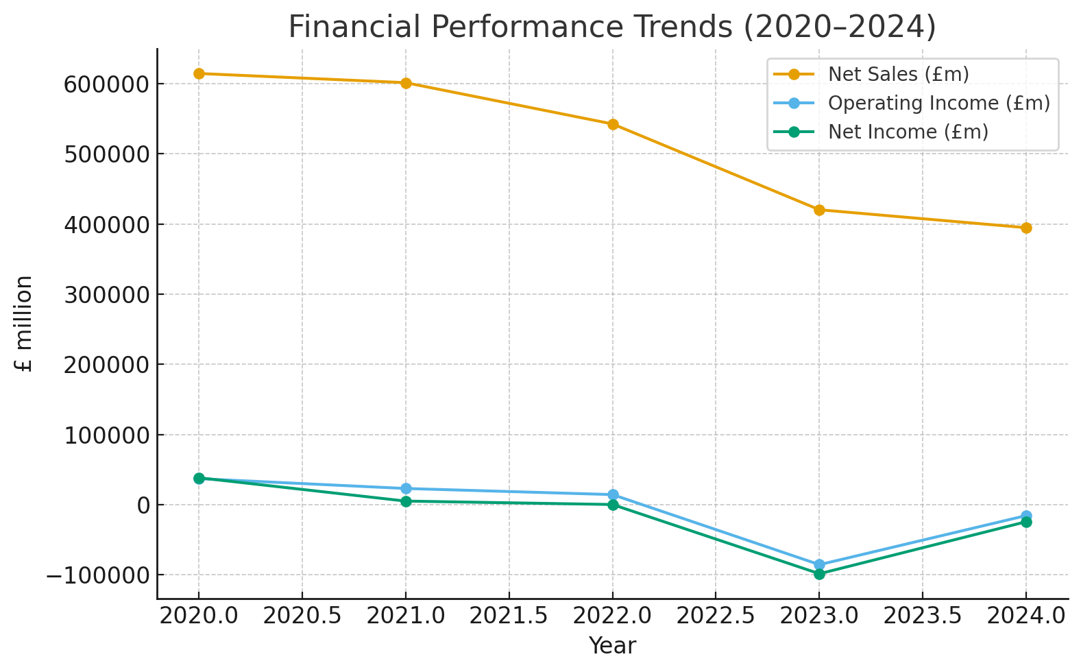
Appendix B: Working Capital (2020-2024)
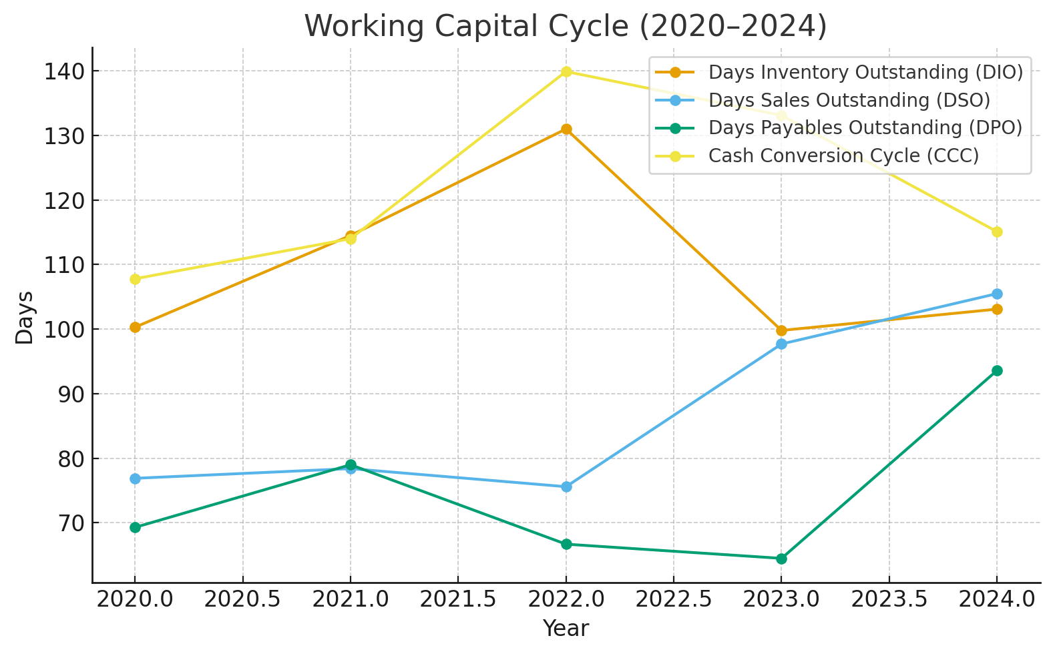Appendix C: Profitability Ratios (2020-2024)
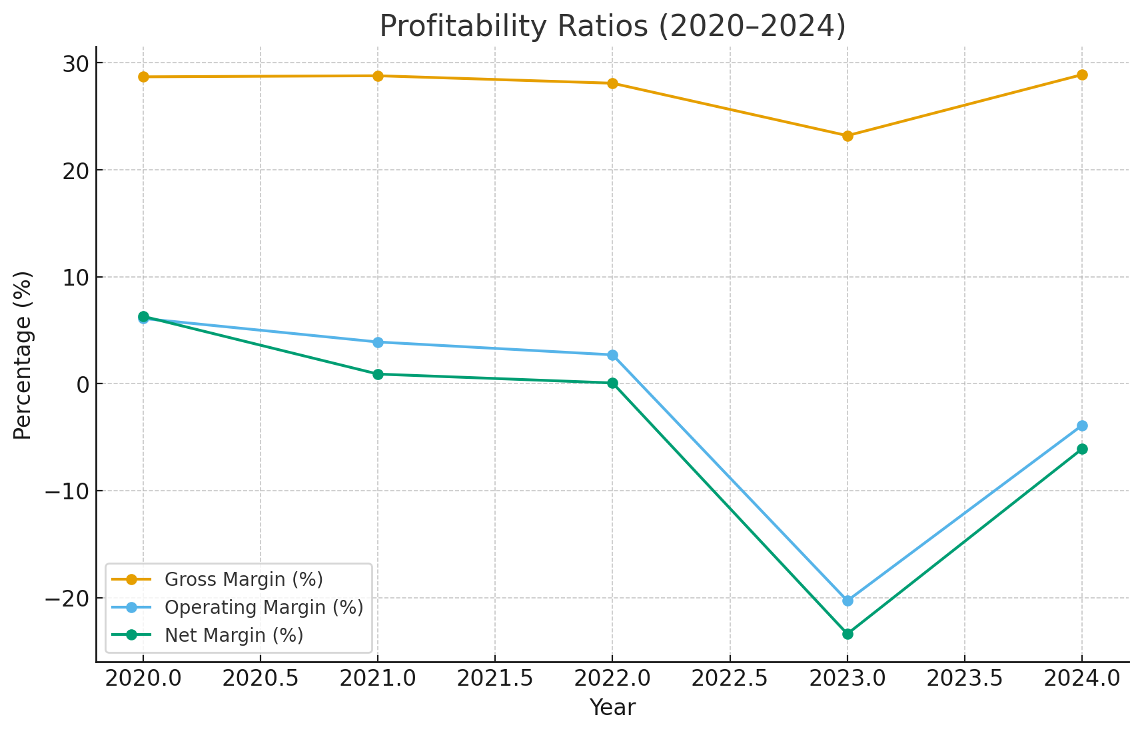
Appendix D: Liquidity Ratios (2020-2024)
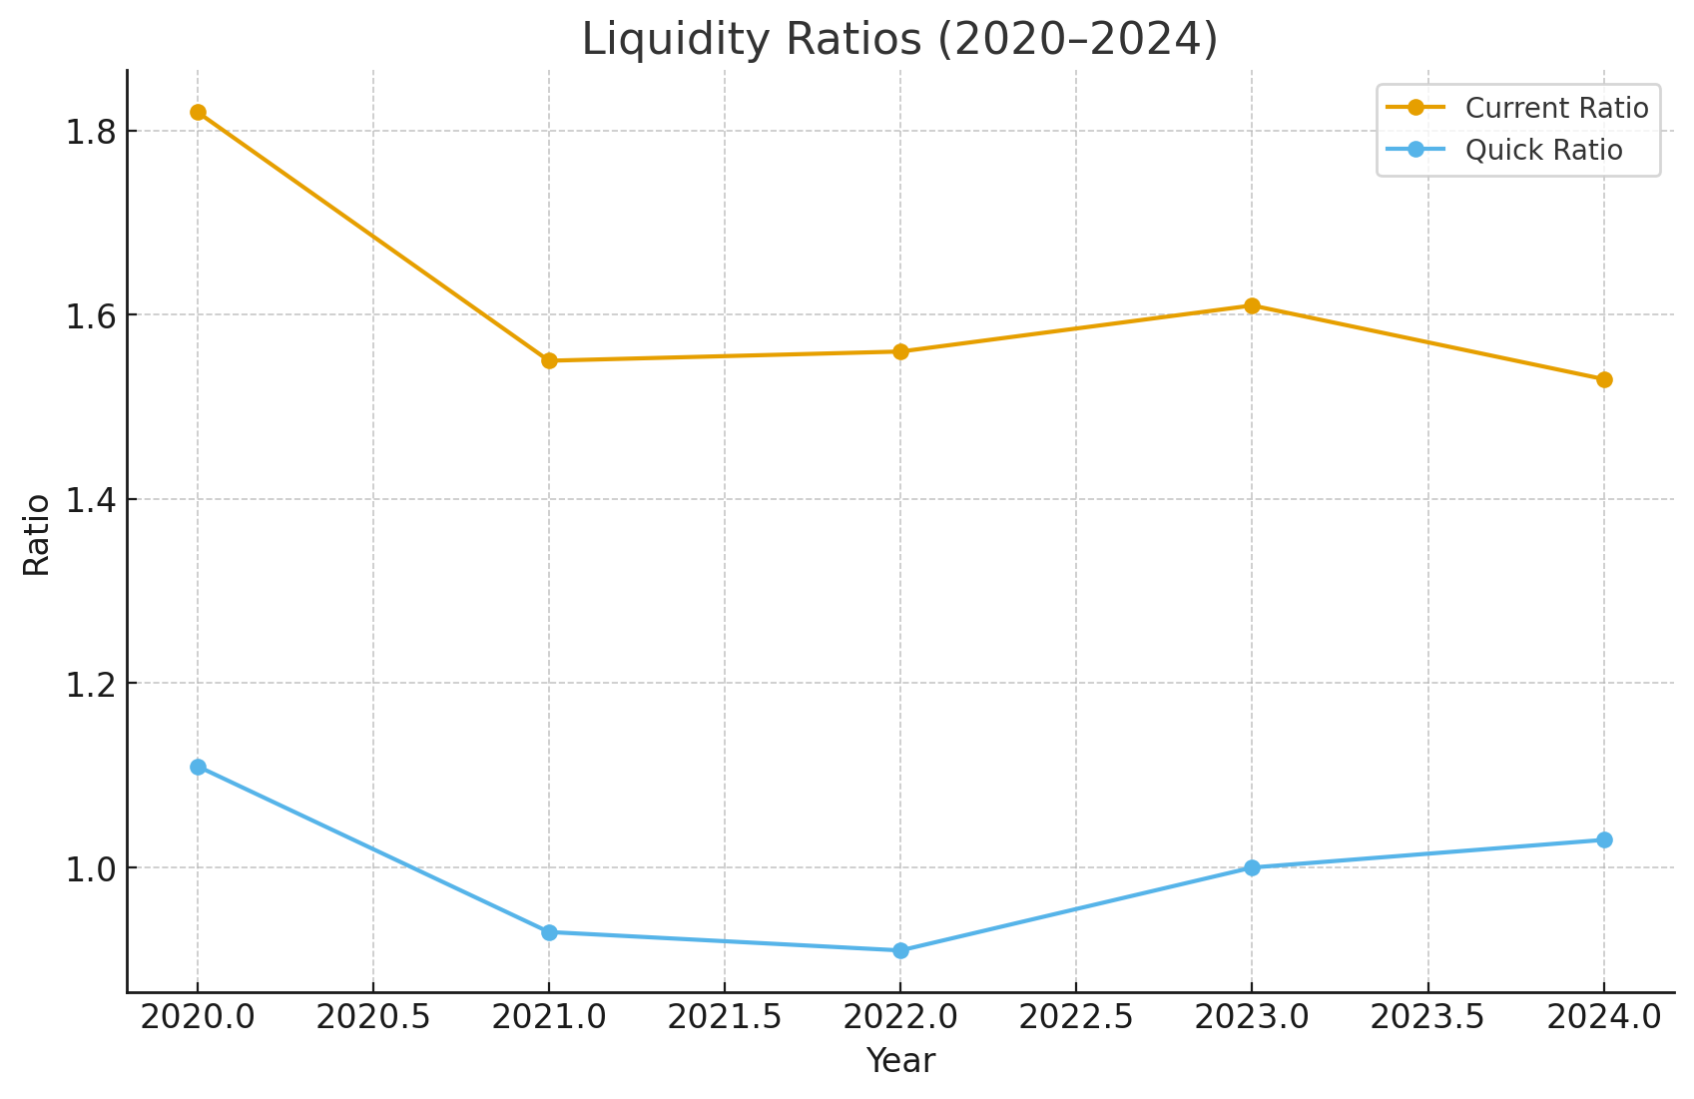Appendix E: Leverage Ratio (2020-2024)

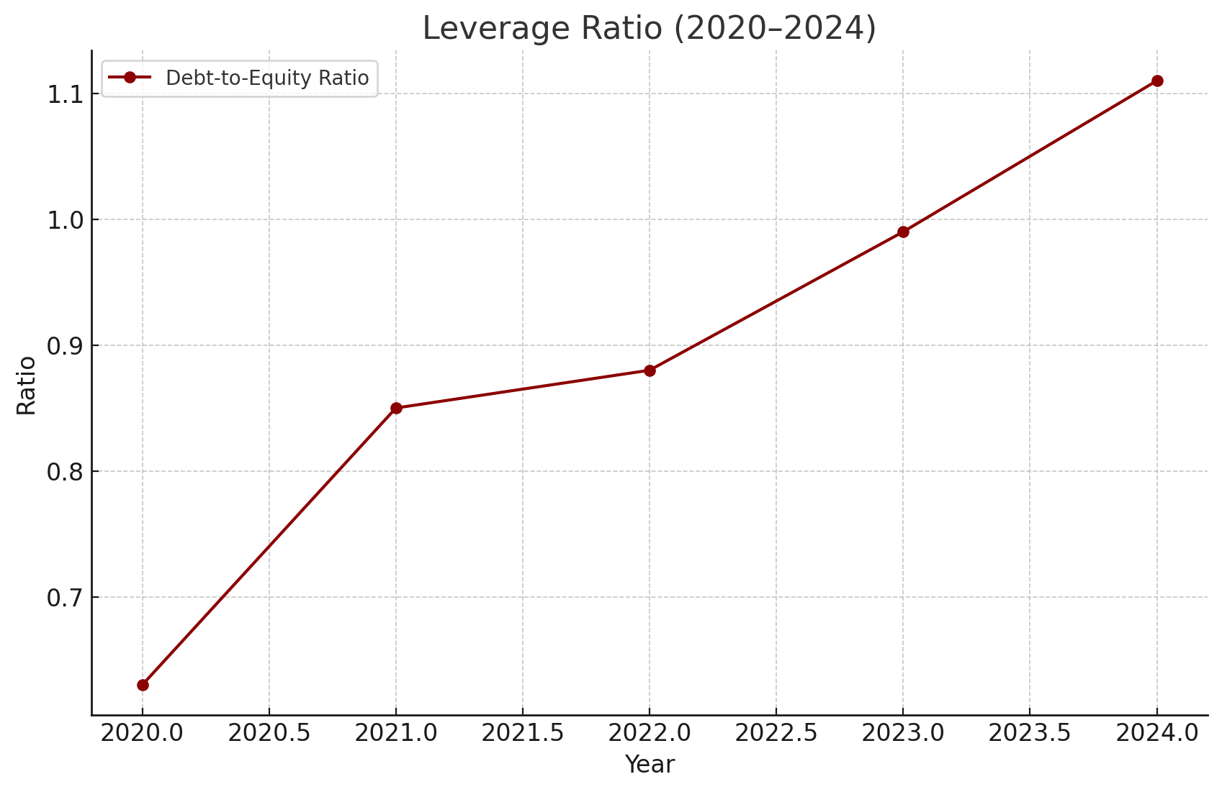
Appendix F: Efficiency Ratios (2020-2024)



