BMDS7000 AC2: Application Functionality Report – EPRO Scrik Digital Dictation System (DRAFT FOR TURNITIN INITIAL CHECK – pre final review and check and Harvard referencing)
- Introduction
The outpatient clinic letter is a clinically rich document that describes the outcome of a patient’s appointment following referral from their primary care physician (GP), and between diagnostics and specialists as part of the patient’s pathway within secondary care. This summary clinical document is an important part of the patient’s overall medical record and contains information pertaining to the investigation into a patient’s condition, any correlating factors and either the next step in the treatment plan at secondary care, or discharge instructions to the GP.
Traditionally, a copy of every clinic letter is provided to the GP and it is now common place for the patient to also receive a copy. In what is often an emotionally charged situation for patients, the clinic letter is welcomed as a means to reflect on the discussions that took place and foster a feeling of being part of what is happening to them. A study by Krishna and Damato (2005) undertaken with patients who received a copy of their clinic letter following their ocular oncologist outpatient appointment, found that patients placed value in receiving the clinic letter and were undeterred by the clinical terms often contained within.
It is critical that the creation and dissemination of clinic letters following an outpatient appointment is timely, to avoid risk to the continued health care of the patient during both their Secondary Care pathway, and on step down back to Primary Care enabling the GP to act on the advice of the discharging clinician (Corson, Hargreaves et al. 2017). The antiquated method of using cassette dictation equipment, has long been recognised as inefficient and risky (Viitanen. 2009). Digital dictation removes the need for cassettes and enables the process of dictation, through to transcription, to be managed within a single system; and has been a key area of growth and development in Health Information Technology (HIT) to ensure more timely access to a patient’s most recent clinical interaction.
1.1 Scope and Purpose
The Ophthalmology Outpatient Services are responsible for the investigation and treatment of medical conditions relating to the eye. Within Betsi Cadwaladr University Health Board (BCUHB), these services are delivered under the three site managements structures of West, Central and East; each reporting to a different Hospital Management Team as part of the site General Surgery Directorates.
In November 2021, the service saw just over 5,800 patient across the three sites, of which 24% were seen as a ‘new’ appointment, with the remaining being seen for a ‘follow-up’ appointment. Over the previous six months, the average number of patients seen was just over 5,500 (BCUHB IRIS Report, Eye Care Measure Dashboard). Every patient that is seen in an outpatient clinic must have a clinic letter produced post-appointment. It is policy within BCUHB that a copy is then retained as part of the patient’s paper medical record, one copy is provided to the referring General Practitioner (GP) and a copy is sent to the patient. Other copies may be provided to other specialities, or diagnostic teams within, or external to BCUHB if referral for further investigation and/or treatment is required.
The Central Ophthalmology team was one of six pilot sites to digitise the patient clinic letters using an early version of the EPRO digital dictation system, and has been using the product for over eight years; present through all of the system upgrades, this team of medical secretaries and clinicians is considered an advance system user. In 2020/21, the project rolled out the West Ophthalmology team who had previously used the clinic letters functionality within the PIMS patient administration system; the East site is scheduled for implementation in Spring 2022. Ophthalmology is on an accelerated road to digitisation of their speciality patient medical record, with a national project to implement OpenEyesTM Electronic Patient Record (EPR). The intention is for the speciality to continue to use the EPRO system, with the clinic letters provided to the OpenEyesTM system repository via HL7 integration.
With the latest upgrade to the EPRO system in November 2021 causing some technical issues in the usability of the system and the planned introduction of another key digital system to their clinical processes, it is timely to undertake an evaluation of the system adoption to ascertain if the EPRO system remains fit for purpose.
  - The EPRO Scrik System

Founded as a company in 2001, EPRO are the suppliers of the BCUHB digital dictation system delivering a range of electronic patient record and medical software applications (https://www.epro.com). The Scrik application is web-based and hosted on premise within BCUHBs infrastructure, integrating to the local Patient Administration Systems (PAS) for the demographic, appointment and admission data.
The application is currently in use for the primary purpose of creating digital clinical letters following an outpatient appointment, with a minor deviation from this purpose by the lung cancer nurses, who use elements of the application to record transactional information. The system use is currently limited to digital dictation, which is on track to complete a roll out pan-BCUHB by July 2022; voice recognition will then follow as a new phase to the project.
The product was introduced originally under the Finance Directorate in 2014 as part of a digital dictation ‘proof of concept’ to replace the analogue workflow (Figure 1), with 6 specialities based in the Central site integrated to the Welsh Patient Administration System (WPAS) central instance.
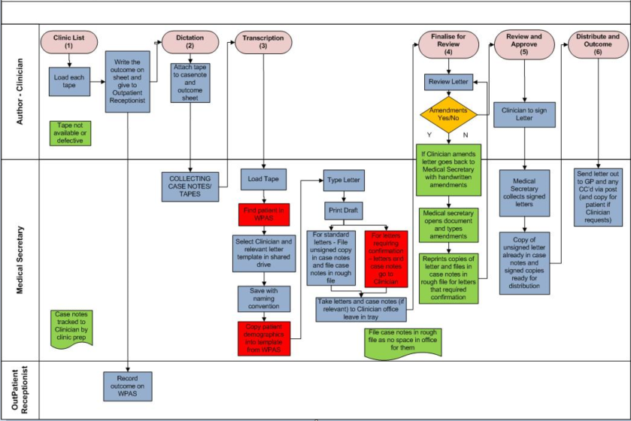
Figure 1. Analogue Process Pre-EPRO System
(Source: EPRO Project Team, 2020)
In July 2019, a formal Project Board was established and it was decided that in order to ensure value for money and to challenge the technical prowess of the EPRO system, the market would be tested against EPRO as the incumbent supplier. Following a robust OJEU tender and evaluation process, the decision was made to move forward with the EPRO system and the project was handed over to the Informatics Directorate to sit within the overarching Patient Records Transition Programme. The project was re-launched within a PRINCE2 project management environment and assigned a full time Project Manager and support. At this point a dedicated System Administrator was appointed to the EPRO system, a role that had previously been assigned informally to a competent system user. The first phase of the project delivered a series of outstanding updates to the system resulting in the ‘EPRO Scrik’ version being available for all original pilot users, delivering better navigation for the user and more flexibility to create standardised templates within the system bespoke to BCUHB. Following this, a rollout plan delivered the application to all specialities in the West site and completed the roll out to the remaining specialities in Central the site; as at November 2022 there are 1,417 users and 512 ‘read-only’ licences.

- Method
2.1 FITT Framework
Approaching an evaluation of the EPRO Digital Dictation system requires us to first determine what it is that we are trying to evaluate (Bürkle, Ammenwerth et al. 2001). As an existing system that is subjected to multiple upgrades, the most recent being in November 2021; allowing flexibility across a range of qualitative and quantitative research methods, the FITT framework (Figure 2) provides the evaluation goals i.e. the fit between the user, technology and task, to understand where across the domains the fit is strong and areas where the fit is weaker (Ammenwerth, Iller et al. 2006).
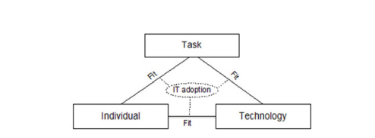
Figure 2. The FITT framework (Ammenwerth, Iller et al. 2006)
2.2 Research Methods
The research evaluation methods were designed to evaluate the EPRO system in the scope of the Ophthalmology users in Central and East sites, applying the FITT framework across the three domain relationships i.e. individual to task, task to technology, and technology to individual.
- Structured Questionnaire
The primary evaluation method is a structured questionnaire. The high level tasks required to produce a clinic letter have not changed significantly through the transition from analogue to digital; digitisation has changed the approach to undertaking these tasks. Based on the task orientated physicians questionnaire developed by Lærum and Faxvaag (2004) for the evaluation of the clinical use of EMR systems, a questionnaire was designed (Appendix A) to quantitatively assess the users perception:
- retrospectively in using the system compared to their previous analogue approach (Section A);
- retrospectively and currently through the system upgrades (Section B);
- of their satisfaction in relation to overall content, accuracy, format and ease of use (Section C); and
- of their overall satisfaction in relation to training received, issue resolution and effort versus benefit (Section C).
The core tasks were identified from the workflows and the training guides, and agreed with the ‘EPRO Project Manager’ to form the basis for the questionnaire.
A Likert scale of both 5 and 7 items was used to capture the response, with three closed ended questions at the start of the questionnaire to ascertain site, role and length of service. In order to address the limitation with the Likert evaluation method of restrictive choice providing quantitative data, responders also had the option within the questionnaire to provide a qualitative response to support their submission in a final open text field, and the option to be contacted for interview to strengthen the validity of the questionnaire submissions. A further limitation of was mitigated with this approach with regards to acquiescence bias by avoiding, with the exception of three final questions in Section C, wording questions as ‘statements’ that can be agreed with. This one questionnaire was designed to gather responses from both the authors (clinicians) and typists (medical secretaries), with options across the relevant sections to select ‘this task doesn’t apply to me’.
The responses were saved with a number and name reference that aligned to an anonymous line reference in the collated data Excel spreadsheet.
The ordinal data gathered from the responses was calculated to find the medium and inter-quartile range (IQR) of each item to ascertain both the level of consensus across the question responses and the aggregated median Likert statement. Consensus was categorised into the following cohorts:
0 = consensus
1 = general consensus
2 = some polarisation
3 = polarisation
- Associated Project Documentation Review and Call Logging System Metrics
Data was gathered from the EPRO financial and project documentation to ascertain the various stakeholders’ commitment to; the product, planned scale of use, demand for the system to undertake the tasks, ongoing issues, and known risks.
Metrics for calls logged by users (any user of the system i.e. beyond the limited Ophthalmology scope of this report), the System Administrator and the Project Team members over the last two years was obtained from the organisation’s ICT Service Desk to evaluate the stability and robustness of the system.
- Literature Review
An unstructured literature review was undertaken to support the evaluation of the fit between the individual and the task i.e. producing a clinic letter following an outpatient appointment.

- Results
3.1 Individual to Task Fit
The fit between the individual and the task is embedded and well understood within healthcare, with the Professional Records Standard Body (2019) setting the standards for writing the outpatient digital clinic letter to support better communication in the environmental context of more flexible models to deliver care to our patients.
The case for writing the clinic letter is compelling; Rayner, Hickey et al. (2020) describe the patient safety and litigation risks that can be realised when a well written clinic letter is not provided to both the GP and the patient as soon as possible following the appointment; with four members of the professional group contributing to the Academy of Medical Royal Colleges (2018) ‘Guidance for Writing Outpatient Clinic Letters to Patients’, which quotes the views of patients describing the multiple health and wellbeing benefits of receiving this key communication from their health care provider.
The fit is evident at a Health Board level from multiple stakeholder perspectives across the evaluation methods, with all stakeholders strongly subscribed to the necessity of the task to producing a clinic letter following an outpatient appointment; the following three examples demonstrate this.
The project documentation review provided evidence that BCUHB as the organisation stakeholder has committed long-term investment in the digital dictation system, signing up to an ‘invest to save’ via the Welsh Government, and further demonstrates commitment to the improvement of the clinic letter process by allocating one of the core Executive Team leads to the project role of Senior Responsible Officer (SRO).
From a clinical stakeholder perspective, the demand for over 500 ‘read only’ licences demonstrates the demand for access to the outpatient clinic letters; furthermore, the two highest risks on the Project Risk Register pertain to clinicians not knowing where to access the latest clinic letter and the provision of that clinic letter to the GP.
The Digital Dictation Project sits within the a programme framework called the ‘Patient Records Transition Programme’. There is evidence in the Project Agenda and Minutes of meeting (October 2021), that via the BCU Digital Health Records Project within the same programme, phases are underway to expand the availability of the EPRO clinic letters through integration with the recently acquired BCUHB Cito Digital Health Record, a system that will provide a cohesive view of the patient record to all secondary, primary and community health care providers across North Wales.
3.2 Task to Technology Fit
The EPRO system design enables the core tasks required to produce a clinic letter following an outpatient appointment

Fig. 3 - Insert basic process map here of the EPRO process……..

A key feature of the system is the ability to standardise the clinic templates with the use of auto text and ‘snippets’, which are sections of reusable text. Whilst this realises the obvious benefit of further reducing the time taken to transcribe the clinician’s audio dictation, it furthermore supports a more standardised output for the receiving GP. It has been found that GPs spend on average less than one minute reading the clinic letter and value receiving the information in a structured letter template (Parks, Kingham et al. 2011). These findings are supported by Corson and Hargreaves et al (2017), who cited the use of templates in their recommendations to improve the timely provision of clinic letters to GPs to mitigate the risks to patient safety.
Over the last two years, there were five hundred calls logged for support on the ICT Service Desk for the EPRO system, an average of twenty one calls per month. Just over 70% of these calls are in the second of the two years, correlating to the scale up.
Overall, ‘Functionality Issues’ and ‘Standard Request’ account for 94% of the categorisation of ‘call types’. Further analysis of the data beyond this is limited by the lack of standardisation within the ‘call type’ categories, i.e. there are multiple examples of the same call ‘titles’ such as ‘EPRO Install’ being used across categories, and often the title is limited to broad terms e.g. ‘EPRO’, ‘EPRO Request’. A rudimental filter search on specific terms yielded the most common reasons for the call being logged as:
- Installation of EPRO (150)
- EPRO (as a single word) or EPRO Issue or EPRO Functionality Issue (100)
- Access (data or system) (35)
- Printing (31)
- Dictation or sound or dictation or foot (23)
- Installation of Glass (17)
- Letter (12)
The review further exposes that 84 (17%) of these calls remain open at the time of the extract; all of which were placed in the year 2021, 33 pertaining to the ‘call type’ of functionality issues, 3 requests for access, 48 standard request.
The highest peak of calls is in October 2021, with the majority of these calls from individuals in Central site requesting EPRO ahead of their scheduled department roll out. Further analysis however, exposes that the remaining two peaks in calls have followed the EPRO system upgrades in September 2020 and November 2021, corroborating the anecdotal feedback that the system upgrades have introduced usability issues.
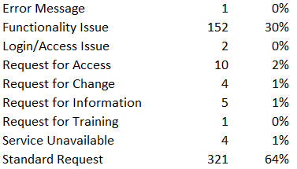

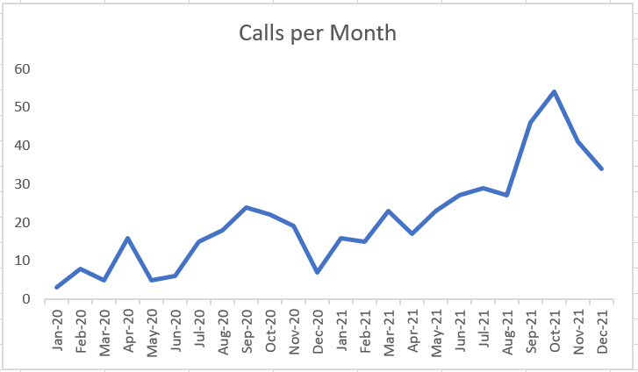

Sept 20 Upgrade

Nov 21 Upgrade

Figure 4 – BCUHB ICT Service Desk Calls
January 2020 to December 2021
Responses to the questionnaire Section C - Part 1 (Q4), provided that this sub-set of Ophthalmology users ‘seldom’ report problems with the system, converse to the qualitative comments provided in the free text section of the questionnaire which highlighted issues with the speed of the system and network, the browser version being incompatible, and printing. The user experience of issues with printing is validated in the responses to Section B (Q5), with some polarisation in consensus to the perception that printing ‘performance is better’, with 16% (two users) stating the ‘performance is significantly worse’ (Mdm=5.5, IQR=2.25).
Section B of the questionnaire, designed to explore user perception retrospectively and currently through the system upgrades, suggests users are generally satisfied that the performance of the system is improving over time. More encouraging is the perception that in the core functionality areas of ‘retrieving and viewing patient clinic letters’ (Mdm=7, IQR=1) and ‘transcribing’ (Mdm=6.5, IQR=1.25) there is general consensus that ‘performance is significantly better’. Many responders also expressed that ‘performance is better’ in regards to ‘Overall workflow’ (Mdm=6, IQR=1.5).
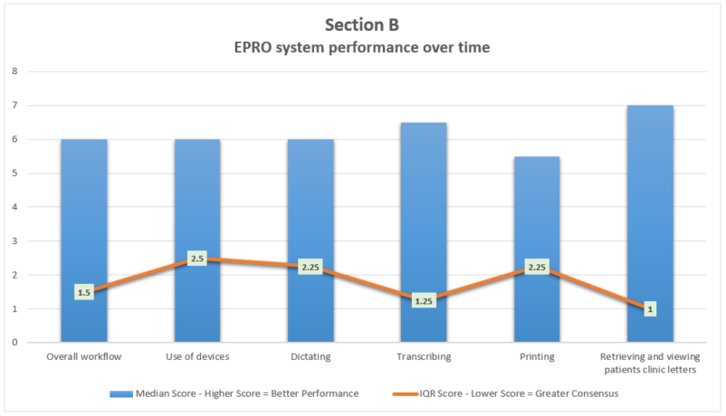
Figure 5. Results of Section B – EPRO system
performance over time

3.3 Individual to Technology Fit
Across the cohort of questions in Section A pertaining to the ‘ease of completing your tasks since moving to the EPRO system’, in all bar one task most respondents indicated it is now ‘significantly easier’ to complete their tasks than it was with their previous analogue approaches (Mdm=7, IQR=0 to 1.5). The one area that indicated a high polarisation in perception was the ‘ease of finding an appropriate device to dictate’; authors (consultants) were divided in their opinion with 67% finding it ‘easier’ or ‘significantly easier’ and 11% expressing ‘no change’ and 22% finding it now ‘slightly more difficult’ (Mdm=7, IQR=3).
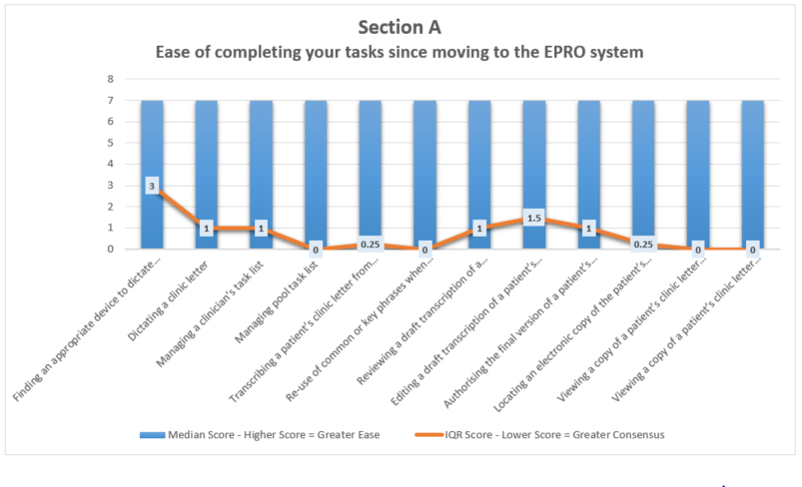
Figure 6. Results of Section A – Ease of completing
your tasks since moving to the EPRO system
Across both the typist and author user groups, there is general consensus that users are satisfied ‘most of the time’ with the format and clarity of the clinic letter created within the system (Mdm=4, IQR=1), with many expressing the same level of satisfaction with regards to how user friendly the system is it, how up to date the system is providing patient activity information and the accuracy of the system (Mdm=4, IQR=0 to 0.5).
There appear however to be a lack of consensus with regards to how often the system provides up to date information on patients personal details (Mdm=4, IQR=2), with 35% of responders expressing they only feel this key area of data is accurate ‘about half the time’ or ‘seldom’.
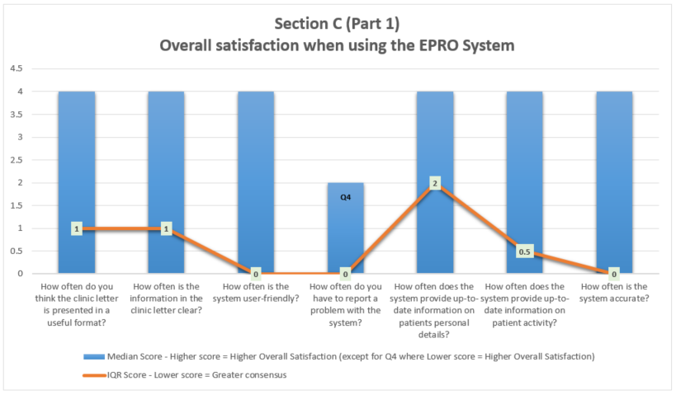
Figure 7. Results of Section C (Part 1) - Overall
satisfaction when using the EPRO system

The final section of the questionnaire explored the user perception of their overall satisfaction in relation to training received, issue resolution and effort versus benefit. There was general agreement that the training provided was clear and appropriate to for the users role (Mdm=6, IQR=1), however one free text comment expanded on their dissatisfaction stating that “I personally found the training unclear as the IT trainer was unable to apply the use of EPRO to our roles……now that (System Administrator) is on board, it is important that training is given by someone who understands the job roles of the staff using the system”.
Whilst the evaluation in Section B resulted in users ‘seldom’ needing to report a problem with the system, opinion was divided with regards to how quickly users get a response with a satisfactory resolution to problems they log with the ICT Service Desk, with just over half (59%) agreeing or strongly agreeing to the statement (Mdm=6, IQR=2).
A key question for the evaluation of any system is whether the user feels that the time and effort it requires from the them to use the system is worth it; if the needs of the user are not met by the system and conversely it is instead more onerous to complete the tasks in the system, then workarounds will be developed (Eason, Waterson. 2014). In this case the majority of the Ophthalmology users that responded ‘agreed’ or ‘strongly agreed’ that the EPRO system is worth the effort is takes to produce the clinic letters (Mdm=7, IQR=1), with one clinician stating “EPRO is one of the few systems that actually works and makes my clinical work easier. I very much hope that its future in the trust is guaranteed. As a clinician, I also use it to look at clinic lists- it would be great if all the specialties used the system. Please, please do not get rid of EPRO”.
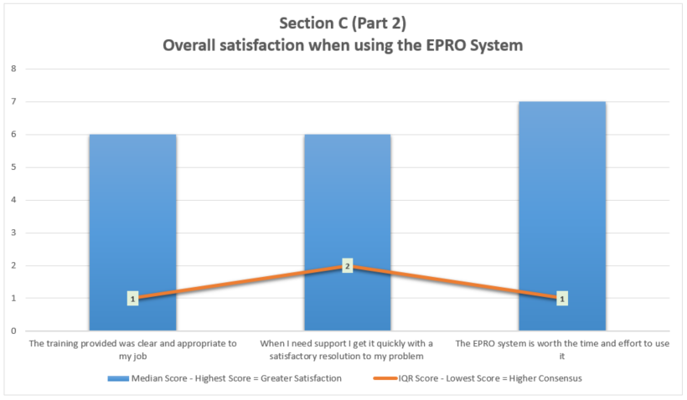
Figure 8. Results of Section C (Part 2) - Overall
satisfaction when using the EPRO system

3.4 FITT Analysis Findings and Recommendations
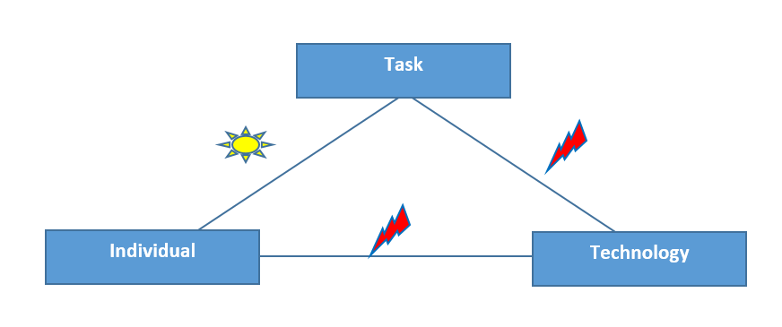
Figure 9. Analysis of the Fit; sun depicts an uncomplicated fit and
one arrow some issues (Ammenwerth, Iller et al. 2006).

The fit between Individual and Task is an uncomplicated fit that is well understood and accepted at both the macro (national) and micro (BCUHB) level within Health Care.
Whilst there is evidence that the system is designed to fit the purpose of producing clinic letters, the fit between the Task and Technology is less robust, with evidence that there are areas that require prioritisation for improvement to underpin a successful scale up into the East site.
There is general consensus among users that creating clinic letters is ‘significantly easier’ with the EPRO system compared to their previous analogue processes, with the majority of users feeling satisfied with the system ‘most of the time’ and ‘agreeing’ or ‘strongly agreeing’ that the EPRO system is worth the effort is takes to produce the clinic letter. However, the over fit between the Individual and Technology has some issues that must be resolved to more firmly embed the system with current users and ahead of more users joining the system.
The following recommendations are to be considered by the EPRO Project Board to strengthen the fit between the two domains of ‘Task and Technology’ and ‘Individual and Technology’ :
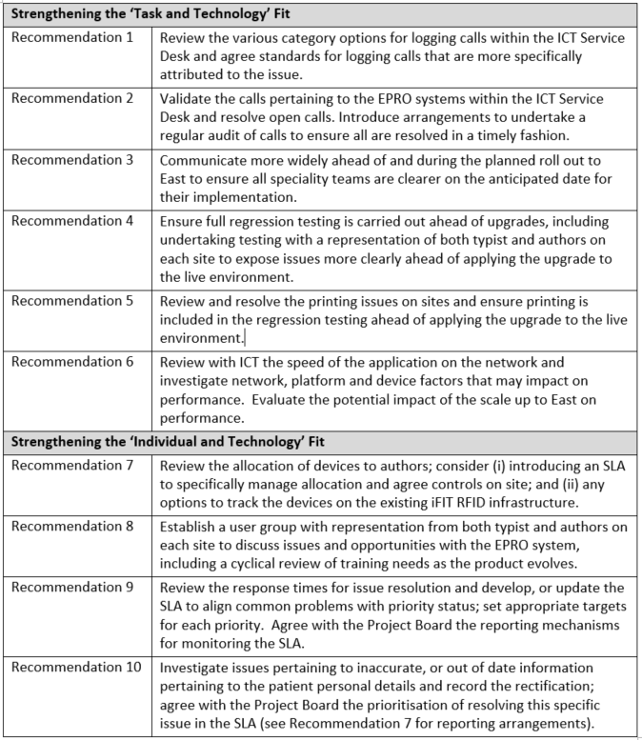
Figure 10. Recommendations to strengthen the fit between
‘Task and Technology’ and ‘Individual and Technology’
.

- Discussion
4.1 Strengths and Limitations of the FITT Framework
The FITT framework’s evaluation of the fit between the ‘individual and the task’ builds on the user acceptability offered within these precursor models:
- Technology Acceptance Model (TAM) that examines the correlation between the cognitive response of the user in terms of their perception of ease of use, to the behavioural response in terms of actual use of the technology (Davis. 1993); and
- Task-Technology Fit Model (TTF) focussing on the importance of the fit between the task and technology and the link to achieving individual performance and avoiding user work arounds (Goodhue, Thompson. 1995).
This report focusses on one key element of a patient’s medical record that supports safe and timely care, the clinic letter managed through the EPRO Scrik digital dictation system. A strength of the FITT Framework is in evaluating an existing system in use at a specific point in time; and as such, lends itself well as a tool that can be used when a system is deemed to be failing, or throughout the life of a system to re-assess if it remains ‘fit’ as it evolves through upgrades and increases to it’s user base (Ammenwerth, Iller et al., 2006). This repetitive retrospective evaluation method sits well within an agile project approach, supporting Deming’s PDSA cycle.
Evolution from analogue to digital is a critical step in achieving the panacea of seamless care across the health care provider sectors. From that aim, success can be more assured by taking a user centric approach the design of clinical systems, involving all stakeholders and ‘to be’ users; and this is where the strengths of the FITT model applying a retrospective analysis approach conversely reflect it limitations. The most benefits realised through user involvement are derived from engagement at the design stage of the system development, when as primary stakeholders their needs and requirements can be understood and mapped into the system workflow (Viitanen. 2009).
The opportunity to take a user centric approach to the design stage of the EPRO scrik system has passed, however the Project Initiation Document describes future phases that take the systems into new territory such as mobile phone usage and speech recognition. This presents a new opportunity to take a user-centric approach to developing this key Health Information Technology (HIT) system, inclusively across the full range of stakeholders to deliver more seamless care. To support this a different evaluation framework can be used that may offer a more robust approach at an earlier stage in the design process. The TPOM framework take a more macro approach to evaluation of HIT systems and expands beyond the FITT Framework to consider the technology, social/human and organisational factors; three domains that embrace the more complex factors associated with seamless care involving stakeholders across organisations (Cresswell, Williams et al. 2020).

4.2 Evaluation Limitations
Across the existing Ophthalmology users in the West and Central sites, 58 questionnaires were emailed out describing the purpose of the survey (Appendix A) and following 2 email reminders, 17 were returned; a response rate of 29.3%. It is acknowledged that the teams were requested to take part in this evaluation at a time of immense pressure and post Christmas, emerging from a further disruptions to service delivery in response to the Omnicrom Covid peak.

Beyond the limitation of restrictive choice and response bias acknowledged in section 2.2 of this report, the Likert scale has further limitations in that it only reveals if one score in the scale is higher than another and does not apply an understanding of the distance between the two scores. The responders may also introduce response bias otherwise known as distortion in other ways such as, avoiding the extreme responses items (central tendency bias) and trying to show themselves, or their teams in a favourable light (social desirability bias). Time constraints and pressures on site prevented active follow-up of responses with interviews, or re-testing the responses; both of which would have supported validation to expose bias responses.
These same constraints prevented observational activity that could be used to strengthen the understanding of the clinical and administrative workflows of the ‘as is’. Figure 3 workflow is an informal flowchart created during this evaluation based on user guides and project documentation in the absence of an existing model within the project, that depicts the tasks at the highest level; whilst it was easy to develop it is open to interpretation.
Finally, this approach has relied on work as documented to understand the work as done and as such, was created far removed from the actuality of the clinical activity and impact on the patient care (Deutsch, E, 2017).
4.3 Conclusion
The findings of this FITT Framework evaluation evidenced a strong fit between the ‘individual to task’ and provided ten recommendations that will improve the fit between other two domains of ‘Task and Technology’ and ‘Individual and Technology’.
The discussion above recognises the limitations to the approach taken in regards to; the evaluation methods used, time available, and environmental constrains imposed by Covid that restricted the opportunity to both carry out a wider range of evaluation methods and validate the results.
It is recommended that additional validation steps are undertaken to provide validity to these results; such as:
- re-visiting the questionnaire responses is introduced with this same group; and
- following up submitted responses with user interviews.
It is further recommended that in order to undertake a deeper FITT evaluation to more fully expose the weaker and stronger fits between the three domains and to inform future improvements and secure user adoption, in addition to the above recommendations the following is considered for inclusion when expanding the survey to other department users beyond Ophthalmology:
- undertaking touch and flow observation to enhance the existing limited documented workflow models and identify the value steps in the existing process;
Finally, there is an opportunity to take a more user-centric approach to evaluation of this key HIT implementation using TPOM, which should be factored into new phase planning stages.

