Iain Martin (2311038)
2311038@student.uwtsd.ac.uk

BA Games Design
Learning in the Digital Era (ACCA4025)
Assignment 1: Development Diary
Contents
Week 1 3
Introduction 3
Lamp Post Guided 3
Week 2 7
Introduction 7
References 7
Lamp Post 8
Week 3 11
Introduction 11
Lego Mini Figure 20 Minutes 11
Reference 11
Lego Mini Figure 12
Horse 10 Minutes 13
Reference 13
Horse 13
Monitor 10 Minutes 14
Reference 14
Monitor 14
Chest 10 Minutes 15
Reference 15
Chest 15
Axe 10 Minutes 16
Reference 16
Axe 16
Week 4 17
Introduction 17
Reference 17
Soda Can 18
Week 5 21
Introduction 21
Reference 21
Cup and Saucer 22
Week 6 & 7 27
Introduction 27
Reference 27
Building 28
Week 8 & 9 31
Introduction 31
Reference 31
Dumpster 31
Conclusion 37
Bibliography 38

Week 1

Introduction
I followed Adam with the rest of the class creating a simple lamp post, I was new to using Maya [1] and had been using Blender [2] for some time, I found it initially difficult to transfer Blender skills to Maya due to changes in shortcuts and the layout in addition to the quirkiness of how some of the simple modelling tools are used compared to Blender.

Lamp Post Guided
Initially starting off with a cylinder and changing its dimensions to be more suitable size for the main pole.
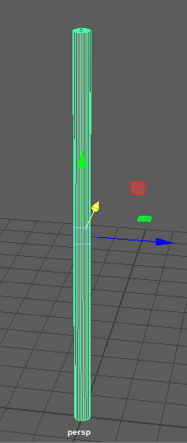
Fig. 1. Starting pole
Moved on to adding edge loops to allow the size of the upper post width to be smaller without bringing it to a point, this is one of the areas that did not seem to mesh well with blender knowledge as blender starts with the loop in the centre of an object as opposed to where the mouse is and the mouse wheel in Maya does not add evenly spaced loops, you need to open a separate window and set these up.
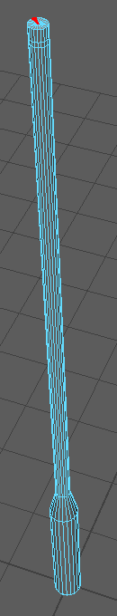
Fig. 2. Edge Loops added and diameter adjusted.
Next extruding the main light from the top and adjusting from verts with the scale tool to flatten the edge and then using edges and extrusions to create a light holder, in addition to adding extra loops and extrusions of faces to try and round off the pole and light.
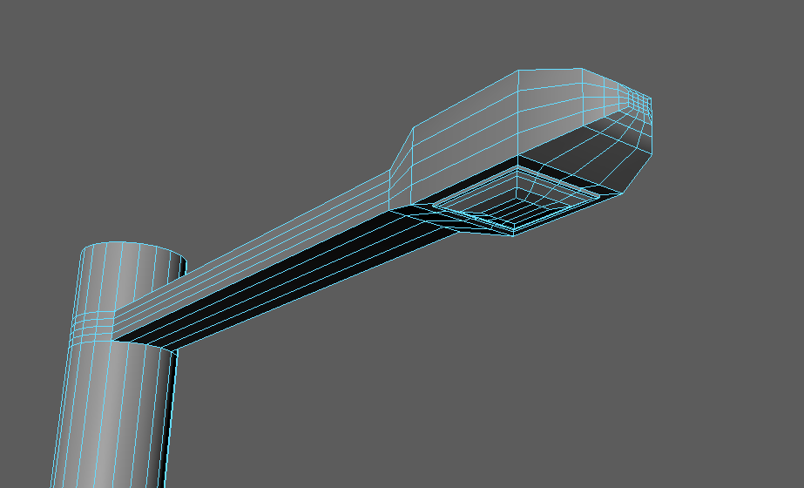
Fig. 3. Light pole and fixture..
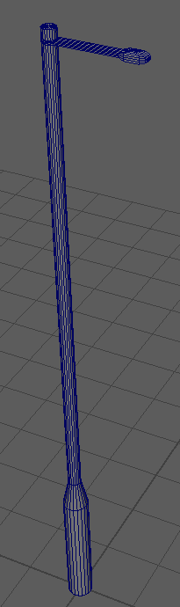
Fig. 4. Finished tutorial Lamp Post.
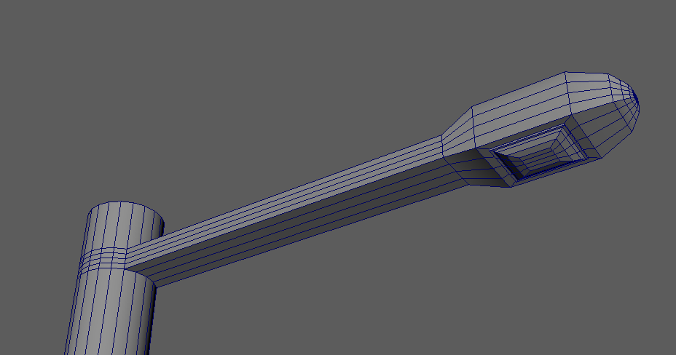
Fig. 5. Finished tutorial upper Lamp Post.
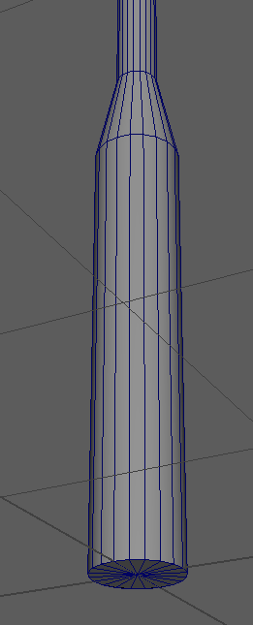
Fig. 6. Finished tutorial lower Lamp Post.

Week 2

Introduction
Going from the tutorial lamp post I looked at some videos on how to do edge loops similar to how blender does from 1 command, although similar it requires more menus and jumping through hoops to get the same effect, I gained advice from 5-Ways to Add Edge Loops in Maya [3].
I investigated different lamp posts to test modelling skills going forward for this and chose some of these as examples.

References
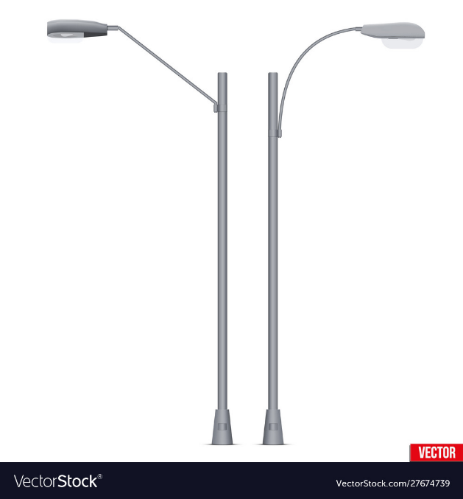
Fig. 7. Lamp post vector image [4].
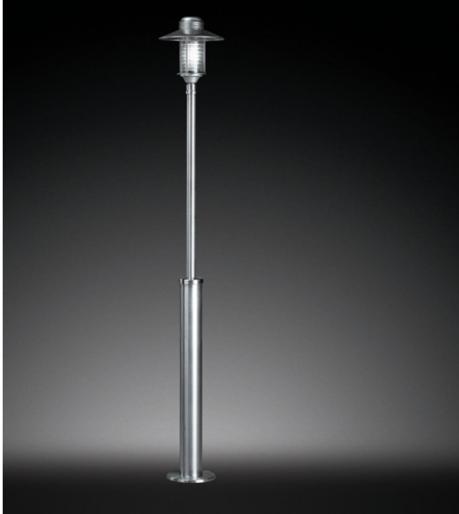
Fig. 8. Lamp post vector image [5].

Lamp Post
Starting off with the right main post from Fig. 7. I used extrusions and multi cut to create edge loops and shape the main post.
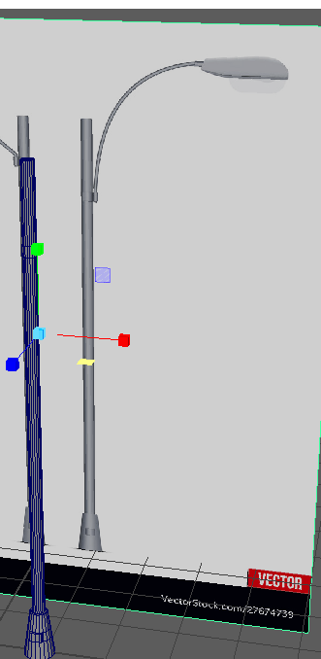
Fig. 9. Main Post.
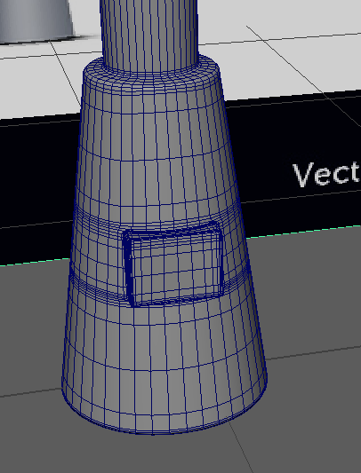
Fig. 10. Lamp Base.
For the curve I investigated a tutorial for maya curves, Maya Tutorial – Create a Tube from a Curve [6].
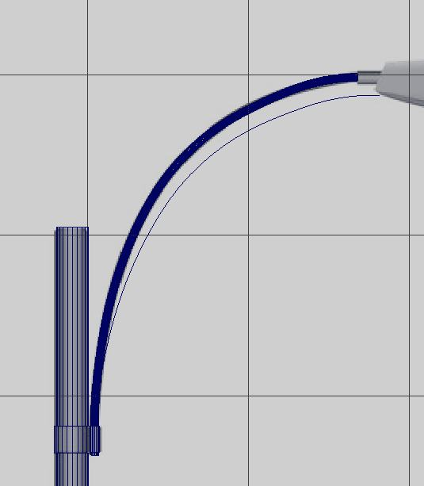
Fig. 11. Curved section.
Using a cube and extruding and adding edge loops to create the shape of the holder and light.
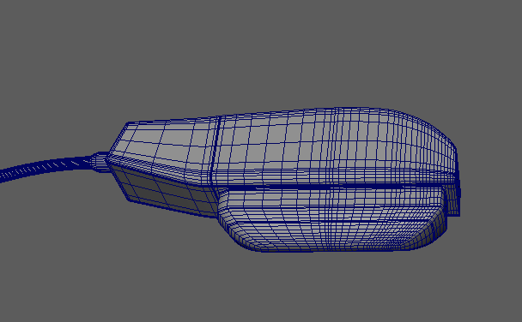
Fig. 12. Lamp.
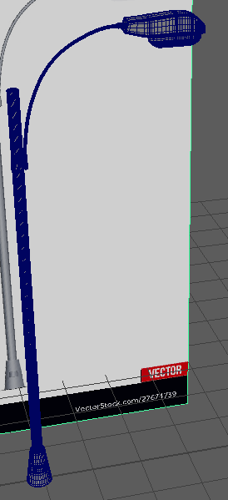
Fig. 13. Lamp Complete with smoothing.

Week 3

Introduction
We had been given a random selection of items to model in 10 – 20 minutes time for each from Adams wheel of random items. This was to help improve searching for reference images and the speed at which we could do a model.

Lego Mini Figure 20 Minutes
1st random model to create was a Lego mini figure.

Reference
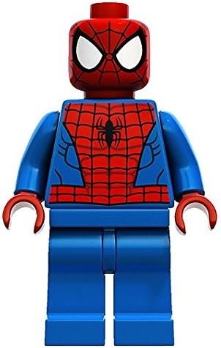
Fig. 14. Spiderman mini Figure [7]

Lego Mini Figure
I spent a little too much time searching for a good reference image and trying to work out how to connect the arms, given a 2nd chance I would have spent less time looking for an image and playing about with the parts and given more time to connect up the parts.
I used cylinders for the arms hips and head which I extruded to get the basic shape, the body and legs where made from cubes and extruded and angled with verts.
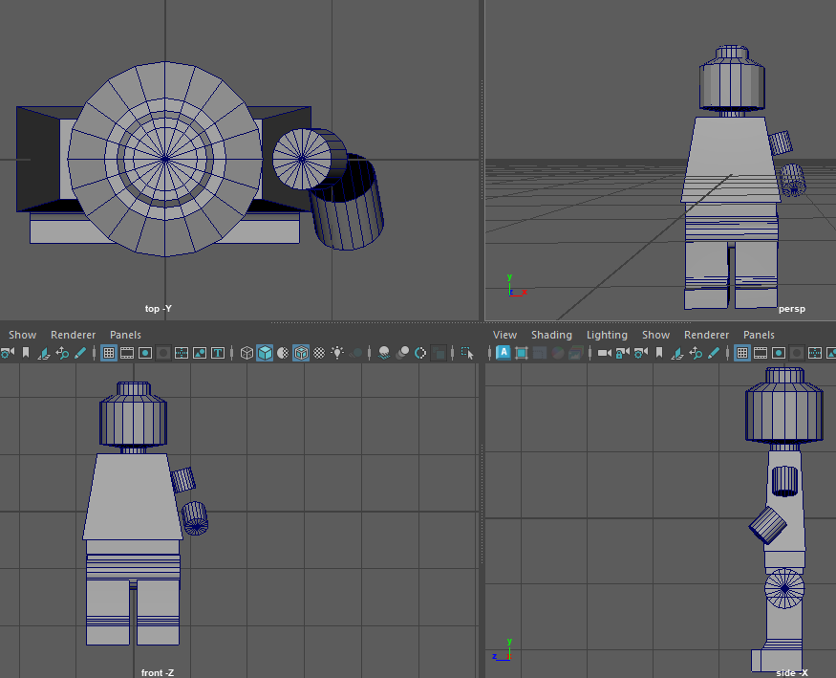
Fig. 15. Lego Mini Figure.

Horse 10 Minutes

Reference
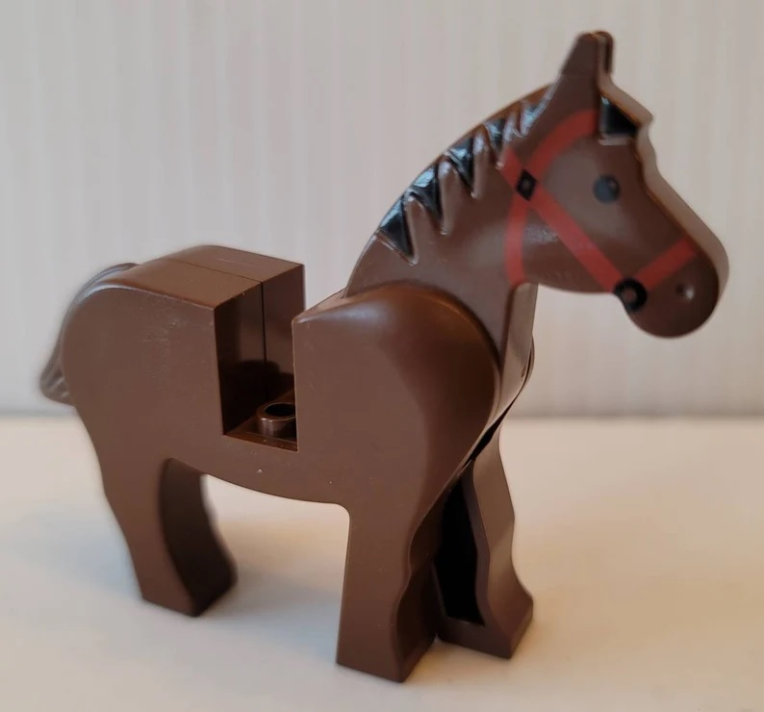
Fig. 16. Spiderman mini-Figure ‘[8].

Horse
I went quicker for the option for a horse by selecting Lego for my chosen theme, I could have gone Minecraft, but the thought of just using a few cubes and being done didn’t appeal. I got most of the horse complete bar its head, I’ll assume this is in someone’s bed….
I used some cylinders and cubes to complete this with extruded areas and faces removed.
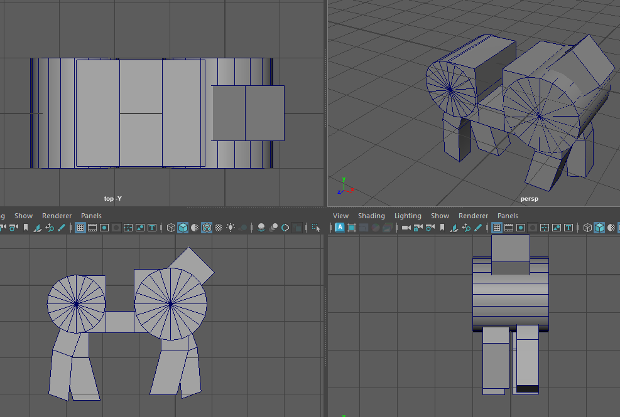
Fig. 17. Horse mini-Figure.

Monitor 10 Minutes

Reference
For this I didn’t use a reference image as I wanted to just go with an image that is ingrained in my head from years of using a CRT Monitor.

Monitor
I took the basic shape of the monitor and relied on a cube and extruded the main shape and adjusted the verts to get where I needed the same can be said with the stand, I added some lettering and even managed to add an image plane of something that I played while using a CRT.
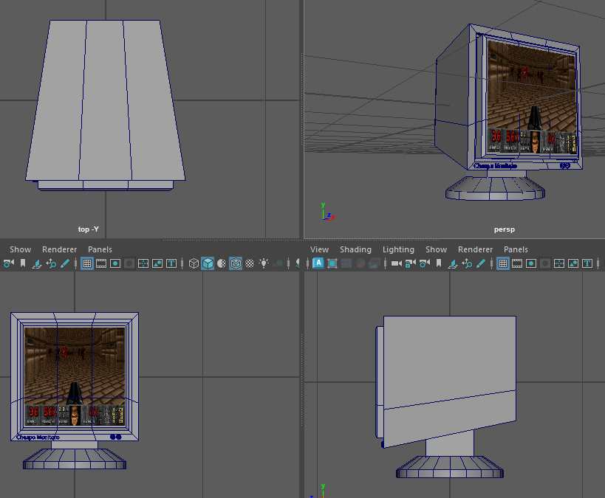
Fig. 18. Monitor.

Chest 10 Minutes

Reference
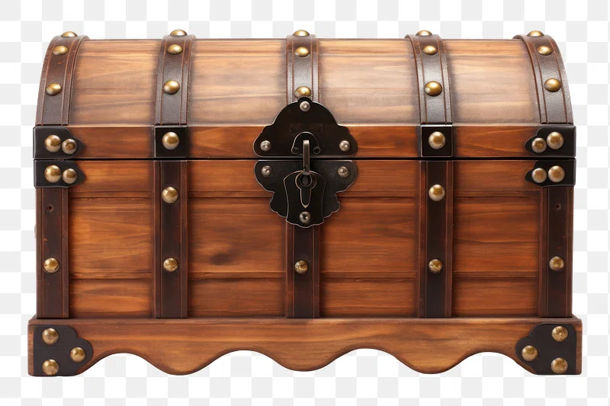
Fig. 19. Chest [9].

Chest
Using a cylinder sliced in half after adjusting the height while keeping the depth larger for the lid and adjusting with additional loops to match the cube to extrude the bands then adding some simple detailing with a sphere cut in half and duplicated across the banding and the lock made from a cube with verts edited and extruded.
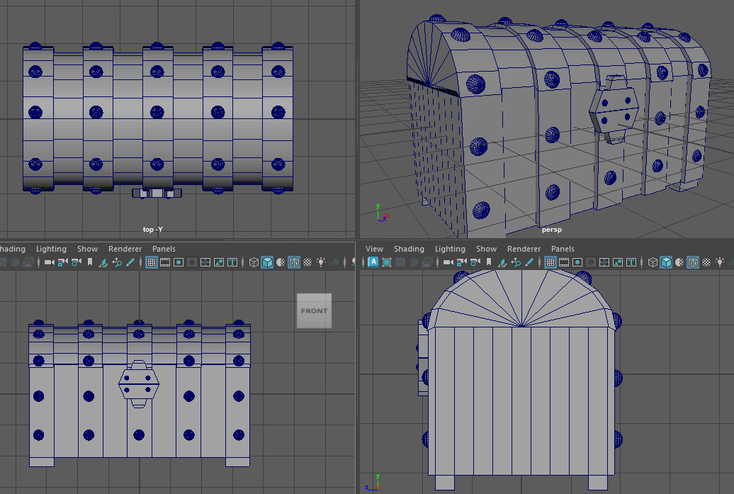
Fig. 20. Chest.

Axe 10 Minutes

Reference
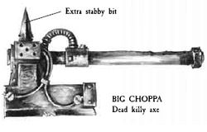
Fig. 21. Axe [10].

Axe
Given just a little more time I could have straightened up the axe and added the cable which I had just started.
I used the cylinder and cube and adjusted by extruding and scaling in addition to adding loops.
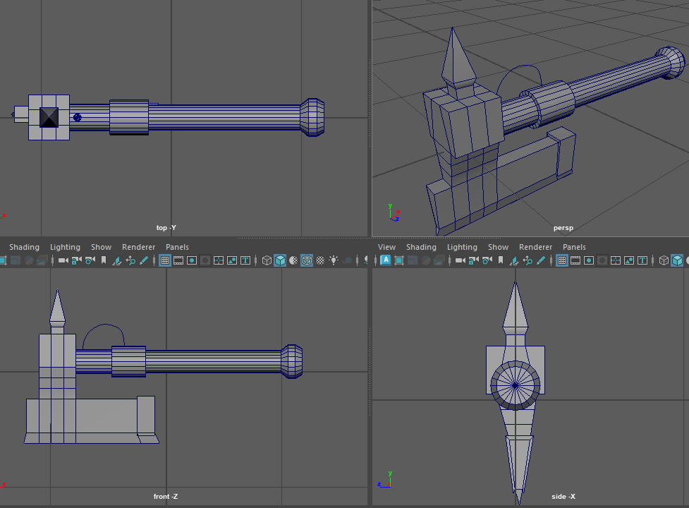
Fig. 22. Axe.

Week 4

Introduction
Next on the list of tasks was a soda can I would use a lot of what I learned about in previous days including upping my speed, which wasn’t too difficult with a can.

Reference
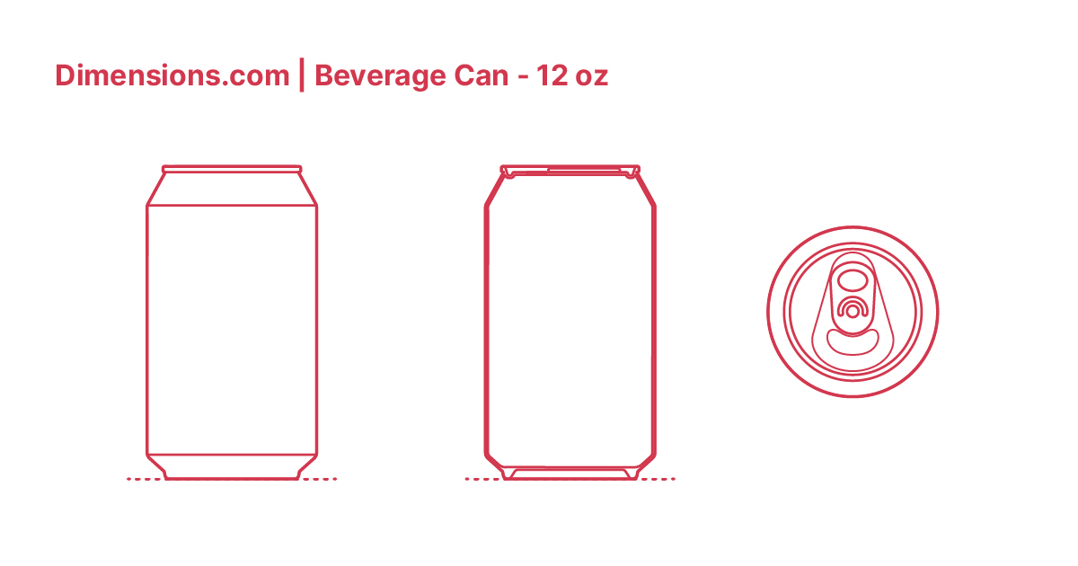
Fig. 23. Soda Can [11].

Soda Can
I started out with a plane to add the reference image and added a cylinder adjusted to the correct size of the reference image.
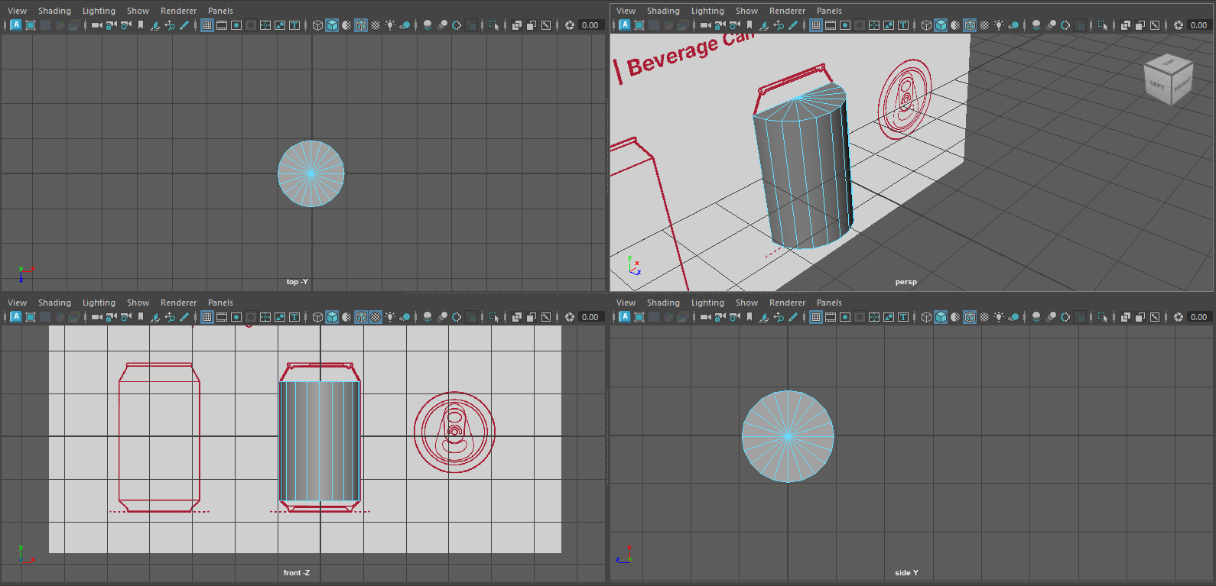
Fig. 24. Soda Can.
I moved onto extruding and scaling inwards to get the top of the can and then doing smaller extrusions to create the top of the can.
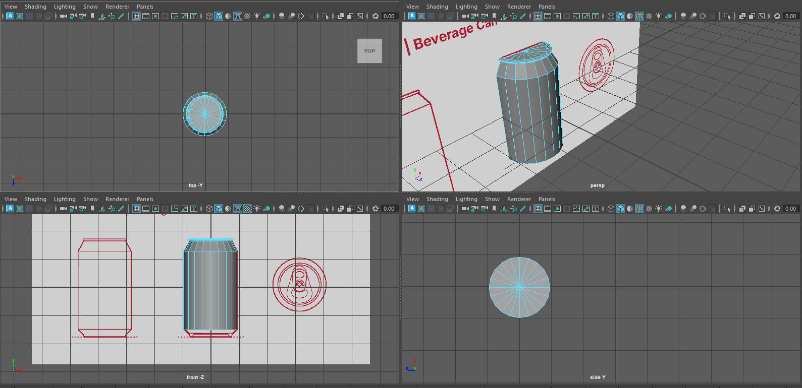
Fig. 25. Soda Can.
I then spoke to Adam on using a plane and image to allow the quad draw to work as this would give the right amount of detail for the ring pull, this was difficult to get my head around at first but eventually it stuck with Adams guidance.
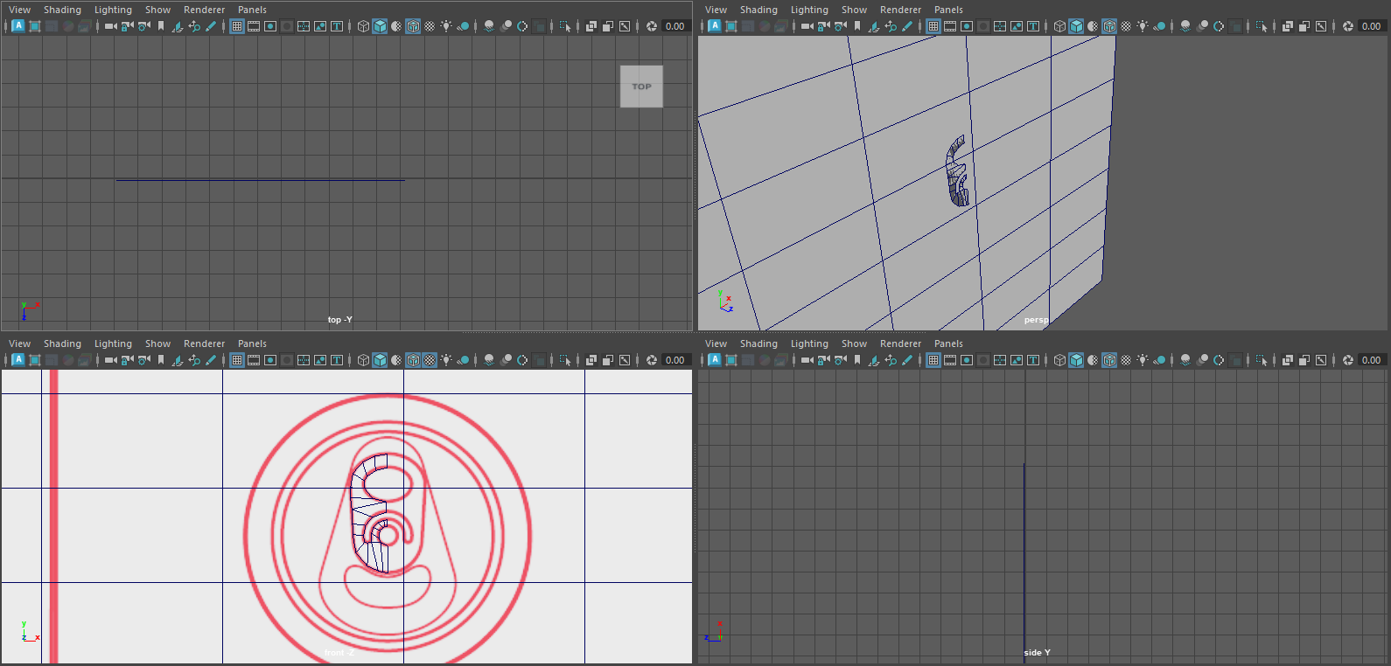
Fig. 26. Ring Pull.
Once this was completed, I straightened the edge by setting the pivot point and selecting the verts and using the scaler to bring them even, then creating a duplicate and doing a minus value before merging the 2 halves, I then extruded in small steps to create depth to the ring pull before adding to the can.
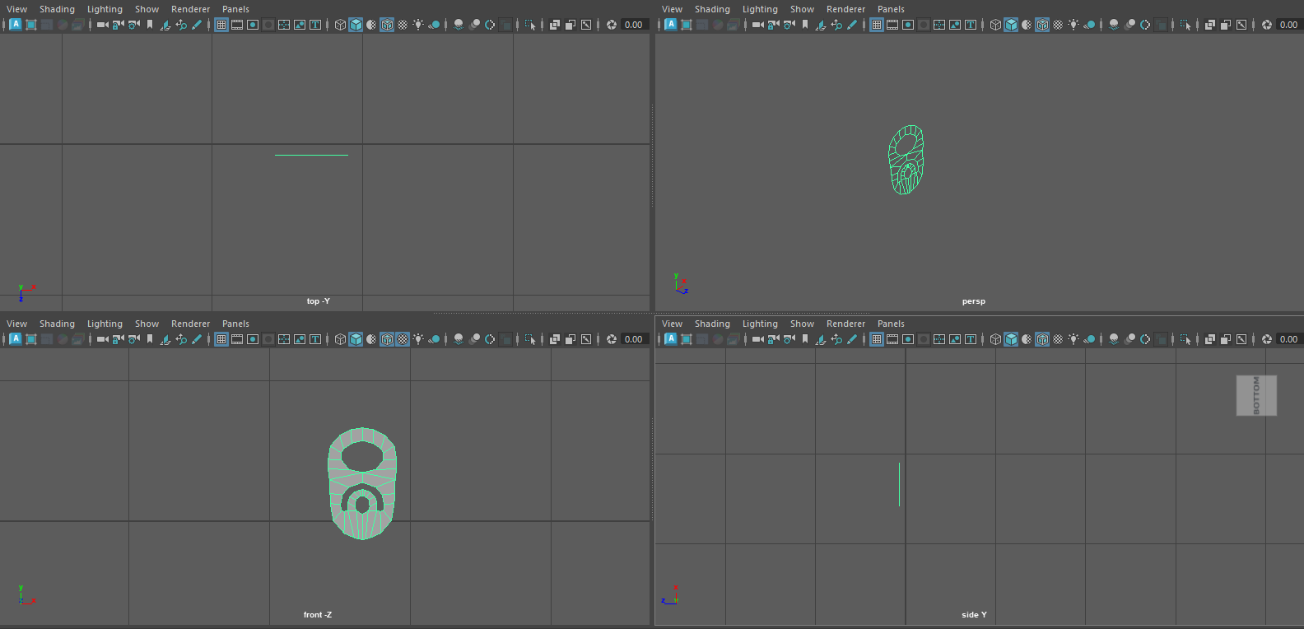
Fig. 27. Ring Pull.
I created the bottom of the can similar to how I completed the top which finished off the can.
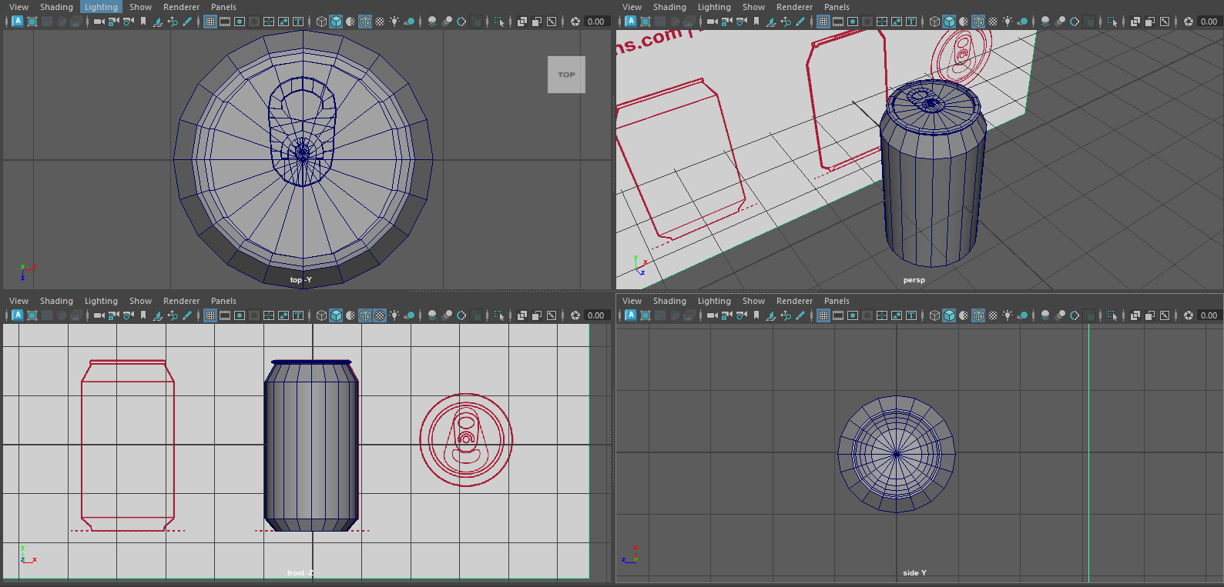
Fig. 27. Final.
I used smoothing once I had merged all separate parts to give it a nicer finish.
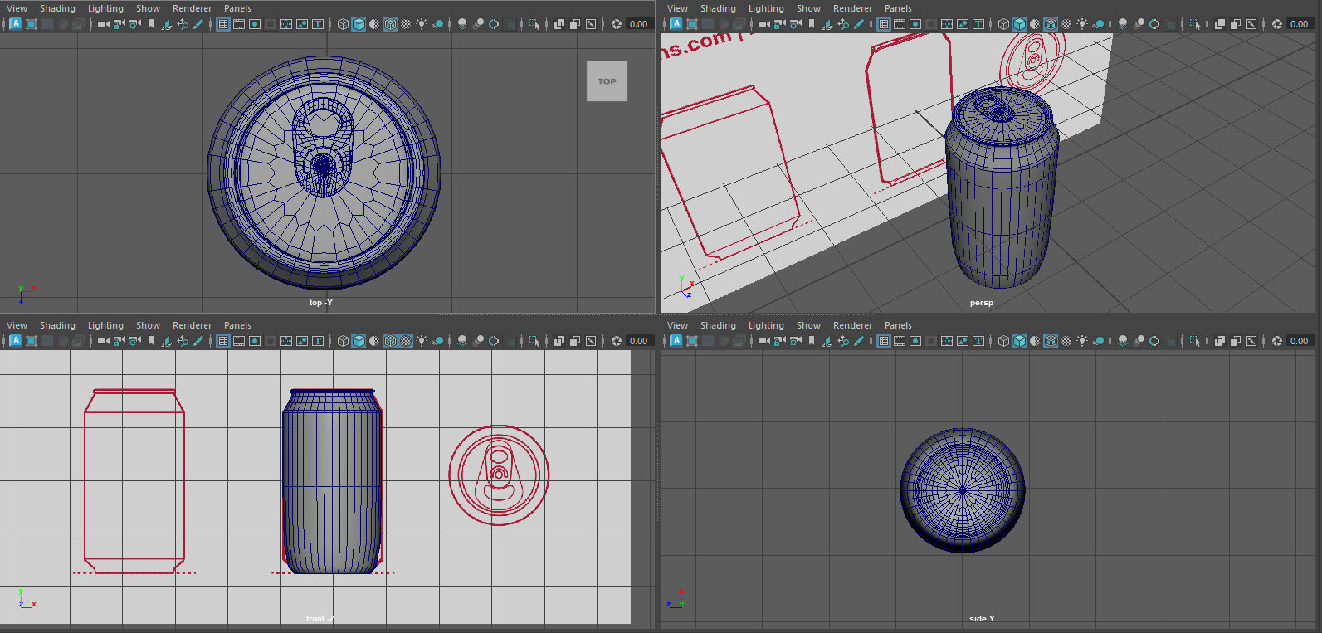
Fig. 28. Final Smoothed.

Week 5

Introduction
Next on the list of tasks was a cup and saucer again I used previous knowledge including using quad draw for the more difficult shape.

Reference
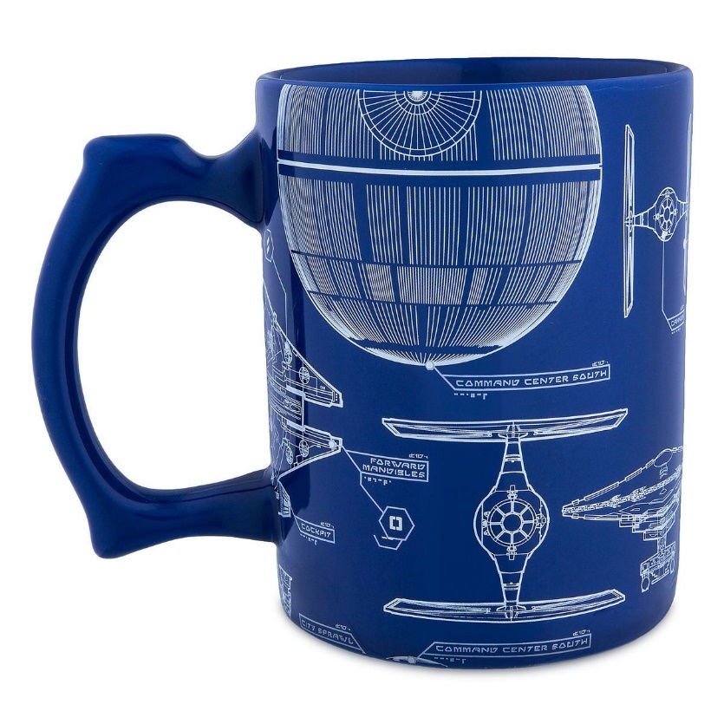
Fig. 29. Cup [12].
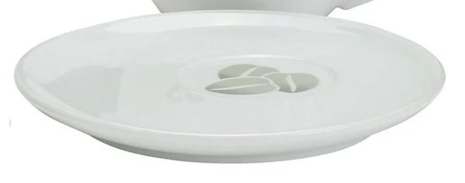
Fig. 30. Saucer [13].

Cup and Saucer
I started out with a free image plane and the mug reference image, starting with a cylinder and scaling to size before extruding in small amounts to give a curve to the top before bringing the extrude inside to create the main mug. For the under side I did similar with the rim and initially made the mistake of making the extrude go to far in, making it poke through the bottom on the inside, I had to undo and make sure I paid attention so as not to go too far.
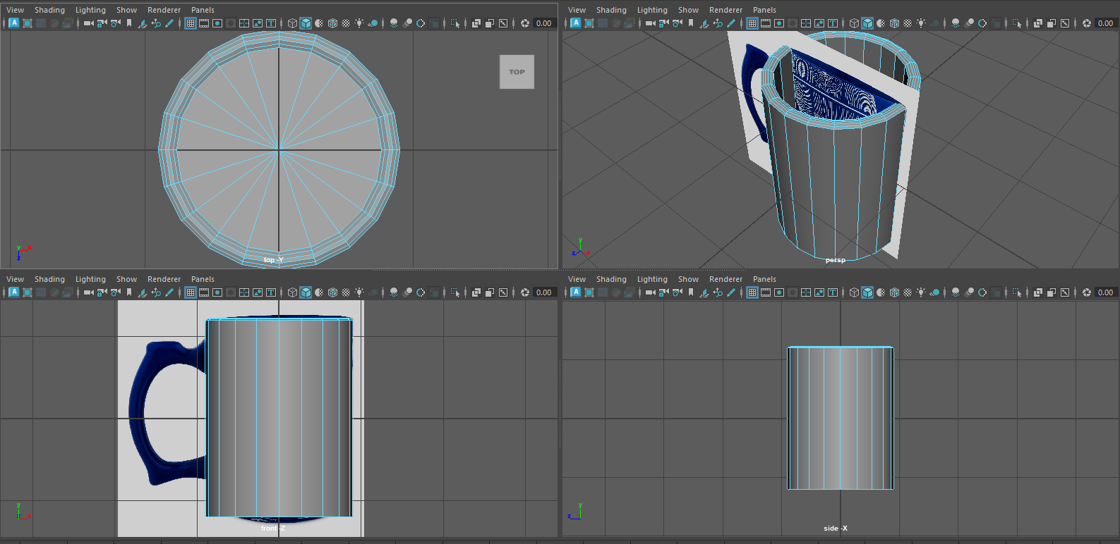
Fig. 31. Mug.
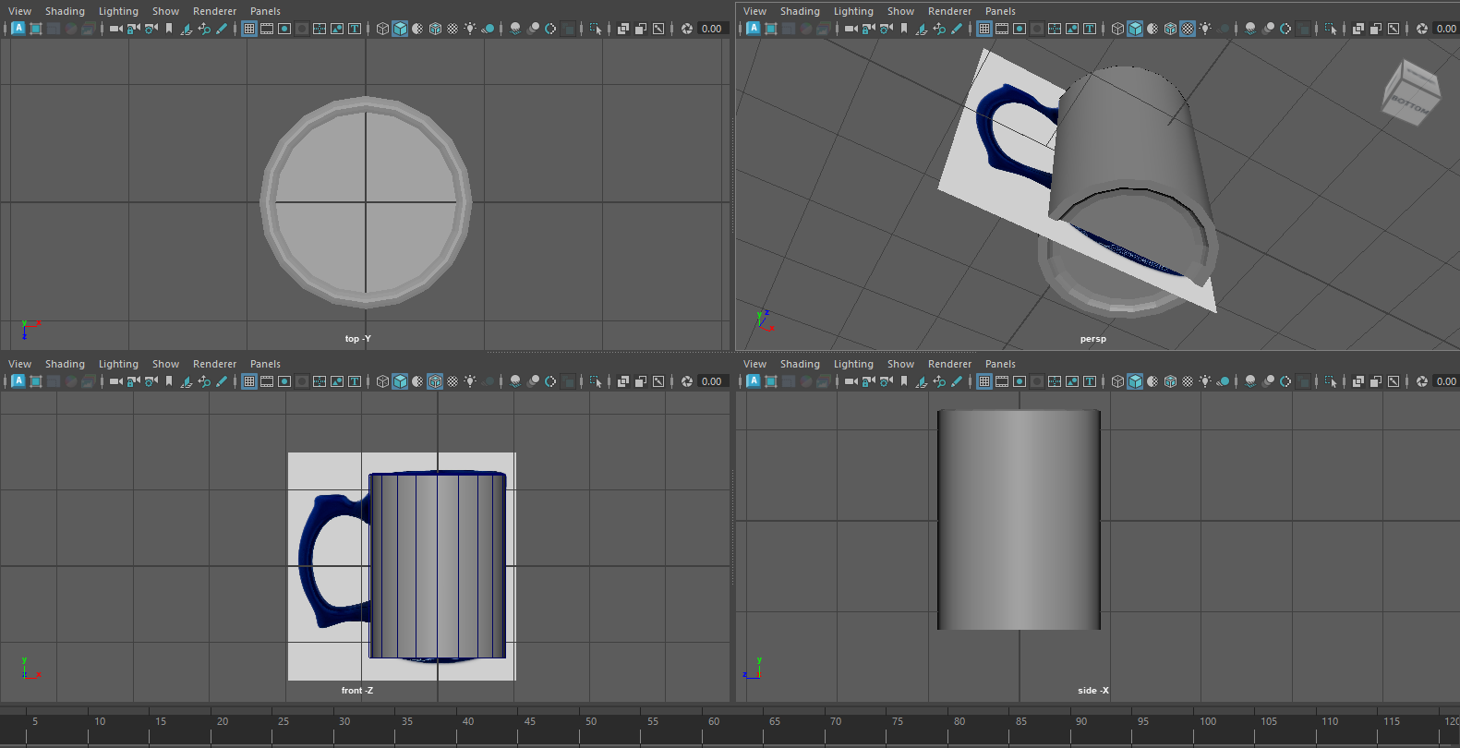
Fig. 32. Mug.
As with the ring pull I created and active image to quad draw over to create the handle which was then extruded to the correct size before being attached to the main mug, making sure as not to pass through to the inside and clearing any faces imbedded in the mug.
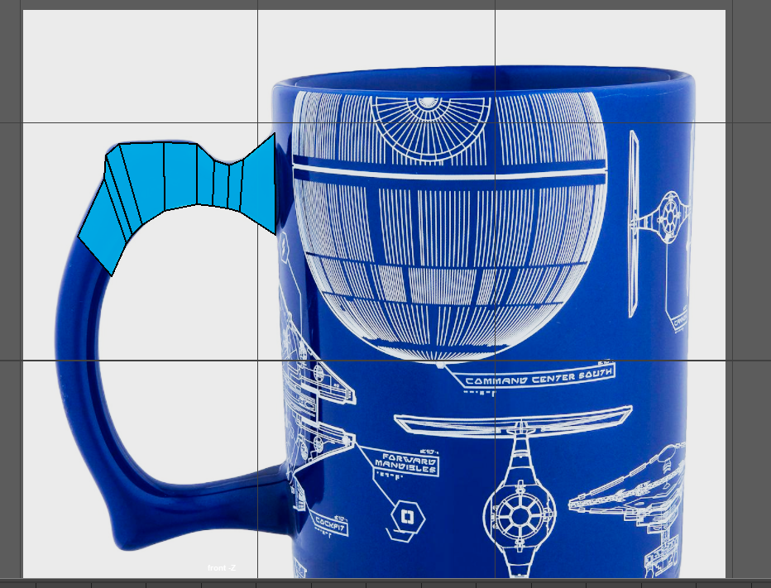
Fig. 33. Mug.
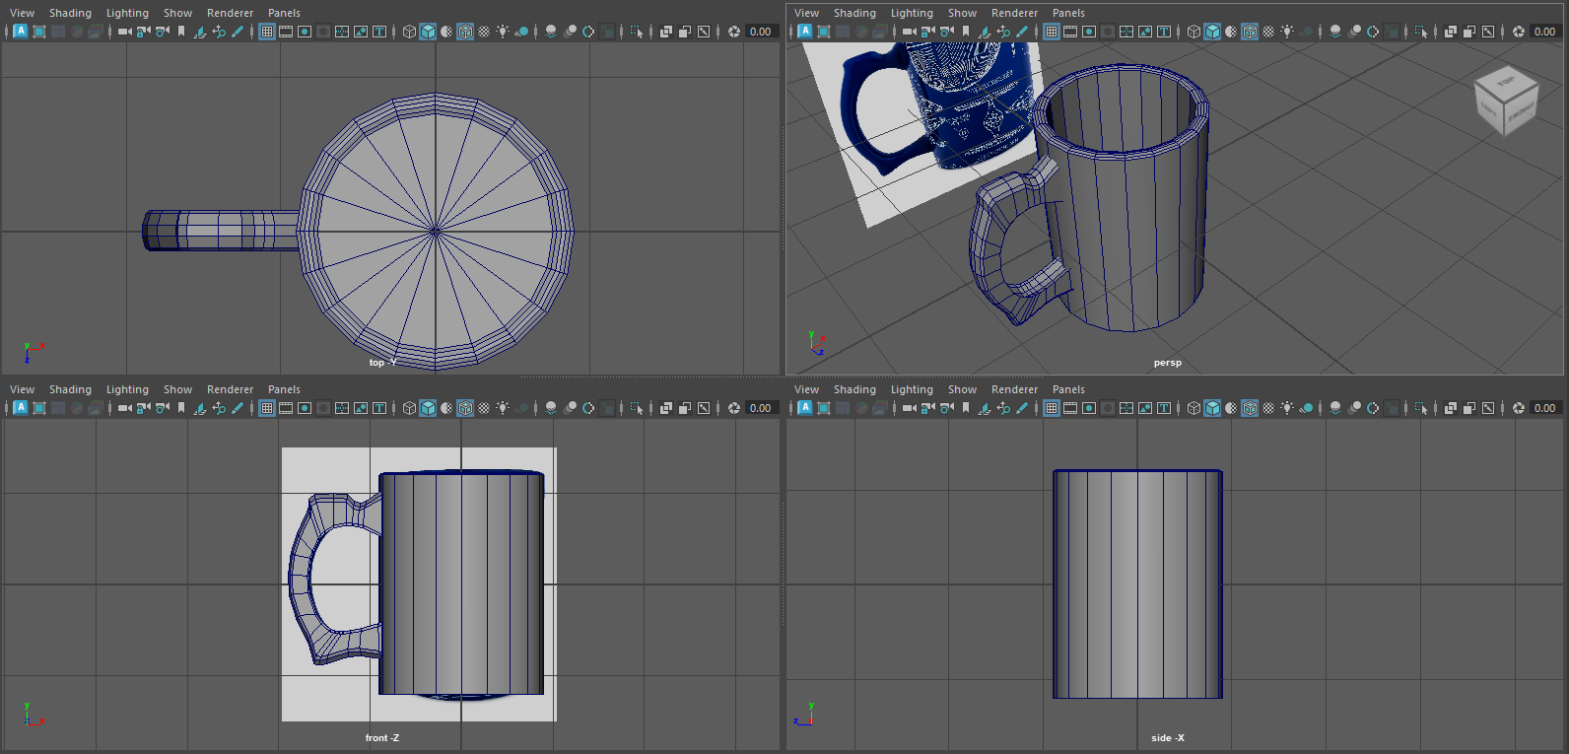
Fig. 34. Mug.
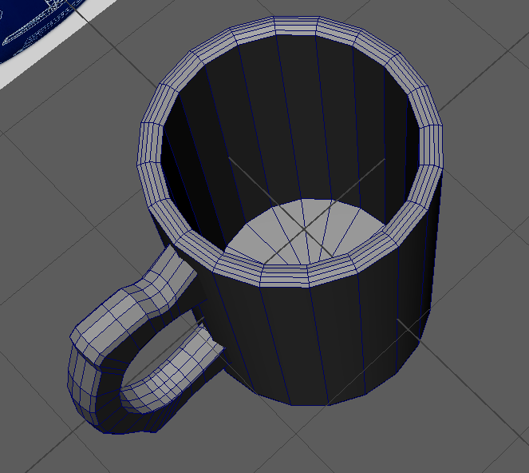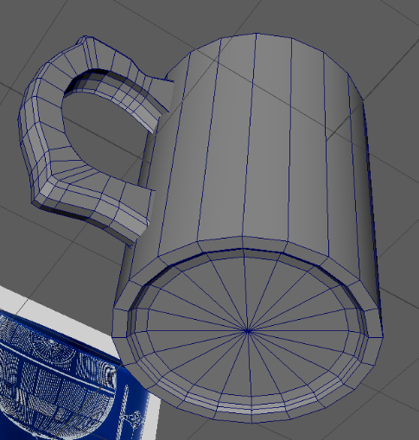
Fig. 35 & 36. Mug Final.
I moved onto the saucer which was a simple cylinder which had additional loops to the face I then adjusted these to give a smooth curve before adjusting the height of verts and faces to complete the saucer.
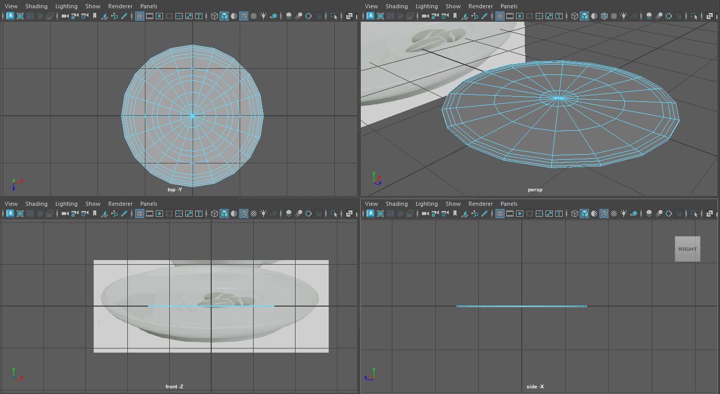
Fig. 37. Saucer.
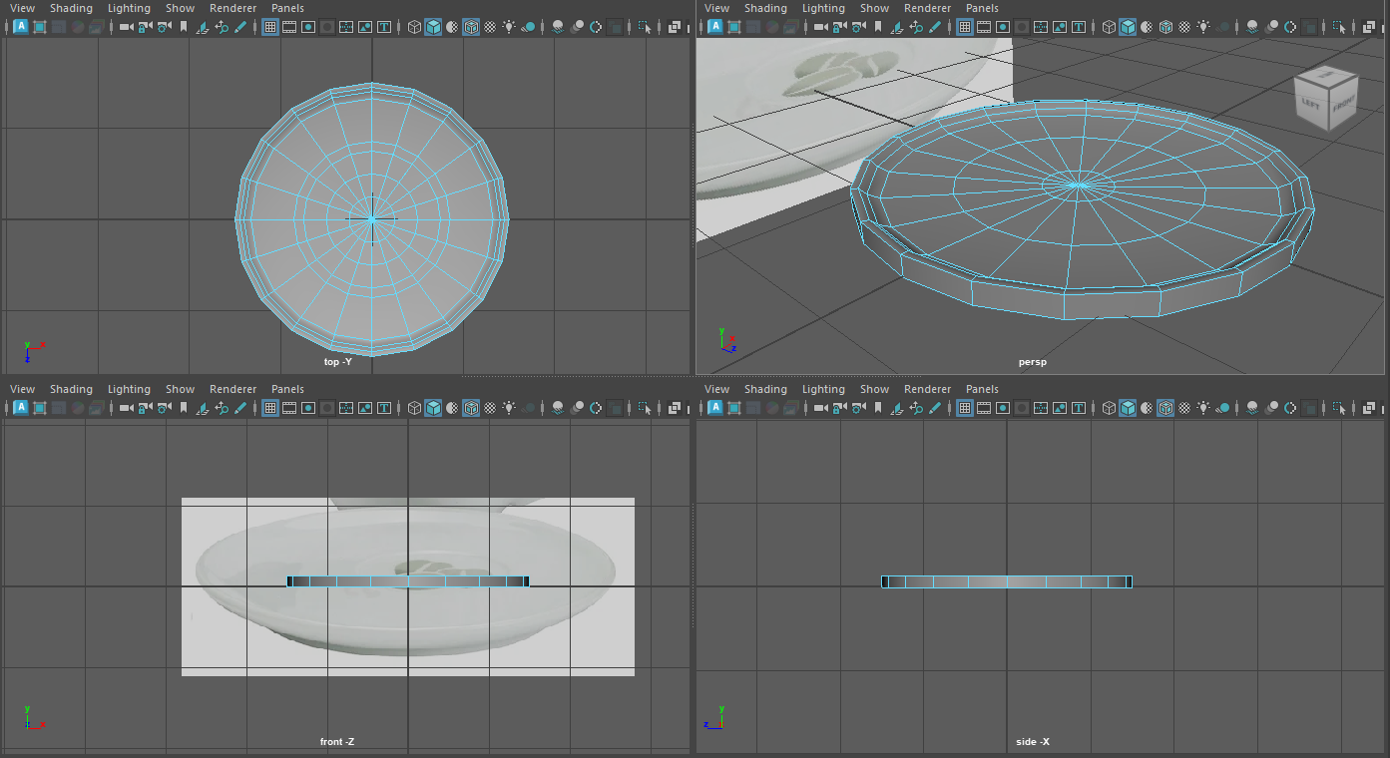
Fig. 38. Saucer.
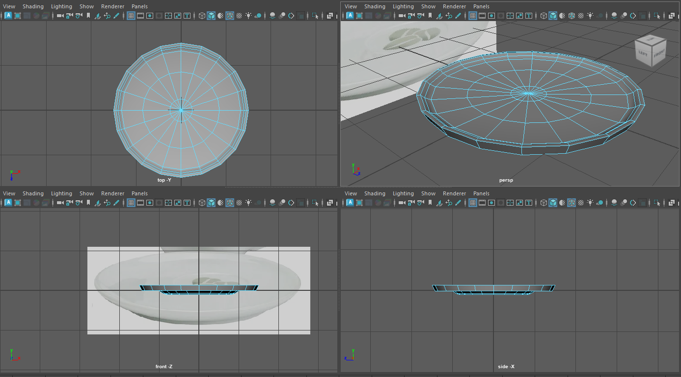
Fig. 39. Saucer.
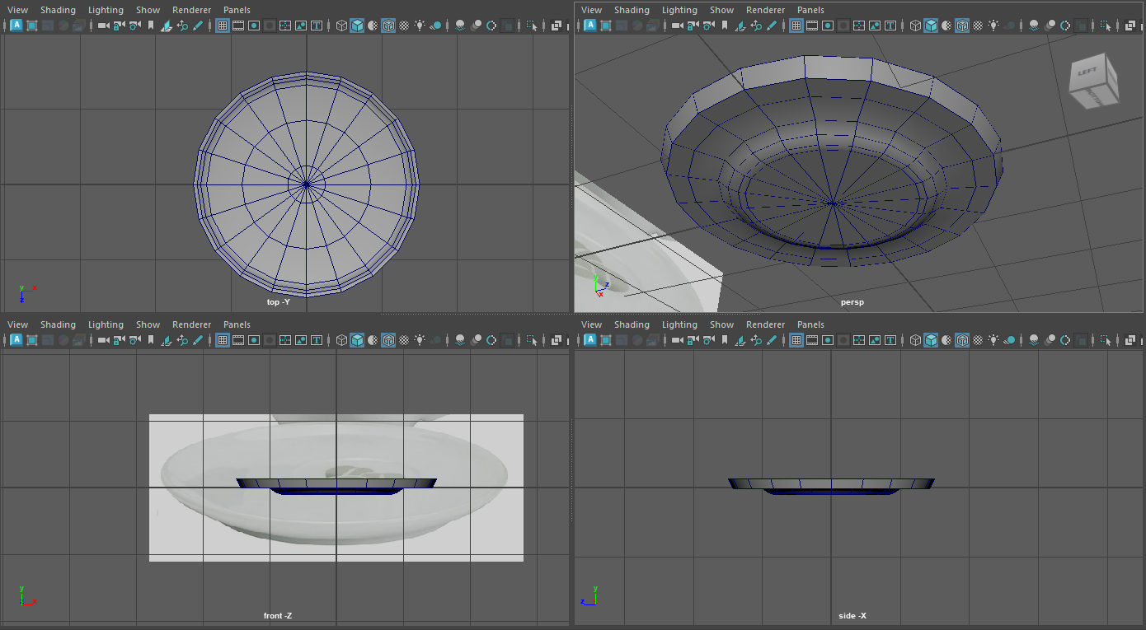
Fig. 40. Saucer.
From here I added the mug to the saucer and then smoothed both to give a cleaner appearance.
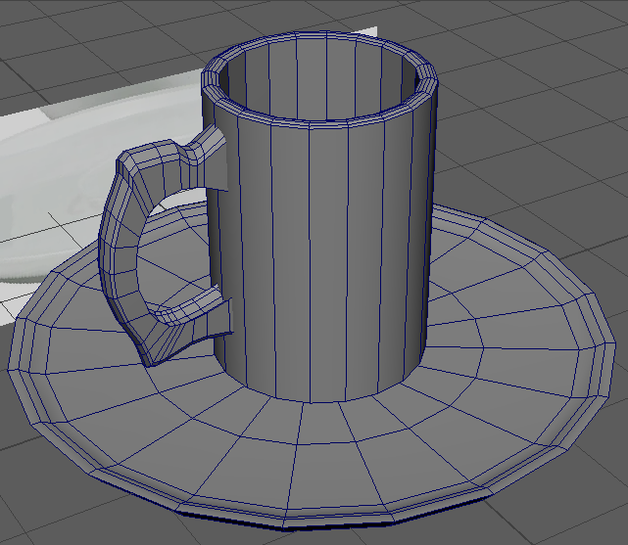
Fig. 41. Cup and Saucer Final.
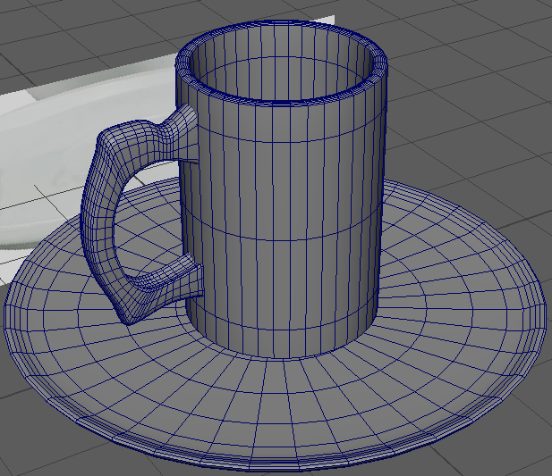
Fig. 41. Cup and Saucer Final Smoothed.

Week 6 & 7

Introduction
Next on the list of tasks was a building, I wanted to tie together everything so chose to go with a simple style factory.

Reference
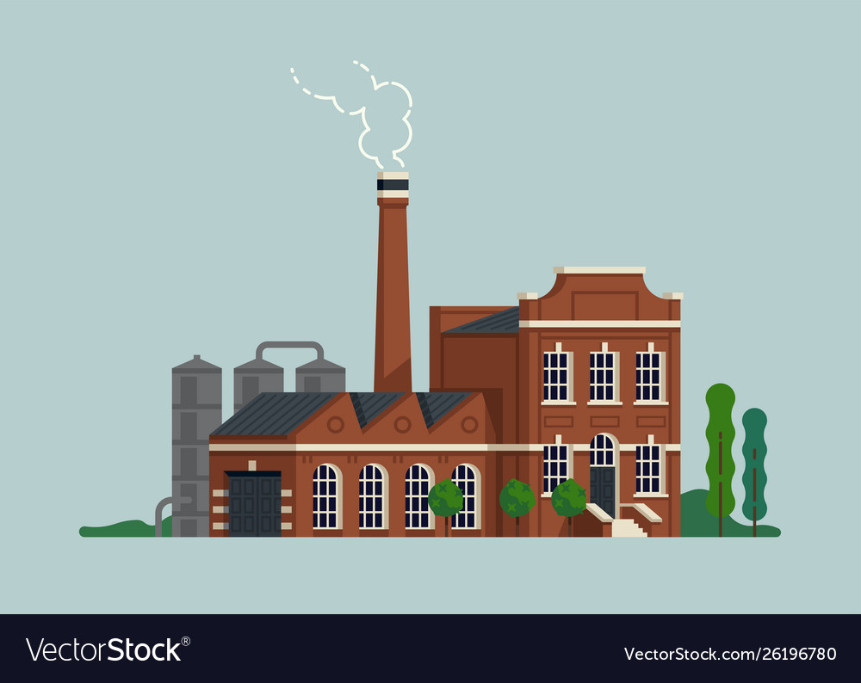
Fig. 42. Building [14].

Building
For the garage area I took a cube and added edge loops extruded some areas and adjusted verts to get the roof.
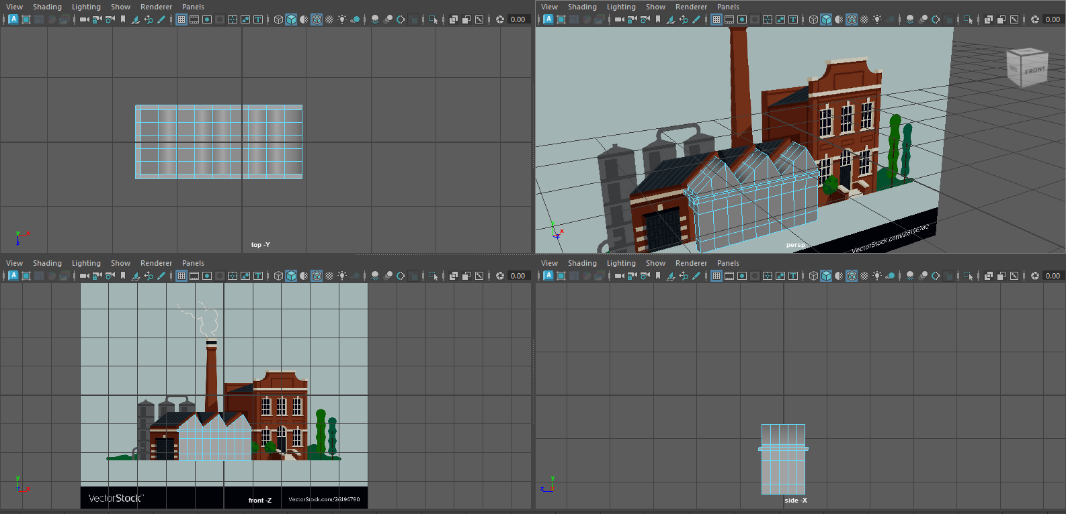
Fig. 43. Building.
I Then created the main building part added extra loops and created windows and doors with extrude.
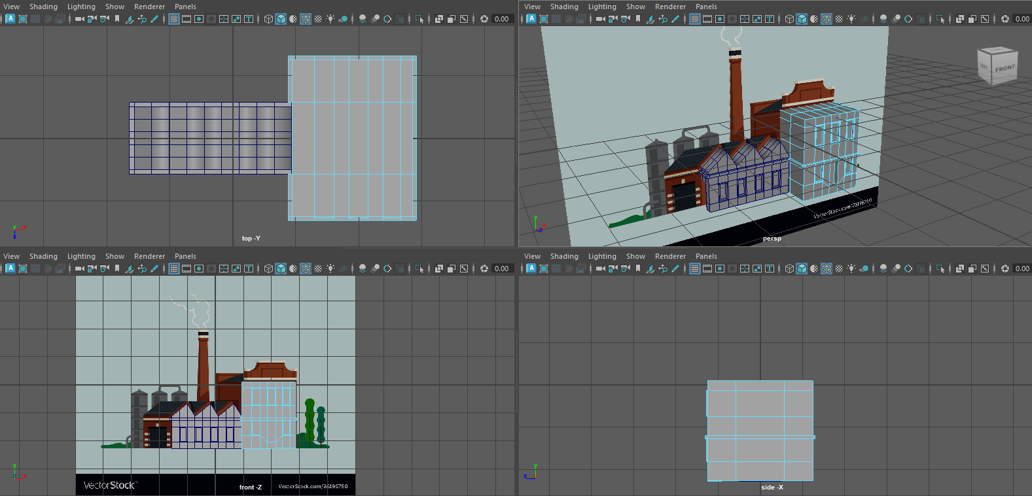
Fig. 44. Building.
I finished off the roof with a cube and moving and merging verts and extruded some stairs before starting on the chimney.]
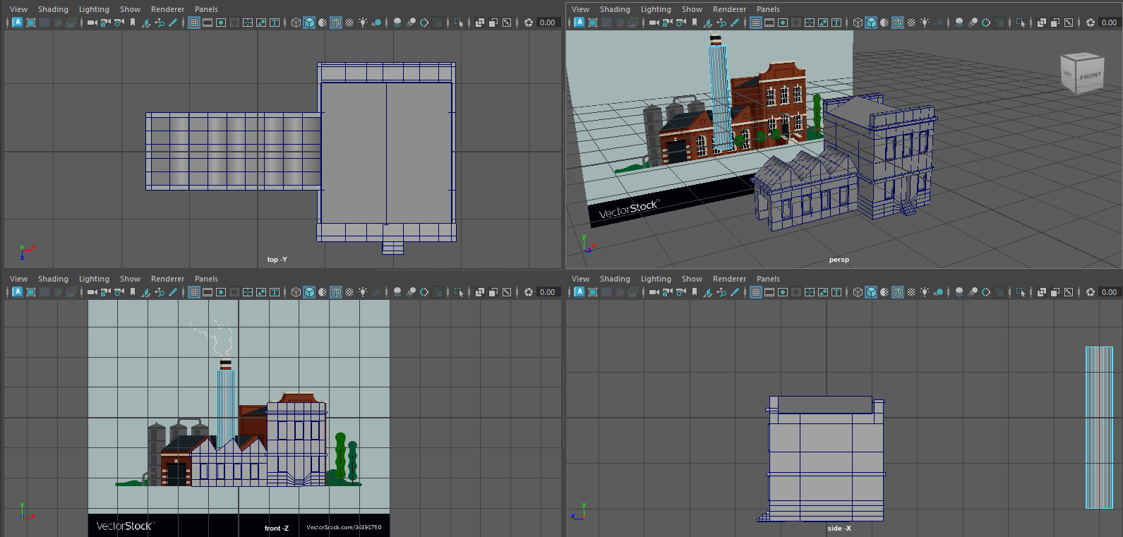
Fig. 45. Building.
I adjusted the chimney with additional loops and added a cube to sit this on making sure to clear some faces.
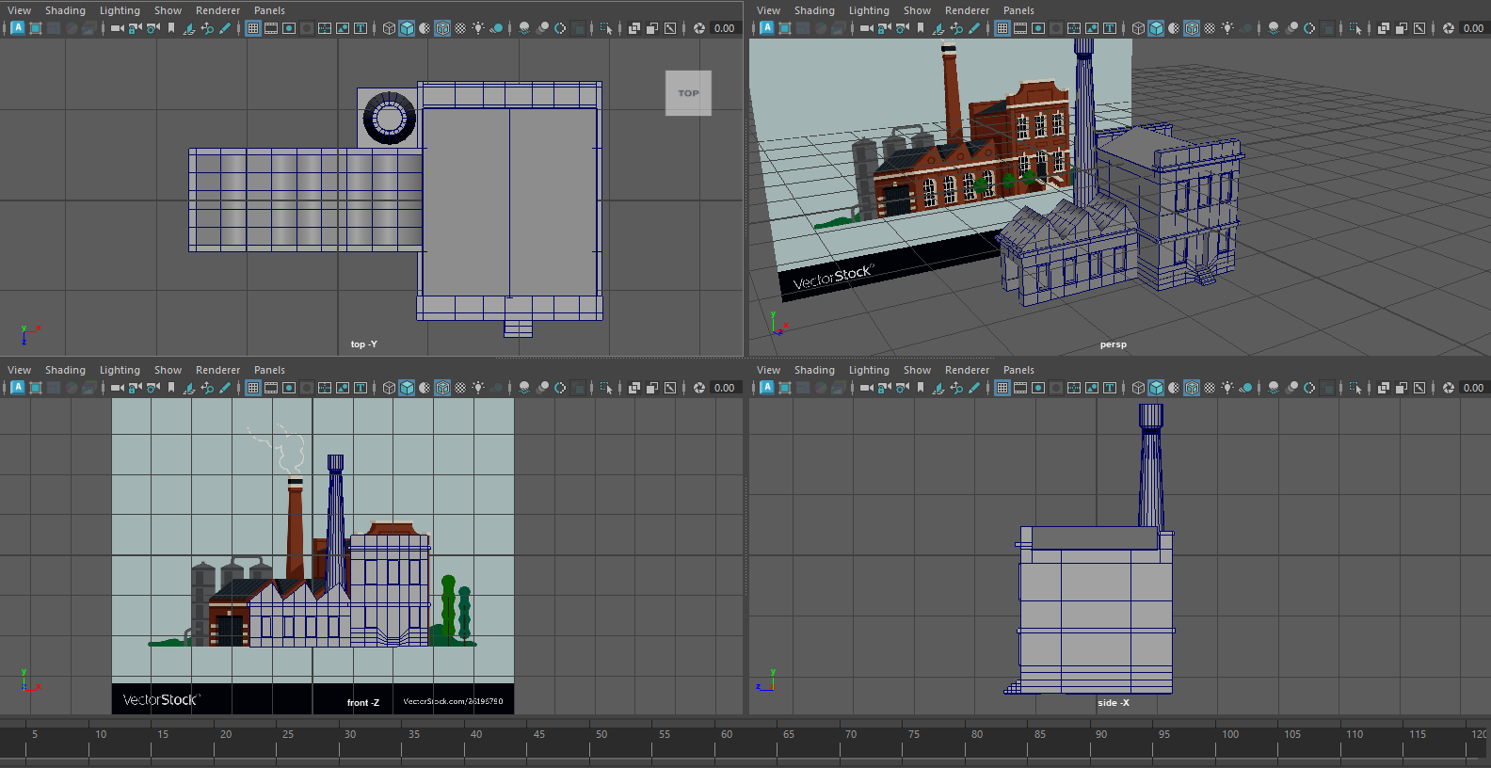
Fig. 46. Building.
I created the silos from cylinders and loops and extruded some details out and adjusting the vert at the top to give a point, I then used cylinders to create the pipework, using bridge to connect the pipes and adjusting the divisions to give a nice curve.
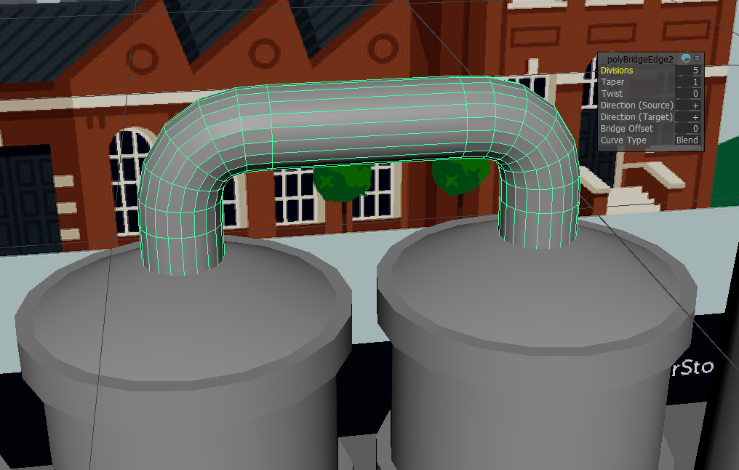
Fig. 47. Building.
For the final model I added extra loops for the cylinder areas so that I could run smooth without losing the details of some of the extrudes completed.
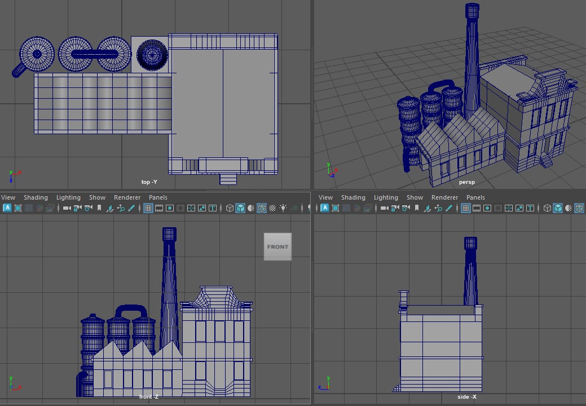
Fig. 48. Building.

Week 8 & 9

Introduction
Next on the list of tasks was a dumpster, I found a few references for a dumpster but went with the lidded version over a skip style, I used a lot of things learned into this and added in Booleans to cut some holes.

Reference
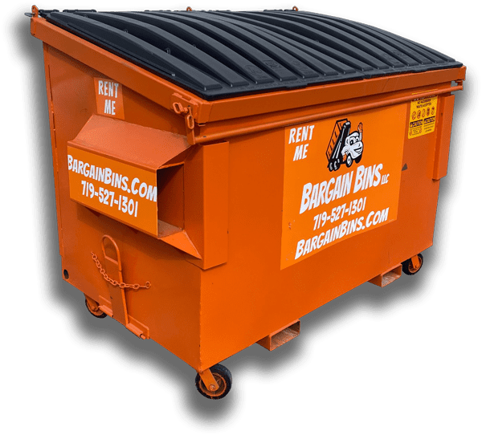
Fig. 49. Dumpster [15].

Dumpster
I started off with the main bin section using a cube and edge loops and extruded areas to get the basic shape. Following this I created the lid using a cut and edited cylinder in addition to a cube removing faces before combining the lid parts.
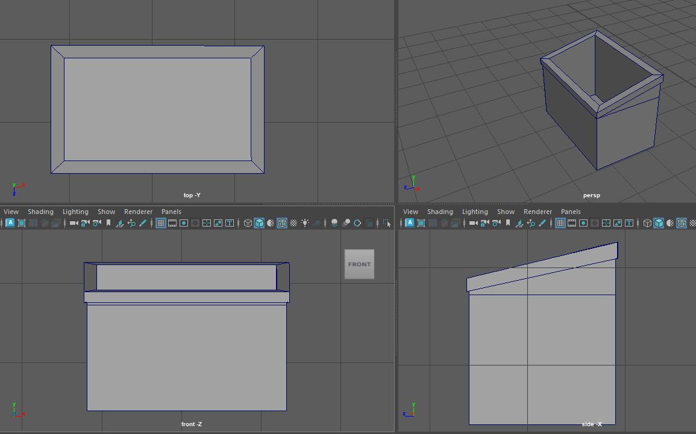
Fig. 50. Dumpster.
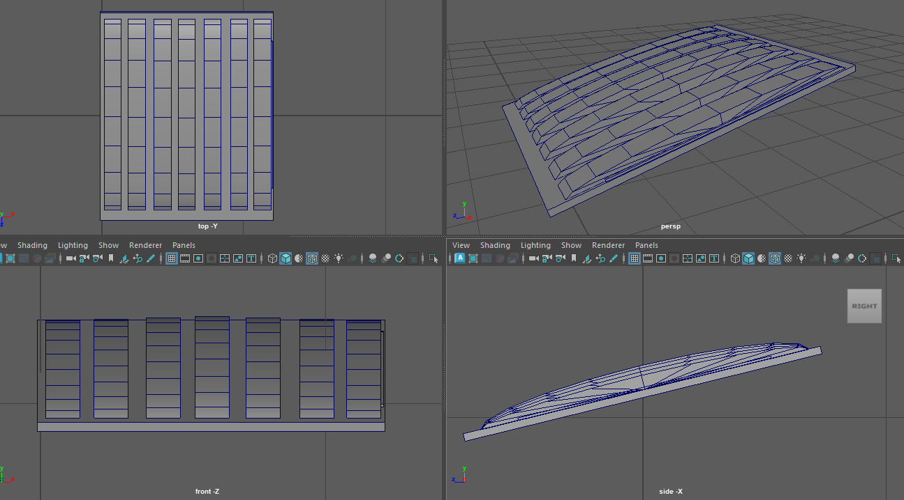
Fig. 51. Dumpster.
I then created some connections for the lid by using cubes and some cylinders where faces were removed for the connectors on the lids and hols bridged on the bin connections before adding a long cylinder to be used as the mounting point.
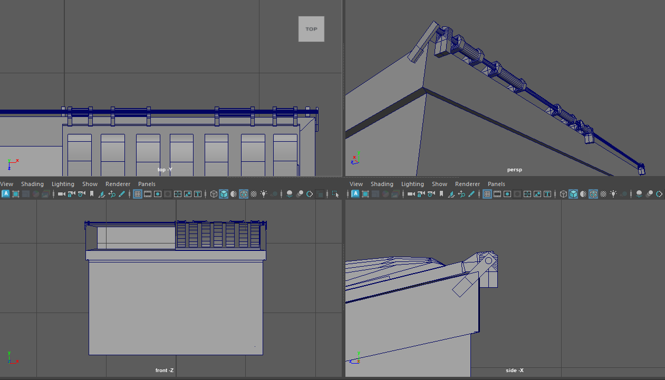
Fig. 52. Dumpster.
I Then created the fixtures for lifting the bin from cubes edited down to size and relevant faces removed for connecting to the main bin, I followed this up with wheels created from cylinders and some cubes edited again to make the connectors. Finaly, I duplicated the 1st bin lid and moved this into position and adjusted the pivot point so I could picot the bin lid open at the right point.
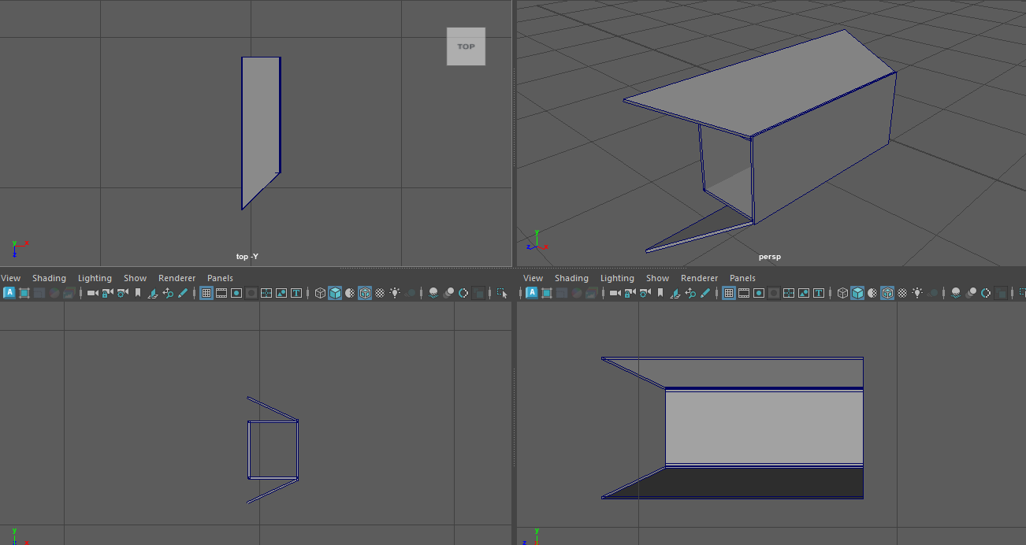
Fig. 53. Dumpster.
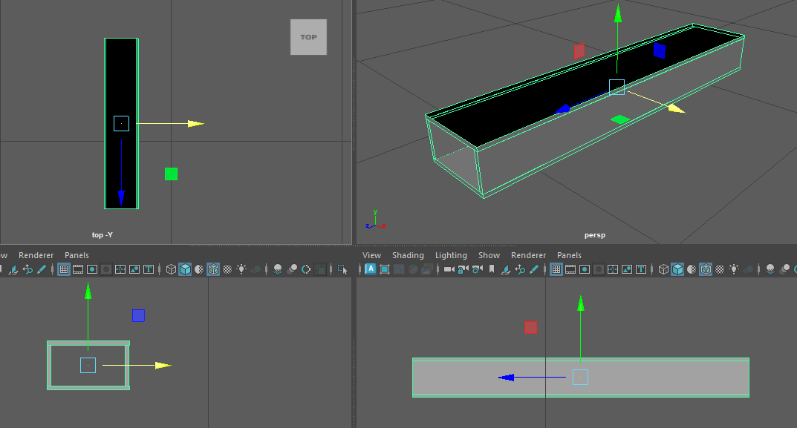
Fig. 54. Dumpster.
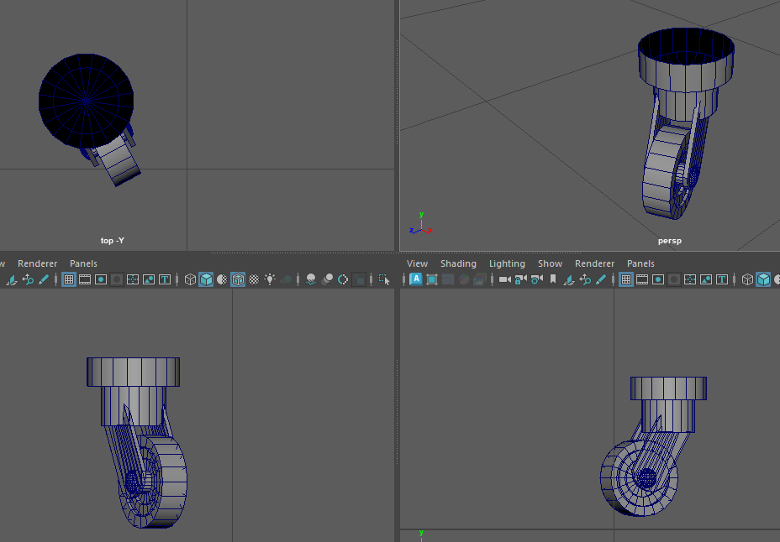
Fig. 55. Dumpster.
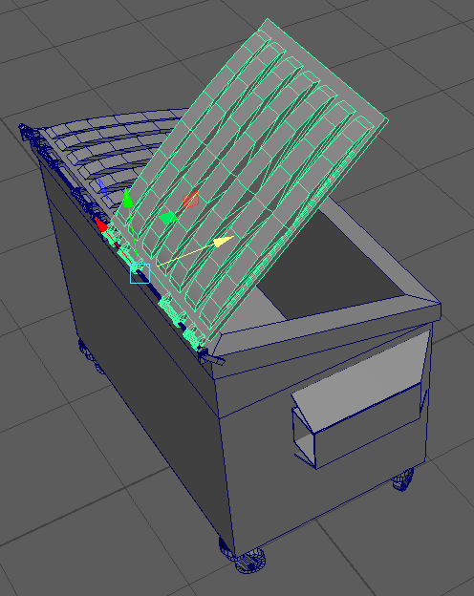
Fig. 56. Dumpster.
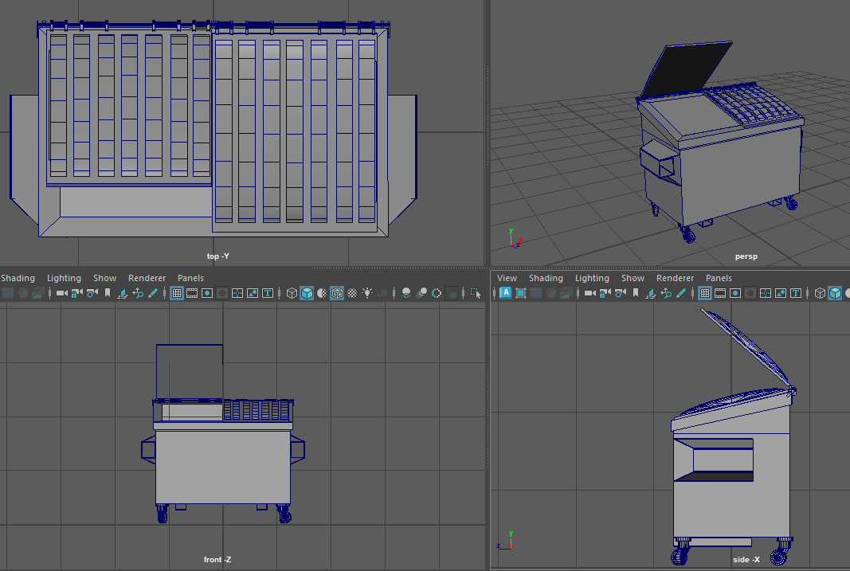
Fig. 57. Dumpster Final.

Conclusion
I have learned a lot from this module and in the use of Maya, which feels more complicated than it should be, I have made some minor mistakes as I have progressed through the different models being created and have relied on getting some advice from Adam on how to do certain things within the software and others I have picked up from tutorials and guides, some of which I know how to do in blender easily but again Maya is so different and seem to want to make things more difficult than it should, I have noticed when doing research into tutorials there are far more readily available for Blender than for Maya.
Most of my issues stemmed from the software than the actual models and I feel would have done the same in Blender as I did in Maya only quicker, but I think that overtime the muscle memory for shortcuts and finding where different tools etc are will improve.
Going forward I think I will be looking at more tutorials for Maya to try and get my head around where some options and tools are to try and improve the model making speed within Maya.
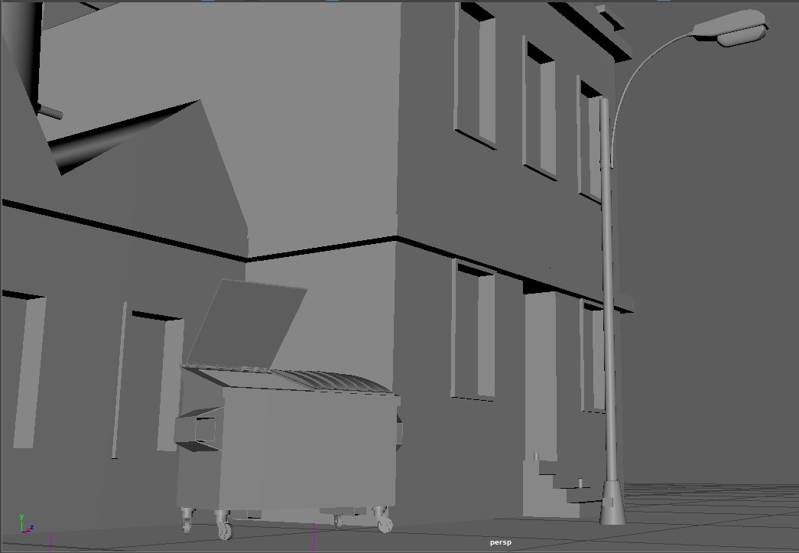
Fig. 58. Main Model Composition.

Bibliography
[1] Maya, 2024.1, [Software], San Francisco: Autodesk, 2023.
[2] Blender, 4.0.2, [Software], Amsterdam: Blender Studio, 2023.
[3] J Antonio “5-Ways to Add Edge Loops in Maya”, YouTube, Mar, 8, 2021. [Online] Available: https://www.youtube.com/watch?v=OvEsi0Biaek [Accessed Oct, 9, 2023].
[4] Btrseller, “Street light lamp post isolated vector image on vectorstock,” VectorStock, https://www.vectorstock.com/royalty-free-vector/street-light-lamp-post-isolated-vector-27674739 (accessed Oct. 9, 2023).
[5] “Garden Light futura lamp-post 95008 sat free delivery,” Lighting Deluxe, https://lighting-deluxe.co.uk/outside-lighting/1953-garden-light-futura-lamp-post.html (accessed Oct. 9, 2023).
[6] Figura “Maya Tutorial – Create a Tube from a Curve”, YouTube, Jan, 28, 2021. [Online] Available: https://www.youtube.com/watch?v=_MubcUmvIjc [Accessed Oct, 16, 2023].
[7] Amazon, “LEGO Superheroes: SPIDERMAN Minifigure (MARVEL),” Amazon.co.uk, https://www.amazon.co.uk/LEGO-Superheroes-SPIDERMAN-Minifigure-MARVEL/dp/B00B692JMG (accessed Oct. 16, 2023).
[8] SystemBricks, “Lego Horse brown lego animal minifigure horse red bridle - etsy,” EGO Horse - Brown LEGO Animal Minifigure Horse Red Bridle, https://www.etsy.com/listing/1102712049/lego-horse-brown-lego-animal-minifigure (accessed Oct. 16, 2023).
[9] Rawpixel, “Treasure chest box images: Free photos, PNG Stickers, wallpapers & backgrounds,” rawpixel, https://www.rawpixel.com/search/treasure%20chest%20box?page=1&path=_topics&sort=curated (accessed Oct. 16, 2023).
[10] K. Kerr, “How effective are Tau Weapons Against Orks?,” Quora, https://www.quora.com/How-effective-are-Tau-weapons-against-Orks (accessed Oct. 16, 2023).
[11] Dimensions, “Beverage can - 12 oz dimensions & drawings,” RSS, https://www.dimensions.com/element/beverage-can-12-oz (accessed Oct. 16, 2023).
[12] “Star wars ship blueprint mug: Shopdisney: Star wars ships, Disney Star Wars, Disney Mugs,” Pinterest, https://www.pinterest.com/pin/712624341015886814/ (accessed Oct. 16, 2023).
[13] Saheel, “Costa Coffee Cup/mug and saucer Primo 275ml with Spoon brand - etsy,” Costa Coffee Cup/Mug And Saucer Primo 275ml With Spoon Brand New, https://www.etsy.com/listing/1011466258/costa-coffee-cupmug-and-saucer-primo (accessed Oct. 16, 2023).
[14] Masha_tace, “Old factory building concept vector image on VectorStock,” VectorStock, https://www.vectorstock.com/royalty-free-vector/old-factory-building-concept-vector-26196780 (accessed Oct. 16, 2023).
[15] Bargain Bins LLC, “Colorado Springs Roll Off & Dumpster Rentals from $140,” Bargain Bins LLC, https://www.bargainbins.com/ (accessed Oct. 16, 2023).

