Project Report

Name: Morgan Jones
Student number: 1706863
Module: (ACDA5004)
Course: Electronic Engineering

Contents
Project Report 1
Name: Morgan Jones 1
Introduction 3
Ideation 3
Product idea 3
Description and illustration 7
Requirements MVP (Minimum Viable Product) and design documentation. 10
How the product is different to others on the market 11
Development 11
References 17
Appendix 18

Introduction
This report will discuss the Product idea, the Description and illustration, the Requirements, Minimum Viable Product, how the product is different to others on the market and development of the device and of technical skills.

Ideation
Product idea
The product idea is to produce a portable SSD/HDD Interactive Cloud Drive device to help the consumer public easily back up data and monitor the data while it’s backing up. This drive will be rechargeable and fully portable in the final design and will have a website to go with it. It integrates a touch screen which allows the user to interact with the drive and access the functions. So in essences it combines two data storage choices.
This device will be adaptable since it uses WIFI or Bluetooth to transmit and receive data to any device that can access a WIFI or Bluetooth connection. Devices such as mobile phones, tablets and laptops can easily connect and access the drive this will be done by changing the settings to allow Bluetooth and Wi-Fi and then sending the files manually with Bluetooth or google chrome another option is automatic upload with is code that will be designed for this purpose which will act similar to OneDrive or google drive.
The software used to do the designs was google SketchUp. “SketchUp is a used for a wide range of 3D modelling projects these range from architecture to video game design to name just a few. The program includes drawing layout functionality, surface rendering, and supports third-party plugins from the Extension Warehouse [1]”.
The reason for this idea is that it is part of a very profitable market due to the fact there is a high demand for the cloud storage and physical storage that is portable and secure. This is shown by the below research and statistics .
First, I will cover the research for the cloud storage side of the project.

CLOUD STORAGE USAGE STATISTICS WITHIN PRIVATE CUSTOMER SECTOR
A study by Statista.com shows that “2 billion worldwide users has been forecasted to store data in the cloud by 2020” [2].
This is down to convenience as you can access documents almost anywhere in the world and from any device. “In the United Kingdom (at EU level) it has noted 38% of all individuals has saved files on the cloud storage and 25% shared their files on the internet storage space, which gave UK second place among all European countries in 2014” [3].

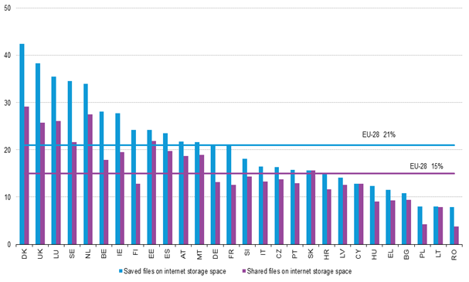
Figure 1 A table showing the Use of internet storage space for saving and sharing files [3]
CLOUD STORAGE USAGE STATISTICS WITHIN BUSINESS CUSTOMER SECTOR
In December 2018, Eurostat did another study which found that “26% of EU enterprises in 2018 used cloud for file storage. The United Kingdom was one of the top countries that did so having around 72% of all enterprises using the cloud to store files [4]”.

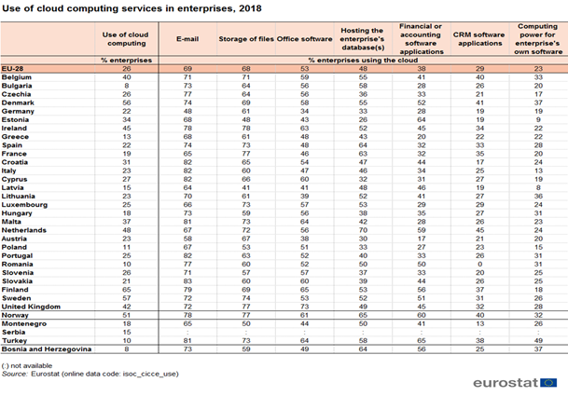
Figure 2 Use of cloud computing services in enterprises, 2018 [4]
MOST POPULAR CLOUD STORAGE SERVICE PROVIDERS
The graph shown below in figure 3 shows “the cloud storage service providers available on the market and their popular according to CloudRail API Integration Solution” [5].
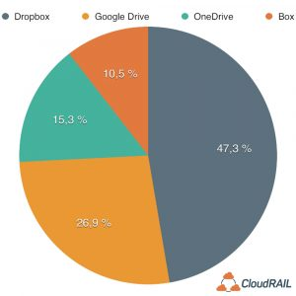
Figure 3 Total Number of Users [5]

Now I will cover the research for the physical device
Market growth
“The solid-state drive (SSD) market was valued at USD 34.86 billion in 2019 and it is expected to reach USD 80.34 billion by 2025. This is down to technological advancements with SSD devices [6]”.
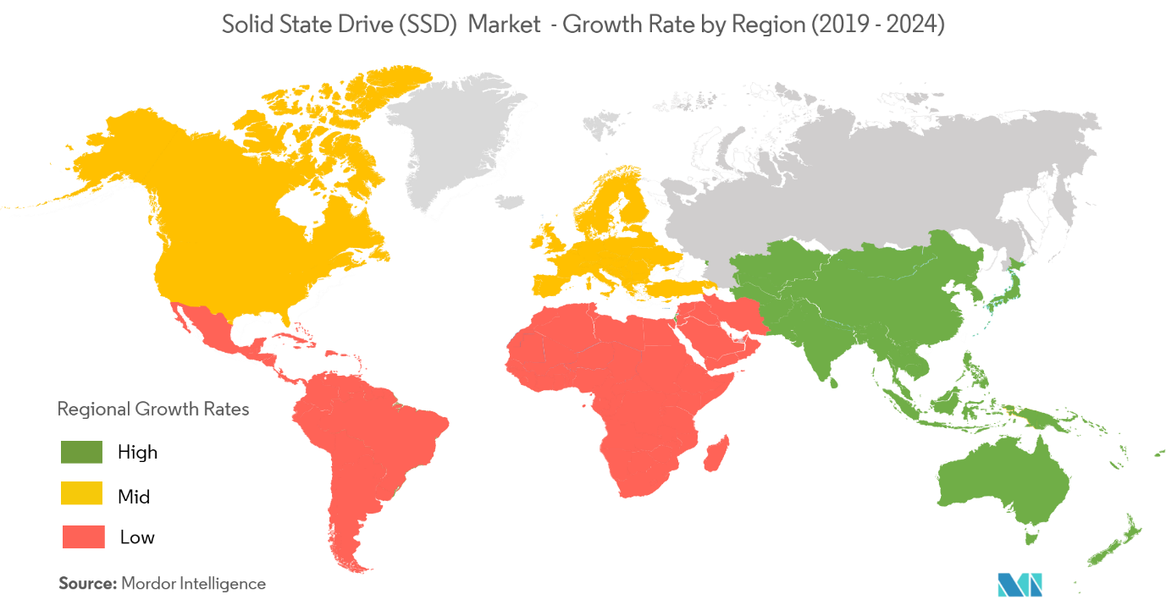
Figure 4 SSD market growth [6]

Device security
External storage drives are also very secure this is “because they can have a password or pin that will allow access to the data stored within and custom data encryption there are also many other security features available (for more information use reference link ) [7]”.

Description and illustration
Description and illustration of the new proposed product
The device will be made from a Raspberry pi, case touch screen.
The reason that a Raspberry pi was used in the device was down to the fact that “it is a low cost, easy to use and a chip sized computer that can be plugged into a number of different screens and can use standard keyboard and mouse or touch screen. It is a device that can be used for personal and business by people of all ages” [8].

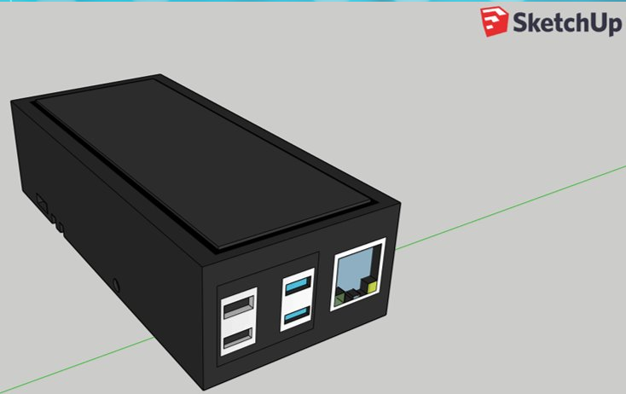
Figure 5 Original external design of Device
The image shown in figure 1 is similar to what the current prototype looks like.
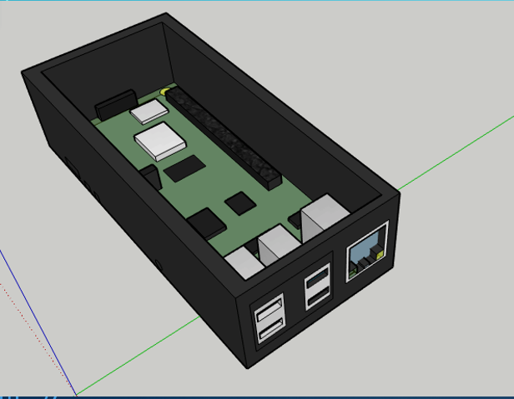
Figure 6 A design used for the prototype showing ports
The image of figure 2 shows the USB 3.0, USB 2.0 and ethernet ports
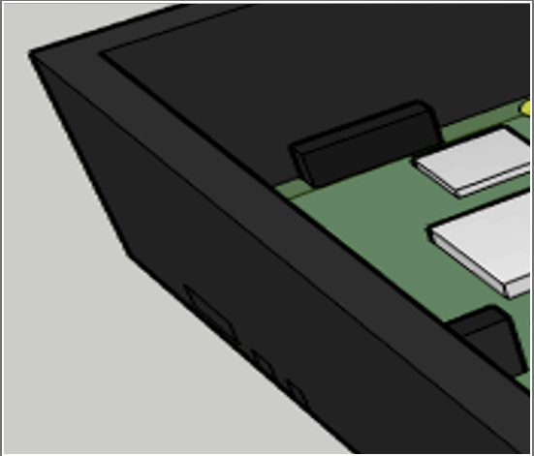
Figure 7 Zoomed in section of figure 2
The image figure 3 show the USB C-type ports zoomed in
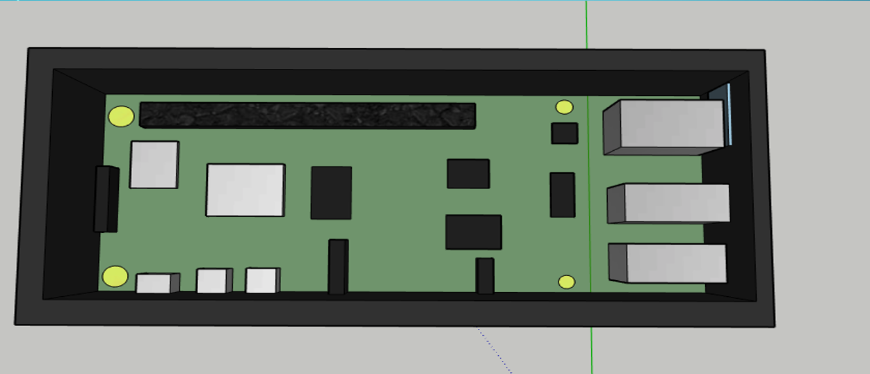
Figure 8 the design of the above view of the inside of the device
The image shown in figure 4 shows The silver section on the walls are the ports for example ethernet, USB 3.0/2.0 and USB C-type. The black sections are used for extra components and the yellow circles are the screws used to keep the raspberry pi in place.

Requirements MVP (Minimum Viable Product) and design documentation.
This section will cover the requirements or MVP and documentation of the creation of the product from basic designs to final product.
The minimum Raspberry pi specs are:
“
CPU – Broadcom BCM2711, Quad core Cortex-A72 (ARM v8) 64-bit SoC @ 1.5GHz
RAM – 1GB, 2GB or 4GB LPDDR4-2400 SDRAM (depending on model)
WiFi – 2.4GHz and 5.0GHz IEEE 802.11 ac wireless, Bluetooth 5.0, BLE
Ethernet – Gigabit
USB – 2 USB 3.0 ports; 2 USB 2.0 ports
GPIO header – Raspberry Pi standard 40 pin
HDMI – 2 X micro-HDMI ports (up to 4kp60 supported)
Display port – 2 lane MIPI DSI
Camera port – 2 lane MIPI CSI
Audio – 4-pole stereo audio and composite video port
Storage – Micro-SD card slot for loading operating system and data storage
Misc – H.265 (4kp60 decode), H264 (1080p60 decode, 1080p30 encode), OpenGL ES 3.0 graphics
OS – Debain Linux 10 based”
[9]
The minimum case and touch specs are:
“
Connectivity technology – HDMI
Display resolution Max – 320*480
Display size – 3.5 inches
Item dimensions – 8 x 5 x 3 cm
Item weight – 100 grams
Max vertical resolution – 480 pixels
Resolution –SD VGA 480p
Power consumption – 0.16A*5V”
[10] [11]

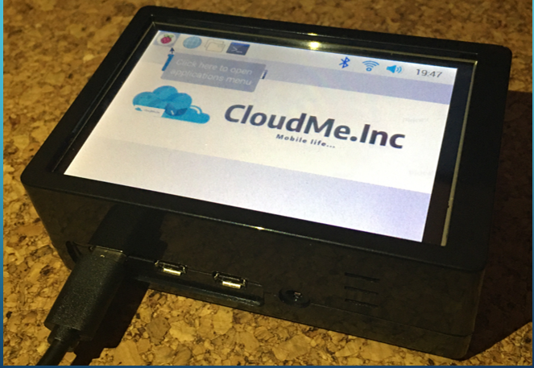
Figure 9 prototype device
How the product is different to others on the market
The product is a combination of two separate meaning there aren’t many competitors. The competitors the product does have are different or have limitations which affect the device capabilities.
One of the competitors is the “Seagate Duet which is compatible with only Amazon Cloud Storage and is free only for 12 months and has a 1 TB hard drive, no Wi-Fi connection, is not wireless and has no internal battery [12]”.
Whereas the CloudMe.inc product has a view/touch screen and can be connected to any cloud storage and is always free unless you need to increase cloud storage capacity it has a variety of hard drive capacities depending on model, can connect to Wi-Fi making it wireless and has an internal battery but this depends on the model.

Another competitor is the “SSK Portable NAS Wireless Hard Drive this device is a wireless personal Cloud storage that contains a 1TB hard drive, it’s portable, equipped with a internal battery but a USB charger is not included and it connects to SSKCloud not to public cloud storage service provider like in Google Drive [13]”.
The SSK is similar to the product but there is view/touch screen, different storage capacities for the hard drive and cloud storage, connects to multiple online storage providers, a Usb charger included,

Development
Document the development of a Prototype. Clearly outline key features. Include screenshots / images, text to describe the implementation process.
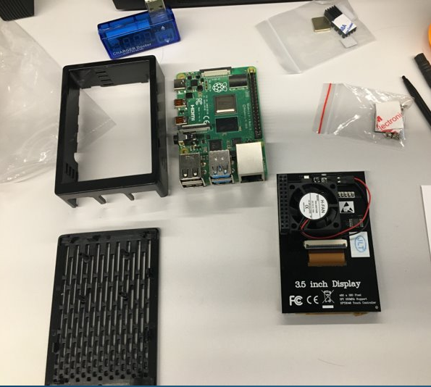
Figure 10 device components before being put together
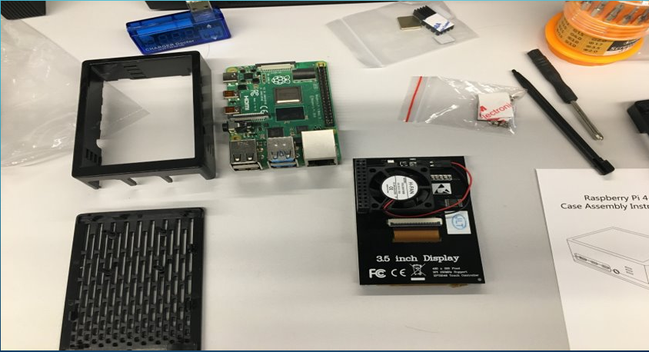
Figure 11 device components before being put together
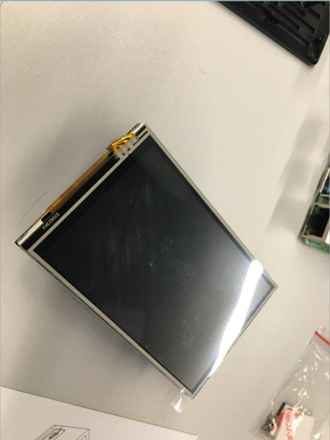
Figure 12 device touchscreen
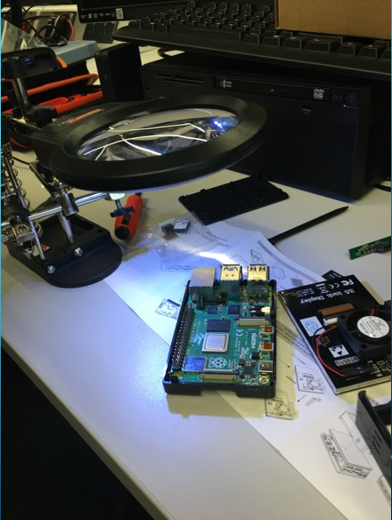
Figure 13 Raspberry pi screwed in to lower section of case
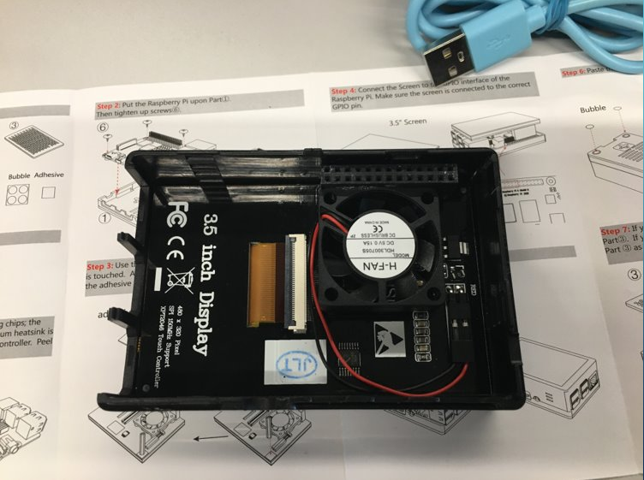
Figure 14 Touchscreen secured to top section of case
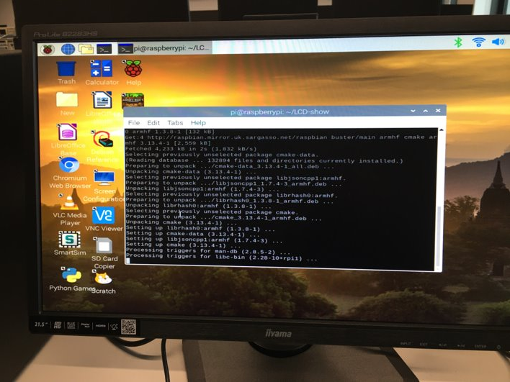
Figure 15 device programming and setup

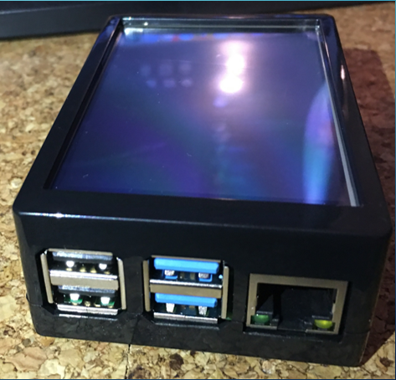
Figure 16 front view of finished prototype device
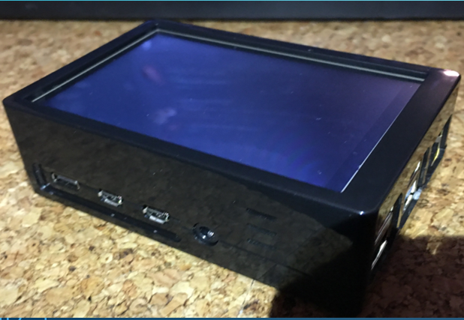
Figure 17 side view of prototype device
Figure 18 high view of prototype device with personalised screen image

In the creation of this device I learned to carefully and combine and connect components and setup a basic user interface for the device.
The features of this device include multiple external ports like Usb type c, Usb 3.0 and 2.0 and a ethernet port. It also has the capability to connect to Wi-Fi and Bluetooth making it possible to upload and share file. You also have the ability to view files stored on the device via a touch screen this screen also helps access google and other application
The specification chosen for the device prototype as shown in the above requirements section was chosen due to time and cost constraints the sizes was also specifically chosen for the device as it had to be portable and light not large and bulky.

References

[1] | B. Gavin, “What is Sketchup (and How Do I Use It)?,” howtogeek, 4 September 2018. [Online]. Available: https://www.howtogeek.com/364232/what-is-sketchup/. [Accessed 11 March 2020].
[2] | A. Holst, “Data Storage - Statistics & Facts,” 19 June 2018. [Online]. Available: https://www.statista.com/topics/3150/data-storage/. [Accessed 20 February 2020].
[3] | “Internet and cloud services - statistics on the use by individuals,” eurostat, [Online]. Available: https://ec.europa.eu/eurostat/statistics-explained/index.php?title=Archive:Internet_and_cloud_services_-_statistics_on_the_use_by_individuals.. [Accessed 20 February 2020].
[4] | “Cloud computing - statistics on the use by enterprises,” eurostat, 2018. [Online]. Available: https://ec.europa.eu/eurostat/statistics-explained/index.php/Cloud_computing_-_statistics_on_the_use_by_enterprises#Types_of_cloud_computing:_public_and_private_cloud. [Accessed 11 March 2020].
[5] | “Cloud Storage Report 2017,” 23 march 2017. [Online]. Available: https://blog.cloudrail.com/cloud-storage-report-2017/. [Accessed 20 Febuary 2020].
[6] | “Solid State Drive (SSD) Market - Growth, Trends, and Forecast (2020 - 2025),” mordorintelligence, [Online]. Available: https://www.mordorintelligence.com/industry-reports/solid-state-drive-market. [Accessed 20 march 2020].
[7] | “best secure drives,” techradar, [Online]. Available: https://www.techradar.com/uk/news/best-secure-drives. [Accessed 1 march 2020].
[8] | “What is a Raspberry Pi?,” Raspberry Pi, [Online]. Available: https://www.raspberrypi.org/help/what-%20is-a-raspberry-pi/. [Accessed 17 February 2020].
[9] | 17 January 2020. [Online]. Available: https://www.raspberrypi.org/.
[10] | 17 January 2020. [Online]. Available: https://www.robotshop.com/uk/35i-tft-lcd-320x480-touch-display-raspberry-pi.html.
[11] | “Raspberry Pi 4 Touch Screen with Case,” Amazon, [Online]. Available: https://www.amazon.co.uk/Raspberry-Touchscreen-320x480-Monitor-Display/dp/B07WSVS1Q1/ref=sr_1_3?crid=2J34BA1YJKVWT&keywords=raspberry+pi+4+case+with+screen&qid=1583934334&sprefix=raspberry+pi+4+case+wit%2Caps%2C141&sr=8-3. [Accessed 17 January 2020].
[12] | “seagatedue,” seagate, [Online]. Available: https://www.seagate.com/gb/en/support/external-hard-drives/portable-hard-drives/seagateduet/. [Accessed 20 march 2020].
[13] | “SSK Portable NAS Wireless Hard Drive 1TB Personal Cloud Smart Storage, External Hard Disk with Personal Wi-Fi Hotspot, Support Auto-Backup, Phone/Tablet PC/Laptop Wireless Remote Access,” SSK, [Online]. Available: https://www.amazon.co.uk/SSK-Portable-Wireless-Personal-Auto-Backup/dp/B07TV2B561/ref=asc_df_B07TV2B561/?tag=googshopuk-21&linkCode=df0&hvadid=372895728902&hvpos=1o2&hvnetw=g&hvrand=9333587447885839440&hvpone=&hvptwo=&hvqmt=&hvdev=c&hvdvcmdl=&hvlocint=&hv. [Accessed 5 march 2020].

Appendix
Reflection: Document how you have developed your Technical and Employability skills.
- Communication – this was developed by using the software discord this is used by the group to talk to each other, send data files and give announcements
- Teamworking – this was developed during the design and creation of the prototype
- Organisation and planning – this was developed by choosing what tasks need to be done, what each group member does and how for long each task could be completed
- Research method – this was done by doing what device would work in the current sales market, competitor research, components research
- Problem solving and Adaptability – this was developed by creating a variety of devices and finding which on was possible and would work best in the given timescale

  - Networking: Review attendance at a relevant industry networking event.
19/02/2020 -Ideas Farm Old Havana 2pm - 4pm

Figure 19 Location of Talk

Figure 20 evidence of talk

Figure 21 Myself and matt Howells at ideas farm
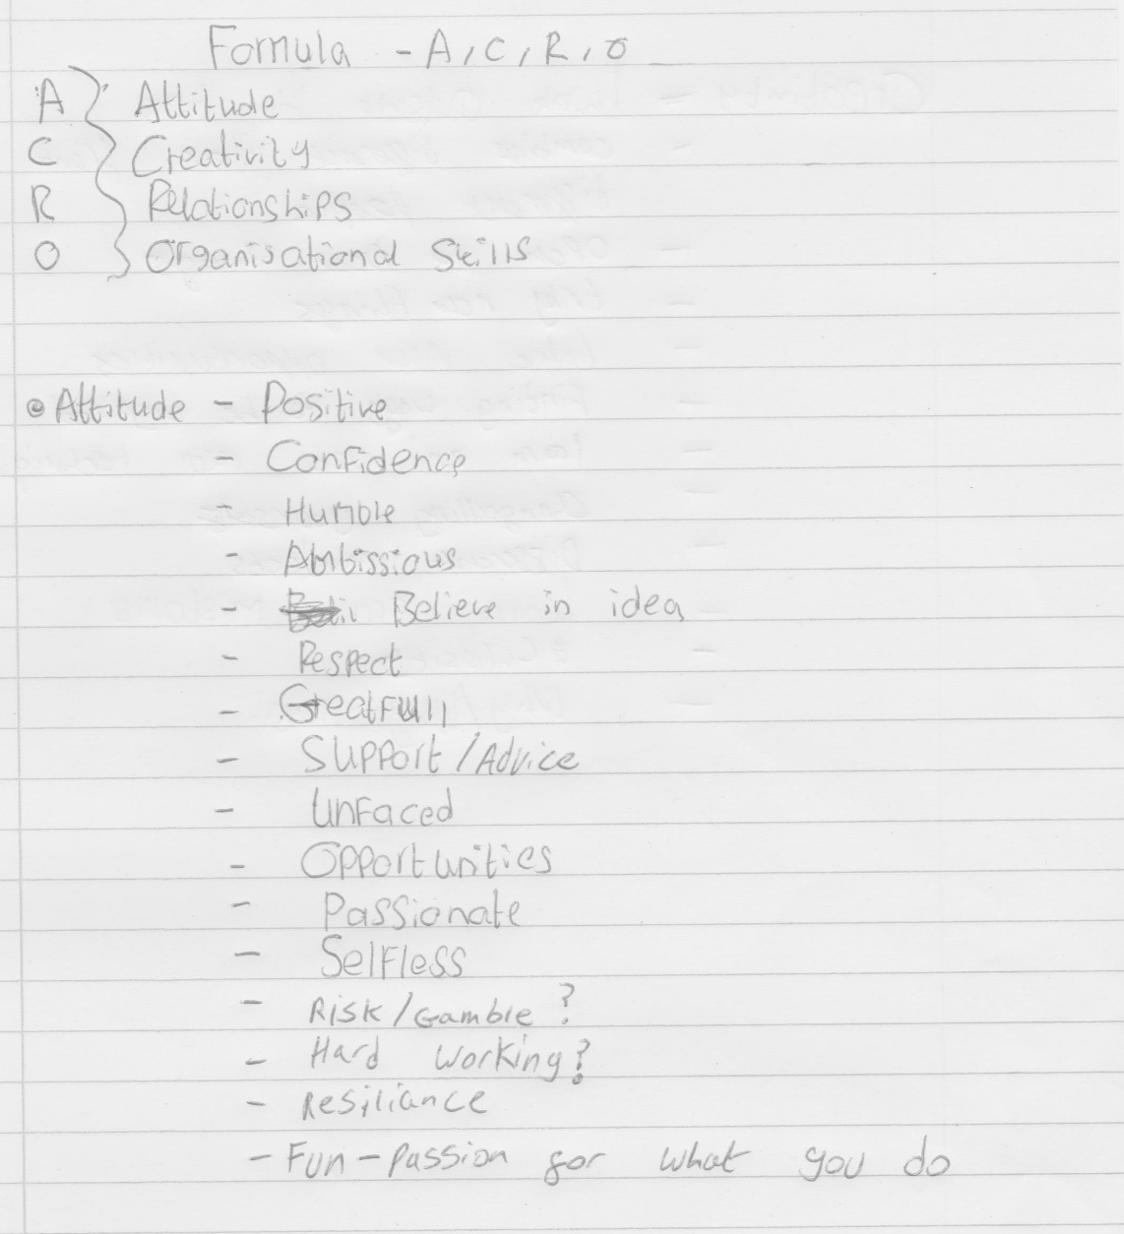
Figure 22 Ideas Farm

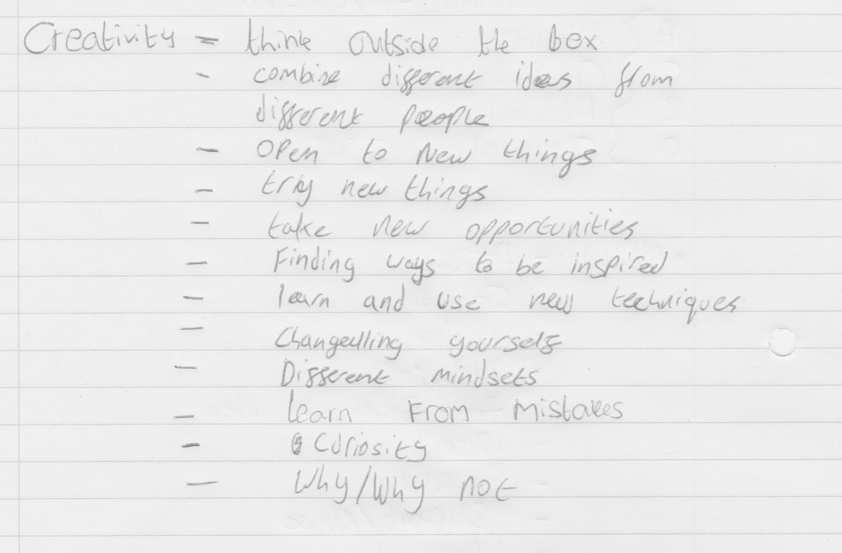
Figure 23 Ideas farm

  - Team-working
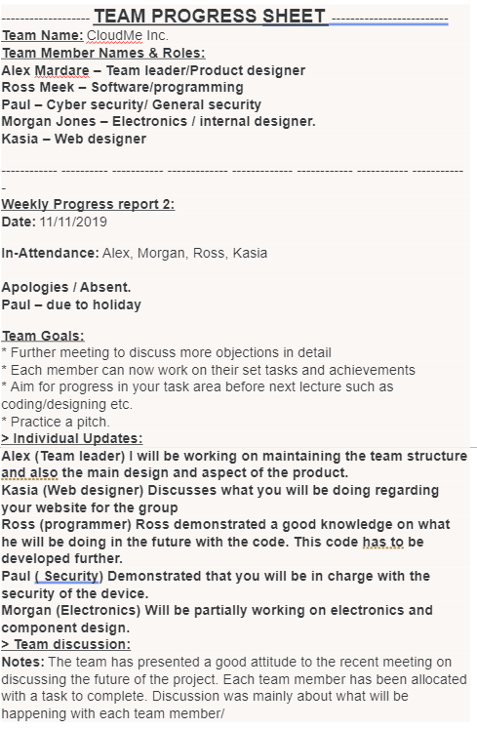

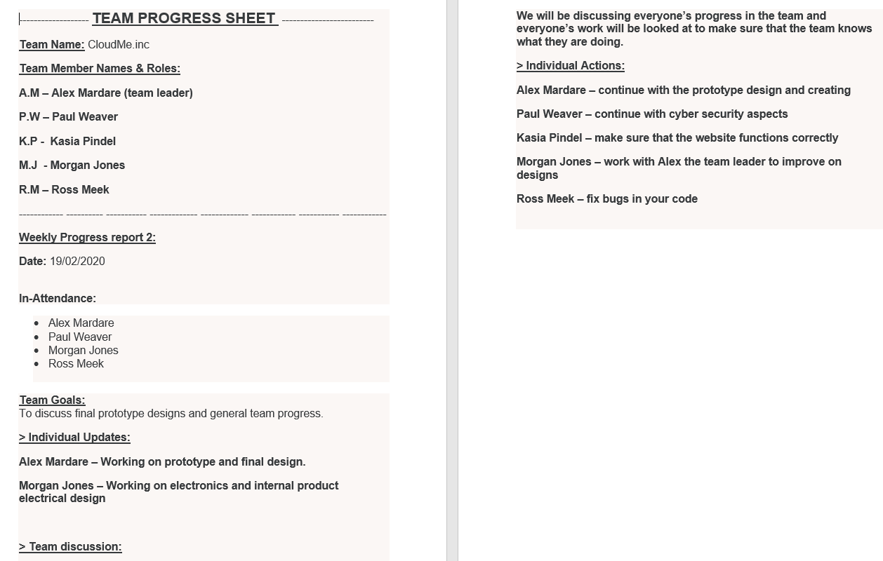
Figure 24 PROGRESS SHEET FROM 19/02/2020
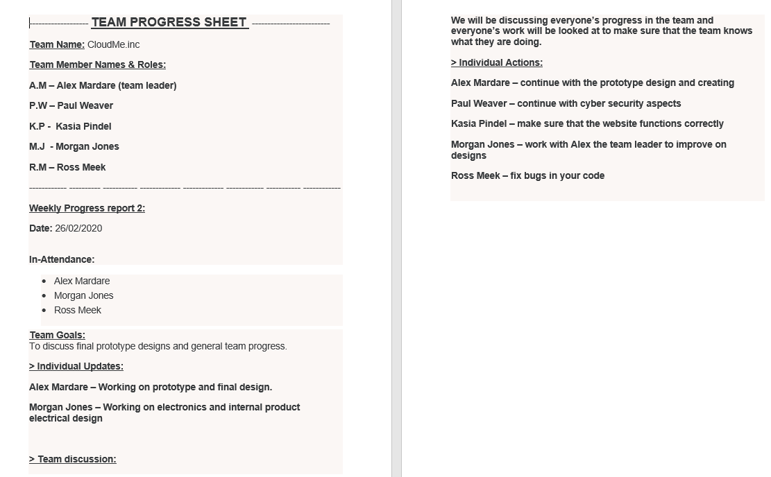
Figure 25 PROGRESS SHEET FROM 26/02/2020
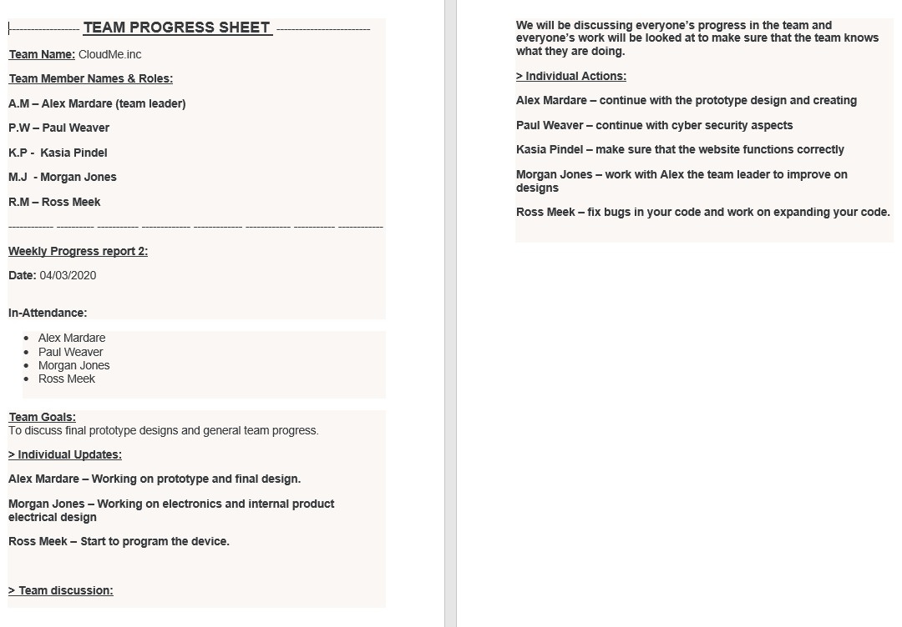
Figure 26 progress sheet from 04/03/2020

