The enchantment of the terrified in the Combat Agate Seal of Pylos
This enchantment of technology will explore the spiritual depths that linger under our objective world, as illustrated by the Combat Agate Seal of Pylos, such as the will to power, and the need to psychologically damage opponents.
An object is an artwork if it has the power to fascinate, through its physical complex properties, or through the powerful images, and tinging of the senses that evoke in one's mind and body, when it is viewed. Art fascinates, compels, and entraps [captivates], as well as delight spectators. (Gell enchantment of technology 1992). For an enchantment to happen ‘the art had to attract the beholder, to stop him in front of itself, and to hold him there in a perfect trance of involvement.’ (Fried 1980: 103 – La Place du Spectateur). Artwork is enchanting if it does something merely than narrate a story or event, (Alpers, 1976: 27). It creates a spell that removes consciousness. (Campbell, 2005).
Artistic agency on display in the seal is enchanting, it’s the artists version of the instructions communicated to him by a patron, which is displayed in the craftmanship. The image, and the prototype, for the image, whether that be the depiction of important men, or the sword found in the Griffin warriors tomb, produces extraordinary effects which we as spectators, and the artist as agent, do not relate to a normal sense of ‘self’ and our place in the world. (Stocker; Davis, The Combat Agate from the Grave of the Griffin Warrior at Pylos, 2017). Instead, the agency is our histories blended with fiction, to symbolise our souls' passions, such as conquest, romantic endeavour or heroic quests against evil. (Layton, 2005). It is captivating the spectators into a language of magical causation (Gell 71) or linking the seal to an extraordinary idea of magical, or ancient tradition, not within our knowledge of reality, but encapsulated in the ancient world and our versions of myth or fiction. (Blakolmer, Image and Architecture: Reflections of Mural Iconography in Seal Images and Other Art Forms of Minoan Crete, 2012).
The Combat Agate Seal (‘hereinafter seal’), acts as a vessel of artistic agency which enchants spectators. It has been suggested, the images are based on myths of Achilles, and he is slaying his enemy in the seal, or its King Nestor. (Curry, 2019). Humans create myths to express our unconscious enchantments, through feelings eliciting gratification. Carl Jung and Campbell believe that science fiction myths are a way for us to illustrate our fasciation towards technological advancement, technological brilliance, and ultimate power. (Jung; Campbell, The Myth of the Hero’s Journey, 2016). The seal demonstrating combat illustrates our innate biological need for power.
The enchantment happens when a patron or spectator cannot understand how a piece of artwork has been made. (Gell, The Technology of Enchantment and the Enchantment of Technology, 1992, edited by Hirsch 2020). It is submitted that all artwork is enchanting, because the artist cannot predict exactly how the art/drawings/carvings will turn-out. This idea of the unknown effect and the exotic materials adds to the artifacts alluring affects. (Okoshi, Discussion of Introspection, extrospection and synaesthesia in ergology from the point of view of a painter: focused on “drawing without an image of drawing”, 2007). We are ‘hypnotized by the [artists] technique”, and the artistic craftmanship is an incarnation of our knowledge and values. (Ferre, Philosophy of Technology, 1998; New Jersey: Prentice Hall, pg 135-41). Another enchantment happens when, the technical excellence exceeds our logical thinking, and makes the seal fall within the magical province of prodigies. It makes spectators, view the object as a piece of artistic genius, because we cannot understand the gap between our artistic technique and the artists creativity. (Derlon; Jeudy-Ballini; Reay-Jones, The Theory of Enchantment and the Enchantment of Theory: The Art of Alfred Gell, Oceania 2010).
Enchantments have been around since humans first walked the planet. Some were positive, such as the ancient spirits which helped nurture humans, to the negative, such as ancient fears which drove tribes' human destruction and sacrifice. (Wulfhurt, Ancestors, Spirits and Healing in Africa and Asia: A Challenge to the Church, LWF Studies, 2005). Religion was the main source of negative enchantments, therefore discrediting religion in favour of scientific thought and progress was the goal of the enlightenment. (Nnaji, Concepts of the Scientific Revolution’: An analysis of the historiographical appraisal of the traditional claims of science, Universitat de Les Illes Balears, 2013). Some argue that enchantments and magic/mysticism has been removed from our modern way of thinking, but it has not. (Reill, The Legacy of the Scientific Revolution’: Science and Enlightenment, Cambridge History of Science: Eighteenth-Century Science, ed. Roy Porter, Cambridge Press, 2003). Now it is based on the enchantments that stem from technology, such as our fascination about nuclear war, and importance of nuclear proliferation, because of our industrialised societies. Max Weber illustrates this when he speaks of Entzauburg or taking the magic or enchantment out of nature - “...Our times is characterized by rationalization and intellectualization, and above all...the disenchantment of the world...our most sublime values have retreated from public life...in the transcendental realm or mystic life or into the brotherliness of direct and personal human relations.” (Webber, The Oxford Handbook of Max Webber, edited by Hanke, Scaff and Whimster, pg. 155). In other words, our fascination to disenchant separates reason and faith, and divides the subject from its object. (Gauchet, The Disenchantment of the World, 1985, pg. 53). As our belief in polytheistic Gods was pushed further away, so was our reliance on talking to stones and becoming enchanted by primordial items/technologies.
Descartes described metaphysics as clear and distinct ideas, based on rationality and supported mathematical proof. In other words, ideas which are formed/enchanted from physical properties which are tangible. (Henry, Metaphysics and the Origins of Modern Science: Descartes the Importance of Laws of Nature, 2004). Enchantments happen when we rationalize the metaphysics of a disenchanted world, that has succeeded in building technologies. (Bailey, The Enchantments of Technology, University of Illinois Press, 2005, pg. 18). This paper, then will only explore the enchantments from the archaeology (sword) and artworks, and specifically the agency in the Combat Agate Seal of Pylos (‘hereinafter seal’), which can be rationalized and limited with a speculative mind, to discover or reconstruct its enchantments.
The sword found in the Griffin warrior grave with the seal, makes one think of sword fighting and the imagery that our minds create or manipulate, when we look at the sword. (Shaft Grave V at Mycenae, Athens, National Archaeological Museum 725). The connotations we link to the sword, such as death juxtaposed with destruction and pride juxtaposed with honour or modern-day patriotism. A sword as a weapon, just as a gun is a weapon, enchants us to think about defending one's homeland or property, and freedoms/beliefs - “our worldviews” or scattered perceptions into a coherent picture of reality. (Bailey, The Enchantments of Technology, University of Illinois, 2005, pg. 11). The sword accompanying the seal, allows us to construct, rather than discover reality, just as modern-day technology allows a fog of war to construct reality through propaganda, instead of discovering the enemy's truths. (Collins and Pinch, The Golem at Large: What You Should Know about Technology, Cambridge: Cambridge University Press, 1998 at pg. 28 –29).
Social change is largely driven by technology. The detail in the sword, represented on the seal, shows that the sword is pointy as it is shown plunging into the neck of a combatant. (Figure.1, Detail of the head of the opponent, photo J. Vanderpool; Courtesy of the Department of Classics, University of Cincinnati). A theory might be then to extend these types of swords grips in sword making in a mass scale, as the antagonist is thrusting a long spear, the most popular military weapon of the era, unsuccessfully at his enemy. (Figure.2, Full Battle scene from the Silver Battle Krater from Shaft Grave IV at Mycenae, Courtesy of F. Blakomer). An enchantment can be the illustration of a sword, in the seal, because it is technology portrayed as a product of further technological progress in the region. The frescoes narrowly focus the societies consciousness into agreement, about what is considered important, such as optimism about technological cultural advancements, which the Mycenaeans' did this through expansion, and Minoans through diplomacy (Layton, 2005). Any sword, can if wielded, do its masters duty in cutting-down enemies. But, the protagonist's sword, is an intimate possession of its owners, or in fact, the artists, personhood, and values. In so far, as the sword depicted in the seal, acts as an extension of the person who owns it. (Gell, 1998: 20-21). An example being the patrons' quest for power or the gratifying pleasure he feels from combat. (Layton, Art and Agency: A Reassessment, Royal Anthropological Institute, N.S, 9, 447-464, 2003). Instead of the State’s elite, who used mediocre seals or poor-quality ones: a quasi-talismanic bird, a wretched Bird-Lady, a sausage-shaped female griffin, talismanic fish, and a lion so poorly engraved that it might be a scratching dog about to fall over (CMS II.6 110, 28, 99, 134, 85: Weingarten, Minoan Seals and Sealings, The Oxford Handbook of the Bronze Age Agean, edited by Eric H. Cline, 2012). The seals similarity points towards an elite (deep state), wanting to use the seals for a collective purpose, whether to exercise political or social authority. (Doumas, Seal Impressions from Akrotiri, Thera: A Preliminary Report, In Minoisch-mykenische Glyptik, 2000, 57-65). The elite would commission objects competitively, with bespoke designs. They would witness the manufacture, which would extend the cultural biography of the artwork, inextricably linking artefacts to people. (Hallager, New Evidence for Seal Use in the Prepalatial and Protopalatial Periods. In Minoisch-mykenische Glyptik, 97-105).
The parts of the seal that draw attention, are the patterns on the dress of the deceased, and the sword in the neck. (Boardman, Greek Gems and Finger Rings. London: Thames and Hudson, 1970, pg. 38). It really draws the attention to the parts which draw out feelings of terror, such as through the protagonist's ‘skill’, he has managed to circumvent the shield and sway the spear, creating a triangular motion in his legs, drawing full attention towards combat. (Carter, The Battle of the Glen’ Revisited: A Gold Signet Ring (CMS. I.16) of the Agean Late Bronze Age in its full Iconographic context (senior honours thesis, Dartmouth College). Attention is deliberately drawn to the deceased ‘unusual garments’ (Lewartowski, Combat, Myths and the Seals in the Griffin Warrior Times, Studies in Ancient Art and Civilization, vol.23, 2019 pg. 80-81). A theory is that the deceased is a primitive human, not as advanced as the protagonist, and ready for conquest – also its that it is Hector of the dancing helmet-crest, who was conquered during the battle of Troy (Stocker; Davis, 2017).
As there are two swords, the seal enchants spectators to the viewpoint that it is not the sword who killed the combatant, it is the persons skill wielding the sword, which supports the whole idea that “guns [substituted to swords] don’t kill, people do.” This is elegantly portrayed in the seal, as the triangular shape of the protagonist, lusting forward, draws the spectator to the combat, as his left leg is bent, allowing him to apply his thrust (Figure.3, Enlarged Drawing of the Combat, Agate,as it appears on the face of the sealstone, Drawing by T. Ross, Courtest of the Department of Classics, University of Cincinnati). Thus, placing the notions of fear and terror elicited from the seal, onto the patron or artist alone, through its images of terror, then mirrored onto its spectators. At the MIT, Sherry Turkle’s experiments show that human beings like to portray themselves as machines...displaying feelings of power and control, safety, and godlike proficiency. (Turkle, The Second Self: Computers and the Human Spirit, the MIT Press, Cambridge Massachusetts, London, England, 2005, pg. 247). She goes as far to say, computers give meaning to life, exacerbating feelings of power and godlikeness. (Ibid). In Minoa, computers did not exist, and these are what we recognise, as the most powerful advancements. However, swords did, and these were recognised as powerful. As such, this author contends that the same associations can be made vis-a-vis swords and their depictions in seals. The seal is a secondary tool used to project its users/patrons' primary values. (Bailey, Ibid, pg. 14). The seal could be used to help technological progress because there can be no technical/scientific thought without enchantment because technological culture is enthralled with dreams, visions, hopes, goals, and expectations. (Bailey, Ibid, pg. 15). Furthermore, it could be used as method of vying for the top-position in a deep state of civil servant-elites, subjugating any rebels. (Hitchcock, The History of the Minoans and the Bronze Age Collapse, Study of Antiquity and the Middle Ages, 2020).
The protagonist in the seal enchants spectators as his hair is unusually long and curly. (Figure.4, Detail of the trailing hair of the victor, Vanderpool, courtesy of the Department of Classics, University of Cincinnati). The curls represented age and maturity, but the man's body is ripped and muscular, not that of an aging man. (Ibid, see Figure 2). Some imaginary-imagery may then be depicted in the craftwork, enchanting the viewer to the fact that he is muscular yet, he is wise and mature or successful. The dramatization might have then been modified, at will, by the artist or the patron, to infuse personhood or the (idealised) identity of its wearer into the image on the seal. The hairs motion, going around the back of his neck, contributes towards the image of violence, as hair would naturally move with the wind in combat. (Blakolmer, The Silver Battle Krater from Shaft Grave IV at Mycenae: Evidence of Fighting ‘Heroes’ on Minoan Palace Walls at Knossos? In Epos: Reconsidering Greek Epic and Aegean Bronze Age Archaeology: Proceeding of the 11th International Aegean Conference, Los Angeles, UCLA, The J. Paul Getty Villa, 20-23 April 2006 (Aegaeum 28), ed. S.P. Morris and R. Laffineur, Liege, pp. 213-224). Such use of rings, specifically seals, to encode messages, and change perceptions of the “worldviews”, might have linked to the ‘flowering of glyptic naturalism’ since any mistake in the detail, could be fixed by re-smelting the metal, unlike frescoes, which would have required completely new artistic creation. (Weingarten, Ibid, 2012, at pg. 322). As such, frescoes might have been used for recording history in Theran, whereas seals for constructing its artists or agent's “worldviews”. (Ibid).
The seal is then an extension of its owner's body, and the purpose of the seal was not to communicate to the [spectator] a specific symbolic message, but to elicit fear in them. (Lowman 1973: 26). In the Early Aegean Bronze Age period, seals were understood to be sphragistic instruments, and so the impressions from the relief would have been stamped on documents. (Weingarten, Minoan Seals and Sealings, The Oxford Handbook of the Bronze Age Agean, 2012, pg. 318). Spectators thus become enchanted because they are viewing not their ideas of fear, but the artists/owners' ideas. Fear is being mirrored onto spectators, making them feel and behave the way the artist/owner wants. (Gell, Art and Agency: An Anthropological Theory, Clarendon Press, Oxford, 1998, pg. 162-5). As such, the seal mystifies spectators’ judgement and potentially their future wills/actions, which are based on rational goals. (Bennett, The Enchantment of Modern Life: Attachments, Crossings and Ethics, Princeton University Press, 2001). This emphasises the power of image, as Burr explains it from a surreal perspective, “anyone who doubt the power of image, needs only drive a rust bucket.” (Chen; Meindl, The Construction of Leadership Images in the Popular Press: The Case of Donald Burr and People Express, State University of New York at Buffalo, Science Quarterly, vol.36, no.4, 1991, pg. 521-551). In other words, the only reason combat would be illustrated on the seal is to illustrate the power that the image has on its spectators, to heighten feelings linked to combat. Rosenberg et al, suggests that this is problematic because the enchantment in the image creates an excessive cost for society. Technology only advances in relation to what’s our soul's passion, linked to technology which will elicit fear, so ethical projects for society will go underfunded, and thus raise moral problems for the society in question. (Rosenberg, Landau, Mowery, Technology and the Wealth of Nations, Stanford University Press, 1992).
When property A shares properties of object B, then A has influence over B. ‘the magician infers that he can produce any effect he desires by merely imitating it’. (Benjamin, Taussig, Mimesis and Alterity: A Particular History of the Senses, Routledge Press, 1993). It is as if the sword, and the connotations that come with a sword, because of our historical perceptions of the use of a sword, as a weapon, have been used to enchant the artist(s) agency, creating the seal, which Taussig suggests would create a world of images and simulacra, so nothing seems real anymore. (Taussig, Ibid, 1993 47-48). The theory is strong as all learned behaviour could be described as imitative, and so the combat in the seal, could be a mimetic emanation. Mimesis requires the seal to resemble, to a high degree, the salient properties of the prototype, here the sword. According to emanation-theories, every image of a thing constitutes a concrete part of that thing itself, meaning that the sword is represented in the seal. Lucretius, suggests that the image [of the combatants], serves as a film, or a rind, such as the image bears an appearance and form...from who's body it is shed [the Griffin warrior], and then wonders forth [the seal’s imagery]. [De Rerum Natura 4: 26 ff. Trans. Munro pp. 44 –45). May visible objects, emit bodies, some in the state of loose diffusion, like oak, heat and fires emit, or swords, death, destruction, and blood emit. As such, the seal elicits from spectators ‘specific acts and specific behaviour’ towards it, (Freedberg, The Power of Images: Studies in the History and Theory of Response, University of Chicago Press, 1989 pg. 68), which are linked to the feelings we possess from the sword's agency, of a ‘mood of terror’. (1998: 68) I will make the argument that, the seal is not then the enchantment, it is the mental attitude towards the seal, born from the artists agency, and the spectators, which creates further fascination and imaginative imagery, which is the enchantment. (Jean-Marie Schaeffer, École des Hautes Études en Sciences Sociales, Paris (EHESS, 2004). The seal is simply a vessel holding the images which leads to our imaginations creating the enchantment [of terror]. In other words, there is nothing that suggests that we link the seal to a past event or a place in time, but instead, the seal entraps us into the fascination of the origin of the seal, and the strictly technical realm of the artist and his views linking the artwork (seal) to the artefacts (the sword). It is better not to make the historical links too, as whatever ancient world is out there, it is too difficult to define for researchers of ancient artworks, cannot be purely objective, as they are fully enthralled in research and thus cannot remain unbiased. (Berg, “Gendered” 301 –13). However, just as scientists cannot evade themselves of responsibility from their creations, neither can the artists of artwork. (Bailey, Ibid, 2005, pg. 15). If “thought is conduct and is to be morally judged as such” (Geertz, Thinking as a Moral Act: Ethical, 1968), then artists and patrons both hold responsibility in their displays of art and should be accountable for consequences.

Bibliography
Table of Books

Gell, The Technology of Enchantment and the Enchantment of Technology, 1992, edited by Hirsch 2020
Webber, The Oxford Handbook of Max Webber, edited by Hanke, Scaff and Whimster, 2019.
Blakolmer, Image and Architecture: Reflections of Mural Iconography in Seal Images and Other Art Forms of Minoan Crete, 2012
Bailey, The Enchantments of Technology, University of Illinois Press, 2005
Turkle, The Second Self: Computers and the Human Spirit, the MIT Press, Cambridge Massachusetts, London, England, 2005
The Legacy of the Scientific Revolution’: Science and Enlightenment, Cambridge History of Science: Eighteenth-Century Science, ed. Roy Porter, Cambridge Press, 2003
Bennett, The Enchantment of Modern Life: Attachments, Crossings and Ethics, Princeton University Press, 2001
Gell, Art and Agency: An Anthropological Theory, Clarendon Press, Oxford, 1998
Ferre, Philosophy of Technology, University of Georgia Press, 1998
Benjamin, Taussig, Mimesis and Alterity: A Particular History of the Senses, Routledge Press, 1993
Rosenberg, Landau, Mowery, Technology and the Wealth of Nations, Stanford University Press, 1992
Power of Images: Studies in the History and Theory of Response, University of Chicago Press, 1989
Gauchet, The Disenchantment of the World, Princeton University Press, 1985
Boardman, Greek Gems and Finger Rings. London: Thames and Hudson, 1970

Table of Journal Articles

Stocker; Davis, The Combat Agate from the Grave of the Griffin Warrior at Pylos, 2017
Jung; Campbell, The Myth of the Hero’s Journey, Academy of Free Ideas, Free Minds for a Free Society, 2016
Nnaji, Concepts of the Scientific Revolution’: An analysis of the historiographical appraisal of the traditional claims of science, Universitat de Les Illes Balears, 2013
Weingarten, Minoan Seals and Sealings, The Oxford Handbook of the Bronze Age Agean, edited by Eric H. Cline, 2012
Hallager, New Evidence for Seal Use in the Prepalatial and Protopalatial Periods. In Minoisch-mykenische Glyptik, 97-105, 2012
Derlon; Jeudy-Ballini; Reay-Jones, The Theory of Enchantment and the Enchantment of Theory: The Art of Alfred Gell, Oceania 2010
(Okoshi, Discussion of Introspection, extrospection and synaesthesia in ergology from the point of view of a painter: focused on “drawing without an image of drawing”, 2007
Blakolmer, The Silver Battle Krater from Shaft Grave IV at Mycenae: Evidence of Fighting ‘Heroes’ on Minoan Palace Walls at Knossos? In Epos: Reconsidering Greek Epic and Aegean Bronze Age Archaeology: Proceeding of the 11th International Aegean Conference, Los Angeles, UCLA, The J. Paul Getty Villa, 20-23 April 2006
Jean-Marie Schaeffer, École des Hautes Études en Sciences Sociales, Paris (EHESS, 2004
Wulfhurt, Ancestors, Spirits and Healing in Africa and Asia: A Challenge to the Church, LWF Studies, 2005
Henry, Metaphysics and the Origins of Modern Science: Descartes the Importance of Laws of Nature, 2004
Layton, Art and Agency: A Reassessment, Royal Anthropological Institute, N.S, 9, 447-464, 2003
The Legacy of the Scientific Revolution’: Science and Enlightenment, Cambridge History of Science: Eighteenth-Century Science, ed. Roy Porter, Cambridge Press, 2003
Doumas, Seal Impressions from Akrotiri, Thera: A Preliminary Report, In Minoisch-mykenische Glyptik, 2000, 57-65
Collins and Pinch, The Golem at Large: What You Should Know about Technology, Cambridge: Cambridge University Press, 1998
Rosenberg, Landau, Mowery, Technology and the Wealth of Nations, Stanford University Press, 1992
Chen; Meindl, The Construction of Leadership Images in the Popular Press: The Case of Donald Burr and People Express, State University of New York at Buffalo, Science Quarterly, vol.36, no.4, 1991
Geertz, Thinking as a Moral Act: Ethical, The Antioch Review, vol 4, 1968

Display of Figures
Figure 1. Detail of the head of the opponent, photo J. Vanderpool; Courtesy of the Department of Classics, University of Cincinnati
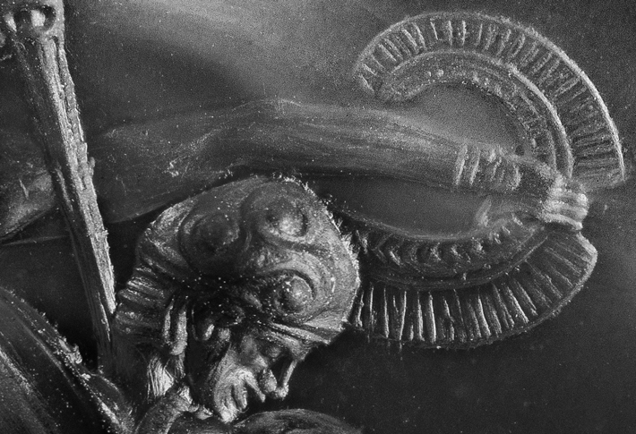

Figure.2, Full Battle scene from the Silver Battle Krater from Shaft Grave IV at Mycenae, Courtesy of F. Blakomer
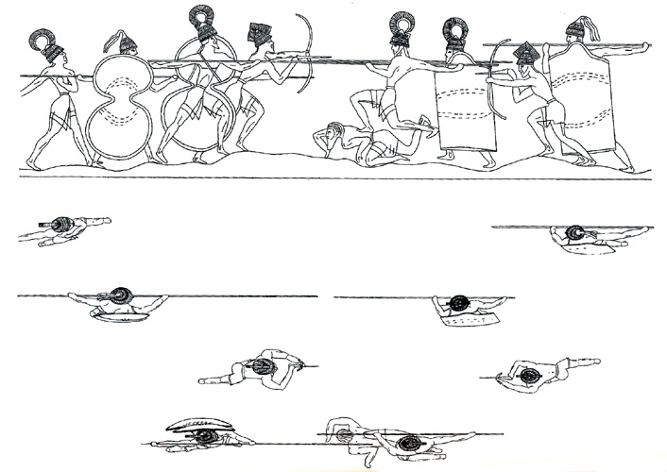

Figure.3, Enlarged Drawing of the Combat, Agate, as it appears on the face of the sealstone, Drawing by T. Ross, Courtesy of the Department of Classics, University of Cincinnati
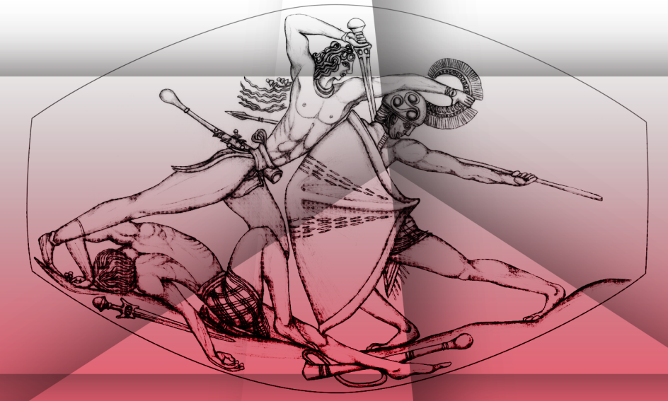

Figure.4, Detail of the trailing hair of the victor, Vanderpool, courtesy of the Department of Classics, University of Cincinnati


