Module title: Introduction to Public Health

module code: LCHS4004

assignment title: Incidence of disease in
communities

Contents
Task 1 – group discussion 2
What might be the first action while addressing polio outbreak? 2
Conclusion 3
Task 2 – case Polio outbreak 4
Report 4
Introduction 4
Strategies undertaken to measure the incidence of polio 4
Strategic ways to monitor the incidence of polio in UK 4
Evaluation of the strategies used in UK to control the incidence of polio 5
Conclusion 6
References 7

Task 1 – Group Discussion

What might be the first action while addressing polio outbreak?
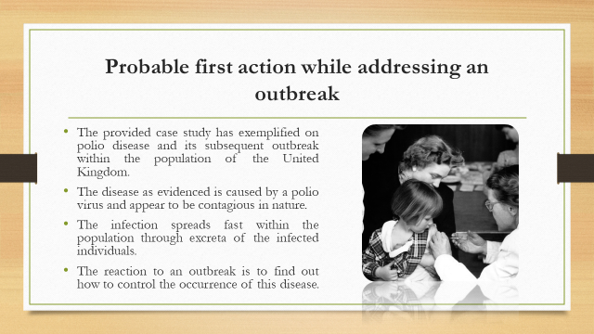
The provided case study has exemplified on polio disease and its subsequent outbreak within the population of the United Kingdom. The disease as evidenced is caused by a polio virus and appear to be contagious in nature. The infection spreads fast within the population through excreta of the infected individuals. Therefore, understanding the fact that polio have a potential to cause an adverse health impact over the population the reaction to an outbreak is to find out how to control the occurrence of this disease. The reaction to the information of outbreak of polio is to focus on how to take strategic steps to prevent this disease as an epidemiology (Guglielmi, 2022).
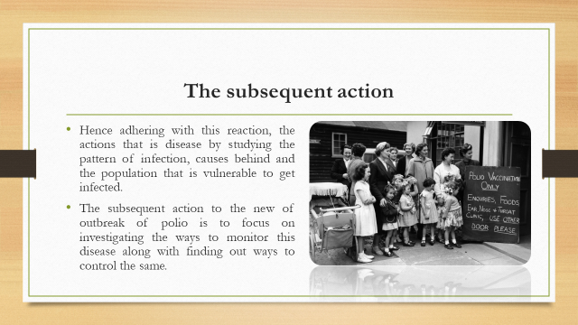
Hence adhering with this reaction, the actions that is disease by studying the pattern of infection, causes behind and the population that is vulnerable to get infected. The subsequent action to the new of outbreak of polio is to focus on investigating the ways to monitor this disease along with finding out ways to control the same (Guglielmi, 2022).
On personal ground I would like to comment that subsequent action to the reaction of an outbreak of polio in the United Kingdom is to arrange for adequate funding and to appoint special medical teams to organize pilot studies and mass campaigning to aware the public from polio.

Task 2 – Case: Polio Outbreak

Report

Introduction
Aligning with the given case discussing of the outbreak of Polio caused by a virus in the United Kingdom a report has been documented to analyse the strategies undertaken by the responsible authorities of the UK to measure the incidence of the cited diseases. The subsequent part of this report shall emphasis on evaluating the strategies considered by the UK government and relevant healthcare organisation to monitor the incidence of Polio along also the strategic approaches undertaken in UK to control the referred disease. The provided case has depicted an outbreak of this viral disease in the early part of 2022 in the country.

Strategies undertaken to measure the incidence of polio
In context of healthcare, the phrase incidence of a disease is referred to the occurrence of new cases of disease over a certain period. An estimation to the number of incidences of any disease is vital particularly for any infectious disease like Polio as it help to understand the source of a disease and the possibly impact of the same. Moreover, by calculating the number of incidences of any infectious disease it is possible to impose control measures thereby prevent the same to turn into an epidemic (Guglielmi, 2022).
The provided case study has discussed the outbreak of Polio which is a viral disease and appears to be highly infectious. As evident from the case, the disease is spread from one person to another when a healthy person encounters the feces of an infected person. In order to resist or control the outbreak of any infectious disease the primary concern is to measure the incidents of this diseases which is also applicable for Polio. The governing body of the United Kingdom is evident to register the number of individuals getting infected through this virus. This is done by registering the number of hospital admissions happened in past 6 months following diagnosed with this disease. An estimation of the number of consultations made and diagnosed with polio but were not admitted to hospitals were also undertaken to find out the prevalence of this disease within the population of the country. Apart from this another record has been maintained stating the number of deaths that have occurred in last 6 months across the United Kingdom after being diagnosed with this infectious disease (Guglielmi, 2022).

Strategic ways to monitor the incidence of polio in UK
Monitoring the incidence of a disease is important concern for the epidemiologists in order to understand the overall pattern of the infection. Moreover, by emphasising to monitor incidence of a disease it is also possible to identify which demographic group of the population is majorly affected. Referring to the provided case scenario strategic ways have been considered to monitor the incidence of Polio. For this purpose, the number of new cases with patients diagnosed with polio are also recorded. To note polio surveillance or monitoring is generally carried out by a surveillance officer who is responsible to collect stool samples from an individual reported with polio infection. The collected samples are transported to a WHO certified polio laboratory for testing and analysis. Additionally, incidences of polio are also monitored by organising polio surveillance campaigns that are also responsible for assessment of the quality and impact of supplementary immunization activities. Monitoring of the incidence of Polio is also carried out by recognising new cases and by detection of any circulation of polio virus (Clarke and Kampmann, 2022).
The overall monitoring of incidence of polio is undertaken by the following ways:
- Finding and reporting children with acute flaccid paralysis or AFP
- Transporting stool samples for clinical studies
- Isolating polio virus
- Mapping of Polio virus.
Incorporation of certain surveillance indicators are also considered to be effective ways of monitoring incidence of Polio. Such indicators reflect the assimilation of data for standardized continuous reporting and form the basis of an epidemiological evidence about the location, demographics of the cited disease (Wilson, 2019).

Evaluation of the strategies used in UK to control the incidence of polio
Understanding the infection causing potential of polio virus and the adverse health impact caused over an infected individual if not treated in time the governing body of the United Kingdom in collaboration with its healthcare organisation has been actively involved to control the incidence of Polio. Organising polio vaccination campaigns is an effective control method undertaken to prevent the incidence of this disease. Moreover, focusing on mass awareness on polio prevention methods and importance of vaccinating the children with polio is another effective and strategic way to control the incidence of the disease. Active participating of the healthcare officials of the country has been able to inform the general population that polio virus is not destroyed by hand sanitizers or alcohol-based product. importance of developing good hand hygiene and thorough washing of hands with soap and water sought to be effective controlling incidences of polio (Bao et al., 2020).
Considering the cause of polio infection efforts are taken by the UK governing body to assure that fecal deposits are not left exposed thereby eliminating the chances of contact with a healthy and unvaccinated individual. Hence the control of incidence of polio were successfully undertaken by conducting routine immunization programs, supplemental immunization activities, Polio surveillance and targeted mop-up campaigns that are identified as four pillars to control incidences of polio. Also, adherence to the three distinct stages of prevention namely primordial prevention, primary prevention and secondary and tertiary prevention are effective in controlling the occurrence of polio. Focus on primordial prevention through vaccination and proper treatment is effective in reducing the occurrence of this disease as polio onset can be prevented through immunization (Meyers and Thomasson, 2021).

Conclusion
On the concluding ground it can be stated that polio being an infectious disease has the potential to cause a huge outbreak subsequently resulting to an epidemic. However, the initiatives undertaken by the governing body of UK has been able to control the number of incidences of the same. The aggressiveness of an infection like Polio can be regulated by strategies to measure and monitor the incidence of polio. Hence the provided case study has also revealed that this polio has been caused from the evolved vaccine derived poliovirus and preventing exposure of unvaccinated individual in contact with Polio infected samples.

References
Bao, J., Thorley, B., Isaacs, D., Dinsmore, N., Elliott, E.J., McIntyre, P. and Britton, P.N., 2020. Polio–the old foe and new challenges: an update for clinicians. Journal of Paediatrics and Child Health, 56(10), pp.1527-1532.
Clarke, E. and Kampmann, B., 2022. No one is safe until everyone is safe—from polio too. bmj, 377.
Guglielmi, G., 2022. What polio's UK presence means for global health. Nature, 607(7918), pp.225-225.
Meyers, K. and Thomasson, M.A., 2021. Can pandemics affect educational attainment? Evidence from the polio epidemic of 1916. Cliometrica, 15(2), pp.231-265.
Wilson, D.J., 2019. Living with polio: the epidemic and its survivors. University of Chicago Press.

