

Task 2
Professional career development report

Student Name: Mihail Pecica
Student ID: 2124360
Module name: Professional Career Development
Module code: (BMSW4005_LON)
Lecturer name: Rita Ukachi-Lois

Table of Contents

1. Introduction 3
2. Current Skills/Gap in skills 4
3. Systematic Approach to Skills acquisition 5
4. Role Play and Decision Making 6
5. Conclusion 7
6. References 8
7. Appendix 9

Introduction

This report is about career development, and it is a reflective report. The word "career" is now often used in the professional world. To put it another way, a career is a plan for introducing people to the labour market that benefits people, organisations, and society as a whole, as well as promoting social ideology and stability (Collin, & Young, 2000). How well a worker does in his professional job determines how far his career will go. According to Riverin-Simard (2000), the process of professional growth may be characterised as an ongoing process of transformation. My long-term objective is to enter the commercial sector as a chartered accountant. As a result, I will discuss my chosen profession in my report as well as the abilities I now possess and those I still need to develop. The whole Moodle will also be reflected using Gibbs' reflection cycle. Gibbs' reflective model is divided into phases, each of which includes a series of questions that must be addressed in order to generate deep reflection. Gibbs recommends the steps: description, feelings, evaluation, analysis, conclusions, and action plan (Gibbs, 1988). Using Gibbs Reflective Cycle, individuals can gain a deeper understanding of the situation, make sense of it, and consider how they might proceed differently.
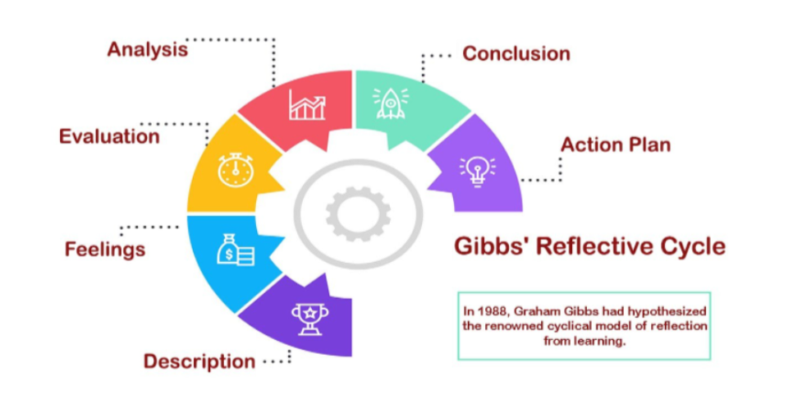
- Description - What occurred? Make sure you do not waffle on about details that are not necessary.
- Feelings – If you could describe your feelings at the time, how would you describe them?
- Evaluation - How did things turn out?
- Analysis - What made things go well? Badly?
- Conclusion - Could you please describe what you have learned?
- Action Plan - In what ways and where can I apply my newly acquired knowledge and experience?

Current Skills/Gap in skills

Description: Since the beginning of this module, I have been very interested in learning more about how I could develop my career and my skills. I would like to become a chartered accountant. I know myself and I know which skills I have and which I should improve. According to skillsyouneed.com, you need effective organisational skills, time saving skills, adaptability and efficiency to become a successful accountant (www.skillsyouneed.com, n.d.). There is no doubt in my mind that I am capable of performing those skills. The ten weeks were full of information and techniques that helped us to develop our skills and learn many new things such a Smart Goals, SWOT analysis, employee rights etc.
Feelings: I almost always felt eager to learn from lecturer Rita and quite intrigued. In week six of our study of employee rights, I made it a point to learn as much as I could about them. This is due to the fact that I conducted online research to learn about my rights as an employee. All employees in the UK are equal, according to cipd.co.uk. It does not matter of your race, gender, sexual orientation, or gender identity, you have the same rights as men and women. I am always self-motivated to complete tasks, therefore as I get more experience, my confidence in my capacity to be an accountant has increased. I have a full-time job in addition to school, therefore I've never been late with an assignment.
Evaluation: Taking the Professional Career Development module will help you gain an understanding of and acquire skills that may be useful in your future career endeavours. You will learn how to write a resume, how to apply for employment, and how to conduct yourself in an interview in this course. My assessment indicates that I am pleased with the calibre of my accounting abilities. Having Time-management skills and being able to finish assignments on time is a very useful ability in the accounting industry because it is a very time-sensitive job (McMillan & Weyers, 2021).
Analysis: It is very important to analyse your skills and to know what you could do and what you could not do. According to Contrell (2021) you need to establish a clear understanding of what you wish to accomplish and why. To define how you will know when your goal has been achieved: what will be different? Make sure that it is a realistic goal (Contrell 2021). There is no doubt in my mind that I intend to become an accountant. The accomplishment of this goal will allow me to accomplish what I have always dreamed of since I was a child.
Conclusion: Employability is something that needs to be started as soon as possible. While it is imperative to develop a work pattern in the first year of university, Year 10 in high school is a good time to begin. (Neugebauer, John, and Jane 2016). Being a student for ten weeks and taking the lesson was incredibly beneficial to me. During that period, I gained a lot of knowledge about how to improve my skills. The program taught me how to create SMART goals, how to conduct a SWOT analysis of myself, employees' rights, the process of recruitment etc. If you want to get the job, you should always be ready for the interview with a strong CV, knowledge about the firm you are asking to work for, and a clear, certain self-evaluation. If I had to select again what I wanted to study, I would without a doubt pick this one.
Action Plan: Though I don't have any experience as an accountant, I am planning to study Finance and Accounting after this course. I am also planning to start working in a small company in the first year of study. I updated my CV to the standards I learned and have set SMART Goals for 2023. I would like to see myself working as a novice accountant in 2024 since knowledge and experience are the abilities I need to develop.

Systematic Approach to Skills acquisition

As I do not have any experience or study do be an accountant I need to have it and then to be an accountant. According to Chris Biggs is not only me in this situation. Instead of basic skills, which are more crucial to a person's performance and employability, there is a skills gap in experience. To employ their auditing and accounting abilities, professionals in many occupations lack the necessary commercial and real-world experience (EmployTest, n.d.). In the next three years, I plan to study hard and earn my accounting diploma. While working on my numerical skills and problem-solving skills, I will also work on improving my analytical skills. Practicing, brainstorming, and reading are the most effective methods for improving it. Following the completion of one year of study, I intend to apply for a position as a junior accountant in order to put what I have learned into practice. In three years I will have a diploma and a lot of experience behind me. This will bring more opportunities to become a chartered accountant.

Role Play and Decision Making

We took on the roles of interviewers and interviewees on December 8th. We choose our partners for this module's second week, and as Ermelindo and I have previously worked in groups, we were paired together. I had to ask him five questions in the first phase of the role play based on the job description and job specification he had previously supplied. Sincerely, I was anxious as always before a presentation in front of people, but overall, I think we did a terrific job. I trained myself to ask pertinent and useful questions prior to this day. I performed some research and discovered that there are seven tactics for doing a successful interview, per Indeed.co.uk (indeed.co.uk, n.a.). Due to my thorough preparation, this interview went well for me. I carefully reviewed his resume and questioned him to learn more about his past. I never asked any personal questions during interviews; instead, I always tried to make the interviewee feel at ease by engaging in conversation. I made notes throughout the interview so that I could decide later and then express that decision via email within three business days (indeed.co.uk, n.a.).
In the second part, I was interviewed by Ermelindo. Due to the fact that my dream job is to be an accountant, I applied for an accounting position at Choice in London. After completing the job description and job specification, I searched the Internet for more information about chartered accountants. During the interview, I tried to answer with calm and confidence so that I would get the job as if it were a real one. The question he asked the most, and I did not like, was about when I improved the accounting process at work. Because I have never held an accounting position, but I know many things from my reading, I have to invent something at the moment. In my opinion he was a skilled interviewer and acted as if it was a real one. During the interview, Ermelindo asked thoughtful questions and kept me curious at all times, explaining at the end when I would receive an email telling me if I got the job or not.
After interviewing Ermelindo for the role of head chef at Portuguese Restaurant, I had to make a choice. Although it was a difficult assignment, he was not hired. His problem-solving abilities and experience were examined, and we determined that he was not the right candidate (resources.workable.com, 2017) . We provide a list of the qualifications and experience needed for the position in our job description. The good news is that he has been given the opportunity to work as a sous chef with the potential to advance to head chef in the future.

Conclusion

In conclusion I want to say that I intend to become an accountant. It goes without saying that I need to practise and increase my skill set, but it's not impossible. I intend to pursue my ambitions and study accounting when this course is complete in order to accomplish this. Overall, the "Professional career development" module provided students with a terrific opportunity to learn about everything from how to write a decent CV, how to enhance their abilities and understand their legal obligations in the UK to how to conduct an interview. This year, I took six modules, but my favourite was the one on careers. To get your desired job, you must put in a lot of effort.

References

- ‌CIPD (2022). Employment Law | CIPD. [online] CIPD. Available at: https://www.cipd.co.uk/knowledge/fundamentals/emp-law. (Accessed 27 Dec. 2022).
- Cottrell, Stella. Skills for Success : Personal Development and Employability, Macmillan Education UK,2021. Pro Quest eBook Central, http://ebookcentral.proquest.com/lib/trinity/detail.action?docID=6577749. (Accessed 21 Dec. 2022).
- EmployTest (n.d.). Overcoming the Accounting Skills Gap with Applicants. [online] www.employtest.com. Available at: https://www.employtest.com/hrblog/hiring-tips/bridging-the-accounting-skills-gap/ [Accessed 5 Jan. 2023].

- Gibbs, G. (1988). Learning by Doing, A Guide to Teaching and Learning Methods. [online] Oxford Brookes University, p.49. Available at: https://thoughtsmostlyaboutlearning.files.wordpress.com/2015/12/learning-by-doing-graham gibbs.pdf, (Accessed 29 Dec. 2022)
- McMillan, K., & Weyers, J., 2021. The Study Skills Book, Pearson Education, Limited, Harlow. Available from: ProQuest Ebook Central. (Accessed 30 December 2022).
- Neugebauer, John, and Jane Evans-Brain. Employability: Making the Most of Your Career Development, SAGE Publications, Limited, 2016. ProQuest Ebook Central, http://ebookcentral.proquest.com/lib/trinity/detail.action?docID=5164548. Pag. 3-8 (Accessed 1 Jan. 2023).
- Recruiting Resources: How to Recruit and Hire Better. (2017). Decision-making interview questions template | Workable. [online] Available at: https://resources.workable.com/decision-making-interview-questions. . (Accessed 19 Dec. 2022).
- Riverin-Simard, D., 2000. Career development in a changing context of the second part of working life, in Collin, A. and Young, R. A. (eds) The Future of Career. Cambridge: Cambridge University Press, pp. 115–129. (Accessed 02 Jan. 2023).
- skillsyouneed.com. (n.d.). Key Skills That Every Accountant Needs | SkillsYouNeed. [online] Available at:https://www.skillsyouneed.com/rhubarb/accountant-key-skills. (Accessed 1 Jan. 2023).
- Young, R. A. and Collin, A., 2000. Introduction: framing the future of career, in Collin, A. and Young, R. A. (eds) The Future of Career. Cambridge: Cambridge University Press, pp. 1–18. (Accessed 30 Dec. 2022)

Appendix


