Market Failure Analysis: The UK Tobacco Industry

Introduction
The UK tobacco market exemplifies market failure, as consumption generates substantial negative externalities that affect public health, environmental sustainability, and economic efficiency. In 2021, the industry generated £4.4 billion in revenue despite well-documented social costs (Statista, 2021). This essay examines tobacco-related market failure through neoclassical economic theory and evaluates regulatory interventions implemented between 2007 and 2017, integrating foundational theory (Pigou, 1920; Baumol & Oates, 1988) with contemporary evidence. The analysis also demonstrates, through hypothetical economic diagrams, how a Pigouvian tax and command-and-control regulation each function in practice to correct the negative externality of consumption and move the market toward the social optimum.

Theoretical Framework
Market failure arises when competitive markets do not reach Pareto efficiency, a state in which no one can be made better off without making someone else worse off (Francis M. Bator, 1958).Pigou (1920) established the foundational framework for analysing negative externalities, demonstrating that when private marginal cost diverges from social marginal cost, markets produce inefficient outcomes. Externalities are spillover effects—situations in which actions impose costs or confer benefits on third parties that are not captured in market prices (Ronald Coase, 1960). Unlike public goods characterised by non-rivalry and non-excludability, externalities arise from uncompensated impacts on uninvolved parties (Stiglitz, 1989). The tobacco market exhibits classic externality characteristics: consumption imposes uncompensated costs through passive smoking (Jamrozik, 2005), environmental damage affects society beyond consumer-producer relationships (World Health Organization, 2017), healthcare costs represent resource consumption not internalised in prices (Royal College of Physicians, 2018), and information asymmetries regarding addiction prevent fully informed choices (Gruber & Köszegi, 2001).

Market Failure Prior to Intervention
Before 2007, the tobacco market showed a significant gap between private and social costs. The Royal College of Physicians (2018) estimated that smoking-related illnesses cost the NHS around £2.5 billion annually, while wider economic costs—including lost productivity—reached approximately £13.9 billion per year. In 2006–07, tobacco duties generated £8.1 billion (HM Revenue & Customs, 2022), exceeding direct NHS treatment costs but falling well short of total social costs once productivity losses, passive smoking, and environmental damage are taken into account. This reveals that taxation failed to fully absorb all externalities, as Pigouvian theory requires the tax to equal the marginal external cost at the optimal quantity (Pigou, 1920). Tobacco consumption caused over 77,000 deaths annually in 2007 (NHS Digital, 2019). Passive smoking created additional external costs: approximately 12,000 annual
deaths resulted from second-hand smoke exposure, with hospitality workers facing 50% higher lung cancer risk (Jamrozik, 2005). The Health and Safety Executive (2004) estimated passive smoking in workplaces caused 617 employee deaths per year. Prior to 2007, UK smoking prevalence stood at 21% of adults (Office for National Statistics, 2019).

Environmental externalities compound market failure by violating industrial ecology principles. Cigarette production requires 600 million trees worldwide each year (World Health Organisation, 2017). Filters contain cellulose acetate, which can take between 18 months to 10 years to decompose, during which toxic chemicals, including arsenic and nicotine, leach into soil and waterways (Novotny et al., 2011). In the UK, approximately 122 tonnes of cigarette waste entered the environment daily, equivalent to 44,530 tonnes annually (Keep Britain Tidy, 2020). This linear production model—extracting resources, manufacturing products, and discarding waste—contradicts circular economy principles that emphasise closed-loop material flows (Graedel & Allenby, 2003).

These externalities create divergence between marginal private cost (MPC) and marginal social cost (MSC), and between marginal private benefit (MPB) and marginal social benefit (MSB). Market equilibrium occurs at quantity Qₘ where demand (MPB) intersects supply (MPC) at price Pₘ. The socially optimal quantity Q* occurs where MSC intersects MSB. Since Qₘ exceeds Q*, the market produces overconsumption. The welfare loss triangle, bounded by MSC, MSB and the vertical line at Q*, represents deadweight loss. Prior to 2007, UK smoking prevalence stood at 21% of adults (Office for National Statistics, 2019).

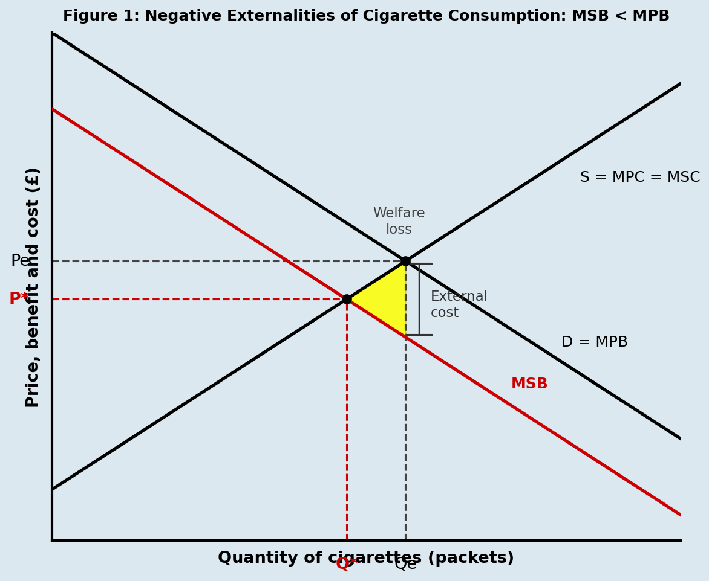
Figure 1: Market Failure Equilibrium

Note: Vertical axis: Price/Cost (£). Horizontal axis: Quantity. MSC above MPC=Supply. MSB below MPB=Demand. Market equilibrium at Qₘ (Supply-Demand intersection, price Pₘ). Social optimum at Q* (MSC-MSB intersection). Deadweight loss triangle between Q*, Qₘ and MSC. Figure generated using the OpenAI image generator.

Regulatory Solutions
The Health Act 2006 implemented comprehensive smoke-free legislation prohibiting smoking in enclosed public spaces and workplaces from July 2007. This command-and-control regulation addresses externalities through quantity restrictions rather than price mechanisms, representing an alternative to Pigouvian taxation (Baumol & Oates, 1988). The choice between regulatory standards and market-based instruments involves trade-offs in administrative efficiency and enforcement costs (Cropper & Oates, 1992). The smoking ban addresses market failure by eliminating externalities from passive smoking, reducing smoking opportunities and social acceptability (shifting MPB leftward), and providing information signals about health risks (Kenkel, 1991; Adda & Cornaglia, 2010). The standardised packaging regulations implemented in 2017 complemented the smoking ban by introducing plain packaging, prohibiting branding, requiring prominent graphic health warnings covering 65% of the packaging, and introducing minimum pack sizes (Department of Health and Social Care, 2017). Implementation costs included industry compliance expenditure estimated at £220 million, though this represents a transfer payment. The genuine resource cost comprised administrative expenses, estimated at £30 million (Department of Health and Social Care, 2016)

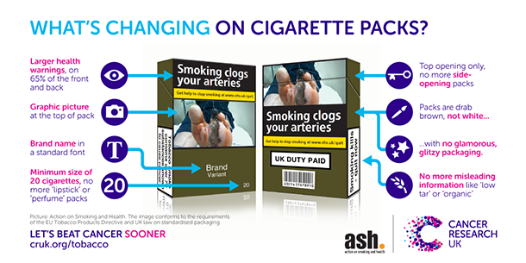
Cancer Research UK. (Hunt, 2016).

Pigouvian Theory
Pigouvian theory states that a per-unit tax set equal to the marginal external cost at the socially optimal output level will internalise the externality and restore market efficiency (Pigou, 1920). For a negative externality of consumption, the supply curve (S = MPC = MSC) remains unchanged because producers are not the source of the external cost. The tax instead acts on the demand side: it is levied on consumers, reducing the price they are willing to pay for each unit by the amount of the tax. This effectively shifts the demand curve downward from D = MPB to D − tax = MSB, so that consumers now face a price that reflects the full social cost of their consumption. The market then clears at Q*, the socially optimal quantity. Consumers pay a higher price Pc (on the original demand curve D at Q*), whilst producers receive a lower price Pp = P* (on the supply curve at Q*). The difference between Pc and Pp is the tax per unit, equal to the marginal external cost. This mechanism eliminates the deadweight welfare loss that previously arose from overconsumption, as illustrated in Figure 3.

In the UK tobacco context, excise duty functions as an approximation of this Pigouvian mechanism. In 2006–07, tobacco duty raised £8.1 billion (HM Revenue & Customs, 2022), but this fell approximately £5.8 billion short of fully internalising total social costs of £13.9 billion (Royal College of Physicians, 2018). The blue rectangle in Figure 3 represents the tax revenue generated, which can be redistributed — for example, through NHS spending on cessation programmes — further improving social welfare. Stavins (2003) notes that market-based instruments such as Pigouvian taxes are theoretically superior to command-and-control regulation in minimising abatement costs across heterogeneous consumers, though distributional concerns limit their political feasibility at the optimal rate (Hiscock et al., 2020).

Market Performance and Sustainability Outcomes
There have been numerous social and economic improvements following intervention. Smoking prevalence declined from 21% in 2007 to 13.9% in 2021, a 34% reduction (Office for National Statistics, 2022). Sims et al. (2010) employed quasi-experimental methods and found that smoke-free legislation independently reduced hospital admissions for myocardial infarction by 2.4% in the first year. Jones et al. (2015) estimated that smoke-free legislation prevented approximately 40,000 hospital admissions over eight years, generating NHS cost savings of £152 million. Smoking-attributable deaths fell from 77,800 in 2007 to 74,600 in 2020, preventing 3,200 premature deaths annually (NHS Digital, 2019; Action on Smoking and Health, 2021). Hospital admissions for smoking-related conditions declined 18% between 2007 and 2020, resulting in NHS cost savings estimated at £1.2 billion annually (Langley et al., 2020). Passive smoking exposure fell substantially: cotinine levels in non-smokers declined 83% between 2006 and 2018 (Jarvis et al., 2019).

Figure 2. Positive Impact of Tobacco Control
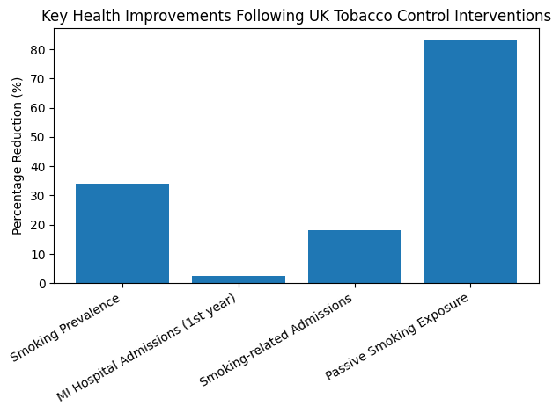

Percentage reductions in key health indicators following UK tobacco control interventions (2006–2021).
Note. Figure generated using the OpenAI image generator. Data derived from Office for National Statistics (2022)

Environmental benefits emerged: cigarette butt litter declined 35% between 2007 and 2020, reducing cleanup costs estimated at £40 million annually (Keep Britain Tidy, 2021). Reduced consumption of 3 million smokers × 13 cigarettes daily × 365 days equals 14.2 billion fewer cigarettes annually (Zafeiridou et al., 2018). Economic welfare analysis reveals that whilst tobacco industry revenues declined from £15.8 billion in 2007 to £12.4 billion in 2020 (Statista, 2021), total social welfare improved. Annual health cost savings of £1.2 billion, productivity gains estimated at £1.8 billion and environmental cost reductions of £200 million generate net social benefits exceeding industry revenue losses (Reed et al., 2021). When passive smoking costs are included, total social benefits approach £3.5 billion per year.

Sustainability Analysis
Evaluating regulatory outcomes requires integrating environmental, social and economic dimensions (Elkington, 1997). Environmental sustainability improved through reduced resource consumption. Economic sustainability improved through better cost-price alignment. Social sustainability presented challenges: Hiscock et al. (2020) found smoking prevalence declined faster among higher socioeconomic groups, with rates falling from 28% to 15% in routine occupational groups compared with 16% to 7% among managerial groups between 2007 and 2020. This widening inequality suggests that regulatory measures proved less effective for disadvantaged populations. The behavioural economics literature demonstrates that regulatory approaches based on information provision are less effective for populations experiencing cognitive depletion from economic stress (Mullainathan & Shafir, 2013). True progress in sustainability means giving disadvantaged groups more real opportunities to improve their lives, not just raising average societal welfare (Sen, 1999). Addressing equity concerns requires complementary policies, including subsidised cessation support and economic interventions that address underlying stressors (Dillard et al., 2009).

Conclusion
Regulatory interventions have been proven to address market failures characterised by negative externalities. Prior to 2007, divergence between private and social costs led to substantial overconsumption, resulting in annual health costs of £13.9 billion, 77,800 preventable deaths, and environmental damage. The 2007 smoking ban and 2017 standardised packaging regulations shifted market outcomes toward the social optimum. Evidence shows smoking prevalence declining 34%, passive smoking exposure falling 83% and NHS cost savings reaching £1.2 billion annually. From a sustainability perspective, the implemented regulations generated predominantly positive environmental and economic outcomes, though widening socioeconomic disparities indicate that distributional equity concerns require targeted interventions. The tobacco case provides insights into addressing consumption-related market failures, demonstrating that regulatory approaches can achieve sustainability objectives whilst revealing the limitations of universal interventions that disproportionately affect disadvantaged populations.

References
Action on Smoking and Health. (2021). Smoking statistics: Disease and death.
https://ash.org.uk/resources/view/statistics-on-smoking
Adda, J., & Cornaglia, F. (2010). The effect of bans and taxes on passive smoking. American
Economic Journal: Applied Economics, 2(1), 1–32. https://doi.org/10.1257/app.2.1.1
Bator, F. M. (1958). The anatomy of market failure. The Quarterly Journal of Economics,
72(3), 351–379. https://doi.org/10.2307/1882231
Baumol, W. J., & Oates, W. E. (1988). The theory of environmental policy (2nd ed.).
Cambridge University Press.
Coase, R. H. (1960). The problem of social cost. The Journal of Law and Economics, 3, 1–
44. https://doi.org/10.1086/466560
Cropper, M. L., & Oates, W. E. (1992). Environmental economics: A survey. Journal of
Economic Literature, 30(2), 675–740.
Dillard, J., Dujon, V., & King, M. C. (Eds.). (2009). Understanding the social dimension of
sustainability. Routledge.
Department of Health and Social Care. (2016). Impact assessment: Standardised packaging.
https://www.gov.uk/government/publications/standardised-packaging-of-tobacco-products-regulations-2015
Department of Health and Social Care. (2017). Standardised packaging regulations 2015.
https://www.legislation.gov.uk/uksi/2015/829/contents/made
Elkington, J. (1997). Cannibals with forks: The triple bottom line. Capstone Publishing.
Graedel, T. E., & Allenby, B. R. (2003). Industrial ecology (2nd ed.). Prentice Hall.
Gruber, J., & Köszegi, B. (2001). Is addiction 'rational'? The Quarterly Journal of Economics,
116(4), 1261–1303. https://doi.org/10.1162/003355301753265570
Hammond, D. (2011). Health warning messages on tobacco products. Tobacco Control,
20(5), 327–337. https://doi.org/10.1136/tc.2010.037630
Health and Safety Executive. (2004). Second-hand smoke in the workplace. HSE Books.
Hiscock, R., Augustin, N. H., Branston, J. R., & Gilmore, A. B. (2020). Longitudinal
inequalities in smoking cessation. BMJ Open, 10(7), Article e037563. https://doi.org/10.1136/bmjopen-2020-037563
HM Revenue & Customs. (2022). Historical hydrocarbon oils duty rates.
https://www.gov.uk/government/statistics/hydrocarbon-oils-bulletin/historical-hydrocarbon-oils-duty-rates--2
Hunt, D. (2016, May 19). From today, cigarette packs will never look the same again. Cancer
Research UK. https://news.cancerresearchuk.org/2016/05/19/from-today-cigarette-packs-will-never-look-the-same-again/
Jamrozik, K. (2005). Deaths attributable to passive smoking. BMJ, 330(7495), 812–815.
https://doi.org/10.1136/bmj.38370.496632.8F
Jarvis, M. J., Feyerabend, C., Bryant, A., Hedges, B., & Primatesta, P. (2019). Passive
smoking in the home. Tobacco Control, 28(2), 129–135. https://doi.org/10.1136/tobaccocontrol-2018-054512
Jones, S., Love, C., Thomson, R., Green, N., & Hyland, A. (2015). Second-hand smoke and
tobacco control. Tobacco Control, 24(e2), e120–e126. https://doi.org/10.1136/tobaccocontrol-2013-051464
Keep Britain Tidy. (2020). Cigarette litter report 2020.
https://www.keepbritaintidy.org/sites/default/files/resources/KBT_Cigarette%20Litter%20Report%202020_0.pdf
Keep Britain Tidy. (2021). Annual litter survey findings.
https://www.keepbritaintidy.org/research
Kenkel, D. S. (1991). Health behavior and schooling. Journal of Political Economy, 99(2),
287–305. https://doi.org/10.1086/261751
Langley, T., Szatkowski, L., Lewis, S., McNeill, A., Gilmore, A. B., Salway, R., & Sims, M.
(2020). Impact of media campaigns. Addiction, 115(3), 555–564. https://doi.org/10.1111/add.14802
Mullainathan, S., & Shafir, E. (2013). Scarcity: Why having too little means so much. Times
Books.
NHS Digital. (2019). Statistics on smoking, England 2019. https://digital.nhs.uk/data-and-
information/publications/statistical/statistics-on-smoking/statistics-on-smoking-england-2019
Novotny, T. E., Lum, K., Smith, E., Wang, V., & Barnes, R. (2011). Cigarettes butts and
environmental policy. International Journal of Environmental Research and Public Health, 8(5), 1687–1708. https://doi.org/10.3390/ijerph8051687
Office for National Statistics. (2019). Adult smoking habits 2019.
https://www.ons.gov.uk/peoplepopulationandcommunity/healthandsocialcare/healthandlifeexpectancies/bulletins/adultsmokinghabitsingreatbritain/2019
Office for National Statistics. (2022). Adult smoking habits 2021.
https://www.ons.gov.uk/peoplepopulationandcommunity/healthandsocialcare/drugusealcoholandsmoking/bulletins/smokingprevalenceintheuk/2021
Office for National Statistics. (2021) Action on Smoking and Health. Office for National
Statistics.
Reed, H., Sharpe, C., Thornley, S., & Cruickshank, K. (2021). Economic impacts of tobacco
control. Tobacco Control, 30(Suppl 1), s27–s32. https://doi.org/10.1136/tobaccocontrol-2020-056042
Royal College of Physicians. (2018). Treating tobacco dependency in the NHS.
https://www.rcplondon.ac.uk/projects/outputs/hiding-plain-sight-treating-tobacco-dependency-nhs
Sen, A. (1999). Development as freedom. Oxford University Press.
Sims, M., Maxwell, R., Bauld, L., & Gilmore, A. (2010). Impact of smoke-free legislation.
BMJ, 340, Article c2161. https://doi.org/10.1136/bmj.c2161
Statista. (2021). Revenue of the tobacco industry UK 2011-2021.
https://www.statista.com/statistics/294397/revenue-of-the-tobacco-industry-in-the-united-kingdom-uk/
Stavins, R. N. (2003). Market-based environmental policy. In K. G. Mäler & J. R. Vincent
(Eds.), Handbook of environmental economics (Vol. 1, pp. 355–435). Elsevier.
Stiglitz, J. E. (1989). Markets, market failures, and development. The American Economic
Review, 79(2), 197–203.
World Health Organization. (2017). Tobacco and its environmental impact.
https://www.who.int/tobacco/publications/environmental-impact-overview/en/
Zafeiridou, M., Hopkinson, N. S., & Voulvoulis, N. (2018). Cigarette smoking: Global
environmental footprint. Environmental Science & Technology, 52(15), 8087–8094. https://doi.org/10.1021/acs.est.8b01533

