MODULE CODE: BMSW4002
EFFECTIVE TEAMWORK AND COMMUNICATION
STUDENT NAME: DOROTHY ACHIAA ANTWI
STUDENT ID: 1906884
LECTURER AME: TIMOTHY HOPKINS

Table of Contents
1. Introduction 3
2. Strategies for capable team working : 3
3. Communication Model: 3
3.1 Communication Skills 4
3.2 Poor Communication and its impact on individual skill: 4
4. Theoretical Support 5
4.1 Team working 5
4.2 Group dynamics 5
5. Team working Case Study: 6
5.1 CaseStudy: 7
5.2 Key Attributes for Teamwork: 7
6. Recommendation: 8
7. Conclusion 8
Reference List 9

1. Introduction
Teamwork and communication are generally determined to aspect help in conducting a specific task. Usually, it creates a thriving work environment by combining talent and also creating core values regarding trust, motivation accountability. In a work environment, effective communication often plays a vital role in keeping the entire team over track and even determining positivity while conducting specific tasks in the work environment. Moreover, it also helps in creating and understanding the awareness regarding promotions that are usually required to adapt by team members after completing specific tasks. This is my decision based upon the strategy, mission skill, theoretical support, case study of effective teamwork and the recommendation for increasing the aspect.

2. Strategies for capable team working:
It is usually essential to determine the approach that should be developed for managing a competent team in the work environment and also discovering the gold that is generally sat by the organization.
- Ensure Leadership Support: for receiving various objectives in the workplace, it is crucial to determine the leader and also build a proper relationship with the leader. Team leader help in solving multiple issues and configure the work environment for the team member and also collaborating for achieving common objectives.
- Leverage Collaboration of Technology: By adapting various new developments, technology will generally facilitate the team number for determining about the tall task and also split easily for providing positive solutions and also maintaining the period.
- Developing Teamwork skill: developing teamwork is generally necessary because it usually increases the behaviour of employees in the workplace and also results in determining the successful outcome of the organization with collaboration.

3. Communication Model:
The perspective of the communication model depends on a particular circumstance. But the underlying system relies on the order of encoding and decoding. There are linear, interactive and transactional models of communication. In the case of a team or any business enterprise, the model of interactive is commonly used. The purpose of a conversation is to share any information between two people. Usually, one person encodes information and sends it by any channel to another one (Kurtz et al. 2017). The responsibility of the other person is to decode the information and understand the actual perspective of the message.
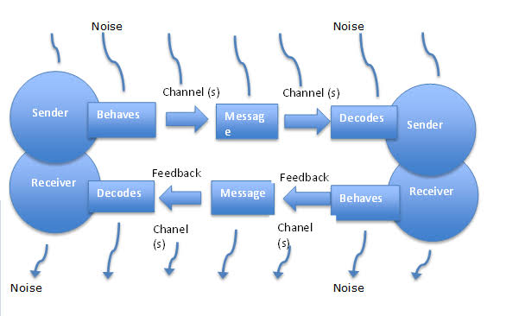
Figure 1: Communication Model
(Source: Kurtz et al. 2017)

3.1 Communication Skills
In the case of teamwork, the most useful skills are the following.
- Listening is what is the critical factor of communication; it helps to make a discussion successful.
- During any discussion, an individual must get into the topic directly, and they should have specific examples related to the item only. More specifically, communication is about straightforward talking.
- Their importance of types of communication like verbal or nonverbal communication. Those must be appropriately used for effectiveness.
- There should not be any impact of stress or emotion in communication. Dolls change the direction of it and create an unwanted situation.
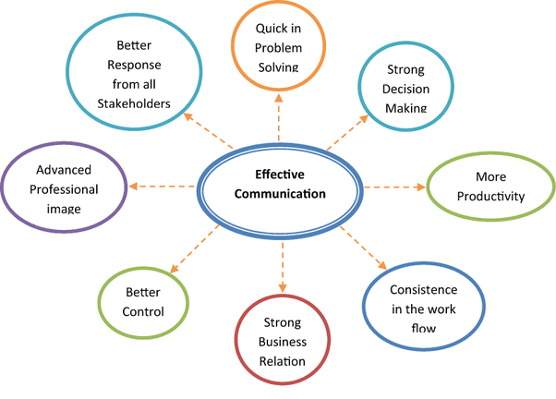
Figure: Communication Skills
(Source: Arnold and Boggs, 2019)

3.2 Poor Communication and its impact on individual skill:
Poor communication is a crucial barrier for personal and professional development for an individual. It creates a negative feeling for the available works and checklist. It makes the situation tougher and disables an individual from successful completion of tasks. Those people cannot focus on one-way communication, and they get a tendency of losing positivity’s. In both personal and professional development plans, the priority of communication is the most. If there is not enough ability for that, then it may push an individual backward from academic stability and employability.

4. Theoretical Support

4.1 Team working
Togetherness is the ultimate goal of a team. The team performs well when it sets up a common goal for itself (Arnold and Boggs, 2019). Members of teamwork collectively to achieve its objectives. Each member is accountable for the group. For successful teamwork, a group sometimes needs some essential skills to handle it. For example, each member of an organization is very well known about the strengths and weaknesses of each other. Hence to work successfully, members can divide the workload according to requirements. Communication is also an essential part of teamwork. Effective communication can increase the overall performance of a team. Every excellent communicator is also a good listener who listens to every suggestion as well. Listening to everyone creates a dynamic atmosphere at the workplace, which is required for a team and other team members to work correctly. Team members shared ideas altogether to understand the perfect way for the completion of a task within the determined time frame. Sometimes the team faces challenges also. But it is managed by the support system that grows within the organization.
Theories development have been started after the failure of the military team in the second world war. Moreover, understanding the effectiveness of teamwork, some social researchers try to find theories based on issues related to corporate activities. In the year 1950, some psychologists surveyed to examine how one person relates to themselves and others in a team. This group tries to understand how relationships among the team members influence the overall performance of the organization (Moore et al. 2018). Another study pointed out that the regular changes in a team adversely affected the outcome of a team's productivity.

4.2 Group dynamics
Group Dynamics is the process by which an individual or a group tries to understand another individual's or group's behaviour and psychology to get the overall information about their experience in the work field. According to Nahavandi, when two or more people interact with each other to complete a common goal in an organized manner, it needs to understand the psyche of those people first (Driskellet al. 2018). It has some academic principles that decide about the productiveness in the upcoming future. Principle of change, the law of readjustment and law of common motives, are some of the policies that help a group to work accordingly. It has four stages, namely group resources, group structure, group processes and group tasks (Barton et al. 2018). These stages are essential as it covers all the aspects of a particular group, whether it is formal or informal.
System theory is the one which can help to understand how a member works within a system. According to Tuckman, there are five stages of group development. These stages are forming, storming, norming, performing and adjourning (Boissyet al. 2016). These stages are essential to solve several issues which enable them to achieve their task correctly. It will determine the success of a group as a collective body. According to George Homan, a group's development depends on its activities, interaction and sentiment. Social exchange theory gives another view on this. It expressed that every individual forms a relationship which is based on trust and mutual understanding. According to social identity, every member gets a character in the group, which gives the morale boost to the members to work collectively and correctly in a working environment.
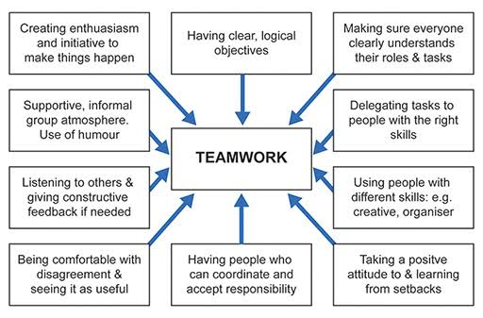
Figure 3: Teamwork
(Source: Boissyet al. 2016)

5. Team working Case Study:
Teamwork is defined as a cooperative process that generally and individually for achieving extraordinary results. Teen virginity helps in developing practical solutions regarding the common purpose or goal by building a mutual relationship between the team members. Moreover, it also helps in building a corporate environment between the individual for sharing via skill and knowledge that are required to achieve a common goal and also highlighted with essential elements that are needed for focusing our goal with a clear purpose (MacLean et al. 2017). While conducting teamwork, it is necessary to determine the attribute that lives in help in identifying the positive impact and also reaching the comparative goal by social independence and collaboration of individuals.
- Commitment to the success of team and sharing: team members required to be committed to all the success of the entire team and also sharing the goal of the project. Moreover, it generally helps in increasing motivation and aiming for achieving the highest level.
- Interdependence: team members are usually required to create an environment where they can easily contribute. It remains favourable for achieving the good and also enabling the individual to be interdependent as for their superior level (Keeet al. 2018). It will also help in promoting and encouraging the team members for learning, achieving and contributing.
- Interpersonal skill: generally, includes the ability for discussing the issue with free mind with the team members and also showing respect, supportiveness, honesty and trustworthiness towards the individual.
- Open communication: active listening generally concerns the requirement of team members and also values the contribution that will generally help in increasing the working effort. Team members are usually required to show their willingness towards receiving constructive criticism and also provide authentic feedback.
- Appropriate team composition: it is essential to determine about the creation of a successful team over the team member is required to be fully aware regarding the job role and also provide understanding about the contribution towards the project (Guchaitet al. 2016).
- The commitment of leadership team and accountability: team members are required to contribute regarding their project and also needed to be aware of the best practices, team process at various new ideas (Moss, 2017). Effective leadership will generally help in the success of the team and also result in sharing different decisions regarding conflict issues.

5.1 Case Study:
Team members generally include various graphic designers, project managers, programmers, and managers. It is quickly determined that a group of undergraduates are using a division in 20 teams for completing a specific task. Where the main aim of the students is to experience the management issues that generally occur while dealing with real projects and real clients which later result in building teamwork for focusing over the conflict. Whether students are usually divided according to their management skill and want a database that will help in investigating successfully and also developing quality full and collaborating success (Lacerenzaet al. 2018). It also results in determining the experience that may generally gain from various dysfunctional focusing groups like interview questionnaires that are usually documented for analysis.

5.2 Key Attributes for Teamwork:

Key Attributes | Description
Sharing goals for team success | - Team Members should be secure while sharing common goals.  - Team Members must also have a strong belief and shared value (Ellis, 2018).
Interdependence | - One cannot succeed until and unless other team members get group success.  - Team members should interact with each other to accomplish the task and also to ensure our success.
Interpersonal Skill | - Individuals should take care of one another.  - Members should have a high level of trust and confidence while committing towards a specific objective.
Communication and Feedback | - Feedback should be provided according to their diversified talent and the knowledge that is usually gained (Korner et al. 2016).  - Enabling the other member for expressing their personal feeling
Appropriate Team | - We are clarifying the role and relationship between the team members for contributing to equal responsibility towards the work.  - Various uncertainty and lack of motivation must be reduced by determining the gap (McEwan et al. 2017).

6. Recommendation:
It is quickly determined that getting success for students is essential to develop the quality of themselves and also being collaborative. Moreover, team members should also reflect on their positive comments and also build a friendly environment in every stage for resolving various conflict and problematic issues. Data that is usually gained or collected from the research is essential to determine effectively by collaborating team members together and also providing positive feedback according to their work. These are also important to decide on about various dysfunctional activity or splitting of jobs without determining the experiences that may also result in lowering of the contribution towards gaining on collecting information for developing interpersonal skills and managerial skills. Moreover, for a successful team, it is essential for transferring knowledge and also increasing various suggestions that will help in improving the situation or issues that are usually faced while conducting the common goal with other team members.

7. Conclusion
Teamwork and communication are internally connected, and implementation of appropriate theories or models make this relation successful. Improper connection creates a conflict that builds teamwork and successful. There are factors like attribute, leadership quality, conflict management capacity among individuals that enable an individual to communicate successfully, and successful communication leads to words successful teamwork.

Reference List
Arnold, E.C. and Boggs, K.U., 2019. Interpersonal Relationships E-Book: Professional Communication Skills for Nurses. Elsevier Health Sciences.
Barton, G., Bruce, A. and Schreiber, R., 2018. Teaching nurses teamwork: Integrative review of competency-based team training in nursing education. Nurse education in practice, 32, pp.129-137.
Bell, S.T., Brown, S.G., Colaneri, A. and Outland, N., 2018. Team composition and the ABCs of teamwork. American Psychologist, 73(4), p.349.
Boissy, A., Windover, A.K., Bokar, D., Karafa, M., Neuendorf, K., Frankel, R.M., Merlino, J. and Rothberg, M.B., 2016. Communication skills training for physicians improves patient satisfaction. Journal of general internal medicine, 31(7), pp.755-761.
Driskell, T., Salas, E. and Driskell, J.E., 2018. Teams in extreme environments: Alterations in team development and teamwork. Human Resource Management Review, 28(4), pp.434-449.
Ellis, P., 2018. Leadership, management and team working in nursing. Learning Matters.
Guchait, P., Lei, P. and Tews, M.J., 2016. Making teamwork work: Team knowledge for team effectiveness. The Journal of psychology, 150(3), pp.300-317.
Kee, J.W., Khoo, H.S., Lim, I. and Koh, M.Y., 2018. Communication skills in patient-doctor interactions: learning from patient complaints. Health Professions Education, 4(2), pp.97-106.
Körner, M., Bütof, S., Müller, C., Zimmermann, L., Becker, S. and Bengel, J., 2016. Interprofessional teamwork and team interventions in chronic care: a systematic review. Journal of Interprofessional Care, 30(1), pp.15-28.
Kurtz, S., Draper, J. and Silverman, J., 2017. Teaching and learning communication skills in medicine. CRC press.
Lacerenza, C.N., Marlow, S.L., Tannenbaum, S.I. and Salas, E., 2018. Team development interventions: Evidence-based approaches for improving teamwork. American Psychologist, 73(4), p.517.
MacLean, S., Kelly, M., Geddes, F. and Della, P., 2017. Use of simulated patients to develop communication skills in nursing education: An integrative review. Nurse education today, 48, pp.90-98.
McEwan, D., Ruissen, G.R., Eys, M.A., Zumbo, B.D. and Beauchamp, M.R., 2017. The effectiveness of teamwork training on teamwork behaviors and team performance: a systematic review and meta-analysis of controlled interventions. PloS one, 12(1), p.e0169604.
Moore, P.M., Rivera, S., Bravo‐Soto, G.A., Olivares, C. and Lawrie, T.A., 2018. Communication skills training for healthcare professionals working with people who have cancer. Cochrane Database of Systematic Reviews, (7).
Moss, B., 2017. Communication skills in health and social care. Sage.

