Module and Title code: ADAD5004 Research in practice
Assignment Title: Lens based Image making
Course: BA Hons Fine Art: Studio Site and context, Level 5
Tutor: Alex Duncan, Paul Duerinckx

Emotions, Flowers, Colour.

Word Count:
2,500

(Excluding title page, Table of contents, List of Figures and Bibliography)

Table of Contents

List of Figures: 2
Introduction 4
Figure 1: ‘The scream’ Edvard Munch, 1893.............................................................................. 5
Figure 2: ‘Untitled’ By Stanley Whitney,2021..............................................................................6
Figure 3: ‘The broken Column’ by Frida Kahlo 1944....................................................................7
Figure 4: ‘Violet Wisteria flower’ By Zoran Milosavljevic, 2021..................................................8

List of Figures:
Figure 1: ‘The scream’ Edvard Munch, 1893. Available at:
The Scream, 1893 by Edvard Munch (Accessed on 10th April 2026) ........................................5
Figure 2: ‘Untitled’ By Stanley Whitney,2021. Available at: Stanley Whitney | Gagosian (Accessed on 10th April 2026) ................................................................................................... 6
Figure 3: ‘The Broken Column’ Frida Kahlo, 1944. Available at: The Broken Column, 1944 by Frida Kahlo (accessed on 16th April 2026) ................................................................................ 7
Figure 4: ‘Violet Wisteria flower’ By Zoran Milosavljevic, 2021. Available at: Wisteria bright flowers in spring, background Stock Photo - Alamy (accessed on 17th April 2026) ............... 8
Figure 5: ‘Alstroemeria’ by Easy to Grow Bulbs, 2026. Available at: Alstroemeria (Princess Lilies) – Easy To Grow Bulbs (Accessed on 21st April 2026) .................................................... 9
Figure 6: ‘Daffodil’ by Tara Evans 2026. (Image owned by me) ............................................. 10
Figure 7: ‘Red Rose’ By Tara Evans 2025. (image owned by me) ............................................ 11
Figure 8: ‘Bluebells’ by Tara Evans 2021. (Image owned by me) ............................................. 12
Figure: 9 ‘Sunflower’ by Camilla Heed. Available at: Photo of a Blooming Yellow Sunflower · Free Stock Photo (Accessed on 5th May 2026) ........................................................................ 13
Figure 10: ‘As Fragile as a Flower’ By Tara Evans, 2026. Available at: Tara Lea Evans – swansea.art (Accessed on May 7th, 2026) ............................................................................... 14
Conclusion............................................................................................................................... 15
Bibliography .............................................................................................................................. 16

Emotions, Flowers, Colour.

Introduction:
In this essay I hope to investigate my personal practice to help understand all the details of my interests between the correlation of linking feelings towards flowers, the correct representation and philosophers and artists that have inspired me to create. In my personal work I have linked feelings that I have experienced with flowers. Flowers are a source of fascination for their beauty and fragility yet easily disposed of when they begin to die. This first enjoyment and later rejection relate to human beings – the feeling of being precious to someone else, only to be discouraged or discarded. though this sounds deep, flowers are a correct representation for a human being in society. Three keywords I would use to describe my project would be Emotions, Flowers, and colour.

‘Feelings, in any strict sense, are things that come and go or wax and wane
in a few seconds, they stab or they grumble; we feel them all over us or else
in a particular part" (Alston, P, Williams, 1969, pg. 100).’ Feelings are a huge factor in us human being in day-to-day life, our whole mood and actions act upon what we are feeling, emotions make us who we are today; without any sense of feelings, we would not be that far in society today. I made my research about the correlation link of flowers to emotions because I as a person am extremely sensitive due to my autism which makes me feel things deeper than a ‘normal’ person would, I misunderstand a lot of vocal tones and actions. Due to this I tend to bottle up my emotions which is why I wanted to stand for myself and
the feelings I have experienced into a project. 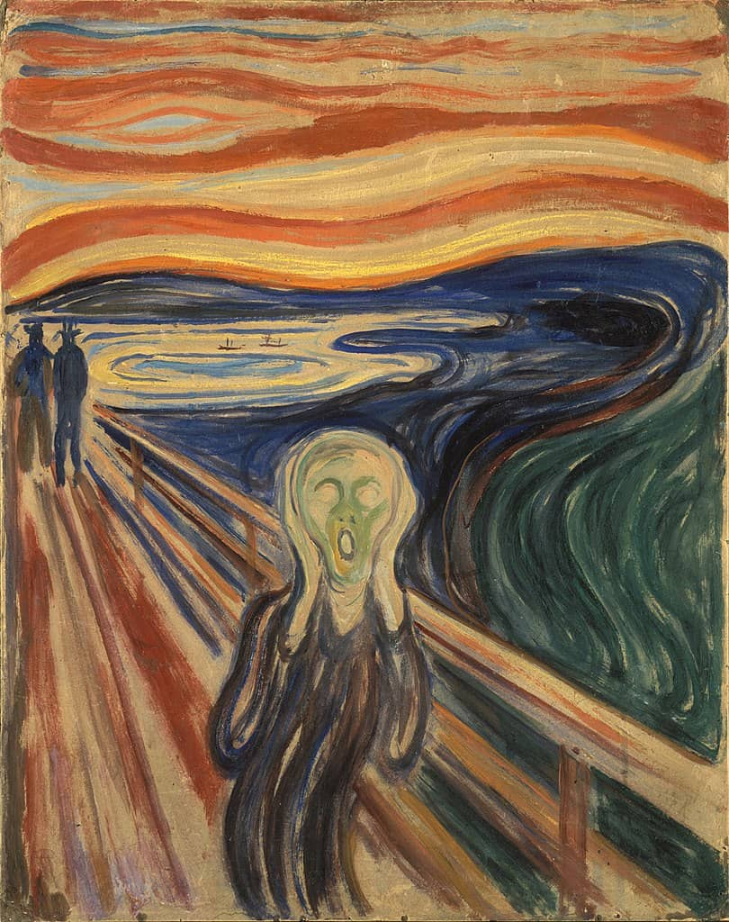
Figure 1: ‘The scream’ By Edvard Munch, 1893.
I have chosen this artwork as a good representation of feelings as Munch portrayed his character to be surrounded with anxiety causing it to give its famous name ‘the scream’. This artwork stands for emotions of constant crippling anxiety and fear.
‘The foreground figure to become distorted by the subjectivized flow of nature; the scream could be interpreted as expressing the agony of the obliteration of human personality by this unifying force.’ (Edvard Munch.org,)
This work very much relates to my practice as I’ve researched emotions and how I incorporated them into my work is linking my projects to the feeling of being used by someone, which is how I have personally felt in a lot of my relationship with peers/ friendships. Emotions aren’t just mood related, emotions are also linked to what we hear and what we see. Music is a big know factor to resonate with our brain and simulate our mood. Music is also known to help people with illnesses and disabilities to increase mood and surrounds.
‘The effect of music on our brains has clinical implications as well. Growing evidence suggests, for example, that listening to Mozart’s Sonata for Two Pianos in D Major can reduce the frequency of seizures in some people with epilepsy.’ (Coony, E 2021, P.g 1)

As an individual with disabilities, I have decided to incorporate music in my work with the influence of different type of genres playing in the background to see how well I preform based off surrounding sounds and mood of the song.

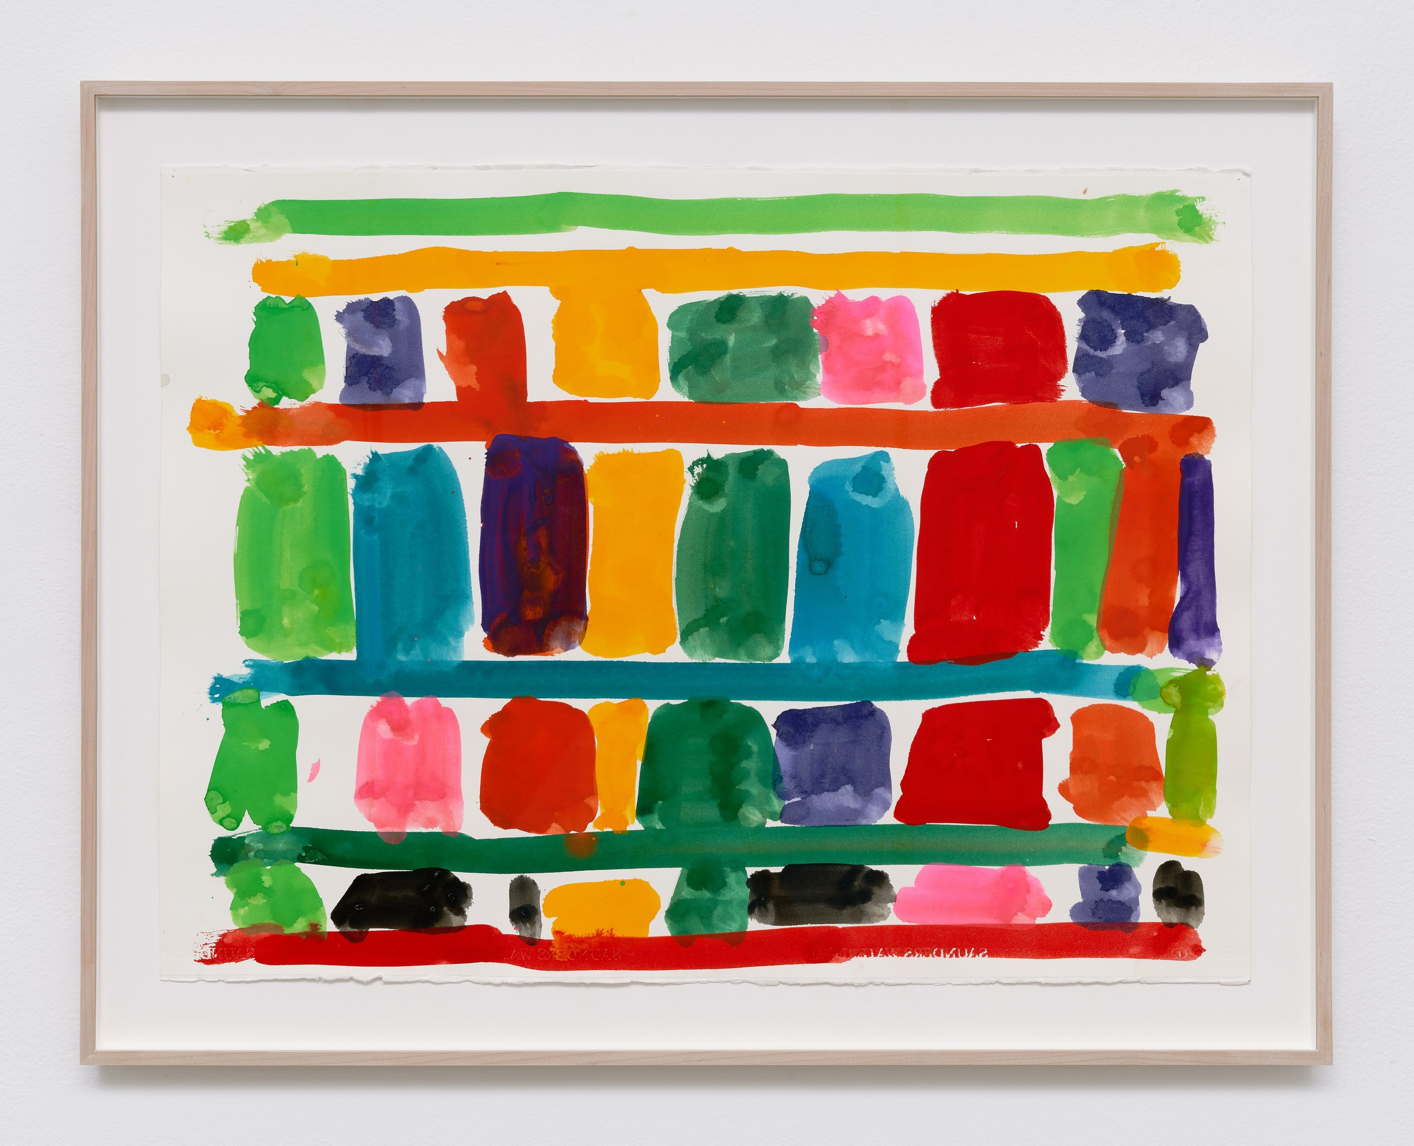

Figure 2: ‘Untitled’ By Stanley Whitney,2021.
Whitney plays jazz music in the background as he creates his artwork, this method is called ‘call and response’ to how he takes in every sound around him and how the finished piece comes out is the response that Whitney’s mind processed every note and instrument.
‘Whitney has long been fascinated by music, admiring jazz legends such as Charlie Parker and Miles Davis. His paintings adopt a similar improvisatory approach.’ (Christies 2026, Stanley Whitney)
The jazz artists Whitney listens and idolizes in his studio time which heavily influences his outcome of style, shape and colour theory. Every piece of work by Whitney was not planned by time and simply made as he went along.
‘The effect reads as both ordered and improvisational, a patchwork of high-key hues that appears simultaneously structured and spontaneous.’ (CALDER CONTEMPORARY, 2026, Stanley Whitney)
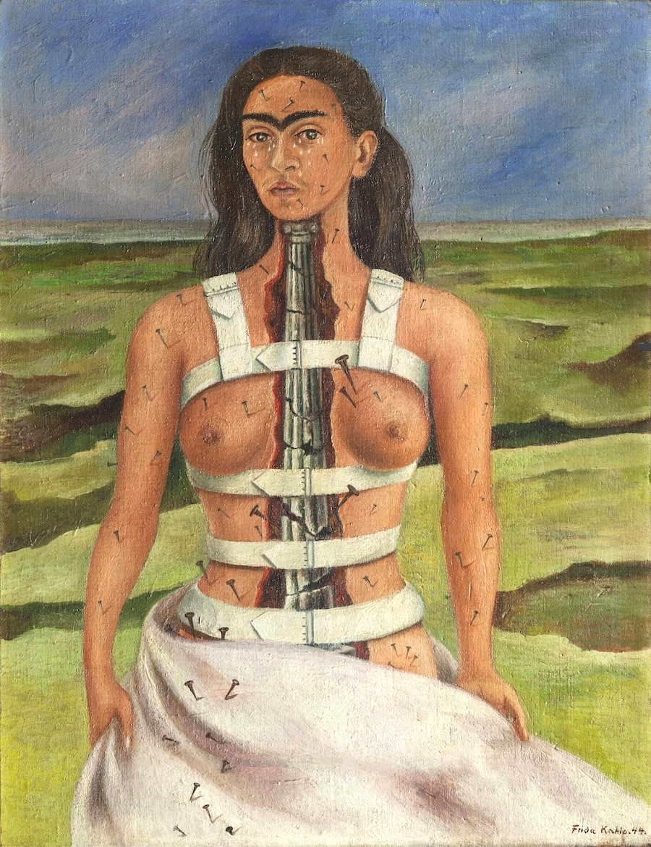
Figure 3: ‘The broken Column’ by Frida Kahlo 1944.
‘This column is fractured and breaking apart, which alludes to her fragile health and the severe injuries she sustained in her youth.’(ARTCHIVE,2026, Frida Kahlo) The column Kahlo painting that is broken and falling apart is the representation of a car accident she got into at a young age which later developed into pain she bared the rest of her life.
‘At 18, Frida barely survived a catastrophic streetcar crash that further displaced vertebrae in her spine, crushed her right foot, and pierced her pelvis with a steel handrail.’ (Art history, 2022) Bringing in her experience into an artwork made the audience feel for her and all the suffering she had borne.

To incorporate emotions into my project about flowers and the colours. I have been receiving my friends and family's favourite flowers and looking into the meaning behind the flowers.
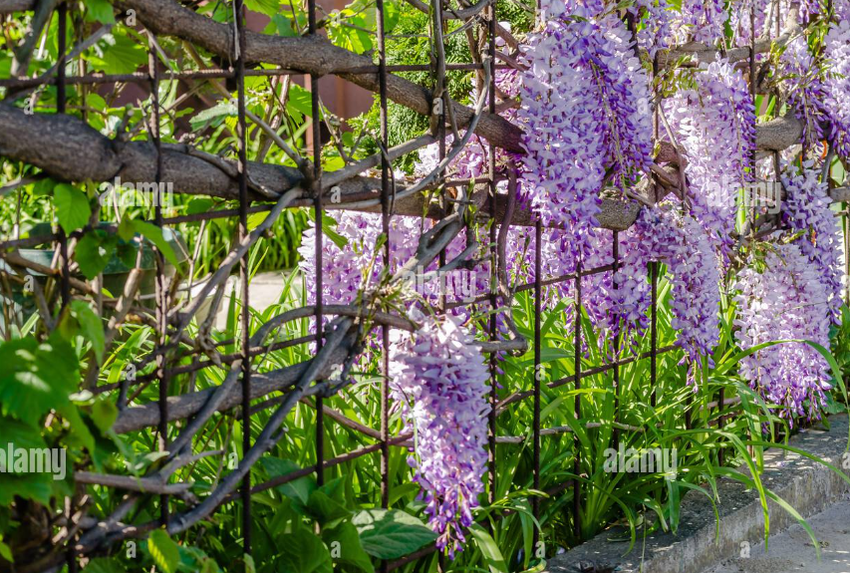
Figure 4: ‘Violet Wisteria flower’ By Zoran Milosavljevic, 2021.
In some cultures, especially Japan, Wisteria’s are known significantly for an heirloom of tradition, to pass a wisteria tree down bloodlines acts as a symbol of endurance and long-lasting life span.
‘Wisteria lives exceptionally long. Some Japanese wisteria trees are over 1,200 years old. This enduring vitality makes it a symbol of endurance and eternal life.’ (Harper, 2026, p.g1,)
Although Japan had a symbol of endurance, the Victorian era of the western world had a deeper meaning. The meaning of Love ‘receiving a sprig of wisteria signalled “I cling to you” or “Welcome.”’ (Harper, L, 2026, p.g 1,) This meaning came from how the vine of the flower hugs onto the entwine as it grows and blooms. Even with the meaning in different era’s the colour of the flower plays a huge part in why you receive them; White flowers were gifted when someone passes way. White flowers are often associated with mourning; the wisteria also plays into this meaning. Most of wisteria gifted back in Victorian and ancient Japan were coloured purple; purple was the significance of ‘Delicateness, refinement, grace, wealth, and royalty.’ (Gaumond, A, 2021, p.g 1,).
The reason Brooke chose this flower to be her, is that she likes how delicate the flower is with the shape of its petals being smaller and more round than how other flowers stereotypically are. The significance of this flower is that it stands out as it is not the same as any other flowers, kind of like humans as we are all the same yet; our looks and personalities differentiate us apart.

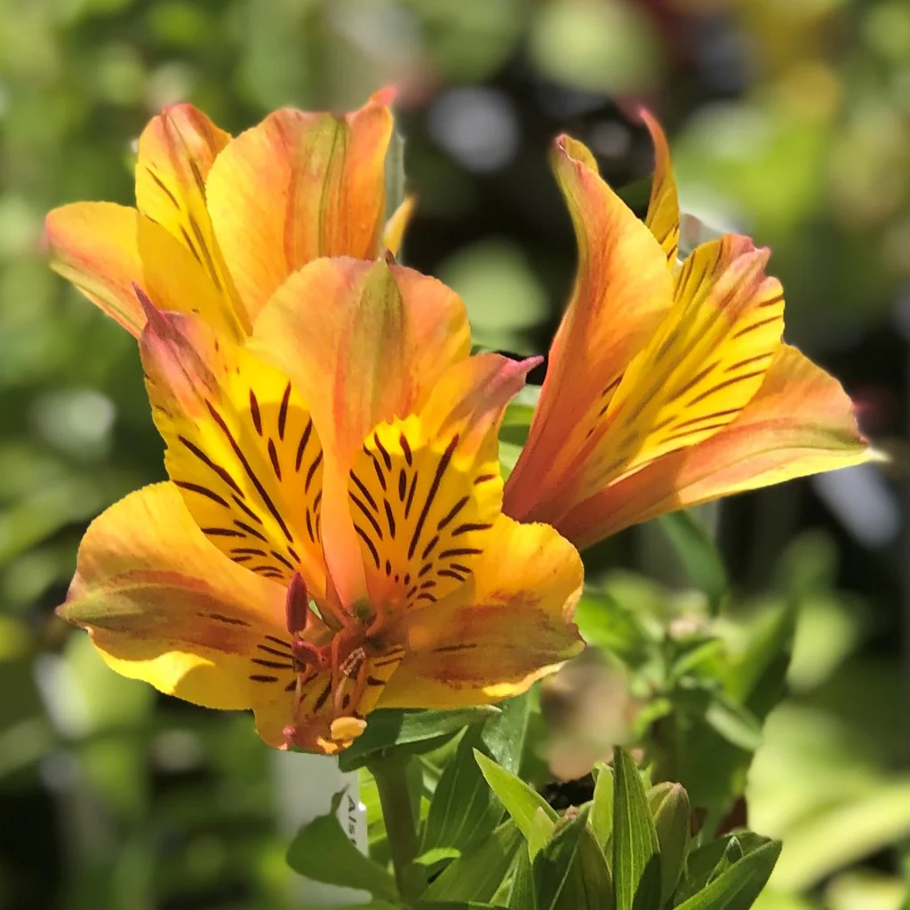
Figure 5: ‘Alstroemeria’ by Easy to Grow Bulbs, 2026.
Alstroemeria flowers also known as Peruvian Lilies, are not only colourful catching to the eye but also hold such a deep value of meaning. The most popular meaning is that alstroemeria’s is that they are for devotion and support, normally given in friendships. ‘Some metaphysical believers keep the flowers around to attract new friends into their lives.’ (Flower meaning, 2026, p.g 1).
Morgan chose alstroemeria as his choice of reputation as it is his favourite flower. Morgan likes the variety of colours alstroemerias bloom in and their patterns are unique. In my final piece, I created two versions of alstroemerias, one was yellow that I found perfect to stand for Morgan. Yellow alstroemerias are ‘Care, cheerfulness and joy’ (Rewers, M, 2026, p.g 1). I found this description a perfect fit for Morgan as his personality is how the flower meaning is described. I also painted pink alstroemerias as a representation of myself; the alstroemerias I painted were pink. Pink is represented as ‘connected to light passion and gentleness.’ ( Gripelements, 2026, p.g 1). For this section of my painting, I chose colour of the flowers that stands for personalities of the people I was portraying into my painting.

Figure 6: ‘Daffodil’ by Tara Evans 2026.
Daffodils are an open flower known for their trumpet like shaped centre, that bloom in early springtime in Wales. Daffodils are what comes to mind immediately when you think of Wales and Welsh people, Daffodils have been rooted deeply into Welsh history and culture since the 19th century; This began when the prime minister David Lloyd George, whom first language was Welsh ‘advocated their use at the investiture ceremony when Edward VIII was made Prince of Wales ’ (Ellis, John, S, 1966, Vol. 18, iss 2). Since then, daffodils have become a cultural flower of symbolisation in Wales. This includes the colour of the flower, Daffodils have two specific colours which are yellow or all white, ‘yellow flowers are symbols of joy and white flowers are symbols of purity ‘(Ret, J, D. Custommapposter, 2026, P.g.1). The colour Wales use to be our daffodils are yellow; the joy is a symbolic of how cheerful Welsh people are.
My father chose daffodils to play the part of him due to his long Welsh roots, being from a family that has lived in Wales for centuries back. Daffodils are a connection too him and his ancestors who have passed, my father’s family are from the countryside of Wales where fields of daffodils bloom in the spring, giving him nostalgia of his childhood.

Figure 7: ‘Red Rose’ By Tara Evans 2025.
Red roses are the most bought flower that people gift on special occasions like Anniversaries, Birthdays, weddings and Mother's Day or even as a romantic gesture. Giving red rosebuds are associated with love and romance, making them a symbol of affection to one and another. There is a saying that comes with picking red roses, ‘The darker the shade of red, the more intense the message of passion and commitment.’ (SpiritualPostsStaff, 2026, p.g 1)
The colour of red roses being associated with love, began thousands of centuries back the ‘association with love dates back to ancient mythology, where red roses were linked to Aphrodite, the goddess of love.’ (The GardeningCook, 2028, p.g 1)
My mother loves red rose and chose them as her favourite flower due to memories of receiving red roses off my father on her birthday, wedding anniversary and Mother's Day. To my mother red roses are seen as a gift of appreciation and love, my mother also loves the shape of the petals on the rose buds.
The softness of the delicate petals is a huge contrast of the sharp pointy thorns on the stem. This is a comparison of humans, the soft petals standing for us human beings navigating through life meanwhile, the sharp thorns on the stem are our past that we carry with us and deal with every day. Even knowing someone's past you still focus on them now, how people ignore the sharp thorns and focus on the soft petals of the rose.

Figure 8: ‘Bluebells’ by Tara Evans 2021.
Bluebells are also known as Perennial plants, named for their bell-like shape, normally coloured violet and baby pink. Bluebells also bloom inn spring like daffodils, often in gardens and fields near daffodils. Bluebells are one of the most common flowers that has the bluest naturally. Bluebells are a symbol for ‘gratitude and humility. However, they can also symbolize constancy and everlasting love.’ (Rebekah, p, 2023, p.g.1). Bluebells are often put in a bouquet when in season in spring, however if not in season they will not be put in bouquets, so time is limited.
Bluebells are included in a variety of folklores ranging from English folklore’s, Fairy connections and for protection. ‘In English folklore, it is said that wearing bluebells will compel a person to only speak the truth.’ (Seasons of Earth,2024, p.g 1). Alongside people wearing bluebells to make someone speak the truth, people also believed that bluebells were a sign of fairies ‘and are said to attract their presence.’ (Caro, T, 2026, p.g 1, Magickal).
I personally chose bluebells as a portrayal of myself as I personally like how they bloom downwards, compared to other flowers that bloom upwards towards the sky. The shape of bluebells like a bell is fascinating to the human eye. They look like objects we can compare them to, that is why they got their name bells.

1971

Figure: 9 ‘Sunflower’ by Camilla Heed.
Sunflowers are known for blooming in late summer going into autumn, they typically bloom in country fields or from a seed that you can also eat. In Aztec tradition, the shape of the sunflower was so similar to the suns shape that ‘Sunflower seeds were offered as tributes, and the flower itself was considered a physical manifestation of the sun on Earth.’ (Rose, S, 2026, p.g 1, Wisdom of the spirit). Alongside the sunflower being a representative of the sun, sunflowers also have a sentimental value with what it is ‘Long life, mainly since most varieties stand in full bloom for months on end during the hottest days of summer’ (Flower meaning, 2027, p.g 1) Sunflowers are the top known flowers known to survive throughout the heat for a good few months on end.
Eve chose a sunflower to be her in the painting; she chose this because she likes how tall they stand and how they sleigh in the wind side to side. The gentleness of a sunflower on the hot summer day makes the scenery more beautiful and makes you feel grateful to be alive to see the sunflowers harvesting. Eve is drawn to the bright appearance of sunflowers how they are shapes and coloured like the sun, the dark seeds draw you in like the dark galaxy of the milky way, reminding you of space and our planets.

Figure 10: ‘As Fragile as a Flower’ By Tara Evans, 2026.

‘People come and go, just how flowers wither and flow, no matter through it all, we all still grow.’ (Evans,T, 2026, p.g 1, Swans art). My art is a representation of people around me day to day, I have included a bunch of friends and family members favourite colours and what the flower symbolises. The flowers are a relation towards how I feel in relationships in the past with being used or not feeling wanted mutually. I have made my friends into the art piece as how flowers grow, they eventually bloom so beautifully. Kind of how I am now as a human being, my friends are helping me grow and bloom brightly. ‘Her visual language tends towards expression with bold colours and imagery.’(Evans,T, 2026, p.g1, Swansea art) Instead of openly writing what i want to say, I decided to let the viewers look at my work and come up with their own summary of what they think my work is about alongside the statements. I have uses bold childlike colours to manipulate the audience into thinking it is just a colourful piece of work, until they read the statement.

2392

Conclusion:
Overall, in this essay I have investigated Emotions, flowers and colours. I first investigated emotions with artworks that made me emotional to view. ‘The scream’ by Edvard munch, ‘Untitled’ By Stanley Whitney, ‘The broken Column’ by Frida Kahlo. This variety of artworks made me feel the same emotions as the artist, seeing how they struggled one way and another. I started to investigate the flowers I created on my final piece ‘As fragile as a flower’ exploring the symbolization and meaning behind these flowers and why e gift them in that specific colour. Lastly, I have looked into my own piece and explained why I chose to create this artwork and an indept explanation on behind every part of the colours and flowers.

Bibliography:

ARTCHIVE, 2026 The Broken Column (1944) by Frida Kahlo – Artchive Accessed 16th April 2026.
Art History, 2022 The Broken Column by Frida Kahlo | Obelisk Art History Accessed 16th April 2026.
Alston, P, Williams, 1961, pg.100 The Philosophical Review, https://www.jstor.org/stable/2183809 Accessed 4th April 2026
Caro,T, 2026, p.g 1, Magickal Bluebell: Folklore, Healing & Magical Uses Accessed on May 5th 2026.
Christies, 2026, P.g 1, Stanley Whitney.
Stanley Whitney | Art for sale, auction results & history Accessed 12th April 2026.
Coony,E 2021,p.g 1 Statnews, New study revives a Mozart sonata as a potential epilepsy therapy | STAT Accessed April 10th, 2026
Ellis, John, S, Welsh history review, 1966, Vole 18, Iss 2. THE PRINCE AND THE DRAGON: WELSH NATIONAL IDENTITY AND THE 1911 INVESTITURE OF THE PRINCE OF WALES - ProQuest Accessed May 4th, 2026.
Evans,T, 2026, p.g 1, Swanseart. Tara Lea Evans – swansea.art Accessed on 10th may 2026.
Flower meaning, 2027, p.g 1 Sunflower Meaning - Flower Meaning Accessed on 7th May 2026.
Frida Kahlo, org The Broken Column, 1944 by Frida Kahlo Accessed 16th April 2026.
Flower meaning,
Gaumond, A, 2021, p.g 1,Petal Republic Wisteria Flower Myths and Contemporary Meanings - Petal Republic Accessed 20th April 2026.
Gripelements, 2026, P.g. Alstroemeria Flower Meaning Based on Colors - GRIP ELEMENTS Accessed on 4th May 2026.
Harper,L, 2026,P.g.1, Flower meanings Wisteria Flower Meaning: Symbolism, Colors, and Cultural Significance Accessed 20th April 2026
Munch,E.Org, N/A. The scream, 1893 by Edvard munch,
The Scream, 1893 by Edvard Munch Accessed on 10th April 2026
Rebekah, p, 2023, p.g.1, Florgeous, Bluebell Flower Meaning and Surprising Symbolism | Florgeous Accessed May 4th 2024.
Ret, J, D. Custommapposter, 2026, P.g.1, The Daffodil: Meanings, Images & Insights (2026) Accessed on May 4th 2026.
Rewers, M, P.g 1, 2026, BLOOMING EXPERT Alstroemeria Meaning: Why Peruvian Lilies Are the Friendship Flower That Lasts 14 Days in a Vase - Blooming Expert Accessed on 4th May 2026.
Seasons of Earth,2024, p.g 1 Bluebell Flower Meaning: Symbolism & Folklore Accessed on May 5th 2026.
Rose, S, 2026, p.g 1, Wisdom of the spirit Sunflower Meaning & Symbolism in Mythology, Folklore & Spirit Work - Wisdom Of The Spirit Accessed on 7th May 2026.
SpiritualPostsStaff,2026, p.g 1, 10 Spiritual Meanings of Red Rose [Symbolism & Significance] - Spiritual Posts Accessed may 5th 2026.
The GardeningCook, 2028, p.g 1 Rose Colors and Meanings – Red, Pink, White, Yellow, and More Accessed may 5th 2026.

