

Student name: Edna F Aguirre
Student ID:2411409

Module name: Introduction to Physiology
Module code: BMHP5023_LON
Lecturer name: Dr. Soban Sadiq
Assessment: Case Study 1

1. Introduction
What is diabetes?
Diabetes is a disorder that triggers an increase in the level of blood glucose (NHS, 2023). Moreover, the body doesn't make enough insulin (MedlinePlus, 2024). It is also called the endocrine disorder, or the pancreas doesn’t react and release the right hormone (Care New England, 2021).
Type 2 diabetes- not producing enough insulin in the normal range. Moreover, the cells don't use insulin properly, even though the pancreas is producing insulin. In addition, the glucose remains in the blood and does not reach the cells (Bessesen, 2023).
The most common chronic metabolic disease is type 2 diabetes mellitus. And the rate and the proportion of T2DM are global problems, involving genetic, the change in DNA and environmental risk factors (Lin and Yin, 2022).
Types of diabetes and who is affected.
- Type 1 is diagnosed in childhood and can be any age and cannot be cured (NHS, 2023).
- Type 2 diabetes is due to age, ethnicity and people who are overweight. Can be changed or stopped with a change of lifestyle. And with treatment (NHS, 2023). Moreover, will develop gradually over several years, when muscle and other cells stop reacting to insulin. The condition is called insulin resistance. Over time, the insulin production stops because of the demand made on the insulin – making cells tires them (The Nutrition Source, 2013).
- Gestational diabetes can happen in pregnancy. And goes away after giving birth (NHS, 2023).
- Prediabetes blood glucose levels are higher than normal but cannot be diagnosed with type 2 diabetes (NHS, 2023).
Common symptoms include
- Feeling very thirsty
- Frequent urination
- Tiredness
- Blurry sight
- Getting thinner
(National Health Service, 2022).

Factors that can contribute to the disease
- Overweight
- Family history
- Poor Lifestyle
- Lack of physical activities
- Age and ethnicity
- Smoking
(Bessesen, 2023).
Risk of having diabetes
- Kidney problem
- Damage to the nerve
- Retinal disease
- Heart problem
- Stroke
(Seery, 2019).
- Diabetic retinopathy permanent damage to sight and eyes
- Diabetic ketoacidosis a deadly condition
(National Health Service, 2022).
Impact of diabetes in the NHS
According to Whicher, O’Neill and Holt (2020), seven per cent of the UK population has diabetes. While 1 million are undiagnosed with type 2 diabetes. Meanwhile, forty thousand children have the condition and every year, three thousand children are diagnosed. Moreover, this disease is responsible for 175 amputations and 530 myocardial infarctions every week. The NHS spend 10 billion pounds a year on diabetes, equal to 10%of its budget: 80% use to treat complications. Moreover, diabetes is a major public health concern in the UK and also in other parts of the world. The quality of life of the individual living with the condition (Whicher, O’Neill and Holt, 2020).
The Endocrine System
The Endocrine and the immune system are the complex and vital systems in the anatomy. The research reveals a multitude of two- way pathways of communication and a reversible order of mechanism( Kaltsans, 2018).
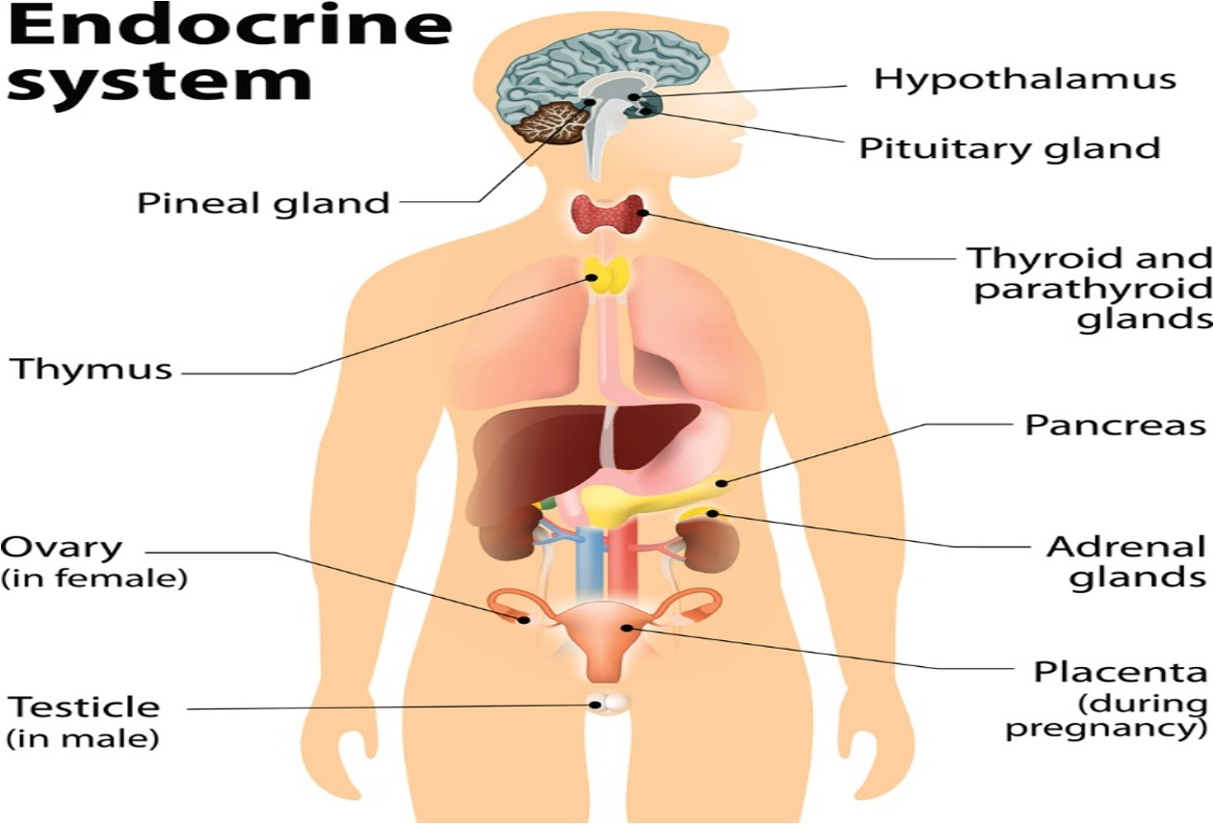 (module in pschology)
Figure 1 above shows that the endocrine system is made up of glands and releases hormones throughout the body.
The Glands and functions
- Pancreas –regulator of blood sugar levels
- Adrenal – makes more blood glucose levels and makes the heart race rate
- Thyroid – monitor our bodily processes
- Pituitary – cultivates growth
- Pineal – controls sleep cycles
- Ovaries – support female sex characteristics
- Testes – development of testosterone
(Amar Singh, 2019)

According to Amar Singh (2019), when you have diabetes, it affects your blood sugar and the internal environment, and insulin helps reduce blood sugar, but glucagon increases the sugar in the blood, which doesn’t function in a diabetic person. In addition, insulin and glucagon work together to maintain the blood levels in people without diabetes. Moreover, when the pancreas doesn't release the right hormones or does not produce insulin, the body stops from regulating the blood glucose, which leads to health issues that could be serious (Whicher, O’Neill and Holt, 2020).

2.Blood Sugar Regulation

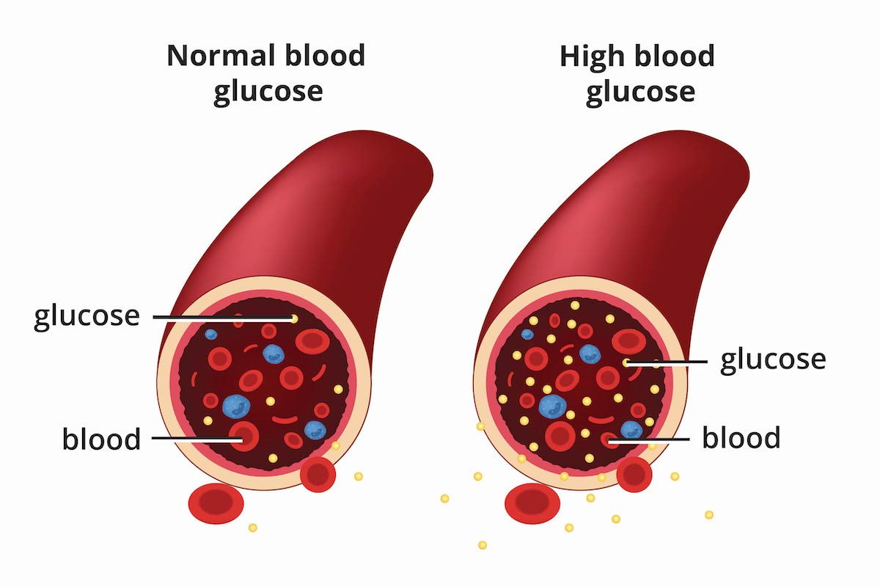 ( Bessesen, 2023)
Figure 2 shows that glucose is high and the normal glucose level

Blood glucose is the primary sugar found in the blood. And the leading energy of the body. In the same way the body digests the food into glucose and goes to the bloodstream, when the blood sugar is high, the pancreas produces insulin. A hormone, which is insulin, helps glucose as energy into the cells (MedlinePlus, 2024).
Two Dangerous Blood Glucose Imbalances
1.Hypoglycaemia; low blood sugar (National Health Service, 2022).
Common early symptoms of low blood sugar include:
- frail
- light-headedness
- starving all the time
- wobbly
- perspiring
- palppitations
- agitated
(Cleveland Clinic, 2023)
2. Hyperglycaemia; sugar in your blood is too high (National Health Service, 2022).
Common causes of high blood sugar includes:
- Unwell
- Stressed
- Consuming sugary or starchy food
- Less active than usual
- Miss the medicine
- Medicine is not working well
- Taking steroids
- Had an operation
(National Health Service, 2022)
A person with diabetes needs to monitor their blood glucose in order to determine the medication strength or need to be adjusted and observe for life-threatening hypoglycaemia. Painless devices will help increase compliance in checking the blood sugar count (Bolla and Priefer, 2020).
Moreover, proper and timely checking of blood sugar will lead to an efffective controls a blood glucose when the range is out of target, and guarantee the safety during the event of acute illness, not only but also minimising related health complications for future diabetes (Gordon, 2019).

3. Cellular Metabolism
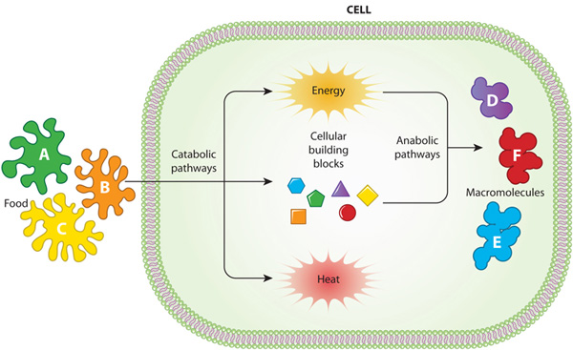 (Nature education, 2014)

Figure 3 tells us how Cellular Metabolism regulates the biochemical processes that happen within the cell to continue life. Correspondingly, the catabolic and the anabolic processes (Escoll and Buchrieser, 2019). The first pathway breaks down the food into nutrients into a usable form (the building blocks). Energy is stored in molecules for later use or released as heat. In Anabolic pathways, new molecules are produced from the products of catabolism: these processes use energy. Via anabolic pathways, new molecules called macromolecules are vital for the construction of new cells and maintaining the cells (Alberts, 2002).
A cell needs an ongoing supply of energy to make and preserve the organism to continue living. This energy comes from a chemical that breaks down the food molecules to serve as a fuel for cells. Furthermore, sugar is the fuel molecule which is relevant they were oxidized in a small amount of carbon dioxide and water to enter our system. Glucose is the leading energy source in most human cells; the same pathways go in plants, fungi and bacteria. Fatty acids and proteins are other molecules that are channelled in enzymatic routes to produce energy. Moreover, the food is digested into smaller molecules for our cells to utilise as a fuel or to stop other molecules, and this comes from the proteins, lipids and polysaccharides. After digesting, the molecules that come from the edibles go into the cytosol of the cell, and slow oxidation begins (Alberts, 2002).

4.The importance of tracking blood sugar levels for type 2 diabetes
Health and safety are vital in monitoring blood sugar if you have diabetes. Lack of tracking of blood glucose will develop long-term problems, and help reduce current issues when checking the blood sugar (Bolla and Priefer, 2020). Moreover, checking the blood sugar can help the current treatment plan if it is effective for the patient. Moreover, it manages the diabetes and gives details on a daily as well as hourly basis. In addition, it is also a way to monitor how your diabetes is being controlled. Especially if they use insulin. The result of the blood sugar can help you think about what to eat, activity, and when to administer the insulin (Cleveland Clinic, 2023).

What is the importance of recording when and how to check blood glucose?
Checking your blood glucose number every day in your target range. Some need to check twice or three times a day, especially those who are taking insulin. You can ask your doctor how often you need to check (MedlinePlus, 2024).

Table 1 The NICE target for blood glucose level is recommended below
Target Level by Type | Upon waking  Millimoles per litre | Pre-prandial  Millimoles per litre | Postprandial  Millimoles per litre
Non diabetic |  | 4.0 t0 5.9 | Lower 7 to 8
Type 2 diabetes |  | 4 to 7 | Lower 8.5
Type 1 diabetes | 5 to 7 | 4 to 7 | 5 to 9
Child with type 1diabetes | 4 to 7 | 4 to 7 | 5 to 9
(Seery, 2019)
Glucose meters can save the results. There are apps nowadays on smartphones to track the levels, or you can do it manually with your book as a record, including the date and time of the test, whether it was before or after a meal. The GP can access your information through the CGM system (Cleveland Clinic, 2023).
1. A blood glucose meter is the standard way to check the blood sugar level at home in a small sample of blood, usually from your fingertip (MedlinePlus, 2024).
2.A Continuous glucose monitoring (CGM ) system is useful for people who take insulin and have low blood glucose problems. The CGM system is inserted under the skin. It has a sensor that measures the level of glucose every few minutes. It can monitor the blood glucose day and night (MedlinePlus, 2024).
3.The blood test called A1C is how the GP will also check the blood sugar; it can monitor the blood sugar level for the past three months. The test is done every 6 months (MedlnePlus, 2024)
Indicators of diabetes or prediabetes are listed below
- Normal: 6.0% (under 42mmol/mol)
- Prediabetes: 6.0 to 6.4% (42 to 47 mmol/mol
- Diabetes: 6.5% or over (48mmol/mol)
(Seery, 2
4.A fasting plasma glucose test is taken in the morning after fasting for 8hours. (Seery, 2019)
5. An oral glucose tolerance test involves the fasting blood sample is taken and then drink 75g of glucose (Seery, 2019)
Recommendations to avoid and for those who already have Diabetes
- At least 5–7% Weight loss
- Lifestyle interventions, more physical activity•
- Eat low saturated fat
- High in dietary fibre and wholegrains,
- Moderate coffee and alcohol, low-fat dairy foods, and green leafy vegetables,
- Avoid processed food, red meats, and fried potatoes
- Nutrition therapy is useful for those who are indanger of diabetes when it is combined with education and clinical care
- Continues advice from a registered dietitian
- Those who have the sickness or their carer should receive structured education when they are diagnosed, with an annual follow-up
patient-centred methods of education and learning styles.
(Dyson et al., 2018)
- Liver health check for those with diabetesto prevent disease progression (Kushala W M Abeysekera et al., 2024)
- Supervising: cholesterol, blood pressure and blood sugar to avoid future health issues (Bessesen, 2023)
- The non-invasive devices for blood glucose monitoring will likely elevate lifestyle for many people
- More individuals are willing to regularly record blood glucose levels if it is comfortable, painless and easy for early detection
(Bolla and Priefer, 2020)
Additional help to check
→ Diabetes (Types 1 and 2)—patient education models. Technology Appraisal TA60. NICE (2003).London.
→ Quality standards for diabetes.NICE (2011) Quality. London.
→ different languages, visit the Diabetes UK language centre (Dyson et al., 2018)

6. Conclusion
In summary, diabetes is a major public health concern in the UK and also in other parts of the world. It impacts the quality of life of the individual living with the condition. Individuals need to have a structured understanding of what diabetes is, the risk of the sickness, the prevention and symptoms and how to monitor and track in a safe and an effective way for the body's needs, especially with type 2 diabetes the importance maintaining the blood sugar to manage the condition and using a painless device to encourage them to check daily or when advised by the health team. Recommendation is vital to help them to live with confidence and understand their sickness, as well as to follow up with individuals with diabetes to avoid further long -term issues.

Reference list
Alberts, B. (2002). How Cells Obtain Energy from Food. [online] NIH. Available at: https://www.ncbi.nlm.nih.gov/books/NBK26882/ [Accessed 7 Mar. 2026].
Amar Singh (2019). The Endocrine System and Diabetes - Pancreas, Liver & Kidneys. [online] Diabetes.co.uk. Available at: https://www.diabetes.co.uk/body/endocrine-system.html [Accessed 7 Mar. 2026].
Bessesen, D. (2023). What is diabetes? [online] National Institute of Diabetes and Digestive and Kidney Diseases. Available at: https://www.niddk.nih.gov/health-information/diabetes/overview/what-is-diabetes [Accessed 28 Feb. 2026].
Bolla, A.S. and Priefer, R. (2020). Blood glucose monitoring- an overview of current and future non-invasive devices. Diabetes & Metabolic Syndrome: Clinical Research & Reviews, 14(5), pp.739–751. https://doi.org/10.1016/j.dsx.2020.05.016.
Care New England (2021). How is the Endocrine System Related to Diabetes? [online] www.carenewengland.org. Available at: https://www.carenewengland.org/blog/endocrine-system-and-diabetes [Accessed 28 Feb. 2026].
Cleveland Clinic (2023). Blood Sugar Monitoring: Why, How & When To Check. [online] Cleveland Clinic. Available at: https://my.clevelandclinic.org/health/treatments/17956-blood-sugar-monitoring [Accessed 8 Mar. 2026].
Diabetes UK (2018). 10 tips for healthy eating with diabetes. [online] Diabetes UK. Available at: https://www.diabetes.org.uk/living-with-diabetes/eating/10-ways-to-eat-well-with-diabetes [Accessed 7 Mar. 2026].
Dyson, P.A., Kelly, T., Deakin, T., Duncan, A., Frost, G., Harrison, Z., Khatri, D., Kunka, D., McArdle, P., Mellor, D., Oliver, L. and Worth, J. (2018). Diabetes UK evidence-based nutrition guidelines for the prevention and management of diabetes. Diabetic Medicine, [online] 28(11), pp.1282–1288. https://doi.org/10.1111/j.1464-5491.2011.03371.x.
Escoll, P. and Buchrieser, C. (2019). Cell Metabolism - an overview | ScienceDirect Topics. [online] www.sciencedirect.com. Available at: https://www.sciencedirect.com/topics/medicine-and-dentistry/cell-metabolism [Accessed 8 Mar. 2026].
Gordon, C. (2019). Blood glucose monitoring in diabetes: rationale and procedure. British Journal of Nursing, [online] 28(7), pp.434–439. https://doi.org/10.12968/bjon.2019.28.7.434.
Kushala W M Abeysekera, Valenti, L., Zobair Younossi, Dillon, J.F., Allen, A.M., Mazen Nourredin, Rinella, M.E., Tacke, F., Sven Francque, Pere Ginès, Thiele, M., Newsome, P.N., Indra Neil Guha, Eslam, M., Schattenberg, J.M., Alqahtani, S.A., Arrese, M., Berzigotti, A., Holleboom, A.G. and Cyrielle Caussy (2024). Implementation of a liver health check in people with type 2 diabetes. The Lancet. Gastroenterology & hepatology, 9(1), pp.83–91. https://doi.org/10.1016/s2468-1253(23)00270-4.
Lin, J.-Y. and Yin, R.-X. (2022). Exposure to Endocrine-Disrupting Chemicals and Type 2 Diabetes Mellitus in Later Life. Exposure and Health, 15. https://doi.org/10.1007/s12403-022-00486-0.
MedlinePlus (2024). Blood Glucose. [online] medlineplus.gov. Available at: https://medlineplus.gov/bloodglucose.html [Accessed 4 Mar. 2026].
National Health Service (2022). Hyperglycaemia (high Blood sugar). [online] NHS. Available at: https://www.nhs.uk/conditions/high-blood-sugar-hyperglycaemia/ [Accessed 28 Feb. 2026].
Nature education (2014). Cell Metabolism | Learn Science at Scitable. [online] www.nature.com. Available at: https://www.nature.com/scitable/topicpage/cell-metabolism-14026182/ [Accessed 7 Mar. 2026].
NHS (2023). Diabetes. [online] NHS. Available at: https://www.nhs.uk/conditions/diabetes/.
Seery, C. (2019). Normal blood sugar ranges and blood sugar ranges for adults and children with type 1 diabetes, type 2 diabetes and blood sugar ranges to determine people with diabetes. [online] Diabetes. Available at: https://www.diabetes.co.uk/diabetes_care/blood-sugar-level-ranges.html#google_vignette [Accessed 28 Feb. 2026].
The Nutrition Source (2013). Carbohydrates and Blood Sugar. [online] The Nutrition Source. Available at: https://nutritionsource.hsph.harvard.edu/carbohydrates/carbohydrates-and-blood-sugar/ [Accessed 7 Mar. 2026].
Tsoli, M. and Kaltsas, G. (2018). Immune System Effects on the Endocrine System. [online] Nih.gov. Available at: https://www.ncbi.nlm.nih.gov/books/NBK279139/ [Accessed 11 Mar. 2026].
Whicher, C.A., O’Neill, S. and Holt, R.I.G. (2020). Diabetes in the UK: 2019. Diabetic Medicine, [online] 37(2), pp.242–247. https://doi.org/10.1111/dme.14225.

